

Elected Members Module

Tech Guide

Overview

URLs
The elected members module can be found using the links below
Landing page
https://thecore.south-ayrshire.gov.uk/memberenquiries
Assist page
https://thecore.south-ayrshire.gov.uk/article/40365/Assist-elected-members

Logging in
Users must be logged in to access the members module and submit enquiries on members’ behalf. The members are the only user profiles permitted to access this module. These user profiles are members of the CM-MEMBERS site group, and have their details stored in the Councillors lookup, located here:
Admin -> Config manager -> Lookups -> Councillors
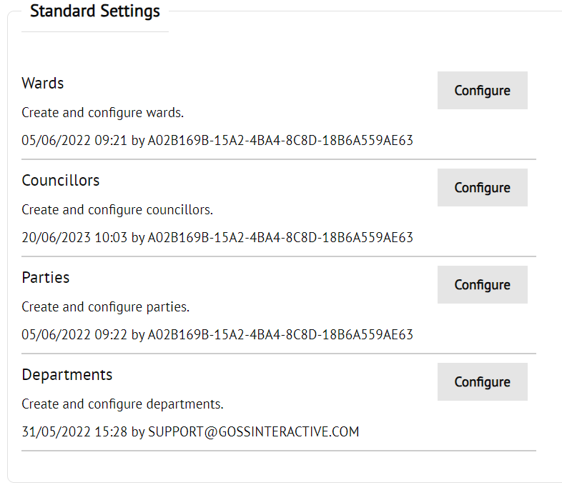
For staff/administrators to access the dashboard/submit an enquiry, they will first have to assist as one of the members via the ‘Assist elected members’ page.
This page is locked down to members of the CM-MEMBER-ENQUIRY group, and will only show user results from the councillors lookup.

Groups
Members:
CM-MEMBERS
Staff submitting/actioning on members’ behalf:
CM-MEMBER-ENQUIRY

Member Enquiries
When users submit an enquiry, the case is sent to the CM-MEMBER-ENQUIRY queue, where a task can be added and assigned to the relevant service. Once this task has been actioned, the case is sent back to the councillor/staff group. Any updates received will be marked in the councillors/staff copy of the case.

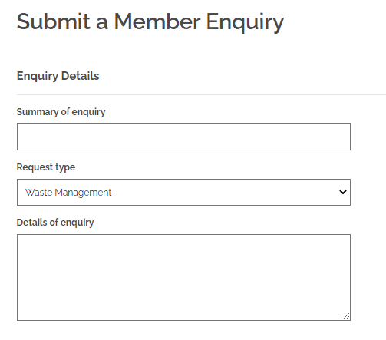
Once submitted, the query will be sent to the relevant service via the metadata details in the enquiryTypes metadata group (ID: 71). TO link these metadata values to the queries being submitted, these values will have to be matched up to the relevant service in the sacintranet.ElectedMembers.CaseManagers endpoint (ID: 1850) (Line 3). Once these values have been linked, add the relevant groups to the membersenquiry casetypes auto-assign groups

Member’s dashboard
Once queries have been submitted, they will be viewable via tasks and via the member’s dashboard. The dashboard will provide a breakdown of every query that the member has submitted, as well as any cases that other members have decided to share with their party and/or ward.
These results will be displayed in both graph and table form, which can be filtered down to only show cases related to specific services (Via the metadata detailed above). The data being pulled for this page is being taken from the goss.CaseManagement.v1.cases.memberenquiry.getDashboardData endpoint (ID: 1426)

