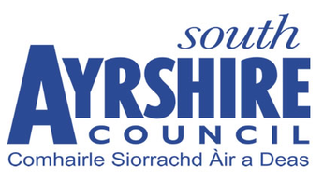

South Ayrshire Council

County Buildings, Wellington Square, Ayr

**CLOSING DATE: 12 NOON WEDNESDAY 15TH NOVEMBER 2023**

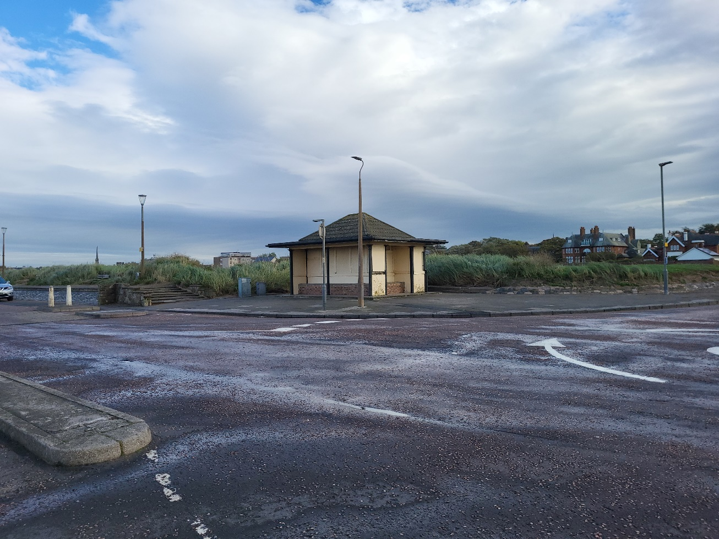

**KIOSK OPPORTUNITY**

**ESPLANADE**

**AYR**

**INTRODUCTION**

This former toilet block/shelter is being made available for let for use as a Kiosk. Enquiries/offers are being sought from those interested in developing the building for this use.

**LOCATION**

Ayr is the administrative and principal retail centre for Ayrshire with a population of around 48,000 persons and a catchment population in excess of 180,000 persons. The town is situated approximately 40 miles south‐west of Glasgow City Centre.

The former shelter is situated on Esplanade adjacent to the mini roundabout at the end of Blackburn Drive. The location is shown in the plan accompanying these details. Bidders should satisfy themselves as to the commercial viability of the location.

**SERVICES**

Information on any services available can be supplied upon request.

**USE**

The subject is being leased for the development for future use as a kiosk or similar use.

**PLANNING**

The below brief has been supplied by the planning department.

The subjects comprise a former toilet block, incorporating sheltered seating areas to 3 sides of the building, with access into the building to the north. The block is situated on Ayr Esplanade, adjacent to the Low Green and just north of the junction with Blackburn Drive and is surrounded by a small area of concrete slabbed landscaping.

The site is located within the Ayr Central Conservation Area, and in an area of open space, as designated within the Council’s Local Development Plan 2 (LDP2). Any planning application for a proposed change of use will be assessed against the development plan comprising both [National Planning Framework 4](https://www.gov.scot/publications/national-planning-framework-4/) and [Local Development Plan 2](https://www.south-ayrshire.gov.uk/article/28782/Local-development-plan-2), for which purpose the development plan is to be read and applied as a whole.

Due to its location within an area of open space, planning policy requires that the scale, use and design of any development is appropriate to the existing character of the open space and there is no individual or cumulative effect on the amenity or recreational value of the Low Green area. Similarly within conservation areas, development should be of a high quality and should preserve and enhance the character and appearance of the conservation area and its settings.

There is no recorded planning history for the site, so it is strongly recommended that to progress any proposals for the site applicants should seek [pre-application advice](https://www.south-ayrshire.gov.uk/article/58720/Pre-Application-Enquiries) from the Planning Service. However the reuse of the existing building for alternative uses may be acceptable if these are complementary to, and in keeping with, the attractive, open and recreational character of the Low Green/Esplanade area, including, potentially, small-scale leisure/recreational, tourism, cultural, retail, or food and drink uses.

**LEASE**

The subjects are offered on the basis of a full repairing and insuring lease (FRI).

**RENTAL**

Rental offers exclusive of VAT, are invited. South Ayrshire Council will not charge VAT on this rental.

**RATEABLE VALUE**

The property is currently excluded from the Valuation Roll. If at any time during the lease the property becomes liable for Non-Domestic Rates, the tenant will be responsible for the payment of all rates levied.

**PROFESSIONAL FEES**

The operator will be responsible for the Council’s reasonable costs and fees incurred in putting in place this agreement.

**OFFERS**

Please note that a closing date for rental offers has been set for **12 noon on Wednesday 15 November 2023**. A formal written offer to lease the shelter for use as a kiosk should be e-mailed to [estates@south-ayrshire.gov.uk](mailto:estates@south-ayrshire.gov.uk) between 11am and 12 noon on Wednesday 15 November 2023. The offer should clearly state the following:

The rental.

The length of lease.

Details of the exact use of the building.

The length of lease.

The proposed alterations.

Whether the offer is subject to any conditions i.e. planning

The estimated time for development.

Offers submitted in any other format will not be considered. Please note that the Council does not bind itself to accept the highest or any offer.

**CONTACT**

For further information please contact: -

Estates Section

South Ayrshire Council

County Buildings

Wellington Square

Ayr

Telephone: 01292 612 914

01292 612 453

E-mail: [robert.campbell@south-ayrshire.gov.uk](mailto:robert.campbell@south-ayrshire.gov.uk)

[estates@south-ayrshire.gov.uk](mailto:estates@south-ayrshire.gov.uk)

South Ayrshire Council gives notice that these particulars are not warranted, nor do they constitute any part of any offer or contract and all statements contained herein are made without any responsibility on the part of the Council and/or its employees. Further, neither South Ayrshire Council and/or its employees are authorised to make or give any representation of warranty in respect of the property described in this brochure. South Ayrshire Council is not obliged to accept the highest, nor any offer.

