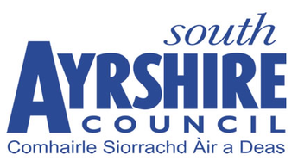

South Ayrshire Council

County Buildings

Wellington Square

Ayr

**CLOSING DATE: 12 NOON WEDNESDAY 15 NOVEMBER 2023**

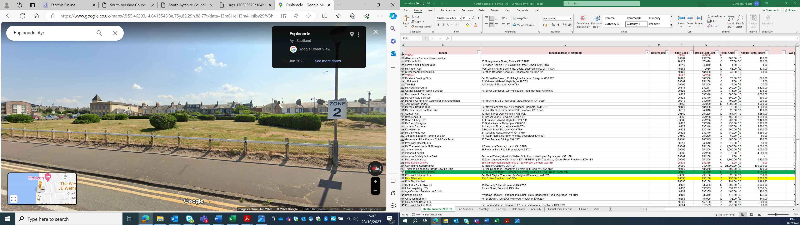

**CRAZY GOLF OPPORTUNITY**

**ESPLANADE**

**AYR**

**INTRODUCTION**

The former crazy golf site is being made available for let and is open to offers.

**LOCATION**

Ayr is the administrative and principal retail centre for Ayrshire with a population of around 48,000 persons and a catchment population in excess of 180,000 persons. The town is situated approximately 40 miles south‐west of Glasgow City Centre.

The crazy golf site is situated adjacent to the esplanade in Ayr in between Charlotte Street and the Horizon Hotel car park. The location is shown in the plan accompanying these details. Bidders should satisfy themselves as to the commercial viability of the location.

**SERVICES**

The operator will be responsible for providing any power for the operation of the crazy golf, if required, as well as meeting the cost of all utilities consumed on the site.

**USE**

The site would be used for crazy golf and no other purpose. Offers involving a Crazy Golf theme eg. Scottish, Ayrshire, Pirate, Dinosaur etc, but utilising the same layout will be especially welcomed

**LEASE**

South Ayrshire Council is prepared to offer a full repairing and insuring lease for the development and operation of crazy golf on this site. The operator will be required to obtain a Public Entertainment Licence.

**RENTAL**

Rental offers exclusive of VAT, are invited. South Ayrshire Council will not charge VAT on this rental.

**RATEABLE VALUE**

The property is currently excluded from the Valuation Roll. If at any time during the lease the property becomes liable for Non-Domestic Rates, the tenant will be responsible for the payment of all rates levied.

**PROFESSIONAL FEES**

The operator will be responsible for the Council’s reasonable costs and fees incurred in putting in place this agreement.

**OFFERS**

Please note that a closing date for rental offers has been set for **12 noon on Wednesday 15th November**. Your offer should specify the following information:

* The rental for the site.
* The proposed length of lease.
* Whether your offer is subject to any conditions.
* Information on how the operator plans to run the crazy golf would be useful.
* Outline plan of course layout and any other proposals
* Any other relevant information.

Offers should be e-mailed to [estates@south-ayrshire.gov.uk](mailto:estates@south-ayrshire.gov.uk) on **Wednesday 15th of November between 11am and 12 noon.**

Please note that the Council does not bind itself to accept the highest or any offer.

**CONTACT**

For further information please contact: -

Estates Section

South Ayrshire Council

County Buildings

Wellington Square

Ayr

Telephone: 01292 612 914

E-mail: [estates@south-ayrshire.gov.uk](mailto:estates@south-ayrshire.gov.uk)

South Ayrshire Council gives notice that these particulars are not warranted, nor do they constitute any part of any offer or contract and all statements contained herein are made without any responsibility on the part of the Council and/or its employees. Further, neither South Ayrshire Council and/or its employees are authorised to make or give any representation of warranty in respect of the property described in this brochure. South Ayrshire Council is not obliged to accept the highest, nor any offer.

