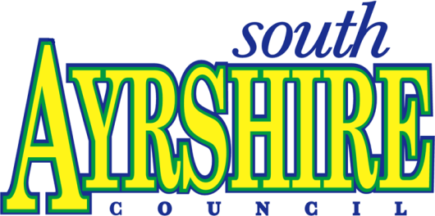

South Ayrshire Council

Chief Executive’s Department

FOOD SERVICE PLAN

2022/2024

# Food Service Plan 2022/2024

**1.0 Service Aims & Objectives**

1.1 **Aims & Objectives**

1.1.1 **Aims**

To deliver an effective and efficient local food enforcement service for South Ayrshire by raising standards of compliance in food businesses, ensuring food produced locally meets all safety requirements and increasing awareness and understanding of food issues in the local community.

NB. For the purpose of this Service Plan and in accordance with the Framework Agreement on Local Authority Food Law Enforcement issued by the Food Standards Scotland, "food" is defined as covering a local authority department’s service covering either food hygiene, food standards or feeding stuffs or a combination of these activities.

* 1. **Links to Corporate Objectives and Plans**

1.2.1 The Service Plan is built upon the South Ayrshire Council’s Vision contained in the document [Our People, Our Place Council Plan 2018-2022](https://ww20.south-ayrshire.gov.uk/ext/committee/committeepapers2018/South%20Ayrshire%20Council/1%20March%202018/SAC01031814%20Council%20Plan%202018-22-App1.pdf) in which the vision of the Council is defined as:

‘We want South Ayrshire to be the best it can be and for all people and places to have the opportunity to reach their full potential.’

1.2.2 The Council has taken the decision to adopt 3 year planning. To support this move service planning replicates this timeframe. The plan will be reviewed each year and changes made as required.

* 1. **Scope of the Service Plan**

This plan covers the full range of duties involved in the enforcement of food. The contents are:

**2.0** **Background**

* 1. **Profile of the Local Authority**

2.2 **Organisational Structure**

* 1. **Scope of the Food Service**
  2. **Demands on the Food Service**

2.5 **Enforcement Policy**

**3.0** **Service Delivery**

3.1 **Food Premises Inspections**

3.2 **FoodComplaints**

* 1. **Home Authority Principle**

3.4 **Advice to Businesses**

3.5 **Food Inspection and Sampling**

3.6 **Control and Investigation of Outbreaks and Food Related Infectious Disease**

* 1. **Food Safety Incidents**
  2. **Liaison with Other Organisations**
  3. **Food Safety and Standards Promotion**

**4.0** **Resources**

4.1**Financial Allocation**

4.2 **Staffing Allocation**

4.3 **Staff Development Plan**

1. **Areas for Development**

**6.0** **Quality Assessment**

**7.0** **Review**

###### 7.1 Review of the Service Plan

7.2 **Indication of Any Variance from Service Plan**

7.3 **Areas of Improvement**

**Appendix 1** **Service Food Plan Resource Demand Calculation**

**Appendix 2** **Sampling Programme 2019/2020**

**2.0** **Background**

2.1 **Profile of the Local Authority**

South Ayrshire is a unitary Local Authority governed by 28 elected members. South **Ayrshire covers 422 square miles on the southwest of Scotland. The area extends** from Troon in the North to Ballantrae in the South and includes the towns of Ayr, Troon, Prestwick, Maybole and Girvan with an estimated population of some 112,140. This population consists of 48% male and 52% female. 26% are over 65 (national average 19%) and 16% are under 16(national average 17%). 1.3% of the population belong to ethnic minorities compared with 4% nationally.The total land area measures 120,223 hectares. The percentage of this land in Agricultural use is 68.9%. The Council has its administrative centre in Ayr. The South Ayrshire economy is broadly based, with a manufacturing sector, a well-developed service sector and a farming sector comprising mainly dairy, beef, lamb and some arable. The largest industry employers for year 2021 were health/social work (9,000 employees or 20.5%), retail (8,000 or 18.2%), manufacturing (4,500 employees or 10.2%), accommodation and food services (4,000 employees or 9.1%). 7 datazones**[1]** (5.2% of the population) are in 5% of the most deprived areas in Scotland The Ports of Ayr and Troon and an international airport at Prestwick serve the area During the summer, the population of the district rises considerably due to a major influx of tourists. Consequently tourism plays a major part in the district economy. Moreover, there is a large holiday complex situated on the outskirts of Ayr.

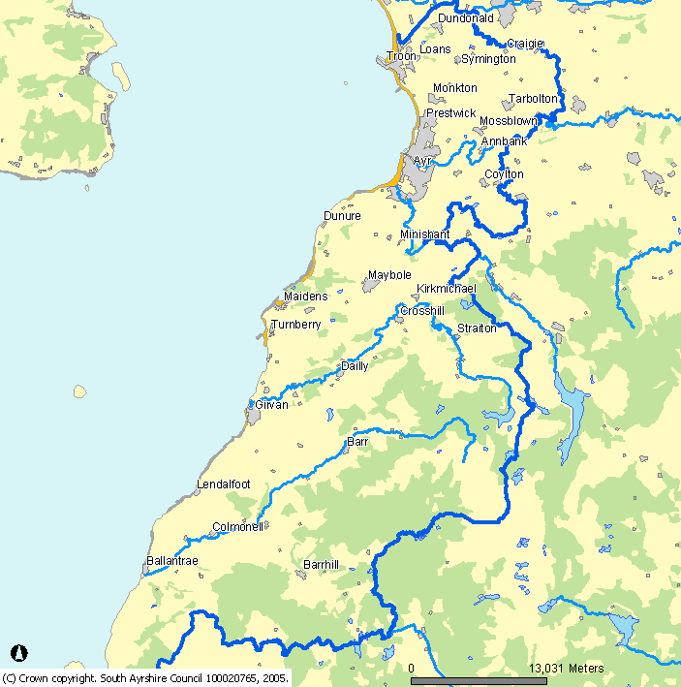

2.2. **Organisational Structure**

Chief Executive

Head of Regulatory Services

Depute Chief Executive and Director of Place

Learning

Depute Chief Executive and Director of People

Trading Standards and Environmental Health Service Lead

South Ayrshire Council operates on a Cabinet Structure with Services reporting to a Portfolio Group who in return report to the Full Council. Regulatory Services report to the Regulatory Panel. The Head of Regulatory Services is Catriona Caves. The Trading Standards and Environmental Health Service Lead is Morton Houston. The Service remit comprises the full range of Environmental Health and Trading Standards functions, including Democratic Governance, Legal & Licensing, Insurance Risk & Safety Management and Civil Contingencies and Business Continuity. Mary Robertson, Coordinator Environmental Health is responsible for the day-to-day delivery of food hygiene, food safety and food standards enforcement and is the Lead Officer for all within the terms of the Food Law Code of Practice Scotland.

* 1. **Scope of the Food Service**

2.3.1 Environmental Health Service

Environmental Health professionals comprise Environmental Health Officers (EHO’s) who undertake food law inspection work in accordance with a predetermined programme of inspections. Food sampling is linked to this programme and is carried out in accordance with a predetermined sampling policy and procedure. Food complaints and food related matters are investigated by these Officers. Our EHO’s are multi-disciplinary and work across the range of Environmental Health disciplines.

The range of food activities undertaken by Environmental Health is as follows:

* Food law inspections are carried out in accordance with a pre-determined programme.
* Food safety visits to approved premises and primary production in accordance with a pre-determined programme.
* Compliance visits to food premises are undertaken at the request of the Licensing Board.
* Food fraud investigations;
* Complaint investigations;
* Communicable disease investigations;
* Food Alert investigations;
* Formal and informal sampling;
* Issue of export health certificates;
* Port Health activities
* Licensing, registration and approval of premises;
* Controlling the importation of foodstuffs though the Air and Seaports and local importers;
* Food Safety promotion;
* Health and Nutrition promotion
* Provision of business advice relating to food safety requirements;
* Maintenance of the Food Hygiene Information System (FHIS);
* Assessing premises for the FSS EatSafe Awards

Within Environmental Health all the officers working in food enforcement are authorised in accordance with the Food Law Code of Practice, dependent on qualifications and experience. A full range of informal and formal approaches to enforcement are employed to ensure compliance with relevant legislation including: -

* Advice and mentoring
* Written warnings;
* Publication of inspection letters for premises with ‘Improvement Required’ status under FHIS;
* Enforcement notices;
* Remedial Action Notices
* Emergency prohibition procedures and voluntary closure of premises;
* Inspection, detention, seizure and voluntary surrender of food not meeting food safety requirements;
* Referrals to the Procurator Fiscal;

* 1. **Demands on the Food Service**

2.4.1 Demands on Environmental Health Service

The total number of food businesses in the district is detailed below.

Food

|  |  |  |  |
| --- | --- | --- | --- |
|  |  | *Approved/Primary Producers* | |
| *Premises type* | *FLRS* | *FH* | *FOODST only* |
| *Primary Producers* |  | *137* |  |
| *Slaughterhouses* |  |  | *4* |
| *Manufacturer/Processor and Packer* |  | *58* |  |
| *Packers* |  | *4* |  |
| *Importers/Exporters* |  | *4* |  |
| *Distributors* |  | *10* |  |
| *Retailers* | *301* |  |  |
| *Restaurants & Other Caterers* | *959* |  |  |
| *Articles/Materials in Contact with Food Manufacturers* |  | *1* |  |
| *Manufacturer selling mainly by retail* | *18* |  |  |
| *Total* | ***1278*** | ***214*** | ***4*** |

* + 1. Of these premises the breakdown of Registrations/Approvals is as follows:

|  |  |
| --- | --- |
| *Approved Fishery Products* | *7* |
| *Approved Meat Products Manufacturers* | *10* |
| *Approved Dairy Products* | *1* |
| *Approved Cold Stores* | *2* |
| *Approved Meat Products and Preparations* | *1* |
| *Approved Meat Preparations* | *1* |
| *Approved Egg Packers* | *3* |
| *Approved Poultry Slaughterhouse* | *1* |
| *Total* | *26* |

2.4.3 Responsibility for food enforcement within the following premises is split between South Ayrshire as the local food authority and Food Standards Scotland Operational Branch:

* Halls, Glenburn Rd, Prestwick. (Licensed cutting plant and Approved Minced Meat & Meat Preparation Plant and Meat Products Plant)
* We Hae Meat Ltd, Cairnhill Farm, Old Dailly, Girvan. (Licensed cutting plant and Approved Minced Meat & Meat Preparation Plant and Meat Products Plant)

There is an abattoir within the town of Ayr, however the enforcement authority is Food Standards Scotland Operational Branch.

A small percentage of premises within the area are of ethnic origin, mainly Cantonese and Asian. Most of these premises have personnel available who are sufficiently fluent in English to ensure a smooth communication flow of information. Notwithstanding this however, our policy in relation to ethnic minority language speakers ensures the food business operator provides an interpreter during inspections. Where required, in case of enforcement action the Service provides a translation service.

* + 1. The food enforcement, safety and standards service is operated from Trading Standards and Environmental Health, 5-7 River Terrace Ayr KA8 0BJ and is available between the hours of 08:45 – 16:45 Monday to Thursday and 08:45 – 16:00 on Fridays. We operate a hybrid work pattern with officers based between their home and the office-base.
    2. Prestwick Airport and the harbours of Ayr and Troon occasionally import products of non-animal origin from third countries. We monitor these imports and sample where necessary to ensure compliance with food safety requirement. There is no enhanced remote transit sheds located in the area.

2.4.6 It is accepted that the provision of a complete and comprehensive food enforcement service requires Officers to be available out with normal office hours. Arrangements are in place to react to emergency situations and pre-determined situations requiring investigation out with normal office hours.

2.5 **Enforcement Policy**

2.5.1 Environmental Health and Trading Standards

The TSEH Joint Enforcement Policy provides a framework for authorised officers to ensure enforcement action is consistent with relevant statutory provisions.

**3.0** **Service Delivery**

3.1 **Food Premises Inspections**

All food premises will be inspected in accordance with the appropriate frequency as outined in the Food Law Codes of Practice with alternative interventions for low risk premises These low risk premises are inspected every 3-5 years unless subject of a complaint, linked to a food poisoning case or identified through intelligence as presenting a greater risk.

|  |  |  |  |  |  |  |
| --- | --- | --- | --- | --- | --- | --- |
| **FLRS Bands** | ***Number of Premises*** | **FLRS Bands** | ***Number of Premises*** | **FLRS Bands** | ***Number of Premises*** | ***Total*** |
| 1A | 2 | 2A | 29 | 3A | 103 | 134 |
| 1B | 15 | 2B | 743 | 3B | 512 | 1270 |
| 1C | 4 | 2C | 49 | 3C | 8 | 61 |
| 1D | 0 | 2D | 2 | 3D | 0 | 2 |
| 1E | 0 | 2E | 0 | 3E | 0 | 0 |
|  | 21 |  | 823 |  | 623 | 1467 |

The yearly programme for 2022/2023 is detailed in the Resource Calculation Appendix 1

Eleven full-time officers are allocated to food hygiene and food standards inspection work for 50% of their time. The Co-ordinator (Food) is involved in food safety related work 50% and the Co-ordinator (Environment) about 20%. Admin support and Service Lead add about 30%

The officers noted above are allocated as lead or assisting officer for each of the approved premises. The lead officers are responsible for completing the required inspections and sampling. Each approved premises is risk assessed as per the Inspection Rating Scheme in Annex 5 of the Food Law Code of Practice Scotland.

3.2 **Food Complaints**

All food complaints will be investigated in accordance with the service complaints procedure.

The estimated number of complaints is as follows:

|  |  |
| --- | --- |
| ***Complaint Type*** | Number of complaints |
| *Condition of Food Premise (Food Hygiene)* | *120* |
| *Condition of Food (foreign bodies, mould etc)* | *30* |
| *Quality of Food (Food Standards)* | *20* |

All food officers are involved in the investigation of food complaints.

* 1. **Primary/Home Authority Principle**

The Service supports both Primary and Home Authority agreements/principles however does not have any formal agreement in place with any specific business. Major manufacturing businesses within the area for which we would be considered originating authority are as follows:

* Hall’s, Glenburn Road, Prestwick
* We Hae Meats Ltd, Girvan
* Punjab Pakora, Crown Street, Ayr
* Grants Distillery, Grangestone Industrial Estate, Girvan
* Girvan Early Growers, Grangeston Industrial Estate, Girvan
  1. **Advice to Businesses**

3.4.1 The Environmental Health Service actively promotes and encourages the involvement of the business community in food safety issues. Work undertaken to date includes:

* advice in compliance with food safety management systems for businesses including mentoring.
* Development of web-based advice
* Support for originating authority businesses.
* Internal consultants to Council Departments on food safety
* Advice and Support for food businesses
* Advice on export health certificates

3.5 **Food Inspection and Sampling**

3.5.1 Environmental Health

Sampling for monitoring and surveillance will be conducted in accordance with our food sampling policy.

The sampling programme for 2022/2023 is detailed at Appendix 2. Further years will be added as they are developed.

All samples are submitted to Glasgow Scientific Services for analysis and/or examination.

Private water supplies within the area are sampled in accordance with the Private Water Supply (Scotland) Regulations. Sampling of the public supplies is carried out on receipt of specific complaints and also to monitor quality of the water supplied by Scottish Water.

Samples taken in response to a food poisoning outbreak will be submitted to Glasgow Scientific Services. The cost of any such analyses is borne by NHS Ayrshire and Arran.

All food samples are recorded on the national Food Surveillance System.

3.6 **Control and Investigation of Outbreaks and Food Related Infectious Disease**

The Environmental Health Section works in partnership with Ayrshire and Arran Health Board’s Consultant in Public Health Medicine in relation to routine investigation of food poisoning notifications and outbreak control situations if required.

All instances of alleged and reported food related infectious disease are investigated in accordance with the service policy, which has regard to NHS Ayrshire and Arran’s policy. Approximately 150 instances of food related infectious diseases are reported every year.

The multi-discipline approach currently adopted ensures that currents levels of investigation can be met from within existing resources. Emergency measures are in place to ensure additional resources will be made available in the event of a major outbreak.

* 1. **Food Safety Incidents**

3.7.1 Environmental Health

All Food Alerts will be dealt with in accordance with the Code of Practice. Action as appropriate is determined by the category of the warning and the local significance, which may include:

* Immediate action involving visits to affected premises requiring removal of suspect foodstuffs.
* Telephone contact with businesses concerning withdrawal from sale of suspect foodstuffs.
* Corresponding with businesses giving advice in relation to action required for suspect foodstuffs.
* Contact and liaison with the local media.

It is anticipated that approximately 100 Food Alerts will be received with only 10% of these requiring a significant level of action.

Where it is appropriate South Ayrshire Council will initiate action in accordance with the relevant legislation and Code of Practice for food safety matters with national significance.

The projected staff involvement will be endeavoured to be met within existing resources.

* 1. **Liaison with Other Organisations**

The Environmental Health Section is an active participant in the West of Scotland Food Liaison Group. The group meets bi-monthly and comprises representatives from 14 authorities together with representatives from Glasgow Scientific Services, Scottish Food Enforcement Liaison Committee and the Food Standards Scotland. The Co-ordinator (Food) is this authority’s representative on the Group.

We are represented on the Ayrshire and Arran Environmental Health Working Group, which is a multi-disciplinary committee comprising Local Authority representatives, Scottish Water, Health and Safety Executive, Scottish Agricultural College, Ayrshire & Arran Health Board, Health Protection Scotland and Food Standards Scotland. This body meets approximately twice per year in South Ayrshire. We are members of the Scottish Port Liaison Network (SPLaN). The Authority is a member of the IDOX Environmental Health Software Scottish Users Group. An officer is a member of the Food Sampling and Surveillence Working Group.

* 1. **Food Safety and Standards Promotion**

3.9.1 Environmental Health

Promotional activities are undertaken as detailed below:

* + - * Advice and guidance in relation to compliance with food safety management systems is available free of charge.
      * The Service maintains a stock of relevant food safety related publicity material, which is available, free of charge to all food businesses.
      * Support for the provision of food safety education to local food businesses by providing lecturers on courses run by local educational training providers.
      * Providing advice and guidance to voluntary organisations to assist with compliance of statutory obligations in accordance with the Council’s food safety policy.
      * Participate in the Food Hygiene Information Scheme, appropriately scoring businesses which are displayed on the national database.
      * Raising awareness of food safety by participating and supporting the National EatSafe Award Scheme.
      * Taking part in the activities relating to the promotion of National Food Safety Week and the National Food Hygiene Campaign.
      * Raising awareness of nutrition by participating and supporting the National Healthy Living Award Scheme
      * Issuing regular social media advice and messaging

**4.0** **Resources**

**4.1** **Financial Allocation**

|  |  |
| --- | --- |
| **Expenditure\*\*** | **EH (£)** |
| Employee Costs pro Rata | 421,000 |
| Test Purchases | 900 |
| Education | 3000 |
| Equipment | 1000 |
| Analyst Fees * 50% of service total | 59,500 |
| Laundry | 400 |
| Clothing | 200 |
| Travel expenses | 5,000 |
| **Total** | 491,000 |
| **Income\*\*** |  |
| Export Health Certificates | 3,500 |
| **Total Cost** | 487,500 |

**Where exact figures are not known estimates are based on 21/22 actuals

As the budget had not been formally issued at the time of writing the above figures are based on Year 21/22. We do not operate on an activity based accounting system therefore accurate figures for the food enforcement regime is not possible.

**4.2** **Staffing Allocation**

4.2.1 Environmental Health

Ten Environmental Health Officers and two Coordinators are involved in food law enforcement holding the Royal Environmental Health Institute of Scotland Diploma in Environmental Health qualification. They are authorised under the Code of Practice commensurate with their training and experience.

Of the above, some officers are in possession of the Certificate in Total Quality Systems Assessment otherwise known as the Lead Assessors Qualification. All officers involved in day-to-day enforcement have attended the either the REHIS or FSA Advanced HACCP Course and the Official Control Verification (OCV) course in addition to structured in house courses.

2.8 Administrational Staff comprising, of a Systems & Administrative Officer an Systems & Administrative Assistant, , an 0.4 Administrative Assistant and 3 Clerical Assistant post to support the Section.

**4.3** **Staff Development Plan**

4.3.1 Environmental Health

Service training needs are reviewed annually in accordance with legislative requirements, FSS guidance and current developments in the food sector. The Council’s Professional Development Review procedure is the mechanism that is used to ensure competences and skills needs are met.

Internal training needs are assessed in accordance with officers’ stage of development in relation to qualifications, experience and specialist involvement.

Full support is given to attendance at annual training courses such as:

* Food Update Course
* Food Standards Update Course
* Law Enforcement Course

In house training by cascading information received from the aforementioned training courses will be carried out.

The officers involved in food enforcement meets on a monthly basis to discuss common issues, share information and experiences to aid consistency of enforcement. Minutes are taken at all technical meetings.

When appropriate, update training in respect of the Environmental Health software system is provided to all enforcement and Admin staff. All food enforcement officers are fully trained in policies and procedures following amendments and or review.

1. **Areas for Development**

**Environmental Health**

5.1 Single Use Plastics

We continue to develop towards zero waste targets as the single use plastics regulations came into force in Scotland in June 2022. Although resources are limited this will be looked at during the current inspection programme within all relevant business groups.

5.2 Policy, Procedures and Processes

Plans are in place to review and update current policies, procedures and processes to ensure all are fit for purpose, streamlining as far as possible and introducing new strategies to help with valuable staff resources.

5.3 EU Exit

We continue to track the developing situation in regards to import/export controls. We have three fish processors utilising the hub route for export with monthly requests for certification for frozen product.

5.4 Public Health Reform

With the published Public Health Priorities for Scotland and the Reform agenda we will be looking to develop partnerships, both locally and nationally, to deliver on reducing health inequalities in relation to food and nutrition. We will consider developing an ‘Improving Public Health’ strategy which would cover food safety work streams.

5.5 Performance Reporting

Consider the use of technology to embed performance reporting into the service plan to reduce the demand on management resource.

5.6 Focussed Sampling

Further analysis of the results of our previous multi-sampling targeted businesses to improve compliance to inform our sampling strategy. This should include the way we communicate and publicise sampling results to the public.

5.7 CLIO

Review and revise incident procedures to include the use of CLIO and undertake cascade training using pilot user guides.

5.8 Food Crime and CLUE

Consider how to integrate the use of CLUE in our daily duties to maximise the sharing of intelligence.

**6.0** **Quality Assessment**

6.1 Environmental Health

* To ensure accuracy and consistency within food enforcement appropriate Line Managers will discuss an intervention strategy for poorly performing food businesses with the food enforcement officers.
* Standard paragraphs are used in inspection letters.
* Customer complaints in respect of food enforcement are dealt with in accordance with the Councils Complaints procedure.
* Regular checks are undertaken for accuracy and relevancy of electronic data entry.

**7.0** **Review**

###### 7.1 Review of the Service Plan

To ensure the plan is relevant to food enforcement needs and is being applied consistently, the Lead Food Officer will undertake an annual review.

An annual report will be forwarded to the Trading Standards and Environmental Health Service Lead detailing performance against set targets and measured outcomes.

7.2 Indication of Any Variance from Service Plan

Following review of the Service Plan the Co-ordinator (Food) will provide an explanation of any variances and provide an action plan to prevent recurrence and highlight areas for future development.

7.3 Areas of Improvement

The Lead Food Officer will analyse performance in relation to the plan, identify areas for improvement or development and report proposed amendments to the Trading Standards and Environmental Health Service Lead.

South Ayrshire Council

Trading Standards and Environmental Health Service

Contact: Morton Houston

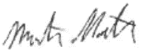

Date: 9 Feb 2023

Revised:

**APPENDIX 1**

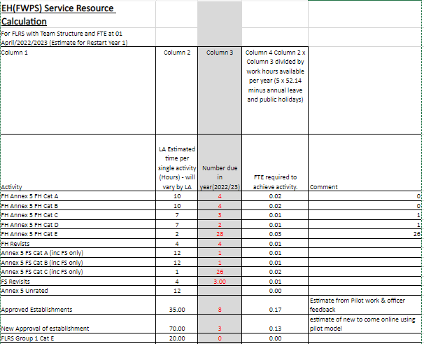 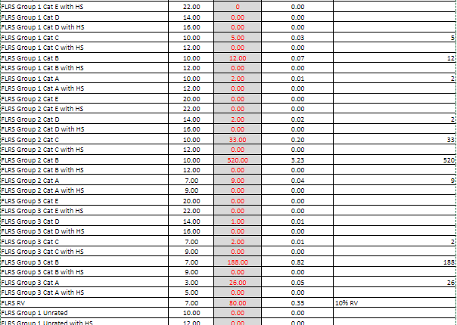

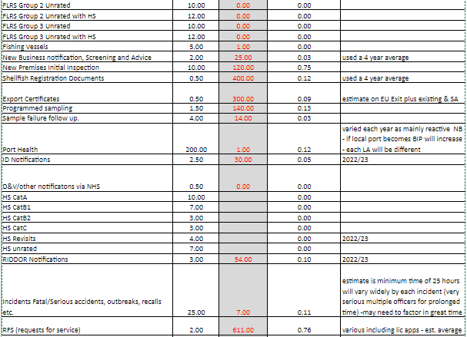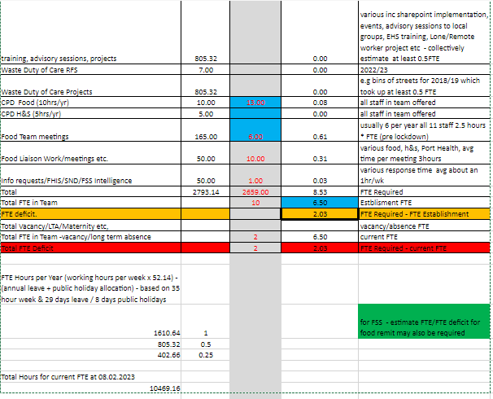

**APPENDIX 2**

**Food Sampling Programme 2022/23**

|  |  |  |  |  |  |
| --- | --- | --- | --- | --- | --- |
| **Priority** | **Food type** | **No of samples** | **Micro/Chem** | **Analysis or examination required** | **Premises** |
| 1 | RTE cured, charcuterie meats | 10 | M | Routine, including Listeria monocytogenes | Manufacturers, retailers, restaurants |
| 2 | RTE cured, smoked fish and pate | 10 | M | Routine, including Listeria monocytogenes | Manufacturers, retailers, restaurants |
| 3 | RTE prepared salad, fruit salad | 10 | M | Routine, including Listeria monocytogenes | Restaurants, takeaways |
| 4  ELG | Ice or glass swabs? | 20 | M | Routine | Public houses, hotels, restaurants |
| 5 | Ice cream (including soft serve) | 10 | M | Routine | Manufacturers, retailers, takeaways, cafes |
| 6  ELG | Pate | 10 | M | Routine, including Campylobacter | Restaurants, delis |
| 7  DONE  A/R | Bacon, cooked ham | 10 | C | Sodium nitrate | Manufacturers, butchers, retailers |
| 8  DONE  A.R | Sausages | 10 | C | Meat content/sulphur dioxide | Manufacturers, butchers |
| 9  DONE  A/R 10 | Vegan/Dairy free meals, cakes | 15 | C | Milk protein | Restaurants, takeaways  (products made on premises) |
| 10 | Gluten free meals and cakes | 15 | C | Gluten | Restaurants, takeaways  (products made on premises) |
| 11  DONE  A/R | Prepared meals containing lamb | 10 | C | Species | Restaurants, takeaways  (focussing on Indian style meals) |
| 12  DONE  A/R | Coloured cakes | 10 | C | Permitted colours | Manufacturers/retailers (including small bakers) |

1. SIMD 2020V2