|  |
| --- |
| ***Stage 1 - Expression of Interest Form***  **Community Asset Transfer (CAT) request** |

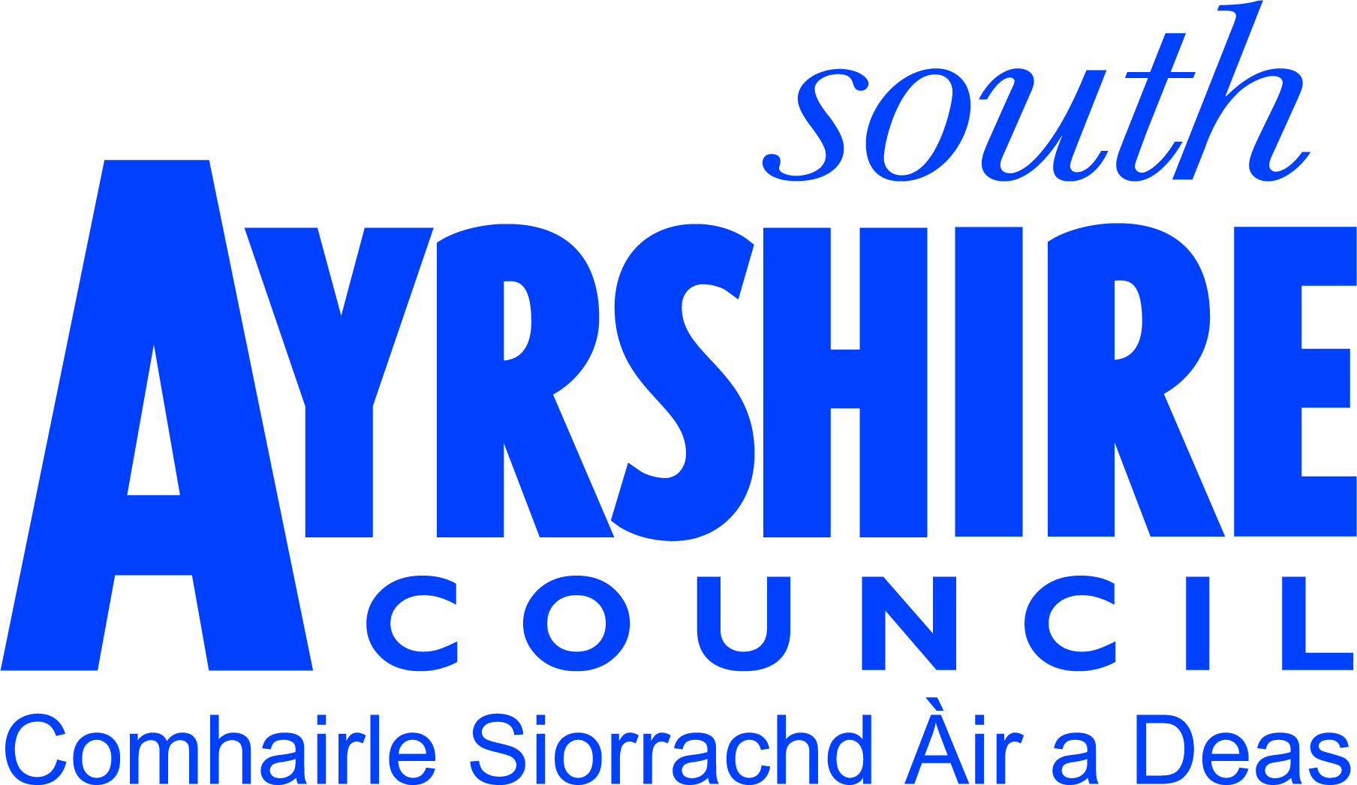

The Expression of Interest opens the conversation between the applicant and South Ayrshire Council regarding the Council-owned asset your organisation is interested in taking ownership or control of.

In submitting this form, it provides access to support from the CAT team through the provision of information, guidance and signposting to appropriate organisations. It also ensures that where applicable, the applicant organisation is supported throughout the considerable work involved in developing a formal **Community Asset Transfer request** (Stage 2) as per **Part 5 of the Community Empowerment (Scotland) 2015 Act** to go forward for a final decision by the Council.

This form must be used when the applicant wishes to request a Development Grant for up to a maximum of £12,000 from the Council’s Advancing Community Assets Fund for costs associated with all types of surveys and investigations relating to the asset for the development of a Stage 2 asset transfer proposal.

Please note that an award of a Development grant from the Advancing Community Assets Fund would not commit the Council to a particular outcome nor guarantee approval of any future asset transfer request that is developed and submitted for consideration. Any future asset transfer request would be determined in accordance with the Council’s approved asset transfer process.

This completed Stage 1 will be submitted to the Council’s Community Asset Transfer Advisory Group (CATAG) who will consider the information and you will be advised of next steps. Where the organisation has also requested a grant, the CATAG will make a recommendation to the Director-Place who will then consider and decide whether to authorise the grant request.

Before completing this form, please take time to read the **Advancing Community Assets (ACA) Fund applicant guidance** and the **Scottish Government Guidance for Community Transfer Bodies**. For assistance in completing this form or if you have any questions regarding a Community Asset Transfer and development grant, please contact:

**Sarah Baird, Community Asset Transfer Team Leader**

**South Ayrshire Council**

**E-mail:** [cat@south-ayrshire.gov.uk](mailto:cat@south-ayrshire.gov.uk) **Telephone:** 01292 613072

1. **Details of the organisation making the Stage 1 Expression of Interest**

|  |  |
| --- | --- |
| **Name of organisation** |  |
| **Address of organisation** |  |
| **Website address** |  |
| **Social media links e.g. Facebook, Twitter** |  |
| **What year was your organisation established?** |  |

1. **Main contact details within organisation**

|  |  |
| --- | --- |
| **Name** |  |
| **Contact Address** |  |
| **Telephone Number** |  |
| **E-mail Address** |  |
| **Position in the organisation** |  |

1. **Eligibility of organisation**

Only certain types of organisations are eligible to apply for certain asset transfer tenure options. Please advise the current status of the organisation as this will help us identify whether you may have to change the status of your organisation prior to submitting a formal Stage 2 asset transfer request.

|  |  |
| --- | --- |
| **What type of organisation are you?** | **Please tick** |
| **Scottish Charitable Incorporated Organisation (SCIO)** |  |
| **Company Limited by Guarantee** |  |
| **Unincorporated Club or Association** |  |
| **Other**: *(please specify)* |  |
| **Charity Number**: *(if applicable)* |  |

|  |  |
| --- | --- |
| **Do you have a formal constitution, governance documents?** | Yes/No |
| **How many people are involved in your organisation?** | Management committee:  Paid full-time staff:  Paid part-time staff:  Volunteers:  Members: |
| **Is the organisation VAT registered?** | Yes – please provide VAT number  No |
|  | |

1. **Please tell us about the Council-owned asset you are interested in.**

This will help us check that we own the asset that you are interested in and give you any relevant information we hold.

|  |  |
| --- | --- |
| **Name of Asset** |  |
| **Address of Asset** |  |
| **Map Reference /Boundary Plan** | Please provide a map or boundary plan – this could be a google street view with the land and/or property you wish to enquire about indicated. This is to ensure all parties are clear on the nature of the request. |

|  |  |
| --- | --- |
| **Type of transfer you are interested in:** | Ownership:  Lease (please indicate length required):  Management rights: |
| **Summarise the reason/s for considering an asset transfer request and how you intend to use the Council asset and any related timescales:** | |

1. **Have you previously discussed your asset transfer proposal with anybody in South Ayrshire Council such as a Councillor or an officer?** Please provide any details.

|  |
| --- |
|  |

**ADVANCING COMMUNITY ASSETS FUND – DEVELOPMENT GRANT REQUEST**

Applicants may apply to the Advancing Community Assets Fund for up to a maximum of £12,000 Development Grant from the Council’s Advancing Community Assets Fund for **costs associated with all types of surveys and investigations relating to the asset** for the development of a Stage 2 asset transfer proposal.

|  |  |
| --- | --- |
| **Do you wish to apply for a development grant?** | Y/N |

|  |  |
| --- | --- |
| **How much development grant are you applying for?** | **£** |

**Provide a detailed cost breakdown itemising expected expenditure that you require the development grant for:**

|  |  |  |
| --- | --- | --- |
| **Item** | **Cost (£)** | **Have estimates/quotes been sought? *If yes please submit copies with the application*** |
|  |  | Y/N |
|  |  | Y/N |
|  |  | Y/N |
|  |  | Y/N |
|  |  | Y/N |
|  | **Total: £** |  |

|  |  |
| --- | --- |
| **Please state what funding, if any, you have received from South Ayrshire Council in the last 3 financial years** |  |

**N.B An award of a Development grant from the Advancing Assets Fund does not commit the Council to a particular outcome nor guarantee approval of any future asset transfer request that is developed and submitted for consideration.**

All grants will be subject to South Ayrshire Council’s standard conditions of grant as detailed in Advancing Community Assets Fund applicant guidance.

1. **Supporting paperwork**

Please include copies of the following with your Stage 1:

|  |
| --- |
| * A bank statement less than 3 months old * Copy of your most recent Annual Accounts or Income and Expenditure Statement. * A copy of the organisations Constitution or Memorandum and Articles of Association * A list of current committee members or current Directors |

This form should be completed and returned to [cat@south-ayrshire.gov.uk](mailto:cat@south-ayrshire.gov.uk). All relevant sections of the application **must be** completed including supporting documents e.g. constitution, financial details etc. Failure to submit a fully completed application may result in a delay or rejection of the application.

1. **Declaration**

On behalf of:

I declare that the information provided in this form is accurate and complete and have included documentation as requested in Section 6. I have read and agree to the conditions detailed in the Advancing Community Assets Fund guidance document and that I have the authority to submit the form on behalf of the named organisation.

Name:

Position within organisation:

Signature (hard copy only):

Date:

**Please return this form to:**

**Email:** [cat@south-ayrshire.gov.uk](mailto:cat@south-ayrshire.gov.uk)

**Post:** Community Asset Transfer team, Asset Management & Community Asset Transfer, South Ayrshire Council, Newton House, 30 Green Street Lane, Ayr KA8 8BH