

**Raising Awareness of Domestic Abuse in South Ayrshire**

**February 2019**

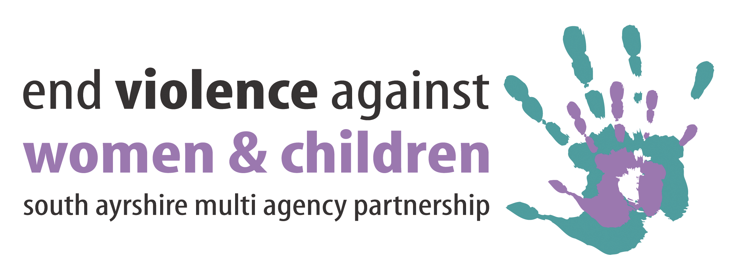

**Introduction**

This position statement provides information on the commitment and approach that South Ayrshire Council has in relation to raising awareness of domestic abuse in South Ayrshire.

**Introduction**

This document provides information on the commitment and approach that South Ayrshire Council has in relation to raising awareness of employees affected by domestic abuse and the implementation of a range of measures to support staff within the workplace.

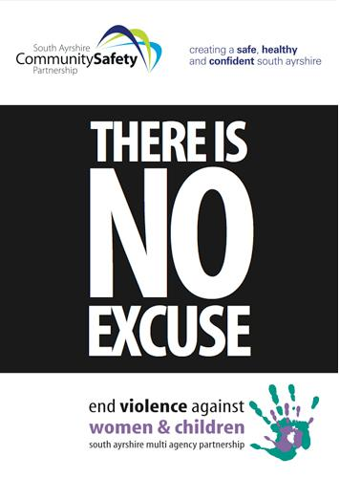South Ayrshire Multi-Agency Partnership (MAP), works closely with its partners to tackle Violence Against Women and Children and to raise awareness of domestic abuse through a range of projects ranging from work with young people, community awareness raising and training for staff.

This statement has been prepared taking account of the information and recommendations contained in [Equally Safe](http://www.google.co.uk/url?url=http://www.gov.scot/Publications/2017/11/5647/1&rct=j&frm=1&q=&esrc=s&sa=U&ved=0ahUKEwin-I_dmJ7bAhWPmLQKHWO3D5YQFgghMAM&usg=AOvVaw0aE64vo2afgpRn655MC3_8)- Scotland’s Strategy for Preventing and Eradicating Violence Against Women and Girls (2017-21) and the 2018-2021 Strategy for South Ayrshire’s Multi-Agency partnership to tackle Violence Against Women and Children.

**What is Domestic Abuse?**

The UK government’s definition of domestic violence is ‘any incident or pattern of incidents of controlling, coercive, threatening behaviour, violence or abuse between those aged 16 or over who are, or have been, intimate partners or family members regardless of gender or sexuality. The abuse can encompass, but is not limited to psychological, physical, sexual, financial, and emotional.’

There is a common misconception that domestic abuse is just physical abuse. This is not the case. Domestic abuse can be physical, sexual, and emotional or mental abuse.

#### Physical abuse includes:

All types of assault and physical attacks like hitting (including with objects), punching, kicking and burning.

#### Sexual abuse includes:

Forcing sexual intercourse or forcing engagement in sexual acts.

#### Mental/emotional abuse includes:

Threats (including threats of violence); criticism and name calling; controlling what you do, where you go and who you speak to; threatening your children, isolating you from friends and family; accusing you of being unfaithful; threatening to 'out' your sexual orientation to family, friends or work or to reveal your HIV/AIDS status

Domestic Abuse is characterised by a pattern of coercive and controlling behaviour and incidents will increase in both severity and frequency.

Domestic abuse is most commonly experienced by women however men also experience domestic abuse. Domestic abuse may, and often does, include a range of abusive behaviours, not all of which are, in themselves, inherently ‘violent’. All forms of domestic abuse stem from the abusers desire for power and control over their partner that tends to get worse over time. It must also be acknowledged that domestic abuse also occurs in same-sex relationships. All employees who experience abuse should be supported regardless of gender and the type of abuse.

Examples of forms of abuse and definitions are detailed in **Appendix 1.**

**Domestic Abuse and the Law**

The Domestic Abuse (Scotland) Act 2011 was passed by Parliament on the 16th March 2011 and received Royal Assent on the 20th April 2011. A further Bill [Domestic Abuse (Scotland) Bill](http://www.parliament.scot/Domestic%20Abuse%20Scotland%20Bill/SPBill08S052017.pdf) received Royal Assent on 9 March 2018.

The Bill makes it a criminal offence, punishable by imprisonment, for a person to behave in a way which is abusive towards a partner or ex-partner. This offence will be aggravated, if a child is involved.

A person will commit an offence if:

* a reasonable person would consider the course of behaviour to be likely to cause their partner or ex-partner to suffer physical or psychological harm; and that either they intended by the course of behaviour to cause their partner or ex-partner to suffer physical or psychological harm or that they were reckless in their course of behaviour to cause their partner or ex-partner to suffer physical or psychological harm.

It is therefore not necessary for a partner or ex-partner to actually prove they have been harmed by the behaviour of their partner or ex-partner. The new law covers not only spouses or civil partners and cohabitants. It also covers people in intimate personal relationships who do not live together.

## ****What constitutes abusive behaviour?****

Abusive behaviour includes behaviour which is:

* violent, threatening or intimidating;
* making a partner or ex-partner dependent or subordinate;
* isolating a partner or ex-partner;
* controlling, regulating or monitoring a partner or ex-partner’s day-to-day activities;
* depriving a partner or ex-partner of, or restricting their freedom; and
* frightening, humiliating, degrading or punishing a partner or ex-partner.

By covering the effects of emotional abuse as well as the effects of physical abuse, this Bill is seen as a breakthrough for Scotland, improving the lives of those who suffer from emotional abuse. As for many years, whilst the impact of emotional abuse can be devastating for victims, it has been difficult to prosecute. Furthermore, the Bill provides that any domestic abuse offence is aggravated when the abusive behaviour is committed towards a partner or ex-partner in a way which involves a child.

**Statistics**

In 2016-17 there were approx. 60,000 incidents of domestic abuse recorded by Police Scotland, and increase of 1% on 2015/16. In Scotland in 2014/15 69% of the victims recorded were females.[1]

Over the last three years South Ayrshire has a higher rate of reporting of domestic abuse incidents than Scotland but is lower than East and North Ayrshire rate. South Ayrshire was the 14th highest in the rate of domestic abuse incidents reported in Scotland in 2014/15 and is lower than Glasgow, Dundee, Renfrewshire and North Lanarkshire.[2]

Domestic Abuse is an issue that costs the UK economy £1.9 billion in lost economic output every year and leads to decreased productivity, increased absenteeism and increased employee turnover.

**Disclosure Scheme for Domestic Abuse Scotland**

The Disclosure Scheme for Domestic Abuse Scotland (also known as Clare’s Law) enables the police to share relevant information about a partner’s abusive past with a potential victim. The scheme aims to enable potential victims to make an informed choice about whether to continue the relationship and provides further help and support to assist the potential victim when making that decision.

Under the scheme, anyone who is concerned that they, or someone they know, could be at risk of domestic abuse from a partner can ask the police about the partner’s previous history of abusive behaviour. The police can disclose information where it is lawful, necessary and proportionate to protect a potential victim from domestic abuse.

An application to the Disclosure Scheme for Domestic Abuse Scotland can be made by contacting the police:

* online at [www.scotland.police.co.uk](http://www.scotland.police.uk/contact-us/disclosure-scheme-for-domestic-abuse-scotland/)
* visit a police office
* phone 101 the non-emergency number for the police
* speak to a member of the police on the street
* phone 999 if there is an immediate risk of harm or it is an emergency.

Guidance about the scheme can be found on the Police Scotland website at [www.scotland.police.uk](http://www.scotland.police.uk/assets/pdf/205073/257814/pdf-making-an-application-about-your-partner?view=Standard).

**Raising Awareness in the Workplace**

The Council has a duty of care for ensuring in so far is as reasonably practicable, the health, safety and welfare of its employees at work where risks to health and well-being are considered and dealt with efficiently. Employees must feel safe to disclose their experience of abuse in order to access support and increase safety for themselves and others.

The Council supports various campaigns against domestic abuse and broader violence against women issues including the annual 16 Days of Action campaign. The 16 Days of Action begins on 25 November (International Day for the Elimination of Violence Against Women) and takes place every year in countries all over the world, ending on 10 December to engage public local activism to fight for the cause.

**1. Managers Responsibilities:**

* Endeavour to support those experiencing domestic abuse in a sympathetic, non-judgemental and confidential manner by creating an environment where the employee feels safe to talk about what they are experiencing and listening to and believing what they are saying. Speak to the employee about their immediate and future safety plan. However, managers must respect the choices and decisions the employee may make about their situation and should not make any referrals without the employees consent.
* Ensure that confidential information is not disclosed and that all employees are aware of their responsibilities in relation to confidentiality especially personal details such as addresses, telephone numbers or shift patterns. There are exceptions when confidentiality can be broken, for example when there are concerns about children or vulnerable adults however further advice should be sought before information is disclosed and should be on a need to know basis only.
* Facilitate a conversation to be able to discuss, identify and implement appropriate support. If an employee confides in a manager, such matters should be addressed positively and sympathetically. Signs that employees could present with if they are experiencing domestic abuse include:
* An increase in absences without explanation;
* Arriving late for work without explanation;
* Unexplained poor performance;
* Anxiety, depression;
* Problems with concentration;
* Injuries, repeated injuries and unexplained bruising.
* Look for changes in the way an employee dresses i.e. excessive clothing on hot days, changes in the amount of make-up worn

There are other ways in which domestic abuse can present itself including:

* Employees receiving repeated, unwelcome telephone calls;
* Employees may be stalked by their former partner whilst travelling to and from work;
* Employees may be subject to verbal abuse/physical abuse travelling to and from work and at work;
* Children who attend school or council nurseries may be under threat of abduction and abuse.
* Be aware of any additional issue for an employee because of their ethnic background, gender, age, sexuality or disability.
* Be aware that colleagues may also be affected. They may be followed to or from work, or subject to questioning about the victim’s contact details or locations. They may have to cover for other workers while they are off, try to fend off the abuse and fear for their own safety. Furthermore, colleagues may be unaware of the abuse or not know how to help.

**2. Practical Support Measures:**

* Carry out a risk assessment and consider the development of a personal safety plan which will consider the employee’s working location(s); working pattern; and support networks and provision of an assumed name at work;
* Divert phone calls and email messages and look to change a phone extension if an employee is receiving harassing calls;
* Agree with the employee what to tell colleagues and how they should respond if their ex/ partner telephones or visits the workplace;
* Ensure the employee does not work alone or in an isolated area and check that staff have arrangements for getting safely to and from home;
* Keep a record of any incidents of abuse on the workplace, including persistent telephone calls, emails or visits to the workplace;
* Contact an HR Advisor regarding an employee referral to Occupational Health;
* Under the Council’s Special Leave Policy, grant appropriate time off e.g., the policy allows for up to 10 days paid leave for urgent domestic distress reasons.
* Arrange flexible work hours or other paid/unpaid leave so the employee can make appointments, go to court, look for new housing, enter counselling, arrange child care, support agencies etc.
* Sign post the employee to a specialist support organisation. South Ayrshire Multi-Agency Partnership to tackle Violence against Women and Children (MAP) has developed to guides on domestic abuse – ‘[Information for Women’](http://www.south-ayrshire.gov.uk/vaw/docs/information%20for%20women.pdf) and an ‘[Information Guide for Workers’](http://www.south-ayrshire.gov.uk/documents/information%20guide%20for%20workers.pdf). Details of other organisations can be found on pages 8 to 10.
* Further information on domestic abuse and violence against women can be found on the MAP website: <http://www.south-ayrshire.gov.uk/vaw/>

**3. Training and Council Policies**

**Council Policies:**

* [Risk and Safety Standard on Violence and Aggression at Work](https://ww20.south-ayrshire.gov.uk/corporateservices/corporateresources/healthandsafety/Shared%20Documents/Violence%20and%20%20Aggression%20Standard.pdf) (includes guidance on Risk Assessment)
* [Special Leave](https://ww20.south-ayrshire.gov.uk/corporateservices/HR/Shared%20Documents/Special%20Leave%20Policy.docx)
* [Flexible Working](https://ww20.south-ayrshire.gov.uk/corporateservices/HR/Shared%20Documents/Flexible%20Working%20Policy2014.doc)
* [Lone Working Standard](https://ww20.south-ayrshire.gov.uk/corporateservices/corporateresources/healthandsafety/Shared%20Documents/Loneworking%20Standard%20Aug17.pdf)

**Training Courses:**

* Domestic Abuse and Stalking is included as a section within the Awareness of Gender Based Violence module on COAST.
* An awareness of how stalking may affect attendance is covered in the Maximising Attendance course for Managers.

**Where To Get Help:**

|  |
| --- |
| **Police Scotland:**  Call **999** If it’s an emergency or you’re in immediate danger. Contact your local neighbourhood policing team **(**[**http://www.police.uk**](http://www.police.uk)**)** if it’s not an emergency. |
| |  |  | | --- | --- | | Name | **South Ayrshire Women's Aid** | | Address | 28 Sandgate, Ayr, KA7 1BW | | Opening Hours | Monday-Friday 9am - 4.30pm | | Telephone | Crisis line: 01292 266482 Children and Young Person's Support Workers: 01292 267 067 Office line: 01292 885667 | | Website | [www.southayrshirewomensaid.org.uk](http://www.southayrshirewomensaid.org.uk/) | |
| |  |  | | --- | --- | | Name | **Domestic Abuse Unit (Police Scotland)** | | Address | 10 St Marnock Street, Kilmarnock | | Opening Hours | Monday - Friday 8.00am - 4.00pm | | Telephone | 01563 505131 | |
| |  |  | | --- | --- | | Name | **Domestic Abuse Helpline** | | Address | 44 Springvale Street, Saltcoats KA21 5LP | | Opening Hours | 24 hour opening - 365 days a year | | Telephone | 0800 027 1234 | |
| |  |  | | --- | --- | | Name | **Shaktie Women's Aid** | | Telephone | 0131 475 2399 | | Website | [www.shaktiedinburgh.co.uk](http://www.shaktiedinburgh.co.uk/) | |
| |  |  | | --- | --- | | Name | **Amina, the Muslim Women's Resource Centre** | | Address | Network House, 311 Calder Street, Glasgow G42 7NQ | | Telephone | [0808 801 0301](tel:08088010301) | |
| |  |  | | --- | --- | | Name | **Hemat Gryffe Women's Aid** | | Address | Flat 0/1, 24 Willowbank Street, Glasgow G3 6LZ | | Telephone | 0141 353 0859 | | Website | [www.hematgryffe.org.uk](http://www.hematgryffe.org.uk/) | |
| |  |  | | --- | --- | | Name | **Moving On Ayrshire** | | Address | Eglington Chambers, 21 Wellington Square, Ayr KA7 1EZ | | Opening Hours | Monday - Friday 9am - 4.30pm | | Telephone | 01292 290546 | | Email | [enquiries@movingonayrshire.com](mailto:enquiries@movingonayrshire.com) | | Website | [www.movingonayrshire.com](http://www.movingonayrshire.com/) | |
| |  |  | | --- | --- | | Name | **Rape Crisis Scotland Helpline** | | Address | 46 Bath Street, Glasgow G2 1HG | | Opening Hours | Daily 6pm - 12 midnight | | Telephone | 08088 00 00 14 | | Website | [www.rapecrisisscotland.org.uk](http://www.rapecrisisscotland.org.uk) | |
| |  |  | | --- | --- | | Name | **Galop (formerly Broken Rainbow) LGBT DV (UK) Helpline** | | Services | Same sex domestic abuse | | Telephone | 0800 999 5428 | |
| |  |  | | --- | --- | | Name | **Men's Advice Line** | | Services | Male victims of domestic abuse, also run by Respect | | Telephone | 0808 801 0327 | | Website | [www.mensadviceline.org.uk](http://www.mensadviceline.org.uk) | |
| |  |  | | --- | --- | | Name | **Victim Support South Ayrshire** | | Address | MacAdam House, 34 Charlotte Street, AYR, KA7 1EA | | Opening Hours | Monday - Friday 10.00am - 2.00pm | | Telephone | 01292 266441 | |
| |  |  | | --- | --- | | Name | **Scotland’s Domestic Abuse and Forced Marriage Helpline** | | Services | Confidential helpline service, run by volunteers | | Opening Hours | 24 hour helpline | | Telephone | 0800 027 1234 | |
| **South Ayrshire Multi-Agency Partnership to tackle Violence Against Women and Children has information on a range of services that can provide support for men and women – this can be accessed at:**  [**http://www.south-ayrshire.gov.uk/vaw/men/**](http://www.south-ayrshire.gov.uk/vaw/men/)  [**http://www.south-ayrshire.gov.uk/vaw/directory.aspx**](http://www.south-ayrshire.gov.uk/vaw/directory.aspx) |





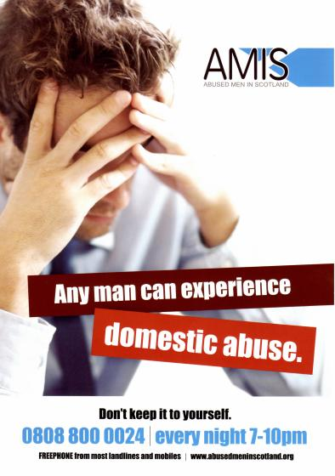

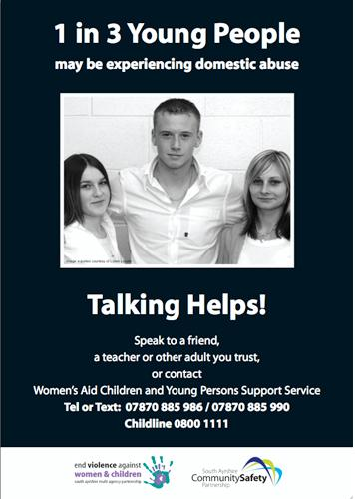

**Appendix 1** – **Definitions and Forms of Abuse**

**Physical abuse** includes all physical violence.

**Emotional abuse** includes humiliation and degradation, isolation from family and friends, threats against the person and children and name calling.

**Sexual abuse** includes rape, using force, threats or intimidation to make a person perform sexual acts or any degrading sexual treatment.

**Financial abuse** includes not being allowed to take a job, being denied access to money which is yours or being forced to ask for money for essentials.

**Controlling behaviour** - a range of acts designed to make a person subordinate and/or dependent by isolating them from sources of support, exploiting their resources and capacities for personal gain, depriving them of the means needed for independence, resistance and escape and regulating their everyday behaviour.

**Coercive behaviour** - an act or a pattern of acts of assault, threats, humiliation and intimidation or other abuse that is used to harm, punish or frighten their victim

**Crimes in the name of ‘honour’** -“Honour based violence” is a crime or incident, which has or may have been committed to protect or defend the honour of the family and/or community’.

“Honour Based Violence” can be distinguished from other forms of violence, as it is often committed with some degree of approval and/or collusion from family and/or community members. Examples may include murder, un-explained death (suicide), fear of or actual forced marriage, controlling sexual activity, domestic abuse (including psychological, physical, sexual, financial or emotional abuse), child abuse, rape, kidnapping, false imprisonment, threats to kill, assault, harassment, forced abortion. This list is not exhaustive.

## Examples of domestic physical abuse:

Physical attacks are the most obvious signs of domestic abuse, and they don't need to leave a visible scar to be damaging. Physically abusive acts include:

* slapping
* punching
* pulling your hair
* scalding or burning
* strangling
* throwing and breaking things
* the use of weapons such as knives or other implements.

## Examples of emotional abuse:

Emotional abuse is not as externally obvious as physical abuse but can be just as, if not more, harmful. Mentally abusive acts attack your personality and emotional well-being, and include:

* humiliation
* constant criticism
* verbal abuse and name calling
* imposition of rules and ultimatums
* enforced isolation from friends and family
* threats against you, your children or your pets
* destruction of your belongings
* jealousy and possessiveness
* control over your income
* control over what you wear and how you look.

1. Police Scotland
2. Police Scotland