



**Raising Awareness of Stalking in South Ayrshire**

**May 2018**

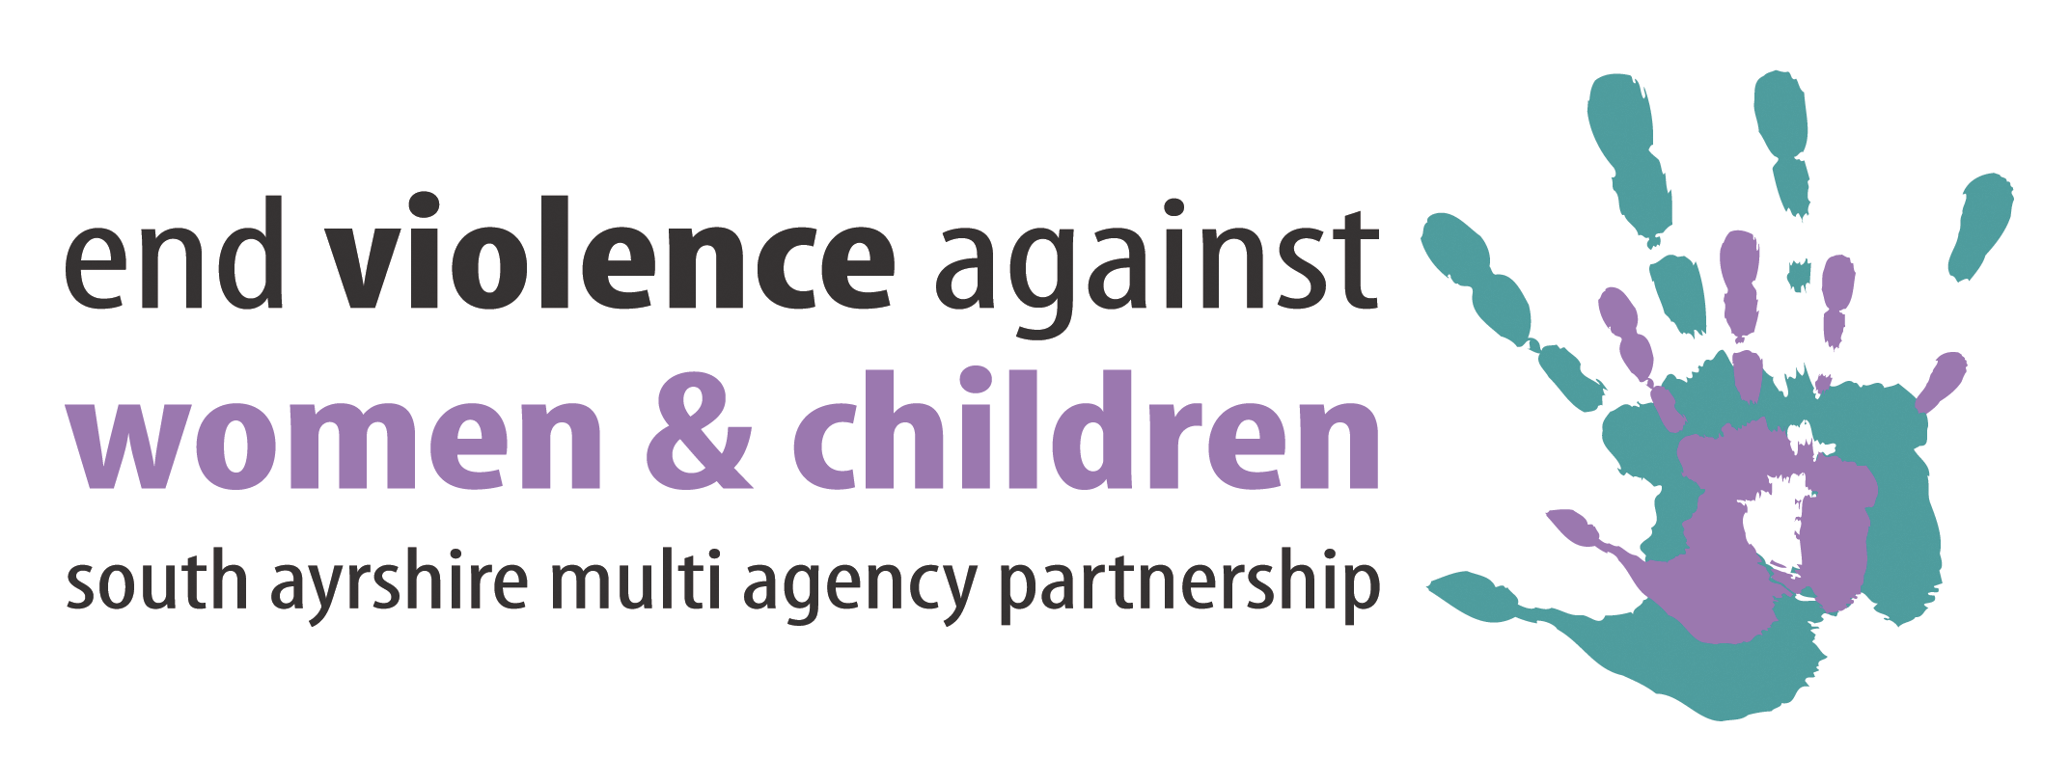

**Introduction**

This position statement provides information on the commitment and approach that South Ayrshire Council has in relation to raising awareness of stalking in South Ayrshire. This is carried out through work undertaken in the **workplace** (the implementation of a range of measures to support both managers and staff) and in **Secondary Schools**.

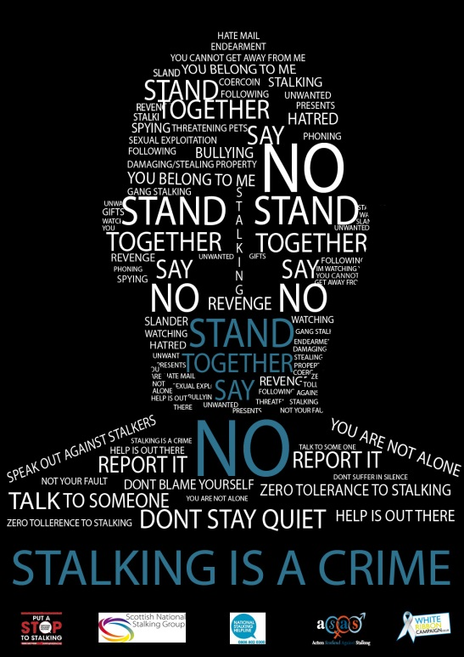South Ayrshire Multi-Agency Partnership to tackle Violence Against Women and Children (MAP) is an affiliate of Scotland’s Scottish National Stalking Group.

Since 2009, the MAP has been working closely with the Scottish National Stalking Group to highlight the seriousness of stalking as a crime and this has been carried out through the promotion of National Stalking Awareness Week campaigns within partner agencies and local communities.

**What is Stalking?**

Stalking is a pattern of repeated, unwanted behaviour that causes a person to feel distressed or scared. It can be perpetrated by men or women and is a psychological as well as a physical crime.[1] Appendix 1 provides a list a list of common stalking behaviours.

It can happen with or without a fear of violence – if a person is receiving unwanted attention and contact but with no threat, it is still stalking. It can have a huge impact on the lives of people affected by stalking including emotional distress, anxiety, stress and depression. [You can view some short films that highlight the impact of stalking by clicking here.](http://www.south-ayrshire.gov.uk/vaw/stalking.aspx)

In the UK, 1 in 5 women and 1 in 10 men are stalked at some point in their lives.[2]

In Scotland, 6.4% of adults reported at least one form of stalking and harassment in the last 12 months. 9.7% of 16-24 year olds and 9.2% of 25-34 year olds had experienced at least one form of stalking/harassment in the last 12 months compared to 2.2% of over 65s, 45% had received unwanted texts/emails and 21.9% were subject to obscene or threatening online contact. [3]

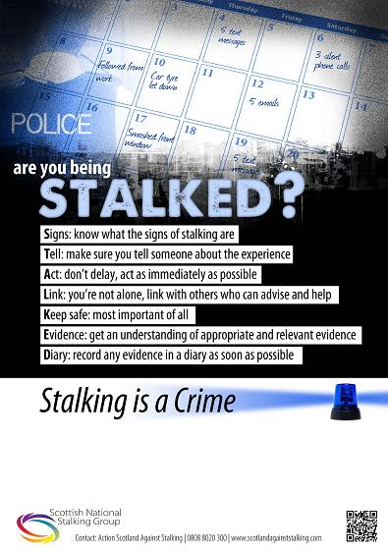**The Law**

In Scotland, there is legal protection from Stalking.

As a result of Action Scotland Against Stalking campaigning, new legislation was introduced which has given Scotland one of the most powerful anti-stalking laws in the world.

Stalking became a specific offence under section 39 of the Criminal Justice and Licensing Act 2010 – it came into effect in December 2010.

The Criminal Justice and Licensing Act was passed on June 30th 2010 and came into effect in December 13th 2010. Section 39 of this Act makes stalking a criminal offence. [You can read the legislation by clicking here.](http://www.legislation.gov.uk/asp/2010/13/section/39/enacted)

South Ayrshire saw an increase in reports of stalking in the last three years. Detection rates fell in 2015/16 but have increased again in 2016/17 to 87.1%. South Ayrshire was the 14th highest in the rate of stalking incidents reported in Scotland in 2016/17 which is the same as the rate for Scotland. The South Ayrshire rate is higher than North Ayrshire, Renfrewshire and West Dunbartonshire. [4]

There has been an increase in the awareness of stalking across South Ayrshire and incidents increased by 11% in the last year. [5]

**Raising Awareness in the Workplace**

South Ayrshire Council is committed to raising awareness of Stalking for its workforce and Elected Members and will provide appropriate guidance and information for all employees, so far as is reasonably practicable, to ensure their health, safety and welfare at work.

Awareness raising campaigns will be organised to support National initiatives – this will alert staff to appropriate measures to be taken if they either know or think a colleague is being stalked.

**Stalking Behaviours**

Behaviours and activities may include but are not limited to the following:

* Unwanted communication – face to face; telephone calls, voice messages, text messages, written correspondence;
* On line communication – friend requests instant messages, blackmail; abuse through social networking sites;
* Following waiting or showing up uninvited at or near a persons’ home, workplace or other place frequented by the employee;
* Sending unwanted gifts;
* Direct verbal or physical threat including death threats;
* Trespassing/vandalism of the person property; criminal damage;
* Gathering information about the individual from friends, family and/or co-workers;
* Making false complaints to employer/policy about the person.

Further examples are provided in Appendix 1

**Managers Responsibility**

Stalking can have a huge impact on the life of a person affected by it – both physically and psychologically. Those who are experiencing stalking may fear that others will judge them and be unable to provide them with appropriate relevant support. It is therefore important that managers are aware of the signs that staff could present with if affected by stalking[6] , for example:

* An increase in absences, particularly short spells due to stress, anxiety or physical injuries;
* Arriving late for work;
* Unexplained poor performance;
* Obsession with time;
* Needing regular time off for appointments without an explanation;
* Working longer hours for no apparent reason.

It is essential that managers understand that any of the above may arise from a range of circumstances of which stalking may be one. If an employee confides in a manger, such matters should be addressed positively and sympathetically ensuring that the employee is aware of the support and assistance that can be provided.

**Practical Support Measures**

* Contact an HR Advisor regarding an employee referral to Occupational Health;
* Sign post the employee to a specialist organisation, details on pages 6 and 7;
* Reassure the employee of confidentiality but highlight circumstances where confidentiality may be broken and information shared with external agencies, e.g., safeguarding concerns about children or vulnerable adults or where action is required to protect the safety of employees;
* Carry out a [risk assessment](https://ww20.south-ayrshire.gov.uk/corporateservices/corporateresources/healthandsafety/Shared%20Documents/Risk%20Assessment%20Standard%20Sept%202016.pdf) with the employee, also consider other employees who may also be exposed to harm;
* Under the Council’s [Special Leave Policy](https://ww20.south-ayrshire.gov.uk/corporateservices/HR/Shared%20Documents/Special%20Leave%20Policy.docx), grant paid time off for employee to attend legal appointments with either solicitors, police and/or support agencies to rearrange housing or childcare support and court appointments;
* If it is identified that the stalker is a member of staff then appropriate action would be considered under the Council’s [Disciplinary Policy and Procedure](https://ww20.south-ayrshire.gov.uk/corporateservices/HR/Shared%20Documents/Disciplinary%20Policy.doc);
* Reviewing the security of personal information held and reminding that personal information such as address telephone number or shift patterns should not be divulged to other employees.

**Safety Considerations for the Employee**

* Having phone calls screened;
* Providing an alternative email address;
* Review of work schedule and/or changing working hours on a temporary or permanent basis;
* Moving to another work location if feasible especially where the employee works alone or in an isolated area;
* Being able to park close to the office and consider an escort to and from car for safety purposes;
* Using different routes to get to and from work;
* Providing emergency contact person and telephone number to line manager;
* Changes to specific duties e.g. to avoid potential contact with the perpetrator in a customer facing role.

**Training and Council Policies**

Council Policies that may offer help and support are as follows:

* [Risk and Safety Standard on Violence and Aggression at Work](https://ww20.south-ayrshire.gov.uk/corporateservices/corporateresources/healthandsafety/Shared%20Documents/Violence%20and%20%20Aggression%20Standard.pdf) (includes guidance on Risk Assessment)
* [Special Leave](https://ww20.south-ayrshire.gov.uk/corporateservices/HR/Shared%20Documents/Special%20Leave%20Policy.docx)
* [Flexible Working](https://ww20.south-ayrshire.gov.uk/corporateservices/HR/Shared%20Documents/Flexible%20Working%20Policy2014.doc)
* [Lone Working Standard](https://ww20.south-ayrshire.gov.uk/corporateservices/corporateresources/healthandsafety/Shared%20Documents/Loneworking%20Standard%20Aug17.pdf)

**Training Courses**

* Stalking is included as a section within the Awareness of Gender Based Violence module on COAST.
* An awareness of how stalking may affect attendance is covered in the Maximising Attendance course for Managers.

**Raising Awareness in Schools**

South Ayrshire Multi-Agency Partnership to tackle Violence Against Women and Children (MAP) and South Ayrshire Child Protection Committee collaborated with Police Scotland and Action Scotland Against Stalking to develop an education resource aimed at raising awareness on the dangers of stalking and the actions that young people can take to keep themselves safe from stalking and cyber-stalking.

Senior pupils from each secondary school collaborated with Action Scotland Against Stalking, the Campus Police Officers and ‘Film School’ (production company) to produce a short film on stalking awareness with the following film plot:

***The story focuses around a young girl who is stalked by a fellow pupil – what starts off as an innocent friends request accepted on Facebook turns into being followed at school, stalked outside of school, notes being left and the impact that it has on the mental health of the girl and her relationships with her friends, boyfriend and home life.***

This film is called ‘Friend Request’ and forms part of the resource which includes also includes a lesson plan and guidance for teaching staff. A guidance leaflet has also been produced for pupils providing steps on staying safe and information on appropriate support agencies.   This resource has been distributed to all schools in South Ayrshire.

**Where To Get Help**

|  |
| --- |
| **Police Scotland**  You can call the police if you have been placed in a state of fear and alarm, if you have been assaulted or sexually assaulted. Assault is a criminal offence and sexual assault is a crime even if you are married to or living with the person committing the offence. Police Scotland Ayrshire Domestic Abuse Unit can give support and information.  [Police Scotland Ayrshire Domestic Abuse Investigation Unit](https://www.scotland.police.uk/domestic-abuse/) 10 St Marnock Street, Kilmarnock  Tel: **01563 505131** or **01563505064** for advice and support – non-emergency only  **In an emergency dial 999.** |
| **Anyone affected by stalking can call the National Stalking Helpline on** [**0808 802 0300**](tel:08088020300)  The National Stalking Helpline provides guidance and information to anybody who is currently or has previously been affected by harassment or stalking. The Helpline can provide guidance on:   * The law in relation to stalking and harassment * Reporting stalking or harassment * Effective gathering of evidence * Ensuring your personal safety and that of your friends and family * Practical steps to reduce the risk     [**http://www.stalkinghelpline.org/**](http://www.stalkinghelpline.org/) |
| **Action Against Stalking has produced advice online for victims of workplace stalking and plan it can be accessed at** [**www.actionagainststalking.org/**](http://www.actionagainststalking.org/) |
| **The Suzy Lamplugh Trust provides advice and information and training about personal safety.**  [**http://www.suzylamplugh.org/**](http://www.suzylamplugh.org/) |
| **South Ayrshire Multi-Agency Partnership to tackle Violence Against Women and Children has information on a range of services that can provide support for men and women – this can be accessed at:**  [**http://www.south-ayrshire.gov.uk/vaw/men/**](http://www.south-ayrshire.gov.uk/vaw/men/)  [**http://www.south-ayrshire.gov.uk/vaw/directory.aspx**](http://www.south-ayrshire.gov.uk/vaw/directory.aspx) |

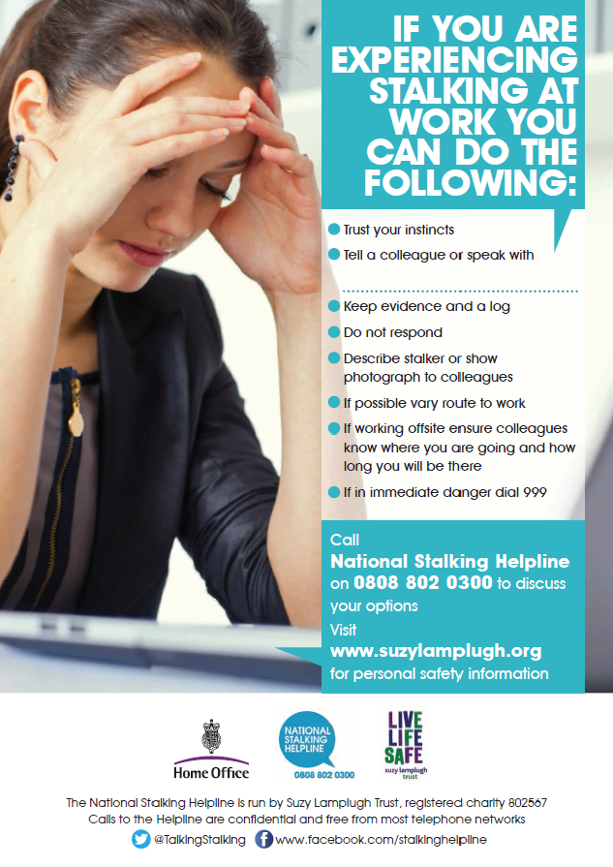

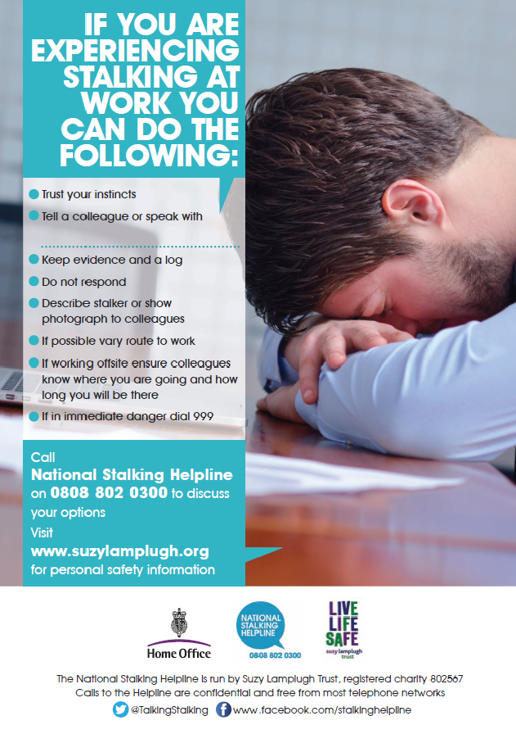

**Appendix 1**

Below are some of the most common stalking behaviours, this list is non exhaustive.

* Following, surveillance, spying
* Standing, loitering: victims home, school, place of work etc.
* Verbal abuse or public humiliation
* Unsolicited,  mail, postcards, photographs gifts from the  endearing to the bizarre,
* Repeatedly texting/emailing/leaving voicemails.
* Planting spyware, viruses into your computer
* Hacking into your computer, email, social media accounts
* Spreading rumours, discrediting
* Threats/violence against the victim, family, friends or pets
* Damage to property, stealing victims belongings
* Physical violence , sexual assault, rape, murder
* Attempting to take children away, limit access by making false allegations or engaging in Parental Alienation.
* “Befriending” victims’ friends, family to get closer to the victim.
* Stealing, interfering post, mail.
* Going through rubbish bins. Leaving offensive material in the garden.
* Breaking into victims’ car, home or office.
* Interfering, damaging personal belongings
* Threatening your freedom by making false allegations to the police.
* Blackmail.  Threatening to divulge information that would be harmful to you.
* Invading your personal space by standing too close or brushing against you
* Ordering unwanted goods to be delivered to your house.
* Seeking physical proximity by applying for jobs where you work, joining your gym, church, professional/social/sports groups or clubs, moving into your neighbourhood or building, etc.
* Leaving or sending threatening objects
* Ordering goods in your name and your address.
* Identity theft. Pretending to be you
* Running up debt in the victim’s name

1. ‘Essential Information for Victims of Stalking’ published by the National Stalking Helpline
2. ‘A Guide for Employers on Dealing with Stalking in the Workplace’ published by the Home Office, National Stalking Helpline and the Suzy Lamplugh Trust.
3. Scottish Crime and Justice Survey 2014/15
4. Police Scotland 2016/2017
5. Police Scotland 2016/2017
6. ‘A Guide for Employers on Dealing with Stalking in the Workplace’ published by the Home Office, National Stalking Helpline and the Suzy Lamplugh Trust.