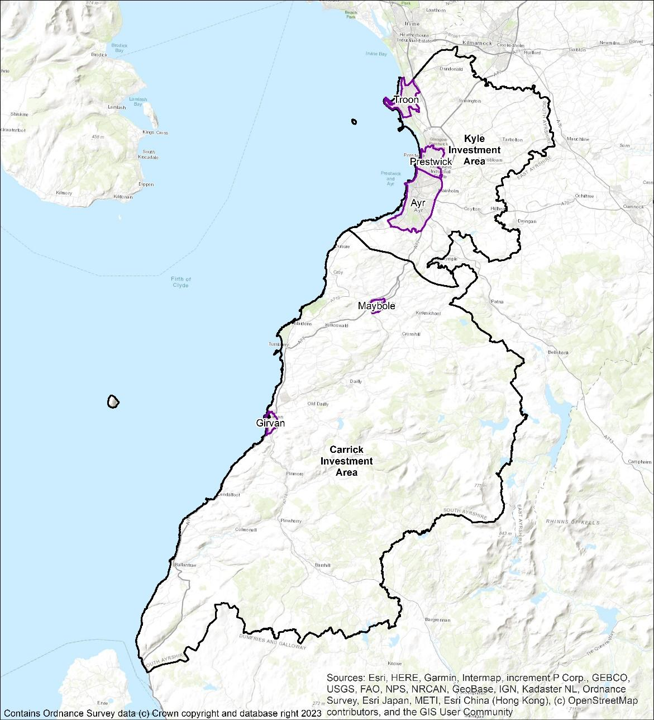

# **South Ayrshire Council**

**Local Heat and Energy Efficiency Strategy**

Draft Strategy - Consultation

# Overview

## What is an LHEES?

The Local Heat and Energy Efficiency Strategy (LHEES) is a long-term strategic framework designed to support energy efficiency and sustainable heat delivery across all buildings in South Ayrshire. This includes council and privately owned buildings and spans domestic and non-domestic sectors. It serves as a roadmap towards achieving our commitment to Net Zero Carbon, eliminating fuel poverty, and working towards a more environmentally conscious and resilient community.

## Why are we doing this?

As part of the Scottish Governments push for net zero by 2045, it is vital that our homes and buildings no longer contribute to climate change, while tackling fuel poverty within our communities.

Our LHEES will support the objectives within the South Ayrshire Council Plan, Scottish Government targets and objectives, and builds towards Scotland’s place in the world.

## What is the focus of this work?

In LHEES, we are looking at area wide approaches, which means focussing on equity, inclusion, and co-creation. Initial work on LHEES will look to build connections with stakeholders from council services and community planning partners, communities and residents, businesses, and the 3rd sector. We are working to build connections with areas of best practice, develop and connect existing areas of work, and form a long-term plan for how we reach our future targets.

In terms of tangible action, this means improving insulation and energy efficiency of all buildings, planning for where area-wide approaches are suitable for heat networks, and identifying what heat provisions are required to meet targets. Throughout this strategy you will find focus sections, these draw out information that will form the basis of delivery plan actions.

This image shows organisation priorities of:
1 - community and sustainability
2 - economy and opportunity
3 - education and skills

**Throughout this document you will find challenge and focus sections, intended to highlight the key considerations, and build to form delivery plan actions. These will reference these priorities.**

**Consultation Question 1**

Do you think the priorities identified are in the best interest of the people of South Ayrshire?

## LHEES Considerations

The LHEES guidance sets out the key considerations for this Strategy, shown in Table 1. These help to categorise building stock into groups that require similar interventions.

Table 1: LHEES Considerations

|  |  |  |  |
| --- | --- | --- | --- |
|  | No. | LHEES Considerations | Description |
| **Heat decarbonisation** | 1 | Off-gas grid buildings | Transitioning from heating oil and LPG in off-gas areas |
|  | 2 | On-gas grid buildings | On-gas grid heat decarbonisation |
|  | 3 | Heat networks | Decarbonisation with heat networks |
| **Energy efficiency and other outcomes** | 4 | Poor building energy efficiency | Poor building energy efficiency |
|  | 5 | Poor building energy efficiency as a driver for fuel poverty | Poor building energy efficiency as a driver for fuel poverty |
|  | 6 | Mixed-tenure, mixed-use and historic buildings | Mixed-tenure and mixed-use buildings, listed buildings and buildings in conservation areas |

In this initial LHEES, South Ayrshire is focussing on:

* Improving energy efficiency and reducing fuel poverty,
* Transitioning off gas buildings to low carbon heating,
* Buildings feasibility for heat networks where appropriate.

**Consultation Question 2**

Do you think the considerations in focus from “LHEES Considerations” are appropriate and connect with the overall LHEES priorities?

# Challenges and Opportunities

The scale of the change involved in decarbonising heat in South Ayrshire should not be understated. Energy transitions present huge challenges economically and socially; however, they do present opportunities as well.

## 3.1 Opportunities

### 3.1.1 Just Energy Transition

The concept of Just Transition originated in the 1980’s and has gained traction in terms of sustainable development and energy transition. The International Labour Organisation (ILO) defines it as “Greening the economy in a way that is as fair and inclusive as possible to everyone concerned, creating decent work opportunities and leaving no one behind.”

This is a principle we seek to embed in the LHEES, improving equity and reducing inequality.

Every Scottish Local Authority must undertake an LHEES, and each will assess the level of interventions required to work towards heat decarbonisation. Combined with legislative drivers this transition to decarbonise heat in buildings has significant implications for supply chain development, reskilling and upskilling, and knowledge transfer.

Recent research has shown that improved energy efficiency was responsible for almost 25% of all GDP growth in the UK since the 1970’s*[1]*, and that early planning and embedding of social equality can significantly improve outcomes*[2]*. In this way, ensuring a just energy transition in South Ayrshire not only supports the local economy to be at the forefront of this national change, but ensures that we are delivering on our commitment to protect those most vulnerable in our communities.

### 3.1.2 Ayrshire Energy Masterplan

The Ayrshire Energy Masterplan represents a cross-authority approach to develop a strategic energy vision for the Ayrshire region. This will include socio- and techno-economic modelling to identify investment opportunities, areas of business growth, and skills and supply chain development areas. Strategic outcomes will link with LHEES through local energy and heat generation, decarbonisation, investment in local carbon technologies, and a just and inclusive energy transition.

The strategy is due to be released in early 2024 and will link closely with the LHEES delivery planning.

### 3.1.3 Engagement & Development

Although LHEES is developed by South Ayrshire Council, this strategy is relevant to all stakeholders in South Ayrshire. To deliver on our commitments, we will need to build and develop engagement routes across services, sectors, and communities.

Consultation on this document will be sought through our community planning partners, registered social landlords, economic development groups, third sector organisations, community groups and members of the public. Through this we look to forge new partnerships and identify new opportunities for collaboration and investment.

### 3.1.4 Community Wealth Building

Community wealth building is a people-centred approach to local economic development, which redirects wealth back into the local economy and the surrounding community. It can deliver more business growth, community owned assets, and improved resilience while building social and environmental justice. This can be done through local anchor organisations such as local councils, community groups, housing associations, or education facilities.

In the Wallacetown Community Energy Project Proposal, the local community association is working in partnership with South Ayrshire Council, seeking to install community owned PV panels onto the roofs of three school buildings in the Wallacetown neighbourhood of Ayr. The Council will purchase the power generated by the panels for use in the school buildings, with the surplus sold to the National Grid. The income earned, after costs, will go to create a new ‘Wallacetown Benefit Fund’ managed by the community, that will fund future education and wellbeing projects.

**Focus**

* ***Priority 1*:** Embed the principles of Just Transition into LHEES development and delivery,
* ***Priority 2*:** Support the Ayrshire Energy Masterplan project to broaden commercial engagement,
* ***Priority 2*:** Establish LHEES within existing consultation routes, and develop new routes where possible
* ***Priority 1 & 2*:** Support the development of the Wallacetown Community Energy Project

## 3.2 Challenges

The challenge of decarbonising heat on an area wide basis is a massive challenge, which this iteration of LHEES seeks to take the first step towards.

One of the main challenges in decarbonising heat in South Ayrshire is the age and energy efficiency of buildings across the authority.

All LHEES work across Scotland is based on the Home Analytics and Non-domestic Analytics datasets, which is managed by Home Energy Scotland on behalf of the Scottish Government. This data set gives property level information about property type, age of construction, EPC, and energy efficiency measures installed.

### 3.2.1 Domestic Buildings

For South Ayrshire records show:

* 57,949 domestic properties in South Ayrshire,
* 8,567 owned by South Ayrshire Council (14%),
* 2,330 owned by housing associations (4%),
* 6,697 owned by private landlords (11%),
* and 39,713 being owner-occupied (68%).

Note: 642 addresses lacked detail and were removed from analysis

There are conservation areas in South Ayrshire and 4,636 domestic properties are situated in those. Listed buildings make up 2 % of the domestic building stock, with South Ayrshire Council owning 26.

The majority of the domestic building stock in South Ayrshire was constructed after 1950 (Figure 2) with 87 % of SAC’s stock built before 1983. Housing association stock has a larger proportion of newer builds, reflected in a high percentage of properties reaching an EPC grade of C or better.

As the LHEES seeks to support decarbonisation of not only buildings we own and manage, but domestic and commercial properties as well, there is an extensive amount of engagement required to inform and support building owners in this journey. Much of this engagement takes place already, through several different routes including tenant participation, registered social landlords, private landlord communications, economic development teams, and community support groups. A main challenge of this LHEES will be coordination of messages across these groups, linking with their priorities and objectives in order to deliver on actions.

**Challenges**

* Higher than Scottish average owner-occupier (58%) and lower than average socially rented (23%) means less direct action available to SAC,
* Higher than average pre-1919 building stock (18%),
* Greater levels of heat demand in private rental and owner occupier properties

**Focus**

* ***Priority 1:***Exemplify *e*xisting best practice work in SAC towards national standard,
* ***Priority 1:*** Support and inform ongoing energy efficiency programmes,
* ***Priority 2:*** Extend engagement with SAC departments, owner-occupiers, Registered social landlords, private rental landlords, and communities.

### 3.2.2 Non-domestic Buildings

The Non-Domestic Baseline Tool utilises data derived from Non-Domestic Analytics data sets. This analysis is based on the best available data, but there are gaps in reliability and coverage. Nevertheless, the data has been used for the baselining step of the LHEES process to get a flavour of the building stock.

This data will be supported through the Ayrshire Energy Masterplan (AEM); an ongoing project across the three Ayrshire’s which looks to identify investment and development opportunities in heat and energy decarbonisation. The introduction of Building Assessment Reports (BAR) from Scottish Government will further develop this picture in the near future.

The Non-Domestic Baseline Tool records 4,135 non-domestic buildings in South Ayrshire. Together, these have an estimated total heat demand of 150,000 MWh/y. An analysis of these properties can be seen in figure 3 below.

Gas is the biggest source of heat but electricity is close behind and, along with oil, they have the largest share of small heat loads. Smaller buildings account for almost half of the total heat demand and supporting those with small oil systems, which would not individually be as expensive, for heat pump or heat network connection could be a priority. It is likely that the small properties utilising electricity are already using heat pumps for heating and cooling.

A large proportion of buildings are pre-1919 with a high heat demand and this group of properties may be a target for energy efficiency measures. The data lists 55 % of these pre-1919 buildings as being retail or financial and 79 % as being in towns, making up most high street retailers.

Generally, non-domestic heating energy demand is dominated by the retail and finance sector *(Figure 3)*.

**Challenges**

* Data availability and reliability,
* Varied challenges with heat demand depending on business type,
* Traditional build high streets with hard-to-treat properties.

**Focus**

* ***Priority 2:*** Existing work through AEM to support engagement with non-domestic owners,
* ***Priority 2:*** Support Building Assessment Report process and integrate data,
* ***Priority 2 & 3:*** Explore co-working opportunities with Economic Development and community planning partners

**Consultation Question 3**

Do you agree with the challenges and opportunities outlined in the “Challenges and Opportunities” section?

Do the areas of focus in this section reflect a suitable first step for domestic and non-domestic decarbonisation?

# Strategic Zones and Baseline

This section illustrates how we have set out Strategic Zones and developed pathways for each. In this section the approach to selecting Strategic Zones is described, as well as the attributes for each which affect the strategic options. Weighted scores are used to assess energy efficiency and factors affecting the development pathways. A higher score is representative of poorer energy efficiency. Full details on the weighting and calculations are available in the **full technical report** in A*ppendix C, D and I*.

## Local Development Plan Areas as LHEES Strategic Zones

Through our LHEES work, “intermediate” geographical zones have been generated to show priority areas to target interventions, the analysis and indicators used can be seen in the **full technical report**, *Appendix A, and I*. In addition to this standard methodology, data was mapped against SACs Local Development Planning boundaries, as shown in figure 4.

Table 2: Domestic properties in the Strategic Zones

|  |  |  |  |  |  |  |
| --- | --- | --- | --- | --- | --- | --- |
| Zone | Total domestic properties |  | Tenure |  |  | Mixed tenure in parent building |
| **SAC** | **Housing Association** | **Private Rental** | **Owner Occupied** |
| Carrick | 3,800 | 470 | 170 | 660 | 2,500 | 214 |
| Kyle | 8,100 | 1,050 | 320 | 800 | 5,930 | 409 |
| Ayr | 24,200 | 4,210 | 1,150 | 2,940 | 15,900 | 5,232 |
| Girvan | 3,400 | 700 | 170 | 330 | 2,200 | 414 |
| Maybole | 2,300 | 520 | 110 | 240 | 1,450 | 311 |
| Prestwick | 7,400 | 680 | 210 | 770 | 5,740 | 908 |
| Troon | 8,000 | 930 | 210 | 940 | 5,920 | 1,647 |

Table 3: Domestic energy efficiency weighted scores by strategic zone

|  |  |  |  |  |  |  |  |  |  |
| --- | --- | --- | --- | --- | --- | --- | --- | --- | --- |
| Strategic Zone | Number of interventions required | | | | Percentage of housing stock | | | | Total Weighted Score |
| **Loft Ins.** | **Glazing Upgrade** | **Wall Ins.** | **All** | **Loft Ins.** | **Glazing Upgrade** | **Wall Ins.** | **All** |
| Carrick | 819 | 373 | 2,159 | 3,351 | 21 % | 10 % | 56 % | 87 % | 29 |
| Kyle | 801 | 375 | 2,500 | 3,676 | 10 % | 5 % | 31 % | 45 % | 15 |
| Ayr | 2,147 | 1,488 | 8,552 | 12,187 | 9 % | 6 % | 35 % | 50 % | 17 |
| Girvan | 497 | 191 | 1,418 | 2,106 | 14 % | 6 % | 41 % | 61 % | 20 |
| Maybole | 250 | 133 | 954 | 1,337 | 11 % | 6 % | 42 % | 58 % | 20 |
| Prestwick | 955 | 310 | 3,278 | 4,543 | 13 % | 4 % | 44 % | 61 % | 20 |
| Troon | 709 | 290 | 3,225 | 4,224 | 9 % | 4 % | 40 % | 53 % | 18 |
| Total | 6,178 | 3,160 | 22,086 | 31,242 |  |  |  |  |  |

## Domestic Energy Efficiency and Fuel Poverty

The Weighted scores for fuel poverty as a results of poor energy efficiency for the strategic zones, using the default weightings have been calculated for the Strategic Zones (Table 7). These are mapped against the data zone levels in figure 9. Carrick and Girvan stand out above the others and the interventions discussed in 7.4 will reduce the scores.

Table 4: Domestic fuel poverty scores by strategic zone

|  |  |  |  |
| --- | --- | --- | --- |
| Strategic Zone | Households with energy bills > 10% of income after housing costs | Households with energy bills > 20% of income after housing costs | Total Weighted Score |
| Carrick | 34 % | 43 % | 31 |
| Kyle | 21 % | 7 % | 18 |
| Ayr | 22 % | 9 % | 19 |
| Girvan | 33 % | 21 % | 27 |
| Maybole | 27 % | 15 % | 23 |
| Prestwick | 18 % | 4 % | 19 |
| Troon | 19 % | 4 % | 18 |

The assessment via strategic zones gives several broad considerations for this and future LHEES work:

**Wall insulation**

Wall insulation is the largest required intervention area with an average of 41% of properties requiring some level of improvement. While there is a proportion of homes with solid walls which are hard to insulate, the most common construction type in every strategic zone is cavity walls which should not hinder improved insulation (Figure 6).

**Loft insultation**

There should be limited barriers to installing loft insulation to owner occupied and privately rented homes, since it is both cheap and usually easy to install.

**Private Sector**

Figure 7 shows the private sector is key for targeting support for improvements. Also in the private sector, 1,069 homes with single glazing are either listed or sit in conservation areas and, consequently, barriers to interventions may be more than just financial.

**Carrick**

Carrick stands out with respect to the weighted scores, with the highest percentage of interventions required and the highest levels of fuel poverty in each category.

**Challenges**

* Data reliability is good for domestic, but there is a need for localised knowledge, engagement, and improvement to deliver successful interventions,
* Scale of intervention required,
* Current funding streams are not adequate to meet scale of challenge.

**Focus**

* ***Priority 1****:* Prioritise areas and interventions highlighted through the baseline work,
* ***Priority 1, 2 & 3***: Assess funding and capacity issues around delivery of measures.

**Consultation Question 4**

Do the identified analysis zones and delivery pathways in the “Strategic Zones and Baseline” section adequately reflect the social and physical landscape of South Ayrshire?

# Technology

## 5.1 Options

There is no single solution to decarbonisation of heat, certainly not on the scale that LHEES is working from. Currently the most viable options from Table 2 for low carbon heat sources are:

* Heat pumps
* Heat networks
* Electric heating

Each property owner will make decisions on which route of change and technology is most suitable for them and their property, at this stage of the LHEES work we seek to outline the most suitable technologies for different properties.

In recent research heat pumps have been shown to be broadly suitable to most property types in the UK, and the LHEES identifies 28,445 properties that could be suitable for heat pumps. However, there are significant challenges with localised and wide scale roll out, including network restrictions, potential internal modifications, upfront costs, and comparable cost of electricity to gas.

As such, consideration for heat pump deployment will be taken on a case-by-case basis to ensure fuel poverty is not adversely impacted.

**Challenges**

* Poor installation or incorrect measures risk increasing energy costs and making fuel poverty worse,
* Grid capacity may constrain large scale roll out of heat pumps,
* High installation costs

**Focus**

* ***Priority 1 & 2****:* Prioritising no/low regret options
* ***Priority 2****:* Monitoring energy costs and funding availability
* ***Priority 2****:* Engagement with Scottish Power Energy Networks in developing area wide approaches.

## 5.2 Mixed Tenure, Mixed use and Historic

**Listed buildings and conservation areas**

Listed buildings can be challenging with respect to energy efficiency improvements, the siting of, for example, air source heat pumps external to the building, and the connection to new district heating pipework.

There are around 1,350 listed domestic properties (data for non-domestic has not been provided). Only 19 % have EPCs rated C or better, with 14 % being F or G.

Like listed buildings, conservation areas represent a particular challenge regarding the introduction of energy efficiency measures and low carbon heat measures. For example, conservation areas are excluded from certain permitted development rights. This can result in properties requiring permission for works that may not have required planning permission in a different area. Conservation areas are more likely to include traditional building types for which energy efficiency measures and low carbon heat sources tend to be more time consuming, challenging or costly to install, if they are possible at all.

There are a little over 4,600 domestic properties in conservation areas (around 8 % of the homes in South Ayrshire), with the vast majority being owner occupied.

**Mixed use buildings**

Around 1,700 domestic properties (3 %) of total are recorded as flats in mixed use buildings. The potential energy efficiency interventions for these properties are laid out in Figure 17, section 7.8 of the **full technical report**. Almost all of these properties are owner occupied or privately rented. As with the general stock, wall insulation appears to be a big target for this typology.

**Challenges**

* Limited direct influence on energy efficiency or heat type,
* Unique and challenging building types,
* Increased cost and challenge for interventions.

**Focus**

* ***Priority 1 & 2****:* Prioritising no/low regret options,
* ***Priority 2 & 3****:* Engagement with local and national groups and industry experts to monitor best practice,
* ***Priority 2 & 3****:* Identify and exemplify existing best practice within South Ayrshire.

**Consultation Question 5**

Do you agree with the areas of focus identified in the “Technology” section?

# Heat Networks

Heat networks, often referred to as district heating systems, are area wide approaches to heating, and combined with sustainable heat sources will play a crucial role in decarbonising heat for our homes and businesses. Unlike traditional heating methods that rely on individual property heating, heat networks operate by sending heat from a central source to multiple buildings through a network of insulated pipes. Globally, 9% of final heat demand is met by heat networks, with European leaders such as Denmark, connecting to 65% of domestic properties.

One of the key advantages of heat networks is the option to use different sources of heat, such as large-scale heat pumps using water, ground, or waste as heat sources, geothermal, and waste heat from industrial processes.

Scottish Government has identified heat networks as a key technology in meeting our climate change duty and assigned output targets through the Heat Networks (Scotland) Act 2021, the first of which is in 2027.

## 6.1 Overview

An analysis of the potential for heat network zones indicates that there are broadly two areas where heat networks may be viable – within Ayr and an industrial cluster near Girvan.

Within Ayr there are three separate zones identified, however, this strategy considers them in the context of a single heat network strategy for Ayr rather than considering them three discrete opportunities.

The Girvan cluster highlights potential waste heat use from commercial operations. An existing feasibility study was undertaken at this site, however at that point in time, it was deemed to be not financially viable. This will be revisited as the market in Scotland develops.

A further potential network is in development near Dailly, using mine water geothermal as a heat source. The Council are engaging with the partners involved to support delivery where possible.

Figure 1: Ayr heat network opportunity – Baseline

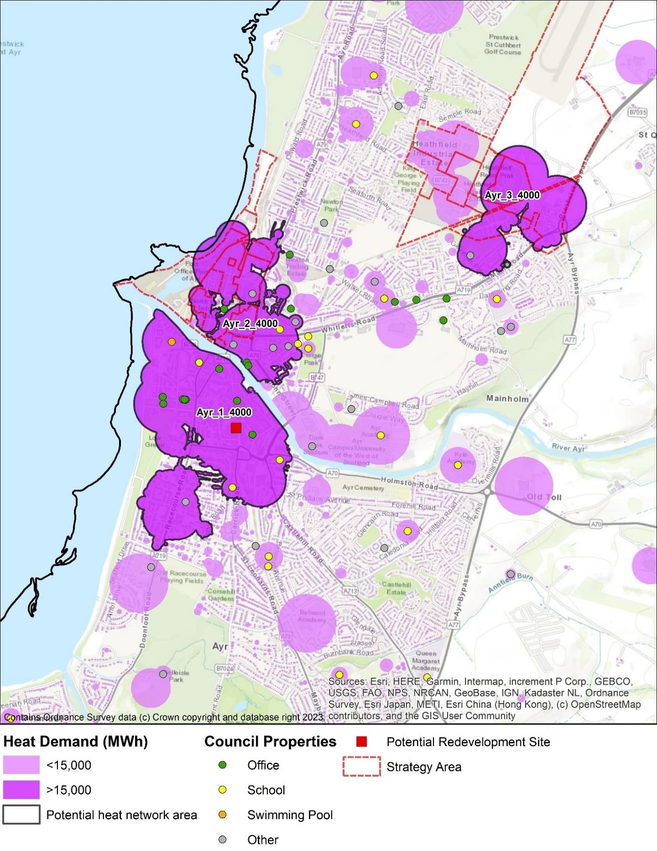

**Challenges**

* Relatively low levels of heat density in South Ayrshire resulting in 3 potential heat network zones,
* Engagement and feasibility are still at an early stage,
* Capital costs and delivery models.

**Focus**

* ***Priority 2:*** Coordination with AEM work to build feasibility studies for identified Heat Network zones,
* ***Priority 2:*** Redevelopment of Girvan Heat Network feasibility,
* ***Priority 3****:* Continued skills development in SAC through engagement with other local authorities, industry, and international mentoring programs.

**Consultation Question 6**

Do you think the areas of focus in the “Heat Network” section are suitable and sufficient for approaching heat network development within South Ayrshire?

# Delivery Areas

In this section we set out potential routes to approach interventions, looking at how we identify and prioritise areas for action.

These approaches will use the data developed from the LHEES methodology to show where interventions can be delivered in a way that creates the most positive impact for the funding available.

Delivery areas have been developed for both a spatial and for technology-led approaches.

## 7.1 Spatial approach

Through the spatial approach, characteristics of buildings have been considered and compared on an area-wide basis with respect to the LHEES considerations.

This type of analysis allows locations to be identified for area-based funding and focuses action to where it could deliver the greatest benefit.

7.1.1 Domestic energy efficiency

Weighted scores for domestic energy efficiency are distributed unevenly across South Ayrshire with higher scores indicating poorer energy efficiency and a greater potential for demand reduction. There are a small number of zones with significantly worse scores, showing value in addressing measures in specific geographical areas.

These areas with the highest scores are a priority, however amongst the top scorers, most homes are in the private sector. This points to a need to address the problems both by spatial zoning and by targeting properties by tenure and technical intervention; for example, a possible lack of wall insulation is the biggest contributing factor to the weighted score in each top delivery area.

7.1.2 Energy efficiency as a driver of fuel poverty

Weighted scores in this section are distributed unevenly across South Ayrshire, with higher scores indicating a greater risk that families are experiencing fuel poverty as a result of poor energy efficiency. There are a small number of zones with significantly worse scores, suggesting that there is value in addressing energy efficiency measures in specific geographical areas.

7.1.3 Mixed tenure, mixed use, and conservation areas

Mixed-tenure and mixed-use properties have unique challenges for the implementation of interventions as they have multiple stakeholders to engage that may have conflicting interests. Mixed-tenure buildings are those which have multiple properties of the same use but differing ownership type, whereas mixed-use buildings will have multiple properties in the same buildings that have different use profiles and are not all residential, such as a shop with a flat above it.

Due to the large number of stakeholders and challenges in this area, a dedicated working group is seen as the best course of action for delivery in mixed use and tenure areas.

Relatively few data zones have homes within conservation areas. The top three zones in Ayr South Harbour and Town Centre are amongst the worst performing zones according to energy efficiency scores and so some conservation areas will be priorities in this stage of LHEES. Additional strategic assessment is required early in the LHEES delivery period to work towards decarbonisation in this area.

The top data zones for listed domestic properties are Ayr South Harbour and town centre, Troon and Carrick north. These are also some of the poorer performers from the point of view of energy efficiency. Consequently, as in the conservation areas, further strategic assessment for this building type will be developed early in the LHEES delivery phase.

**Challenges**

* Mixed tenure, mixed use, conservation areas and listed buildings present significant challenges in area-wide decarbonisation,
* Traditional high street buildings present increased challenge.

**Focus**

* ***Priority 2:*** Creation of working group to ensure mixed use and tenure buildings are considered within area wide approaches,
* ***Priority 2 & 3:*** Monitor national landscape, connect, and build on current internal capacity for further strategic assessment of conservation and listed building decarbonisation.

## 7.2 Fuel Poverty

The fuel poverty analysis was undertaken using the information in the home analytics data set and supporting indicators against 2023 fuel costs. This building-level analysis was aggregated to provide an indication of how affordable it is to heat houses in each area.

### 7.2.1 Social Impact of Multiple Deprivation

The LHEES considers fuel poverty where it can be reduced through energy efficiency measures. Understanding which locations have higher rates of overall deprivation as well as specifically income deprivation informs decisions on areas of focus.

### 7.2.2 Overlaying Multiple Considerations

The analysis generated a number of rankings to determine where to start with interventions. The Weighted Energy Efficiency Score and Fuel Poverty rankings are, thanks to the latter being based on the former, well linked and can be used interchangeably with similar outcomes.

However, SIMD and income ranks are not correlated with the Weighted Energy Efficiency Score. Data zones with the worst energy performance are found to be ones which are relatively affluent, so addressing funding towards fuel consumption reductions would not address the issue of real-world fuel poverty. However, since there are likely to be income poor households in areas which are more affluent on average, the poor energy efficiency of those properties or the relative lack of energy efficient properties does still warrant targeted intervention.

These observations lead to priority approaches taking account of multiple factors, rather than a single approach.

**Challenges**

* 60% of homes in decile 5 and lower
* SIMD and income ranks are not correlated with the Weighted Energy Efficiency Score
* Multiple factor assessment required

**Focus**

* ***Priority 1:*** Integration of SIMD ratings in intervention targeting,
* ***Priority 2:*** Cross departmental working to ensure LHEES actions connect to other strategy, policy and projects.

**Consultation Question 7**

Do you agree with the focus areas identified in the “Delivery Areas” section?

Are there any other considerations you would like to see used to identify priority delivery areas?

# Pathways for all of South Ayrshire

## 8.1 Decarbonisation of Heat Pathway

The journey to the decarbonisation of each domestic property in South Ayrshire is shown in Figure 16.

The first column shows the proportions of properties which begin with each fuel source.

The second groups the properties by their current total heat demand in kWh/year.

The third column show changes to heat demand once reasonable energy efficiency measures have been applied.

The fourth column shows how suitable each property is for each of the low carbon heat measures. This assumes all listed heat network zones are developed but doesn’t consider further expansion.

Finally, the column on the right shows the final future heat demand.

Figure 2: Decarbonisation and energy efficiency pathway

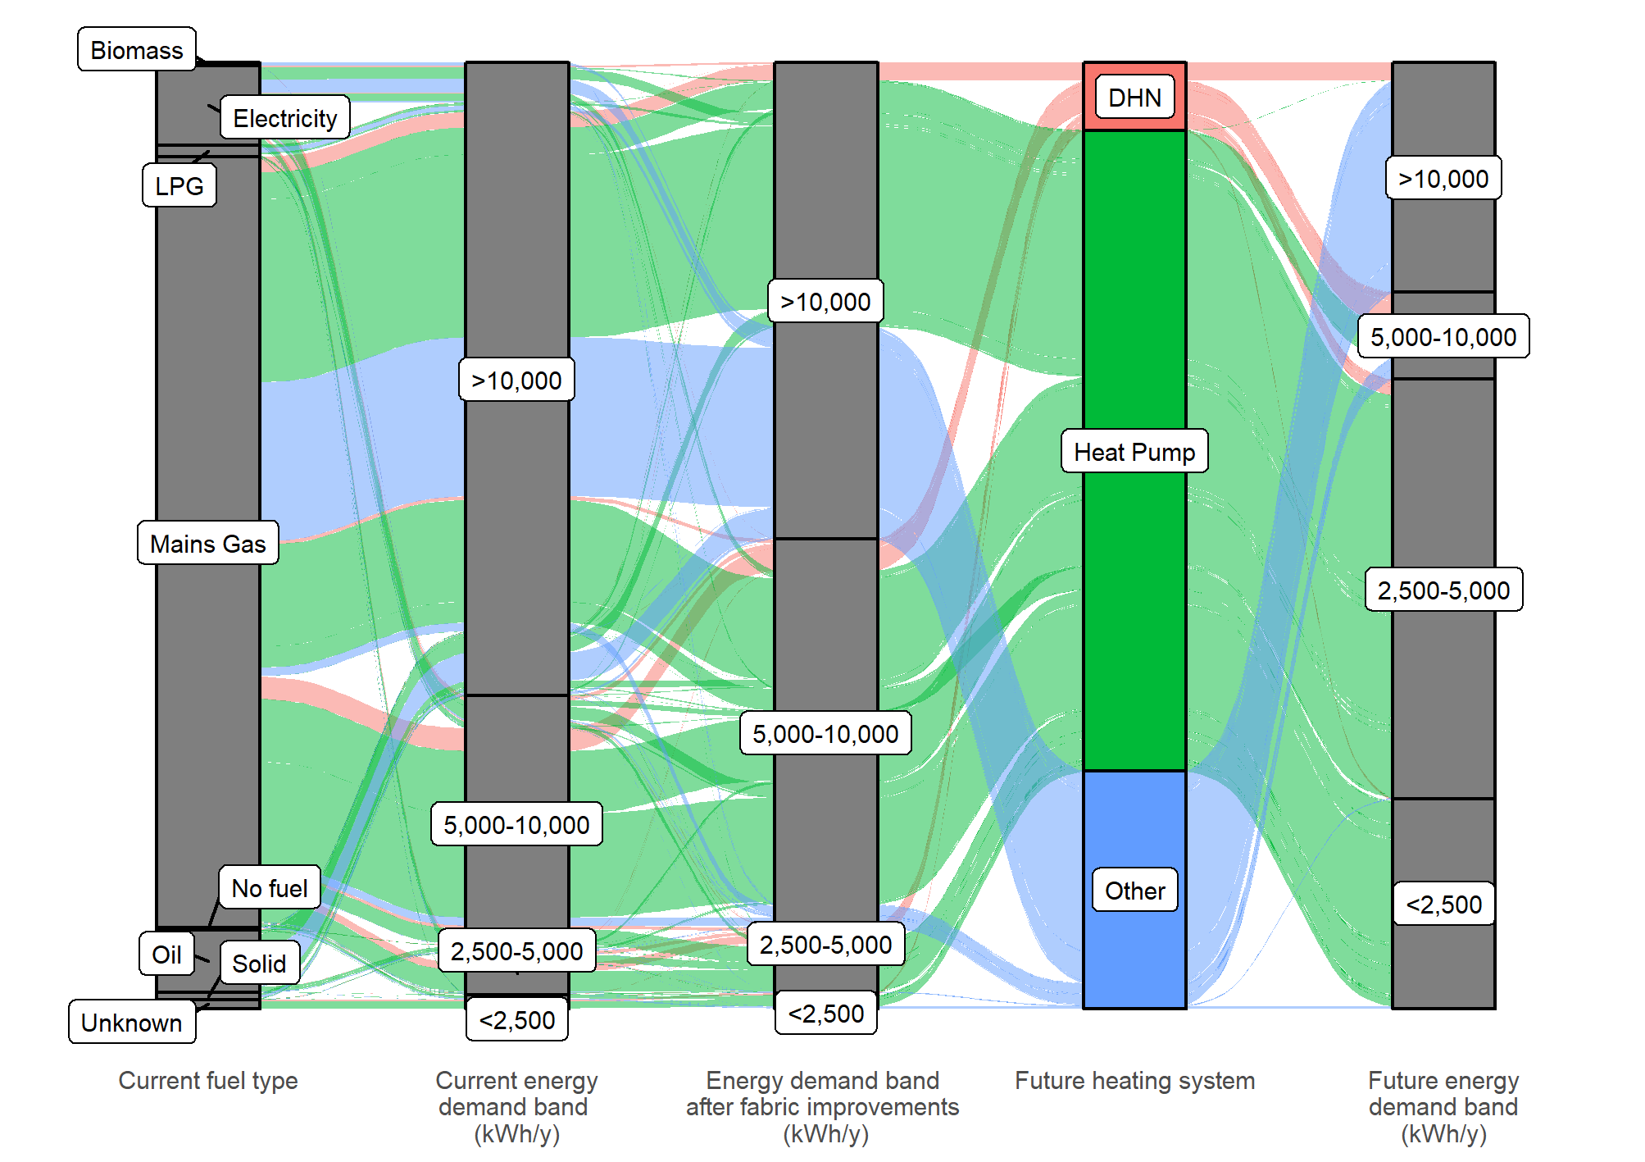

**Challenges**

* Pathways represent long term ambitions and commitment,
* Skills and supply chain shortfalls are a national challenge,
* Poor quality or inappropriate interventions can make fuel poverty worse.

**Focus**

* ***Priority 3:*** Engagement with Prestwick Airport, further and higher education organisations on potential industry and skills development
* ***Priority 2:*** Ensure multi-level assessment on interventions to prevent adverse effects on fuel poverty,
* ***Priority 2:*** Maintain engagement with UK and Scottish Government’s industry regulation on heat network development.

**Consultation Question 8**

Do you agree with the focus areas identified in the “Pathways for all South Ayrshire” section?

Are there any other considerations you would like to see to develop delivery pathways?

# Governance

This LHEES provides a first step towards decarbonising heat and reducing fuel poverty in South Ayrshire. In improving energy efficiency and prioritising low carbon solutions in areas where they can have the greatest impact, this strategy can support council and commercial investment, community engagement and wealth building, and an equitable energy transition. The delivery plan proposals are built from the data from the LHEES methodology and provide a series of potential projects from the challenges identified.

These challenges cannot be delivered in isolation by a single department, or by the Council alone. As such it is vital that a governance structure be put in place to ensure collaboration between internal and external stakeholders.

Figure 27 provides a potential structural overview for governance in this area. This will require development of roles and responsibilities, much of which will be developed through this consultation period and prior to the final strategy release. To ensure the successful delivery of LHEES actions, collaboration between stakeholders, internally and externally is vital.

Figure 3: Outline LHEES Governance model

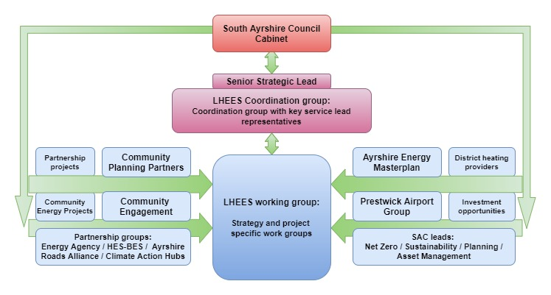

**Focus**

* Establish stakeholder links and agree suitable governance structures.

**Consultation Question 9**

Do you agree with the governance structure outlined in the “Governance” section?

Are there other established groups that should be considered?

# Delivery Plan Proposals

As part of the LHEES process, a delivery plan will be prepared to support and direct actions. This will be a live document, updated regularly to reflect changes in national and local circumstance. As such, the proposals below are an initial overview of potential actions, that are likely to evolve over the course of the next year.

Table 4: Proposed Delivery Plan Actions

|  |  |  |
| --- | --- | --- |
| Action No. | Action | Timescale |
| 1 | Ensure sufficient dissemination of SAC LHEES delivery plan to all key internal and external stakeholders. | 2024 |
| 2 | Set up the working groups highlighted for:   * LHEES Coordination and Strategy governance groups, * Specific issue areas such as mixed use/tenure and historic buildings | 2024 |
| 3 | Establish governance structure and agree meeting schedules | 2024 |
| 4 | Engage with other LA’s, Universities, NHS trusts and other large public sector organisations to learn from their experience of decarbonisation and LHEES considerations on large estates. | 2024-25 |
| 5 | Engage with the public using educational material on energy efficiency, technologies, funding opportunities, methods to reduce heating bills, and suitable tariffs to encourage early adopters of heat pumps. | 2024-26 |
| 6 | Engage with the public on heat network potentials and technologies | 2025-26 |
| 7 | Create a shared forum for lessons learnt from early adopters on heat pump operational best practices. | 2025 |
| 8 | Create ongoing case studies of SAC decarbonisation and fuel poverty reduction implementations, and learn from other case studies, to create a live up to date lessons learnt document. Including contacting MCS/Ofgem/Scottish Government/UK Government about current heat pump performance and how to make sure high COP and a good experience is achieved. | 2024-25 |
| 9 | Set up a working group with SPEN to monitor network constraints to coordinate transition work. | 2024-25 |
| 10 | Engage with local colleges and local installers to assess skills gaps in heat pump delivery. | 2024-25 |
| 11 | Assess potential routes for the long-term investment required for the interventions. | 2025-26 |
| 12 | Engage with supply chains to allow the visibility of secure pipeline of work for several years to come, to encourage growth of local skills and reduce the risk of local skill shortage. | 2025-26 |
| 13 | Complete feasibility studies on proposed heat network zones. | 2024-25 |
| 14 | Annual monitoring/report of gas prices compared to typical cost of heat from heat networks to ensure potential heat networks do not worsen fuel poverty. | Ongoing |
| 15 | Commence development of business cases in all heat networks deemed feasible. | 2025-26 |
| 16 | Assess loft insulation upgrades in the top third of LHEES data zones for SAC owned dwellings. | 2025-26 |
| 17 | Assess cavity wall insulations interventions in the top third of data LHEES zones for SAC owned dwellings, record ongoing progress. | 2025-26 |
| 18 | Assess hot water cylinder insulation upgrades in the top third of LHEES data zones for SAC owned dwellings. | 2025-26 |
| 19 | Assess internal or external wall insulation upgrades in the top third of LHEES data zones for SAC owned dwellings. | 2026-27 |
| 20 | Assess single to double glazing window upgrades in the top third of LHEES data zones for SAC owned dwellings. | 2027-28 |
| 21 | Assess with partner organisations and national groups any pilot studies / demonstration projects / field trials on heat pump deployment and operational best practises. | Ongoing |
| 22 | Assess heat pumps potential on case-by-case basis in properties that are currently using LPG/Oil/Solid fuels. Focus on the top third of data zones that are SAC owned. | 2025-29 |
| 23 | Assess heat pumps potential in properties that are currently using direct electric heating. Focus on the top third of data zones that are SAC owned, where they can be made suitable for heat pumps | 2025-29 |
| 24 | Coordinate with Scottish Government and collect improved datasets for 5 yearly LHEES update. | Ongoing |
| 25 | 5 yearly updates of LHEES. | 2029 |

**Challenges**

* Wide range of potential actions and areas, cross-cutting multiple council departments, organisations, groups,
* Technology and legislation will develop over the course of this action plan.

**Focus**

* Maintain focus on identified LHEES priorities.

**Consultation Question 10**

Do you agree with the actions identified in the “Delivery Plan Proposals” section?

Are there other actions that you believe would support LHEES delivery?

1. <https://ukerc.ac.uk/news/energy-efficiency-contributed-25-of-uk-economic-growth-since-1971/>
2. <https://www.gov.scot/publications/transitions-comparative-perspective/pages/5/>