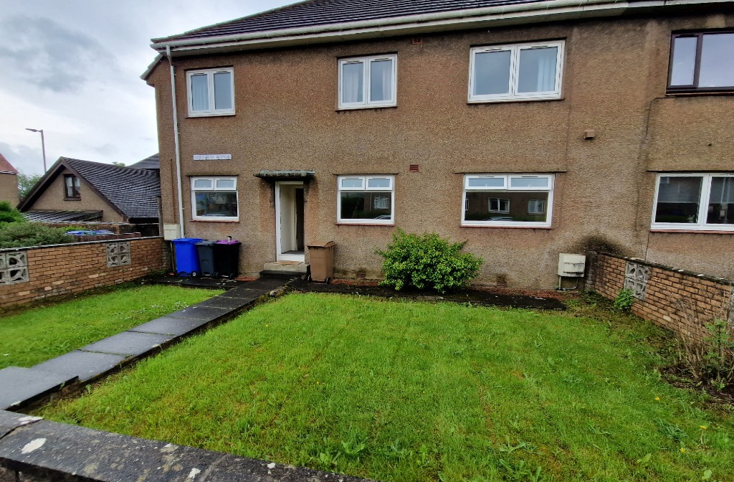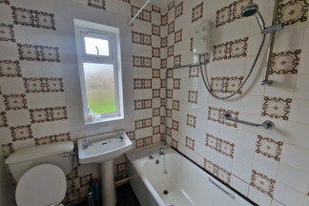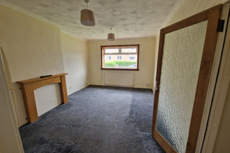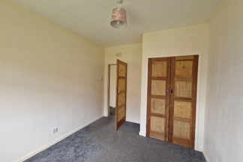

* Ground Level
* Gas Central Heating
* White Goods
* Carpet & linoleum thoughout
* Double Glazing
* Three Piece Bathroom Suite
* Pets Allowed
* Front and Rear Gardens

**prs@south-ayrshire.gov.uk**

Email

Phone

**01292 473477**

**Council tax band: B | EPC rating: D**

**3**

**1**

**1**

**Mochrum Avenue, Maybole**

**£600 PCM**

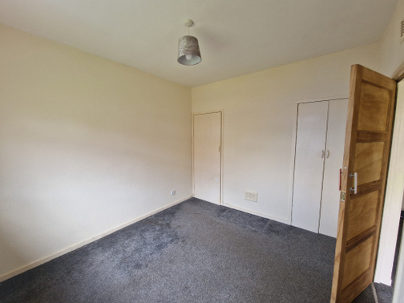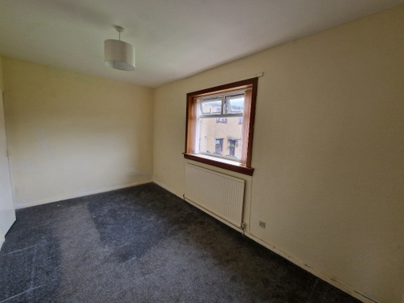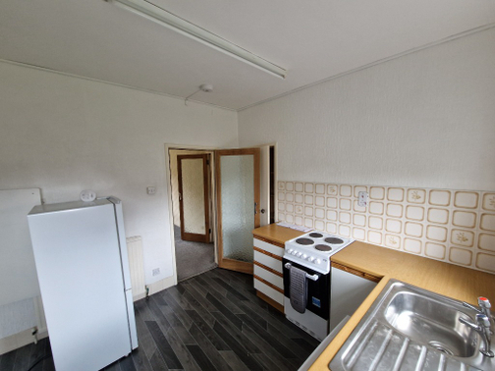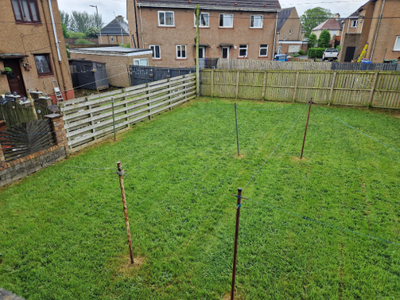

Your Choice Lettings and Property Management are delighted to introduce to the market, this well situated three bedroom property in Maybole.

The property comes with a generously sized, low maintenance front and rear gardens. The flat is light and spacious, with full carpeting throughout and lineolum fitted in the kitchen and bathroom. The décor of the property is neutral and well maintained.

The property offers gas central heating and double glazing throughout, with street parking outside of the property. The bathroom has a three piece suite including a bath with overhead shower, theres an airing cupboard outside of the bathroom, offering ample storage.

The bedrooms are all generous double rooms and each room has a built in wardrobe cupboard for extra storage space.The kitchen is a generous size and includes white goods, such as, fridge freezer, washing machine and cooker.

The local area has a range of amenities, schools and offers great transports links to Ayr and Glasgow.

**Photographs**

**Description**

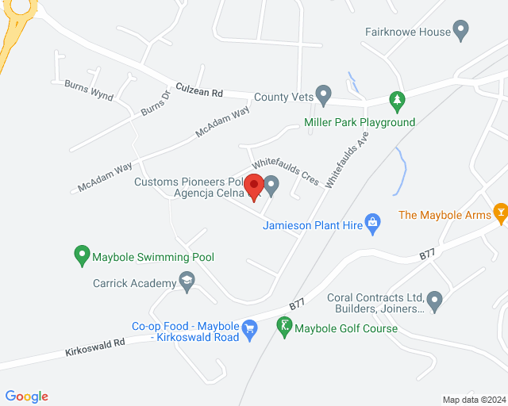

______________________________________________________________________________________________

______________________________________________________________________________________________

______________________________________________________________________________________________

______________________________________________________________________________________________

______________________________________________________________________________________________

______________________________________________________________________________________________

______________________________________________________________________________________________

______________________________________________________________________________________________

______________________________________________________________________________________________

______________________________________________________________________________________________

______________________________________________________________________________________________

______________________________________________________________________________________________

______________________________________________________________________________________________

**Notes**

**Map**

Landlord Registration: 951735/370/07111 & 243282/370/14221

LARN: 2008004

**www.yourfirm.co.uk**