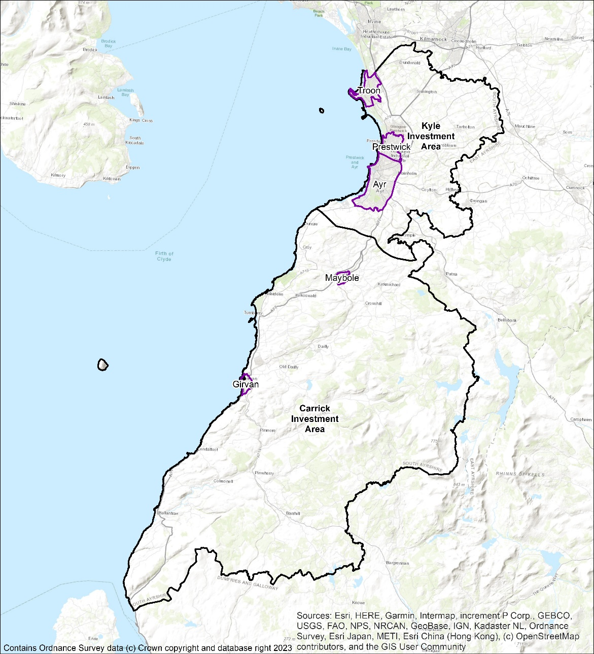

Local Heat and Energy Efficiency Strategy – Technical report
Report for: South Ayrshire Council

Ricardo ref. ED18430 Issue: V5 19/12/2023

Contents
1. Executive Summary 3
2. Abbreviations 4
3. Introduction 5
3.1 Overview of LHEES 5
3.2 Strategy Scope and Limitations 5
4. Background Information 6
4.1 LHEES Structure, Function and Scope 6
4.1.1 LHEES Structure 6
4.1.2 LHEES Considerations 6
4.1.3 LHEES Approach 6
4.2 Heat Decarbonisation Interventions 7
5. Policy and Strategy Context 10
5.1 LHEES Policy Context 10
5.2 Heat Decarbonisation – Scottish Government Policy 10
5.3 Energy Efficiency – Scottish Government Legislation 10
5.4 Summary of Policy and Legislation 11
5.5 Local Policy and Strategy, and Linkages 11
5.6 Summary of Ongoing Work at South Ayrshire Council 13
6. Baselining 15
6.1 Baseline Summary Across South Ayrshire 15
6.1.1 Domestic Building Stock 15
6.1.2 Non-domestic Building Stock 17
7. Generation of Strategic Zones and Pathways, Including Potential Zones for Heat Networks 22
7.1 Purpose 22
7.2 Local Development Plan Areas as LHEES Strategic Zones 22
7.3 Domestic Properties and Tenure 23
7.4 Domestic Energy Efficiency 25
7.5 Domestic Energy Efficiency and Fuel Poverty 28
7.6 Heat Network Zoning 29
7.6.1 Approach 29
7.6.2 South Ayrshire Council Overview 29
7.6.3 Ayr 30
7.6.4 Girvan industrial cluster 33
7.7 Low carbon heat – other than heat networks 35
7.7.1 Low carbon heating technologies 35
7.7.2 Individual or communal heat pump systems 35
7.7.3 Assessing suitability for heat pumps 35
7.8 Mixed Tenure, Mixed use and Historic 37
7.9 Building-Level Heat Decarbonisation 39
8. Delivery Areas 41
8.1 Spatial Approach 41
8.1.1 Purpose 41
8.1.2 Domestic Energy Efficiency 41
8.1.3 Energy Efficiency as a Driver for Fuel Poverty 43
8.1.4 Mixed-Tenure, Mixed-Use and Historical 45
8.1.4.1 Mixed-Tenure 45
8.1.4.2 Conservation Areas and Listed Buildings 47
8.1.5 Fuel Poverty – Absolute 51
8.1.6 Social Impact of Multiple Deprivation 52
8.1.7 Overlaying Multiple Considerations 54
8.1.8 Heat Pump Suitability 55
8.2 Technology-Led Approach 57
8.2.1 Purpose 57
8.2.2 Logic for Technology Grouping 57
8.2.3 Intervention Categories 57
8.3 Non-domestic properties 62
8.3.1 Overview of properties to decarbonise 62
8.3.2 Non-domestic buildings energy efficiency 66
8.3.3 South Ayrshire Council Portfolio 66
9. Pathways for all of South Ayrshire 67
9.1 Decarbonisation of Heat Pathway 67
9.2 Fuel Poverty 69
9.3 Heat Networks 71
9.4 Individual and Communal Heat Pumps 71
10. Pathways for Strategic Zones 73
10.1 Strategic Zones 73
10.2 Ayr 74
10.3 Carrick 75
10.4 Girvan 76
10.5 Kyle 77
10.6 Maybole 78
10.7 Prestwick 79
10.8 Troon 80
11. Conclusions 81
Appendix A Index of Tables and Figures ii
Appendix B Legislation Relating to LHEES iv
Appendix C Analysis of Core Indicators by Intermediate Zone vi
Appendix D Analysis of Core Indicators by Data Zone x
Appendix E Off-gas grid and On-gas grid xix
Appendix F Heat Network Zone Maps xxi
Appendix G Heat Pump Suitability Maps xxv
Appendix H Default indicators and calculation weightings xxxi
Appendix I Intervention Details xxxiii
Appendix J Intervention Costs lxviii

Refer to Appendix A for a list of the tables and figures included in this report.

Executive Summary
The Local Heat and Energy Efficiency Strategies (Scotland) Order 2022 places a duty on local authorities to prepare and update a Local Heat and Energy Efficiency Strategy (LHEES) and Delivery Plan.
LHEESs are primarily driven by Scotland’s statutory targets for greenhouse gas (GHG) emissions reduction and fuel poverty:
- Net zero emissions by 2045 and 75% reduction by 2030; and
- In 2040, as far as reasonably possible, no household in Scotland is in fuel poverty.
This strategy targets improvements in energy efficiency and moves to low carbon heat sources.
Current overview – Domestic
The majority of the domestic building stock in South Ayrshire was constructed after 1950 (Figure 2) but 87 % of South Ayrshire Council’s stock was built before 1983. By contrast, the housing association stock has a larger proportion of newer builds and this may be reflected in the greater proportion of housing association properties reaching an EPC grade of C or better.
Data shows that SAC’s domestic properties have a good level of energy efficiency, with only 2% requiring glazing upgrade and 11% requiring wall insulation upgrades. Data does shows potential improvements in loft insulation top up. This presents a challenge in meeting increasing EPC requirements and moves to net zero as remaining measures are likely to be at a higher cost.
The private sector has a greater challenge to improve EPCs both proportionally and in absolute numbers of properties and South Ayrshire Council will consider how these upgrades can be supported.
This is illustrated in the figure below, showing higher heat demand in private and owner-occupied tenures compared to local authority and housing association properties.
Figure ES1: Domestic heating energy demand
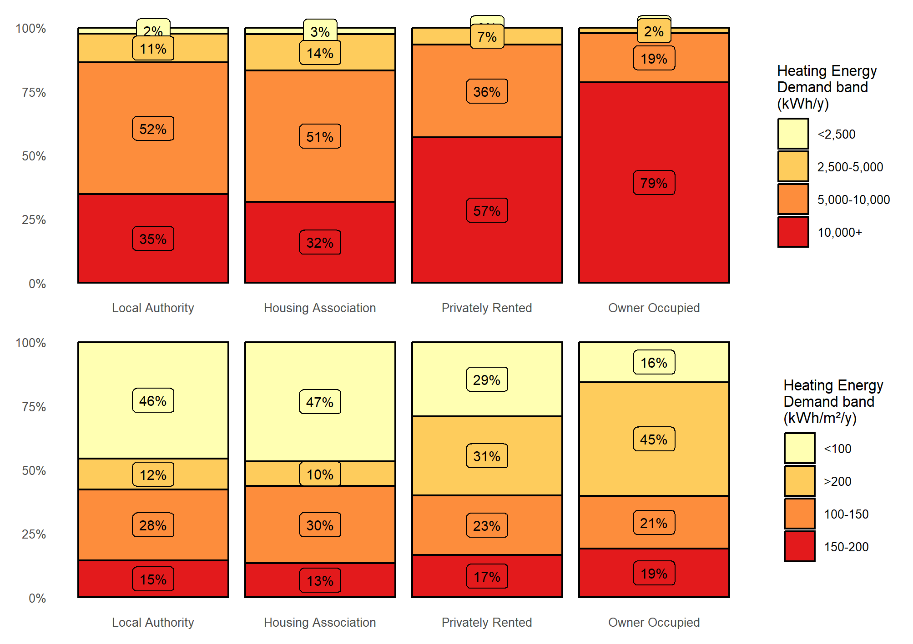
Current overview – Non-domestic
Confidence in the non-domestic dataset used for this analysis is low and work is required to improve data collection and quality. This will be supported through the Scottish Government’s Building Assessment Report (BAR) process and work on the Ayrshire Energy Masterplan (EAM).

Strategic zoning and pathways
The LHEES guidance requires the Council to set out strategic zones and develop pathways for each. Local development planning boundaries were chosen as they link with aligning strategies and policies.

Energy Efficiency
Weighted scores for energy efficiency were developed for each strategic zone based on the three key measures of loft insulation thickness, wall insulation, and glazing upgrade. Higher scores illustrate a lower energy efficiency.
Table ES1: Domestic energy efficiency weighted scores by strategic zone
Strategic Zone | Number of interventions required |  |  |  | Percentage of housing stock |  |  |  | Total Weighted Score
 | Loft Ins. | Glazing Upgrade | Wall Ins. | All | Loft Ins. | Glazing Upgrade | Wall Ins. | All
Carrick | 819 | 373 | 2,159 | 3,351 | 21 % | 10 % | 56 % | 87 % | 29
Kyle | 801 | 375 | 2,500 | 3,676 | 10 % | 5 % | 31 % | 45 % | 15
Ayr | 2,147 | 1,488 | 8,552 | 12,187 | 9 % | 6 % | 35 % | 50 % | 17
Girvan | 497 | 191 | 1,418 | 2,106 | 14 % | 6 % | 41 % | 61 % | 20
Maybole | 250 | 133 | 954 | 1,337 | 11 % | 6 % | 42 % | 58 % | 20
Prestwick | 955 | 310 | 3,278 | 4,543 | 13 % | 4 % | 44 % | 61 % | 20
Troon | 709 | 290 | 3,225 | 4,224 | 9 % | 4 % | 40 % | 53 % | 18
Total | 6,178 | 3,160 | 22,086 | 31,242
Cost effectiveness of energy efficiency measures
Looking at the impact of energy efficiency measures on overall consumption helps to identify which measures are the most effective way to reduce heating demand, helping both fuel poverty and heat decarbonisation. Loft insulation upgrades is by far the lowest cost method to reduce heating demands. On the other hand, installing external wall insulation on the outside of buildings that already have cavity or internal wall insulation is deemed as the least cost-effective way to reduce heat demand. However, there may be other reasons for doing less cost-effective measures, such as funding streams being allocated only to specific measures or improving the aesthetics of the building with external wall insulation or window upgrades.
Table ES2: Summary of energy efficiency interventions across all buildings in South Ayrshire
Measure | Heat Demand Reduction (kWh/y) | Fuel Savings per Investment Cost (£/£)
All wall insulation measures | 160,400,000 | 0.040
All loft insulation measures | 181,700,000 | 0.430
All Single to Double Glazing upgrade | 6,600,000 | 0.064
All cylinder insulation measures | 16,600,000 | 0.192
All Combined Measures | 365,300,000 | 0.062

Fuel Poverty
The Weighted Scores were calculated for each Locality to compare the potential to reduce fuel poverty by improving energy measures. This combines the energy efficiency score with the risk that each household is in fuel poverty, taken from Home Analytics. Carrick and Girvan stand out above the others and the interventions discussed in 7.4 will help to reduce these scores. Further data overlays are under consideration to enhance monitoring of fuel poverty and associated issues, such as health inequalities.
Table 8: Domestic fuel poverty scores by strategic zone
Strategic Zone | Households with energy bills > 10% of income after housing costs | Households with energy bills > 20% of income after housing costs | Total Weighted Score
Carrick | 34 % | 43 % | 31
Kyle | 21 % | 7 % | 18
Ayr | 22 % | 9 % | 19
Girvan | 33 % | 21 % | 27
Maybole | 27 % | 15 % | 23
Prestwick | 18 % | 4 % | 19
Troon | 19 % | 4 % | 18

Heat Networks
An analysis of the potential for heat network zones indicates that there are broadly two areas where heat networks may be viable – within Ayr and an industrial cluster near Girvan.
Within Ayr there are three separate zones identified, however, this strategy considers them in the context of a single heat network strategy for Ayr rather than considering them three discrete opportunities.
Two of the heat network zones in Ayr show sufficient total load and anchor points to consider construction and intersect with identified business development areas. These zones also cover a significant amount of conservation areas and listed buildings, which can be hard to treat with other low carbon heat sources. The Girvan industrial cluster is within close proximity to an existing feasibility study, which will be reviewed under new funding structures.
The LHEES work will also take cognisance of developing commercial networks such as Dalquharran estate feasibility mine water geothermal project.
Heat pump suitability
From this analysis up to 49% of domestic properties in South Ayrshire could be suitable for heat pump installation without significant interventions. If reasonable energy efficiency measures were applied, this increases to 65%. Applying all possible energy efficiency interventions increases this to 74%, leaving 26% of properties less likely to be suitable for a heat pump with current prices and technologies.
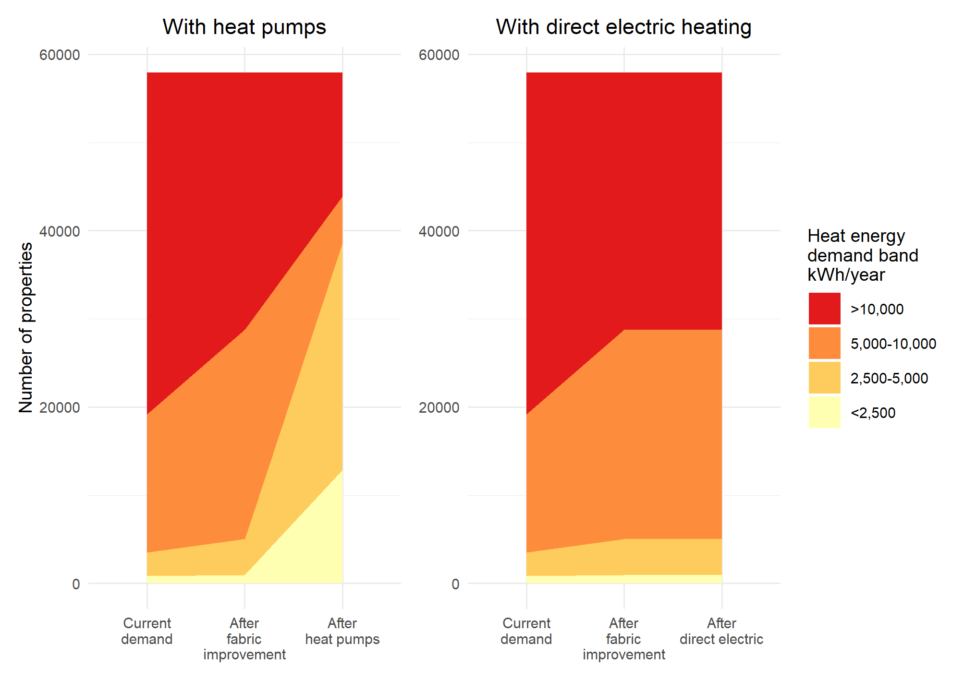
As shown above, heat pumps can contribute to reduction in total energy demand and support reduction of fuel poverty in turn.
Individual or communal heat pumps
This LHEES also considers communal heat pump systems – both where a single heat pump heats a whole building or where a network of heat pumps share a single heat source, sometimes referred to as a 5th generation heat network, as having similar energy efficiency requirements as individual heat pump systems. Therefore, they are considered as a single grouping for the purposes of this LHEES.
Delivery zones
Two approaches to identifying actions are set out in this LHEES – a spatial approach identifying delivery zones to make use of area-based funding and align with local priorities, as well as grouping properties and interventions based on them having similar attributes regardless of location. To ensure that the best social and financial value, this LHEES will look to overlay multiple considerations when planning interventions.
Pathways
The journey to the decarbonisation of each domestic property in South Ayrshire is shown below. The first column shows the properties current fuel source. The second groups the properties by their total current heat demand. The third column shows changes if reasonable energy efficiency measures are applied. The fourth shows potential future heating systems, and finally, the column on the right shows the resulting change in total heat demand.
Figure ES2: Decarbonisation and energy efficiency pathway
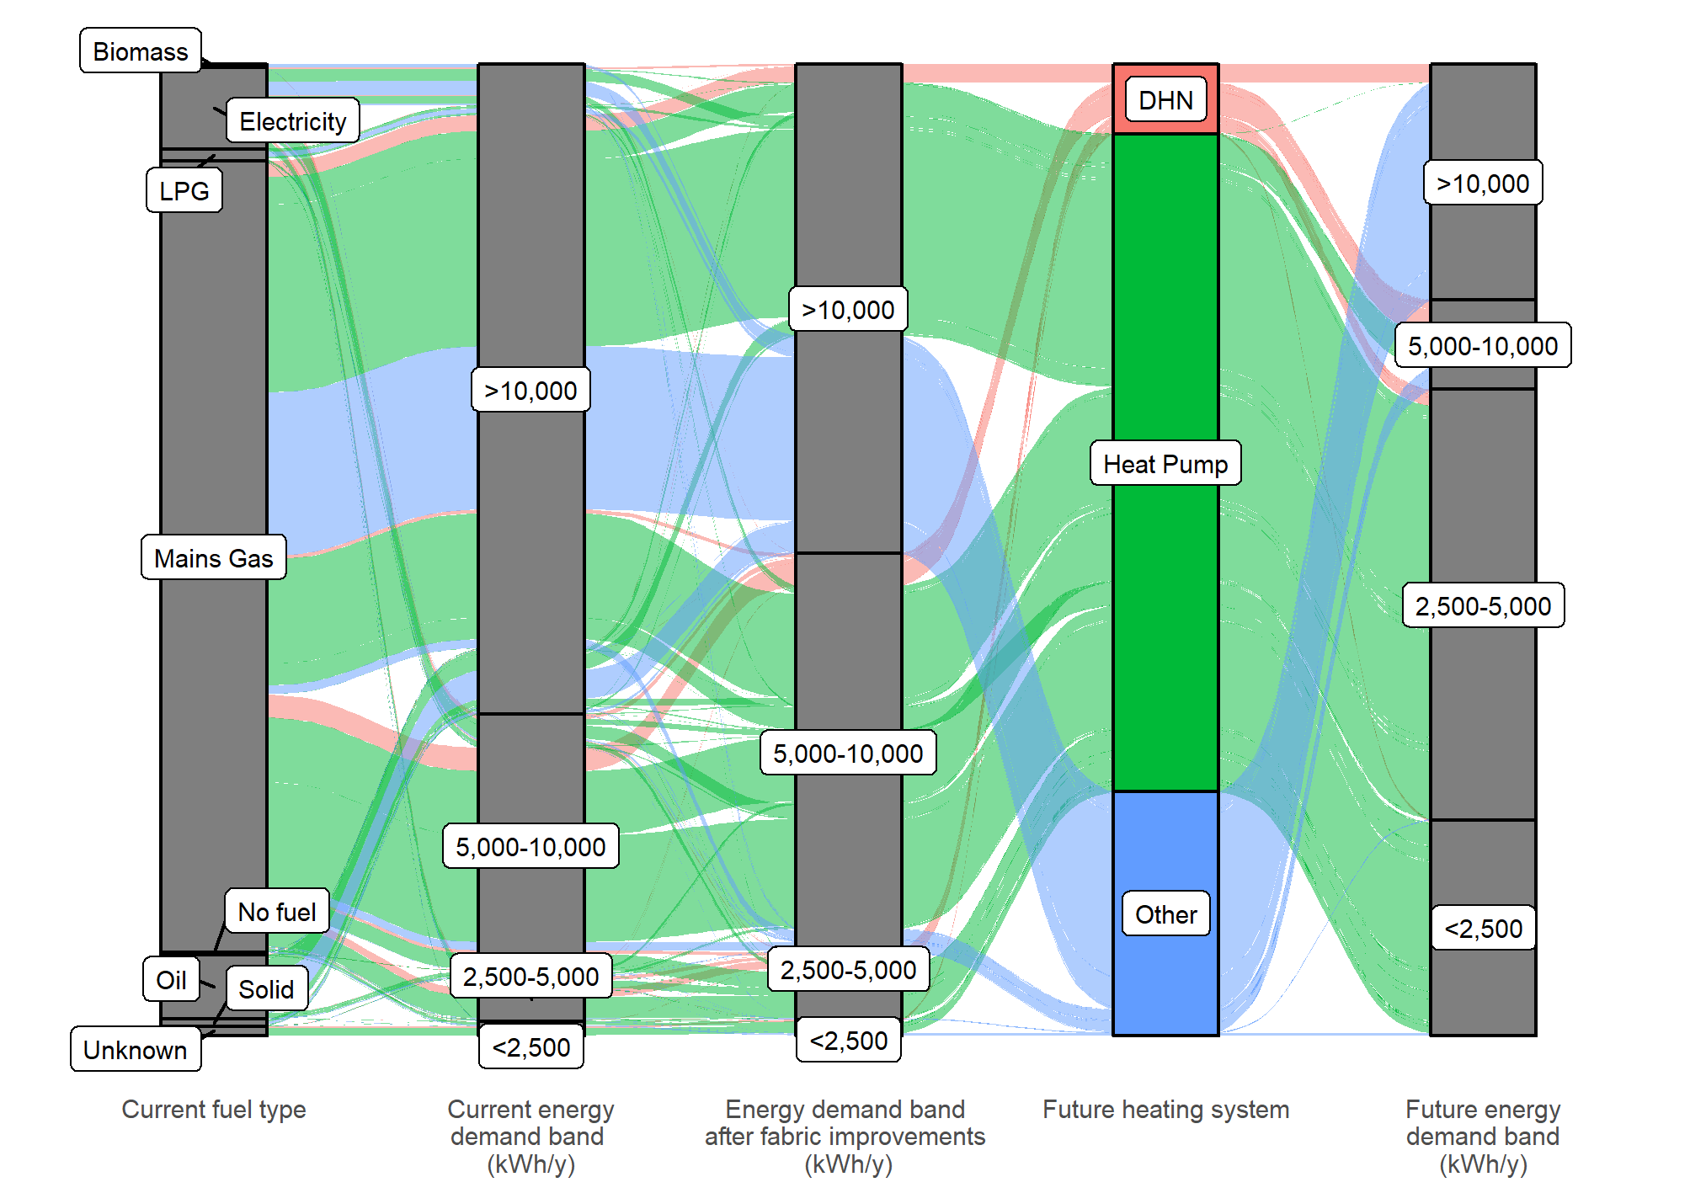
From this, heat pumps will play a large part in decarbonisation of South Ayrshires domestic properties. This assumes that all areas of heat network are developed but does not consider expansion beyond the current scope.

Stakeholder consultation
Engagement with stakeholders was sought and undertaken, both within the council and with external partners. Feedback was considered throughout the development of the LHEES. Public responses were thematically assessed, and key principles were integrated into this version of the LHEES. Analysis can be seen in Appendix D of the LHEES Strategy 2024-29.
Conclusions
From this analysis, energy efficiency and heat pump development will play a large role in the decarbonisation of South Ayrshire properties, reducing energy demand and the risk of fuel poverty within the most vulnerable in society. Heat networks will play a part, but due to a lower heat density compared to more urban authorities this is confined to two main districts.
Significant levels of engagement will be required to support property owners in this transition, for both commercial and domestic sectors, and integrating works such as the Ayrshire Energy Masterplan will be essential. The data from this LHEES will support the prioritisation of both interventions and technology in future decision making.
With dedicated resource to support the LHEES process, the Council has the opportunity to play in supporting role in not only the decarbonisation of its own building stock but act as a coordinating partner for regional partners.

Abbreviations

Table 1: Abbreviations
Acronym | Description
BAR | Building Assessment Report
COP | Coefficient of Performance
EES | Energy Efficient Scotland
EESSH | Energy Efficiency Standard for Social Housing
EPC | Energy Performance Certificate
ESCCS | Environmental Sustainability & Climate Change Strategy
EST | Energy Saving Trust
GHG | Greenhouse gas
GIS | Geographic Information System
EES: ABS | Energy Efficient Scotland: Area Base Schemes
IZ | Intermediate Zone
LA | Local Authority
LHEES | Local Heat and Energy Efficiency Strategy
LPG | Liquefied Petroleum Gas
Mxd | Map Exchange Document
PEAT | Portfolio Energy Analysis Tool
SAC | South Ayrshire Council
SAP | Standard Assessment Procedure
UPRN | Unique Property Reference Number

Introduction

Overview of LHEES
The Local Heat and Energy Efficiency Strategies (Scotland) Order 2022 places a duty on local authorities to prepare and update a Local Heat and Energy Efficiency Strategy (LHEES) and Delivery Plan. This document is prepared by South Ayrshire Council (SAC) to fulfil its duty under that Order.
This Strategy sets out the long-term plan for decarbonising heat in buildings in the SAC area and improving their energy efficiency.
LHEESs are primarily driven by Scotland’s statutory targets for greenhouse gas (GHG) emissions reduction and fuel poverty:
- Net zero emissions by 2045 and 75% reduction by 2030; and
- In 2040, as far as reasonably possible, no household in Scotland is in fuel poverty.
The Strategy should:
- Set out how each segment of the building stock needs to change to meet national and local objectives, including achieving zero greenhouse gas emissions in the building sector, and the removal of poor energy efficiency as a driver of fuel poverty;
- Identify strategic heat decarbonisation zones, and set out the principal measures for reducing buildings emissions within each zone; and
- Prioritise areas for delivery, against national and local priorities.
Accompanying this Strategy is a Delivery Plan. This has been developed in partnership with key stakeholders, and provides a strong basis for action for local communities, government, investors, developers and wider stakeholders, pinpointing areas for targeted intervention and early, low-regrets measures. The Strategies and Delivery Plans will be reviewed and updated on a five-year basis.

Strategy Scope and Limitations
The scope is focused on heat decarbonisation, energy efficiency and fuel poverty and does not include wider energy system planning directly, but the LHEES can be used as a building block for wider LA energy planning.
While there are some limitations with the domestic building dataset, which is primarily based on Home Analytics, it is of sufficient quality and reliability to allow detailed analysis and conclusions. However, the non-domestic data, which is primarily based on Non-Domestic Analytics, this is less reliable overall due to a dataset that has significantly more gaps in it and a much wider use for heat. the variety of heat uses and a significantly more limited dataset. For this reason, there are limitations to the level of detail in the outputs from non-domestic buildings.

Background Information

LHEES Structure, Function and Scope

LHEES Structure
As established in the Local Heat and Energy Efficiency Strategies (Scotland) Order 2022, LHEES should have a two-part structure. This document sets out the long-term mix and the accompanying Delivery Plan sets out actions to support implementation of this Strategy.

LHEES Considerations
The LHEES guidance sets out the key considerations for this Strategy, shown in Table 2. These help to categorise building stock into groups that require similar interventions.
Table 2: LHEES Considerations
 | No. | LHEES Considerations | Description
Heat decarbonisation | 1 | Off-gas grid buildings | Transitioning form heating oil and LPG in off-gas areas
 | 2 | On-gas grid buildings | On-gas grid heat decarbonisation
 | 3 | Heat networks | Decarbonisation with heat networks
Energy efficiency and other outcomes | 4 | Poor building energy efficiency | Poor building energy efficiency
 | 5 | Poor building energy efficiency as a driver for fuel poverty | Poor building energy efficiency as a driver for fuel poverty
 | 6 | Mixed-tenure, mixed-use and historic buildings | Mixed-tenure and mixed-use buildings, listed buildings and buildings in conservation areas

South Ayrshire Council policies do not differentiate by connection to the gas grid or if buildings are mixed tenure, mixed use and historic buildings. Instead, the policies apply to the full array of building stock.

LHEES Approach
A suggested LHEES methodology is supplied by the Scottish Government as shown in Figure 1. Although the approach used is based on the proposed methodology shown below, the details have been adjusted to suit the specific context of South Ayrshire. The methodology is broken down into eight stages that align with the work set out in the LHEES Guidance.
The completion of these stages provides South Ayrshire Council with the data analysis and evidence base to enable development of this Strategy and the accompanying Delivery Plan document. The completion of work carried out in stages 1-4 feeds into the Strategy plan, and the completion of stages 4-6 alongside the Strategy feeds into the Delivery Plan.
Figure 1: Summary of LHEES Approach and Stages
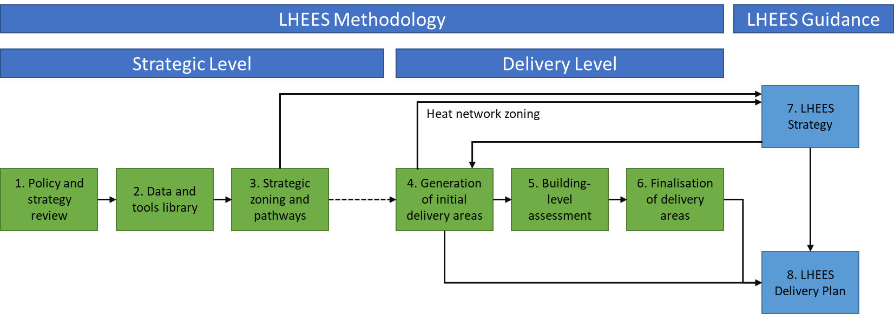

Heat Decarbonisation Interventions
There are a range of potential low carbon heat sources which are likely to play a role in the LHEES. A technology agnostic approach has been taken to consider the full range of technologies without bias, weighing up the advantages and disadvantages of each measure on fuel poverty and decarbonisation. Table 3 summarises these technologies. In assessing the impact of interventions, this Strategy considers the heating energy consumption of properties (in kWh) and the specific heating energy demand (kWh/m²). The resulting improvements in Energy Performance Certificate (EPC) rating or SAP score are not considered. This is because the associated rating improvement would change with future methodological adjustments. Some adjustments are already planned, and these methodologies may continue to be adjusted over time. This focus on the heat demand of these buildings in isolation provides clarity on the real-world impact, particularly around fuel poverty.
There may be differences in prioritisation for specific projects based on the methodology for assessing energy efficiency applicable at that time.
Table 3: Heat decarbonisation interventions
Intervention | Heat decarbonisation | Effect on fuel poverty | Suitability
Energy efficiency | Measures such as double glazing, draught proofing and insulation reduce energy demand which in turn increases the viability for switching to low carbon heat sources | Improved energy efficiency leads to reduced energy costs, which reduces fuel poverty.  Grants and loans are available for lower income households. | Where feasible and cost-effective, HIBS aims for all homes to have the at least the equivalent of EPC band C by 2033
Heat pumps | Heat pumps use electricity to extract heat from the air, ground, water or waste water. Grid electricity is continuing a trend of decarbonisation through renewable energy. | Appropriately designed and well-running heat pumps can reduce costs, particularly compared to electric heating.  Savings are dependent upon the relative price of electricity compared to the fuel displaced as well as the coefficient of performance (COP) of the installation.  Replacing electric heating with a heat pump can reduce energy consumption and reduce fuel poverty. | Heat pumps are commonly used in cold climate, such as Scandinavia and research has found that all UK house types are suitable for heat pumps. Where necessary, upgrades to heat emitters or hot water storage can present practical challenges in some properties.  The electricity network will need to accommodate increase in electricity demand from heat pumps, direct electrical heating, and other energy sources such as Electric Vehicles.  Hot water production is usually provided through a hot water cylinder, which requires space in a property.
Heat networks | Heat networks, which use waste heat, heat pumps or bioenergy as their energy source | The Competition and Markets Authority found that up to 90 % of heat network customers enjoy similar, or lower, bills than those with standard gas boilers and heat networks can cut both emissions and bills. | Heat networks are suitable for all building types but only in areas with a sufficient density of heat demand
Electric heating | Electricity to extract heat from the air or ground. Grid electricity is continuing a trend of decarbonisation through renewable energy | While direct electric heating is more efficient than combustion boilers, including gas, the high cost of electricity must be considered for households at risk of entering fuel poverty.  Storage heaters can be used to harness cheaper electricity at night but can emit and waste heat when not required | Electric heating is suitable for all properties with a suitable electricity connection. Hot water production is usually provided through a hot water cylinder, which requires space in a property.
Bioenergy | Sustainably sourced, bioenergy (i.e., solid biomass, biogas or biomethane) is regarded as carbon neutral | There is uncertainty surrounding the future supply of bioenergy and biomass boilers tend to have more maintenance requirements than gas boilers | HIBS indicates that bioenergy is likely to have a limited role in the decarbonisation of the building stock. There may be some buildings for which bioenergy can play a role, for example in hard to treat off-gas properties where heat pumps are unsuitable.  However, the UK’s Green Gas Support Scheme aims to increase the proportion of biomethane in the gas grid.  A bioenergy Action Plan is due to be published in late 2023.  Air quality concerns need to be considered in urban settings
Hydrogen | Green hydrogen is produced by splitting water using renewable electricity while blue hydrogen is produced from fossil fuels plus carbon capture. Therefore, both production routes are deemed as low carbon in UK and Scottish legislation.  Increased availability of hydrogen for heat will have positive implications for the suitability of hybrid heat pump systems, which may be cost-effective solutions | Currently hydrogen is an underdeveloped fuel and is associated with high costs. The future of hydrogen prices is uncertain but may become competitive with other energy sources in the coming decades. However, without Government incentives prices for green hydrogen are unlikely to be lower cost than using direct electrical heating or heat pumps as hydrogen system efficiency is lower than using electrified heating. | Hydrogen is not currently available for supply of heat to domestic properties and is not seen as an immediate solution.

The Heat in Buildings Strategy (HIBS) states that for the period to 2030, focus must be placed on accelerating the deployment of tried and tested measures where they are known to be no or low regrets. These have been identified to be:
- Energy efficiency measures for both existing and new buildings;
- Individual heat pumps in buildings off the gas network which currently use high carbon heating fuels;
- Heat pumps for on-gas buildings where initial assessments suggest heat pumps are likely to be cost effective and are less likely to receive a main hydrogen gas supply in the future; and
- Low and zero emission heat networks in areas deemed suitable.

Policy and Strategy Context

LHEES Policy Context
The Local Heat and Energy Efficiency Strategies (Scotland) Order 2022 stipulates that each local authority area must prepare and publish (a) a Local Heat and Energy Efficiency Strategy, and (b) a local heat and energy efficiency Delivery Plan by the end of 2023. These will be the principal mechanism for locally-led heat planning. Both must be kept under review and updated at five yearly intervals.
The six LHEES Considerations, as outlined in Table 2, are in two categories, namely “heat decarbonisation” and “energy efficiency and other outcomes”.
On a UK level, there exists legally-binding legislation to reach net zero emissions by 2050. The Net Zero Strategy: Build Back Greener report denotes than one third of emissions are a result of heating for homes and workplaces. The UK Government is responsible for regulation of the electricity and gas networks and markets. Other targets are set, such as reaching 600,000 heat pump installations nationwide by 2028.
The Scottish Government has more ambitious targets than the UK, with net zero by 2045 and interim targets of 75 % by 2030 and 90 % by 2040. There are certain powers which are devolved to the Scottish Government such as promoting renewable energy and energy efficiency, while many aspects of energy policy are reserved by the UK Government. Chapter 10 of the Heat in Buildings Strategy (HIBS) discusses the need for the UK and Scottish Government to work alongside each other to facilitate the decarbonisation of heat.

Heat Decarbonisation – Scottish Government Policy
The Scottish Government’s Climate Change Plan update was published in December 2020. The next full plan is due to be completed by early 2025. To achieve net zero by 2045, Scotland has committed to reducing emissions by 75 % (compared to 1990) by 2030. As part of this, around 50 % of homes and non-domestic buildings will need to convert to a low or zero carbon heating system by 2030. An investment of £1.6 billion has been earmarked for heat and energy efficiency over the next Parliament.
HIBS sets out a pathway to zero building emissions by 2045 and describes 111 actions and proposals that the government will take to work towards these targets. A new provisional Renewable Heat Target is presented whereby at least 22 % of non-electrical heat in buildings is to be supplied by renewable sources by 2030, up from today’s estimated 4 % level.
These policies feed into the LHEES Considerations of:
- Off-gas grid buildings;
- On-gas grid buildings;
- Heat networks; and
- Poor building energy efficiency as a driver for fuel poverty.

Energy Efficiency – Scottish Government Legislation
The Tackling Fuel Poverty in Scotland: A Strategic Approach sets the target to maximise the number of fuel poor households attaining EPC B by 2040. At the time of writing, the Scottish Government are consulting on an EPC reform, which likely will have an impact on the grading of the building stock and the effect of measures. The Fuel Poverty Act sets an overarching target that in the year 2040, as far as reasonably practicable, no household in Scotland is in fuel poverty and, in any event, no more than 5 % of households are fuel poor, no more than 1 % are in extreme fuel poverty and the fuel poverty gap is no more than £250 (in 2015 prices).
The Scottish Government will require that all residential properties in Scotland achieve EPC C by 2033, where technically and legally feasible and cost-effective. For the social rented sector, no housing should be let after 2025 if the EPC rating is lower than EPC D. For the owner occupier sector, new energy efficiency regulations will be introduced between 2023 to 2025.
These policies feed into the LHEES Considerations of:
- Poor building energy efficiency;
- Poor building energy efficiency as a driver of fuel poverty; and
- Mixed-tenure, mixed-use and historic buildings.

Summary of Policy and Legislation
Scotland boasts a suite of legislation that supports the transition to Net Zero. These cover overarching targets for emission reduction and heat supply, energy efficiency drivers and planning, and support for skills development and Just Transition. Refer to Appendix B for a summary.

Local Policy and Strategy, and Linkages
Relating to the LHEES Considerations, the Council’s strategies, policies, and plans have been reviewed with specific areas of local analysis highlighted for relevance.
Table 4: Local Policies and Strategies
Strategy, Policy, Plan | Description | Linkages
Local Housing Strategy | The LHS is a 5-year plan to support people of South Ayrshire to find good quality housing, develop a sense of identity and belonging, reduce homelessness, and support all residents in their ability to live in a warm, dry, energy efficient home that meets their needs. | Cross-cutting theme – Sustainability, climate change and biodiversity  Agreed Principle: Healthy Homes and Fuel Poverty  Outcomes: HH1, HH2, HH3, HH5
Local Development Plan | The LDP2 is a spatial land use document which guides the future use of land in our cities, towns, and rural areas. It considers and addresses land use issues arising from the implications of economic, social, and environmental change. In doing so, this document provides an overall, joined up approach to managing development that can set out ambitious but realistic long-term visions the South Ayrshire Council area. | Core themes C - Our Environmental Responsibilities How we will be mindful of our responsibilities for the protection of our natural, built, and cultural heritage resources.  Core Principles: C1 – We will promote the sustainable use of natural, built, and cultural heritage resources.  Strategic Policy 1: Sustainable Development - We will support the principles of sustainable development by making sure that development meets the following standards:  - Designed to maximise energy efficiency through building siting, orientation, and materials,  - Helps mitigate and adapt to the effects of climate change.  - Includes the use of micro-renewables, wherever appropriate  - Wherever possible, Incorporates or facilitates the development of District heating / heat networks.
Strategic Housing Investment Plan 2023/24 – 2027/28 | The Strategic Housing Investment Plan (SHIP) 2023/24 – 2027/28 sets out the strategic investment priorities for affordable housing over the next five years that will achieve outcomes set out in the Local Housing Strategy and HNDA. | Strategic priority – Sustainable Communities and Sustainable Developments  All projects proposed in the SHIP will help to tackle fuel poverty and ensure that heat is affordable for residents by increasing energy efficiency and reducing the amount of energy required to heat the home.
Sustainable Development and Climate Change Strategy 2019 – 24 | This strategy sets out a coherent framework for the council projects, policies and initiatives which promote sustainable development, mitigate climate changing emissions, and adapt to the impacts of climate change.  It focuses on the themes of sustainable council, environment, and community with broad outcomes and actions for each. | Outcome 1 - reducing emissions from energy use, improving economic development opportunities, and embedding mitigation, adaptation, and partnership working.  Outcome 3 - links through energy activities within local communities.

Summary of Ongoing Work at South Ayrshire Council
South Ayrshire has extensive work ongoing to reduce emissions within our own estate, and within our communities.
Internal:
- Strategic direction is coordinated through working groups on Net Zero and Sustainable Development & Climate Change, creating a pipeline of projects and consultation.
- Retrofit works are supported through SALIX funding, SAC central repairs, and through the ongoing capital program.
- Headline projects include:
  - Extensive LED lighting replacement over the past xx year
  - High consumer retrofits, including swimming pool ventilation and heat recovery
  - Installation of IQVision, building management software saving over £300,000 in two years
- Sustainability and energy efficiency are now driving principles in new builds, supported through Professional Design Services (PDS)
  - Renewables generated 770,000 kWh of our buildings heat and electricity in 2022/23 and continue to be a priority element of all new builds.
  - The Sustainable Design Guide in development will provide a framework to ensure industry best practice is implemented in all retrofit and new builds.
  - Continue to expand on our seven education buildings powered through low/zero emissions heating systems including Prestwick and Carrick Education campus’, Dailly and Colmonell Primary Schools, and Forehill, Cherrytree, and Struthers Early Years centres.
  - These are joined by South Ayrshire’s first net zero building, Bridge Street Depot, which will, instead of contributing to climate change, actively save 8 tonnes of CO2 every year
Housing:
- South Ayrshire continues to lead the way on energy efficiency improvements to social housing stock.
  - 92.19% of our social housing is compliant with Scottish Housing Quality Standards compared to a local authority average of 70.91%
  - 93.60% of our social housing is complaint with Energy Efficiency Standard for Social Housing compared to a local authority average of 87.63%
  - External wall insulation programs are ongoing through partners The Energy Agency, delivering over 3,200 projects since 2013
- Private landlords / RSL
- New Builds / Industry best practice
  - Work alongside partner organisations including private and registered social landlords to ensure industry best practice is applied in all new builds
  - Consultation
Community Planning Partners
- The South Ayrshire Community Planning Partnership is made up of 5 Strategic Delivery Partnerships which work together to deliver on the strategic themes of Place and Wellbeing with the vision of ‘All together – growing, caring and living a better life’. The Sustainability Partnership is one of the 5 Strategic Delivery Partnerships developing and delivering our LOIP (Local Outcome Improvement Plan) and is focused on the four priority areas of energy, food, travel and nature as agreed by the Community Planning Executive in November 2023. The Sustainability Partnership also has a recognised role to work across all the SDPs given the cross-cutting nature of its role within the partnership. Further consultation and work to develop action plans and performance framework to support the new LOIP will be undertaken in 2024.
Economic Development
- The Ayrshire Energy Masterplan represents a cross-authority approach to develop a strategic energy vision for the Ayrshire region. This will include socio- and techno-economic modelling to identify investment opportunities, areas of business growth, and skills and supply chain development areas. Strategic outcomes will link with LHEES through local energy and heat generation, decarbonisation, investment in local carbon technologies, and a just and inclusive energy transition.
  - The strategy is due to be released in early 2024 and will link closely with the LHEES delivery planning.

Baselining

Baseline Summary Across South Ayrshire

Domestic Building Stock
The Home Analytics dataset records 57,949 domestic properties in South Ayrshire, with 8,567 being in the ownership of South Ayrshire Council and a further 2,330 owned by housing associations. Private landlords hold 6,697 properties, with 39,713 being owner-occupied. A further 530 addresses lack data and are excluded from the remainder of the analysis. There are conservation areas in South Ayrshire and 4,636 domestic properties are situated in those. Listed buildings make up just 2 % of the domestic building stock, with South Ayrshire Council owning just 26.
The majority of the domestic building stock in South Ayrshire was constructed after 1950 (Figure 2) but 87 % of South Ayrshire Council’s stock was built before 1983. By contrast, the housing association stock has a larger proportion of newer builds and this may be reflected in the greater proportion of housing association properties reaching an EPC grade of C or better.
The private sector, though, has a greater challenge to improve EPCs both proportionally and in absolute numbers of properties and South Ayrshire Council will have to consider how this swathe of upgrades can be supported. A trickle of properties will return from the private sector to the local authority through the buy back scheme, which will give the Council the opportunity to improve them but the majority will need some other form of support or guidance.
Note that around one third of domestic properties are located in small towns and rural areas where future heat networks are unlikely to supply and so other routes to heat decarbonisation will be required.
It should be noted that the Home Analytics total differs from the Scottish Assessors Association total of 56,749 (December 2023); it is the Home Analytics data which is used throughout this report.
Figure 2: Domestic buildings- Distributions of age, EPC rating and gas grid connectivity by tenure type
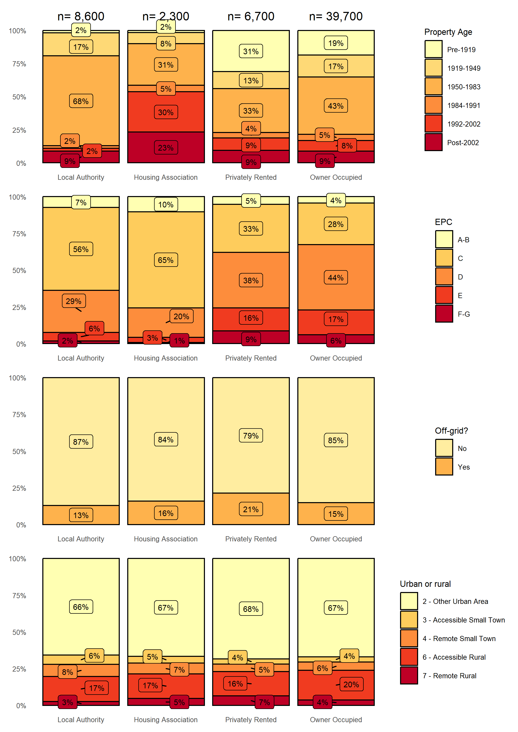
Note, for clarity, percentages rounded to nearest integer and counts rounded to nearest hundred
EPC ratings include a number of other factors in addition to a property’s demand for heat. Isolating the heating demand of properties allows an understanding of the existing heat demand and to isolate the benefit to households of energy efficiency measures from other factors which affect EPC rating. The properties have been split into bands by firstly their total requirement for heat and the heat required per m², based on what is recorded in the Home Analytics dataset, shown in Figure 3. As with EPCs, the worst performing homes are in owner occupied properties. For fuel poverty to be reduced the number of units of heat would need to be reduced (kWh/year) and heating energy demand per square metre (kWh/m²/year).
Figure 3: Domestic heating energy demand

Non-domestic Building Stock
The Non-Domestic Baseline Tool utilises data derived from Non-Domestic Analytics, which is not based entirely on concrete data collected from building owners but is, in large part, imputed from a few measured parameters. For example, the floor area of a building may be estimated from its footprint on a map and an estimated number of levels based on its height. The energy consumption may then be estimated by multiplying the estimated floor area by a benchmark figure for the building type. This can lead to errors, of course, and so analytical results should be read with caution. To gauge the relevant degree of caution, Ricardo compared the top ten gas-consuming sites in South Ayrshire Council’s portfolio with the corresponding entries in the dataset. Non-Domestic Analytics underestimated the demand of all ten sites by between 36 and 94 %. This indicates that the data may not be strong in identifying the correct energy demand.
Nevertheless, the data has been used for the baselining step of the LHEES process to get a flavour of the building stock. The Non-Domestic Baseline Tool records 4,135 non-domestic buildings in South Ayrshire. Together, these have an estimated total heat demand of 150,000 MWh/y.
Figure 4 shows the aggregated heat demand for different energy sources. Gas is the biggest source of heat but electricity is close behind and, along with oil, they have the largest share of small heat loads. Smaller buildings account for almost half of the total heat demand (Figure 5) and targeting those small oil systems, which would not individually be expensive, for heat pump or heat network connection could be a priority. It is likely that the small properties utilising electricity are already using heat pumps for heating and cooling.
Figure 4: Non-domestic heat demand by energy source and demand category
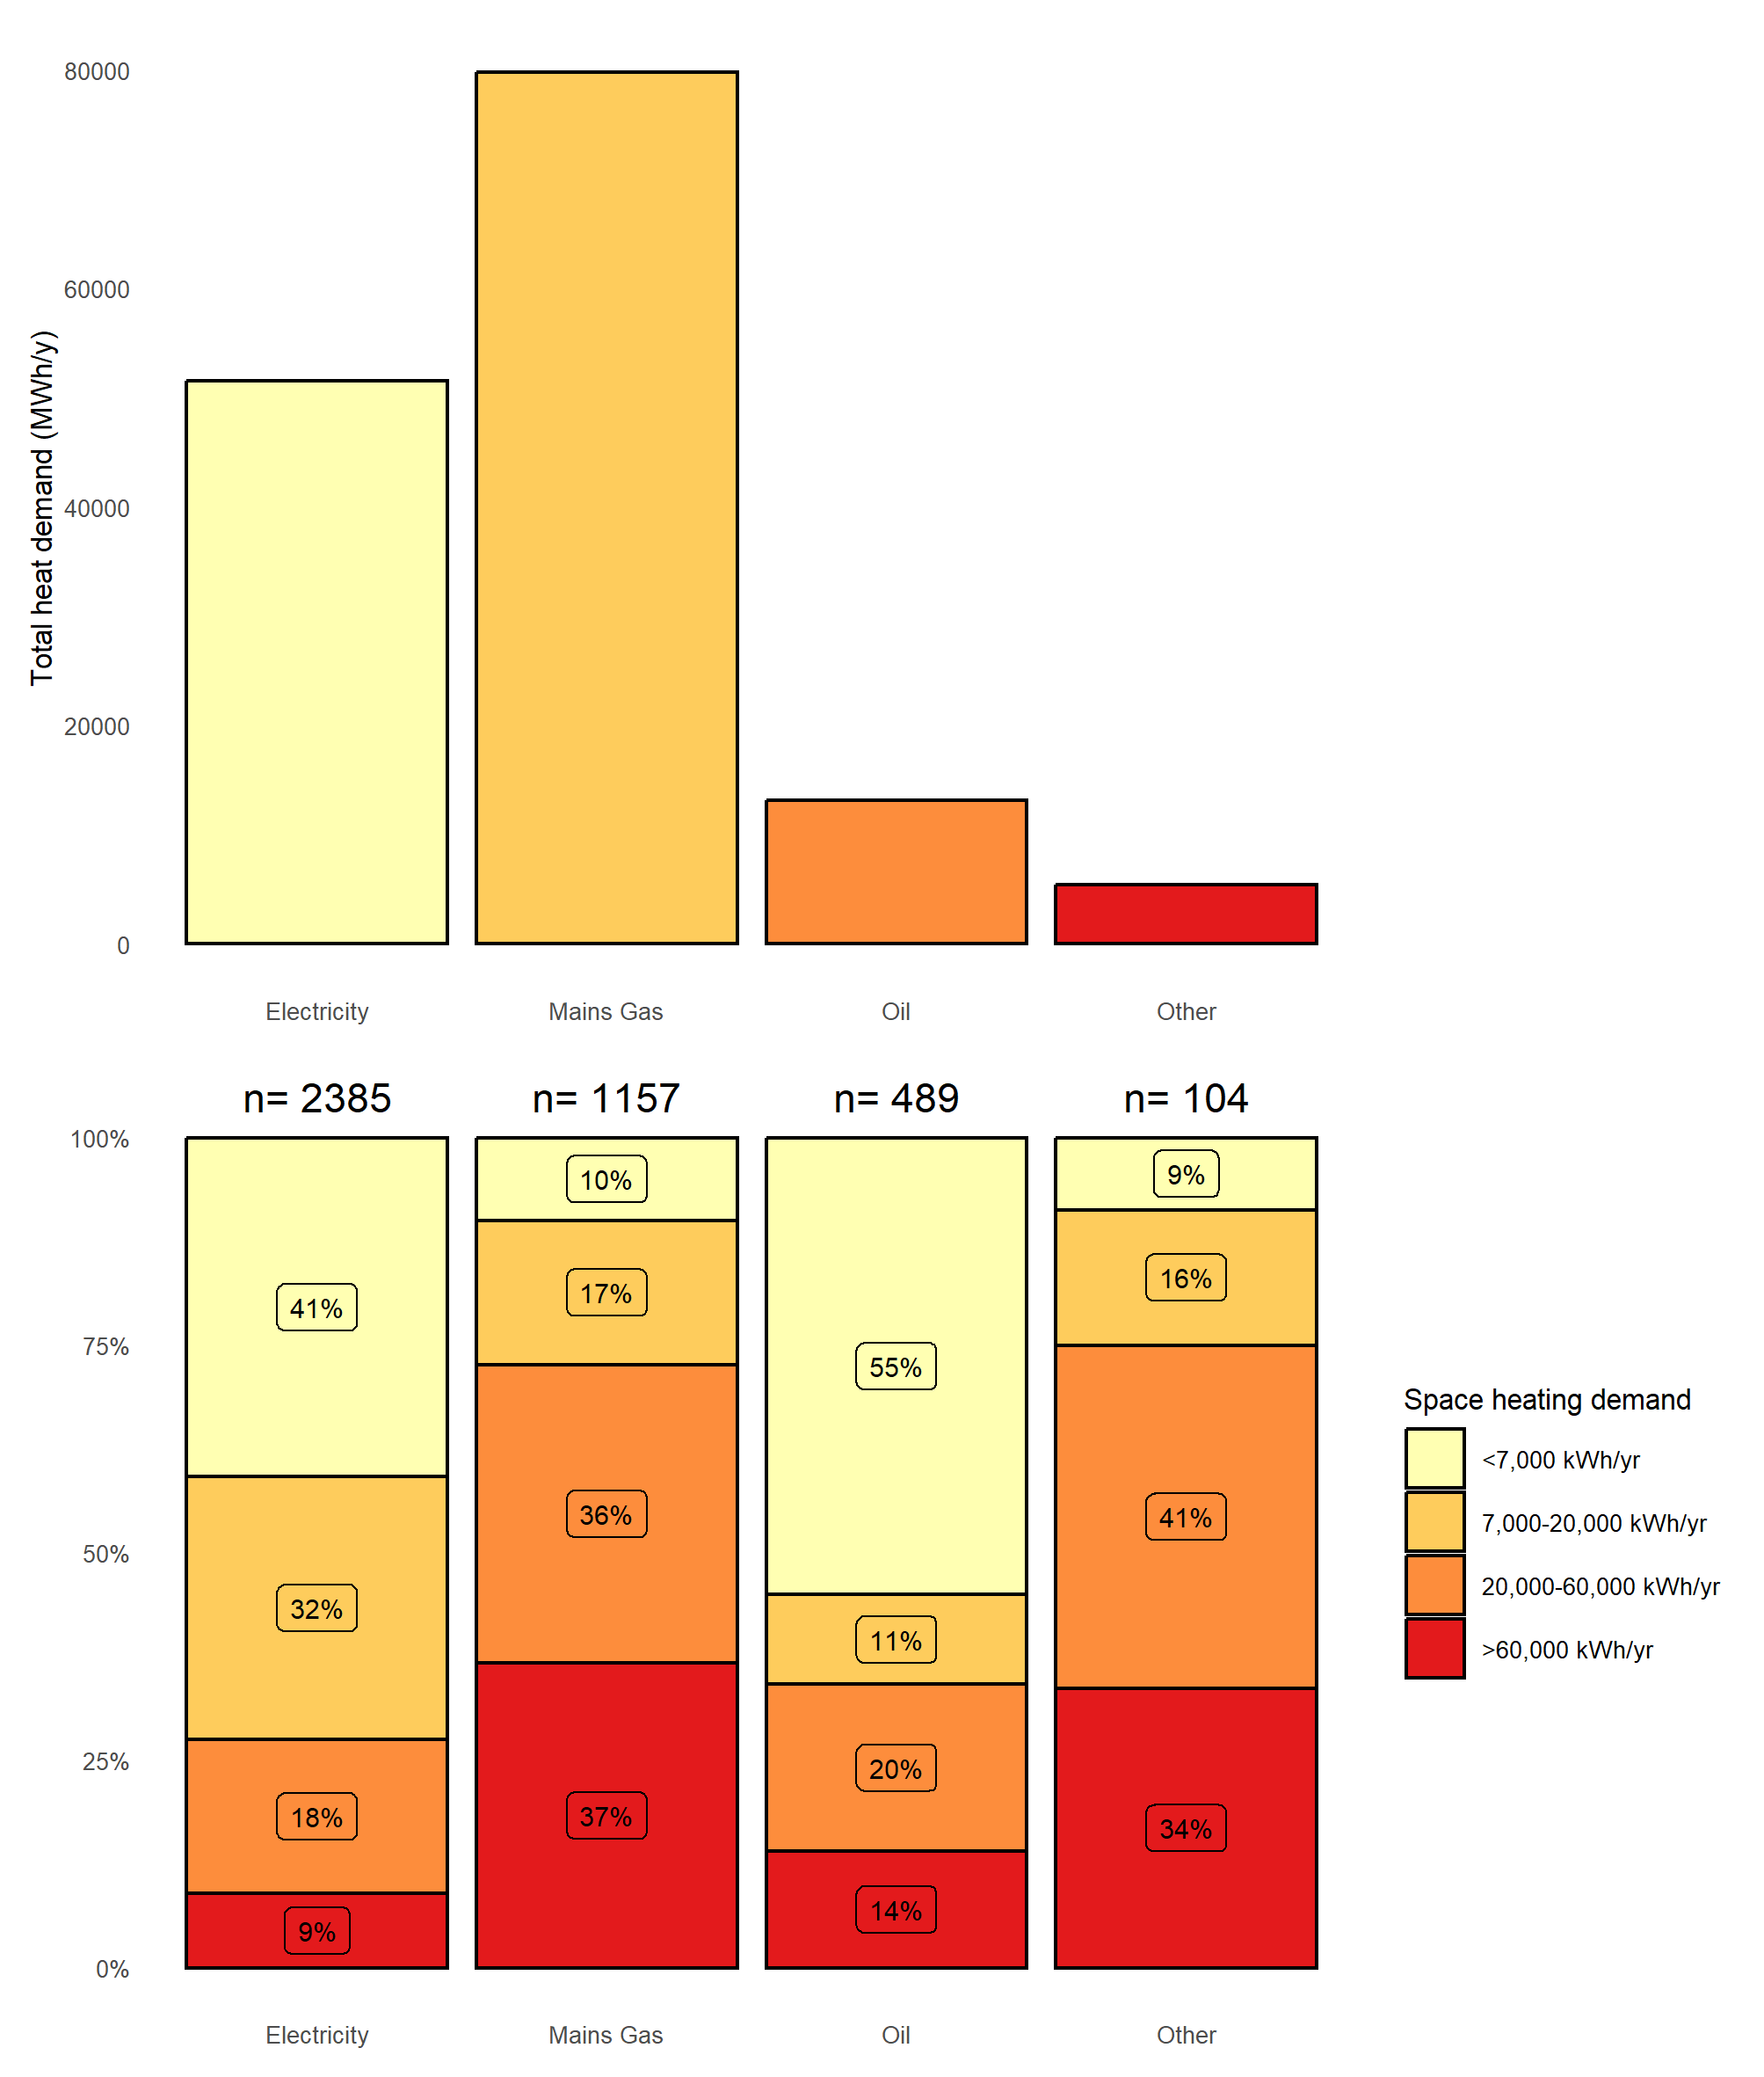
Note, for clarity, percentages rounded to nearest integer and counts rounded to nearest hundred
Figure 5: Non-domestic heat demand by energy source and floor area category
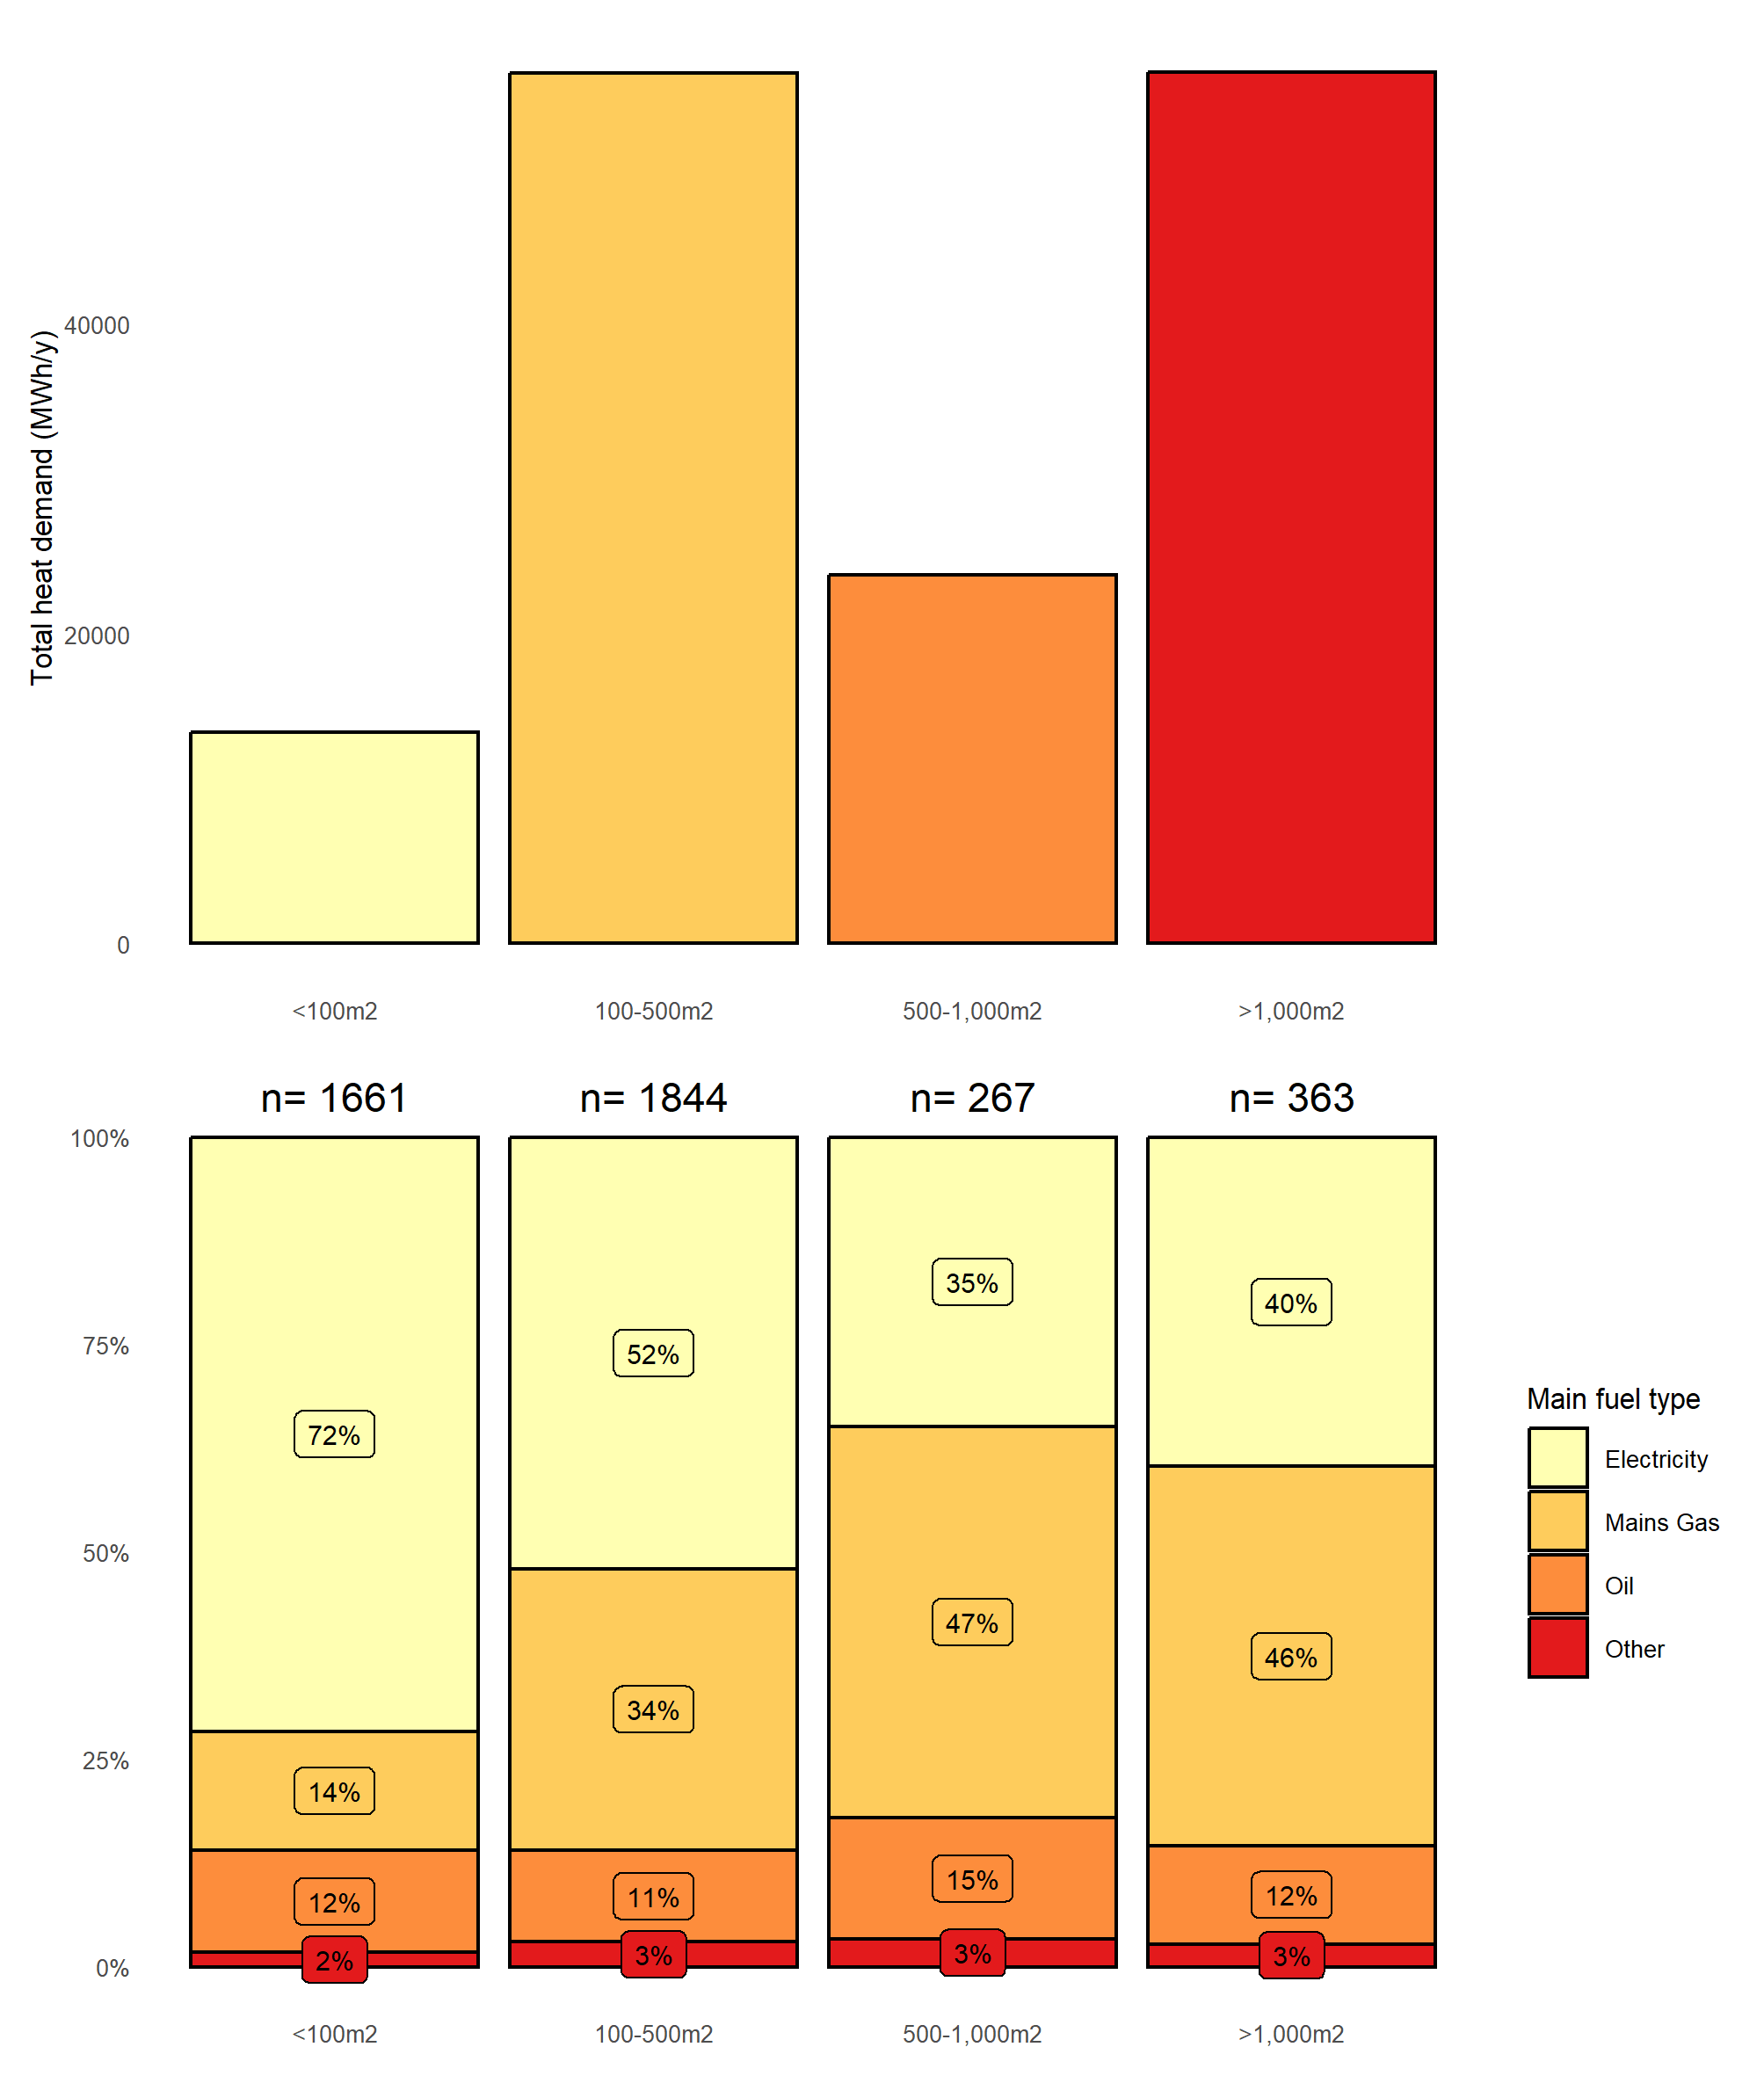
Note, for clarity, percentages rounded to nearest integer and counts rounded to nearest hundred

The pattern of building age (Figure 6) shows a large proportion of pre-1919 buildings with a high heat demand and this group of properties may be a target for energy efficiency measures. The data lists 55 % of these pre-1919 buildings as being retail or financial and 79 % as being in towns and cities, so presumably these are typical high street properties.
Figure 6: Non-domestic heat demand by energy source and building age category
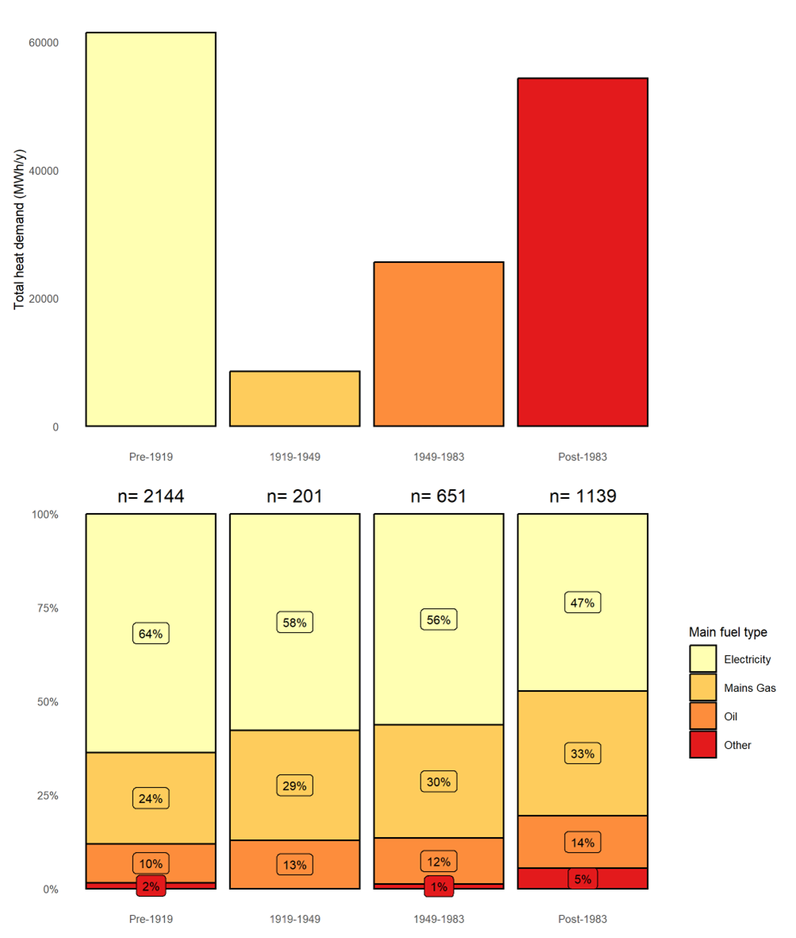
Note, for clarity, percentages rounded to nearest integer and counts rounded to nearest hundred

Generally, non-domestic heating energy demand is dominated by the retail and finance sector (Figure 7).
Figure 7: Non-domestic building type by heat demand
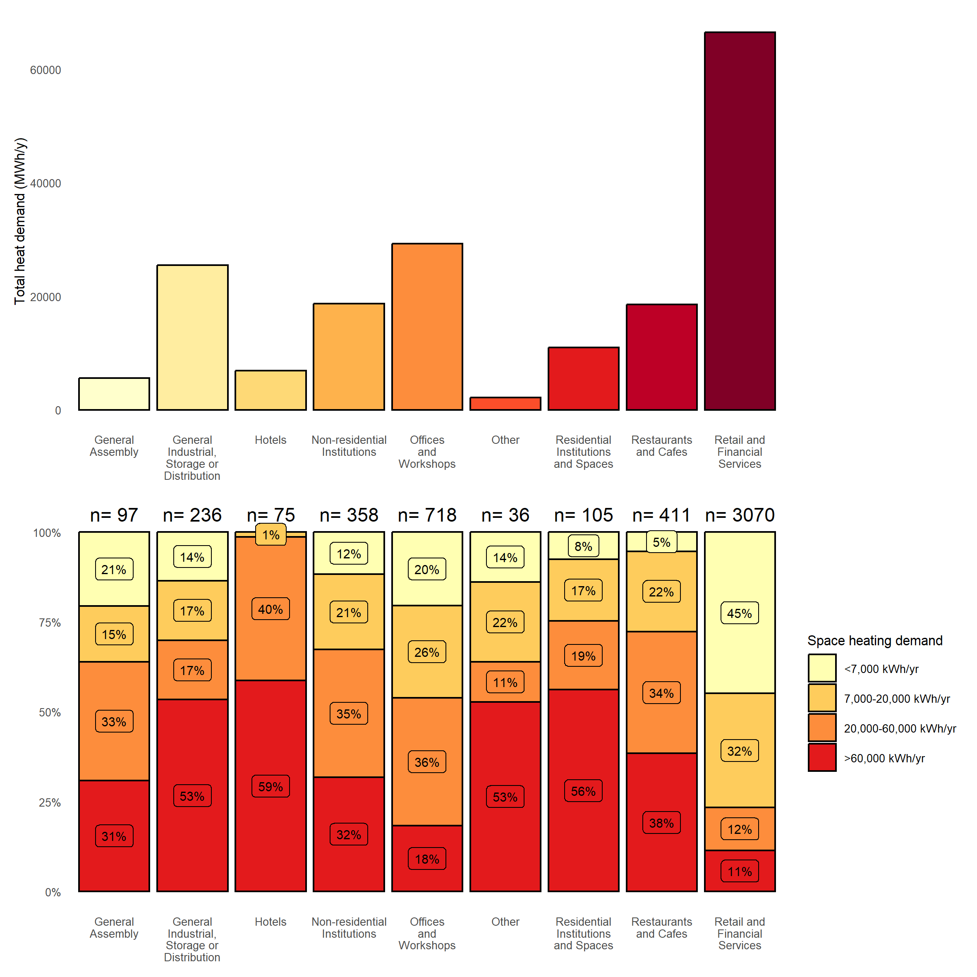
Note, for clarity, percentages rounded to nearest integer and counts rounded to nearest hundred

Generation of Strategic Zones and Pathways, Including Potential Zones for Heat Networks

Purpose
The LHEES Guidance requires the Council to set out Strategic Zones and develop a pathway for each. In this section the approach to selecting Strategic Zones is described, as well as the attributes for each which affect the strategic options.

Local Development Plan Areas as LHEES Strategic Zones
The standard methodology for LHEES generates ranked lists of places (“Intermediate” geographical zones) with the “poorest performing” homes with respect to the Indicators (see Appendix IAppendix C) and thus generates targets for intervention. This analysis is presented in Appendix A.
However, it is also possible to examine the data by South Ayrshire’s own Local Development Plan boundaries and this is more appropriate for planning the delivery of LHEES actions. These zones are mapped out in Figure 8.
Figure 8: South Ayrshire’s Strategic Zones
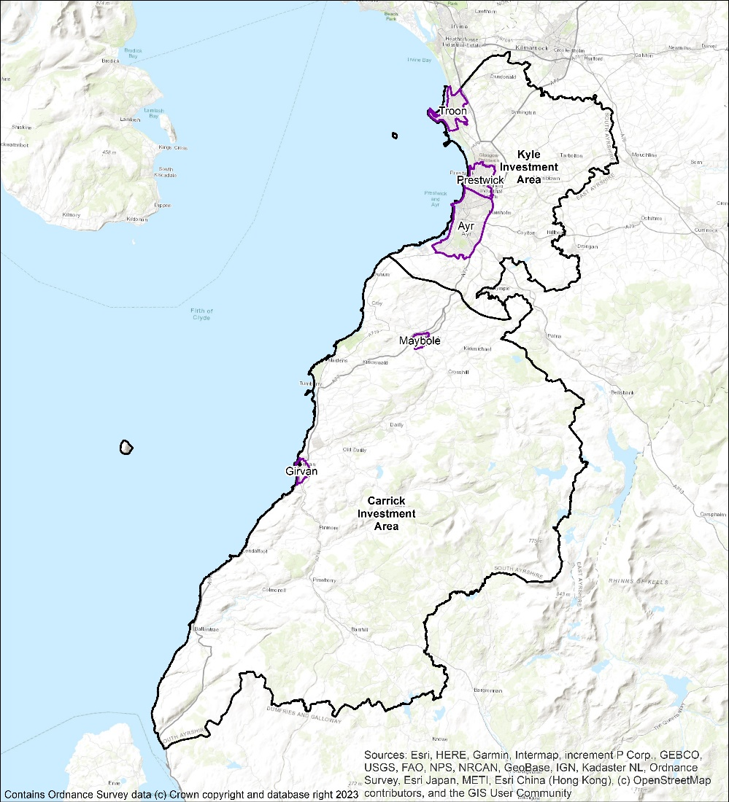

Domestic Properties and Tenure
The numbers of domestic properties in the Home Analytics dataset, broken down by Zone and tenure are given in Table 5.
Table 5: Domestic properties in the Strategic Zones
Zone | Total domestic properties | Tenure |  |  |  | Mixed tenure in parent building
 |  | SAC | Housing Association | Private Rental | Owner Occupied
Carrick | 3,800 | 470 | 170 | 660 | 2,500 | 214
Kyle | 8,100 | 1,050 | 320 | 800 | 5,930 | 409
Ayr | 24,200 | 4,210 | 1,150 | 2,940 | 15,900 | 5,232
Girvan | 3,400 | 700 | 170 | 330 | 2,200 | 414
Maybole | 2,300 | 520 | 110 | 240 | 1,450 | 311
Prestwick | 7,400 | 680 | 210 | 770 | 5,740 | 908
Troon | 8,000 | 930 | 210 | 940 | 5,920 | 1,647

A baseline assessment of these properties by area, similar to that in 6.1.1, is shown in Figure 9.
Figure 9: Baselining of domestic properties in the Strategic Zones
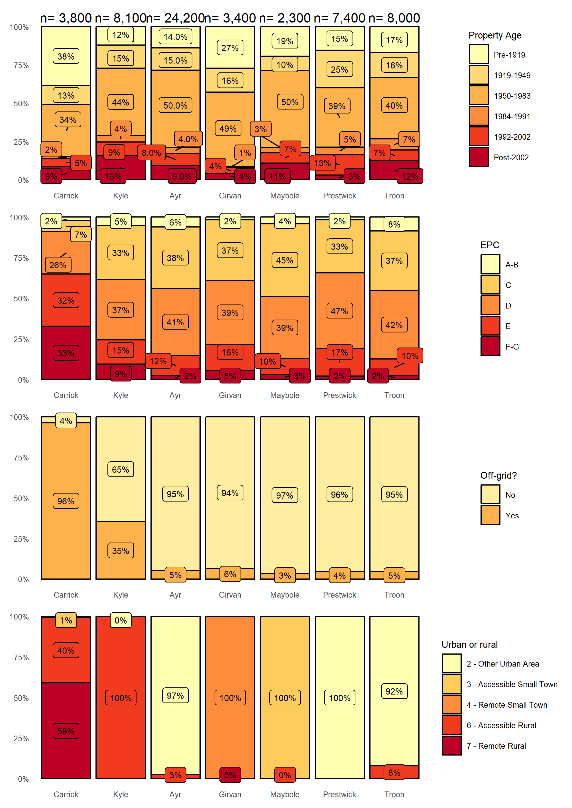
Note, for clarity, percentages rounded to nearest integer and counts rounded to nearest hundred

Domestic Energy Efficiency
The Weighted Scores for energy efficiency (Table 6) for the strategic zones, using the default weightings as discussed in Appendix I have been calculated. Carrick stands out with respect to the weighted scores, while wall insulation is a key requirement across all zones.
Table 6: Domestic energy efficiency weighted scores by strategic zone
Strategic Zone | Number of interventions required |  |  |  | Percentage of housing stock |  |  |  | Total Weighted Score
 | Loft Ins. | Glazing Upgrade | Wall Ins. | All | Loft Ins. | Glazing Upgrade | Wall Ins. | All
Carrick | 819 | 373 | 2,159 | 3,351 | 21 % | 10 % | 56 % | 87 % | 29
Kyle | 801 | 375 | 2,500 | 3,676 | 10 % | 5 % | 31 % | 45 % | 15
Ayr | 2,147 | 1,488 | 8,552 | 12,187 | 9 % | 6 % | 35 % | 50 % | 17
Girvan | 497 | 191 | 1,418 | 2,106 | 14 % | 6 % | 41 % | 61 % | 20
Maybole | 250 | 133 | 954 | 1,337 | 11 % | 6 % | 42 % | 58 % | 20
Prestwick | 955 | 310 | 3,278 | 4,543 | 13 % | 4 % | 44 % | 61 % | 20
Troon | 709 | 290 | 3,225 | 4,224 | 9 % | 4 % | 40 % | 53 % | 18
Total | 6,178 | 3,160 | 54,180 | 14,386

The three suggested interventions broken down by strategic zone and tenure are shown in Figure 10. Much of the Home Analytics data is implied from other observations (wall construction type, for example) where there is no direct observation of a feature (wall insulation, for example) and this may mislead. A target for the LHEES strategy must be to improve the quality of the data used for decision-making and this may be done in tandem with the Scottish Government to improve the Home Analytics dataset.
Notwithstanding the question over data confidence, it appears that, as noted in 6.1.1, the private sector is the key sector for targeting support for improvements.
The biggest burden of potential interventions, according to Table 6, is wall insulation. Figure 11 shows that, in owner occupied homes, while there is a reasonable proportion of homes with solid walls which are hard to insulate, the most common construction type in every strategic zone is cavity walls, which should not hinder improved insulation.
Also in the private sector, 1,069 homes with single glazing are either listed or sit in conservation areas and, consequently, barriers to upgrades may be more than just financial.
There should be limited barriers to installing loft insulation to owner occupied and privately rented homes, since it is both cheap and usually easy to install.

Figure 10: Domestic properties requiring upgrades to glazing, and loft and wall insulation
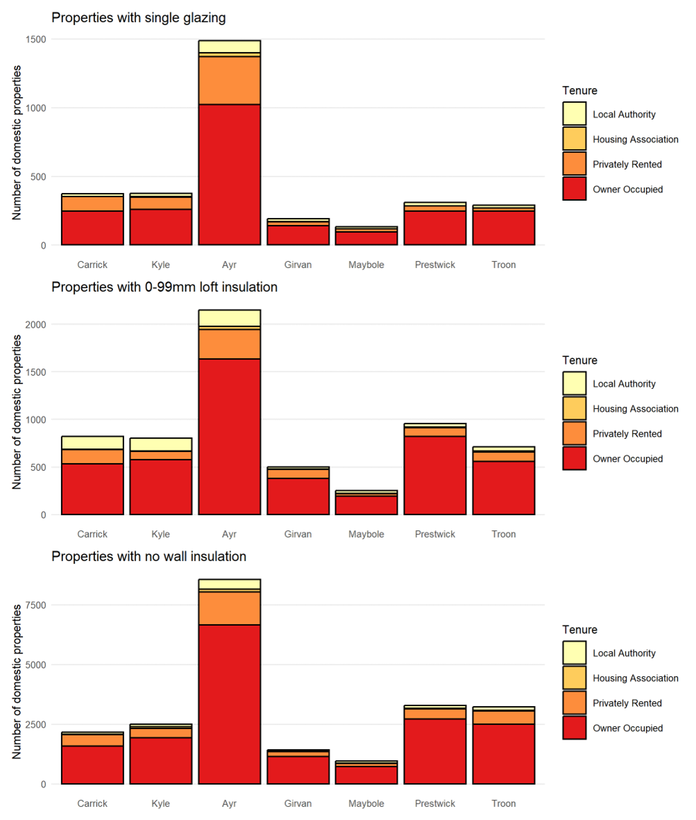
Figure 11: Wall construction in privately rented and owner-occupied houses
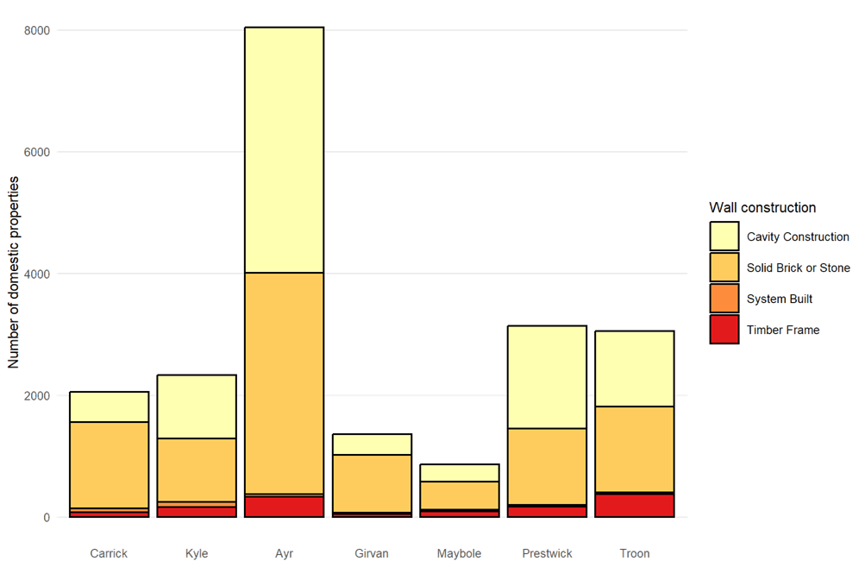

Table 7 shows the breakdown of the effect the energy efficiency interventions have on reducing energy demand across all the South Ayrshire building stock. For reference the baseline heat demand per year for the domestic buildings in South Ayrshire Council is 835,000,000 kWh. This data helps to identify which measures are the most effective way to reduce heating demand, helping both fuel poverty and heat decarbonisation. Loft insulation upgrades is by far the lowest cost method to reduce heating demands. On the other hand, installing external wall insulation on the outside of buildings that already have cavity or internal wall insulation is deemed as the least cost-effective way to reduce heat demand. However, there may be other reasons for doing less cost-effective measures, such as funding streams being allocated only to specific measures or improving the aesthetics of the building with external wall insulation or window upgrades.
Table 7: Summary of energy efficiency interventions across all buildings in South Ayrshire
Measure | Heat Demand Reduction (kWh/y) | Fuel Savings per Investment Cost
Cavity Wall Insulation (CWI) | 40,800,000 | 0.220
Internal Wall Insulation (IWI) | 3,400,000 | 0.113
External Wall Insulation (only wall measure) | 37,800,000 | 0.079
External Wall Insulation (alongside CWI or IWI) | 78,400,000 | 0.023
All wall insulation measures | 160,400,000 | 0.040
Loft insulation upgrade from <100mm | 26,300,000 | 1.003
Loft insulation upgrade from 100-250mm | 64,800,000 | 0.529
Loft insulation upgrade from 250-300mm | 90,500,000 | 0.227
All loft insulation measures | 181,700,000 | 0.430
All Single to Double Glazing upgrade | 6,600,000 | 0.064
Cylinder insulation upgrade from <50mm | 14,500,000 | 0.216
Cylinder insulation upgrade from 50-80mm | 2,000,000 | 0.110
All cylinder insulation measures | 16,600,000 | 0.192
All Combined Measures | 365,300,000 | 0.062

Domestic Energy Efficiency and Fuel Poverty
The Weighted Scores for fuel poverty as a results of poor energy efficiency for the strategic zones, using the default weightings have been calculated for the Strategic Zones (Table 8).
Carrick and Girvan stand out above the others and the interventions discussed in 7.4 will reduce the scores.
Table 8: Domestic fuel poverty scores by strategic zone
Strategic Zone | Households with energy bills > 10% of income after housing costs | Households with energy bills > 20% of income after housing costs | Total Weighted Score
Carrick | 34 % | 43 % | 31
Kyle | 21 % | 7 % | 18
Ayr | 22 % | 9 % | 19
Girvan | 33 % | 21 % | 27
Maybole | 27 % | 15 % | 23
Prestwick | 18 % | 4 % | 19
Troon | 19 % | 4 % | 18

Heat Network Zoning

Approach
The principal determining factors for the feasibility of heat networks are the heat density in an area and the presence of one or more “anchor loads” – loads which are large, stable and likely to connect.
To assess these factors, the Scottish Heat Map data was supplemented with data from the Council on fuel consumption within their estate. A data validation exercise was carried out to remove any duplicate points, heat demands which were uncertain (calculation code 1 in Scottish heat map data), dubious heat loads (e.g., too large for the building size or type) and buildings in sectors less likely to enter into commercial agreements. The purpose of this was to ensure that areas identified have as high a chance of being developed as possible.
The maps presented illustrate the heat demand density of buildings and highlight the possible anchor loads with the addition of other data including local authority-owned properties, potential sources of heat and areas of future development.
Where areas were shown to be viable, additional checks were carried out on the anchor heat loads and any loads considered erroneous were removed from the analysis. This included a number of industrial buildings where the heat required for space heating had been estimated to be very high and a number of instances of heat demands being double counted.
The purpose of this data cleaning is to maximise the likelihood that areas identified in this analysis would make viable heat networks.
Further validation of both the actual heat demands of the buildings and their suitability for connection to heat networks would be important before deciding on future heat network areas.
The linear heat density method was used – this involves drawing a circle around each building the diameter of which is proportional to the heat load of the property. Two measures of heat network viability were used:
- A baseline scenario (purple shades throughout this analysis) using 4,000 kWh/y/m where the circle around each property (in kWh) is divided by 4,000 to give a radius in metres around the property; and
- A stringent scenario (green shades throughout this analysis) using 8,000 kWh/y/m where the radius of the circle is the heat load in kWh divided by 8,000.
The 4,000 kWh/y/m measure highlights more areas as being potentially suitable and the 8,000 kWh/y/m shows fewer areas, but those areas have a higher chance of forming a successful heat network.
Measures of more than 8,000 kWh/y/m were not considered due to a lack of areas with suitable heat density – this is consistent with South Ayrshire not having any dense urban areas. There were no areas identified using 16,000 kWh/y/m or higher.
Finally, the areas were filtered based on whether a continuous area could be formed where the circles around each heat load formed, which enclosed heat loads totalling 15,000 MWh/y or more.
This heat load represents a 3 MW heat source operating for 5,000 full load equivalent hours per year. The purpose is to identify those areas where it is likely that there is sufficient heat load to warrant a new energy centre being constructed. This is intended only as a guide and the exact cost of each energy centre and network would need to be calculated at feasibility stage.

South Ayrshire Council Overview
An analysis of the potential for heat network zones indicates that there are broadly two areas where heat networks may be viable – within Ayr and an industrial cluster near Girvan.
Within Ayr there are three separate zones identified, however, this strategy considers them in the context of a single heat network strategy for Ayr rather than considering them three discrete opportunities.
Figure 12: South Ayrshire overview of potential heat network zones
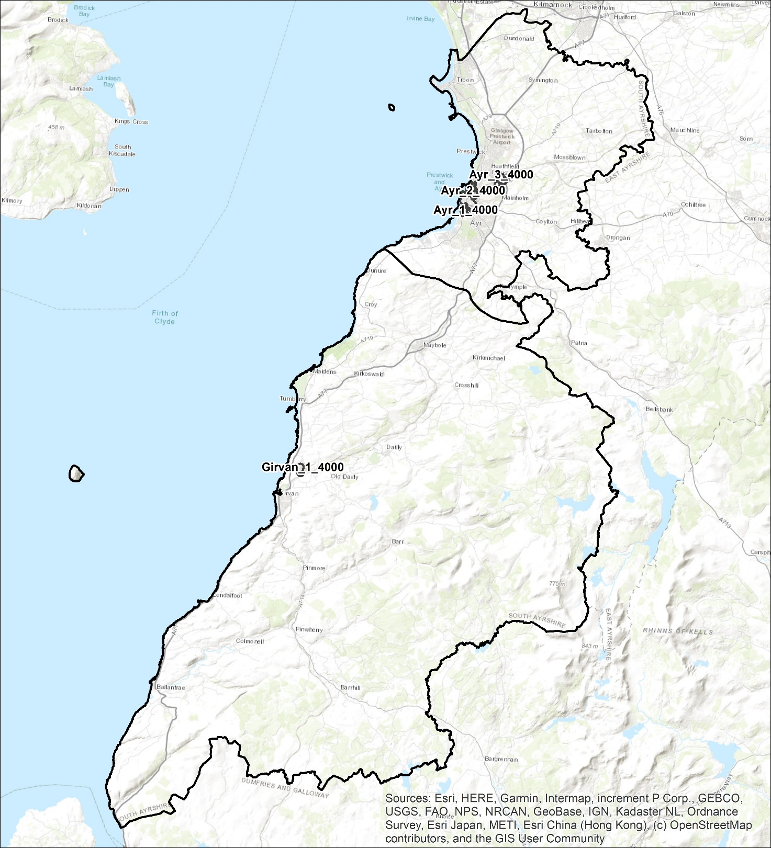

Ayr
The analysis shows that there is a cluster of properties in the town centre, South of the river, which could be considered an area for district heating (Figure 13). This area has both sufficient total load to consider constructing a new network and associated infrastructure, as well as a number of anchor loads including Council owned buildings.
North of the river, there is a heat network area which could be connected to the town centre by one of the bridges crossing the river to form a single heat network opportunity. The business strategy areas highlighted in a red outline are also in this zone and the third to the North East. The Council will coordinate between business and any other party on any actions being planned in this area so that it can be considered as part of any future heat network feasibility study.
A cluster of industrial buildings, Ayr_3_4000. This differs from the town centre areas as there is a less diverse range of tenures and building types and therefore close coordination with businesses is going to be important when considering any heat network development.
Figure 13: Ayr heat network opportunity – Baseline
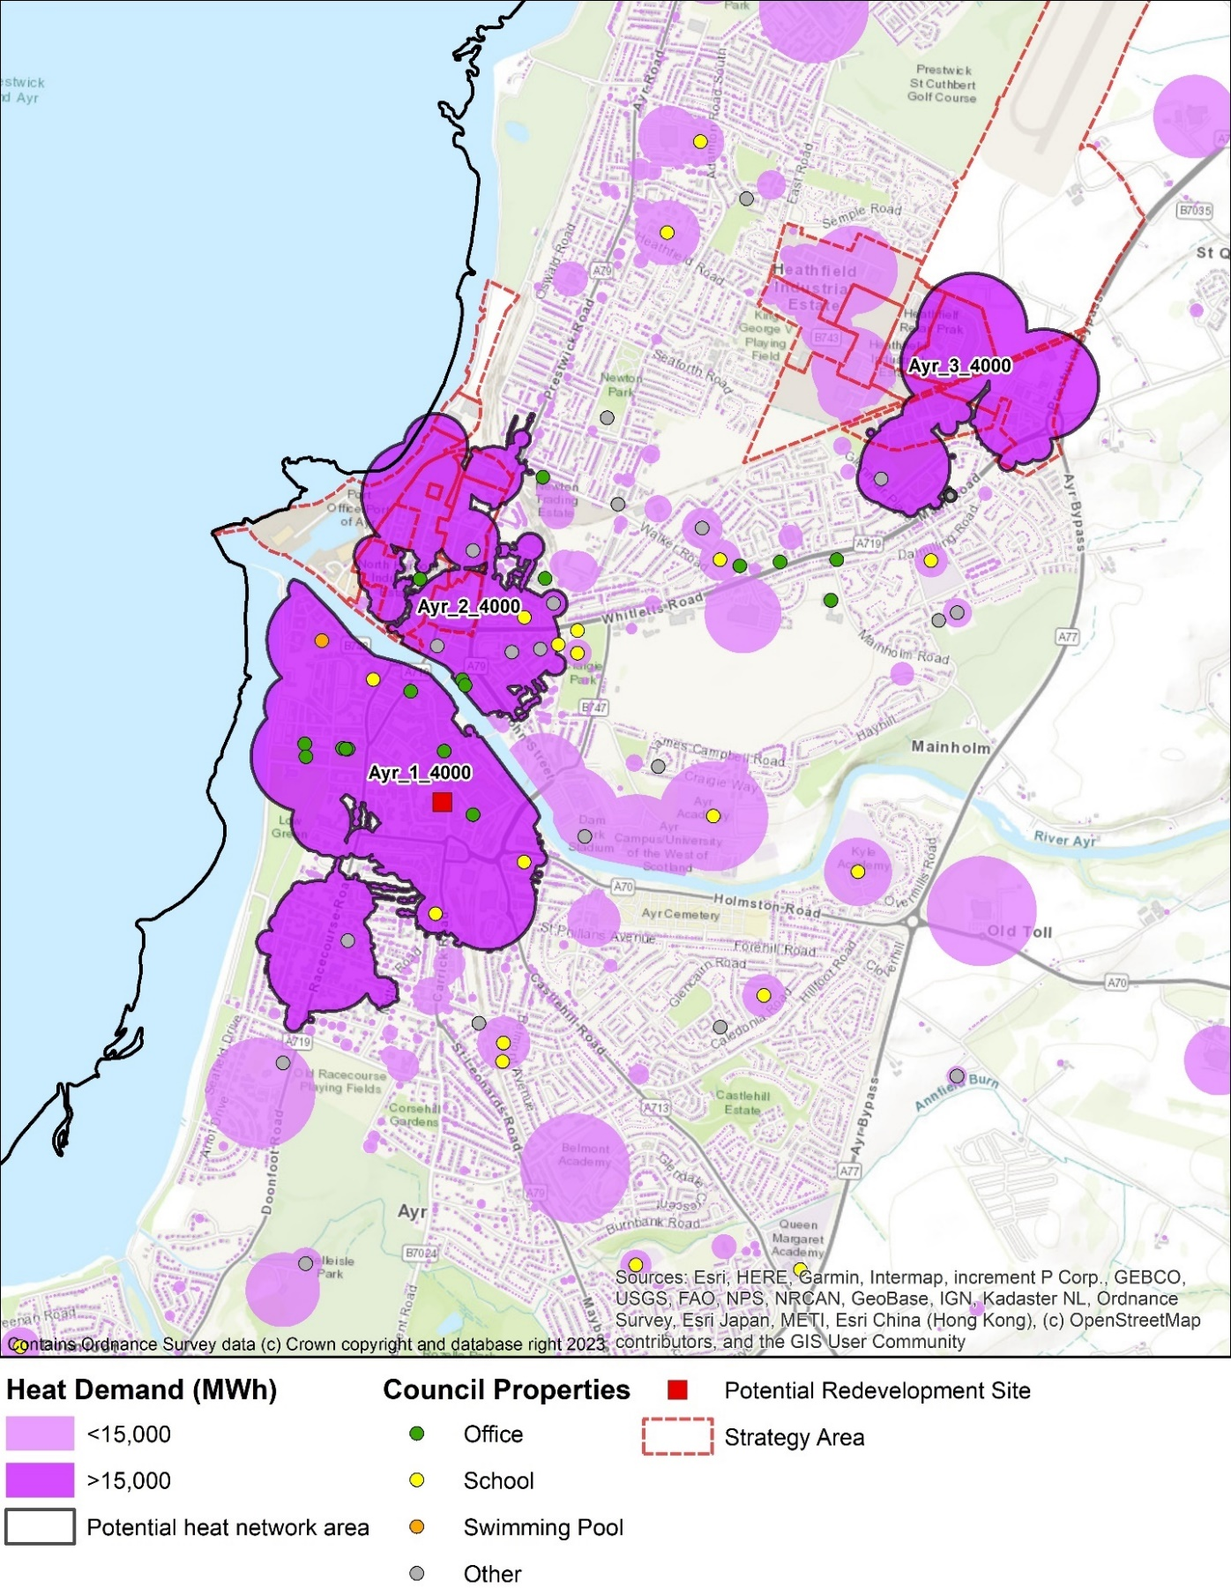
The Ayr_3_4000 zone is also close to the Prestwick airport site. The Council will coordinate with stakeholders about any future opportunity for heat networks to serve the users of heat on this site.
The town centre also contains a large number of listed buildings and a conservation area.
There are additional barriers to decarbonising historic buildings and a heat network could minimise the need for changes to the buildings while ensuring they are decarbonised. Heat networks avoid the need for significant heating plant to be located at each building.
More detailed investigation of each building is important to identify what the opportunities and constraints are for each specific building. Specific attention needs to be paid to:
- whether the existing heating system in the building is likely to be compatible with district heating
- the location of the existing heating plant the route to connect this to the district heating network
- protected attributes of the building and its surroundings
Figure 14 Listed buildings and conservation areas
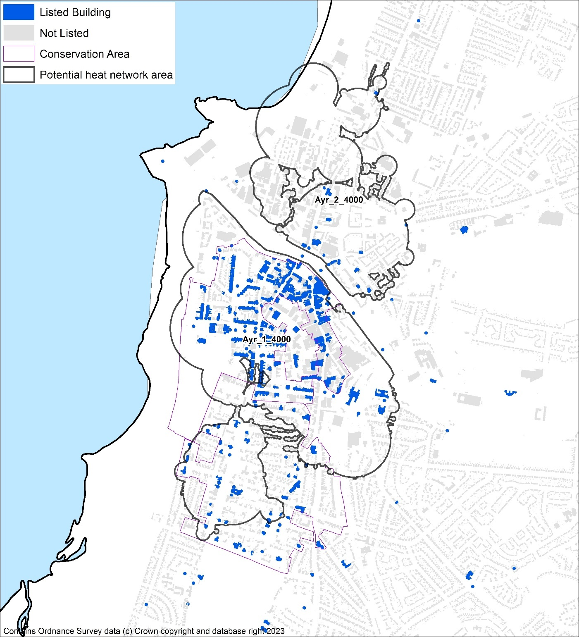

Girvan industrial cluster
An industrial cluster was identified to the North of Girvan which includes a substantial use of industrial energy including heat. This site has complex energy flows and houses both a Biomass CHP and a substantial anaerobic digestion site and involves a number of industrial businesses. However, a heat network feasibility study determined that there are not currently significant heat demands sufficiently close to the site to allow a district heating scheme to be developed. If significant future developments were to be planned near the site then the opportunity for heat networking could be revisited and local plan zoning may be a lever to influence this. The feasibility study may be revisited in the future.
Figure 15 Girvan industrial heat cluster
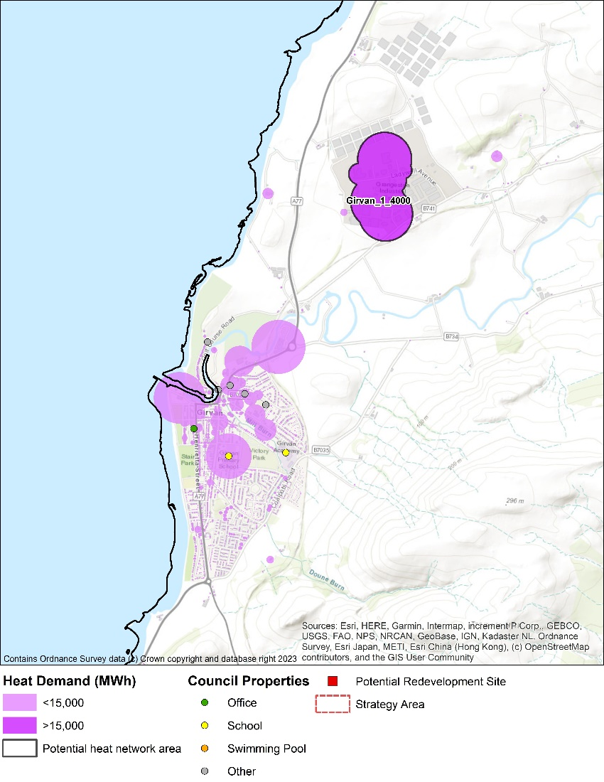
It is not within the scope of LHEES to consider other energy vectors, however, the site is in close proximity to the transport corridor containing the A77 connecting the Central Belt of Scotland to the ferry ports of Cairnryan and Larne.
As such, there could be a substantial road transport fuel demand in this area and the site and its energy flows should be considered as part of any future low carbon transport fuels for the area.

Low carbon heat – other than heat networks
For the majority of properties in South Ayrshire it does not appear that large heat networks will be a viable low carbon heat option. There are a range of other low carbon heating technologies which may be suitable and are discussed below.

Low carbon heating technologies
A list of technologies is outlined in section Table 3.
Each property owner will make decisions on the technology which is suitable for their property. This analysis seeks to predict what will be found to be the most suitable technology and for which property. While heat pumps are likely to be the most suitable heating system (7.7.3), technologies such as electric heating and biomass will be appropriate to some specific properties and other technologies such as hydrogen should not be ruled out entirely at this stage, as they may have a role to play in future LHEES iterations.

Individual or communal heat pump systems
It is possible for a single dwelling to have its own heating system, for a whole building to have a single heat pump system or for many buildings to be connected together into district heating schemes.
This Strategy considers communal heat pump systems – both where a single heat pump heats a whole building or where a network of heat pumps share a single heat source, sometimes referred to as a 5th generation heat network, as having similar energy efficiency requirements as individual heat pump systems. Therefore, they are considered as a single grouping for the purposes of this Strategy
In practice, whether it is practical to install an air source or ground source heat pump in a flat depends upon a number of site specific factors including space available, noise, visual impact and other planning restrictions. Conversely for a communal system to be installed the agreement of multiple property owners may be required which is complex.
Similarly, each property owner can decide to make their own compromises between installation cost, disruption and operating cost. It is usually possible to achieve lower operating costs by using larger radiators. For the purpose of this Strategy a property has been deemed suitable for an individual or communal heat pump system if it is likely to be possible to achieve a good operating efficiency.
Higher temperature heat pumps can be used which remove some practical limitations such as using a shared heating/hot water system to avoid each property needing a hot water cylinder. However, there is a trade-off as they have lower efficiencies (lower COP) and therefore are considered as one of a number of alternative solutions which we have grouped together as “other”.

Assessing suitability for heat pumps
This section estimates how many properties in South Ayrshire would be suitable for heat pumps. Every property would have to have a more detailed assessment to confirm if it was indeed suitable, though there is not an agreed benchmark for assessing the suitability of each property for heat pumps in domestic properties.
Properties suitable without further upgrades
In practice, the limiting factor as to whether a low temperature heat pump could be used for space heating is a sufficiency of space to have radiators which are big enough to heat each room at the low radiator temperatures desired for efficient heat pump operation. The DESNZ Electrification of Heat Demonstration project report, conducted by Energy Systems Catapult, concluded:
“The project has not identified any particular type or age of property that cannot have a successful heat pump installation. The suggestion that there are particular home archetypes in Britain that are “unsuitable” for heat pumps is not supported by project experience and data.”
However, in practice, properties with high heat demand per square meter (low energy efficiency) are more likely to be challenging to install a low temperature heat pump and achieve adequate operating costs. High temperature heat pumps can be used but have higher running costs than low temperature heat pumps.
For the purposes of this Strategy, therefore, the criterion for the suitability of optimally-efficient individual heat pumps is that the property must have a predicted heat demand per floor area of less than 160 kWh/year/m² which equates to approximately 3 W/m²K and 2,200 heating degree days or approximately 75 W/m² of peak heat demand. In reality, this is conservative and some homes which do not meet this criterion do already have heat pumps installed, highlighting their flexibility, even if it is difficult to get a low cost of heat with such systems.
Of the circa 58,000 domestic properties in South Ayrshire, 28,445 could be suitable already for new heat pumps installations, as shown in Table 9, according to this criterion.
With additional energy efficiency measures
In completing the more cost-effective energy efficiency measures, the number of heat pump suitable properties increases to over half across the local authority. The reduction in heating demand from those energy efficiency improvements has the added benefit of not only reducing the cost of heating, but also in reducing the size of the heat pump and reducing the requirement for radiator or electricity connection upgrades.
Going a step further and completing additional energy efficiency measures which are not as cost-effective, such as external wall insulation on properties with cavity wall insulation, allows a further 5,000 properties to be classed as suitable for heat pumps by these measures.
Other factors limiting suitability
Another criterion is also considered to allow for standard domestic heat pumps operating on a single-phase power supply. Domestic heat pumps are typically limited to 15 kW thermal power in a single unit on single phase electricity, which will equate to approximately 35,000 kWh/y of heat demand. With both factors considered together, Table 9 shows the overall number of properties that are currently suitable for heat pumps.
Using these criteria can then help identify and target specific properties that are most in need of additional energy efficiency upgrades, including those which are not as cost-effective.
There are other challenges with locating heat pumps, such as finding a suitable location on the outside of flats or installing hot water cylinders in properties without cylinders.
There are a number of types of heat pumps available, including air, ground, water source heat pumps, shared loop heat pumps, also known as 5th generation heat networks, as well as those which distribute heat through water-based heating systems and those which heat air directly. While most installations are currently air-to-water heat pumps, other types of heat pumps could be chosen, and this Strategy does not determine which type of heat pump is most viable for individual buildings. Shared loop heat pump systems and larger heat pump systems distributing heat through a communal heating system in a building can be more suitable for flats, where locating a heat pump and hot water cylinder in or on each property is challenging.
Table 9: Heat pump suitability
Heat Pump Suitability | Currently | Cost effective energy efficiency measures <160kWh/m²/y | All energy efficiency measures <160kWh/m²/y
No. of Properties <160kWh/m²/y | 28,445 | 37,708 | 42,647
No. of Properties <35,000kWh/y | 56,776 | 57,592 | 57,641
<160kWh/m²/y and <35,000kWh/y | 28,441 | 37,707 | 42,646

This leaves around 15,000 properties less likely to be suitable for heat pumps, according to these rules of thumb, but there are other options A building-by-building assessment may find other ways to improve the feasibility of heat pumps, such as other energy efficiency measures beyond the standard windows, walls and loft upgrades considered so far.
In the lowest demand properties electric heating is an option for providing low carbon heat where the total cost of heat is consistent with fuel poverty targets.
In larger properties which are not considered suitable in this Strategy due to the capacity of heating they require, there are several possible low carbon heating solutions. Biomass boilers or heating system consisting of a combination of a heat pump and a backup heat source. In places where the electricity connection allows it may be possible to install multiple heat pumps or a 3-phase heat pump, however this is more likely to incur additional charges for electricity connection upgrades and need to be treated on a case-by-case basis beyond the scope of this Strategy.
Hard to treat properties which already have heat pumps
While this Strategy considers properties to be likely suitable for a heat pump based on the criteria above, properties which do not meet these criteria may still be suitable for a heat pump system but the challenges involved in designing and installing the system will be greater and the costs of doing so are likely to be higher.
There are 182 properties which already have a heat pump, have a heat demand over 160kWh/m the data is based on an EPC, there are a further 53 where the data in home analytics is estimated.
This suggests that there are properties which have solved the problems associated with designing and installing heat pumps in these properties have been solved.
There may therefore be an opportunity to both learn from these installations and to increase the number or properties considered suitable in future iterations of this Strategy

Mixed Tenure, Mixed use and Historic
Listed buildings can be challenging with respect to energy efficiency improvements, the siting of, for example, air source heat pumps external to the building, and the connection to new district heating pipework.
There are around 1,350 listed domestic properties (data for non-domestic has not been provided). Only 19 % have EPCs rated C or better, with 14 % being F or G. This is less favourable than typical (Figure 2) but not extreme.
Like listed buildings, conservation areas represent a particular challenge regarding the introduction of energy efficiency measures and low carbon heat measures. For example, conservation areas are excluded from certain permitted development rights. This can result in properties requiring permission for works that may not have required planning permission if located in a different area. Conservation areas are also more likely to include traditional building types. Energy efficiency measures and low carbon heat sources tend to be more time consuming, challenging or costly to install, if they are possible at all.
The energy efficiency intervention data in Figure 10 has been revisited with a focus on properties in conservation areas- see Figure 16. There are a little over 4,600 domestic properties in conservation areas (around 8 % of the homes in South Ayrshire), with the vast majority being owner occupied.
Figure 16: Conservation area properties requiring upgrades to glazing, and loft and wall insulation
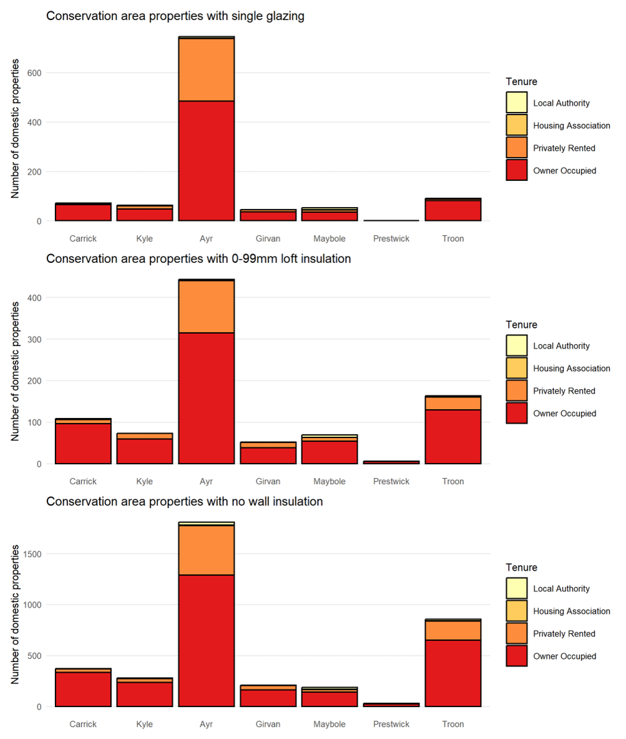
Around 1,700 domestic properties (3 %) of total are recorded as flats in mixed use buildings. The potential energy efficiency interventions for these properties are laid out in Figure 17. Almost all of these properties are owner occupied or privately rented. As with the general stock, wall insulation appears to be a big target for this typology.
Figure 17: Domestic properties in mixed use buildings requiring upgrades to glazing, and loft and wall insulation
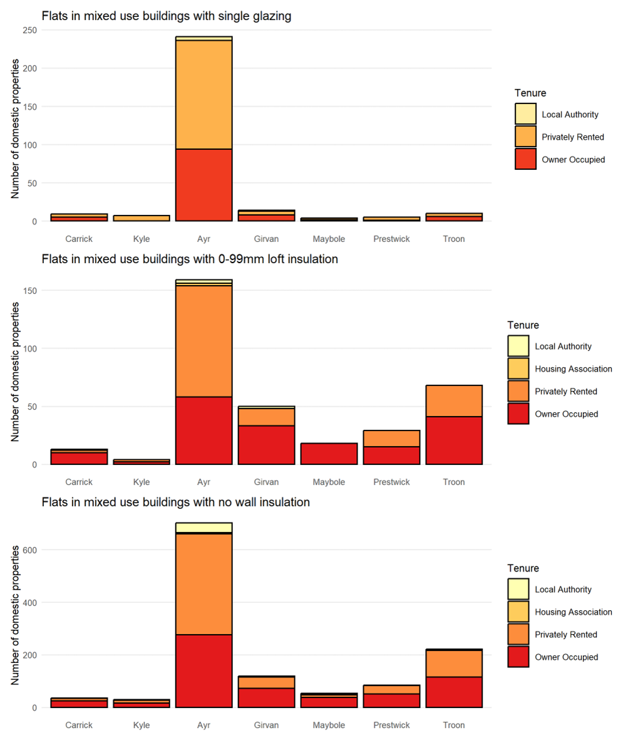

Building-Level Heat Decarbonisation
To decarbonise and reduce fuel poverty across the region Table 10 shows how each key measure can contribute to each locality.
Due to the relatively low heat demand density across most of South Ayrshire potential district heating opportunities are limited to around 9.2% of the domestic properties.
Most buildings are suitable for heat pumps after insulation measures have been considered. Many properties in a potential heat network zone may also be suitable for heat pumps.
Combining the suitability of these two measures leaves the remaining buildings which would require further investigation on the best steps forward to decarbonise them, as discussed in Section 0. Although there is a reasonable distribution of these properties across the Council, there are higher absolute numbers in the rural areas due to larger amounts of flats which are less suitable for individual heat pump installations.
Table 10: Impact of measures on domestic buildings by Locality
 | Properties | Current Heat Demand (kWh/y) | Potential Heat Network Properties | Suitable for a Heat Pump | Not Suitable for a Heat Network or Heat Pump and Not Using Biomass | Not suitable for Heat Network or Heat Pump (%)
All South Ayrshire | 57,900 | 835,034,000 | 5,304 | 43.434 | 13,386 | 23 %
Ayr | 24,400 | 334,935,000 | 5,304 | 19,040 | 4,239 | 17 %
Carrick | 3,900 | 78,227,000 | - | 2,109 | 1,811 | 46 %
Girvan | 3,500 | 51,841,000 | - | 2,483 | 985 | 28 %
Kyle | 8,300 | 123,566,000 | - | 6,051 | 2,268 | 27 %
Maybole | 2,300 | 30,381,000 | - | 1,717 | 591 | 26 %
Prestwick | 7,400 | 108,928,000 | - | 5,841 | 1,598 | 21 %
Troon | 8,100 | 107,155,000 | - | 6,193 | 1,894 | 23 %

Delivery Areas

Spatial Approach

Purpose
This section sets out how interventions could be prioritised and to identify specific areas for possible action. It considers the characteristics of the South Ayrshire buildings using a spatial approach and shows differences between areas of South Ayrshire with respect to the LHEES considerations. This approach identifies areas where delivery actions can be targeted.
Specifically, this is to allow locations to be identified for any future area-based funding mechanism. By setting out a range of metrics this allows the specific objectives of Council policy or funding scheme rules to be used to identify areas most suitable for that action.
The analysis set out in this report is conducted a higher spatial granularity than in the Strategy to allow targeting of delivery actions.

Domestic Energy Efficiency
The attributes of each home were taken from the Home Analytics data; this contains information on the construction of each building and the suitability for a range of energy efficiency measures. In order to identify areas where insulation measures have the potential to reduce heat demands and improve energy efficiency, the weightings were used as set out in Appendix I. The score for each data zone was calculated using a version of the LHEES Baseline Tool, adapted to provide outputs at Delivery Area resolution.
The Weighted Scores are distributed unevenly across South Ayrshire with higher scores indicating poorer energy efficiency and a greater potential for demand reduction (Figure 18, Figure 19 and details in Table 20 in Appendix D). There are a small number of zones with significantly worse scores, suggesting that there is value in addressing energy efficiency measures in specific geographical areas.
Clearly, those Areas with the highest scores are a priority but, amongst the top scorers, most homes are in the private sector and, therefore, not under South Ayrshire Council’s control. This points to a need to address the problems both by this spatial zoning and by targeting properties by tenure and technical intervention; for example, a possible lack of wall insulation is the biggest contributing factor to the Weighted Score in each top Delivery Area.

Figure 18: Map of Weighted Energy Efficiency Score – Data Zone Level
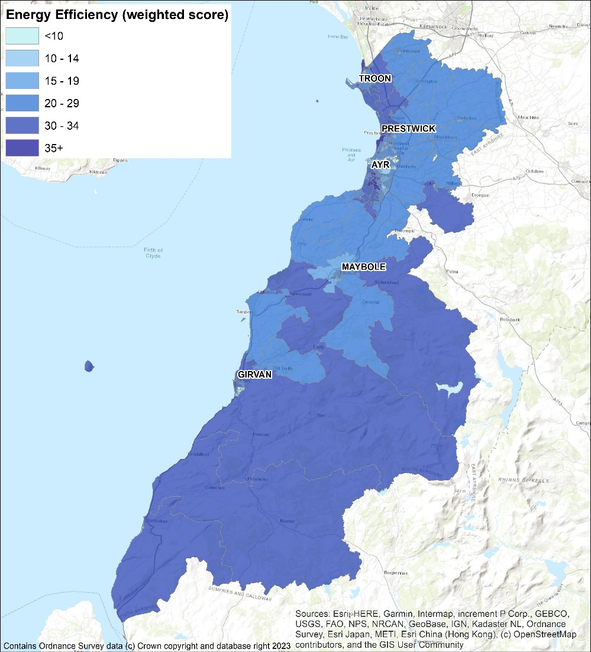
Figure 19: Histogram of Weighted Energy Efficiency Score – Data Zone Level
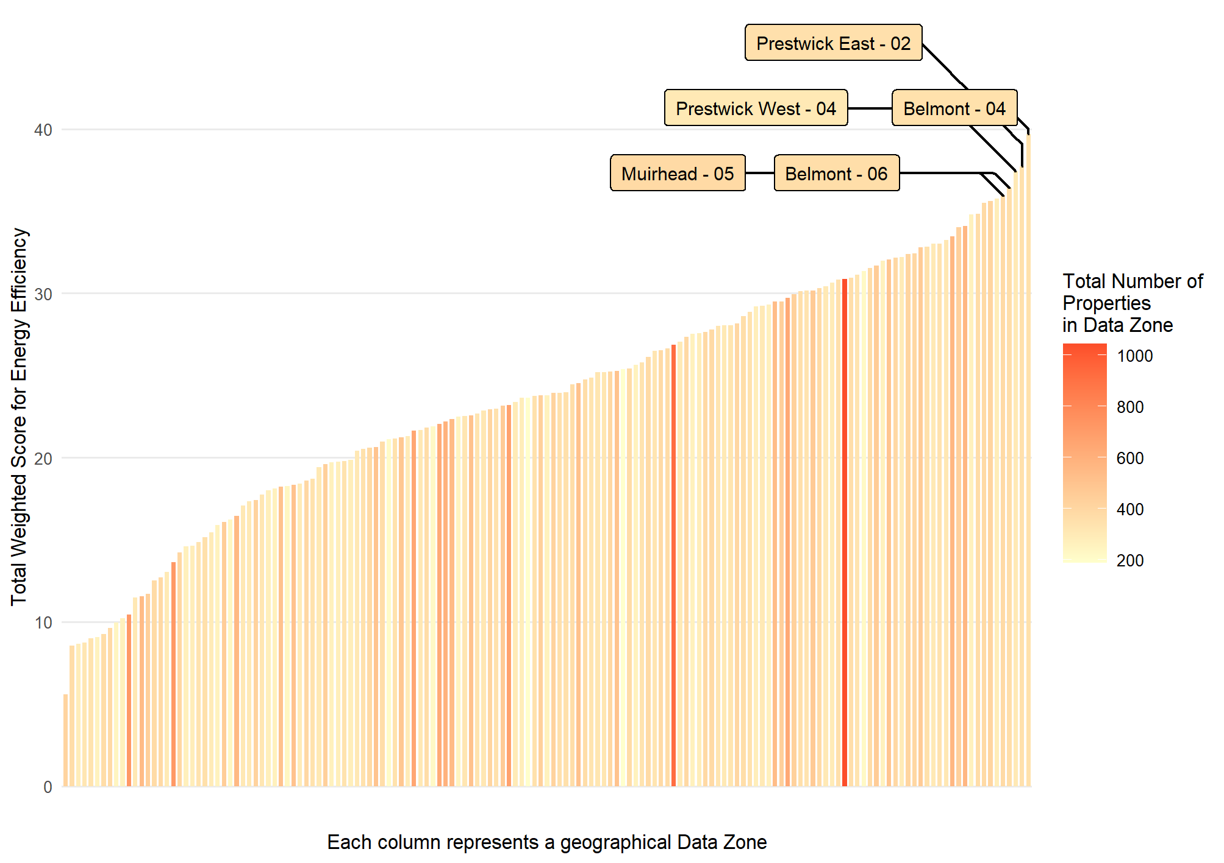

Energy Efficiency as a Driver for Fuel Poverty
This section considers where energy efficiency measures have the potential to reduce fuel poverty. The analysis uses a weighted score as set out in Appendix I.
The Weighted Scores are distributed unevenly across South Ayrshire (Figure 20, Figure 21 and details in Table 21 in Appendix D), with higher scores indicating a greater risk that families are experiencing fuel poverty as a result of poor energy efficiency. There are a small number of zones with significantly worse scores, suggesting that there is value in addressing energy efficiency measures in specific geographical areas.

Figure 20: Map of Energy Efficiency as a Driver of Fuel Poverty – Data Zone Level
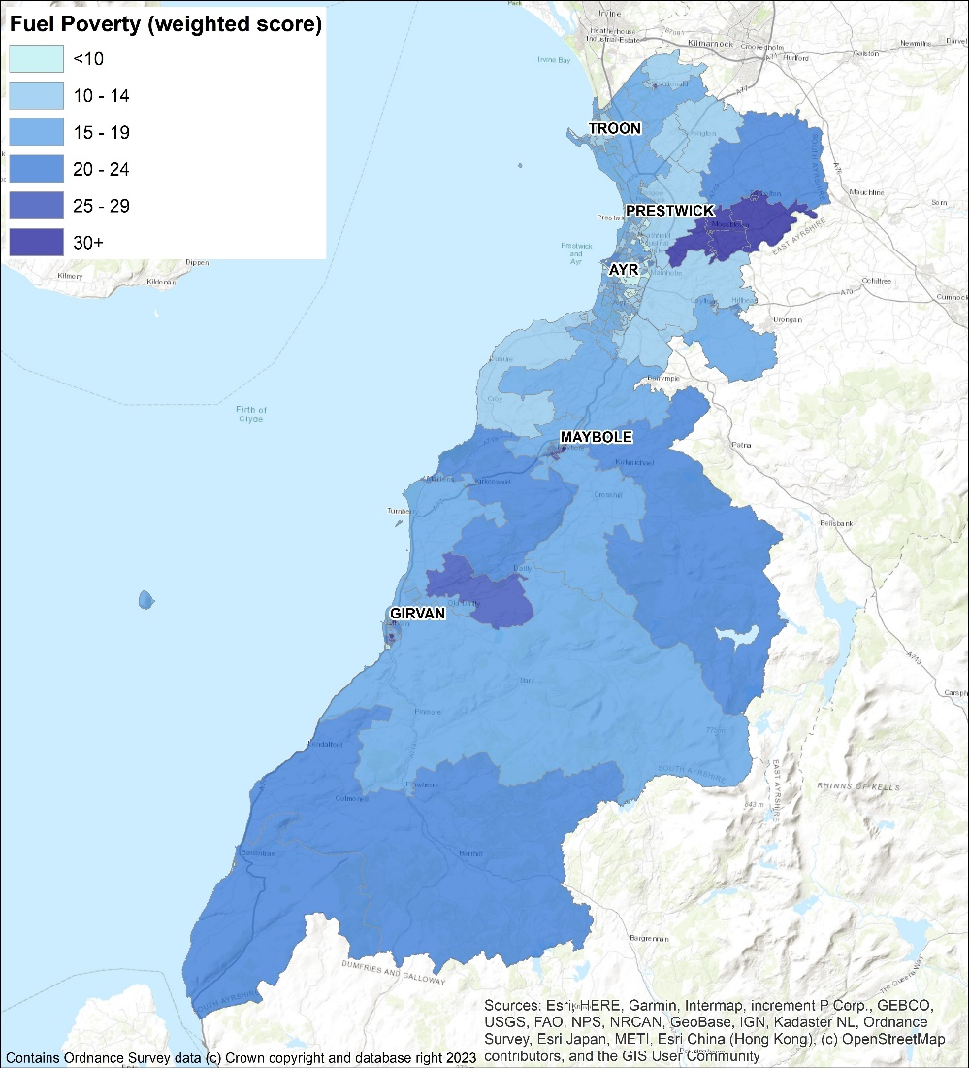
Figure 21: Histogram of Weighted Fuel Poverty Score – Data Zone Level
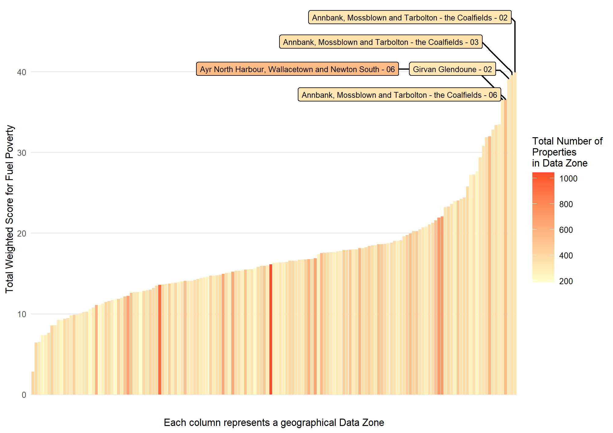

Mixed-Tenure, Mixed-Use and Historical
Mixed-tenure and mixed-use properties have unique challenges for the implementation of interventions as they have multiple stakeholders to engage with that may have conflicting interests. Mixed-tenure buildings are those which have multiple properties of the same use, whereas mixed-use buildings will have multiple properties in the same buildings that have different use profiles and are not all residential, such as a shop with a flat above it.

Mixed-Tenure
It is apparent that there is a wide variation in the number of mixed-tenure buildings between data zones (Figure 22 and Figure 23). This ownership type will require specialised engagement, funding and delivery strategies in order to implement the necessary energy efficiency measures. The technical solutions themselves will also potentially differ, since this group includes the range from high flats to sandstone tenements. A dedicated working group to resolve the unique challenges of mixed-tenure buildings may be the best course of action to make progress on the properties that may have multiple stakeholders and heating profiles. The prioritisation of zones will be dependent on the prioritisation identified for energy efficiency measures as much as on the order presented here.
Figure 22: Map of Mixed-Tenure Properties – Data Zone Level
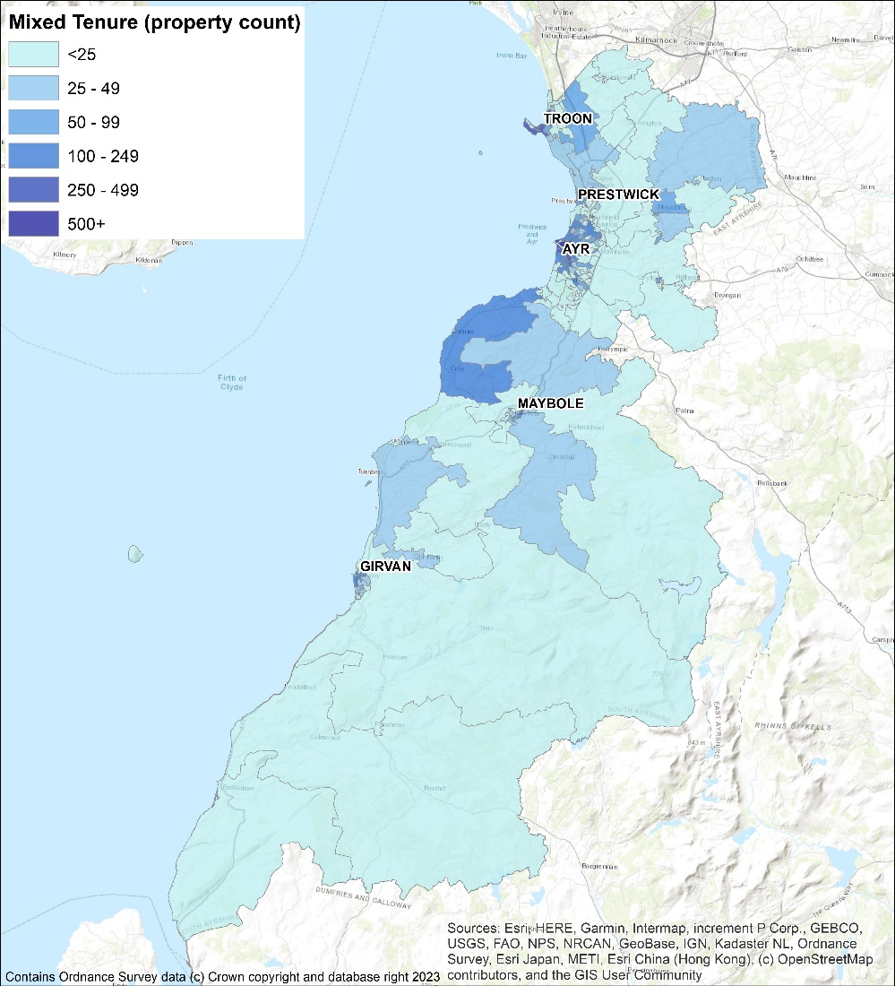

Figure 23: Histogram of Number of Mixed-Tenure Buildings – Data Zone Level
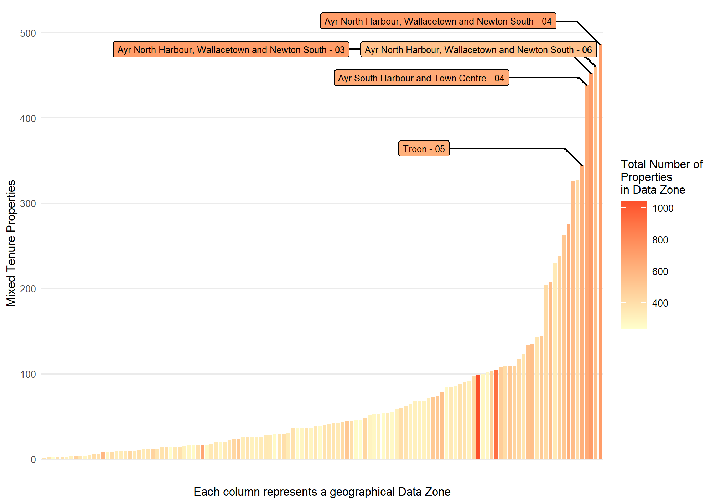

Conservation Areas and Listed Buildings
Relatively few Data Zones have homes within conservation areas (Figure 24). The top three zones (Figure 25) also appear amongst the worst performing Zones according to Energy Efficiency Score and so it is clear that properties in at least some conservation areas will be priorities and that appropriate solutions for these areas will need to be rolled out early in the LHEES delivery period.
Figure 24: Mapped Domestic Properties within Conservation Area by Data Zone
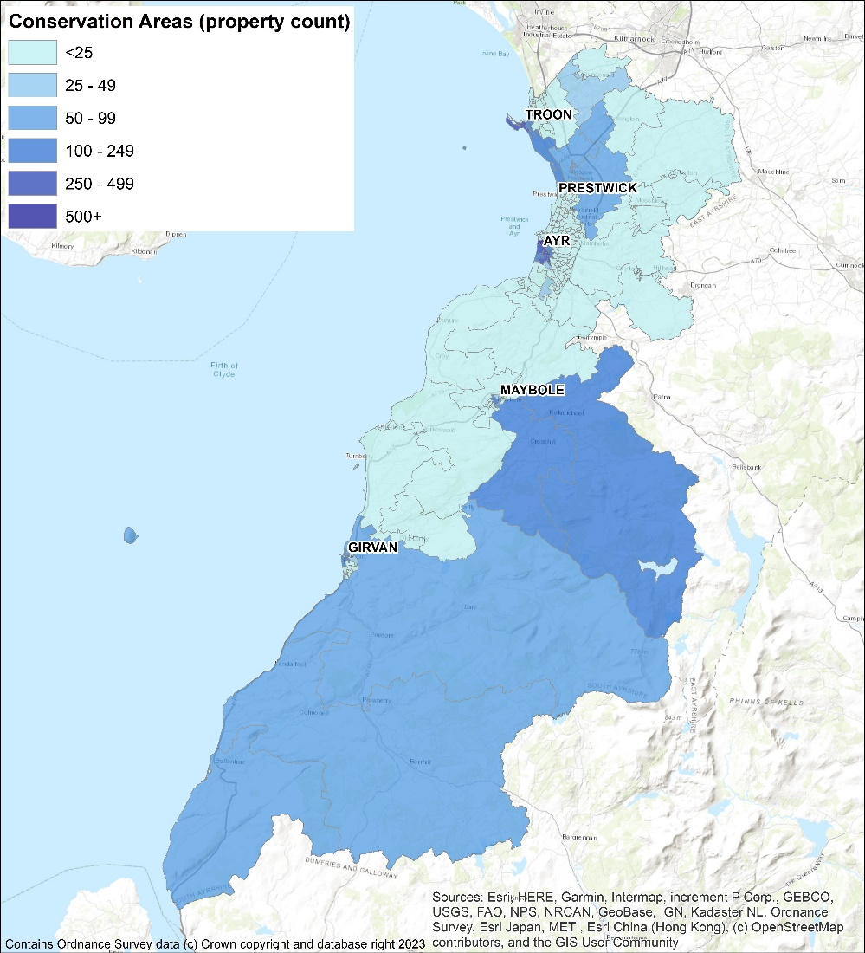
Figure 25: Domestic Properties in Conservation Areas by Data Zones Histogram
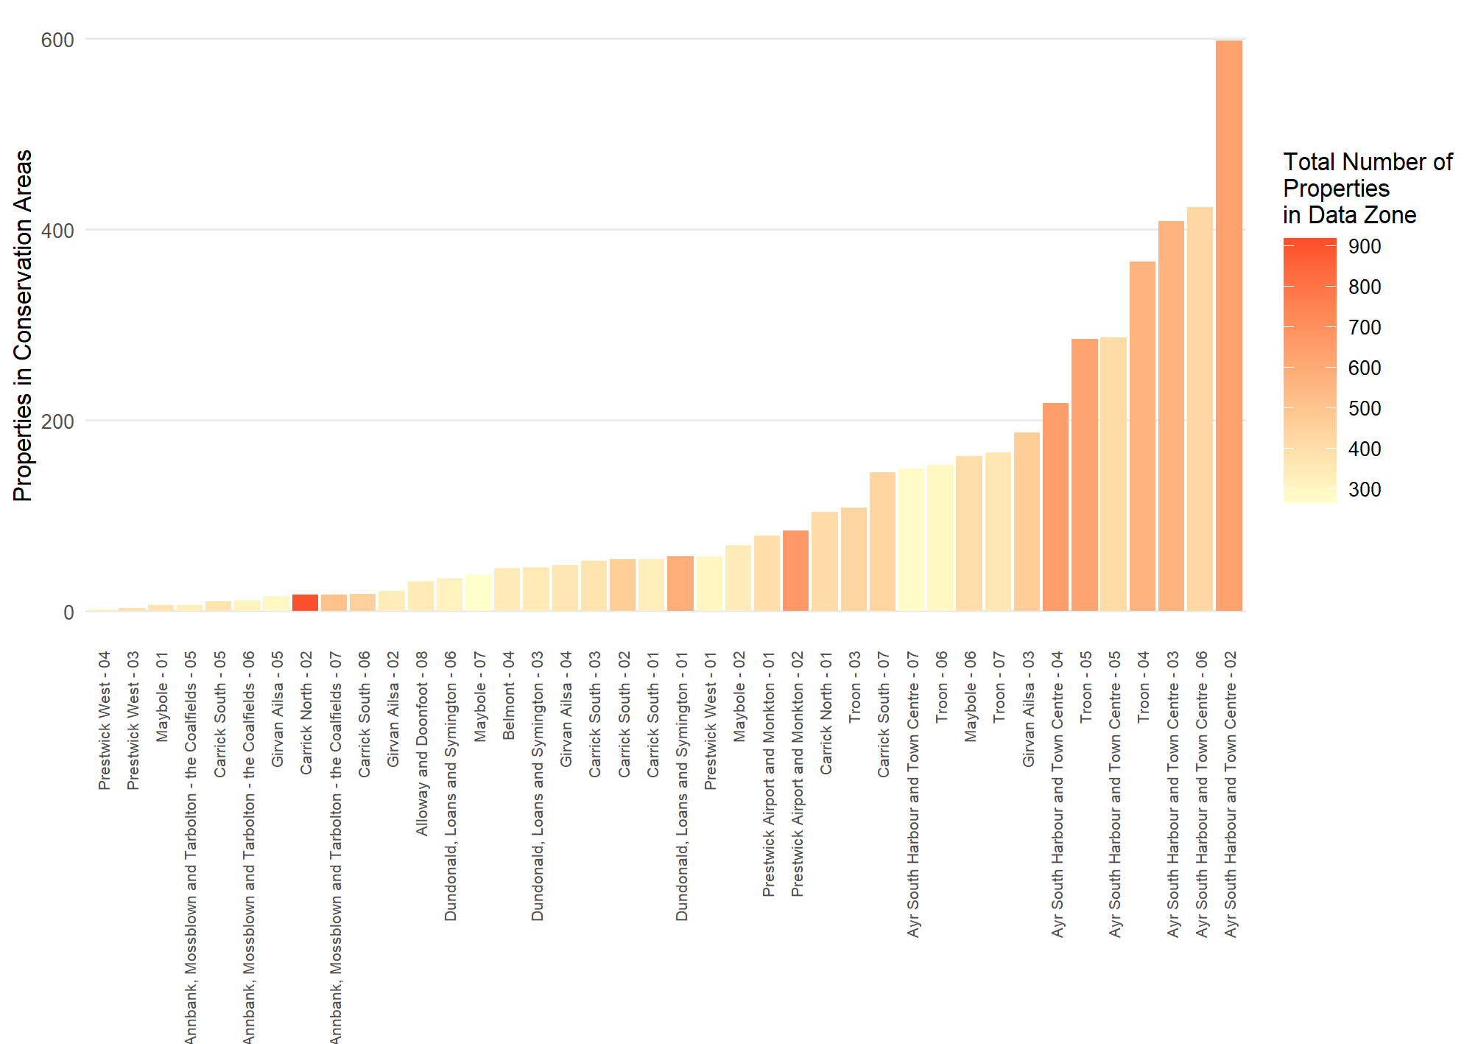
Again, there are a reasonable number of domestic properties (Figure 26 and Figure 27). The top four data zones are also amongst the poorer performers from the point of view of energy efficiency. Consequently, as in the conservation areas, the special strategies for this building type will have to be delivered early in the LHEES delivery phase.
Figure 26: Mapped Listed Domestic Properties by Data Zone
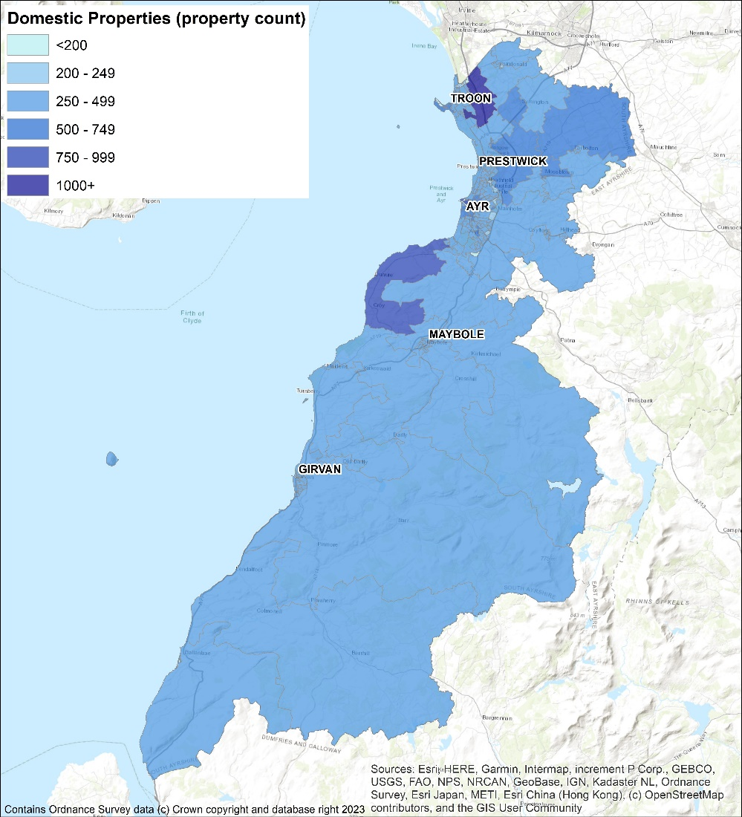
Figure 27: Listed Domestic Properties by Data Zone Histogram
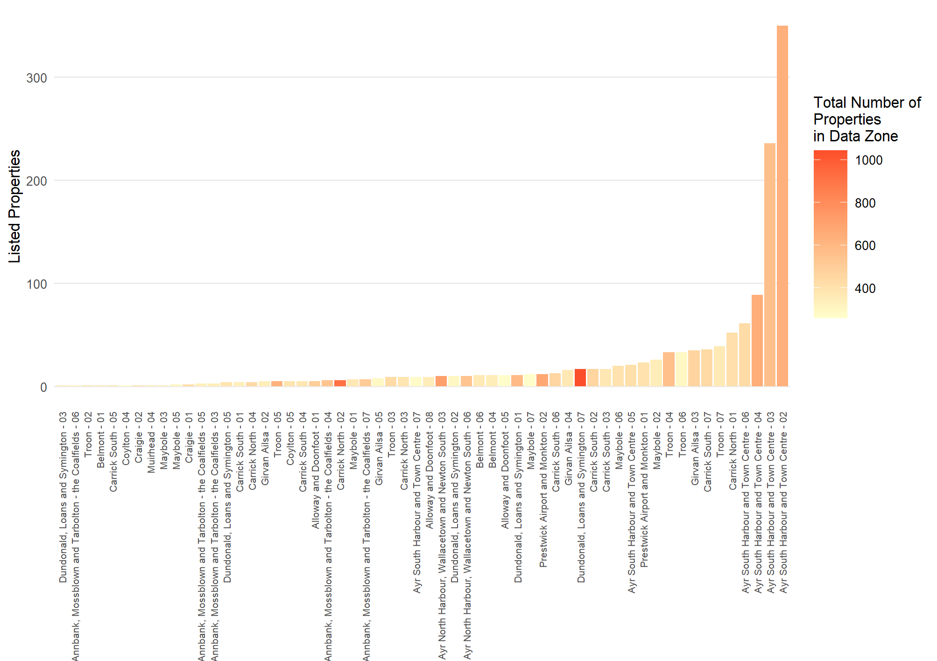

Fuel Poverty – Absolute
The fuel poverty indicator analysis used in the baseline tool was supplemented with additional analysis based on the heat demands and fuel type presented in the Home Analytics dataset and the subsequent cost to the heat each property based on the utility prices given in Table 11. This building-level analysis was aggregated to intermediate zone and is intended to provide an indication of how affordable it is to heat houses in each area and is not a detailed prediction.
Table 11: Fuel prices used in fuel poverty analysis
Fuel | Autumn 2023 Price Cap
Electricity Rate | £0.270
Mains Gas | £0.070
Oil | £0.116
LPG | £0.119
Biomass/Solid | £0.068
Standing Charges
Mains Gas | £0.45
Electricity | £0.27

The number of homes in each income decile are given in Table 12; 60 % of homes are in decile Five or lower. The 10 least affordable Intermediate Geography Zones, those with the fewest percentage of homes which could be affordably heated by households in income decile Five or lower, are listed in in Table 13.
Table 12: Number of homes by SIMD income decile
SIMD Income | Number of homes | Percentage of homes by income decile
One | 5,920 | 10%
Two | 4,960 | 9%
Three | 4,080 | 7%
Four | 9,980 | 17%
Five | 9,790 | 17%
Six | 2,840 | 5%
Seven | 4,430 | 8%
Eight | 4,230 | 7%
Nine | 7,250 | 13%
Ten | 3,840 | 7%

Table 13: Percentage of homes which could be affordably heated by households in income decile five or lower
Strategic Zone | Percentage of homes which could be heated by households in income decile five or lower without being in fuel poverty
Carrick | 18 %
Kyle | 60 %
Girvan | 73 %
Ayr | 74 %
Prestwick | 74 %
Troon | 78 %
Maybole | 84 %

Social Impact of Multiple Deprivation
The Local Heat and Energy Efficiency Strategy and Delivery plan consider fuel poverty where it can be reduced through energy efficiency measures. Understanding which locations have higher rates of overall deprivation as well as specifically income deprivation, can inform decisions on areas of focus.
Figure 28: Map of overall SIMD rank
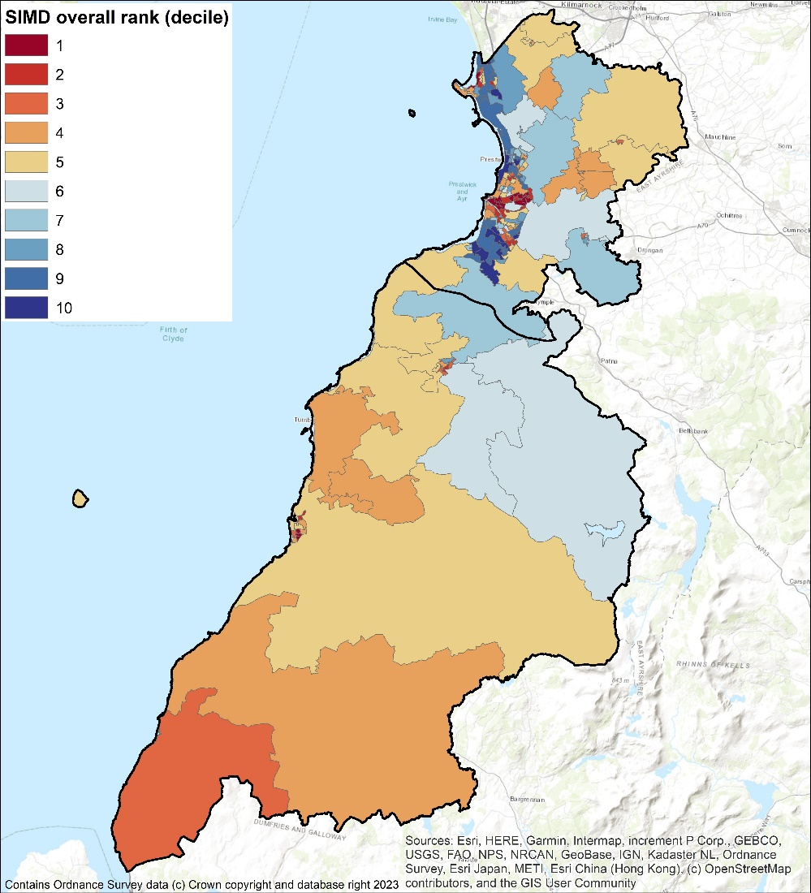
Figure 29: Map of income SIMD rank
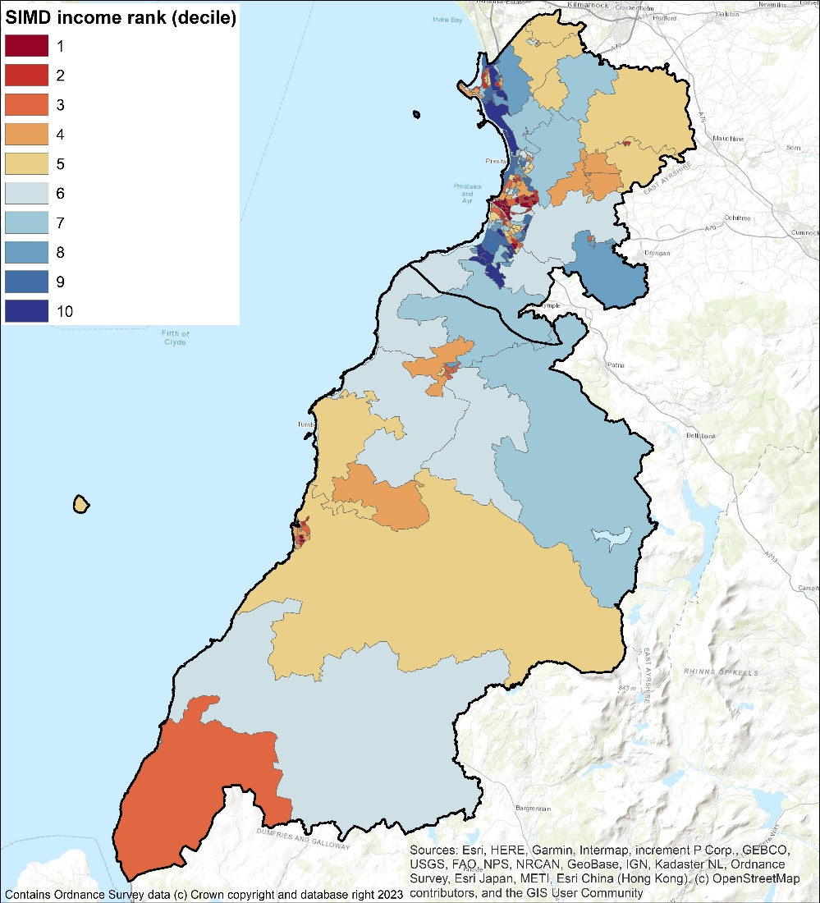

Overlaying Multiple Considerations
The analysis has generated various rankings for the purpose of determining where to start with interventions. The Weighted Energy Efficiency Score and Fuel Poverty rankings are, thanks to the latter being based on the former, very highly correlated and could be used interchangeably with similar outcomes. However, SIMD and income ranks are not correlated at all with the Weighted Energy Efficiency Score. Figure 30 highlights that the data zones with the worst energy performance are ones which are relatively affluent, so addressing funding towards fuel consumption reductions would not universally address the issue of real-world fuel poverty. However, since there are likely to be income poor households in areas which are more affluent on average, the poor energy efficiency of those properties or the relative lack of energy efficient properties could still warrant targeted intervention.
These observations suggest that prioritisation approaches need to take account of multiple factors, addressed in 8.2.3.
Figure 30: Data Zones ranked by Weighted Energy Efficiency Score and coloured by SIMD rank
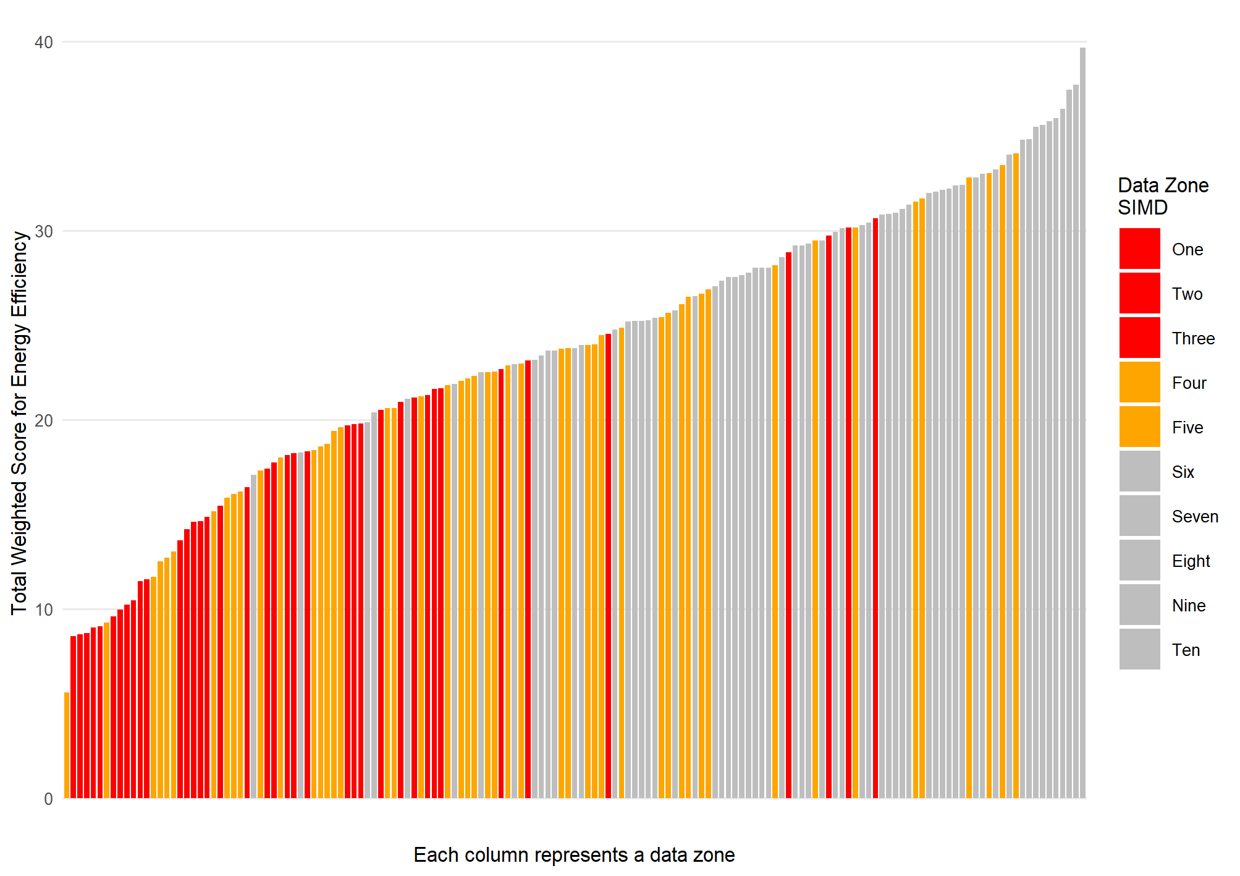

Heat Pump Suitability
This section highlights where there are significant proportion of properties where there is a greater challenge with implementing a heat pump solution, even after reasonable energy efficiency measures are considered.
Low temperature solutions may be possible by solving challenges for a specific building type. Other technologies such as air-to-air heat pumps or exhaust air heat pumps may have specific applications such as small flats with few rooms.
There are a range of possible solutions depending upon the building type, however when combining the heat network analysis with the potential for heat pumps this shows where there are clusters of properties which are likely to be hard to treat.
Further analysis of these clusters could be considered to identify which solution is most appropriate for that specific area. While it may be that an ideal solution is then found, it may be that none of the possible solutions are ideal. In this case, engaging with stakeholders and understanding the specific needs of building owners and households is going to be particularly important to the Council identifying what role it can play in identifying potential solutions and supporting their implementation. Detailed maps are provided in Appendix G and an overview is shown below in Figure 31.
Figure 31: Heat pump suitability and potential heat network areas
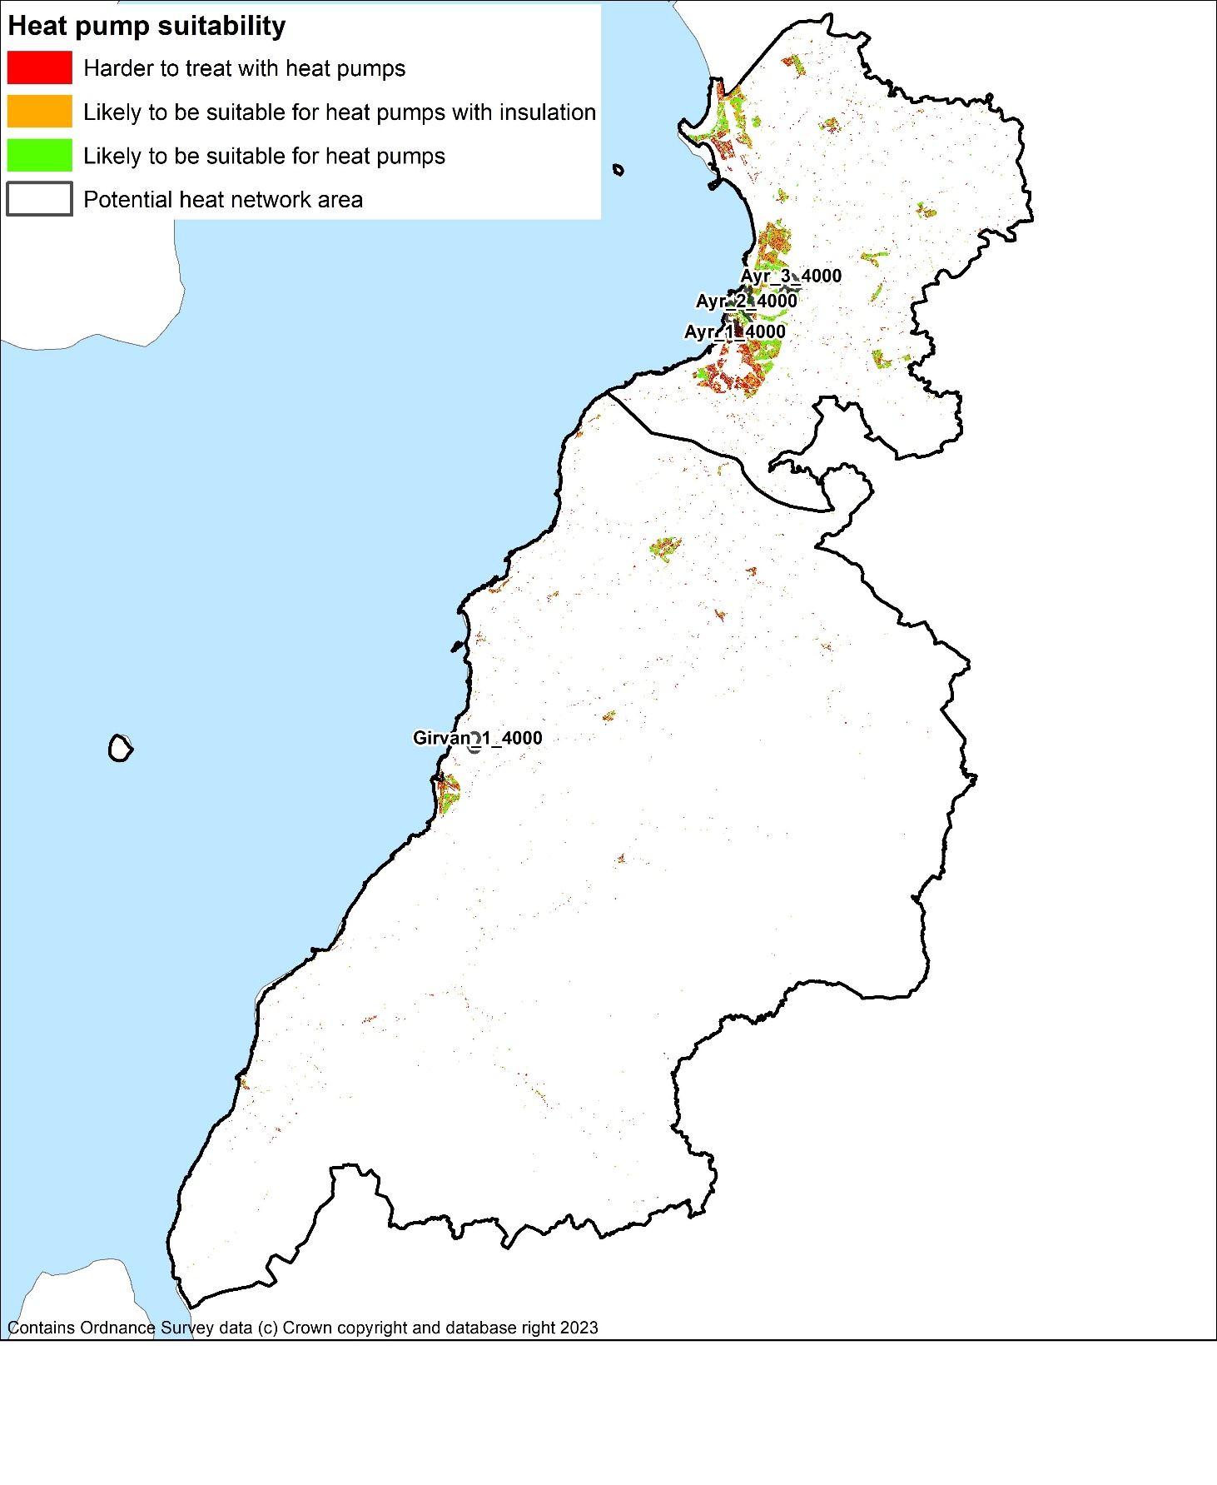
Low temperature solutions may be possible by solving particular challenges for a specific building type. Other technologies such as air-to-air heat pumps may most suitable specific applications such as small flats with few rooms.
There are a range of possible solutions depending upon the building type, however when combining the heat network analysis with the potential for heat pumps this shows where there are clusters of properties which are likely to be hard to treat.
Further analysis of these clusters could be considered to identify which solution is most appropriate for that specific area. While it may be that an ideal solution is then found, it may be that none of the possible solutions are ideal. In this case, engaging with stakeholders and understanding the specific needs of building owners and households is going to be particularly important to the Council identifying what role it can play in identifying potential solutions and supporting their implementation.

Technology-Led Approach

Purpose
As an alternative to the spatial approach, the interventions in this section are grouped by tenure, who owns the property, as well as other factors which would affect the viability and benefit of specific technologies. This would allow alternative means of targeting properties for interventions, either by the Council in its own properties or to assist other stakeholders in identifying changes they can make to their properties.

Logic for Technology Grouping
In addition to considering the data on each building’s construction, type and insulation levels by data zone, analysis was carried out based on the other attributes which are important to how measures could be implemented and who would make those decisions. In this section, therefore, the interventions are grouped by tenure and the fuel being displaced to aggregate the interventions in an alternative way. This allows comparison of costs and benefits of installing different measures to be considered for a specific tenure.
The Council can play a different role in encouraging the installation of energy efficiency and low carbon heat sources in different tenures, meaning this analysis is intended to inform decisions throughout the next 5 years.
Energy efficiency measures are considered key interventions to help both reduction of fuel poverty and decarbonisation by reducing heat demands leading to lower carbon emissions. In addition, the implementation of energy efficiency measures improves the operational effectiveness and the sizing requirement of heat pumps.
There are two heating technologies which have the most potential to improve both energy efficiency, contribute to decarbonisation and potentially reduce fuel poverty. District heat networks are a key technology in areas with higher heat density makes them viable and in some new build estates. The second option, which is the main route forward for buildings across South Ayrshire, is installation of heat pumps either for a specific dwelling or a communal system serving a number of dwellings, such as a block of flats.
There are a range of technologies which could be considered for properties less suitable to heat networks or conventional air-to-water heat pump technologies. These include biomass, direct electric heating, air-to-air heat pumps, and high-temperature or 3-phase air-to-water heat pumps.

Intervention Categories
The data on each individual property has been assessed and the measures that each property is suitable for has been estimated. They are grouped according to LHEES consideration and tenure.
The potential interventions are grouped by the factors which would affect their implementation. As such, Table 14 forms a list from which actions can be selected rather than a list being committed to at this stage.
An individual property may appear multiple times in Table 14 if it requires multiple interventions. It is possible that, due to programming, the multiple interventions would take place at the same time but that is not an imperative i.e., all the windows in a data zone could be upgraded at a separate time to loft insulation. Details of each of these possible interventions are set out in Appendix J.

Table 14: Intervention summary table
Intervention Reference | LHEES Consideration | Tenure | Energy Efficiency Measure | Displaced Fuel | SAC Action | Number of Properties | Notes
1 | 1) Off-gas grid buildings | All |  | Various | 1.1 Survey properties with missing data.  1.2 Install low carbon heating in off-gas grid buildings. | 8,935
2 | 2) On-gas grid buildings | All |  | Gas | 2.1 Survey properties with missing data.  2.2 Install low carbon heating in on-gas grid buildings. | 57,949
3 | 4) Poor building energy efficiency  5) Poor building energy efficiency as a driver for fuel poverty | Local Authority | Loft insulation | n/a | 3.1 Survey properties with missing data.  3.2 Upgrade all insulation to 300 mm mineral wool (or equivalent) | 1,933 | There should be an economy of scale
4 | 4) Poor building energy efficiency  5) Poor building energy efficiency as a driver for fuel poverty | Local Authority | Wall insulation | n/a | 4.1 Assess priority  4.2 Assess feasibility  4.3 Install cavity or cladding insulation | 998
5 | 4) Poor building energy efficiency  5) Poor building energy efficiency as a driver for fuel poverty | Local Authority | Glazing upgrade | n/a | 3.1 Assess priority  3.2 Install double-glazing | 213
6 | 4) Poor building energy efficiency  5) Poor building energy efficiency as a driver for fuel poverty | Local Authority | Heat pump installation | Electricity | 4.1 Survey properties for wet heating system installation requirements.  4.2 Install ASHP | 871 | Cost for retrofitting will be variable. There should be an economy of scale.
7 | 4) Poor building energy efficiency  5) Poor building energy efficiency as a driver for fuel poverty | Local Authority | Heat pump installation | Oil/ LPG | 5.1 Install ASHP | 325
8 | 1) On gas grid  4) Poor building energy efficiency  5) Fuel Poverty Resulting from poor building energy efficiency | Local Authority | Heat pump installation | Gas | 6.1 install ASHP  6.2 install electric cooker | 7,266 | May only improve fuel poverty if the gas meter and standing charge removed.
9 | 4) Poor building energy efficiency  5) Poor building energy efficiency as a driver for fuel poverty | Local Authority | Heat pump installation | Solid | 7.1 Survey for requirement for wet heating system  7.2 Install ASHP | 86
10 | 4) Poor building energy efficiency  5) Poor building energy efficiency as a driver for fuel poverty | Local Authority | Heat pump installation | Biomass | 8.1 Survey for requirement for wet heating system  8.2 Install ASHP | 0
11 | 4) Poor building energy efficiency  5) Poor building energy efficiency as a driver for fuel poverty | Housing Association | Loft insulation | n/a |  | 703
12 | 4) Poor building energy efficiency  5) Poor building energy efficiency as a driver for fuel poverty | Housing Association | Wall insulation | n/a |  | 257
13 | 4) Poor building energy efficiency  5) Poor building energy efficiency as a driver for fuel poverty | Housing Association | Glazing upgrade | n/a |  | 40
14 | 4) Poor building energy efficiency  5) Poor building energy efficiency as a driver for fuel poverty | Housing Association | Heat pump | Electricity |  | 339
15 | 4) Poor building energy efficiency  5) Poor building energy efficiency as a driver for fuel poverty | Housing Association | Heat pump | Oil/LPG |  | 42
16 | 2) On-gas grid buildings  4) Poor building energy efficiency  5) Poor building energy efficiency as a driver for fuel poverty | Housing Association | Heat pump | Gas |  | 1,930 | May only improve fuel poverty if the gas meter and standing charge removed.
17 | 4) Poor building energy efficiency  5) Poor building energy efficiency as a driver for fuel poverty | Housing Association | Heat pump | Solid |  | 4 | Low volume = Low impact
18 | 4) Poor building energy efficiency  5) Poor building energy efficiency as a driver for fuel poverty | Owner occupied | Loft insulation | n/a |  | 16,880
19 | 4) Poor building energy efficiency  5) Poor building energy efficiency as a driver for fuel poverty | Owner occupied | Wall insulation | n/a |  | 17,232
20 | 4) Poor building energy efficiency  5) Poor building energy efficiency as a driver for fuel poverty | Owner occupied | Glazing upgrade | n/a |  | 2,254
21 | 4) Poor building energy efficiency  5) Poor building energy efficiency as a driver for fuel poverty | Owner occupied | Heat pump | Electricity |  | 2,686
22 | 4) Poor building energy efficiency  5) Poor building energy efficiency as a driver for fuel poverty | Owner occupied | Heat pump | Oil/LPG |  | 3,433
23 | 2) On-gas grid buildings  4) Poor building energy efficiency  5) Poor building energy efficiency as a driver for fuel poverty | Owner occupied | Heat pump | Gas |  | 33,071 | May only improve fuel poverty if the gas meter and standing charge removed.
24 | 4) Poor building energy efficiency  5) Poor building energy efficiency as a driver for fuel poverty | Owner occupied | Heat pump | Solid |  | 290
25 | 4) Poor building energy efficiency  5) Poor building energy efficiency as a driver for fuel poverty | Owner occupied | Heat pump | Biomass |  | 136 | Low priority wrt. carbon
26 | 4) Poor building energy efficiency  5) Poor building energy efficiency as a driver for fuel poverty | Privately rented | Loft insulation | n/a |  | 2,711
27 | 4) Poor building energy efficiency  5) Poor building energy efficiency as a driver for fuel poverty | Privately rented | Wall insulation | n/a |  | 3,599
28 | 4) Poor building energy efficiency  5) Poor building energy efficiency as a driver for fuel poverty | Privately rented | Glazing upgrade | n/a |  | 653
29 | 4) Poor building energy efficiency  5) Poor building energy efficiency as a driver for fuel poverty | Privately rented | Heat pump | Electricity |  | 893
30 | 4) Poor building energy efficiency  5) Poor building energy efficiency as a driver for fuel poverty | Privately rented | Heat pump | Oil/LPG |  | 730
31 | 2) On-gas grid buildings  4) Poor building energy efficiency  5) Poor building energy efficiency as a driver for fuel poverty | Privately rented | Heat pump | Gas |  | 4,920 | May only improve fuel poverty if the gas meter and standing charge removed.
32 | 4) Poor building energy efficiency  5) Poor building energy efficiency as a driver for fuel poverty | Privately rented | Heat pump | Solid |  | 55
33 | 4) Poor building energy efficiency  5) Poor building energy efficiency as a driver for fuel poverty | Privately rented | Heat pump | Biomass |  | 62
34 | 6) Mixed-tenure, mixed-use and historic buildings | Mixed | All | - | 32.1 Map which of the above interventions apply to mixed-tenure
35 | 6) Mixed-tenure, mixed-use and historic buildings | Historic | All | - | 33.1 Map which of the above interventions apply to mixed-tenure

Non-domestic properties

Overview of properties to decarbonise
The non-domestic stock was characterised in 6.1.2 and the following conclusions could be drawn:
- The majority of properties are heated by either electricity or gas (Figure 4)- and electricity will eventually decarbonise itself
- The majority of the smallest properties are heated electrically (Figure 5) – and the remainder will likely suit small air-to-air-heat pump systems)
- The majority of properties are either in the oldest or youngest age categories (Figure 6)
Strategically, then, the focus should be on gas-heated properties greater than 100m². Common building types in this category include Retail and Finance, Offices and Workshops, and Non-residential Institutions (Figure 32). By estimated heat demand, these three sectors are still top of the list, alongside hotels (Figure 33) so these should be the target of decarbonisation efforts.
However, these conclusions are based on the data available and due to the known discrepancies in the base data’s estimate of heat demand and of type of fuel used, validating and improving the available data is important as part of any engagement with property owners.
Figure 32: Larger, gas-heated non-domestic properties by use type
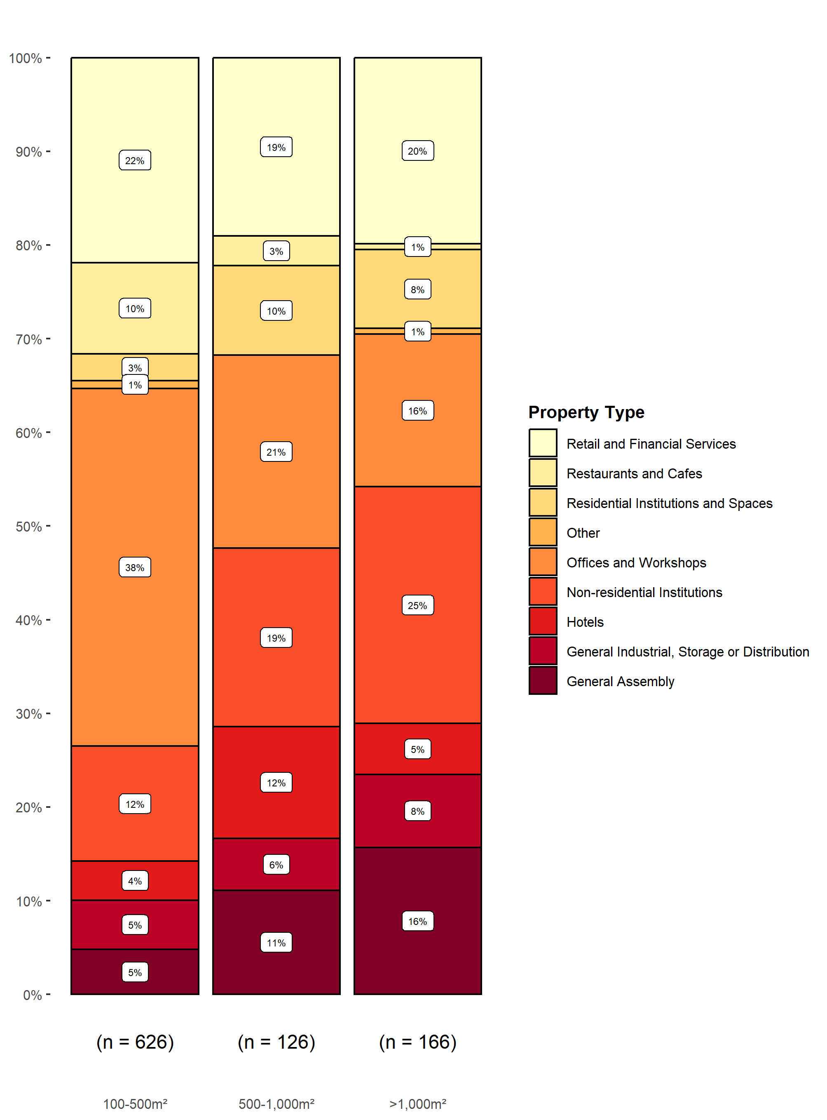
Figure 33: Space heating demand in larger, non-domestic, gas-heated buildings by type
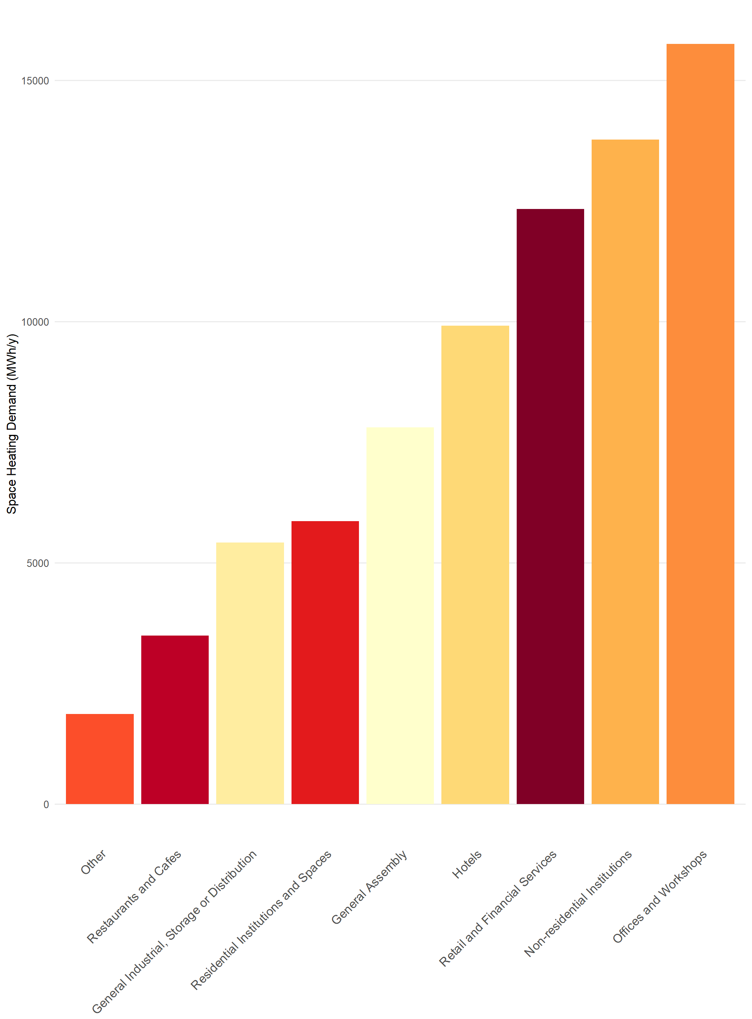

Placeholder:
Replace with real map
Figure 34: Map with top non-domestic, gas-heated energy consuming types
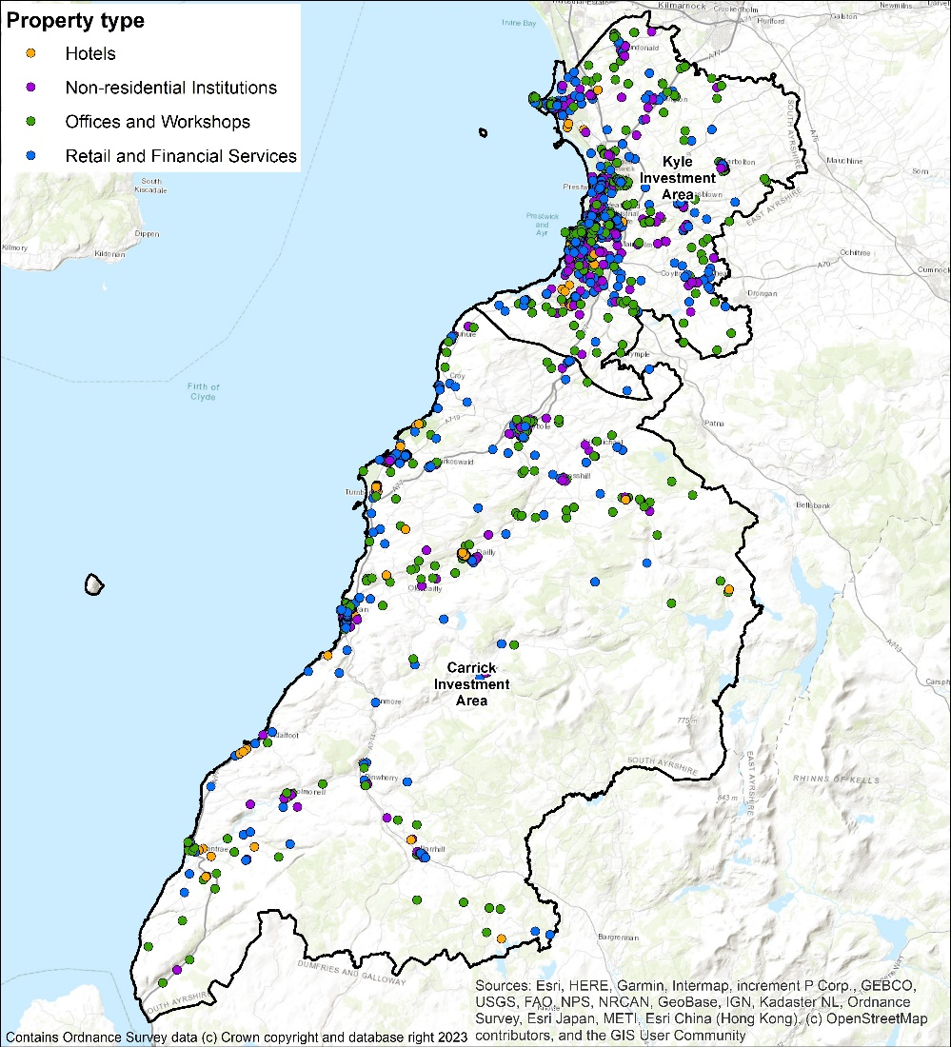

Non-domestic buildings energy efficiency
Using the publicly-available EPC records, around 2,000 EPCs are lodged for South Ayrshire. By far the largest proportion of these have a rating of G (Table 15). This must be viewed as a target to improve energy efficiency overall in South Ayrshire.
Table 15: Non-domestic EPCs in South Ayrshire
EPC Rating | Count | Percentage
A | 27 | 1 %
B | 87 | 4 %
C | 233 | 12 %
D | 315 | 16 %
E | 354 | 18 %
F | 255 | 13 %
G | 693 | 35 %

South Ayrshire Council Portfolio
South Ayrshire Council own 10 buildings with oil as a heat source which consume over 900 MWh/year of heat. Over 100 more council-owned buildings consume over 36,000 MWh of heat from gas. These are significant amounts of heat to be decarbonised and a first step to achieving this will be to prepare energy efficiency and decarbonisation plans for each building.

Pathways for all of South Ayrshire

Decarbonisation of Heat Pathway
The journey to the decarbonisation of each domestic property in South Ayrshire is shown in Figure 35. The first column shows the proportions of properties which begin with each fuel source. The second groups the properties by their total heat demand, in kWh/year. The third column assumes reasonable energy efficiency measures have been applied and groups the properties by their improved heat demand. The suitability of each property for each of the low carbon heat measures is then shown. This assumes all listed heat network zones are developed but doesn’t consider further expansion. It can be seen clearly that heat pumps are the most suitable technology for the majority of homes. Finally, the column on the right shows the energy imported to the property to meet heat demand. For heat networks, this is simply heat purchased. For electric heating and heat pumps it is units of electricity.
Figure 35: Decarbonisation and energy efficiency pathway
The shifting of individual properties down from one energy demand band to the next is visualised in Figure 36, where the comparison of heat pumps to direct electric heating shows how effective heat pumps will be in reducing the risk of fuel poverty.
At a local authority level, Figure 37 shows how interventions in and shifting demand of individual properties could reduce the total heat energy consumption in South Ayrshire. It is also evident in Figure 36 and Figure 37 that heat pumps on their own make a bigger difference to energy demand than fabric improvements but fabric improvements have a role in both demand reduction and in making homes suitable for heat pumps (8.1.8).
Figure 36: Shifting energy demand by fabric improvement and heat pump installation
Figure 37: Total electricity demand reduction after energy efficiency measures and/ or heating system upgrade
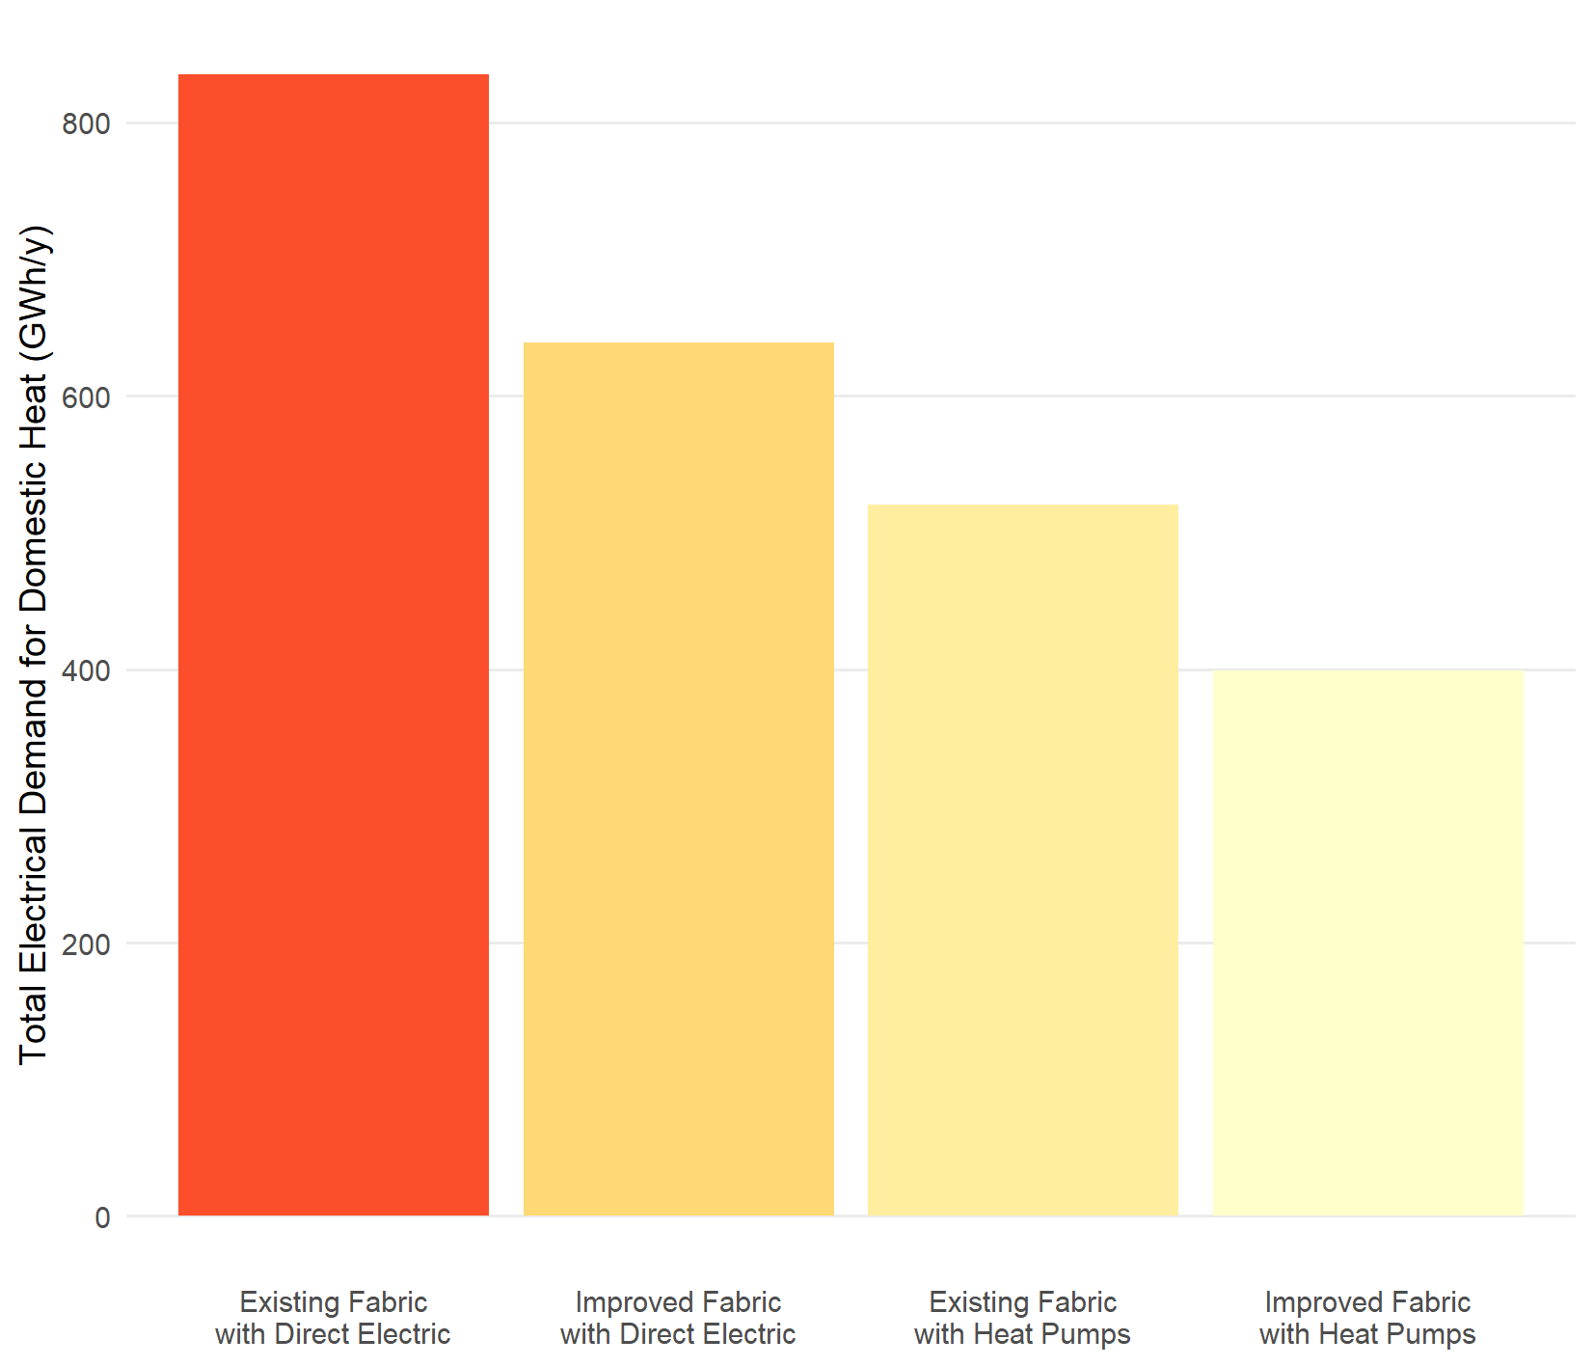

Fuel Poverty
Reducing the heat demand of the buildings through installing energy efficiency measures is clearly important as it can both reduce the amount of heat to be decarbonised and the cost of heating. This section examines the properties in the areas with the lowest SIMD score to illustrate the combined effect of energy efficiency and low carbon heating on the amount of energy that the household would have to pay for, to fully heat their home and, consequently, on their risk of fuel poverty.
Figure 38: Effect of actions in all properties in SIMD 1 areas – energy efficiency and heat pumps
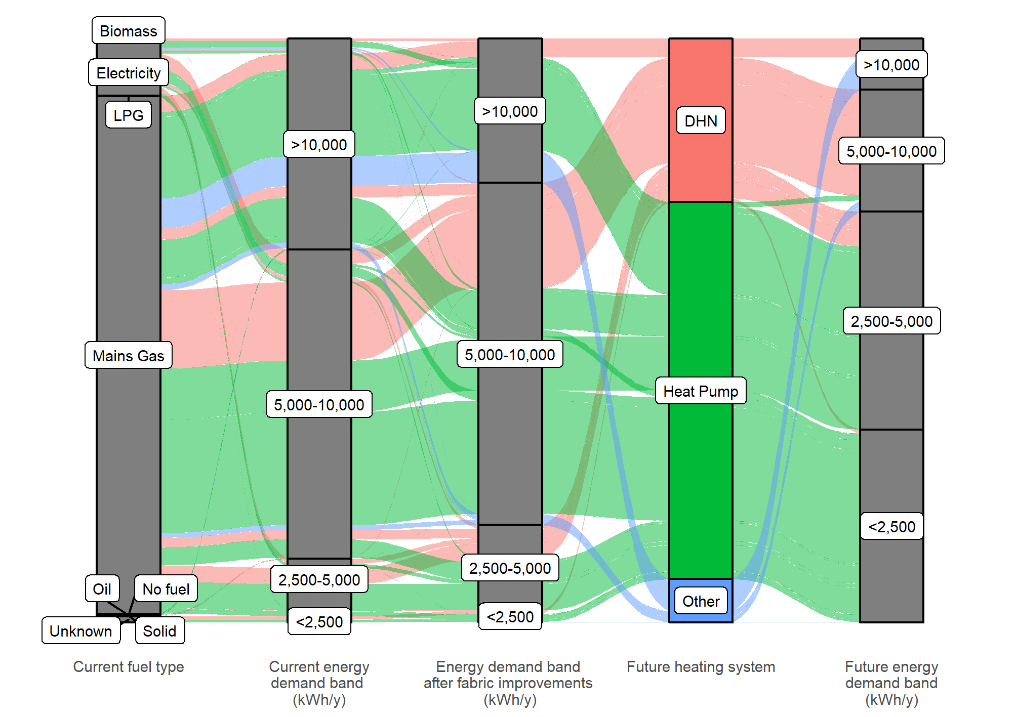
Figure 38 shows the decarbonisation journeys for all properties in areas which have a SIMD score of 1, the most deprived areas. This shows the main heating fuel they use at present, the proportion of properties in each energy demand band (kWh/year) and then the numbers in each band after energy efficiency measures and low carbon heating technologies are installed.
Installing energy efficiency measures significantly reduces the number of properties with heat demands of over 10,000 kWh/year. Utilising heat pumps reduces this further to a very small proportion but also results in one quarter of homes being in the lowest band, with an annual demand of <2,500 kWh/y. If direct electric heating, rather than heat pumps, were used as the low-carbon choice, then the number of homes in SIMD 1 areas with such low energy demand would be negligible (the third column in Figure 38). For the purposes of this Strategy, heat pumps are considered the preferred solution to minimise fuel poverty, in properties where low-cost district heating is not an option.
Other factors
There are several factors which affect fuel poverty and outlining the effect of energy efficiency measures in improving fuel poverty is complex. Household income after housing costs has a significant effect but is out of scope of this Strategy.
Unheated homes
The Scottish Housing Condition Survey 2019 states:
23 % of fuel poor and 28 % of extreme fuel poor say that their heating keeps them warm enough in winter "only sometimes" or "never",
For these households, reducing the heat demand through insulation both reduces how much it would cost them to heat their home, should they be able to do so, and limits the temperature to which the property will fall in any periods when they do not or are unable to heat it. For those at highest risk of not heating their homes the decision as to whether to focus capital spend on additional insulation measures or lower cost heating systems is therefore complex.
With insulation measures, there are a range of measures which have different costs and energy reductions and there is no single approach suitable for all buildings or situations.

Heat Networks
Heat networks have a role to play in the future of heat in South Ayrshire. Heat networks can be either district heating schemes, which are strategic scale developments where multiple buildings are connected, smaller heat networks, within a single campus, or communal heating systems in a specific building. Within this Strategy, the phrase “heat networks” refers to district heating schemes where multiple buildings are connected by underground pipework.
The maps in Appendix F highlight a number of areas around Ayr which have potential to be developed into heat networks.
The suitability of the buildings for connection to heat networks is not known. Further work such as Building Assessment Reports (BARs) and engagement with stakeholders is important to inform future decisions on these sites.
Even in the zones where heat networks are an option, there are differences between the domestic properties which are most likely to be suitable, such as blocks of flats, and properties which are less likely to be suitable, such as detached houses.
Therefore, due to both the limited proportion of properties in areas where heat networks are likely to be viable and there being properties unlikely to be suitable for connection, it is essential that the Strategy considers other low carbon heat sources in parallel.
This does not preclude heat networks being developed to their full potential and it may be that a phased approach to heat networks and district heating could see smaller networks initially focus on the most viable properties with further expansion at a later date.

Individual and Communal Heat Pumps
Of the technologies currently available to supply low carbon heat, heat pumps have been assessed to be currently suitable for the majority of buildings. Heat pump deployment, and the role they play in decarbonising buildings, has to lead to a cost of heat that is comparable to natural gas boilers and user experience of operating the systems has to be positive. There are examples of people having bad experiences living with heat pumps and while there are equally many good experiences, it is essential to understand what is required for heat pumps to meet the needs of residents. In order to ensure that the heat pump systems installed are of good quality and perform as expected, the sharing of good practice and case studies is emphasised.
South Ayrshire Council will work with internal stakeholders to consider the most appropriate low carbon heating system for properties that it owns as well as working closely with social landlords to share the latest information on issues such as: good practice; communication with tenants prior to installation; sharing information with tenants on how to operate systems which have been installed; peer to peer support within the community; the role of the advice services in supporting tenants.
It is essential that there is a supply chain which is capable of installing the technologies set out above. South Ayrshire Council will work consider what actions which the Council could take to encourage a local supply chain of low carbon heating installers.
While it is for each property owner to make their own decision on the heating system they prefer, there is a role for the Council in ensuring that accurate and up-to date information is available to households, tenants, landlords and owner occupiers to support decision making. This is likely to including signposting to national advice schemes operated by Scottish Government or UK Government.
Finally, for any new technology ensuring quality of installation is important to ensure that it meets the needs of households, tenants and property owners. The Council will work with stakeholders to identify any role that South Ayrshire Council can play in ensuring the quality of installations as well as referring to national schemes such as the Microgeneration Certification Scheme.

Pathways for Strategic Zones

Strategic Zones
Figure 39: Strategic zones
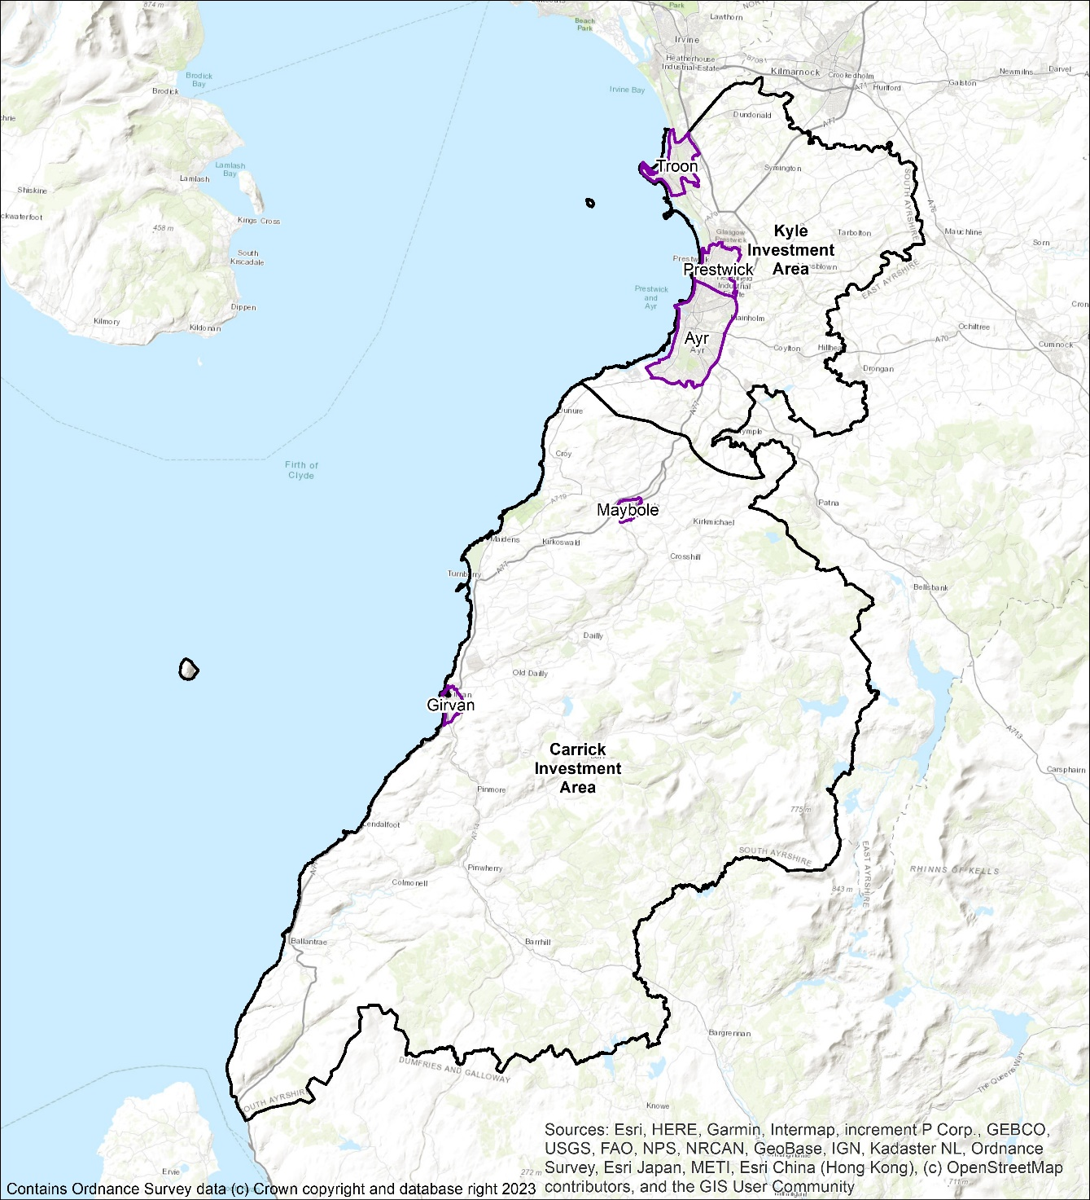

Ayr
Figure 40 shows all domestic properties within the Ayr area and, from the left, the heating fuel each uses today, the energy demand of the property per unit of floor area, the energy demand after the application of reasonable energy efficiency measures and finally the most suitable heating technology for each property at present.
The majority of properties in the Ayr area are suitable for heat pumps but the impact of energy efficiency measures is modest, reflecting the EPC rating spread (Figure 9).
Ayr also has potential for heat network zones. The pathway shows the proportion of domestic properties which are within the potential heat network area.
Figure 40: Decarbonisation pathway for domestic properties in Ayr
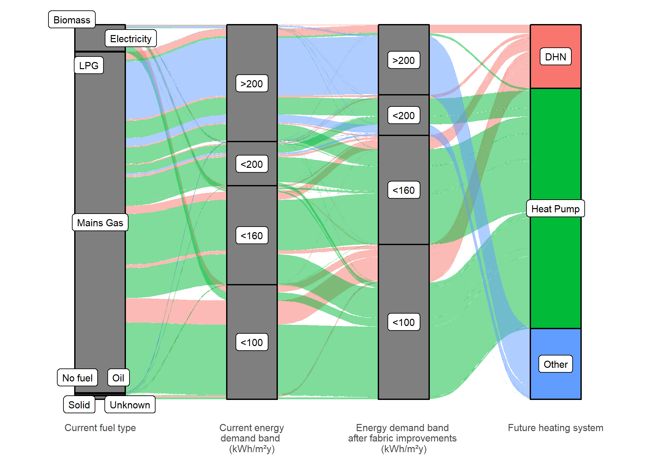

Carrick
Figure 41Figure 40 shows all domestic properties within the Carrick area and, from the left, the heating fuel each uses today, the energy demand of the property per unit of floor area, the energy demand after the application of reasonable energy efficiency measures and finally the most suitable heating technology for each property at present.
Carrick is a rural area with very few properties on mains gas and a significant number using oil. Energy saving measures make a big impact, reflecting the poor EPC scores (Figure 9). Around half of the properties in the Carrick area are suitable for simple heat pump installations but the other half may need other solutions (see 0). Carrick has a higher proportion than other areas of detached homes built before 1919 and theses are to factors which contribute to poor energy efficiency.
Figure 41: Heat decarbonisation pathway for Carrick
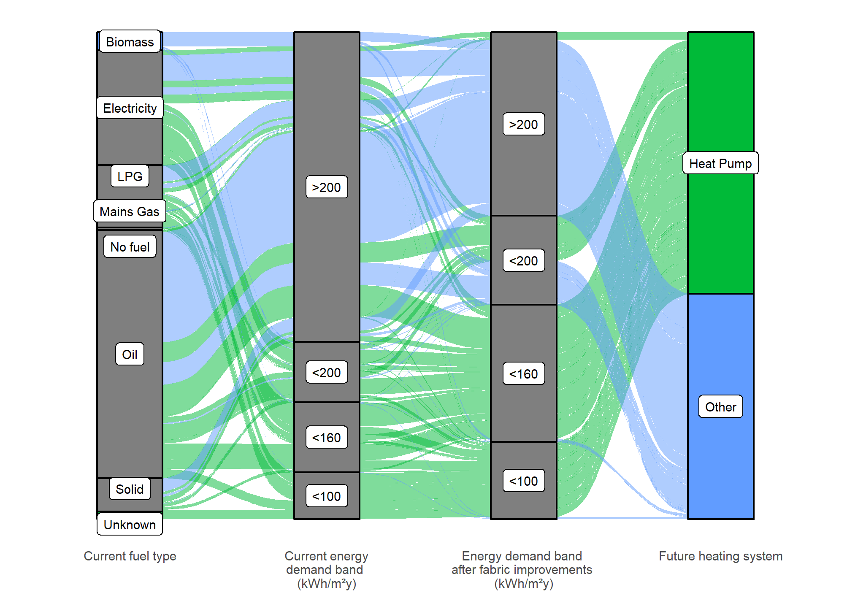
There are a significant number of properties which have high heat demand and are hard to treat. The data shows that there are 90 properties in this area which are considered by this Strategy to be hard to treat with heat pumps, but which already have heat pumps.
This suggests that there are installers and property owners who have solved the problems associated with installing heat pumps in these hard to treat properties. There is an opportunity to learn from these installations, share good practice and form case studies which show potential solutions.

Girvan
Figure 42 shows all domestic properties within the Girvan area and, from the left, the heating fuel each uses today, the energy demand of the property per unit of floor area, the energy demand after the application of reasonable energy efficiency measures and finally the most suitable heating technology for each property at present.
The majority of homes in the Girvan area are suitable for simple heat pump installations.

Figure 42: Heat decarbonisation pathway for Girvan
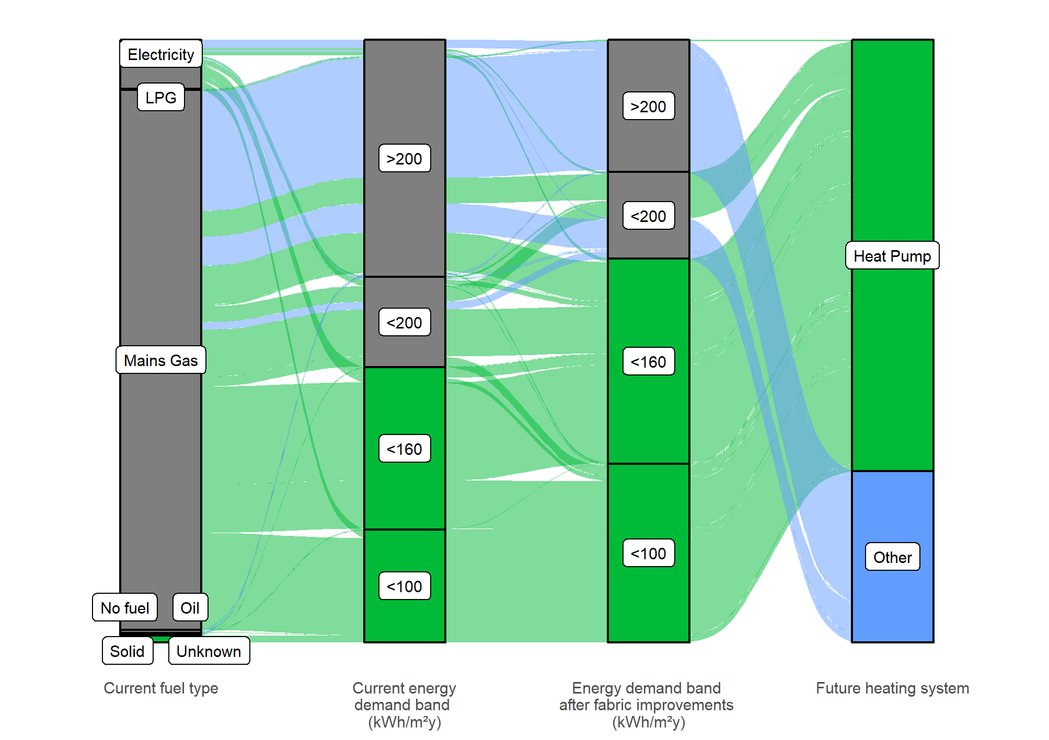

Kyle
Figure 43shows all domestic properties within the Kyle area and, from the left, the heating fuel each uses today, the energy demand of the property per unit of floor area, the energy demand after the application of reasonable energy efficiency measures and finally the most suitable heating technology for each property at present.
The majority of homes in the Kyle area are suitable for simple heat pump installations.

Figure 43: Heat decarbonisation pathway for Kyle
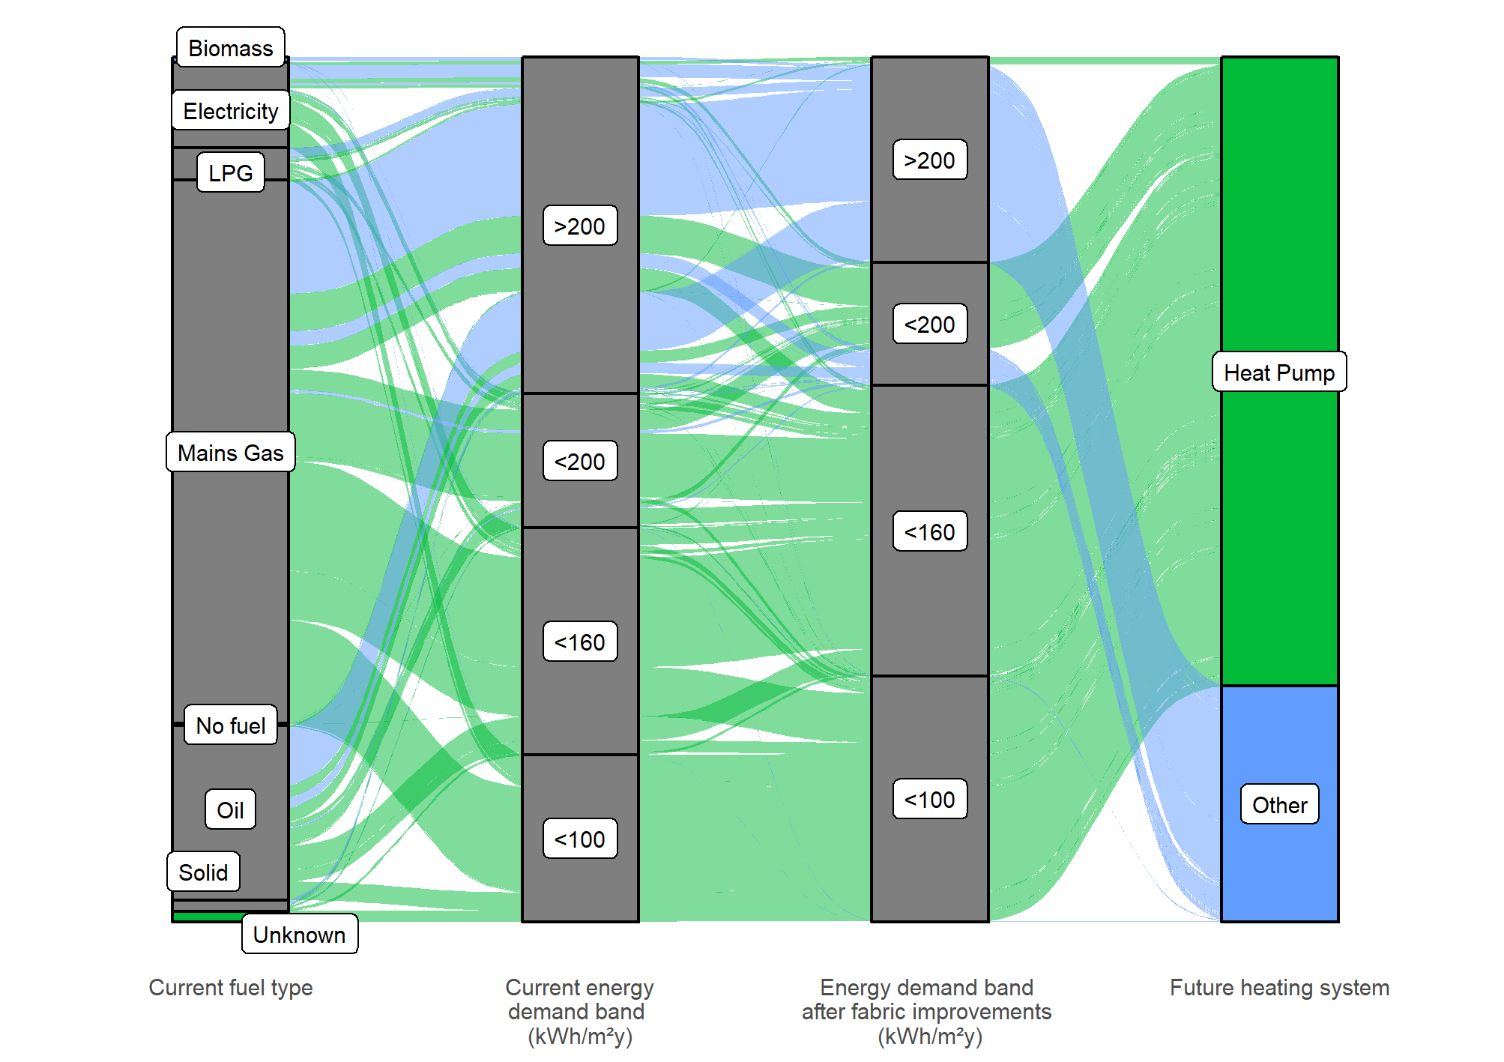

Maybole
Figure 44 shows all domestic properties within the Maybole area and, from the left, the heating fuel each uses today, the energy demand of the property per unit of floor area, the energy demand after the application of reasonable energy efficiency measures and finally the most suitable heating technology for each property at present.
The majority of homes in the Maybole area are suitable for simple heat pump installations.

Figure 44: Heat decarbonisation pathway for Maybole
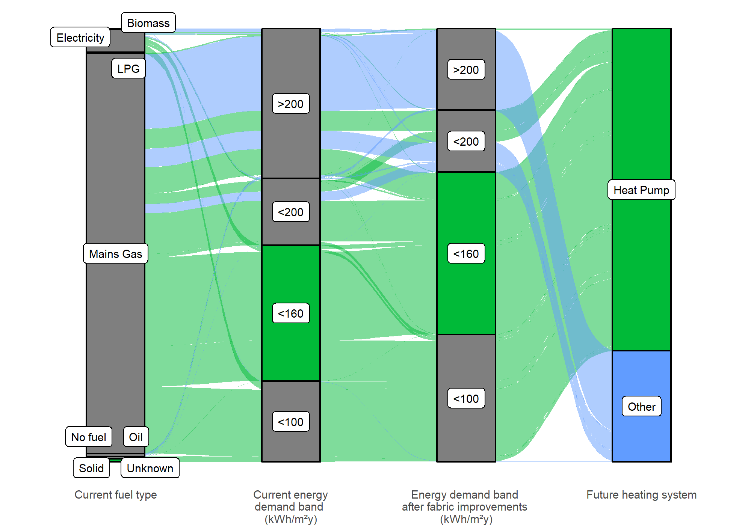

Prestwick
Figure 45 shows all domestic properties within the Prestwick area and, from the left, the heating fuel each uses today, the energy demand of the property per unit of floor area, the energy demand after the application of reasonable energy efficiency measures and finally the most suitable heating technology for each property at present.
The majority of homes in the Prestwick area are suitable for simple heat pump installations.

Figure 45: Heat decarbonisation pathway for Prestwick
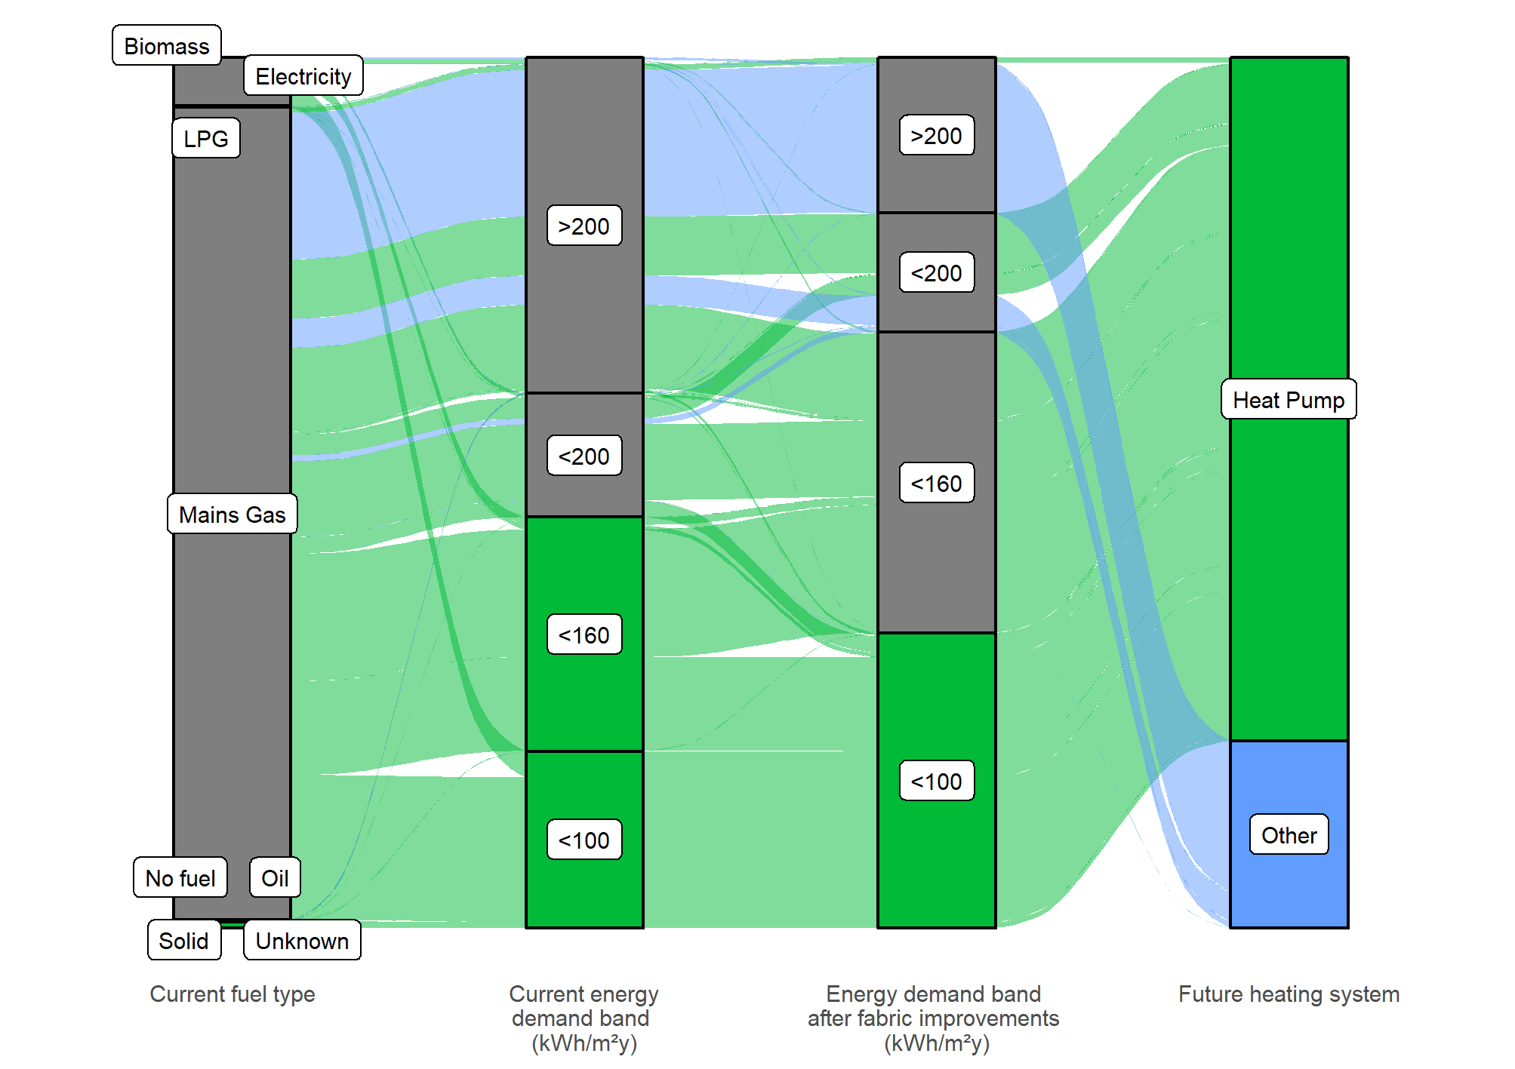

Troon
Figure 46 shows all domestic properties within the Troon area and, from the left, the heating fuel each uses today, the energy demand of the property per unit of floor area, the energy demand after the application of reasonable energy efficiency measures and finally the most suitable heating technology for each property at present.
The majority of homes in the Troon area are suitable for simple heat pump installations.
Figure 46: Heat decarbonisation pathway for Troon
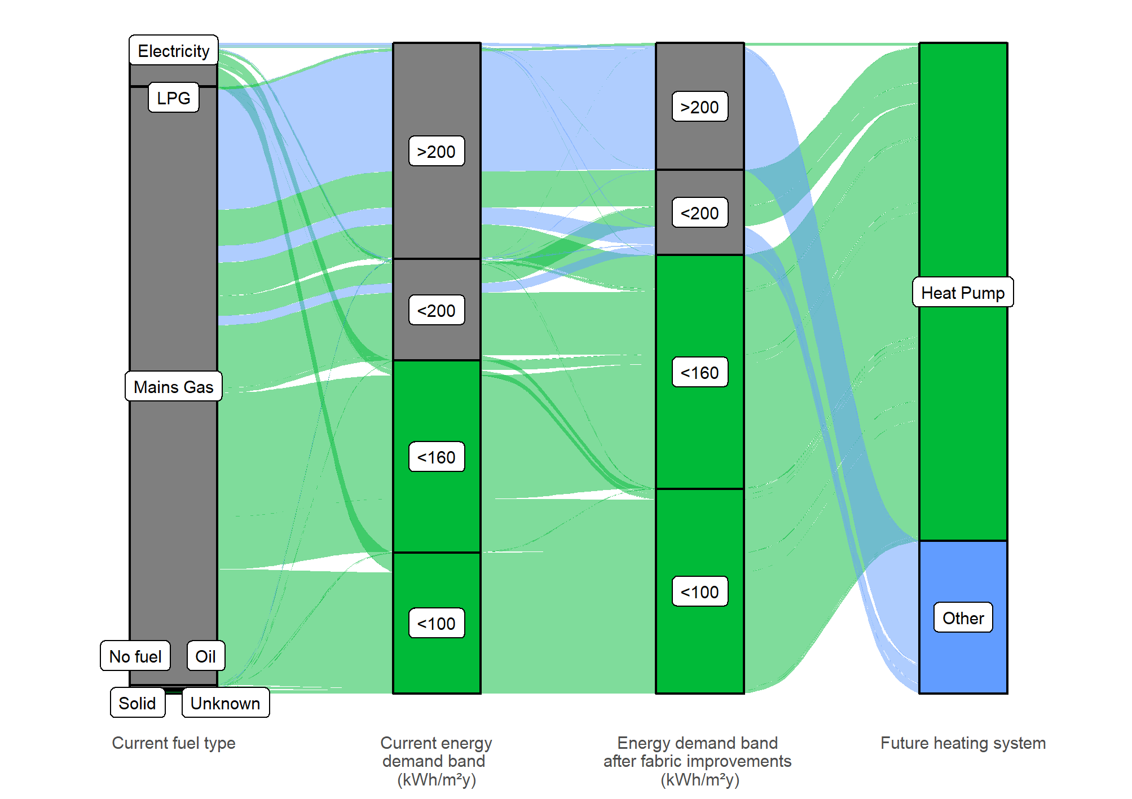

Conclusions
The analysis shows that for South Ayrshire to meet the two main objectives of decarbonising heat and reducing fuel poverty caused by poor energy efficiency a combination of measures are required and possible.
The strategic approach will be:
- Insulation of buildings where practical.
- Support development of district heating networks where they can provide reliable low carbon heat at a reasonable cost.
- Encourage deployment of individual or communal heat pump systems which deliver reliable heat at a reasonable cost.
- Decarbonise the Council’s non-domestic buildings:
  - In areas where district heating may be an option – consider being a customer or a supplier of heat.
  - In areas where district heating unlikely – identify alternative decarbonisation pathways.
- Work with businesses to develop their decarbonisation plans.
- Support economic development and inward investment through identification of heat opportunity areas.

Appendices
- Index of Tables and Figures
Table of Figures
Figure 1: Summary of LHEES Approach and Stages 7
Figure 2: Domestic buildings- Distributions of age, EPC rating and gas grid connectivity by tenure type 16
Figure 3: Domestic heating energy demand 17
Figure 4: Non-domestic heat demand by energy source and demand category 18
Figure 5: Non-domestic heat demand by energy source and floor area category 19
Figure 6: Non-domestic heat demand by energy source and building age category 20
Figure 7: Non-domestic building type by heat demand 21
Figure 8: South Ayrshire’s Strategic Zones 22
Figure 9: Baselining of domestic properties in the Strategic Zones 24
Figure 10: Domestic properties requiring upgrades to glazing, and loft and wall insulation 26
Figure 11: Wall construction in privately rented and owner-occupied houses 27
Figure 12: South Ayrshire overview of potential heat network zones 30
Figure 13: Ayr heat network opportunity – Baseline 31
Figure 14 Listed buildings and conservation areas 32
Figure 15 Girvan industrial heat cluster 33
Figure 16: Conservation area properties requiring upgrades to glazing, and loft and wall insulation 38
Figure 17: Domestic properties in mixed use buildings requiring upgrades to glazing, and loft and wall insulation 39
Figure 18: Map of Weighted Energy Efficiency Score – Data Zone Level 42
Figure 19: Histogram of Weighted Energy Efficiency Score – Data Zone Level 43
Figure 20: Map of Energy Efficiency as a Driver of Fuel Poverty – Data Zone Level 44
Figure 21: Histogram of Weighted Fuel Poverty Score – Data Zone Level 45
Figure 22: Map of Mixed-Tenure Properties – Data Zone Level 46
Figure 23: Histogram of Number of Mixed-Tenure Buildings – Data Zone Level 47
Figure 24: Mapped Domestic Properties within Conservation Area by Data Zone 48
Figure 25: Domestic Properties in Conservation Areas by Data Zones Histogram 49
Figure 26: Mapped Listed Domestic Properties by Data Zone 50
Figure 27: Listed Domestic Properties by Data Zone Histogram 51
Figure 28: Map of overall SIMD rank 53
Figure 29: Map of income SIMD rank 54
Figure 30: Data Zones ranked by Weighted Energy Efficiency Score and coloured by SIMD rank 55
Figure 31: Heat pump suitability and potential heat network areas 56
Figure 32: Larger, gas-heated non-domestic properties by use type 63
Figure 33: Space heating demand in larger, non-domestic, gas-heated buildings by type 64
Figure 34: Map with top non-domestic, gas-heated energy consuming types 65
Figure 35: Decarbonisation and energy efficiency pathway 67
Figure 36: Shifting energy demand by fabric improvement and heat pump installation 68
Figure 37: Total electricity demand reduction after energy efficiency measures and/ or heating system upgrade 69
Figure 38: Effect of actions in all properties in SIMD 1 areas – energy efficiency and heat pumps 70
Figure 39: Strategic zones 73
Figure 40: Decarbonisation pathway for domestic properties in Ayr 74
Figure 41: Heat decarbonisation pathway for Carrick 75
Figure 42: Heat decarbonisation pathway for Girvan 76
Figure 43: Heat decarbonisation pathway for Kyle 77
Figure 44: Heat decarbonisation pathway for Maybole 78
Figure 45: Heat decarbonisation pathway for Prestwick 79
Figure 46: Heat decarbonisation pathway for Troon 80
Figure 47: Weighted Energy Efficiency Scores vii
Figure 48: Weighted scores for fuel poverty resulting from poor energy efficiency viii
Figure 49: Heat transition categories for off-gas grid domestic properties xix
Figure 50: Heat transition categories for on-gas grid domestic properties xx
Figure 51 Ayr heat network zones – 4,000kWh/m (baseline) xxi
Figure 52 Ayr Heat network zones - 8,000kWh/m (Stringent) xxii
Figure 53 Girvan heat network zone (industrial) – 4,000kWh/m (baseline) xxiii
Figure 54 Girvan heat network zone (industrial) - 8,000kWh/m (baseline) xxiv
Figure 55: Heat pump suitability map- Ayr xxv
Figure 56: Heat pump suitability map- Girvan xxvi
Figure 57: Heat pump suitability map- Troon xxvii
Figure 58: Heat pump suitability map- Maybole xxviii
Figure 59: Heat pump suitability map- Ballantrae xxix
Figure 60: Heat pump suitability map- Dailly xxx

Table of Tables
Table 1: Abbreviations 4
Table 2: LHEES Considerations 6
Table 3: Heat decarbonisation interventions 8
Table 4: Local Policies and Strategies 11
Table 5: Domestic properties in the Strategic Zones 23
Table 6: Domestic energy efficiency weighted scores by strategic zone 25
Table 7: Summary of energy efficiency interventions across all buildings in South Ayrshire 27
Table 8: Domestic fuel poverty scores by strategic zone 28
Table 9: Heat pump suitability 36
Table 10: Impact of measures on domestic buildings by Locality 40
Table 11: Fuel prices used in fuel poverty analysis 51
Table 12: Number of homes by SIMD income decile 52
Table 13: Percentage of homes which could be affordably heated by households in income decile five or lower 52
Table 14: Intervention summary table 58
Table 15: Non-domestic EPCs in South Ayrshire 66
Table 16: Summary of policy and legislation iv
Table 17: Domestic energy efficiency- ranking by highest weighted score vi
Table 18: Domestic fuel poverty resulting from poor energy efficiency - highest ranked zones (default weightings) vii
Table 19: Domestic heating systems on and off the gas grid ix
Table 20: Energy Efficiency Weighted Scores and Interventions by Data Zones x
Table 21: Fuel Poverty Weighted Scores by Data Zones xiv
Table 22: Summary of Energy Efficiency Interventions Across all Buildings in South Ayrshire lxix
Table 23: Summary of Heating Systems Changes Across all South Ayrshire lxx
Table 24: Summary of Interventions Across Local Authority Owned Buildings lxxi
Table 25: Interventions for the Top Third of Data Zones, by Energy Efficiency as a Driver for Fuel Poverty lxxii
Table 26: Interventions for the Top Third of Data Zones, by Energy Efficiency as a Driver for Fuel Poverty, for LA-Owned Properties lxxiv
Table 27: Current Fuel Source in LA-Owned Homes in the Top Third of Data Zones by Fuel Poverty lxxv
Table 28: Cost of Fuels Used for this Analysis. lxxvi
Table 29: Annual Cost and Emissions of Heating, in Heat Pump Suitable Properties lxxvi

- Legislation Relating to LHEES
Table 16: Summary of policy and legislation
UK-Wide
The Climate Change Act 2008 (2050 Target Amendment) Order 2019:
Net Zero GHG Emissions by 2050
National – General
Heat in Buildings Strategy (2021)
Sets out a pathway to zero emissions buildings by 2045 and includes the New Renewable Heat Target for 2030
The Heat Networks (Scotland) Act 2021, which was followed by the Heat Network Delivery Plan, has targeted for 2.6 TWh to be supplied by heat networked by 2027 and 6 TWh by 2030. By October 2023, Scottish Ministers are required to set a target for 2035. The Act places a duty on local authorities to conduct a review of areas likely to be particularly suitable for heat networks within its area.
The Fuel Poverty (Targets, Definition and Strategy) (Scotland) Act 2019 which both defines fuel poverty and sets targets for fuel poverty eradication by 2040 with interim targets for 2030 and 2035. Following this, the Tackling Fuel Poverty in Scotland: A Strategic Approach was published in late 2021, which contains a strong focus on energy efficiency as a driver for fuel poverty.
Climate Change (Scotland) Act 2009: Public bodies have a duty to contribute to Scotland’s national emission reduction target
Climate Change (Emissions Reduction Targets) (Scotland) Act 2019: 75 % emissions reduction by 2030, 90 % emission reduction by 2040, and net zero GHG emissions by 2045
Update to the Climate Change Plan (2018-2032)
- By 2030 at least 50 % Scotland’s building stock heated using zero emission systems;
- Retrofit buildings and achieve ultra-high levels of fabric efficiency in new builds; and
- Reduce car kilometres by 20 % by 2030.
Scottish Government Climate Change Plan Update – Securing a Green Recovery on a Path to Net Zero (2020): Focus on green recovery to deliver net zero ambitions following the Covid-19 pandemic. Emphasis on green jobs, adaptation, and tackling fuel poverty.
- “By 2040, no more than 5 % of households in fuel poverty, and no more than 1 % in extreme fuel poverty”
Scottish Government Hydrogen Action Plan (2022): Ambition of 5GW of hydrogen production capacity by 2030 and 25GW by 2045.
Climate Emergency Skills Action Plan (Skills Development Scotland / Scottish Government) (2020): Local authorities are lead partners on Priority Area 1: Supporting a green labour market recovery from Covid-19, and Priority Area 5: Ensuring fairness and inclusion in the skills system as part of a just transition to net zero.
Scotland’s fourth National Planning Framework (NPF4)
- Encourage the reuse of brownfield, vacant and derelict land for new developments.
Draft Energy Strategy and Just Transition Plan (2023): “More than 20GW of additional renewable electricity on-and offshore by 2030”

National – Public Sector Specific
The Climate Change (Duties of Public Bodies: Reporting Requirements) (Scotland) Amendment Order 2020: Public bodies must report in their Public Bodies Climate Change Duties (PBCCD) Annual Reports:
- where applicable, “targets for reducing indirect emissions of greenhouse gases” Indirect emissions include supply chain emissions, and
- how they align their spending plans and use of resources to contribute to reducing emissions and delivering emissions reduction targets and report on this from March 2022.
Scottish Government and Scottish Green Party: draft shared policy programme (2021):
- “All publicly owned buildings to meet zero emission heating requirements, with a backstop of 2038.” This implies that most buildings would be decarbonised well before that. The programme commits to “a series of phased targets” for decarbonisation of public sector buildings starting in 2024. This will be driven through building standards/Heat in Buildings Regulations.
- “All new buildings where a building warrant is applied for from 2024 must use zero emissions heating as the primary heating source and meet significantly higher energy efficiency standards”.
Public Sector Leadership on the Global Climate Emergency (2021):
- “Decarbonise estate by 2038 at the latest, with zero carbon direct emissions from all buildings”.
- “Any fugitive emissions that can be reduced to absolute zero must be, however some areas of fugitive emissions may not be able to be reduced to absolute zero by 2045”.
- Public sector bodies must set emissions reduction targets for indirect emissions (such as business travel).

- Analysis of Core Indicators by Intermediate Zone
In this section, we are able to examine the data broken down by Intermediate Zone, which allows targets to be more easily identified within the constraints of data accuracy discussed earlier.
Domestic Energy Efficiency
The Home Analytics tool calculates a weighted energy efficiency score, which takes the frequency of 3 metrics, (low loft insulation thickness, a lack of wall insulation and a lack of double- / triple-glazing) across the building stock in a zone and weights them (by default, each is equally weighted) and then sums the 3 values to get a total energy efficiency score. A high score equates to poor energy efficiency in aggregate across the zone.
Table 17 ranks the top 12 intermediate zones on overall weighted score for energy efficiency. The maximum possible score (i.e. if every home in the zone had no loft or wall insulation and single glazing) is 100 so these scores are not high. It is notable that the spread across the zones is quite wide, with four standing out (Figure 47), suggesting that there may be grounds to prioritise interventions in one geographic area over another.
Wall insulation appears to be the most obvious target for improvement with the number of houses requiring an intervention ranging from 35 to 66 % in these 12 zones (compare to 2 to 22 % for loft insulation).

Table 17: Domestic energy efficiency- ranking by highest weighted score
Rank | Zones with highest total weighted score | Total weighted score | Number of potential interventions identified | Number of properties in zone
1 | Ayr South Harbour and Town Centre | 33 | 3,327 | 3,376
2 | Girvan Ailsa | 33 | 1,776 | 1,811
3 | Carrick South | 31 | 2,591 | 2,813
4 | Prestwick West | 30 | 1,871 | 2,060
5 | Troon | 25 | 2,271 | 2,983
6 | Prestwick East | 22 | 1,734 | 2,594
7 | Belmont | 21 | 1,613 | 2,529
8 | Maybole | 20 | 1,387 | 2,355
9 | Alloway and Doonfoot | 19 | 1,575 | 2,749
10 | Newton North | 17 | 1,131 | 2,208
11 | Ayr North Harbour, Wallacetown and Newton South | 17 | 1,630 | 3,211
12 | Prestwick Airport and Monkton | 17 | 836 | 1,658
There are a total of 25 zones.
Figure 47: Weighted Energy Efficiency Scores
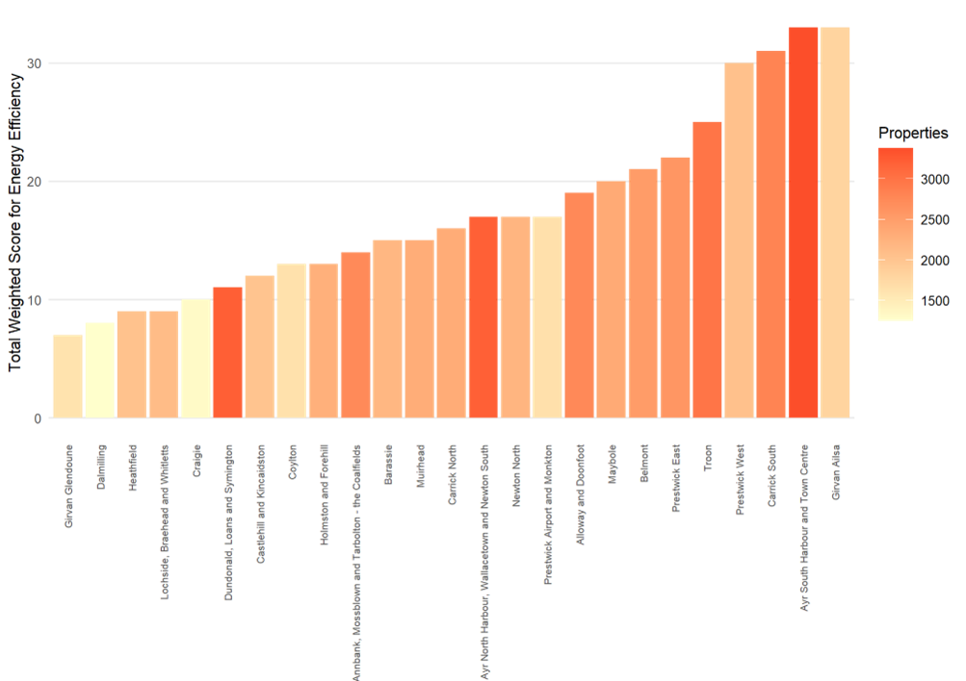
Domestic Fuel Poverty
The Home Analytics tool calculates a weighted energy efficiency score, which takes the frequency of 5 metrics, (low loft insulation thickness, a lack of wall insulation, a lack of double- / triple-glazing, number of households in fuel poverty and the number of households in extreme poverty) across the building stock in a zone and weights them (by default, the construction parameters are weighted 16.7%, with fuel poverty at 50% and extreme effectively poverty removed by a weighting of zero) and then sums the 5 values to get a total fuel poverty score. A high score equates to extensive fuel poverty as a result of poor energy efficiency across the zone.
It should be emphasised that this measure is intended to highlight homes where a lack of energy efficiency is a driver of fuel poverty and is not an outright measure of fuel poverty.
The ranking of the top 12 zones where energy efficiency is a driver for fuel poverty is shown in Table 18. The default weightings are used and, if specific interventions to tackle fuel poverty are to be prioritised during later stages of LHEES, then it may be appropriate to re-calculate these weighted scores based on the type of intervention planned. The variance between zones is less than for the Total Energy Efficiency Score with only the top three (the same top three) standing out (Figure 48).
Table 18: Domestic fuel poverty resulting from poor energy efficiency - highest ranked zones (default weightings)
 | Zones with highest total weighted score | Total weighted score | Number of properties in zone
1 | Carrick South | 33 | 2,813
2 | Girvan Ailsa | 31 | 1,811
3 | Ayr South Harbour and Town Centre | 27 | 3,376
4 | Ayr North Harbour, Wallacetown and Newton South | 24 | 3,211
5 | Maybole | 23 | 2,355
6 | Prestwick West | 23 | 2,060
7 | Girvan Glendoune | 22 | 1,618
8 | Troon | 21 | 2,983
9 | Lochside, Braehead and Whitletts | 20 | 2,121
10 | Annbank, Mossblown and Tarbolton - the Coalfields | 20 | 2,738
11 | Prestwick East | 20 | 2,594
12 | Dalmilling | 19 | 1,249
There are a total of 25 zones. A further 3 zones have a score of 19.
Figure 48: Weighted scores for fuel poverty resulting from poor energy efficiency
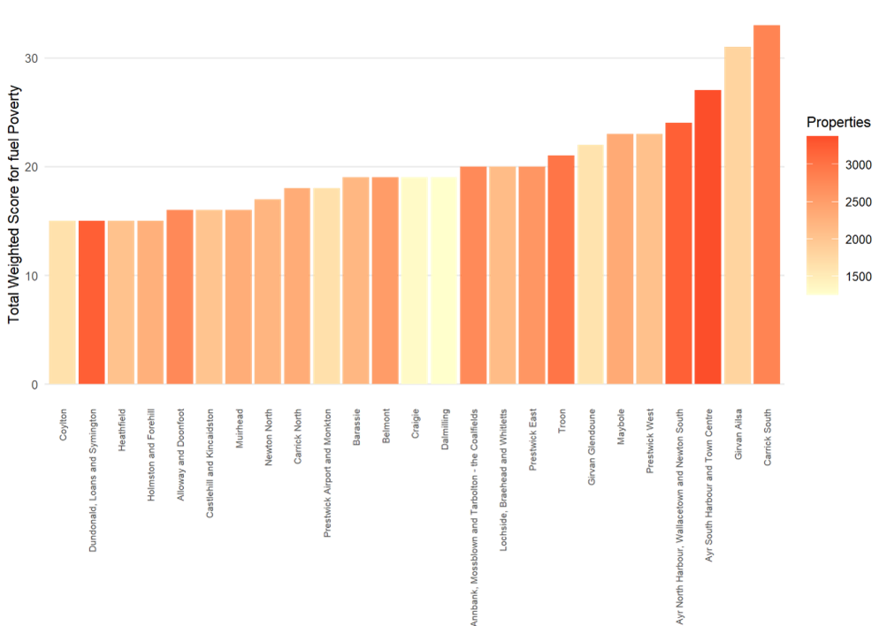
Domestic Buildings and the Gas Grid
Being on or off the existing gas grid are considerations within the LHEES process because this influences the likely future supply and decarbonisation of heat. On-grid buildings are likely to be currently using a fuel which is not getting less carbon intensive but are likely to have wet heating systems, suitable for heat network connections or heat pumps. Off-grid buildings are likely to be using a fuel which is getting closer to carbon neutral but not likely to have a wet system suitable for an electricity-saving upgrade to heat pumps. Of the off-grid properties, more use direct electrical heating than boilers. While these properties do not have water based heating systems, they are more likely to both reduce their energy consumption and running cost by switching to a heat pump than properties using lower cost energy sources. As such heat pumps in these properties could contribute to fuel poverty reduction but not necessarily towards net zero targets.
Table 19 details the heating systems associated with domestic properties on and off the gas grid. Almost all the on grid homes have boilers and, physical situation aside, are likely to be able to be connected to heat networks or heat pumps. However, given the energy efficiency status of the housing stock (Figure 2 and Table 17) and the age (Figure 2) it is likely that interventions to reduce heat losses and adjust heating systems to operate at lower temperatures will be required to allow heat pump installations in places where there are unlikely to be heat networks.
Table 19: Domestic heating systems on and off the gas grid
Heating System | On grid |  | Off grid
 | Count | Percentage | Count | Percentage
Communal | 77 | <1 % | 79 | 1 %
Heat pump | 440 | <1 % | 308 | 4 %
Boiler | 46,464 | 96 % | 5,443 | 62 %
Room heater | 430 | <1 % | 685 | 8 %
Storage heater | 805 | 2% | 2,076 | 24 %
Other or none | 268 | <1 % | 232 | 3 %
Communal heating systems refer to a heating system which provides heat to multiple properties within the same building.

- Analysis of Core Indicators by Data Zone

Domestic Energy Efficiency
The Home Analytics tool calculates a weighted energy efficiency score, which takes the frequency of 3 metrics, (low loft insulation thickness, a lack of wall insulation and a lack of double- / triple-glazing) across the building stock in a zone and weights them (by default, each is equally weighted) and then sums the 3 values to get a total energy efficiency score. A high score equates to poor energy efficiency in aggregate across the zone.
Table 20 lists all the zones and is the companion to Figure 19.
Table 20: Energy Efficiency Weighted Scores and Interventions by Data Zones
Data zone | Percentage of lofts with less than 99mm insulation | Percentage of windows which are single glazed | Percentage of walls which are uninsulated | Total Weighted Score for Energy Efficiency
Ayr South Harbour and Town Centre - 02 | 20% | 35% | 74% | 42.9
Ayr South Harbour and Town Centre - 06 | 20% | 30% | 77% | 42.0
Ayr South Harbour and Town Centre - 05 | 21% | 25% | 74% | 39.7
Girvan Ailsa - 02 | 35% | 7% | 76% | 39.0
Ayr South Harbour and Town Centre - 03 | 13% | 26% | 75% | 37.8
Prestwick West - 03 | 29% | 5% | 76% | 36.6
Belmont - 04 | 16% | 12% | 83% | 36.6
Carrick South - 02 | 25% | 12% | 73% | 36.4
Prestwick West - 02 | 24% | 10% | 75% | 36.3
Prestwick East - 02 | 28% | 7% | 74% | 35.9
Girvan Ailsa - 03 | 24% | 9% | 74% | 35.7
Girvan Ailsa - 05 | 24% | 8% | 68% | 33.4
Mauchline Rural - 02 | 0% | 0% | 100% | 33.0
Carrick South - 06 | 26% | 10% | 63% | 33.0
Girvan Ailsa - 01 | 27% | 6% | 66% | 33.0
Troon - 04 | 15% | 5% | 78% | 32.5
Ayr North Harbour, Wallacetown and Newton South - 02 | 24% | 4% | 69% | 32.1
Prestwick West - 04 | 15% | 6% | 74% | 31.7
Prestwick West - 05 | 18% | 9% | 68% | 31.3
Troon - 03 | 18% | 5% | 70% | 30.7
Carrick South - 07 | 21% | 15% | 57% | 30.7
Prestwick East - 03 | 23% | 9% | 57% | 29.3
Carrick South - 03 | 21% | 6% | 60% | 28.9
Newton North - 06 | 28% | 3% | 55% | 28.9
Carrick South - 04 | 19% | 13% | 52% | 28.2
Belmont - 01 | 13% | 11% | 59% | 27.6
Carrick North - 01 | 13% | 11% | 58% | 27.5
Maybole - 07 | 12% | 12% | 59% | 27.4
Carrick North - 03 | 26% | 12% | 44% | 27.1
Carrick South - 01 | 17% | 8% | 56% | 26.9
Troon - 06 | 9% | 12% | 59% | 26.7
Troon - 07 | 9% | 11% | 60% | 26.6
Belmont - 06 | 10% | 11% | 59% | 26.5
Ayr South Harbour and Town Centre - 07 | 10% | 15% | 55% | 26.4
Barassie - 01 | 15% | 3% | 61% | 26.4
Newton North - 04 | 16% | 5% | 57% | 25.9
Maybole - 06 | 11% | 10% | 56% | 25.6
Ayr North Harbour, Wallacetown and Newton South - 01 | 25% | 4% | 48% | 25.6
Ayr South Harbour and Town Centre - 04 | 12% | 13% | 50% | 24.9
Prestwick East - 01 | 18% | 3% | 51% | 24.1
Carrick South - 05 | 17% | 7% | 48% | 23.6
Troon - 02 | 19% | 5% | 46% | 23.3
Prestwick West - 01 | 11% | 5% | 55% | 23.2
Annbank, Mossblown and Tarbolton - the Coalfields - 02 | 14% | 3% | 52% | 22.8
Maybole - 01 | 21% | 3% | 43% | 22.1
Alloway and Doonfoot - 01 | 12% | 5% | 50% | 22.1
Alloway and Doonfoot - 07 | 2% | 2% | 62% | 22.0
Prestwick East - 06 | 19% | 2% | 45% | 21.7
Barassie - 06 | 5% | 2% | 56% | 21.1
Alloway and Doonfoot - 08 | 7% | 8% | 49% | 21.1
Dundonald, Loans and Symington - 02 | 16% | 6% | 40% | 20.5
Alloway and Doonfoot - 06 | 4% | 3% | 54% | 20.2
Muirhead - 08 | 5% | 4% | 52% | 20.1
Alloway and Doonfoot - 05 | 2% | 5% | 54% | 19.9
Prestwick West - 06 | 12% | 3% | 45% | 19.9
Holmston and Forehill - 02 | 9% | 6% | 45% | 19.8
Maybole - 03 | 15% | 4% | 39% | 19.6
Muirhead - 05 | 1% | 8% | 51% | 19.5
Muirhead - 06 | 16% | 2% | 39% | 18.9
Holmston and Forehill - 05 | 14% | 1% | 40% | 18.6
Maybole - 02 | 10% | 5% | 40% | 18.5
Girvan Ailsa - 04 | 9% | 8% | 39% | 18.4
Belmont - 07 | 9% | 3% | 43% | 18.3
Prestwick Airport and Monkton - 02 | 20% | 2% | 32% | 18.1
Troon - 05 | 11% | 1% | 42% | 17.9
Prestwick Airport and Monkton - 01 | 10% | 5% | 39% | 17.8
Annbank, Mossblown and Tarbolton - the Coalfields - 07 | 9% | 7% | 37% | 17.7
Prestwick East - 04 | 15% | 2% | 36% | 17.7
Craigie - 01 | 8% | 1% | 42% | 17.1
Newton North - 02 | 10% | 1% | 40% | 17.0
Barassie - 03 | 9% | 2% | 40% | 16.9
Maybole - 04 | 10% | 5% | 37% | 16.8
Troon - 01 | 3% | 3% | 45% | 16.8
Newton North - 01 | 8% | 3% | 40% | 16.6
Dundonald, Loans and Symington - 05 | 23% | 7% | 19% | 16.5
Annbank, Mossblown and Tarbolton - the Coalfields - 05 | 11% | 3% | 35% | 16.4
Muirhead - 04 | 4% | 6% | 40% | 16.4
Dundonald, Loans and Symington - 06 | 9% | 5% | 35% | 16.4
Prestwick Airport and Monkton - 04 | 6% | 3% | 40% | 16.1
Prestwick East - 07 | 12% | 2% | 34% | 15.8
Alloway and Doonfoot - 04 | 6% | 3% | 38% | 15.5
Coylton - 05 | 5% | 8% | 34% | 15.4
Castlehill and Kincaidston - 02 | 10% | 3% | 32% | 15.3
Alloway and Doonfoot - 03 | 9% | 3% | 34% | 15.3
Belmont - 03 | 7% | 9% | 29% | 14.9
Lochside, Braehead and Whitletts - 06 | 9% | 3% | 31% | 14.4
Carrick North - 04 | 8% | 5% | 30% | 14.3
Muirhead - 07 | 13% | 1% | 28% | 14.1
Muirhead - 03 | 8% | 1% | 33% | 14.0
Castlehill and Kincaidston - 06 | 8% | 6% | 28% | 14.0
Dalmilling - 01 | 7% | 4% | 31% | 13.9
Coylton - 02 | 9% | 2% | 32% | 13.9
Coylton - 04 | 9% | 1% | 31% | 13.7
Annbank, Mossblown and Tarbolton - the Coalfields - 03 | 5% | 3% | 33% | 13.5
Belmont - 05 | 6% | 3% | 31% | 13.1
Heathfield - 04 | 5% | 3% | 31% | 13.0
Holmston and Forehill - 03 | 4% | 4% | 30% | 12.5
Annbank, Mossblown and Tarbolton - the Coalfields - 06 | 8% | 4% | 26% | 12.5
Castlehill and Kincaidston - 07 | 6% | 5% | 26% | 12.4
Dundonald, Loans and Symington - 03 | 3% | 4% | 30% | 12.3
Prestwick Airport and Monkton - 03 | 2% | 5% | 30% | 12.3
Belmont - 02 | 8% | 8% | 21% | 12.3
Ayr North Harbour, Wallacetown and Newton South - 03 | 8% | 4% | 25% | 12.2
Newton North - 05 | 10% | 2% | 23% | 12.0
Alloway and Doonfoot - 02 | 0% | 5% | 31% | 12.0
Ayr North Harbour, Wallacetown and Newton South - 04 | 8% | 3% | 25% | 11.7
Ayr North Harbour, Wallacetown and Newton South - 06 | 5% | 2% | 28% | 11.6
Castlehill and Kincaidston - 04 | 13% | 4% | 17% | 11.4
Heathfield - 06 | 2% | 2% | 30% | 11.2
Holmston and Forehill - 04 | 7% | 5% | 21% | 10.9
Castlehill and Kincaidston - 05 | 4% | 3% | 25% | 10.8
Dundonald, Loans and Symington - 01 | 10% | 3% | 18% | 10.7
Annbank, Mossblown and Tarbolton - the Coalfields - 04 | 10% | 4% | 18% | 10.4
Coylton - 01 | 3% | 2% | 26% | 10.2
Prestwick East - 05 | 6% | 5% | 19% | 10.0
Holmston and Forehill - 07 | 2% | 2% | 26% | 9.8
Coylton - 03 | 4% | 4% | 21% | 9.7
Holmston and Forehill - 06 | 8% | 4% | 17% | 9.6
Lochside, Braehead and Whitletts - 05 | 5% | 1% | 23% | 9.6
Muirhead - 02 | 10% | 1% | 17% | 9.5
Castlehill and Kincaidston - 01 | 6% | 2% | 20% | 9.5
Ayr North Harbour, Wallacetown and Newton South - 05 | 3% | 6% | 20% | 9.5
Heathfield - 05 | 5% | 3% | 21% | 9.3
Lochside, Braehead and Whitletts - 04 | 7% | 2% | 19% | 9.1
Craigie - 03 | 4% | 1% | 20% | 8.4
Carrick North - 02 | 8% | 2% | 15% | 8.1
Holmston and Forehill - 01 | 3% | 3% | 19% | 8.1
Girvan Glendoune - 05 | 2% | 2% | 21% | 8.0
Castlehill and Kincaidston - 03 | 8% | 2% | 14% | 7.9
Girvan Glendoune - 03 | 5% | 3% | 15% | 7.8
Dundonald, Loans and Symington - 04 | 8% | 0% | 15% | 7.7
Newton North - 03 | 4% | 2% | 17% | 7.7
Muirhead - 01 | 5% | 3% | 15% | 7.5
Barassie - 04 | 7% | 3% | 13% | 7.4
Heathfield - 01 | 3% | 3% | 16% | 7.4
Heathfield - 02 | 4% | 0% | 17% | 7.3
Annbank, Mossblown and Tarbolton - the Coalfields - 01 | 12% | 3% | 6% | 7.0
Girvan Glendoune - 01 | 6% | 4% | 11% | 6.8
Barassie - 05 | 6% | 2% | 11% | 6.7
Barassie - 02 | 4% | 2% | 13% | 6.4
Lochside, Braehead and Whitletts - 03 | 4% | 1% | 13% | 6.2
Dundonald, Loans and Symington - 07 | 2% | 2% | 15% | 6.2
Craigie - 02 | 6% | 1% | 11% | 6.0
Dalmilling - 02 | 8% | 3% | 7% | 5.9
Girvan Glendoune - 04 | 3% | 1% | 13% | 5.8
Lochside, Braehead and Whitletts - 02 | 6% | 2% | 9% | 5.7
Girvan Glendoune - 02 | 2% | 5% | 9% | 5.4
Lochside, Braehead and Whitletts - 01 | 4% | 2% | 9% | 5.0
Dalmilling - 04 | 2% | 1% | 12% | 4.7
Maybole - 05 | 2% | 0% | 12% | 4.7
Dalmilling - 03 | 5% | 2% | 7% | 4.6
Carrick North - 05 | 1% | 2% | 12% | 4.6
Heathfield - 03 | 2% | 1% | 6% | 2.9
Ayr South Harbour and Town Centre - 01 | 1% | 0% | 0% | 0.3

Domestic Fuel Poverty Resulting from Poor Energy Efficiency
The Home Analytics tool calculates a weighted energy efficiency score, which takes the frequency of 5 metrics, (low loft insulation thickness, a lack of wall insulation, a lack of double- / triple-glazing, number of households in fuel poverty and the number of households in extreme poverty) across the building stock in a zone and weights them (by default, the construction parameters are weighted 16.7%, with fuel poverty at 50% and extreme effectively poverty removed by a weighting of zero) and then sums the 5 values to get a total fuel poverty score. A high score equates to extensive fuel poverty as a result of poor energy efficiency across the zone.
It should be emphasised that this measure is intended to highlight homes where a lack of energy efficiency is a driver of fuel poverty and is not an outright measure of fuel poverty.
Table 21 lists all the zones and is the companion to Figure 21.
Table 21: Fuel Poverty Weighted Scores by Data Zones
Data Zone | Percentage of lofts with less than 99mm insulation | Percentage of windows which are single glazed | Percentage of walls which are uninsulated | Households in fuel poverty | Households in extreme fuel poverty | Total Weighted Score
 |  |  |  | (fuel bill >10 % of income after housing) | (fuel bill >20 % of income after housing)
Carrick South - 02 | 25% | 12% | 73% | 35% | 49% | 35.4
Ayr South Harbour and Town Centre - 02 | 20% | 35% | 74% | 27% | 18% | 34.5
Girvan Ailsa - 05 | 24% | 8% | 68% | 34% | 26% | 33.5
Carrick South - 03 | 21% | 6% | 60% | 38% | 74% | 33.1
Carrick South - 06 | 26% | 10% | 63% | 34% | 42% | 33.1
Girvan Ailsa - 02 | 35% | 7% | 76% | 26% | 11% | 32.0
Girvan Ailsa - 01 | 27% | 6% | 66% | 31% | 19% | 31.7
Carrick South - 01 | 17% | 8% | 56% | 37% | 47% | 31.6
Carrick South - 05 | 17% | 7% | 48% | 38% | 69% | 30.7
Girvan Ailsa - 03 | 24% | 9% | 74% | 26% | 12% | 30.6
Ayr South Harbour and Town Centre - 06 | 20% | 30% | 77% | 16% | 0% | 28.9
Carrick North - 01 | 13% | 11% | 58% | 30% | 33% | 28.5
Ayr South Harbour and Town Centre - 03 | 13% | 26% | 75% | 18% | 1% | 27.6
Troon - 04 | 15% | 5% | 78% | 22% | 5% | 27.1
Ayr South Harbour and Town Centre - 04 | 12% | 13% | 50% | 30% | 18% | 27.1
Carrick South - 07 | 21% | 15% | 57% | 24% | 8% | 27.0
Prestwick West - 02 | 24% | 10% | 75% | 18% | 1% | 26.8
Ayr South Harbour and Town Centre - 05 | 21% | 25% | 74% | 14% | 0% | 26.7
Maybole - 06 | 11% | 10% | 56% | 27% | 15% | 26.3
Girvan Ailsa - 04 | 9% | 8% | 39% | 34% | 18% | 26.0
Ayr North Harbour, Wallacetown and Newton South - 02 | 24% | 4% | 69% | 20% | 3% | 25.6
Annbank, Mossblown and Tarbolton - the Coalfields - 02 | 14% | 3% | 52% | 29% | 17% | 25.5
Maybole - 01 | 21% | 3% | 43% | 29% | 18% | 25.2
Prestwick West - 03 | 29% | 5% | 76% | 14% | 0% | 25.1
Ayr North Harbour, Wallacetown and Newton South - 01 | 25% | 4% | 48% | 25% | 9% | 25.0
Prestwick West - 04 | 15% | 6% | 74% | 19% | 2% | 24.9
Carrick North - 03 | 26% | 12% | 44% | 23% | 8% | 24.9
Maybole - 03 | 15% | 4% | 39% | 30% | 19% | 24.8
Maybole - 02 | 10% | 5% | 40% | 31% | 22% | 24.8
Troon - 03 | 18% | 5% | 70% | 19% | 4% | 24.6
Belmont - 04 | 16% | 12% | 83% | 13% | 1% | 24.5
Craigie - 01 | 8% | 1% | 42% | 32% | 38% | 24.2
Prestwick East - 02 | 28% | 7% | 74% | 13% | 0% | 24.1
Girvan Glendoune - 02 | 2% | 5% | 9% | 42% | 31% | 23.8
Girvan Glendoune - 04 | 3% | 1% | 13% | 42% | 38% | 23.7
Mauchline Rural - 02 | 0% | 0% | 100% | 15% | 0% | 23.7
Belmont - 01 | 13% | 11% | 59% | 20% | 6% | 23.5
Newton North - 06 | 28% | 3% | 55% | 18% | 2% | 23.3
Ayr North Harbour, Wallacetown and Newton South - 03 | 8% | 4% | 25% | 34% | 28% | 23.2
Barassie - 06 | 5% | 2% | 56% | 26% | 7% | 23.2
Barassie - 03 | 9% | 2% | 40% | 29% | 18% | 23.0
Prestwick West - 05 | 18% | 9% | 68% | 14% | 0% | 22.5
Heathfield - 04 | 5% | 3% | 31% | 32% | 19% | 22.2
Girvan Glendoune - 03 | 5% | 3% | 15% | 37% | 29% | 22.2
Ayr North Harbour, Wallacetown and Newton South - 05 | 3% | 6% | 20% | 35% | 33% | 22.1
Barassie - 01 | 15% | 3% | 61% | 18% | 2% | 22.0
Lochside, Braehead and Whitletts - 02 | 6% | 2% | 9% | 38% | 31% | 21.9
Prestwick East - 06 | 19% | 2% | 45% | 23% | 7% | 21.9
Ayr North Harbour, Wallacetown and Newton South - 04 | 8% | 3% | 25% | 32% | 29% | 21.8
Dalmilling - 01 | 7% | 4% | 31% | 30% | 17% | 21.8
Girvan Glendoune - 01 | 6% | 4% | 11% | 37% | 19% | 21.7
Annbank, Mossblown and Tarbolton - the Coalfields - 07 | 9% | 7% | 37% | 26% | 15% | 21.5
Ayr North Harbour, Wallacetown and Newton South - 06 | 5% | 2% | 28% | 32% | 22% | 21.5
Prestwick East - 01 | 18% | 3% | 51% | 19% | 4% | 21.4
Annbank, Mossblown and Tarbolton - the Coalfields - 05 | 11% | 3% | 35% | 27% | 17% | 21.3
Annbank, Mossblown and Tarbolton - the Coalfields - 06 | 8% | 4% | 26% | 30% | 32% | 21.2
Lochside, Braehead and Whitletts - 03 | 4% | 1% | 13% | 36% | 31% | 21.0
Maybole - 04 | 10% | 5% | 37% | 25% | 14% | 21.0
Troon - 07 | 9% | 11% | 60% | 15% | 1% | 20.8
Prestwick East - 03 | 23% | 9% | 57% | 13% | 0% | 20.7
Lochside, Braehead and Whitletts - 06 | 9% | 3% | 31% | 27% | 13% | 20.7
Prestwick Airport and Monkton - 04 | 6% | 3% | 40% | 26% | 10% | 20.7
Maybole - 07 | 12% | 12% | 59% | 14% | 0% | 20.6
Holmston and Forehill - 02 | 9% | 6% | 45% | 21% | 9% | 20.2
Ayr South Harbour and Town Centre - 07 | 10% | 15% | 55% | 14% | 0% | 20.2
Prestwick West - 01 | 11% | 5% | 55% | 18% | 2% | 20.2
Troon - 06 | 9% | 12% | 59% | 14% | 0% | 20.1
Newton North - 04 | 16% | 5% | 57% | 15% | 0% | 20.0
Lochside, Braehead and Whitletts - 04 | 7% | 2% | 19% | 31% | 21% | 19.8
Dalmilling - 03 | 5% | 2% | 7% | 35% | 33% | 19.6
Castlehill and Kincaidston - 04 | 13% | 4% | 17% | 28% | 12% | 19.5
Muirhead - 01 | 5% | 3% | 15% | 32% | 29% | 19.5
Dundonald, Loans and Symington - 02 | 16% | 6% | 40% | 18% | 1% | 19.3
Belmont - 06 | 10% | 11% | 59% | 12% | 0% | 19.2
Castlehill and Kincaidston - 06 | 8% | 6% | 28% | 24% | 14% | 19.1
Troon - 05 | 11% | 1% | 42% | 20% | 5% | 18.9
Muirhead - 06 | 16% | 2% | 39% | 18% | 1% | 18.4
Lochside, Braehead and Whitletts - 05 | 5% | 1% | 23% | 27% | 22% | 18.4
Dalmilling - 04 | 2% | 1% | 12% | 32% | 22% | 18.4
Lochside, Braehead and Whitletts - 01 | 4% | 2% | 9% | 32% | 18% | 18.3
Newton North - 02 | 10% | 1% | 40% | 20% | 1% | 18.2
Prestwick Airport and Monkton - 02 | 20% | 2% | 32% | 18% | 0% | 18.1
Dundonald, Loans and Symington - 04 | 8% | 0% | 15% | 29% | 26% | 18.0
Craigie - 03 | 4% | 1% | 20% | 28% | 12% | 18.0
Castlehill and Kincaidston - 05 | 4% | 3% | 25% | 25% | 8% | 17.9
Alloway and Doonfoot - 08 | 7% | 8% | 49% | 15% | 0% | 17.7
Troon - 02 | 19% | 5% | 46% | 13% | 0% | 17.7
Prestwick East - 05 | 6% | 5% | 19% | 25% | 11% | 17.6
Annbank, Mossblown and Tarbolton - the Coalfields - 03 | 5% | 3% | 33% | 22% | 5% | 17.5
Prestwick East - 04 | 15% | 2% | 36% | 17% | 0% | 17.4
Alloway and Doonfoot - 01 | 12% | 5% | 50% | 13% | 0% | 17.2
Prestwick West - 06 | 12% | 3% | 45% | 15% | 0% | 17.1
Alloway and Doonfoot - 07 | 2% | 2% | 62% | 13% | 0% | 17.1
Coylton - 05 | 5% | 8% | 34% | 19% | 2% | 17.0
Prestwick Airport and Monkton - 01 | 10% | 5% | 39% | 16% | 0% | 16.9
Dundonald, Loans and Symington - 06 | 9% | 5% | 35% | 17% | 1% | 16.7
Annbank, Mossblown and Tarbolton - the Coalfields - 04 | 10% | 4% | 18% | 23% | 11% | 16.7
Newton North - 01 | 8% | 3% | 40% | 17% | 0% | 16.6
Belmont - 05 | 6% | 3% | 31% | 20% | 2% | 16.6
Dundonald, Loans and Symington - 03 | 3% | 4% | 30% | 21% | 8% | 16.6
Belmont - 02 | 8% | 8% | 21% | 21% | 7% | 16.6
Girvan Glendoune - 05 | 2% | 2% | 21% | 25% | 14% | 16.6
Dundonald, Loans and Symington - 05 | 23% | 7% | 19% | 16% | 0% | 16.4
Annbank, Mossblown and Tarbolton - the Coalfields - 01 | 12% | 3% | 6% | 26% | 14% | 16.4
Coylton - 01 | 3% | 2% | 26% | 23% | 11% | 16.3
Alloway and Doonfoot - 05 | 2% | 5% | 54% | 13% | 0% | 16.3
Heathfield - 05 | 5% | 3% | 21% | 23% | 13% | 16.3
Alloway and Doonfoot - 06 | 4% | 3% | 54% | 13% | 0% | 16.1
Belmont - 03 | 7% | 9% | 29% | 18% | 1% | 16.1
Muirhead - 08 | 5% | 4% | 52% | 12% | 0% | 16.0
Dalmilling - 02 | 8% | 3% | 7% | 26% | 18% | 15.8
Coylton - 04 | 9% | 1% | 31% | 18% | 1% | 15.7
Prestwick East - 07 | 12% | 2% | 34% | 16% | 0% | 15.7
Castlehill and Kincaidston - 07 | 6% | 5% | 26% | 19% | 1% | 15.6
Muirhead - 05 | 1% | 8% | 51% | 12% | 0% | 15.6
Muirhead - 02 | 10% | 1% | 17% | 22% | 6% | 15.5
Holmston and Forehill - 05 | 14% | 1% | 40% | 13% | 0% | 15.5
Holmston and Forehill - 06 | 8% | 4% | 17% | 21% | 7% | 15.5
Barassie - 02 | 4% | 2% | 13% | 24% | 9% | 15.3
Belmont - 07 | 9% | 3% | 43% | 13% | 0% | 15.3
Heathfield - 06 | 2% | 2% | 30% | 20% | 1% | 15.2
Heathfield - 01 | 3% | 3% | 16% | 23% | 10% | 15.2
Maybole - 05 | 2% | 0% | 12% | 25% | 12% | 14.8
Craigie - 02 | 6% | 1% | 11% | 24% | 7% | 14.8
Holmston and Forehill - 04 | 7% | 5% | 21% | 19% | 1% | 14.8
Troon - 01 | 3% | 3% | 45% | 13% | 0% | 14.6
Muirhead - 04 | 4% | 6% | 40% | 13% | 0% | 14.4
Carrick North - 04 | 8% | 5% | 30% | 14% | 0% | 14.2
Coylton - 02 | 9% | 2% | 32% | 15% | 0% | 14.1
Castlehill and Kincaidston - 03 | 8% | 2% | 14% | 20% | 2% | 14.1
Prestwick Airport and Monkton - 03 | 2% | 5% | 30% | 16% | 0% | 14.0
Alloway and Doonfoot - 03 | 9% | 3% | 34% | 13% | 1% | 13.9
Alloway and Doonfoot - 04 | 6% | 3% | 38% | 13% | 0% | 13.9
Dundonald, Loans and Symington - 01 | 10% | 3% | 18% | 17% | 1% | 13.9
Castlehill and Kincaidston - 02 | 10% | 3% | 32% | 13% | 0% | 13.8
Muirhead - 07 | 13% | 1% | 28% | 13% | 0% | 13.5
Holmston and Forehill - 03 | 4% | 4% | 30% | 14% | 0% | 13.3
Newton North - 05 | 10% | 2% | 23% | 15% | 0% | 13.2
Muirhead - 03 | 8% | 1% | 33% | 13% | 0% | 13.2
Newton North - 03 | 4% | 2% | 17% | 18% | 1% | 13.0
Barassie - 05 | 6% | 2% | 11% | 19% | 0% | 12.9
Carrick North - 02 | 8% | 2% | 15% | 18% | 3% | 12.9
Alloway and Doonfoot - 02 | 0% | 5% | 31% | 14% | 0% | 12.6
Barassie - 04 | 7% | 3% | 13% | 17% | 0% | 12.2
Holmston and Forehill - 07 | 2% | 2% | 26% | 14% | 0% | 11.9
Coylton - 03 | 4% | 4% | 21% | 14% | 0% | 11.9
Holmston and Forehill - 01 | 3% | 3% | 19% | 16% | 0% | 11.8
Castlehill and Kincaidston - 01 | 6% | 2% | 20% | 13% | 0% | 11.0
Heathfield - 02 | 4% | 0% | 17% | 14% | 0% | 10.8
Dundonald, Loans and Symington - 07 | 2% | 2% | 15% | 14% | 0% | 10.3
Carrick North - 05 | 1% | 2% | 12% | 14% | 0% | 9.4
Ayr South Harbour and Town Centre - 01 | 1% | 0% | 0% | 18% | 1% | 9.0
Heathfield - 03 | 2% | 1% | 6% | 14% | 0% | 8.6

- Off-gas grid and On-gas grid
The domestic baseline tool outlines a method of categorising properties based on their suitability for heat pumps. While this report uses an alternative methodology as set out in section 7.7.3, the, this appendix sets out the findings of the methodology set out in the baseline tool.
Off-gas grid
The Domestic Baseline Tool categorises individual properties according to how difficult it will be to transition each property to a low-carbon heat source. This is based on several factors including, for example, the existing heating system, listed status and the existing fabric. Category 0 properties are already low carbon, Category 1 properties are ready make use of a heat pump with minimal changes to the existing building and Category 2 properties could transition with modest changes. Category 3 properties may require such substantial changes that other electrical or biomass heat sources may be more suitable.
Figure 49 shows that most off-grid properties sit in Category 3, meaning that there is a potential challenge to convert these to efficient heat-pump systems.
Figure 49: Heat transition categories for off-gas grid domestic properties
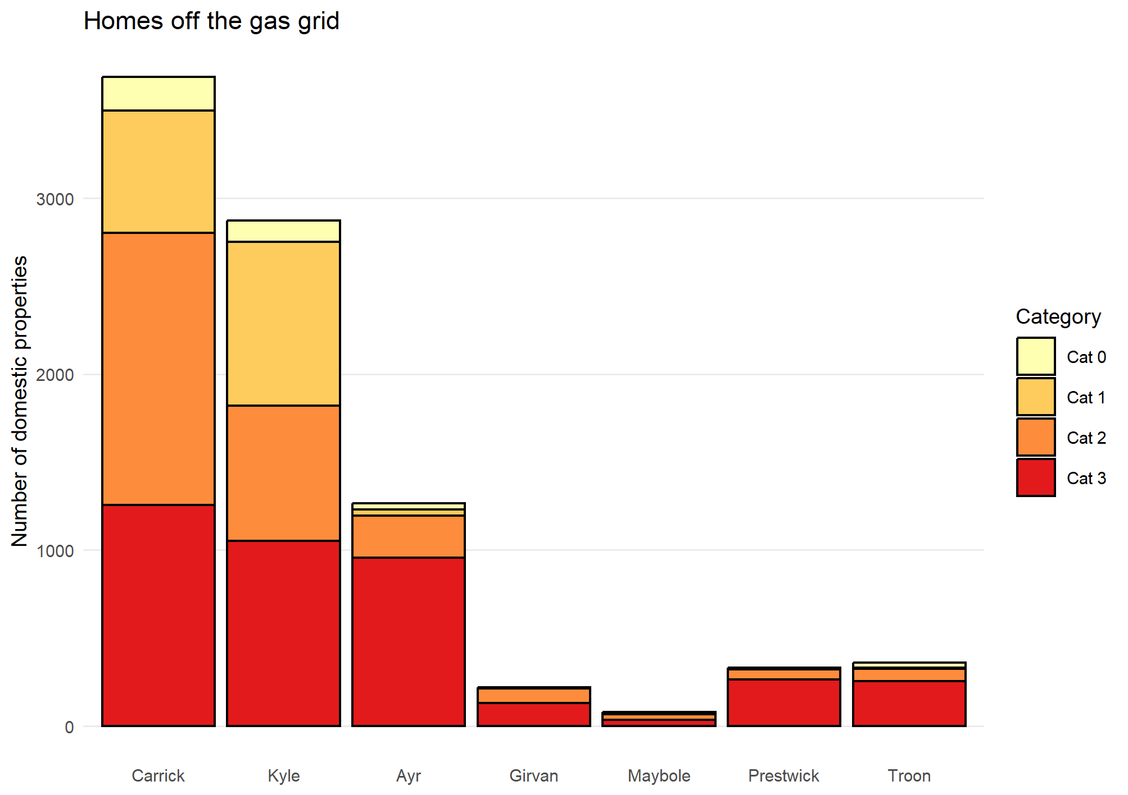

On-gas grid
On-gas grid buildings are similarly categorised by the Domestic Baseline Tool although it might be expected that more on-grid properties will find themselves in areas with heat networks and a connection to these rather than heat pumps might be likely. Most properties are in Categories 1 and 2 (Figure 50) and so lend themselves to transition, although Ayr has a large proportion of Category 3 homes.
Figure 50: Heat transition categories for on-gas grid domestic properties
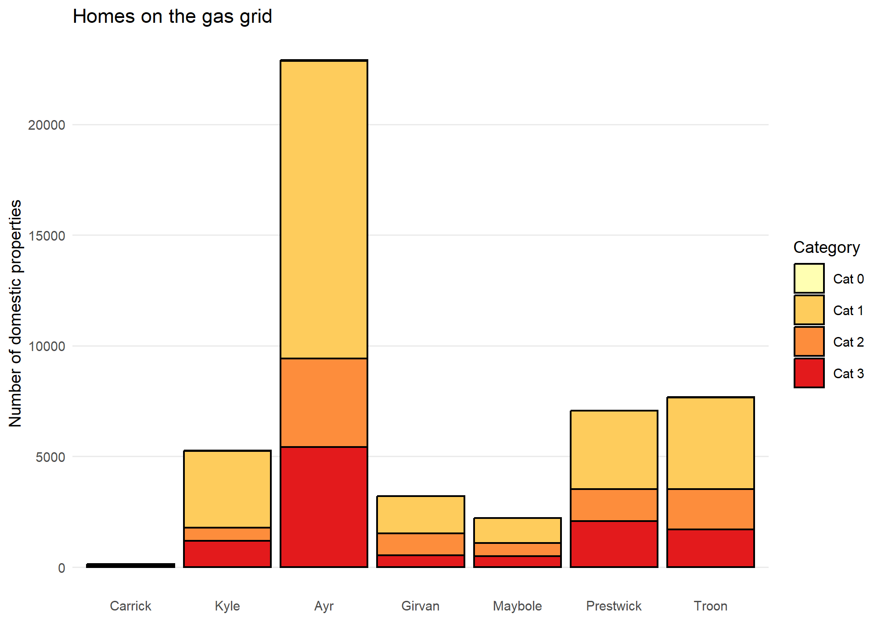

- Heat Network Zone Maps

Figure 51 Ayr heat network zones – 4,000kWh/m (baseline)
Figure 52 Ayr Heat network zones - 8,000kWh/m (Stringent)
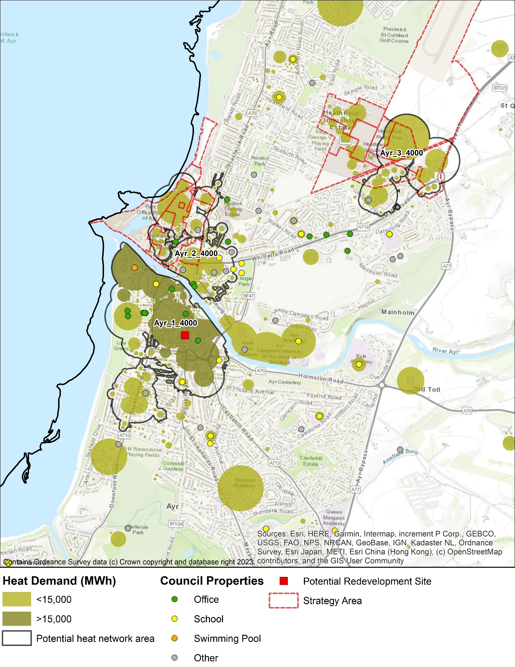
Figure 53 Girvan heat network zone (industrial) – 4,000kWh/m (baseline)
Figure 54 Girvan heat network zone (industrial) - 8,000kWh/m (baseline)
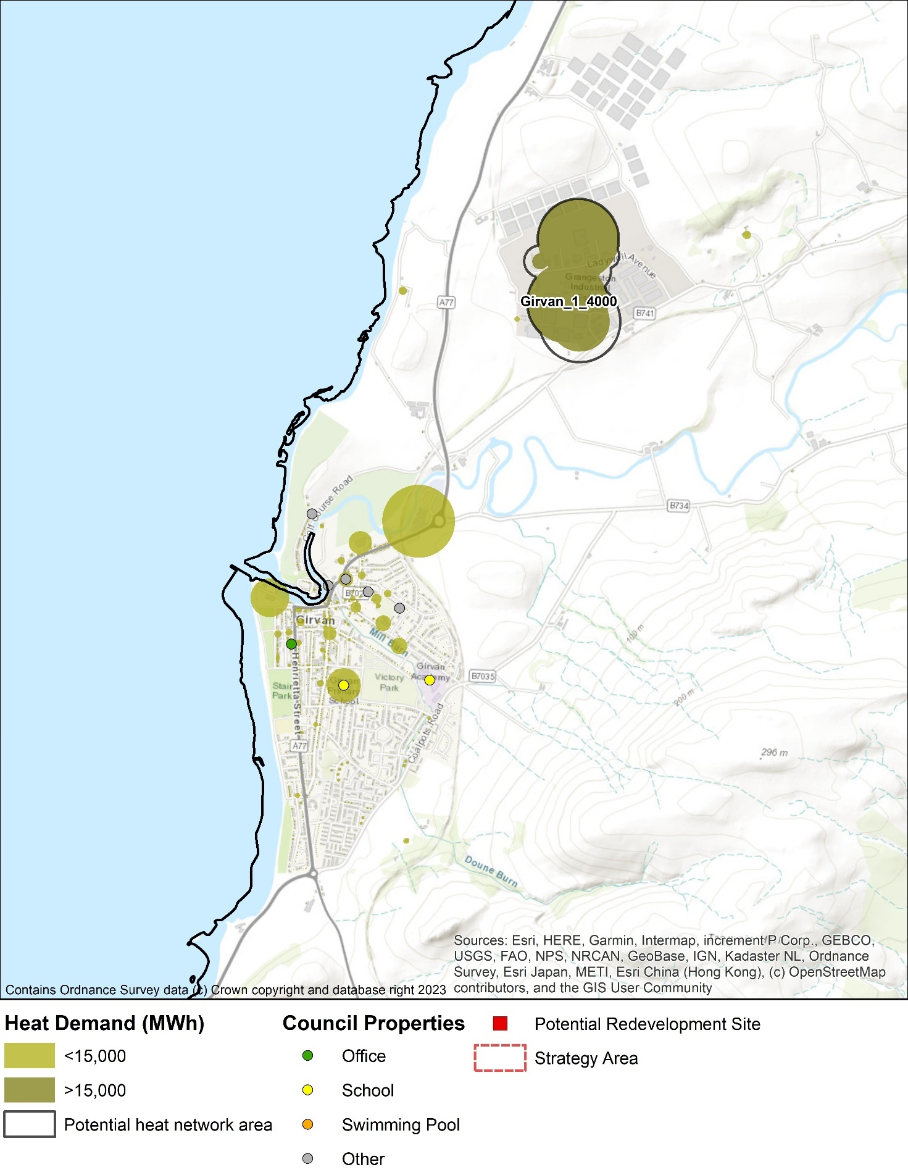
- Heat Pump Suitability Maps
The maps in this appendix highlight, using the methodology described in 7.7.3, which homes are ready for heat pumps today (green), will be ready with modest energy efficiency interventions (orange) and may be more difficult to convert (red).

Figure 55: Heat pump suitability map- Ayr
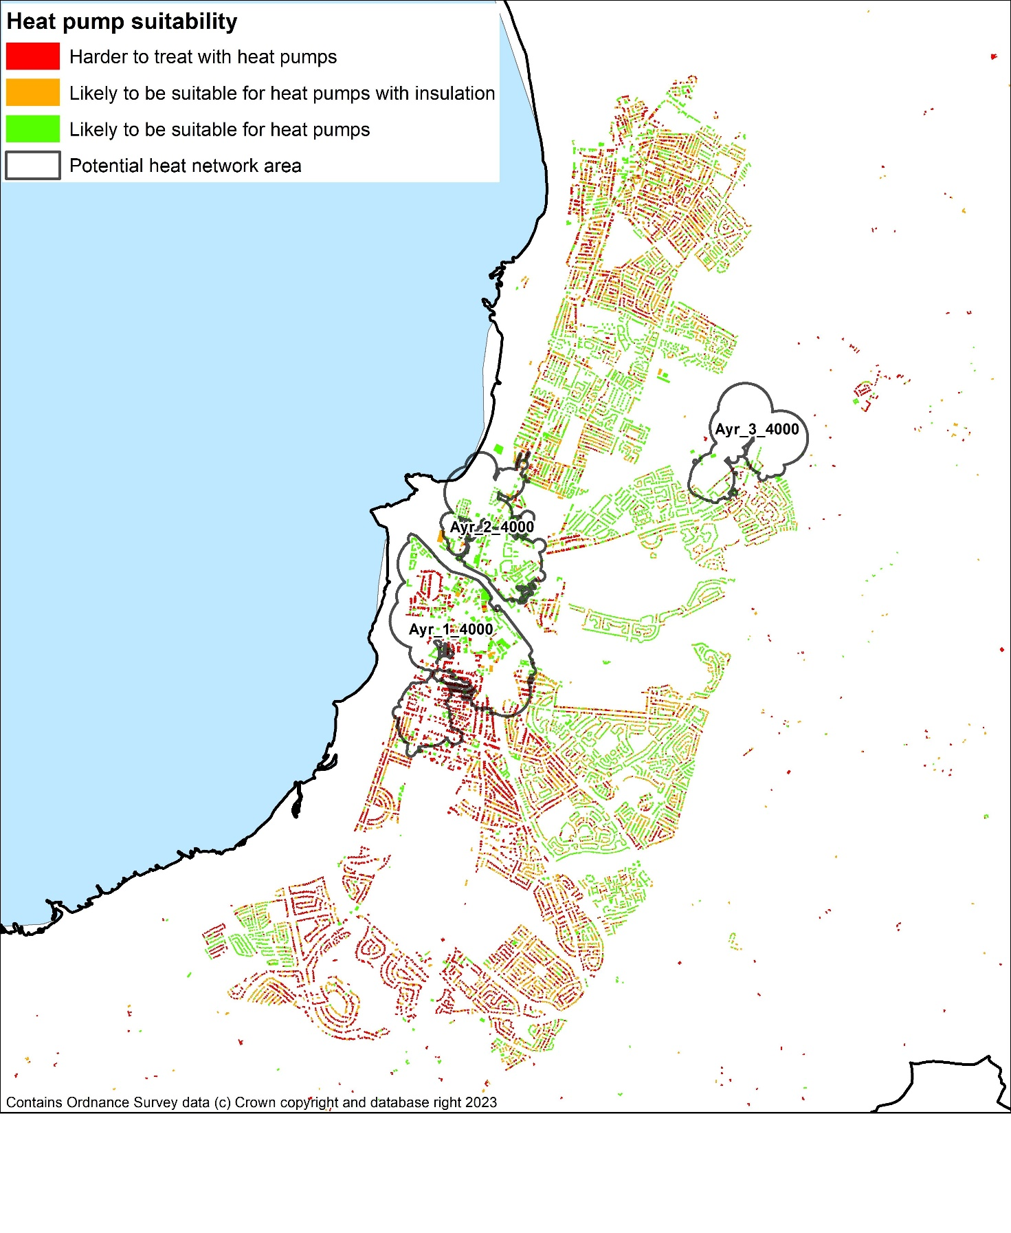

Figure 56: Heat pump suitability map- Girvan
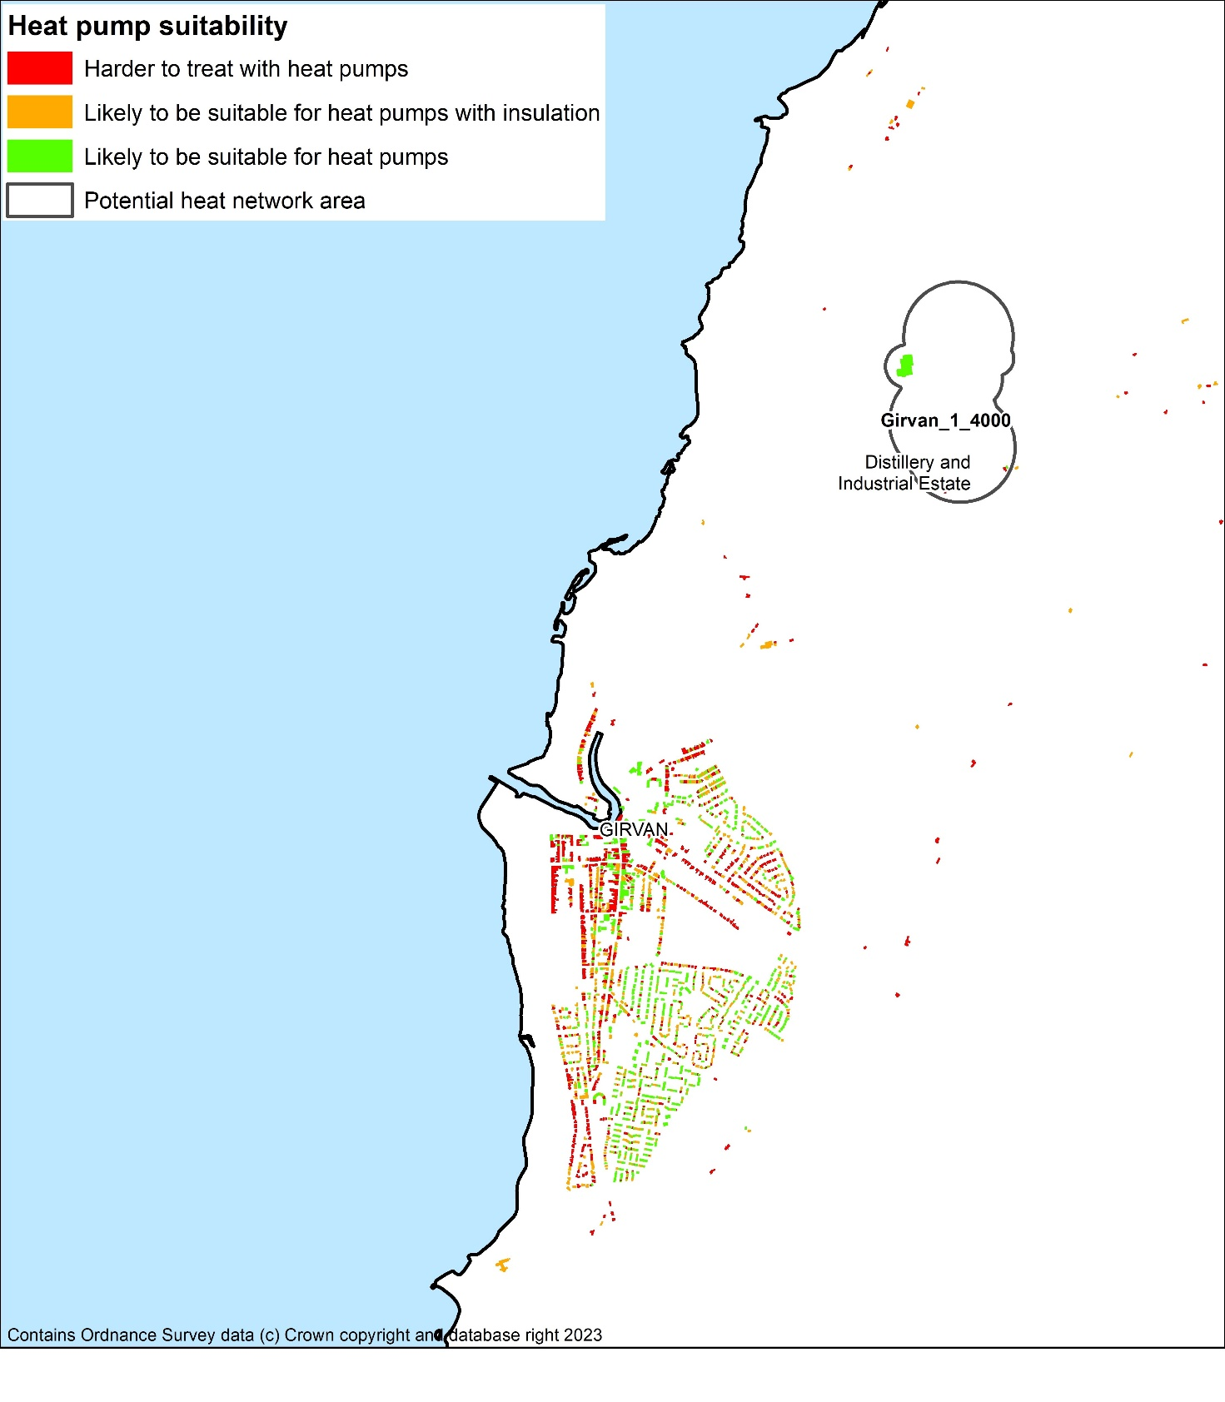

Figure 57: Heat pump suitability map- Troon
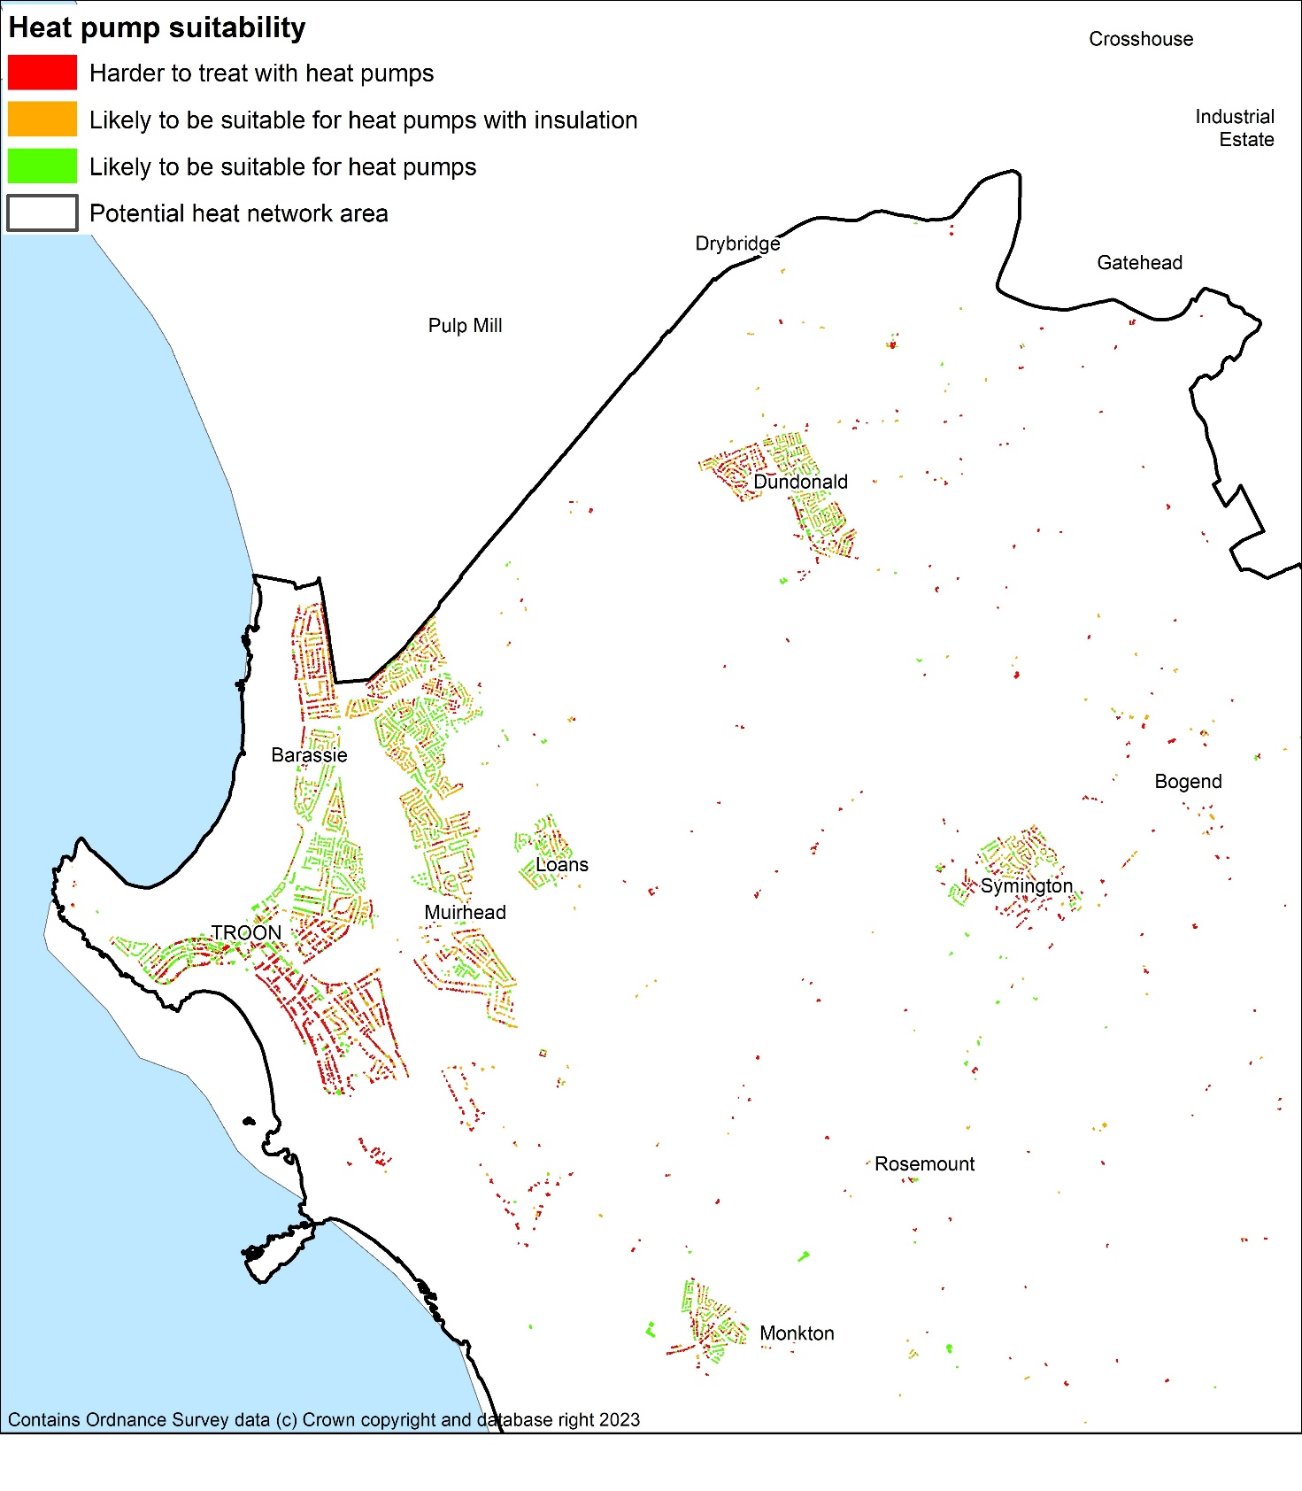

Figure 58: Heat pump suitability map- Maybole
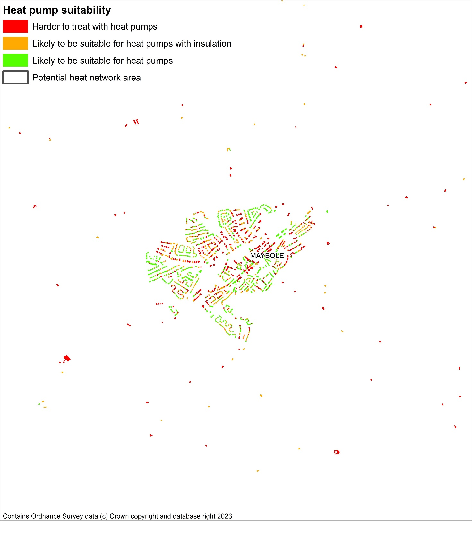

Figure 59: Heat pump suitability map- Ballantrae
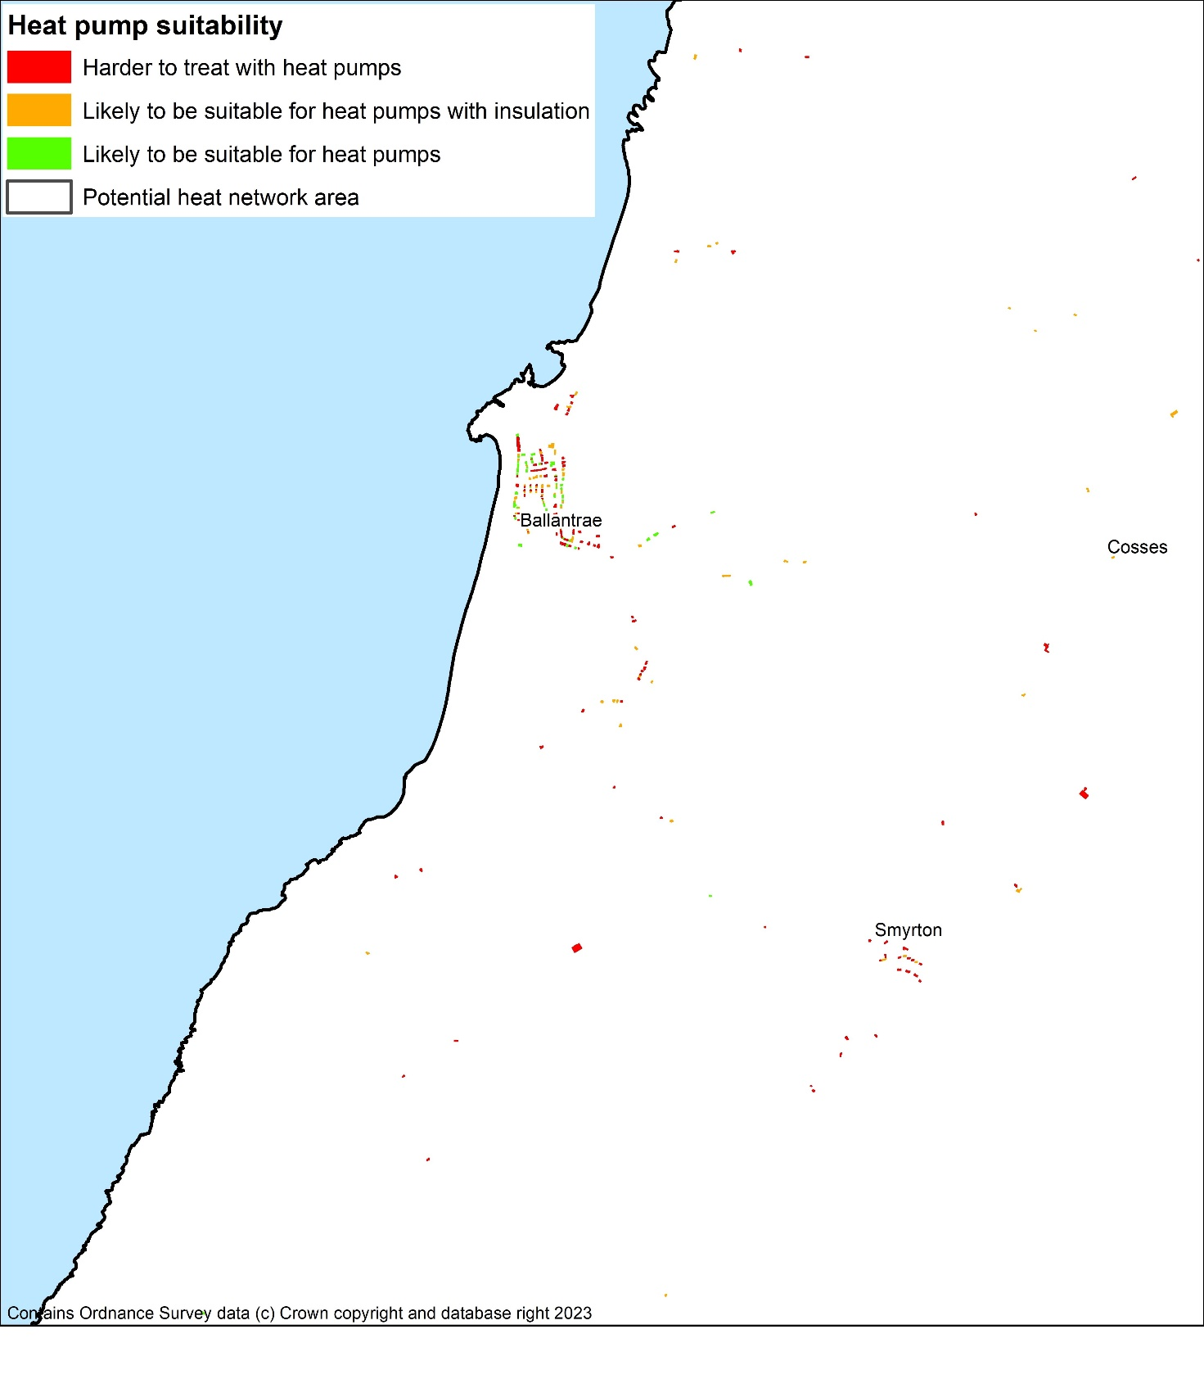

Figure 60: Heat pump suitability map- Dailly
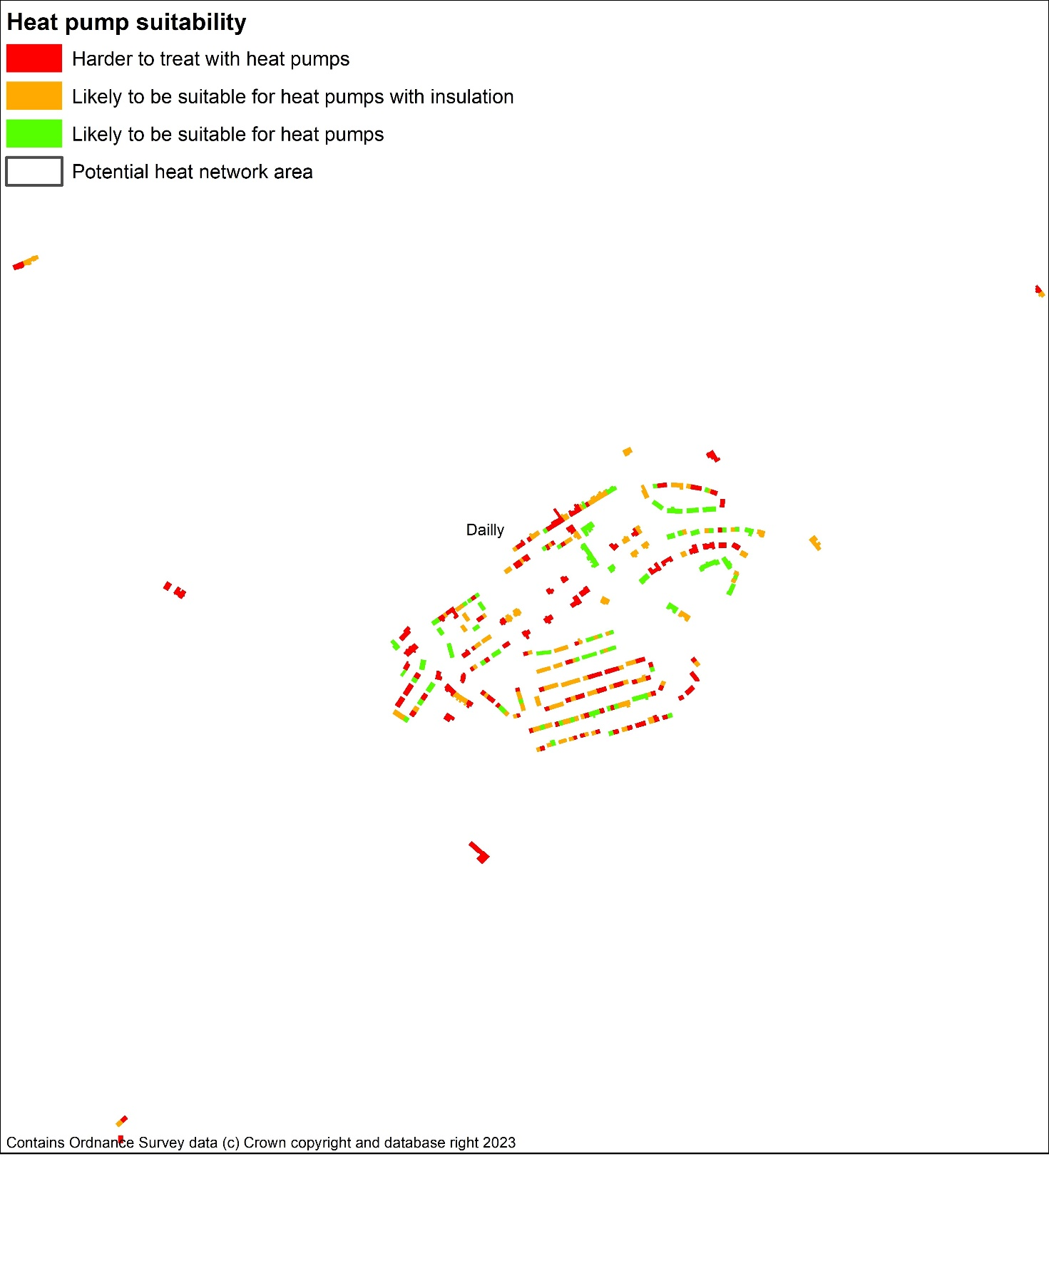

- Default indicators and calculation weightings
The LHEES methodology sets out a core set of default indicators and analysis weightings which have been used in this report. For each of the six given considerations defined in Table 2 the purpose of an Indicator is:
- To act as a key information field to help characterise the local authority using the Baseline tool as part of LHEES stage 3 (authority-wide and at a strategic level).
- To act as a key information field to support strategic zoning and generation of initial delivery areas (as part of LHEES stages 3 and 4).
- If suitable, to act as a key information field to measure progress against targets over the duration of the LHEES – set out in LHEES stage 8, LHEES Delivery Plan. For some Considerations, one Target and Indicator may be sufficient, but for others a range of Indicators may be appropriate to contextualise and characterise performance against a Target and/or progress towards a Consideration.
There is flexibility to update and augment these indicators to support local needs or for more focused analysis linked to specific actions and project identification within the future Delivery Plan. In reviewing the policies identified, there was no reason found to amend the indicators used in the National Assessment and as such, this study uses these default indicators and weighting values.

Theme | Indicator | Criteria | Weighting | Description | Data source. if known
Building energy efficiency | Loft insulation | <100mm (prediction) (Yes) | 33.33% | Binary identifier. Used to identify properties with a low energy efficiency, properties with no or minimal loft insulation. | Home Analytics
 | Single glazed windows | Binary (Yes) | 33.33% | Binary identifier. Used to identify properties with a low energy efficiency, properties with single glazed windows. | Home Analytics
 | Wall insulation prediction (all construction types) | Binary (Uninsulated) | 33.33% | Binary identifier. Used to identify properties with a low energy efficiency, properties with uninsulated walls. | Home Analytics
Additional example Indicators that could be used to support Delivery Level Area identification as part of LHEES stage 4 and Delivery Plan | Tenure type | User defined |  | Four types; housing association, owner/ occupier, private rented, local authority. User can filter by interest. | Home Analytics
 | Building age | User defined |  | Defined in six age brackets. User can filter by interest. | Home Analytics
 | Non-traditional build design type | Solid wall (binary) |  | User can filter by interest. | Home Analytics
 | EPC Rating | E, F or G |  | User can filter by interest. | Home Analytics
Indicators of fuel poverty | Probability of fuel poverty | % likelihood | 50% | 50% is default but set to 0% if extreme fuel poverty is to be analysed. | Home Analytics
 | Probability of extreme fuel poverty | % likelihood | 0% | 0% is a default Weighting applied. User can adjust balance by selecting 0% or 50% to switch analysis focus between fuel poverty or extreme fuel poverty. | Home Analytics
Building energy efficiency | Loft insulation | <100mm (prediction) (Yes) | 16.67% | Poor energy efficiency Indicators sum to 50% of overall Weighting, each have an equal Weighting. | Home Analytics
 | Single glazed windows | Binary (Yes) | 16.67% |  | Home Analytics
 | Wall insulation prediction (all construction types) | Binary (Uninsulated) | 16.67% |  | Home Analytics
Additional example Indicators that could be used to support Delivery Level Area identification as part of LHEES stage 4 and Delivery Plan | Tenure type | User defined |  | Four types; housing association, owner/ occupier, private rented, local authority. User can filter by interest. | Home Analytics
 | Building age | User defined |  | Defined in six age brackets. User can filter by interest. | Home Analytics
 | Non-traditional build design type | Solid wall (binary) |  | User can filter by interest. | Home Analytics
 | EPC Rating | E, F or G |  | User can filter by interest. | Home Analytics

- Intervention Costs

Total Domestic Intervention Costs
The capital costs of the interventions and the potential energy savings attributed to the interventions have been estimated. Costs and emissions for each fuel source used in the analysis are based on Department for Energy Security and Net Zero figures. This differs from the data found in SAP and reduced SAP for EPC and Property Energy Analysis Tool (PEAT) calculations as they are not as frequently updated.
Table 22 shows the breakdown of the capital expenditure required per intervention and the effect this intervention has on reducing energy demand across all the South Ayrshire Council building stock. For reference, the baseline heat demand per year for the domestic buildings in South Ayrshire Council is estimated to be 987,000 MWh. This data helps to identify which measures are the most effective way to reduce heating demand, helping both fuel poverty and heat decarbonisation. Loft insulation upgrade is by far the lowest cost method to reduce heating demands. On the other hand, installing external wall insulation on the outside of buildings that already have cavity or internal wall insulation is deemed as the least cost-effective way to reduce heat demand. However, they may be other reasons for doing less cost-effective measures, such as funding streams being allocated only to specific measures or improving the aesthetics of the building with external wall insulation or window upgrades.
Table 22: Summary of Energy Efficiency Interventions Across all Buildings in South Ayrshire
Fabric Measure | Capital Cost (£m) | Heat Demand Reduction (MWh/y) | Cost Effectiveness (kWh/y/£) | Fuel Savings per Investment Cost  (£/£)
Cavity Wall Insulation (CWI) | 27.6 | 40,800 | 1.48 | 0.22
Internal Wall Insulation (IWI) | 5.0 | 3,400 | 0.69 | 0.11
External Wall Insulation  (only wall measure) | 78.7 | 37,800 | 0.48 | 0.08
External Wall Insulation  (alongside CWI or IWI) | 503.2 | 78,400 | 0.16 | 0.02
All wall insulation measures | 614.5 | 160,400 | 0.26 | 0.04
Loft insulation upgrade from <100mm | 4.2 | 26,300 | 6.28 | 1.00
Loft insulation upgrade from 100-250mm | 11.0 | 64,800 | 5.89 | 0.53
Loft insulation upgrade from 250-300mm | 17.2 | 90,500 | 5.25 | 0.23
All loft insulation measures | 32.4 | 181,700 | 5.60 | 0.43
All Single to Double Glazing upgrade | 17.1 | 6,600 | 0.39 | 0.06
Cylinder insulation upgrade from <50mm | 10.2 | 14,500 | 1.42 | 0.22
Cylinder insulation upgrade from 50-80mm | 3.0 | 2,000 | 0.68 | 0.11
All cylinder insulation measures | 13.2 | 16,600 | 1.26 | 0.19
All Measures | 677.2 | 365,300 | 0.54 | 0.06

Table 23 the total investment cost across the area from replacing the current heating systems with heat pumps is shown. The return on investment from the reduction in annual fuel costs compared to the cost of installing the heat pump highlights how cost-effective heat pumps can be at reducing fuel poverty. This is particularly the case for buildings currently heated from direct electric, LPG, or Oil. Although the fuel savings from gas boilers switching to heat pumps is still as effective as external wall insulation on buildings that have already have cavity or internal wall insulation. Although the cost of solid fuels may be lower than that of heat pumps, the improvement in air quality from switching away from burning coal may be worthwhile for the residents alongside the decarbonisation benefits.
Total costs are estimated using the cost of individual heat pumps, although some of these may be communal heat pump systems. Of the heat pump suitable dwellings around 18,000 are flats, and 1,300 are flats that are smaller than 60m². These small flats are the ones which may benefit the most from communal heat pump systems as they may struggle to have space for hot water cylinders or equivalent thermal storage that is required alongside an individual heat pump. The Home Analytics dataset does not specifically state if properties currently have a hot water cylinder, if this data becomes available it can be used to further filter down the small flats by ones that don’t already have a cylinder to highlight the more challenging properties for individual heat pumps.
Table 23: Summary of Heating Systems Changes Across all South Ayrshire
Heating System | Number of Buildings | Heat Pump Suitable | Cost of Heat Pump Installation (£m) | Fuel Savings per Investment Cost (£/£)
Biomass | 209 | - | - | -
LPG | 742 | 453 | 3.9 | 0.10
Main Gas | 47,187 | 36,044 | 306.4 | 0.02
No Fuel listed | 162 | 121 | 1.0 | -
Oil | 3,836 | 2,023 | 17.2 | 0.12
Solid | 436 | 258 | 2.2 | -0.05
Unknown | 530 | 530 | 4.5 | -
Direct electric | 4,538 | 3,699 | 31.4 | 0.21
Heat pump | 309 | 306 | - | 0.00
All Heating Systems | 57,949 | 43,434 | 366.6 | 0.04

Table 24 shows all the fabric measures for the dwellings that are owned by the Council. These are all the measures that South Ayrshire Council have direct influence over. The scale of the investment required to implement all the energy efficiency measures, let alone changing the heating source, is far beyond what is achievable for the Council, emphasising the important of further specific targeting of measures.
Table 24: Summary of Interventions Across Local Authority Owned Buildings
Measure | Capital Cost (£m) | Heat Demand Reduction (MWh/y)
Cavity Wall Insulation (CWI) | 5.1 | 6,100
Internal Wall Insulation (IWI) | 1.0 | 500
External Wall Insulation (only wall measure) | 8.8 | 3,700
External Wall Insulation (alongside CWI or IWI) | 72.6 | 10,500
All wall insulation measures | 87.5 | 20,900
Loft insulation upgrade from <100mm | 0.6 | 2,800
Loft insulation upgrade from 100-250mm | 1.9 | 5,200
Loft insulation upgrade from 250-300mm | 2.8 | 3,000
All loft insulation measures | 5.3 | 11,000
All Single to Double Glazing upgrade | 2.0 | 700
Cylinder insulation upgrade from <50mm | 1.5 | 2,100
Cylinder insulation upgrade from 50-80mm | 0.4 | 300
All cylinder insulation measures | 2.0 | 2,400
All Measures | 96.8 | 34,900

Top Third of Data Zones Intervention Costs
Table 25 shows the interventions for the top third of data zones as ordered by energy efficiency as a driver for fuel poverty, for all domestic buildings in South Ayrshire.
Table 25: Interventions for the Top Third of Data Zones, by Energy Efficiency as a Driver for Fuel Poverty
Measure | Capital Cost (£) | Heat Demand Reduction (kWh/y)
Cavity Wall Insulation (CWI) | 7,100,000 | 10,500,000
Internal Wall Insulation (IWI) | 1,800,000 | 1,300,000
External Wall Insulation (only wall measure) | 42,300,000 | 20,500,000
External Wall Insulation (alongside CWI or IWI) | 138,100,000 | 20,700,000
All wall insulation measures | 189,200,000 | 53,000,000
Loft insulation upgrade from <100mm | 1,700,000 | 10,500,000
Loft insulation upgrade from 100-250mm | 3,300,000 | 11,900,000
Loft insulation upgrade from 250-300mm | 5,400,000 | 8,300,000
All loft insulation measures | 10,400,000 | 30,700,000
All Single to Double Glazing upgrade | 6,200,000 | 2,500,000
Cylinder insulation upgrade from <50mm | 3,400,000 | 4,800,000
Cylinder insulation upgrade from 50-80mm | 1,000,000 | 700,000
All cylinder insulation measures | 4,400,000 | 5,500,000
All Measures | 210,200,000 | 91,700,000

Local Authority Properties in the Top Third of Data Zones - Affordable Interventions
The interventions in Table 26 are for LA owned buildings which are located in the top third of data zones by fuel poverty, are now at a value which is more realistic for South Ayrshire Council to be able to have an impact on and in the areas where they should have the largest impact in helping reduce fuel poverty. This is a total of 4,717 properties, out of the 73,000 properties in the area.
As adding external wall insulation into buildings that already have cavity or internal wall insulation is a less cost-effective way of reducing heat demand, it is a lower priority intervention and therefore excluded from the recommendations and the total values. If there are specific funding streams that are only available for EWI, or this brings other non LHEES benefits this intervention may still be implemented.

Table 26: Interventions for the Top Third of Data Zones, by Energy Efficiency as a Driver for Fuel Poverty, for LA-Owned Properties
Measure | Capital Cost (£) | Heat Demand Reduction (kWh/y)
Cavity Wall Insulation (CWI) | £560,000 | 690,000
Internal Wall Insulation (IWI) | £280,000 | 180,000
External Wall Insulation (only wall measure (EWI)) | £920,000 | 320,000
All wall insulation measures (excluding EWI alongside CWI or IWI) | £1,760,000 | 1,190,000
Loft insulation upgrade from <100mm | £220,000 | 620,000
Loft insulation upgrade from 100-250mm | £390,000 | 1,000,000
Loft insulation upgrade from 250-300mm | £1,000,000 | 1,090,000
All loft insulation measures | £1,640,000 | 2,700,000
All Single to Double Glazing upgrade | £510,000 | 130,000
Cylinder insulation upgrade from <50mm | £710,000 | 880,000
Cylinder insulation upgrade from 50-80mm | £240,000 | 150,000
All cylinder insulation measures | £940,000 | 1,030,000
All Measures (excluding EWI alongside CWI or IWI) | £4,850,000 | 5,060,000

In addition to the energy efficiency measures, and estimated costs, across the top third of data zones by fuel poverty, Table 27 groups buildings by fuel source.
Table 27: Current Fuel Source in LA-Owned Homes in the Top Third of Data Zones by Fuel Poverty
Main Fuel | Number of Buildings | Heat Pump Suitable | Cost of Heat Pump Installation (£)
Biomass | 8 | N/A | 0
LPG | 3 | 2 | 17,000
Main Gas | 3,238 | 2946 | 25,000,000
No Fuel listed | 10 | 9 | 80,000
Oil | 299 | 233 | 2,000,000
Solid | 75 | 45 | 400,000
Unknown | 0 | 0 | 0
Electricity (direct electric heating) | 446 | 384 | 3,300,000
Electricity (heat pump) | 22 | N/A | 0
Total | 4,101 | 3,641 | 30,900,000

As well as the LA properties that South Ayrshire Council can have a direct influence over, there is also funding allocated which can help the LHEES considerations for other tenancy properties. South Ayrshire Council can help to engage with relevant owners and tenants to utilise the following funding. More information is found in this LHEES Strategy about the funding streams.
- Area Based Scheme - Funding for owner occupied or privately rented properties that are Council Tax bands A-C can help with insulation and double-glazing installations in addition to the adoption of renewable technologies.
- Warmer Homes Scotland - Funding for homeowners or private sector tenants, to install wall and loft insulation as well as renewables to bring their home up to tolerable living standards.
- Home Energy Scotland Loan - For homeowners to install glazing and renewable systems.
- Home Energy Scotland Private Rented Sector Landlord Loan – To help private rented sector landlords to install insulation, glazing and renewables.
- ECO3 Home Heating Cost Reduction Obligation – For people who qualify for Warm Home Discount and other means tested eligibility to have wall or windows installed.
- ECO3 Local Authority Flexibility Scheme – For low income and those vulnerable to the cold to have wall or loft insulation or window upgrades.
- Registered Social Landlord Loan – For landlords to install wall insulation or windows.
- Energy Efficiency Business Support – Technical advice, loans, and grants on energy efficiency measures for SME, not for profit organisations and charities.
- Heat Network Fund – A maximum of 50% of the capital cost towards eligible heat networks creation or expansion.

Heat Pumps, the Cost and Carbon Emissions
The cost and emissions of heat is dependent on the quantity of heat demand, the heating system efficiency, and the cost of fuel. These factors can help in reducing fuel poverty and in decarbonisation across South Ayrshire Council. Table 28 shows the cost of fuels used in this analysis, this data is from the UK Government Department for Energy Security and Net Zero 2023 Greenbook.
A simple comparison can be made using the cost of fuel to compare the cost of heat using gas boilers compared to heat pumps. For a gas cost of 0.103 £/kWh, with an 80% boiler efficiency this equates to 0.129 £/kWh of heat. Compared to a flat rate electricity cost of 0.34 £/kWh, as long as a heat pump can operate at a minimum COP of 2.64, then the heat pump will be lower cost to operate. As mentioned, the UK Government has set a requirement for heat pumps to be designed to operate at a COP of greater than 2.8 to be eligible for funding, implying that with the current cost of gas and electricity heat pumps should always reduce fuel bills and help reduce fuel poverty compared to gas boilers.
In addition, if switching to heat pumps means a building no longer requires gas, by not requiring gas for cooking or a fireplace, then there will be further benefits by not having to pay a gas standing charge.
For heat pumps to be effective measures they should be achieving a COP of 3 or greater, higher values have been achievable in trials with good practise. The Council need to ensure the role out of heat pumps in our properties comes with a good experience and high operating efficiencies, then importantly this information needs to be disseminated across the area.
Using a COP for heat pumps of 3.0 for the analysis, with this heat pump efficiency, compared to direct electric heating which operates close to 100% efficient, a heat pump should reduce fuel bills by a factor of three. This assumes a flat rate tariff, whereas for tariffs with lower night-time rate this difference will be reduced. Although a heat pump can still utilise low night rates direct electric can be more flexible at using the lower rate. Overall heat pump will be a significant benefit in reducing fuel poverty in homes with direct electric heating, which are likely the homes that currently have the highest cost of heat.
Table 28: Cost of Fuels Used for this Analysis.
Fuel | Cost (£/kWh)
Biomass | 0.08
Solid | 0.0665
Electricity | 0.34 (flat rate)
LPG | 0.155
Mains Gas | 0.103
Oil | 0.155

Table 29 shows the total annual cost and emissions from heating all the buildings in South Ayrshire Council. Heat pumps use a COP of 3, direct electric heating uses an efficiency of 100%, and boilers use an efficiency based on the boiler efficiency from their EPC in the Home Analytics dataset.
Table 29: Annual Cost and Emissions of Heating, in Heat Pump Suitable Properties
 | Annual Cost of Heat (£) | Annual Emissions (tCO2e)
Current Scenario | 134,300,000 | 210,000
Current heating system, with all energy efficiency measures, excluding EWI on buildings with CWI or IWI | 101,100,000 | 160,000
Transition to heat pumps in suitable properties, with all energy efficiency measures,  excluding EWI on buildings with CWI or IWI | 73,200,000 | 42,000
Heat pumps in 2035 | - | 0

Although this analysis uses heat pumps operating at a COP of 3.0, the COP can be improved upon by reducing the flow temperature of the heat pump, resulting in lower cost of heating. Increasing to larger radiators with more thermal power, or convection radiators, allows the buildings heat demand to be met with a lower flow rate. It is recommended for North Ayrshire Council to trial different radiator packages, to find the optimum trade off from more expensive larger/more powerful radiators against the reduced operational cost from lower flow temperatures. The EPC recognises the benefit of lower flow temperature heat pump systems and improves the score.
The results in Table 29 use a flat rate tariff for simplicity of calculations and to allow for a worst-case low level of consumer engagement with the heating system. If users are more engaged or allow intelligent control systems for the heat pumps to interact with the modern array of tariffs available, there can be significant further benefits for the user, including cost savings, associated emissions reduction and reduction in electrical network demand. These dynamic or variable time of use tariffs reward consumers who shift their demand to off-peak times balancing the renewable energy supply and demands. Heat pumps can use these times of low cost and low emissions electricity to charge hot water cylinders, they can also be used to maintain a level of temperature in the building, which also has the benefit of reducing the peak heat demand and allowing further lower flow temperatures.
With the current associate emissions from electricity generation, installation of heat pumps makes a significantly larger reduction to heating associated emissions in North Ayrshire than the energy efficiency measures. As the electricity emissions reduce towards the 2035 target of 0 gCO₂/kWh the benefit of heat pumps on emissions reduction increases.

<Do not type anything beyond here – go back before the Section Break and click Show/Hide on the Home tab to view the section break – this text will not print>

Appendix J Governance
This LHEES provides a first step towards decarbonising heat and reducing fuel poverty in South Ayrshire. In improving energy efficiency and prioritising low carbon solutions in areas where they can have the greatest impact, this strategy can support council and commercial investment, community engagement and wealth building, and an equitable energy transition. The delivery plan proposals are built from the data from the LHEES methodology and provide a series of potential projects from the challenges identified.
These challenges cannot be delivered in isolation by a single department, or by the Council alone. As such it is vital that a governance structure be put in place to ensure collaboration between internal and external stakeholders.
Figure 61 provides a structural overview for governance in this area.
Figure 61: Outline LHEES Governance model
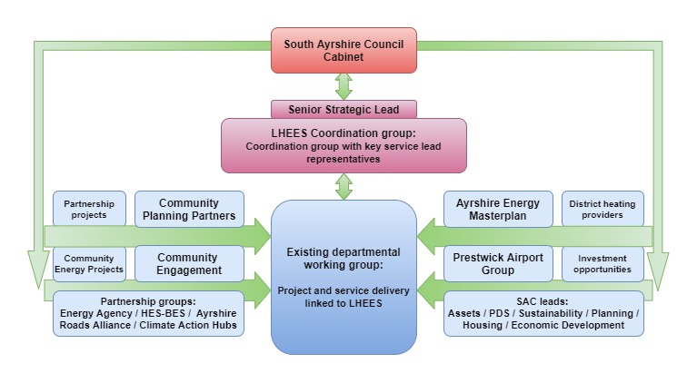
The LHEES Coordination group will provide strategic oversight and guidance for the development and implementation of the Council’s LHEES strategy and delivery plan. Each member of the group will provide insight from their area of expertise to support existing delivery plan actions and refine new and existing areas of intervention, with support from the LHEES officer. They will also ensure decisions made by the group are adhered to by services.
The group will provide information and scrutiny on:
- Development and attribution of LHEES delivery plan actions,
- Development of heat network projects,
- Risk and issue identification,
- Wider stakeholder identification and engagement,
- Dissemination of information,
- Benefits realisation and reporting.

Group responsibilities
Each group member would be responsible for service level identification of:
- Existing or potential projects relevant to LHEES,
- Co-working opportunities,
- Relevant legislative changes and consultations,
- Alignment of service level projects with strategic priorities,
- Attribution and implementation of service specific delivery plan actions.
Membership
The LHEES Coordination group membership is identified below as those with high levels of interaction and interest in the strategy and delivery plan.
Figure 62: LHEES engagement matrix
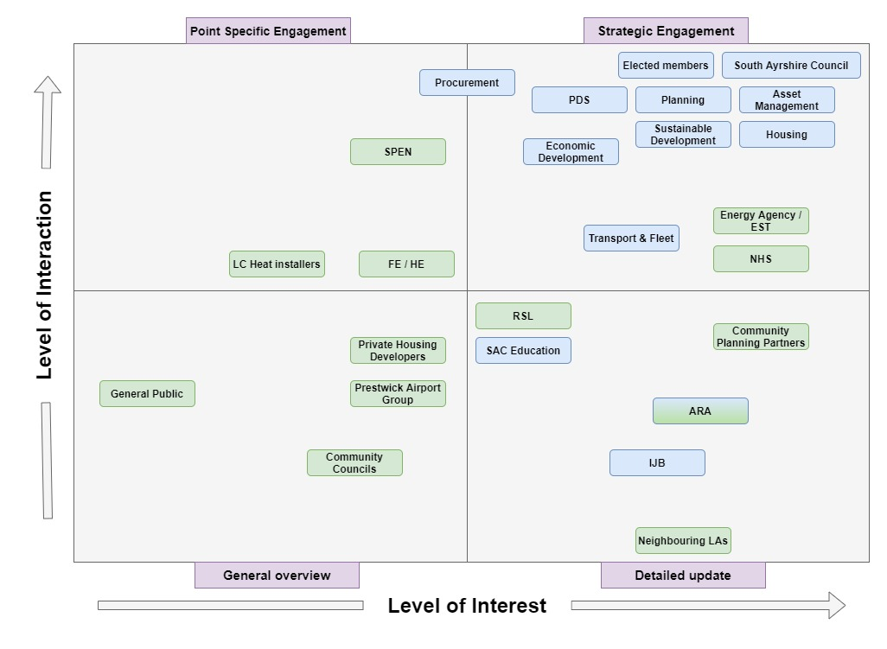
From this, we derive 4 levels of interaction with associated groups:
- Strategic engagement – membership of the governance group.
- Point specific engagement – engaged with on specific projects rather than the strategy as a whole.
- Detailed updates – detailed information on strategy and project progress shared regularly to assess synergies.
- General overview – general information about overall progress shared periodically.
As such, the following departments and officers have been identified to participate in the governance group.

Tracking and Reporting
The group will track and report progress through a series of routes:
Feedback to Portfolio Holder: Buildings, Housing and Environment by Service Lead Asset Management. Where appropriate membership officers will report actions back through in-service routes to respective portfolio holders to expand engagement.
Local Outcome Improvement Planning – As Energy is one of the four identified Community Planning Partnership areas, relevant six-monthly/quarterly progress reports will be provided to the board.
Annual Cabinet report & Members Briefing – with the annual review of the delivery plan actions, progress on existing actions and proposed actions for the year ahead will be delivered to cabinet annually, with an accompanying members brief on progress and intent for the year ahead.

The Local Heat and Energy Efficiency Strategies (Scotland) Order 2022 (legislation.gov.uk)
Local heat and energy efficiency strategies and delivery plans: guidance - gov.scot (www.gov.scot)
The Local Heat and Energy Efficiency Strategies (Scotland) Order 2022 (legislation.gov.uk)
Local heat and energy efficiency strategies and delivery plans: guidance - gov.scot (www.gov.scot)
An Energy System Catapult electrification of heat project in the UK finds all housing types are suitable for heat pumps.
Delivering Net Zero for Scotland’s Buildings - A Consultation on proposals for a Heat in Buildings Bill (www.gov.scot)
Heat in Buildings Strategy - achieving net zero emissions in Scotland's buildings - gov.scot (www.gov.scot)
Net Zero Strategy: Build Back Greener - GOV.UK (www.gov.uk)
Heat Pump Investment Roadmap (publishing.service.gov.uk)
Heat in Buildings Strategy - achieving net zero emissions in Scotland's buildings - gov.scot (www.gov.scot)
Securing a green recovery on a path to net zero: climate change plan 2018–2032 - update - gov.scot (www.gov.scot)
Increased funding to tackle fuel poverty and climate change - gov.scot (www.gov.scot)
Tackling fuel poverty in Scotland: a strategic approach - gov.scot (www.gov.scot)
Energy Performance Certificates - Energy efficiency - gov.scot (www.gov.scot)
The energy used by a heat pump depends upon the coefficient of performance which is related to the water temperature in the heating system at design conditions. Designing heating systems at lower water temperatures allows higher COP when providing space heating but requires larger radiators. The criteria chosen is intended to be such that a heat pump could be installed and be expected to achieve a COP of 3, however confirming this for an individual property would require a detailed calculation at design stage.
Electrification of Heat Demonstration Project: winning bids, case studies and project data - GOV.UK (www.gov.uk)
All housing types are suitable for heat pumps, finds Electrification of Heat project - Energy Systems Catapult
5 Energy Perceptions - Scottish house condition survey: 2019 key findings - gov.scot (www.gov.scot)
Heat networks: Building Assessment Report (BAR) guidance - gov.scot (www.gov.scot)
Detached houses may be considered to be less suitable to connect due to the individual sections of pipework that are required to connect the buildings to the network, on a linear heat density approach, the longer the connecting pipework, the “harder” the pipework has to work to satisfy loads.
Boiler Upgrade Scheme (BUS) - Installers | Ofgem

