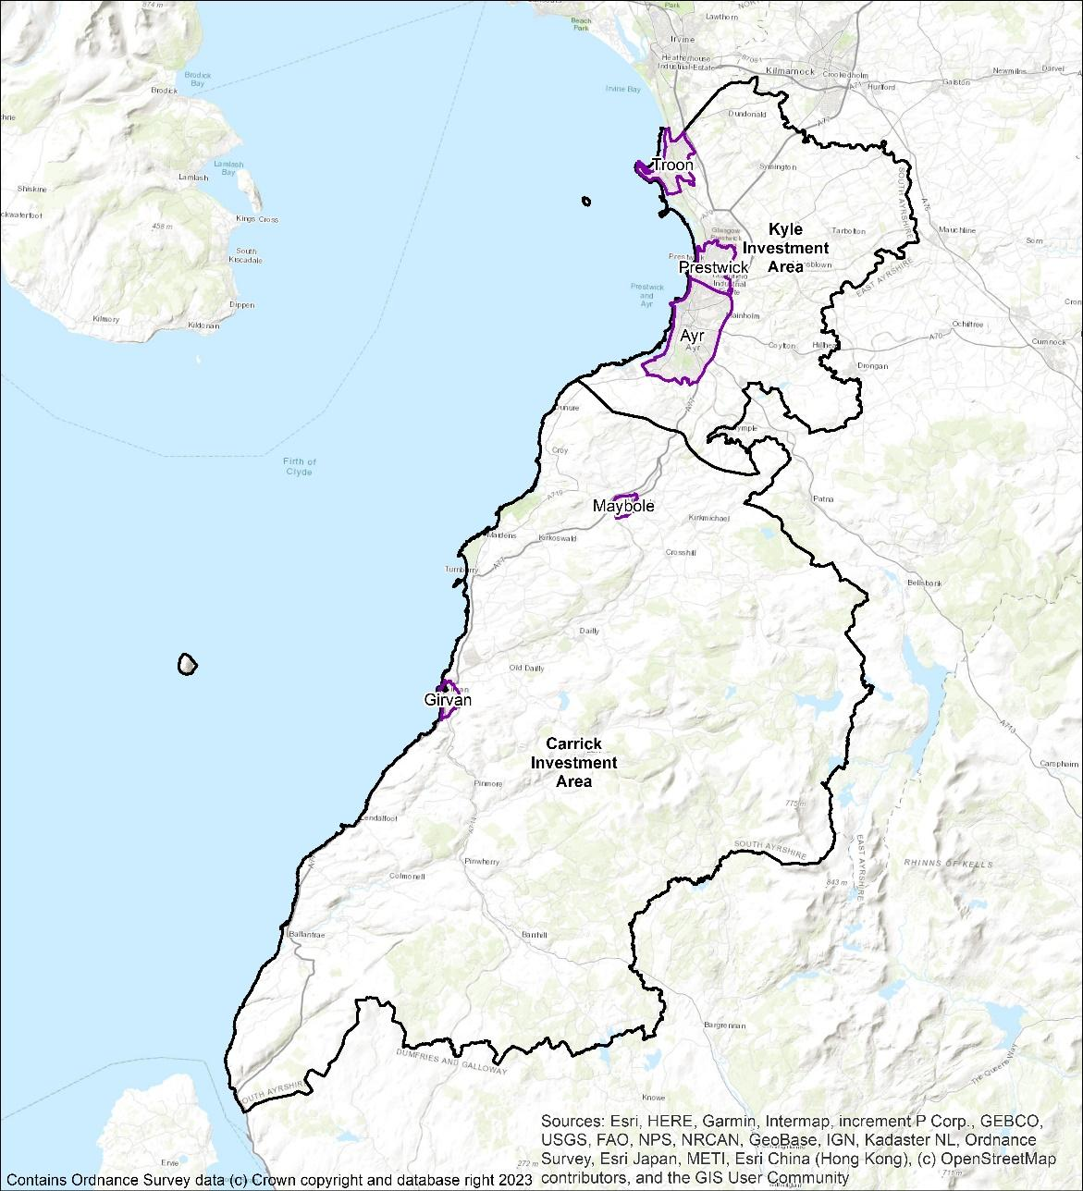

# **South Ayrshire Council**

**Local Heat and Energy Efficiency Strategy**

2024 - 2029

# Foreword

As the Portfolio holder for Buildings, Housing, and the Environment in South Ayrshire, it is with great pride that I introduce the Local Heat and Energy Efficiency Strategy (LHEES) for our council area. This strategy marks a pivotal step in our commitment to a sustainable and resilient future, aligning with our aspirations to achieve Net Zero by 2045.

Local authorities across Scotland bear a responsibility for the energy we consume and the emissions this creates, and South Ayrshire is no exception. Through this strategy, we embark on a journey to not only address our local climate challenges but also to contribute meaningfully to the global imperative of mitigating the impacts of the climate emergency.

Our priorities in South Ayrshire focus on our communities, ensuring people can thrive within a flourishing economy, with good quality, energy efficient housing, and an open and transparent, inclusive democracy. This strategy lays out our forthcoming initiatives, including the investigation into zero emissions heating systems and heat network potential, reinforcement of our dedication to providing affordable warmth to our most vulnerable citizens, and commitment to partnership working.

In our pursuit of Net Zero, a just transition is paramount. Communities across South Ayrshire are already feeling the effects of climate change, and our commitment is to ensure that they not only endure but prosper throughout this transition. We recognise the importance of co-creating solutions with our communities, placing them at the heart of our endeavours.

Building on our past achievements, including notable reductions in carbon emissions, we acknowledge that resting on our laurels is not an option. This LHEES document will work in tandem with our Ayrshire Energy Masterplan. This pan-Ayrshire initiative is designed to support investment and economic development across the three authorities, in conjunctions with the Ayrshire Growth Deal. By collaborating with our diverse stakeholders, we will turn these strategies into tangible progress, pushing closer to our vision of a Net Zero Carbon South Ayrshire.

This strategy represents a live document, an evolving piece of work that will adapt in line with wider changes in legislation, research, and technology and innovation. I extend an invitation to all residents, businesses, and stakeholders in South Ayrshire to stay engaged with this work and help to shape the future of our region towards one of sustainability and resilience.





*Councillor Martin Kilbride, Portfolio holder for Buildings, Housing, and the Environment*

**Contents**

**South Ayrshire Council** 1

Foreword 2

1. Overview 5

1.1 What is an LHEES? 5

1.2 Why are we doing this? 5

1.3 What is the focus of this work? 5

1.4 How can you get involved? 5

2. Introduction 6

2.1 Overview of LHEES 6

3. South Ayrshire Priorities 7

4. Background Information 8

4.1 LHEES Structure 8

4.2 LHEES Considerations 8

4.3 Interventions 8

4.4 Consultation and Engagement 10

5. Policy and Strategy Context 11

5.1 National Strategic Context 11

5.2 Local Policy and Strategy Context 11

6. Challenges and Opportunities 14

Opportunities 14

6.1 Just Energy Transition 14

6.2 Ayrshire Energy Masterplan 14

6.3 Engagement & Development 14

6.4 Community Wealth Building 15

Challenges 16

6.5 Domestic Buildings 16

6.6 Non-domestic Buildings 19

7. Strategic Zones and Baseline 21

7.1 Local Development Plan Areas as LHEES Strategic Zones 21

7.2 Domestic Properties and Tenure 22

7.3 Domestic Energy Efficiency 23

7.4 Domestic Energy Efficiency and Fuel Poverty 26

8. Technology 30

8.1 Options 30

8.2 Heat Pumps 30

8.3 Electric Heating 31

8.4 Mixed Tenure, Mixed use and Historic 31

9. Heat Networks 33

9.1 Approach 33

9.2 Overview 34

9.2.1 Ayr 34

9.2.2 Girvan industrial cluster 36

10. Delivery Areas 39

10.1 Spatial approach 39

10.2 Fuel Poverty 40

10.2.1 Social Impact of Multiple Deprivation 41

10.2.2 Overlaying Multiple Considerations 43

10.3 Technology-Led Approach 44

10.3.1 Technology Groupings 44

10.3.2 Heat Pump Suitability 45

11. Pathways for all of South Ayrshire 47

11.1 Decarbonisation of Heat Pathway 47

11.2 Fuel Poverty 49

11.3 Heat Networks 50

11.4 Individual and Communal Heat Pumps 50

12. Pathways for Strategic Zones 52

13. Governance 56

14. Delivery Plan Proposals 59

Appendix A: LHEES Scope, Limitations and Approach 61

Appendix B: Legislation Relating to LHEES 62

Appendix C: Heat Pump Suitability Maps 64

Appendix D: Consultation Thematic Summary 70

Scottish Government Response 71

# Overview

## What is an LHEES?

The Local Heat and Energy Efficiency Strategy (LHEES) is a long-term strategic framework designed to support energy efficiency and sustainable heat delivery across all buildings in South Ayrshire. This includes council and privately owned buildings and spans domestic and non-domestic sectors. It serves as a roadmap towards achieving our commitment to Net Zero Carbon, eliminating fuel poverty, and working towards a more environmentally conscious and resilient community.

## Why are we doing this?

As part of the Scottish Governments push for net zero by 2045, it is vital that our homes and buildings no longer contribute to climate change, while tackling fuel poverty within our communities.

Our LHEES will support the objectives within the South Ayrshire Council Plan, Scottish Government targets and objectives, and builds towards Scotland’s place in the world.

## What is the focus of this work?

In LHEES, we are looking at area wide approaches, which means focussing on equity, inclusion, and co-creation. Initial work on LHEES will look to build connections with stakeholders from council services and community planning partners, communities and residents, businesses, and the 3rd sector. We are working to build connections with areas of best practice, develop and connect existing areas of work, and further develop this long-term plan of how we reach our future targets.

In terms of tangible action, this means improving insulation and energy efficiency of all buildings, planning for where area-wide approaches are suitable for heat networks, and identifying what heat provisions are required to meet targets. Throughout this strategy you will find focus sections, these draw out information that will form the basis of delivery plan actions.

## How can you get involved?

Active community engagement is crucial to the success of the LHEES. All stakeholders are encouraged to participate by providing feedback and insights.

We need to take an inclusive approach that ensures this strategy is not only well-informed, but reflective of the diverse needs and perspectives within South Ayrshire. Initial consultation included public consultations, community workshops, and other outreach initiatives, and our aim is to continue community engagement over the course of this strategy.

In order to make the LHEES accessible for all readers, two additional versions are available online.

For a brief look at the Strategy, there is the **Summary report,** and for a more comprehensive overview, the **full technical report** can be found online.

# Introduction

## Overview of LHEES

The Local Heat and Energy Efficiency Strategies (Scotland) Order 2022[1] places a duty on local authorities to prepare and update a Local Heat and Energy Efficiency Strategy (LHEES) and Delivery Plan. This document is prepared by South Ayrshire Council (SAC) to fulfil its duty under that Order.

This Strategy sets out the long-term plan for decarbonising heat in buildings in the SAC area and improving their energy efficiency.

LHEESs are primarily driven by Scotland’s statutory targets for greenhouse gas (GHG) emissions reduction and fuel poverty[2]:

* Net zero emissions by 2045 and 75% reduction by 2030; and
* In 2040, as far as reasonably possible, no household in Scotland is in fuel poverty.

The Strategy should:

* Set out how each segment of the building stock needs to change to meet national and local objectives, including achieving zero greenhouse gas emissions in the building sector, and the removal of poor energy efficiency as a driver of fuel poverty;
* Identify strategic heat decarbonisation zones, and set out the principal measures for reducing buildings emissions within each zone; and
* Prioritise areas for delivery, against national and local priorities.

Accompanying this Strategy is a Delivery Plan. This has been developed in partnership with key partners and provides a strong basis for action for local communities, government, investors, developers and wider stakeholders, pinpointing areas for targeted intervention and early, low-regrets measures.

The strategy will be reviewed and updated on a five-year basis, delivery plans will be an active record of projects and will be updated annually.

For strategy scope and limitations, please see appendix A.

# South Ayrshire Priorities

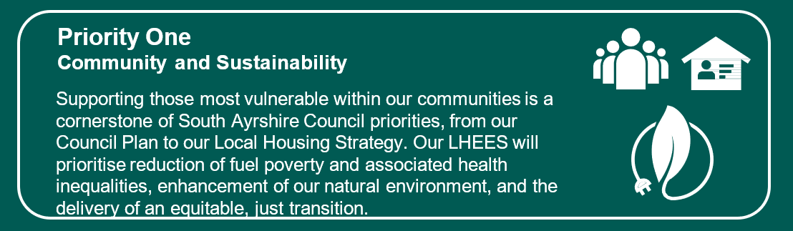

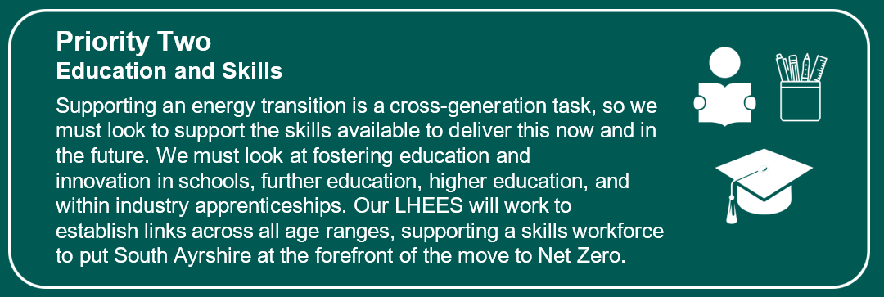

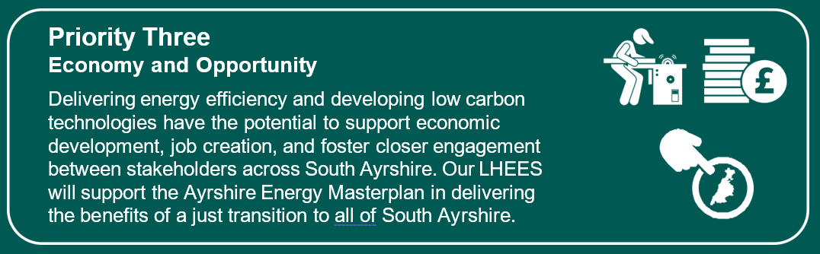

Throughout this document you will find challenge and focus sections, intended to highlight the key considerations, and build to form delivery plan actions. These will reference these priorities.

The connecting priority between these is to ensure open and transparent communication between stakeholders, partners, and communities.

# Background Information

## 4.1 LHEES Structure

As established in the Local Heat and Energy Efficiency Strategies (Scotland) Order 2022, LHEES should have a two-part structure. This document sets out the long-term aims and the accompanying Delivery Plan sets out actions to support implementation of this Strategy.

## 4.2 LHEES Considerations

The LHEES guidance sets out the key considerations for this Strategy, shown in Table 1. These help to categorise building stock into groups that require similar interventions.

Table 1: LHEES Considerations

|  |  |  |  |
| --- | --- | --- | --- |
|  | No. | LHEES Considerations | Description |
| **Heat decarbonisation** | 1 | Off-gas grid buildings | Transitioning from heating oil and LPG in off-gas areas |
|  | 2 | On-gas grid buildings | On-gas grid heat decarbonisation |
|  | 3 | Heat networks | Decarbonisation with heat networks |
| **Energy efficiency and other outcomes** | 4 | Poor building energy efficiency | Poor building energy efficiency |
|  | 5 | Poor building energy efficiency as a driver for fuel poverty | Poor building energy efficiency as a driver for fuel poverty |
|  | 6 | Mixed-tenure, mixed-use and historic buildings | Mixed-tenure and mixed-use buildings, listed buildings and buildings in conservation areas |

This LHEES has been developed in line with the Scottish Government methodology, with some adjustments to suit the specific context of the authority. For detail on the LHEES approach and methodology, please refer to Appendix A.

In this iteration of LHEES, South Ayrshire is focussing on:

* Improving energy efficiency and reducing fuel poverty,
  + Including assessment of energy efficiency as a driver for ill-health and health inequalities
* Transitioning off gas buildings to low carbon heating,
* Buildings feasibility for heat networks where appropriate.

## 4.3 Interventions

There are a range of potential interventions, from energy efficiency measures to low and zero carbon heating systems, which will play a role in South Ayrshire’s LHEES. Table 2 summarises these technologies and developed routes. Key technologies are developed further in Section 8.

The Scottish Governments Heat in Buildings Strategy[3] (HIBS) states that for the period to 2030, focus must be on accelerating the deployment of tried and tested measures where they are known to be no or low regrets.

As noted, South Ayrshire’s focus with regard to technologies for this initial LHEES will look at improving energy efficiency for fuel poverty and health, transitioning off gas buildings to low carbon heating, and building feasibility for heat networks.

Table 2: Heat decarbonisation routes

|  |  |  |  |
| --- | --- | --- | --- |
| Intervention | Heat decarbonisation | Effect on fuel poverty | Suitability |
| Energy efficiency | Measures such as double glazing, draught proofing and insulation reduce energy demand which in turn increases the viability for switching to low carbon heat sources | Improved energy efficiency leads to reduced energy costs, which reduces fuel poverty.  Grants and loans are available for lower income households. | Where feasible and cost-effective, the Scottish Government aims for all homes to have the at least the equivalent of EPC band C by 2033 |
| Heat pumps | Heat pumps use electricity to extract heat from the air, ground, water or wastewater. Grid electricity is continuing a trend of decarbonisation through renewable energy. | Appropriately designed and well-running heat pumps can reduce costs, particularly compared to electric heating.  Savings are dependent upon the relative price of electricity compared to the fuel displaced as well as the coefficient of performance (COP) of the installation.  Replacing electric heating with a heat pump can reduce energy consumption and reduce fuel poverty. | Heat pumps are commonly used in cold climate, such as Scandinavia and research has found that all UK house types are suitable for heat pumps[4]. Where necessary, upgrades to heat emitters or hot water storage can present practical challenges in some properties.  The electricity network will need to accommodate increase in electricity demand from heat pumps, direct electrical heating, and other energy sources such as Electric Vehicles.  Hot water production is usually provided through a hot water cylinder, which requires space in a property. |
| Heat networks | Heat networks, which use waste heat, heat pumps or bioenergy as their energy source | The Competition and Markets Authority found that up to 90 % of heat network customers enjoy similar, or lower, bills than those with standard gas boilers and heat networks can cut both emissions and bills. | Heat networks are suitable for all building types but only in areas with a sufficient density of heat demand |
| Electric heating | Electricity to extract heat from the air or ground. Grid electricity is continuing a trend of decarbonisation through renewable energy | While direct electric heating is more efficient than combustion boilers, including gas, the high cost of electricity must be considered for households at risk of entering fuel poverty.  Storage heaters can be used to harness cheaper electricity at night but can emit and waste heat when not required | Electric heating is suitable for all properties with a suitable electricity connection. Hot water production is usually provided through a hot water cylinder, which requires space in a property. |
| Bioenergy | Sustainably sourced, bioenergy (i.e., solid biomass, biogas or biomethane) is regarded as carbon neutral | There is uncertainty surrounding the future supply of bioenergy and biomass boilers tend to have more maintenance requirements than gas boilers | HIBS indicates that bioenergy is likely to have a limited role in the decarbonisation of the building stock. There may be some buildings for which bioenergy can play a role, for example in hard to treat off-gas properties where heat pumps are unsuitable.  However, the UK’s Green Gas Support Scheme aims to increase the proportion of biomethane in the gas grid.  A bioenergy Action Plan is due to be published in late 2023.  Air quality concerns need to be considered in urban settings as well as the health impacts of indoor air pollution. |
| Hydrogen | Green hydrogen is produced by splitting water using renewable electricity while blue hydrogen is produced from fossil fuels plus carbon capture. Therefore, both production routes are deemed as low carbon in UK and Scottish legislation.  Increased availability of hydrogen for heat will have positive implications for the suitability of hybrid heat pump systems, which may be cost-effective solutions | Currently hydrogen is an underdeveloped fuel and is associated with high costs. The future of hydrogen prices is uncertain but may become competitive with other energy sources in the coming decades. However, without Government incentives prices for green hydrogen are unlikely to be lower cost than using direct electrical heating or heat pumps as hydrogen system efficiency is lower than using electrified heating. | Hydrogen is not currently available for supply of heat to domestic properties and is not seen as an immediate solution[5]. |

## 4.4 Consultation

Consultation on the development of this LHEES was sought through our community planning partners, registered social landlords, economic development groups, third sector organisations, community groups and members of the public.

Responses were thematically assessed, and key principles were integrated into this version of the LHEES. Analysis can be seen in Appendix D.

# Policy and Strategy Context

## 5.1 National Strategic Context

On a UK level, there exists legally binding legislation to reach net zero emissions by 2050. The Net Zero Strategy: Build Back Greener[6] report denotes than one third of emissions are a result of heating for homes and workplaces. The UK Government is responsible for regulation of the electricity and gas networks and markets. Other targets are set, such as reaching 600,000 heat pump installations nationwide by 2028[7].

The Scottish Government has more ambitious targets than the UK, with net zero by 2045 and interim targets of 75 % by 2030 and 90 % by 2040. There are certain powers which are devolved to the Scottish Government such as promoting renewable energy and energy efficiency, while many aspects of energy policy are reserved by the UK Government. Chapter 10 of the Heat in Buildings Strategy[8] (HIBS) discusses the need for the UK and Scottish Government to work alongside each other to facilitate the decarbonisation of heat.

The Tackling Fuel Poverty in Scotland: A Strategic Approach[9] sets the target to maximise the number of fuel poor households attaining EPC B by 2040. At the time of writing, the Scottish Government are consulting on an EPC reform, which likely will have an impact on the grading of the building stock and the effect of measures[10]. The Fuel Poverty Act sets an overarching target that in the year 2040, as far as reasonably practicable, no household in Scotland is in fuel poverty and, in any event, no more than 5 % of households are fuel poor, no more than 1 % are in extreme fuel poverty and the fuel poverty gap is no more than £250 (in 2015 prices).

The Scottish Government will require that all residential properties in Scotland achieve EPC C by 2033, where technically and legally feasible and cost-effective. For the social rented sector, no housing should be let after 2025 if the EPC rating is lower than EPC D. For the owner occupier sector, new energy efficiency regulations will be introduced between 2023 to 2025.

These policies feed into the LHEES Considerations of:

1. Poor building energy efficiency;
2. Poor building energy efficiency as a driver of fuel poverty; and
3. Mixed-tenure, mixed-use and historic buildings.

A detailed outline of this and other Scottish policy drivers and contexts can be seen in Appendix B.

## 5.2 Local Policy and Strategy Context

LHEES is not a strategy on its own. Policies and strategies across the council are designed to be interoperable, supporting and developing the principles within the Council Plan. In this way, table 3 shows a sample of the links to and from LHEES within other council strategies, plans and policies.

Priorities from these strategies have been considered in the LHEES development and within the ongoing governance of delivery. The governance group includes representative from each strategy service area, and a key aspect of this group is the ongoing interoperation of policy and strategy links. More detail can be found in section 13.

Table 3: Local Policies and Strategies

|  |  |  |
| --- | --- | --- |
| Strategy, Policy, Plan | Description | Linkages |
| [Statutory Development Plan](https://www.south-ayrshire.gov.uk/article/28782/Local-development-plan-2) | The statutory development plan comprises both Scottish Governments National Planning Framework ([NPF4](https://www.gov.scot/publications/national-planning-framework-4/)) and South Ayrshire Council’s Local Development Plan ([LDP2](https://www.south-ayrshire.gov.uk/article/28782/Local-development-plan-2)).  The LDP2 is a spatial land use document which guides the future use of land in our cities, towns, and rural areas. It considers and addresses land use issues arising from the implications of economic, social, and environmental change. In doing so, this document provides an overall, joined up approach to managing development that can set out ambitious but realistic long-term visions the South Ayrshire Council area.  This plan forms the prime consideration in the determination of planning applications. | **LDP Linkages:**  **Core themes C - Our Environmental Responsibilities**  How we will be mindful of our responsibilities for the protection of our natural, built, and cultural heritage resources.  Core Principles: C1 – We will promote the sustainable use of natural, built, and cultural heritage resources.  Strategic Policy 1: Sustainable Development - We will support the principles of sustainable development by making sure that development meets the following standards:   * + Designed to maximise energy efficiency through building siting, orientation, and materials,   + Helps mitigate and adapt to the effects of climate change.   + Includes the use of micro-renewables, wherever appropriate   + Wherever possible, Incorporates or facilitates the development of District heating / heat networks.   For reference:  Low and zero-carbon buildings (pg. 82)  LDP policy: renewable energy (pg. 82)  LDP policy: heat networks (pg. 84) |
| [Local Housing Strategy](https://www.south-ayrshire.gov.uk/article/27563/Local-housing-strategy) | The LHS is a 5-year plan to support people of South Ayrshire to find good quality housing, develop a sense of identity and belonging, reduce homelessness, and support all residents in their ability to live in a warm, dry, energy efficient home that meets their needs. | **Cross-cutting themes**  – Sustainability, climate change and biodiversity  Agreed Principle: Healthy Homes and Fuel Poverty  Outcomes: HH1, HH2, HH3, HH5 |
| [Strategic Housing Investment Plan 2023/24 – 2027/28](https://www.south-ayrshire.gov.uk/article/58917/Strategic-Housing-Investment-Plan) | The Strategic Housing Investment Plan (SHIP) 2023/24 – 2027/28 sets out the strategic investment priorities for affordable housing over the next five years that will achieve outcomes set out in the Local Housing Strategy and HNDA. | **Strategic priority – Sustainable Communities and Sustainable Developments**  All projects proposed in the SHIP will help to tackle fuel poverty and ensure that heat is affordable for residents by increasing energy efficiency and reducing the amount of energy required to heat the home. |
| [Sustainable Development and Climate Change Strategy 2019 – 24](https://www.south-ayrshire.gov.uk/article/59329/Tackling-climate-change-at-South-Ayrshire-Council#:~:text=The%20strategy%20has%20three%20themes,and%20livelihoods%20of%20local%20communities.) | This strategy sets out a coherent framework for the council projects, policies and initiatives which promote sustainable development, mitigate climate changing emissions, and adapt to the impacts of climate change.  It focuses on the themes of sustainable council, environment, and community with broad outcomes and actions for each. | **Outcome 1** - reducing emissions from energy use, improving economic development opportunities, and embedding mitigation, adaptation, and partnership working.  **Outcome 3** - links through energy activities within local communities. |

# Challenges and Opportunities

The scale of the change involved in decarbonising heat in South Ayrshire should not be understated. Energy transitions present huge challenges economically and socially; however, they do present opportunities as well.

## Opportunities

### 6.1 Just Energy Transition

The concept of Just Transition originated in the 1980’s and has gained traction in terms of sustainable development and energy transition. The International Labour Organisation (ILO) defines it as “Greening the economy in a way that is as fair and inclusive as possible to everyone concerned, creating decent work opportunities and leaving no one behind.”

This is a principle we seek to embed in the LHEES, improving equity and reducing inequality.

Every Scottish Local Authority must undertake an LHEES, and each will assess the level of interventions required to work towards heat decarbonisation. Combined with legislative drivers this transition to decarbonise heat in buildings has significant implications for supply chain development, reskilling and upskilling, and knowledge transfer.

Recent research has shown that improved energy efficiency was responsible for almost 25% of all GDP growth in the UK since the 1970’s*[11]*, and that early planning and embedding of social equality can significantly improve outcomes*[12]*. In this way, ensuring a just energy transition in South Ayrshire not only supports the local economy to be at the forefront of this national change, but ensures that we are delivering on our commitment to protect those most vulnerable in our communities.

South Ayrshire Council is committed to embedding the principles of social equity and just transition in our decarbonisation journey and will work with key partners like Sustainable Scotland Network to develop deliverable actions towards this goal.

### 6.2 Ayrshire Energy Masterplan

The Ayrshire Energy Masterplan represents a cross-authority approach to develop a strategic energy vision for the Ayrshire region. This will include socio- and techno-economic modelling to identify investment opportunities, areas of business growth, and skills and supply chain development areas. Strategic outcomes will link with LHEES through local energy and heat generation, decarbonisation, investment in local carbon technologies, and a just and inclusive energy transition.

The strategy is due to be released in 2024 and will link closely with the LHEES delivery planning.

### 6.3 Engagement & Development

Although LHEES is developed by South Ayrshire Council, this strategy is relevant to all stakeholders in South Ayrshire. To deliver on our commitments, we will need to build and develop engagement routes across services, sectors, and communities.

Consultation on this document was sought through our community planning partners, registered social landlords, economic development groups, third sector organisations, community groups and members of the public. Responses were thematically assessed, and key principles were integrated into this version of the LHEES. Analysis can be seen in Appendix D.

Implementing LHEES and associated actions will require continuation and extension of partnerships such as Ayrshire and Arran NHS Trust, Energy Agency, and Home Energy Scotland through the LHEES coordination group and Local Area Outcome Planning (LOIP) forums. The ongoing work of these organisations and other local partners highlight areas of best practice, show links between housing and health, and ensure that external funding for advice and measures is delivered effectively and at speed.

Public and community engagement will continue beyond the consultation period through LOIP forums and community councils. With the scale of the required transition, public communication is vital and arguably work beyond the scale of local authority intervention is required. Further internal development on engagement can be seen in Section 13: Governance, however a public engagement strategy will be required as part of the delivery plan actions.

### 6.4 Community Wealth Building

Community wealth building is a people-centred approach to local economic development, which redirects wealth back into the local economy and the surrounding community. It can deliver more business growth, community owned assets, and improved resilience while building social and environmental justice. This can be done through local anchor organisations such as local councils, community groups, housing associations, or education facilities.

In the Wallacetown Community Energy Project Proposal, the local community association is working in partnership with South Ayrshire Council, seeking to install community owned PV panels onto the roofs of three school buildings in the Wallacetown neighbourhood of Ayr. The Council will purchase the power generated by the panels for use in the school buildings, with the surplus sold to the National Grid. The income earned, after costs, will go to create a new ‘Wallacetown Benefit Fund’ managed by the community, that will fund future education and wellbeing projects.

This project not only supports community ownership and wealth building in one of Scotland’s most deprived areas, but builds connections between local residents, community groups, Strathclyde University, and council teams.

The association has a wider vision to make Wallacetown a NetZero Sustainable Village, drawing on partnership experience to support decarbonisation. An example of this was the MSc Group Project on an Urban District Heating feasibility study linking directly to Wallacetown and SACs LHEES strategy. Going forward the Council and the university will engage with the joint Energy Working Group to identify sustainability projects that will help jointly achieve the vision of making Wallacetown a NetZero Village, a model of good practice that can be shared.

**Focus**

* ***Priority 1*:** Embed the principles of Just Transition into LHEES development and delivery,
* ***Priority 1 & 3*:** Support the development of the Wallacetown Community Energy Project & Net Zero Village,
* ***Priority 3*:** Support the Ayrshire Energy Masterplan project to broaden commercial engagement,
* ***Priority 3*:** Establish LHEES within existing consultation routes, and develop new routes where possible

## Challenges

The challenge of decarbonising heat on an area-wide basis is a massive challenge, which this iteration of LHEES seeks to take the first steps towards.

One of the main challenges in decarbonising heat in South Ayrshire is the age and energy efficiency of buildings across the authority. All LHEES work across Scotland is based on the Home Analytics (HA) and Non-domestic Analytics (NDA) datasets, which is managed by Home Energy Scotland on behalf of the Scottish Government. This data set gives property level information about property type, age of construction, EPC, and energy efficiency measures installed.

### 6.5 Domestic Buildings

For South Ayrshire records show:

* 57,949 domestic properties in South Ayrshire,
* 8,567 owned by South Ayrshire Council (14%),
* 2,330 owned by housing associations (4%),
* 6,697 owned by private landlords (11%),
* and 39,713 being owner-occupied (68%).

Note: 642 addresses lacked detail and were removed from analysis

With the majority of homes owner occupied, this present significant challenge in direct Council-led intervention. Development of stakeholder engagement through partner organisations such as the Energy Agency and Home Energy Scotland can support homeowners with advice and funding where available.

The majority of the domestic building stock in South Ayrshire was constructed after 1950 (Figure 2) with 87 % of SAC’s stock built before 1983. Housing association stock has a larger proportion of newer builds, reflected in a high percentage of properties reaching an EPC grade of C or better.

There are conservation areas in South Ayrshire and 4,636 domestic properties are situated in those. Listed buildings make up 2 % of the domestic building stock, with South Ayrshire Council owning 26.

As the LHEES seeks to support decarbonisation of not only buildings we own and manage, but domestic and commercial properties as well, engagement is required to inform and support building owners in this journey. Existing engagement routes such as tenant participation, registered social landlords, private landlord communications, economic development teams, and community support groups will be assessed and where appropriate representatives brought in to consult through the Coordination group. A main challenge of this LHEES will be coordination of messages across these groups, linking with their priorities and objectives in order to deliver on actions.

Data challenges are also a consideration, both in quality and variety of data. There is a need to validate both HA and NDA data sets against Council data sets and enrich this through layering of other relevant data, such as substation headroom or health and equality information. The sharing and handling of this data will require a joint working exercise between community planning partners.

**Challenges**

* Higher than Scottish average owner-occupier (58%) and lower than average socially rented (23%) means less direct action available to SAC,
* Greater levels of heat demand in private rental and owner occupier properties with minimal scope of direct intervention
* Higher than average pre-1919 building stock (18%),
* Data quality and variety

**Focus**

* ***Priority 1:***Exemplify *e*xisting best practice work in SAC towards national standard,
* ***Priority 1:*** Support ongoing energy efficiency programmes
* ***Priority 3:*** Extend engagement with SAC departments, owner-occupiers, registered social landlords, private rental landlords, and communities through governance group.

Figure 1: Domestic heating energy demand

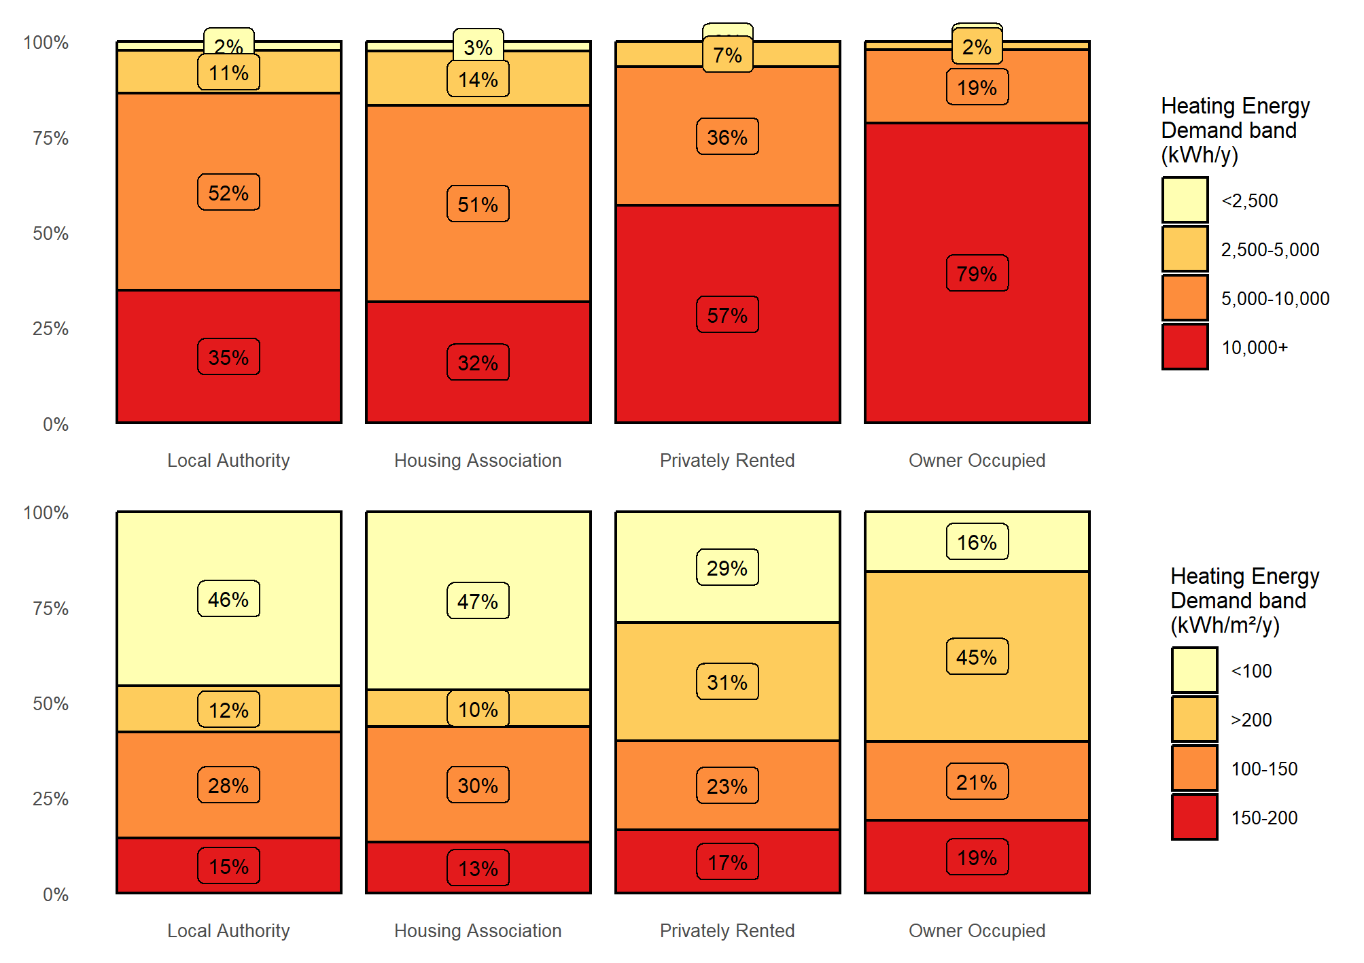

Figure 2: Domestic buildings- Distributions of age, EPC rating and gas grid connectivity by tenure type

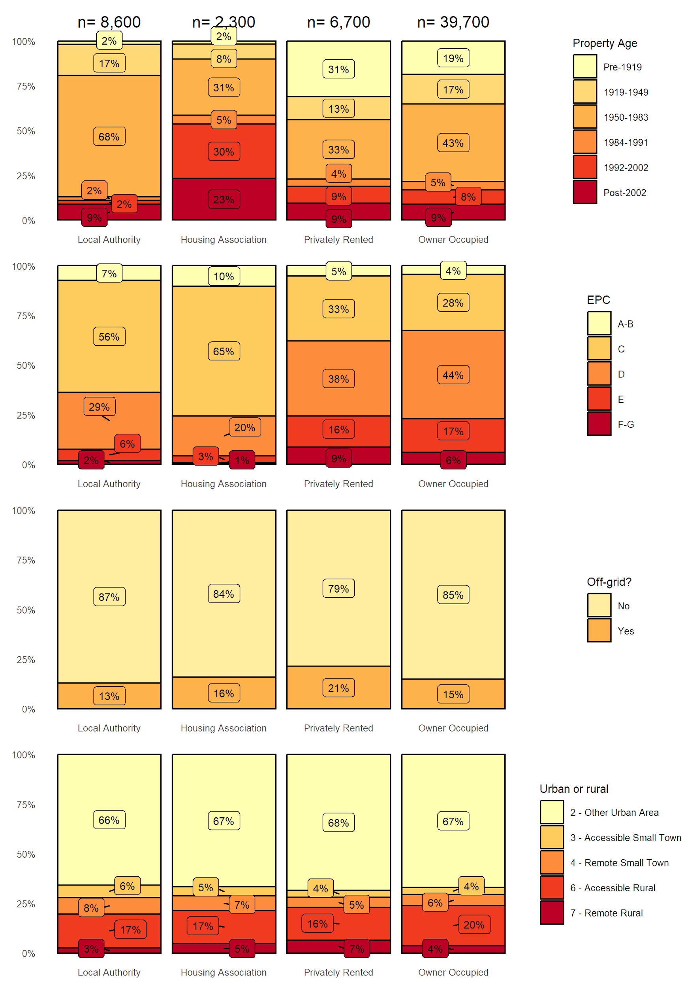

*Note, for clarity, percentages rounded to nearest integer and counts rounded to nearest hundred*

### 6.6 Non-domestic Buildings

The Non-Domestic Baseline Tool utilises data derived from Non-Domestic Analytics data sets. This analysis is based on the best available data, but there are gaps in reliability and coverage. Nevertheless, the data has been used for the baselining step of the LHEES process to get a flavour of the building stock.

This data will be supported through the Ayrshire Energy Masterplan (AEM); an ongoing project across the three Ayrshire’s which looks to identify investment and development opportunities in heat and energy decarbonisation. The introduction of Building Assessment Reports (BAR) from Scottish Government will further develop this picture in the near future.

The Non-Domestic Baseline Tool records 4,135 non-domestic buildings in South Ayrshire. Together, these have an estimated total heat demand of 150,000 MWh/y. An analysis of these properties can be seen in figure 3 below.

Gas is the biggest source of heat but electricity is close behind and, along with oil, they have the largest share of small heat loads. Smaller buildings account for almost half of the total heat demand and supporting those with small oil systems, which would not individually be as expensive, for heat pump or heat network connection could be a priority. It is likely that the small properties utilising electricity are already using heat pumps for heating and cooling.

A large proportion of buildings are pre-1919 with a high heat demand and this group of properties may be a target for energy efficiency measures. The data lists 55 % of these pre-1919 buildings as being retail or financial and 79 % as being in towns, making up most high street retailers.

Generally, non-domestic heating energy demand is dominated by the retail and finance sector *(Figure 3)*.

**Challenges**

* Data availability and reliability,
* Varied challenges with heat demand depending on business type,
* Traditional build high streets with hard-to-treat properties.

**Focus**

* ***Priority 3:*** Existing work through AEM to support engagement with non-domestic owners,
* ***Priority 3:*** Support Building Assessment Report (BAR) process and integrate data,
* ***Priority 2 & 3:*** Explore co-working opportunities with Economic Development and community planning partners

Figure 3: Non-domestic building type by heat demand

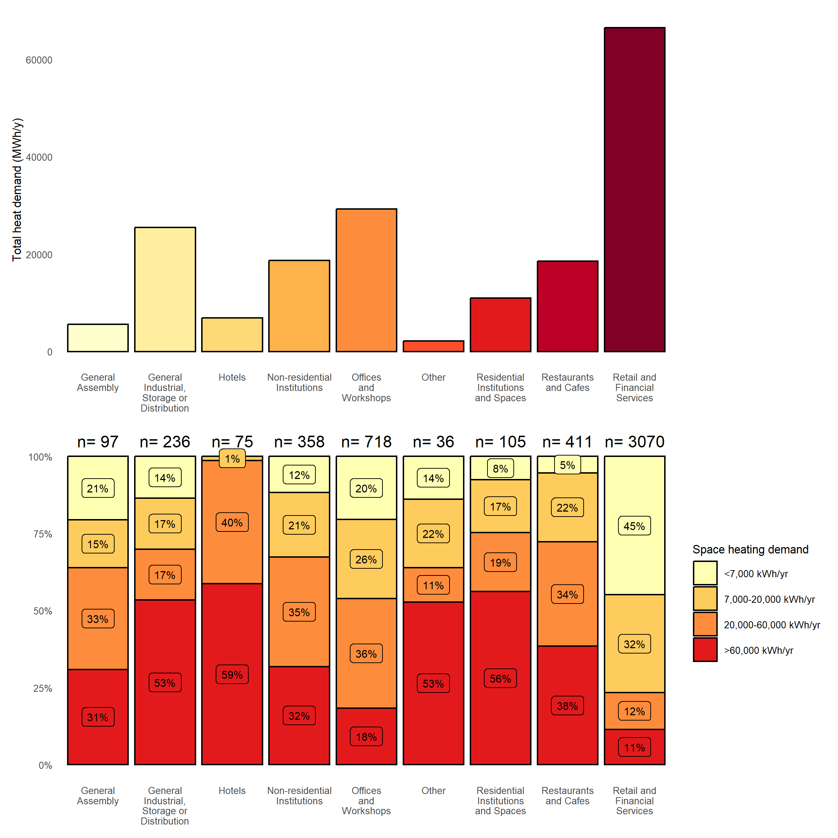

*Note, for clarity, percentages rounded to nearest integer and counts rounded to nearest hundred.*

# Strategic Zones and Baseline

This section illustrates how we have set out Strategic Zones and developed pathways for each. In this section the approach to selecting Strategic Zones is described, as well as the attributes for each which affect the strategic options. Weighted scores are used to assess energy efficiency and factors affecting the development pathways. A higher score is representative of poorer energy efficiency. Full details on the weighting and calculations are available in the **full technical report** in A*ppendix C, D and I*.

## Local Development Plan Areas as LHEES Strategic Zones

Through our LHEES work, “intermediate” geographical zones have been generated to show priority areas to target interventions, the analysis and indicators used can be seen in the **full technical report**, *Appendix A, and I*. In addition to this standard methodology, data was mapped against SACs Local Development Planning boundaries, as shown in figure 4.

Figure 4: South Ayrshire’s Strategic Zones

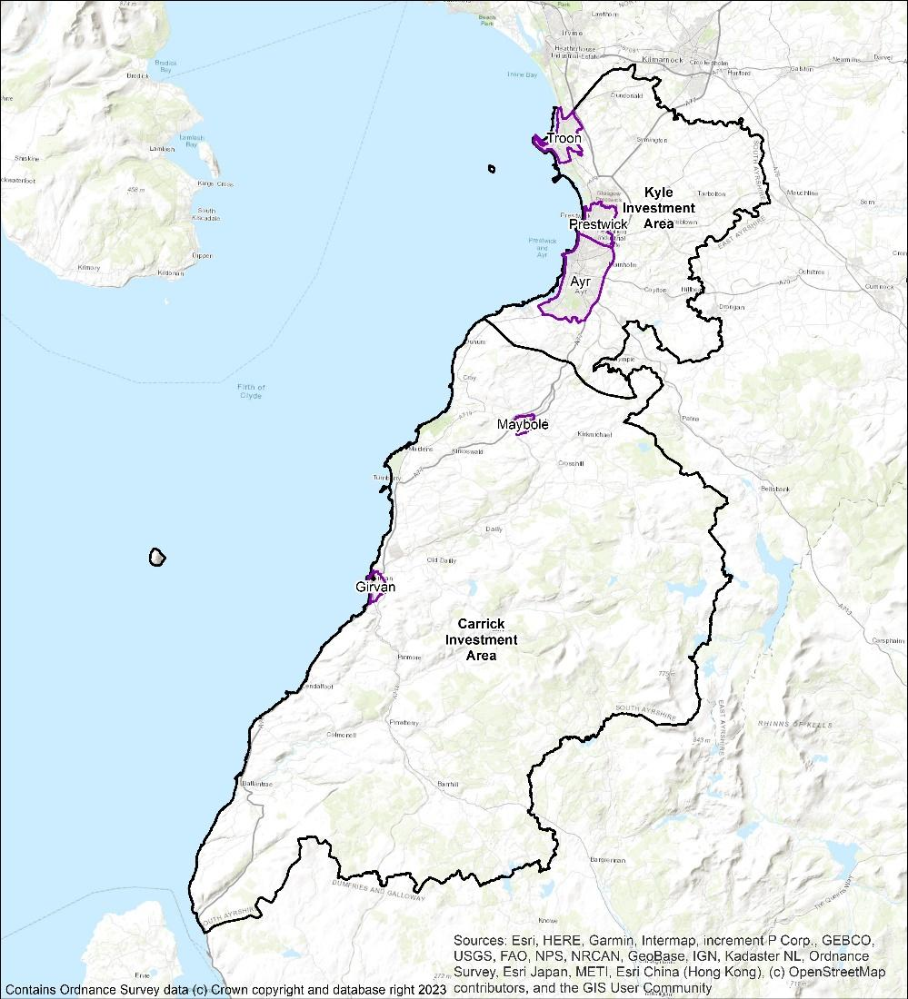

Creating a baseline of information about our building stock in South Ayrshire gives both a starting point to approach the task of decarbonisation, and a reference to measure our progress against in future. Meetings with Locality Planning groups and community councils have been undertaken for Girvan, Maybole and Carrick zones, and will continue with wider zones throughout LHEES delivery.

## Domestic Properties and Tenure

The numbers of domestic properties in the Home Analytics dataset, broken down by Zone and tenure are given in Table 4.

Table 4: Domestic properties in the Strategic Zones

|  |  |  |  |  |  |  |
| --- | --- | --- | --- | --- | --- | --- |
| Zone | Total domestic properties |  | Tenure |  |  | Mixed tenure in parent building |
| **SAC** | **Housing Association** | **Private Rental** | **Owner Occupied** |  |
| Carrick | 3,800 | 470 | 170 | 660 | 2,500 | 214 |
| Kyle | 8,100 | 1,050 | 320 | 800 | 5,930 | 409 |
| Ayr | 24,200 | 4,210 | 1,150 | 2,940 | 15,900 | 5,232 |
| Girvan | 3,400 | 700 | 170 | 330 | 2,200 | 414 |
| Maybole | 2,300 | 520 | 110 | 240 | 1,450 | 311 |
| Prestwick | 7,400 | 680 | 210 | 770 | 5,740 | 908 |
| Troon | 8,000 | 930 | 210 | 940 | 5,920 | 1,647 |

A baseline assessment of these properties by area, age, EPC, gas grid connection and urban or rural designation is shown in Figure 5.

Figure 5: Baselining of domestic properties in the Strategic Zones

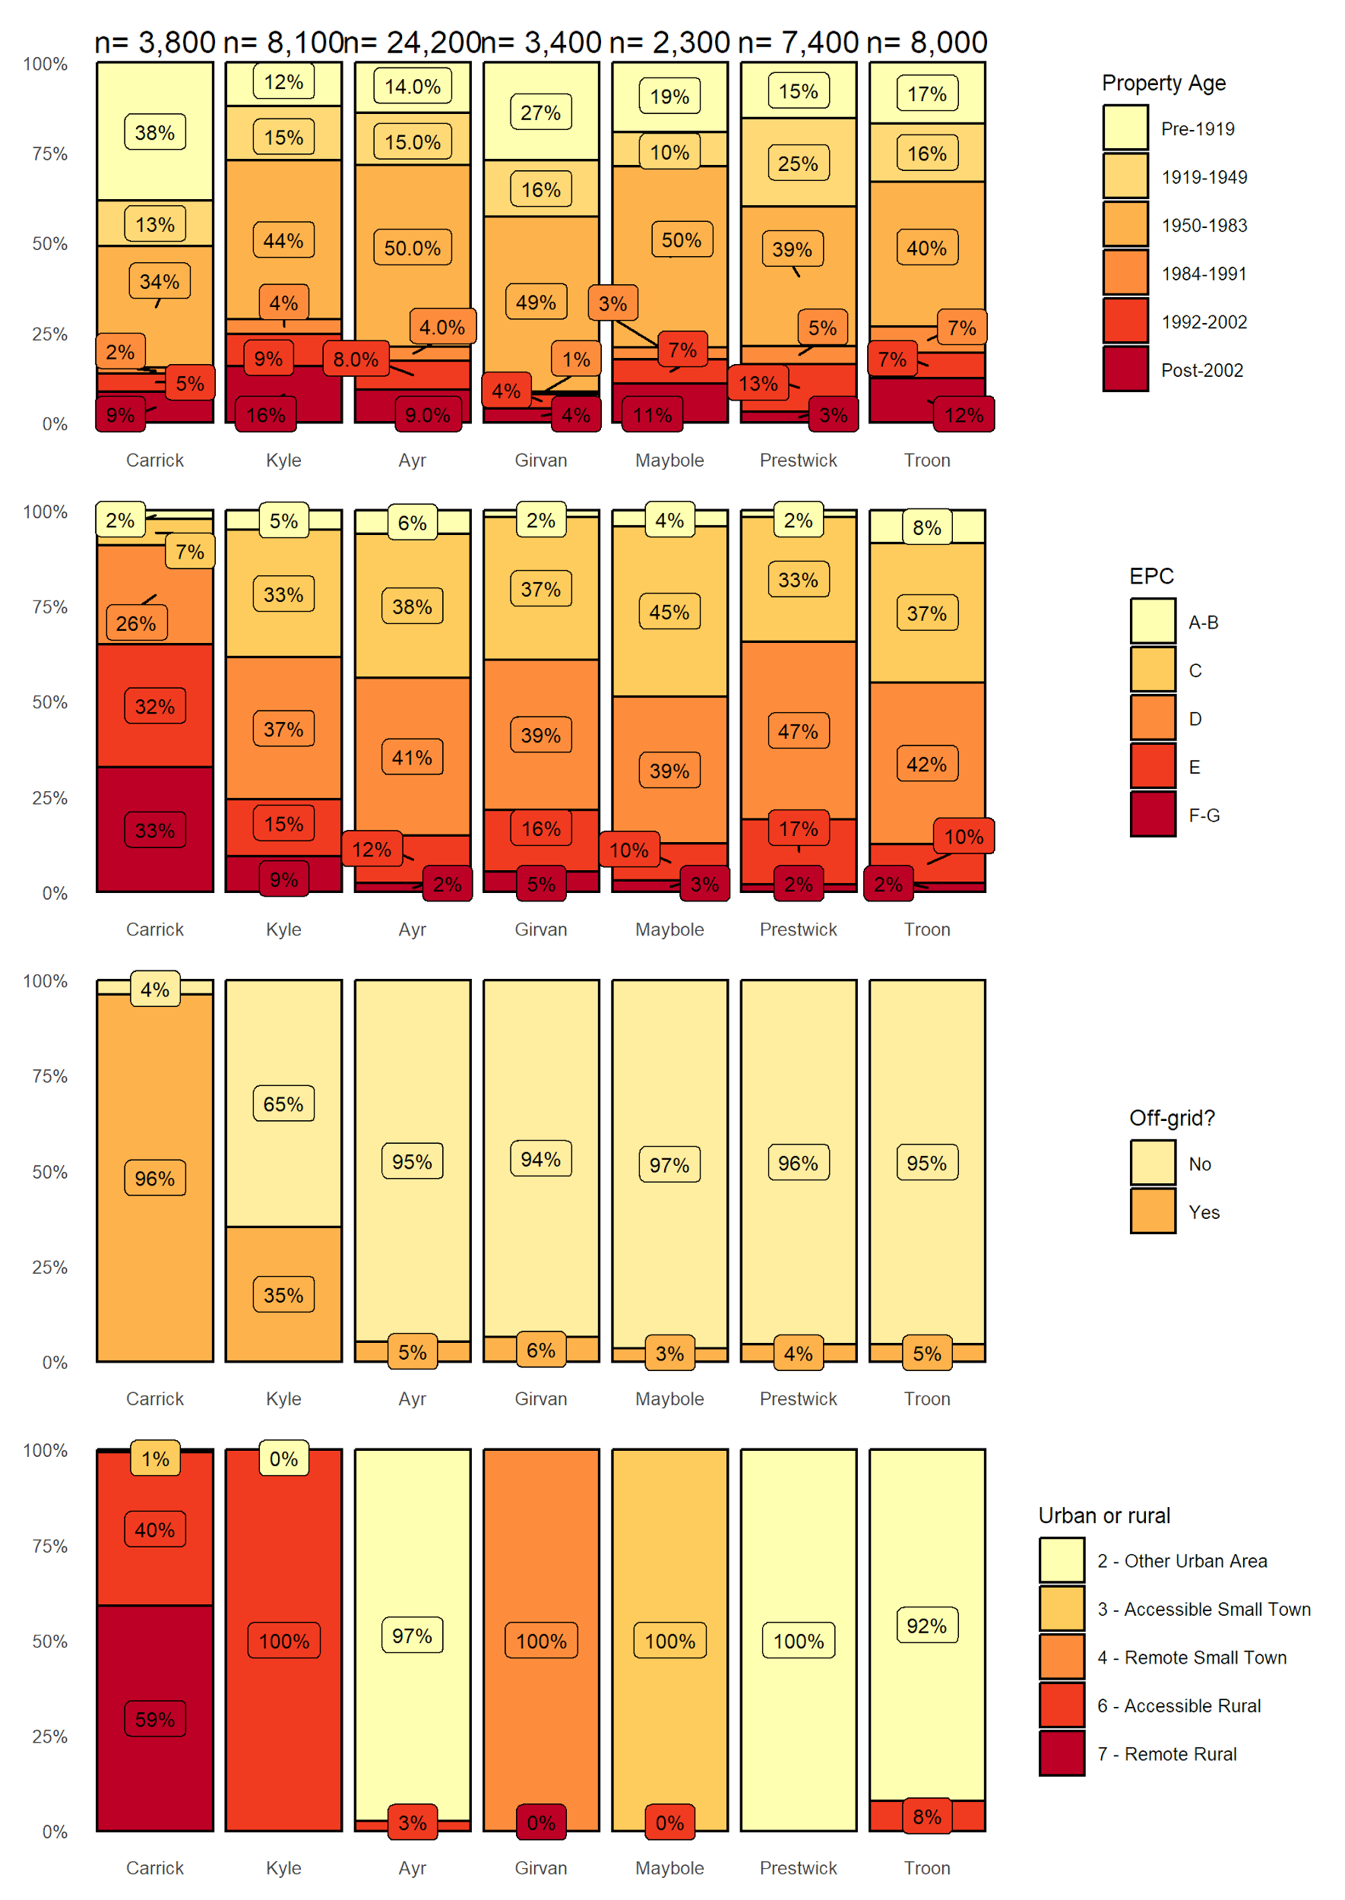



*Note, for clarity, percentages rounded to nearest integer and counts rounded to nearest hundred.*

## Domestic Energy Efficiency

In order to improve energy efficiency in domestic buildings, a wide range of improvements must be considered. This work is already underway, in line with council priorities and programs such as Home Energy Efficiency Programmes for Scotland: Area Based Schemes (HEEPS:ABS). This LHEES will seek to support and expand both funding and delivery as required to meet objectives.

Table 5 shows interventions required for each strategic zone and their weighted score with mapping shown in figure 6.

Table 5: Domestic energy efficiency weighted scores by strategic zone

|  |  |  |  |  |  |  |  |  |  |
| --- | --- | --- | --- | --- | --- | --- | --- | --- | --- |
| Strategic Zone | Number of interventions required | | | | Percentage of housing stock | | | | Total Weighted Score |
|  | **Loft Ins.** | **Glazing Upgrade** | **Wall Ins.** | **All** | **Loft Ins.** | **Glazing Upgrade** | **Wall Ins.** | **All** |  |
| Carrick | 819 | 373 | 2,159 | 3,351 | 21 % | 10 % | 56 % | 87 % | 29 |
| Kyle | 801 | 375 | 2,500 | 3,676 | 10 % | 5 % | 31 % | 45 % | 15 |
| Ayr | 2,147 | 1,488 | 8,552 | 12,187 | 9 % | 6 % | 35 % | 50 % | 17 |
| Girvan | 497 | 191 | 1,418 | 2,106 | 14 % | 6 % | 41 % | 61 % | 20 |
| Maybole | 250 | 133 | 954 | 1,337 | 11 % | 6 % | 42 % | 58 % | 20 |
| Prestwick | 955 | 310 | 3,278 | 4,543 | 13 % | 4 % | 44 % | 61 % | 20 |
| Troon | 709 | 290 | 3,225 | 4,224 | 9 % | 4 % | 40 % | 53 % | 18 |
| Total | 6,178 | 3,160 | 22,086 | 31,424 |  |  |  |  |  |

The three groups of interventions are broken down by strategic zone and tenure are shown in Figure 6. Much of the Home Analytics data is implied from other observations (e.g. wall construction) where there is no direct observation of a feature (e.g. wall insulation). A target for this LHEES is to improve the quality of the data used for decision-making and this can be done in tandem with the Scottish Government to improve the Home Analytics dataset.

Figure 6: Domestic properties requiring upgrades to glazing, and loft and wall insulation

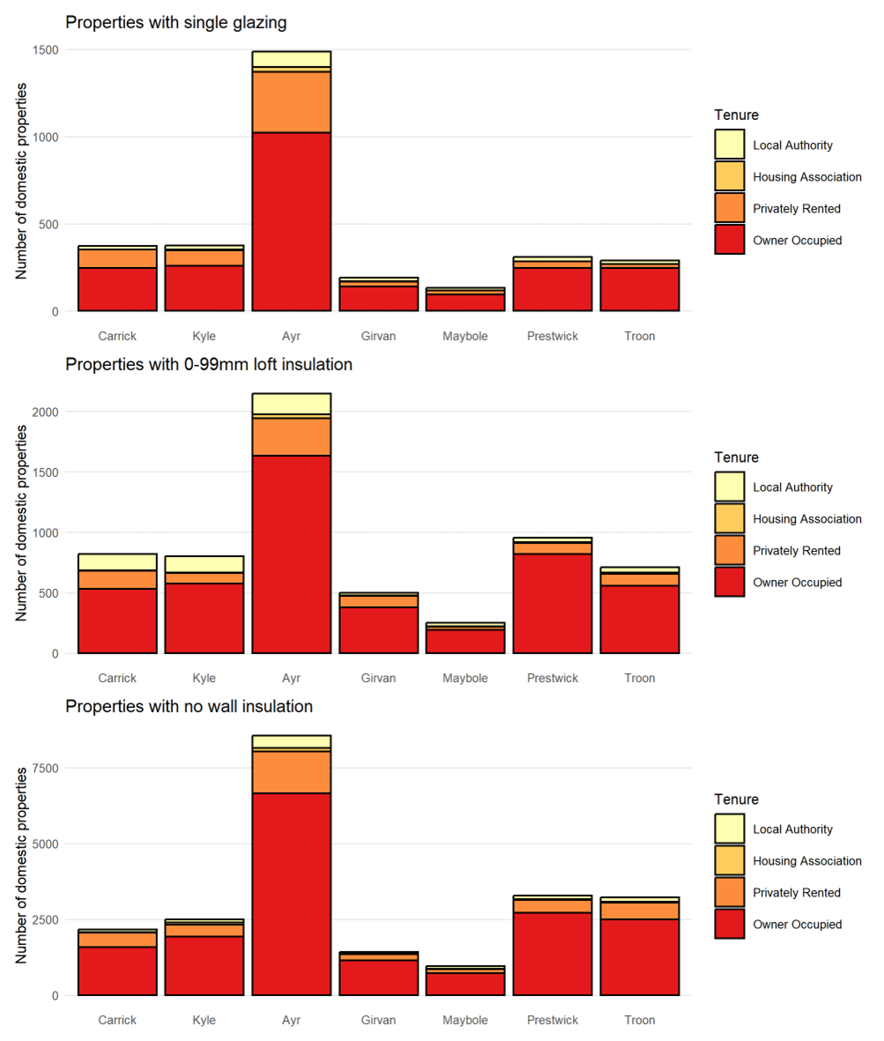



Figure 7: Map of Weighted Energy Efficiency Score – Data Zone Level

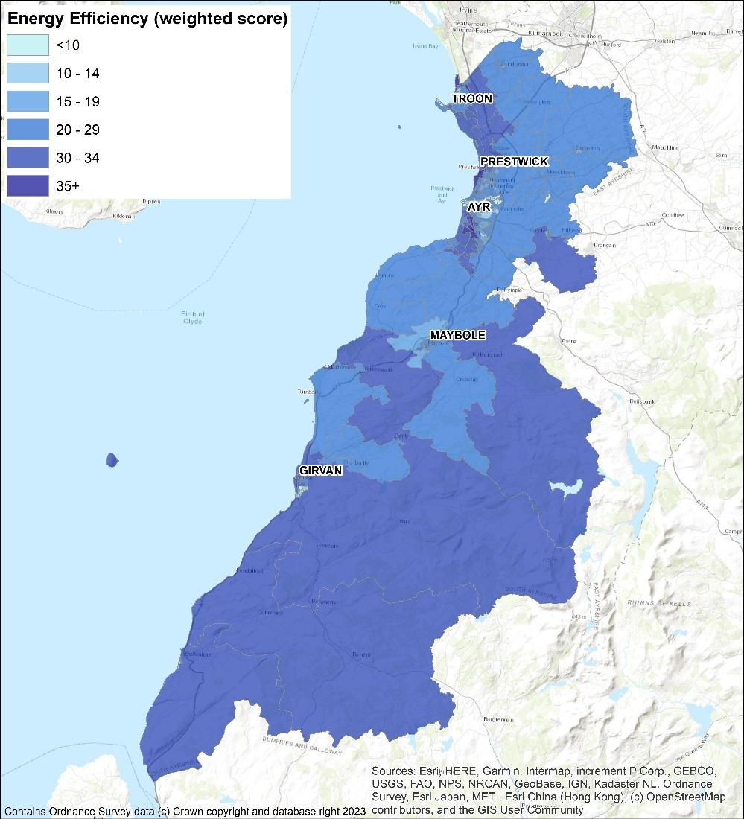

The baseline heat demand per year for the domestic buildings in South Ayrshire Council is 835,000,000 kWh. Table 6 shows the potential effect energy efficiency interventions can have on reducing demand across all the South Ayrshire building stock. This helps identify which measures are most cost effective, helping both fuel poverty and heat decarbonisation. Loft insulation upgrades is by far the lowest cost method to reduce heating demands. On the other hand, installing external wall insulation on the outside of buildings that already have cavity or internal wall insulation is deemed as the least cost-effective way to reduce heat demand. However, other factors such as available funding streams or improving the aesthetics of the building with external wall insulation or window upgrades can drive lower efficiency improvements.

Table 6: Summary of energy efficiency interventions across all buildings in South Ayrshire

|  |  |  |
| --- | --- | --- |
| Measure | Heat Demand Reduction (kWh/y) | Fuel Savings per Investment Cost |
| Cavity Wall Insulation (CWI) | 40,800,000 | 0.220 |
| Internal Wall Insulation (IWI) | 3,400,000 | 0.113 |
| External Wall Insulation (only wall measure) | 37,800,000 | 0.079 |
| External Wall Insulation (alongside CWI or IWI) | 78,400,000 | 0.023 |
| **All wall insulation measures** | **160,400,000** | **0.040** |
|  |  |  |
| Loft insulation upgrade from <100mm | 26,300,000 | 1.003 |
| Loft insulation upgrade from 100-250mm | 64,800,000 | 0.529 |
| Loft insulation upgrade from 250-300mm | 90,500,000 | 0.227 |
| **All loft insulation measures** | **181,700,000** | **0.430** |
|  |  |  |
| **All Single to Double Glazing upgrade** | **6,600,000** | **0.064** |
|  |  |  |
| Cylinder insulation upgrade from <50mm | 14,500,000 | 0.216 |
| Cylinder insulation upgrade from 50-80mm | 2,000,000 | 0.110 |
| **All cylinder insulation measures** | **16,600,000** | **0.192** |
|  |  |  |
| **All Combined Measures** | **365,300,000** | **0.062** |

## Domestic Energy Efficiency and Fuel Poverty

The Weighted scores for fuel poverty as a results of poor energy efficiency for the strategic zones, using the default weightings have been calculated for the Strategic Zones (Table 7). These are mapped against the data zone levels in figure 9. Carrick and Girvan stand out above the others and the interventions discussed in 7.4 will reduce the scores.

Table 7: Domestic fuel poverty scores by strategic zone

|  |  |  |  |
| --- | --- | --- | --- |
| Strategic Zone | Households with energy bills > 10% of income after housing costs | Households with energy bills > 20% of income after housing costs | Total Weighted Score |
| Carrick | 34 % | 43 % | 31 |
| Kyle | 21 % | 7 % | 18 |
| Ayr | 22 % | 9 % | 19 |
| Girvan | 33 % | 21 % | 27 |
| Maybole | 27 % | 15 % | 23 |
| Prestwick | 18 % | 4 % | 19 |
| Troon | 19 % | 4 % | 18 |

Figure 8: Map of Energy Efficiency as a Driver of Fuel Poverty – Data Zone Level

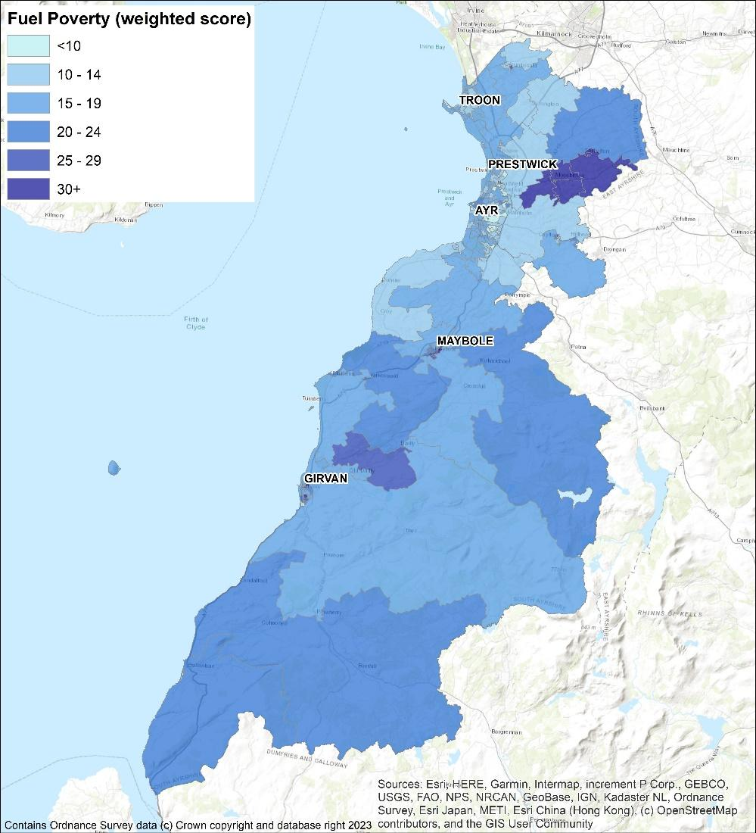

**Analysis**

This analysis of baseline data gives several considerations for this and future LHEES work:

**Loft insultation**

There should be limited barriers to installing loft insulation to owner occupied and privately rented homes, since it is both cheap and usually easy to install.

**Enhancing Dataset**

HA data is comprehensive, however will require to be crosschecked with local knowledge and Council datasets to improve targeting. Layering of data with health information to assess energy efficiency as a driver for health inequalities could provide more contextual targeting of interventions.

**Local Authority and Housing Association**

Local authority housing stock represents the most easily accessible interventions, generally covered through rolling maintenance programs. As such, Council properties with single glazing and substandard loft insulation will be assessed against Council records as it is likely these are cloned records.

**Carrick**

Carrick stands out with respect to the weighted scores, with the highest percentage of interventions required in each category.

**Wall insulation**

Wall insulation is the largest required intervention area with an average of 41% of properties requiring some level of improvement. While there is a proportion of homes with solid walls which are hard to insulate, the most common construction type in every strategic zone is cavity walls which should not hinder improved insulation (Figure 6).

**Private Sector**

The private sector represents the largest proportion of each intervention area. Additionally, 1,069 homes with single glazing are either listed or sit in conservation areas and, consequently, barriers to interventions may be more than just financial. Partnership working with Energy Agency and Home Energy Scotland will be essential to support intervention in this area.

**Challenges**

* Data reliability is good for domestic, but there is a need for localised knowledge, engagement, and layering of datasets to deliver successful interventions,
* Scale of intervention required,
* Current funding streams are not adequate to meet scale of challenge.

**Focus**

* ***Priority 1****:* Prioritise areas and interventions highlighted through the baseline work,
* ***Priority 1 & 2:*** Continue Locality Planning and Community Council engagement sessions to build understanding and engagement,
* ***Priority 1, 2 & 3***: Assess funding and capacity issues around delivery of measures.

# 8. Technology

## 8.1 Options

There is no single solution to decarbonisation of heat, certainly not on the scale that LHEES is working from. Currently the most viable options from Table 2 for low carbon heat sources are:

* Heat pumps
* Heat networks
* Electric heating

Each property owner will make decisions on which route of change and technology is most suitable for them and their property, at this stage of the LHEES work we seek to outline the most suitable technologies for different properties.

## 8.2 Heat Pumps

All properties have been assessed for suitability for heat pumps as part of the LHEES, with the method and results available in the **full technical report,** section 7.7.3 and Appendix G. This is an overview, and in practice there will be assessments done on a case-by-case basis, however the DESNZ Electrification of Heat Demonstration project[13] report, conducted by Energy Systems Catapult, concluded:

*“The project has not identified any particular type or age of property that cannot have a successful heat pump installation. The suggestion that there are particular home archetypes in Britain that are “unsuitable” for heat pumps is not supported by project experience and data.”[14]*

As a result, of the 58,000 domestic properties in question, 28,445 could currently be suitable for heat pump installation. This includes individual and communal heating systems.

This level of electrification of heating could place significant pressures on the electricity grid. A key action in the delivery plan is to develop engagement with Scottish Power Energy Networks (SPEN), alongside close working with the Ayrshire Energy Masterplan. Increased coordination with commercial and grid investment planning in the near to medium term will improve longer term area-wide delivery, allowing for early warning of potential grid constraints and reducing risks and barriers to delivery.

**Challenges**

* Poor installation or incorrect measures risk increasing energy costs and making fuel poverty worse,
* Grid capacity may constrain large scale roll out of heat pumps,
* High installation costs

**Focus**

* ***Priority 1 & 2****:* Prioritising no/low regret options
* ***Priority 2****:* Monitoring energy costs and funding availability
* ***Priority 2****:* Engagement with Scottish Power Energy Networks in developing area wide approaches.

## Electric Heating

Electric heating can include a series of different solutions, the most prominent of which is high-efficiency storage heaters. These store heat generated overnight while electricity is cheaper and release it gradually over the course of the day. These systems require a cheaper off-peak electricity tariff to heat the home. Fuel poverty research by Scottish Government in 2020 cited mixed views with storage heating, varying from no significant issues, to challenges with affordability, tariff and operation confusion, and difficulties with price comparison and switching*[15]*.

High-efficiency systems can offer a more cost-effective solution compared to conventional storage systems or direct radiant panels. Research suggests that of the 1.7m homes in the UK heated with electric storage heaters, 63% of which are over 12 years old, upgrading and correctly specifying system sizes can reduce bills and positively impacts of fuel poverty*[16]*.

## Mixed Tenure, Mixed use and Historic

**Listed buildings and conservation areas**

Listed buildings can be challenging with respect to energy efficiency improvements, the siting of, for example, air source heat pumps external to the building, and the connection to new district heating pipework.

There are around 1,350 listed domestic properties (data for non-domestic has not been provided). Only 19 % have EPCs rated C or better, with 14 % being F or G.

Like listed buildings, conservation areas represent a particular challenge regarding the introduction of energy efficiency measures and low carbon heat measures. For example, conservation areas are excluded from certain permitted development rights. This can result in properties requiring permission for works that may not have required planning permission in a different area. Conservation areas are more likely to include traditional building types for which energy efficiency measures and low carbon heat sources tend to be more time consuming, challenging or costly to install, if they are possible at all.

There are a little over 4,600 domestic properties in conservation areas (around 8 % of the homes in South Ayrshire), with the vast majority being owner occupied.

**Mixed use buildings**

Around 1,700 domestic properties (3 %) of total are recorded as flats in mixed use buildings. The potential energy efficiency interventions for these properties are laid out in Figure 16, section 7.8 of the **full technical report**. Almost all of these properties are owner occupied or privately rented. As with the general stock, wall insulation appears to be a big target for this typology.

**Challenges**

* Limited direct influence on energy efficiency or heat type,
* Unique and challenging building types,
* Increased cost and challenge for interventions,
* Incorrect installation or operation of technologies can exacerbate fuel poverty.

**Focus**

* ***Priority 1 & 2****:* Prioritising no/low regret options,
* ***Priority 2 & 3****:* Engagement with local and national groups and industry experts to monitor best practice,
* ***Priority 2 & 3****:* Identify and exemplify existing best practice within South Ayrshire.

# 9. Heat Networks

Heat networks, often referred to as district heating systems, are area wide approaches to heating, and combined with sustainable heat sources will play a crucial role in decarbonising heat for our homes and businesses. Unlike traditional heating methods that rely on individual property heating, heat networks operate by sending heat from a central source to multiple buildings through a network of insulated pipes. Globally, 9% of final heat demand is met by heat networks, with European leaders such as Denmark, connecting to 65% of domestic properties.

One of the key advantages of heat networks is the option to use different sources of heat, such as large-scale heat pumps using water, ground, or waste as heat sources, geothermal, and waste heat from industrial processes.

Scottish Government has identified heat networks as a key technology in meeting our climate change duty and assigned output targets through the Heat Networks (Scotland) Act 2021, the first of which is in 2027.

## 9.1 Approach

The principal determining factors for the feasibility of heat networks are the heat density in an area and the presence of one or more “anchor loads” – consumers which are large, stable, and likely to connect.

To assess these factors, the Scottish Heat Map data was supplemented with data from the Council on fuel consumption within their estate. A data validation exercise was carried out to remove any duplicate points, heat demands which were uncertain, dubious heat loads and buildings in sectors less likely to enter into commercial agreements. Where areas were shown to be viable, additional checks were carried out on the anchor heat loads and any loads considered erroneous were removed from the analysis.

Further validation of both the actual heat demands of the buildings and their suitability for connection to heat networks will be assessed before identifying future heat network areas.

The maps presented illustrate the heat demand density of buildings and highlight the possible anchor loads with the addition of other data including local authority-owned properties, potential sources of heat and areas of future development.

The linear heat density method was used – involving drawing a circle around each building the diameter of which is proportional to the heat load of the property. Two measures of heat network viability were used:

* A baseline scenario (purple shades throughout this analysis) using 4,000 kWh/y/m where the circle around each property (in kWh) is divided by 4,000 to give a radius in metres around the property; and
* A stringent scenario (green shades throughout this analysis) using 8,000 kWh/y/m where the radius of the circle is the heat load in kWh divided by 8,000.

The 4,000 kWh/y/m measure highlights more areas as being potentially suitable and the 8,000 kWh/y/m shows fewer areas but are areas with a higher chance of forming a successful heat network.

Finally, the areas were filtered based on whether a continuous area could be formed where the circles around each heat load formed, which enclosed heat loads totalling 15,000 MWh/y or more.

This heat load represents a 3 MW heat source operating for 5,000 full load equivalent hours per year. The purpose is to identify those areas where it is likely that there is sufficient heat load to warrant a new energy centre being constructed. This is intended only as a guide and the exact cost of each energy centre and network would need to be calculated at feasibility stage.

## 9.2 Overview

An analysis of the potential for heat network zones indicates that there are broadly two areas where heat networks may be viable – within Ayr and an industrial cluster near Girvan.

Within Ayr there are three separate zones identified, however, this strategy considers them in the context of a single heat network strategy for Ayr rather than considering them three discrete opportunities.

### 9.2.1 Ayr

The analysis shows that there is a cluster of properties in the town centre, South of the river, which could be considered an area for district heating (Figure 9). This area has both sufficient total load to consider constructing a new network and associated infrastructure, as well as a number of anchor loads including Council owned buildings.

North of the river, there is a heat network area which could be connected to the town centre by one of the bridges crossing the river to form a single heat network opportunity. The business strategy areas highlighted in a red outline are also in this zone and the third to the North East.

A cluster of industrial buildings, Ayr_3_4000, differs from the town centre areas as there is a less diverse range of tenures and building types, and therefore close coordination with businesses is going to be important when considering any heat network development.

Working in tandem with the Ayrshire Energy Masterplan will ensure consultation and engagement of businesses, forming a coordinated approach to feasibility and development work.

The Ayr_3_4000 zone is also close to the Prestwick airport site. The Council will coordinate with stakeholders about any future opportunity for heat networks to serve the users of heat on this site.

The town centre also contains a large number of listed buildings and a conservation area.

There are additional barriers to decarbonising historic buildings and a heat network could minimise the need for changes to the buildings while ensuring they are decarbonised. Heat networks avoid the need for significant heating plant to be located at each building.

More detailed investigation of each building is important to identify what the opportunities and constraints are for each specific building. Specific attention needs to be paid to:

* whether the existing heating system in the building is likely to be compatible with district heating
* the location of the existing heating plant the route to connect this to the district heating network
* protected attributes of the building and its surroundings

Figure 9: Ayr heat network opportunity – Baseline

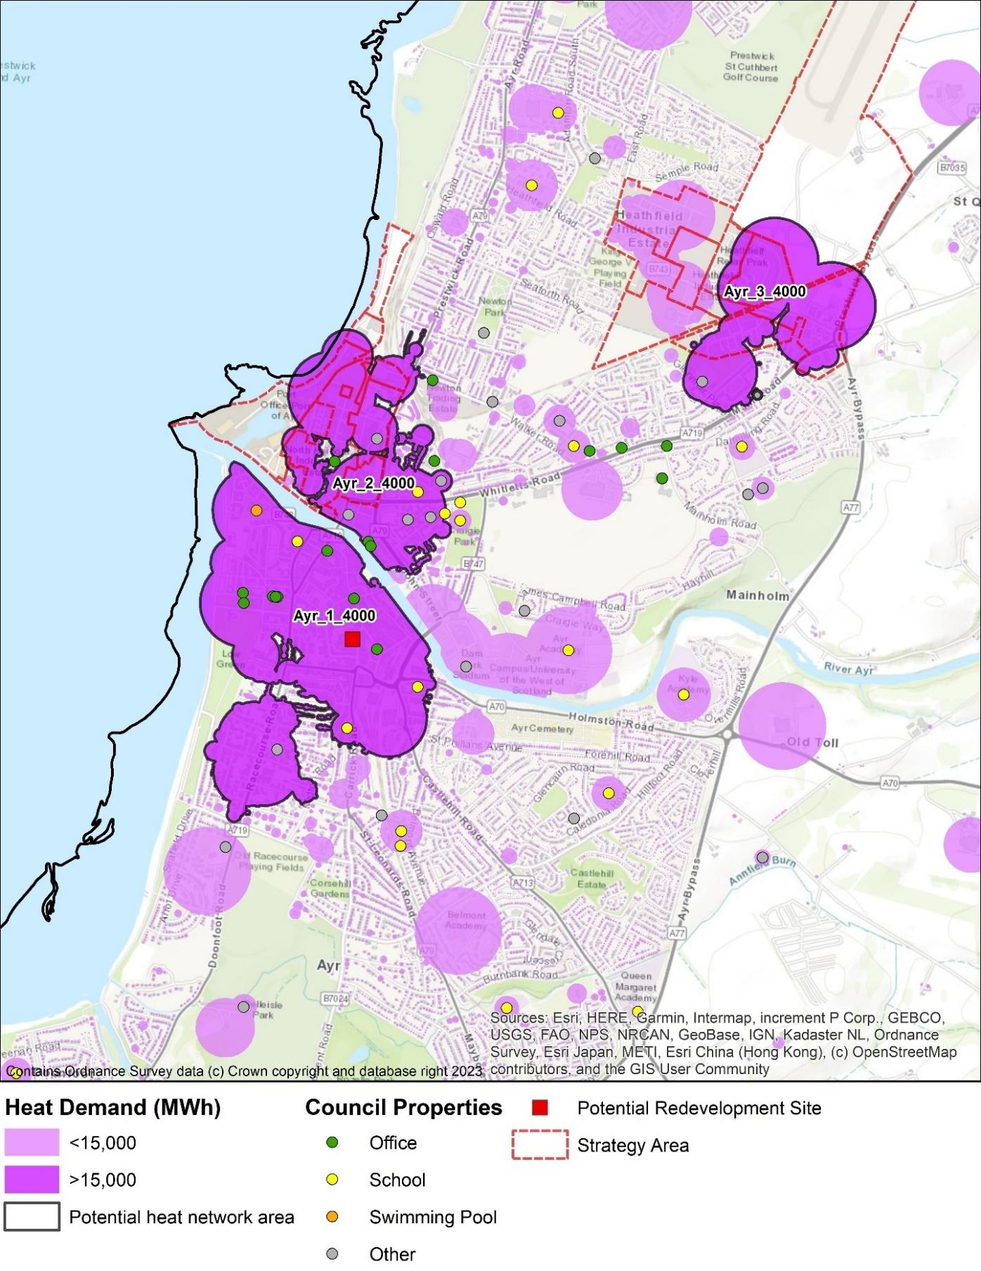

Figure 10: Listed buildings and conservation areas

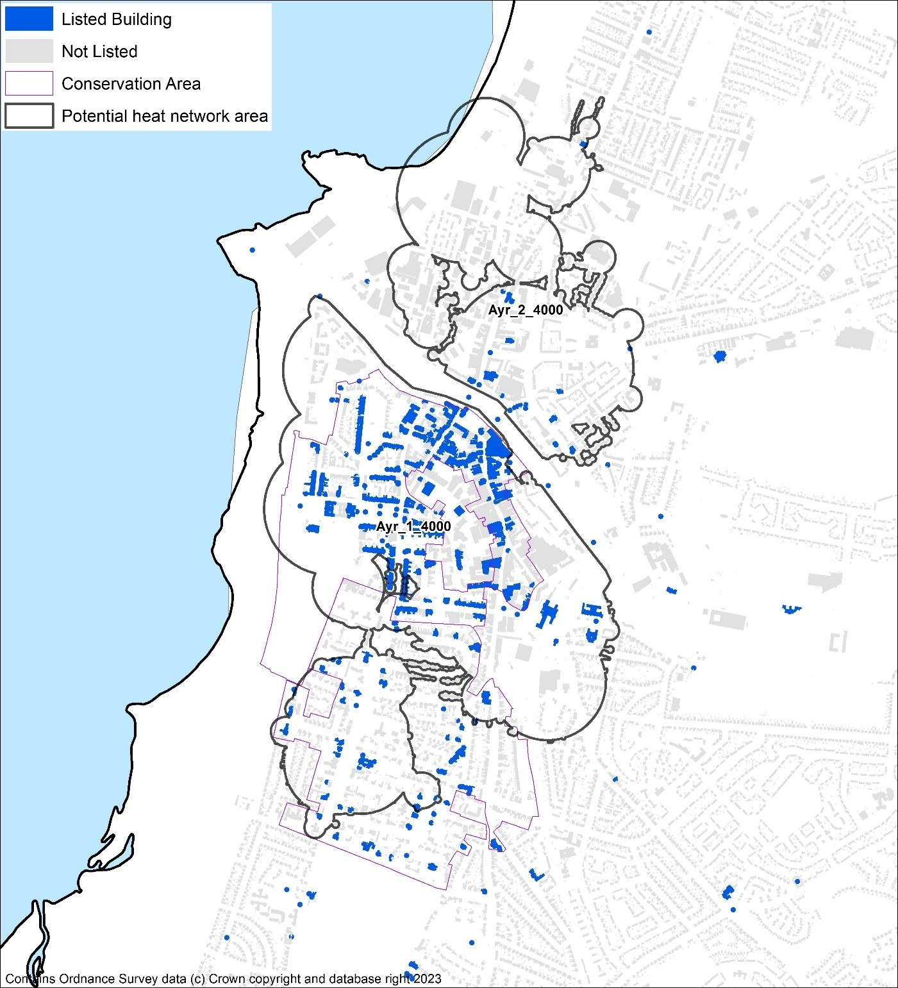

### 9.2.2 Girvan industrial cluster

An industrial cluster was identified to the North of Girvan which includes a substantial use of industrial energy including heat. This site has complex energy flows and houses both a Biomass CHP and a substantial anaerobic digestion site and involves a number of industrial businesses. However, a heat network feasibility study determined that there are not currently significant heat demands sufficiently close to the site to allow a district heating scheme to be developed. If significant future developments were to be planned near the site then the opportunity for heat networking could be revisited and local plan zoning may be a lever to influence this. The feasibility study may be revisited in the future.

Figure 11: Girvan industrial heat cluster

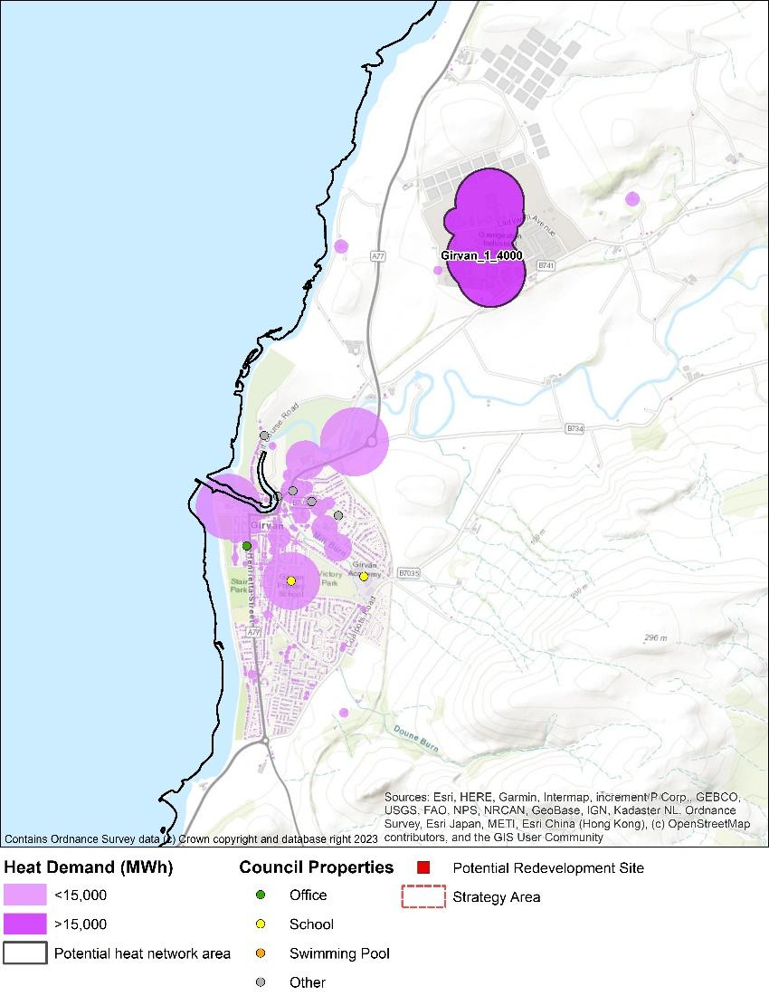

There is an existing feasibility study for district heating from the site to Girvan itself, however current markets are not financially viable. The feasibility study will be revisited as the industry develops within Scotland.

It is not within the scope of LHEES to consider other energy vectors, however, the site is in close proximity to the transport corridor containing the A77 connecting the Central Belt of Scotland to the ferry ports of Cairnryan and Larne. As such, there could be a substantial road transport fuel demand in this area and the site, and its energy flows should be considered as part of any future low carbon transport fuels for the area.

Work is continuing on South Ayrshire’s latest Local Development Plan (LDP3), guided by the National Planning Framework 4 (NPF4). This iteration will encapsulate South Ayrshire Council’s commitment to heat network delivery by:

* coordinating work with LHEES delivery plan actions,
* Requiring new development areas to consider heat network viability,
* Requiring proposals within or adjacent to an existing Heat Network to be designed to connect to the heat network, or allow for future connection to a planned heat network,
* Investigating heat network potential in Southeast Ayr.

**Challenges**

* Relatively low levels of heat density in South Ayrshire resulting in 3 potential heat network zones,
* Engagement and feasibility are still at an early stage,
* Capital costs and delivery models.

**Focus**

* ***Priority 3:***Coordinate with LDP3 development
* ***Priority 3:*** Coordination with AEM work to build feasibility studies for identified Heat Network zones,
* ***Priority 3:*** Redevelopment of Girvan Heat Network feasibility,
* ***Priority 2****:* Continued skills development in SAC through engagement with other local authorities, industry, and international mentoring programs.

# Delivery Areas

In this section we set out potential routes to approach interventions, looking at how we identify and prioritise areas for action.

These approaches will use the data developed from the LHEES methodology to show where interventions can be delivered in a way that creates the most positive impact for the funding available. This is done using weighted scores as discussed in section 7. The **full technical report** gives further detail on the assessment and weightings applied to the Home Analytics data in *Appendix C* for intermediate zones, *Appendix D* for data zones, and *Appendix I* for the weighting and calculations. These have been completed in relation to the relevant LHEES considerations as shown in table 1, 4.2.

Delivery areas have been developed for both a spatial and for technology-led approaches.

## 10.1 Spatial approach

Through the spatial approach, characteristics of buildings have been considered and compared on an area-wide basis with respect to the LHEES considerations. This has been considered at intermediate and data zone levels, with overviews given at strategic zone levels as shown in section 7.

This type of analysis allows locations to be identified for area-based funding and focuses action to where it could deliver the greatest benefit.

**Energy efficiency as a driver of fuel poverty**

Weighted scores in this section are distributed unevenly across South Ayrshire, with higher scores indicating a greater risk that families are experiencing fuel poverty as a result of poor energy efficiency. There are a small number of zones with significantly worse scores, suggesting that there is value in addressing energy efficiency measures in specific geographical areas.

Fuel poverty is a hugely complex challenge; one that is intrinsically linked to physical infrastructure. As the primary driver for action, all delivery areas will be considered against, and linked to fuel poverty metrics.

**Domestic energy efficiency**

Weighted scores for domestic energy efficiency are distributed unevenly across South Ayrshire with higher scores indicating poorer energy efficiency and a greater potential for demand reduction. There are a small number of zones with significantly worse scores, showing value in addressing measures in specific geographical areas.

Areas with the highest scores are considered within the priority listings, however this data must be considered against wider factors to be most effective as discussed in 10.2.2.

Amongst the top scorers most homes are in the private sector. This points to a need to address the problems both by spatial zoning and by targeting properties by tenure and technical intervention; for example, a lack of wall insulation is the biggest contributing factor to the weighted score in each top delivery area.

**Mixed tenure, mixed use, and conservation areas**

Mixed-tenure and mixed-use properties have unique challenges for the implementation of interventions as they have multiple stakeholders to engage that may have conflicting interests. Mixed-tenure buildings are those which have multiple properties of the same use but differing ownership type, whereas mixed-use buildings will have multiple properties in the same buildings that have different use profiles and are not all residential, such as a shop with a flat above it.

Due to the large number of stakeholders and challenges in this area, a dedicated working group is seen as the best course of action for delivery in mixed use and tenure areas.

Relatively few data zones have homes within conservation areas. The top three zones in Ayr South Harbour and Town Centre are amongst the worst performing zones according to energy efficiency scores and so some conservation areas will be priorities in this stage of LHEES. Additional strategic assessment is required early in the LHEES delivery period to work towards decarbonisation in this area, prioritising where fuel poverty can be positively impacted.

The top data zones for listed domestic properties are Ayr South Harbour and town centre, Troon and Carrick north. These are also some of the poorer performers from the point of view of energy efficiency. Consequently, as in the conservation areas, further strategic assessment for this building type will be developed early in the LHEES delivery phase.

**Challenges**

* Mixed tenure, mixed use, conservation areas and listed buildings present significant challenges in area-wide decarbonisation,
* Traditional high street buildings present increased challenge.

**Focus**

* ***Priority 1:***Ensure that all LHEES delivery area prioritisation considers fuel poverty metrics,
* ***Priority 2:*** Creation of working group to ensure mixed use and tenure buildings are considered within area wide approaches,
* ***Priority 2 & 3:*** Monitor nation landscape and connect and build on current internal capacity for further strategic assessment of conservation and listed building decarbonisation.

## 10.2 Fuel Poverty

The fuel poverty indicator analysis used in the baseline tool was supplemented with additional analysis based on the heat demands and fuel type presented in the Home Analytics dataset and the subsequent cost to the heat each property based on the utility prices given in Table 8. This building-level analysis was aggregated to intermediate zone and is intended to provide an indication of how affordable it is to heat houses in each area and is not a detailed prediction.

Table 8: Fuel prices used in fuel poverty analysis

|  |  |
| --- | --- |
| Fuel | Autumn 2023 Price Cap |
| Electricity Rate | £0.270 |
| Mains Gas | £0.070 |
| Oil | £0.116 |
| LPG | £0.119 |
| Biomass/Solid | £0.068 |
| **Standing Charges** |  |
| Mains Gas | £0.45 |
| Electricity | £0.27 |

The number of homes in each income decile are given in Table 9; 60 % of homes are in decile Five or lower. The 10 least affordable Intermediate Geography Zones, those with the fewest percentage of homes which could be affordably heated by households in income decile Five or lower, are listed in in Table 10.

Table 9: Number of homes by SIMD income decile

|  |  |  |
| --- | --- | --- |
| SIMD Income | Number of homes | Percentage of homes by income decile |
| One | 5,920 | 10% |
| Two | 4,960 | 9% |
| Three | 4,080 | 7% |
| Four | 9,980 | 17% |
| Five | 9,790 | 17% |
| Six | 2,840 | 5% |
| Seven | 4,430 | 8% |
| Eight | 4,230 | 7% |
| Nine | 7,250 | 13% |
| Ten | 3,840 | 7% |

Table 10: Percentage of homes which could be affordably heated by households in income decile five or lower

|  |  |
| --- | --- |
| Strategic Zone | Percentage of homes which could be heated by households in income decile five or lower without being in fuel poverty |
| Carrick | 18 % |
| Kyle | 60 % |
| Girvan | 73 % |
| Ayr | 74 % |
| Prestwick | 74 % |
| Troon | 78 % |
| Maybole | 84 % |

### 10.2.1 Social Impact of Multiple Deprivation

The Local Heat and Energy Efficiency Strategy and Delivery plan consider fuel poverty where it can be reduced through energy efficiency measures. Understanding which locations have higher rates of overall deprivation as well as specifically income deprivation, can inform decisions on areas of focus.

Figure 12: Map of overall SIMD rank

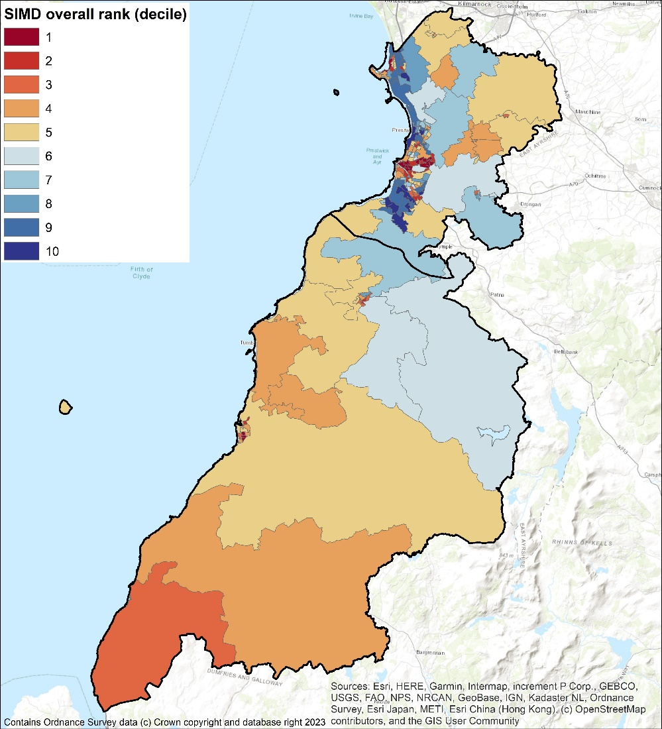

Figure 13: Map of income SIMD rank

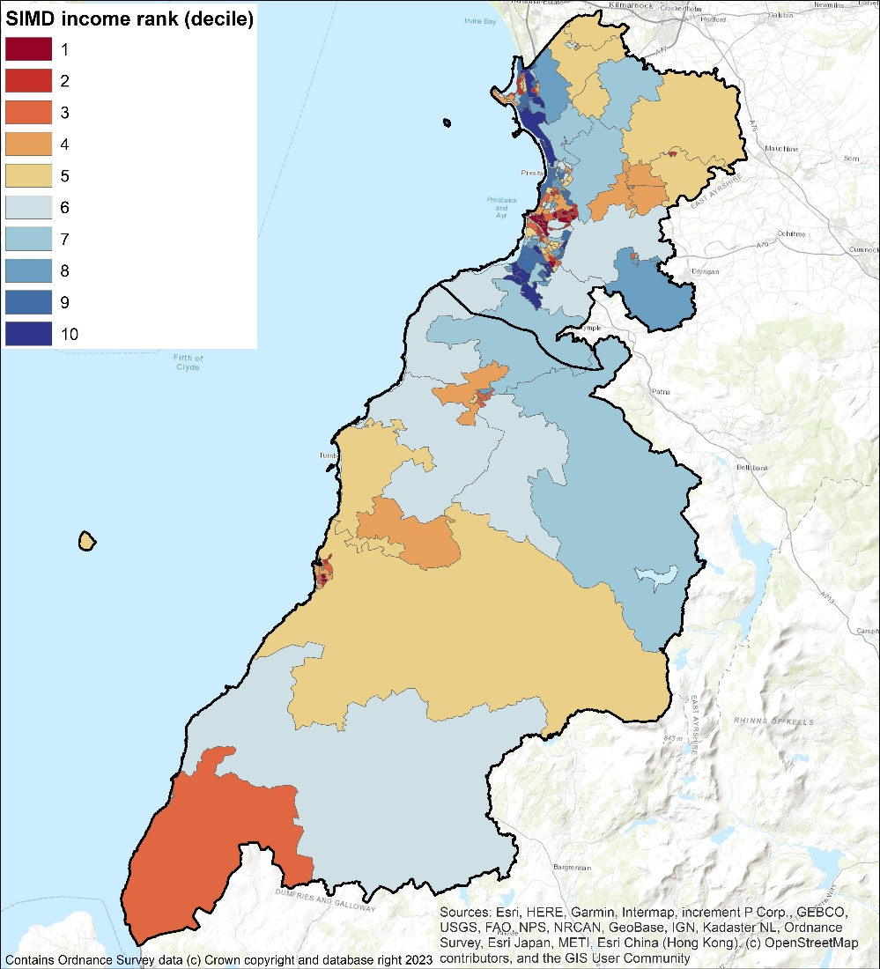

### 10.2.2 Overlaying Multiple Considerations

The analysis has generated various rankings for the purpose of determining where to start with interventions. The Weighted Energy Efficiency Score and Fuel Poverty rankings are, thanks to the latter being based on the former, very highly correlated and can be used interchangeably with similar outcomes. However, SIMD and income ranks are not correlated with the Weighted Energy Efficiency Score. Data zones with the worst energy performance are found to be ones which are relatively affluent, so addressing funding towards fuel consumption reductions would not address the issue of real-world fuel poverty. However, since there are likely to be income poor households in areas which are more affluent on average, the poor energy efficiency of those properties or the relative lack of energy efficient properties does still warrant targeted investigation and intervention. This will be developed within the time frame of this iteration of LHEES.

**Health Inequalities**

The impacts of fuel poverty are not only financial but have significant consequences for health and wellbeing. Poor property repair, dampness, and low temperatures all impact physical and mental health, leading to increases in respiratory illness, increased risk of heart disease, worsening conditions like arthritis, and increased levels of anxiety and depression. In 2023 it was estimated that the NHS spends £1.4 billion annually treating illness associated with living in cold or damp housing[17].

Partnership working between NHS A&A and SAC will look at assess the viability of identifying households at risk of health effects from cold homes, allowing more granular assessment for delivery of interventions. Combining this with characteristics such as single parents or pensioners, or pre-payment meters, could further refine areas of focus where available.

**Challenges**

* 60% of homes in decile 5 and lower
* SIMD and income ranks are not correlated with the Weighted Energy Efficiency Score
* Multiple factor assessment required

**Focus**

* ***Priority 1:*** Integration of SIMD ratings in intervention targeting,
* ***Priority 1:*** Investigation into further overlayed datasets and considerations,
* ***Priority 2:*** Cross departmental and partnership working to ensure LHEES actions connect to other strategy, policy and projects.

## 10.3 Technology-Led Approach

As an alternative to the spatial approach, this approach groups interventions by tenure and fuel type, which would affect the viability and benefit of key technology interventions. This allows alternative means of targeting properties for interventions, either in our own properties or to assist other stakeholders in identifying changes they can make.

### 10.3.1 Technology Groupings

In addition to considering the data on buildings from the view of a weighted score by data zone, analysis was carried out to assess interventions based on fuel type and tenure. The LHEES is a strategy for the whole of South Ayrshire Council area, therefore it is important to consider not only what measure can be implemented but who the decision maker is for these measures. This cost benefit comparison will be a vital element of engaging with stakeholders and the wider public.

The Council can play a different role in encouraging the installation of energy efficiency, and the adoption of low carbon heat sources, so this analysis is intended to inform decisions throughout the next 5 years.

Energy efficiency measures are considered key interventions to help both reduction of fuel poverty and decarbonisation by reducing heat demands leading to lower carbon emissions. In addition, the implementation of energy efficiency measures improves the operational effectiveness and the sizing requirement of heat pumps.

There are two heating technologies which have the most potential to improve both energy efficiency, contribute to decarbonisation and potentially reduce fuel poverty. District heat networks (section 9) are a key technology in areas with higher heat density makes them viable and in some new build estates. The second option, which is the main route forward for buildings across South Ayrshire, is installation of heat pumps either for a specific dwelling or a communal system serving a number of dwellings, such as a block of flats.

There are a range of technologies which could be considered for properties less suitable to heat networks or conventional air-to-water heat pump technologies. These include biomass, direct electric heating, air-to-air heat pumps, and high-temperature or 3-phase air-to-water heat pumps.

The data on each individual property has been assessed and the measures that each property is suitable for has been estimated. They are grouped according to LHEES consideration and tenure.

It should be noted that these represent a list of all potential interventions, rather than specific projects or commitments. This can be seen in the **full technical report**, table 14, section 8.2.3.

### Heat Pump Suitability

This section highlights where there are a significant proportion of properties where there is a greater challenge with implementing a heat pump solution, even after reasonable energy efficiency measures are considered.

Low temperature solutions may be possible by solving challenges for a specific building type. Other technologies such as air-to-air heat pumps or exhaust air heat pumps may have specific applications such as small flats with few rooms.

There are a range of possible solutions depending upon the building type, however when combining the heat network analysis with the potential for heat pumps this shows where there are clusters of properties which are likely to be hard to treat.

Further analysis of these clusters could be considered to identify which solution is most appropriate for that specific area. While it may be that an ideal solution is then found, it may be that none of the possible solutions are ideal. In this case, engaging with stakeholders and understanding the specific needs of building owners and households is going to be particularly important. Detailed maps are provided in Appendix C, and a mapped overview of heat pump suitability is shown below in Figure 14.

The metrics used give an overview of physical heat pump suitability only. This metric does not consider factors such as unheated homes discussed in 11.2. As such, any delivery work relating to these metrics would consider wider factors alongside.

Figure 14: Heat pump suitability and potential heat network areas

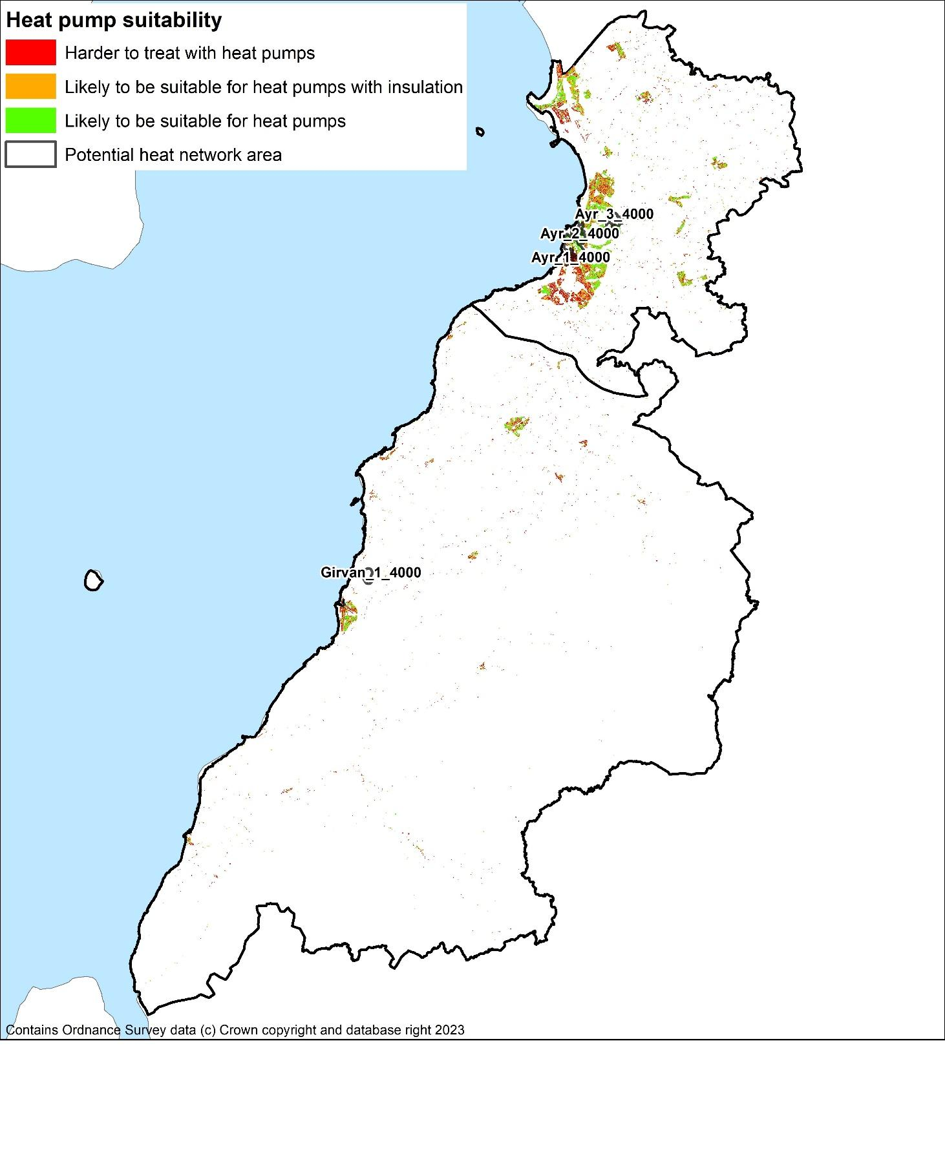

## 10.4 Initial Focus Areas

From the initial data outputs from the baseline toolkit, the highest ranked zones where poor energy efficiency is a driver for fuel poverty are shown in table 11. The **Full Technical Report** examines this to data zones level in Appendix B.

The weighted scores combine energy efficiency measures and fuel poverty metrics, with a higher score showing greater need for intervention. The properties in table 11 represent over 50% of South Ayrshire’s total, so data zone level analysis will be used to assess the highest ranking areas within each strategic zone against SIMD rankings.

A work stream is being assessed to integrate health inequality data to ensure greater granularity of approach. This will be reviewed over the next 18 months to assess viability.

Delivery plan actions have been formed to assess the top third of SAC owned properties in each of the most affected areas.

Table 11: Domestic fuel poverty resulting from poor energy efficiency – highest ranked zones (default weightings)

|  |  |  |
| --- | --- | --- |
| **Zones with highest total weighted score** | **Total weighted score** | **Number of properties in zone** |
| Carrick South | 33 | 2,813 |
| Girvan Ailsa | 31 | 1,811 |
| Ayr South Harbour and Town Centre | 27 | 3,376 |
| Ayr North Harbour, Wallacetown and Newton South | 24 | 3,211 |
| Maybole | 23 | 2,355 |
| Prestwick West | 23 | 2,060 |
| Girvan Glendoune | 22 | 1,618 |
| Troon | 21 | 2,983 |
| Lochside, Braehead and Whitletts | 20 | 2,121 |
| Annbank, Mossblown and Tarbolton - the Coalfields | 20 | 2,738 |
| Prestwick East | 20 | 2,594 |
| Dalmilling | 19 | 1,249 |

# Pathways for all of South Ayrshire

## Decarbonisation of Heat Pathway

The journey to the decarbonisation of each domestic property in South Ayrshire is shown in Figure 15.

The first column shows the proportions of properties which begin with each fuel source.

The second groups the properties by their current total heat demand in kWh/year.

The third column show changes to heat demand once reasonable energy efficiency measures have been applied.

The fourth column shows how suitable each property is for each of the low carbon heat measures. This assumes all listed heat network zones are developed but doesn’t consider further expansion.

Finally, the column on the right shows the final future heat demand.

Figure 15: Decarbonisation and energy efficiency pathway

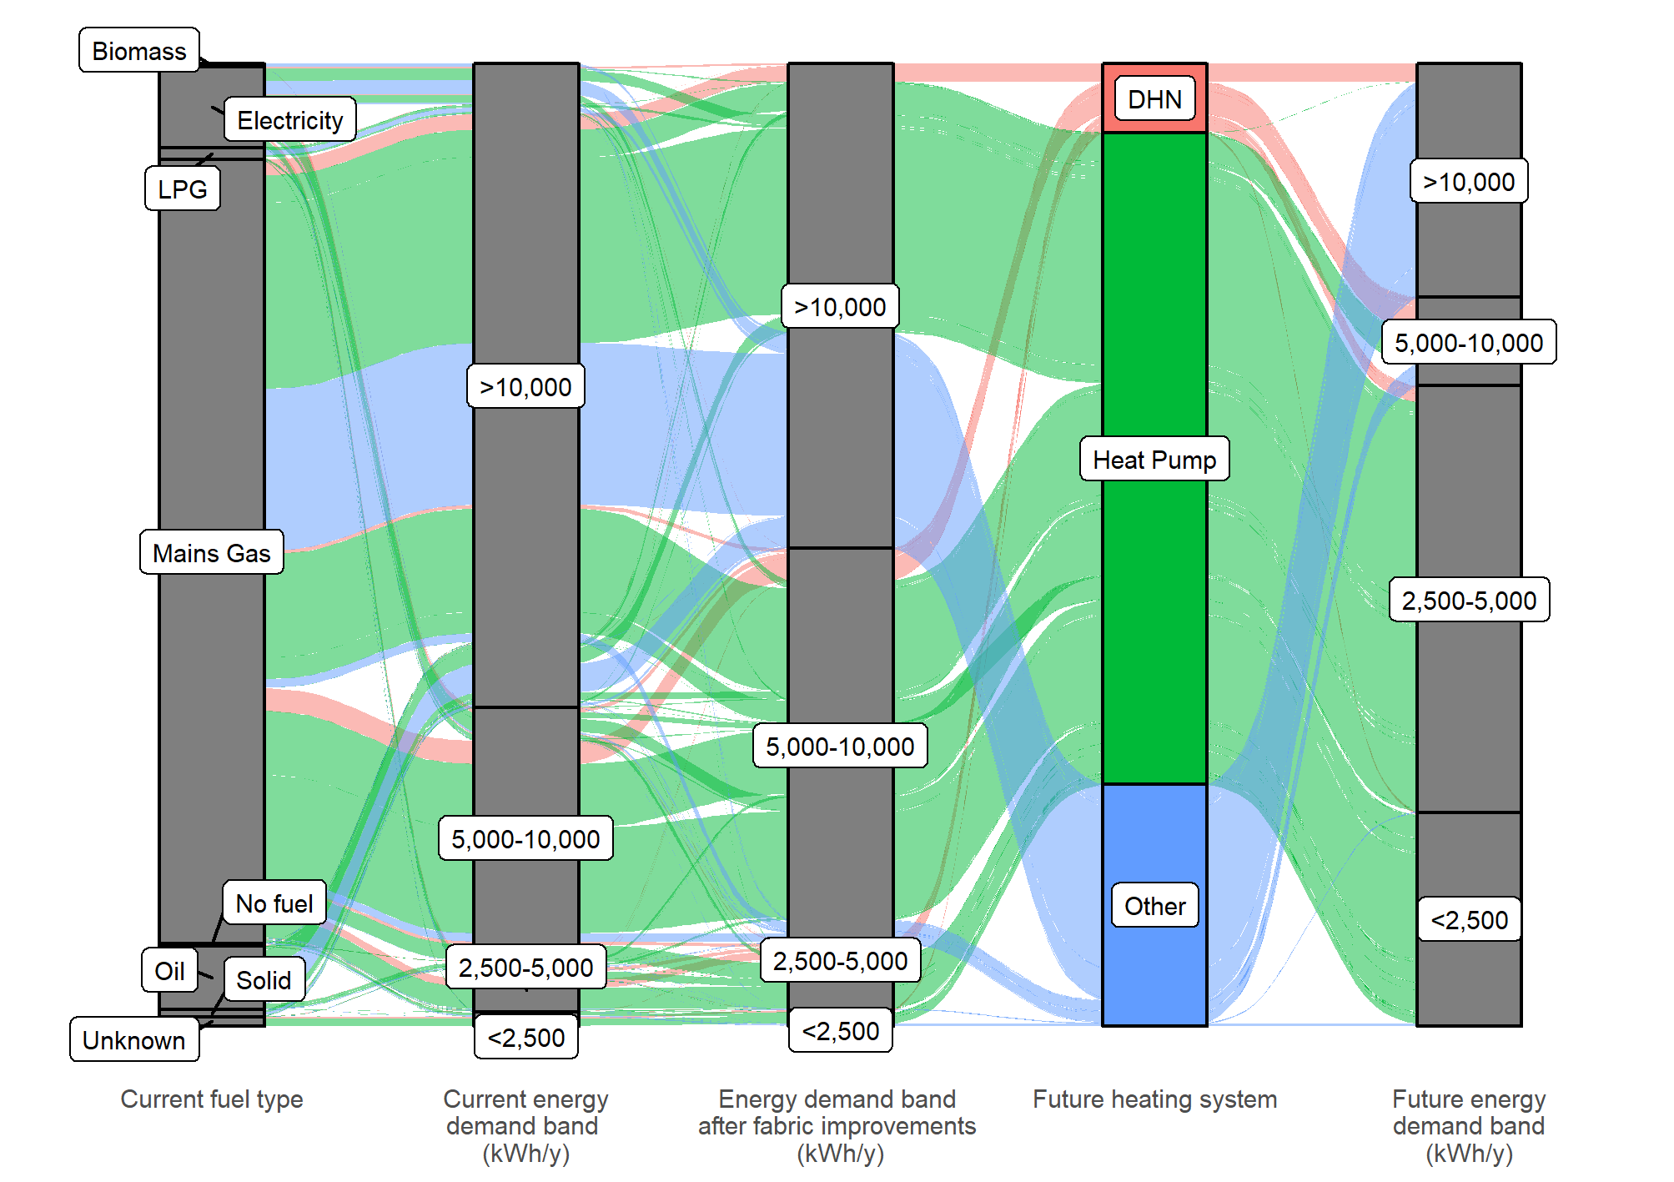

The shifting of individual properties down from one energy demand band to the next is visualised in Figure 16, where the comparison of heat pumps to direct electric heating shows how effective heat pumps will be in reducing the risk of fuel poverty.

At a local authority level, Figure 17 shows how interventions and shifting demand could reduce the total heat energy consumption. It is also shows that heat pumps on their own make a bigger difference to energy demand than fabric improvements but fabric improvements have a vital role in both demand reduction and in making homes suitable for heat pumps.

Figure 16: Shifting energy demand by fabric improvement and heat pump installation

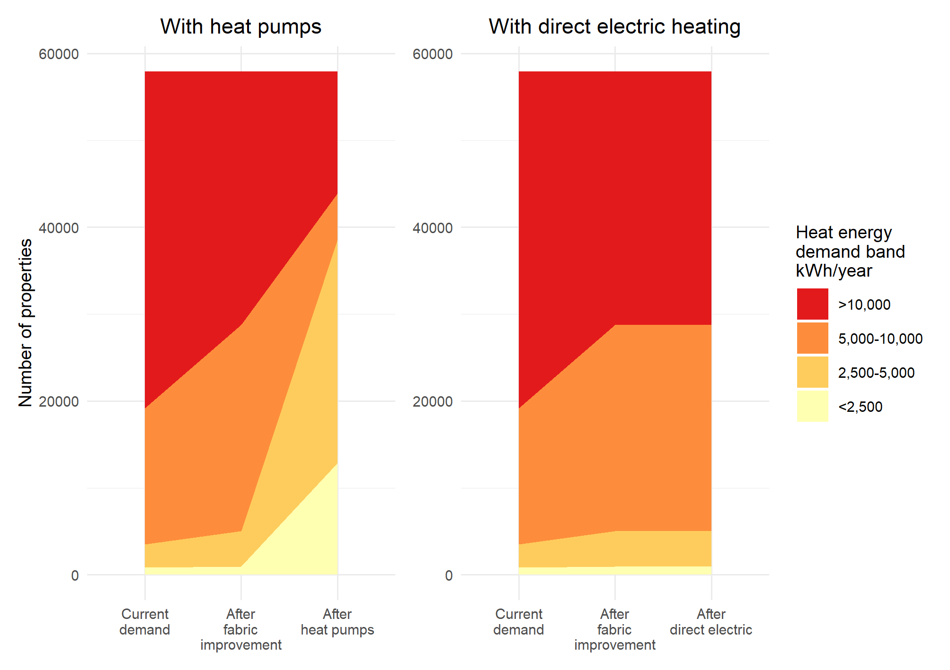

Figure 17: Total electricity demand reduction after energy efficiency measures and/ or heating system upgrade

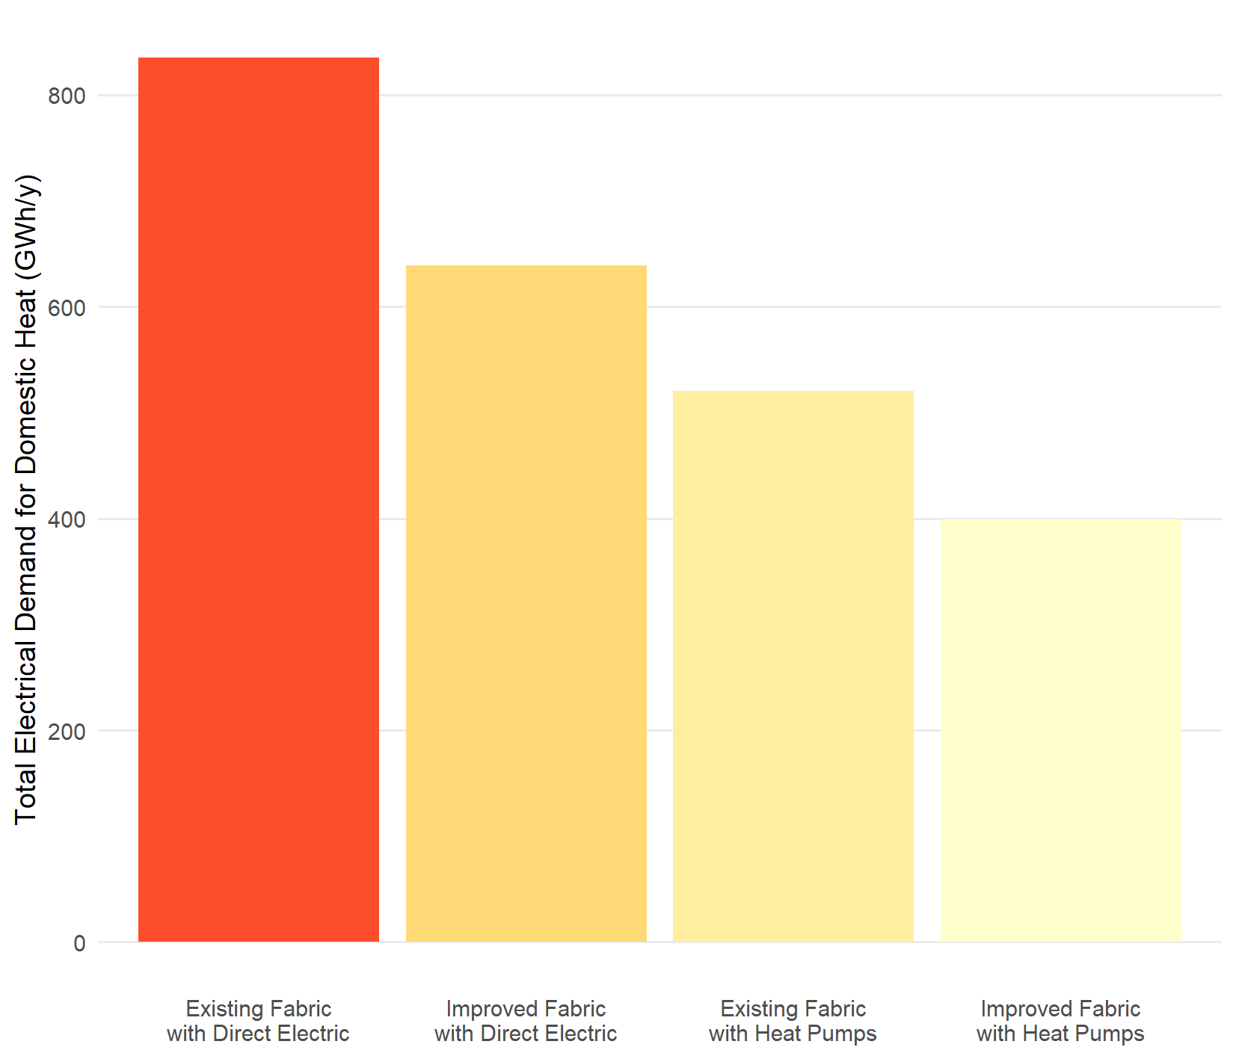

## Fuel Poverty

Reducing the heat demand of the buildings through installing energy efficiency measures is clearly important as it can both reduce the amount of heat to be decarbonised and the cost of heating. This section examines the properties in the areas with the lowest SIMD score to illustrate the combined effect of energy efficiency and low carbon heating on the amount of energy that the household would have to pay for, to fully heat their home and, consequently, on their risk of fuel poverty.

Figure 18 shows the decarbonisation journeys for properties which have a SIMD score of 1, the most deprived areas. This shows the main heating fuel they use at present, the proportion of properties in each energy demand band (kWh/year) and then the numbers in each band after energy efficiency measures and low carbon heating technologies are installed.

Figure 18: Effect of actions in all properties in SIMD 1 areas – energy efficiency and heat pumps

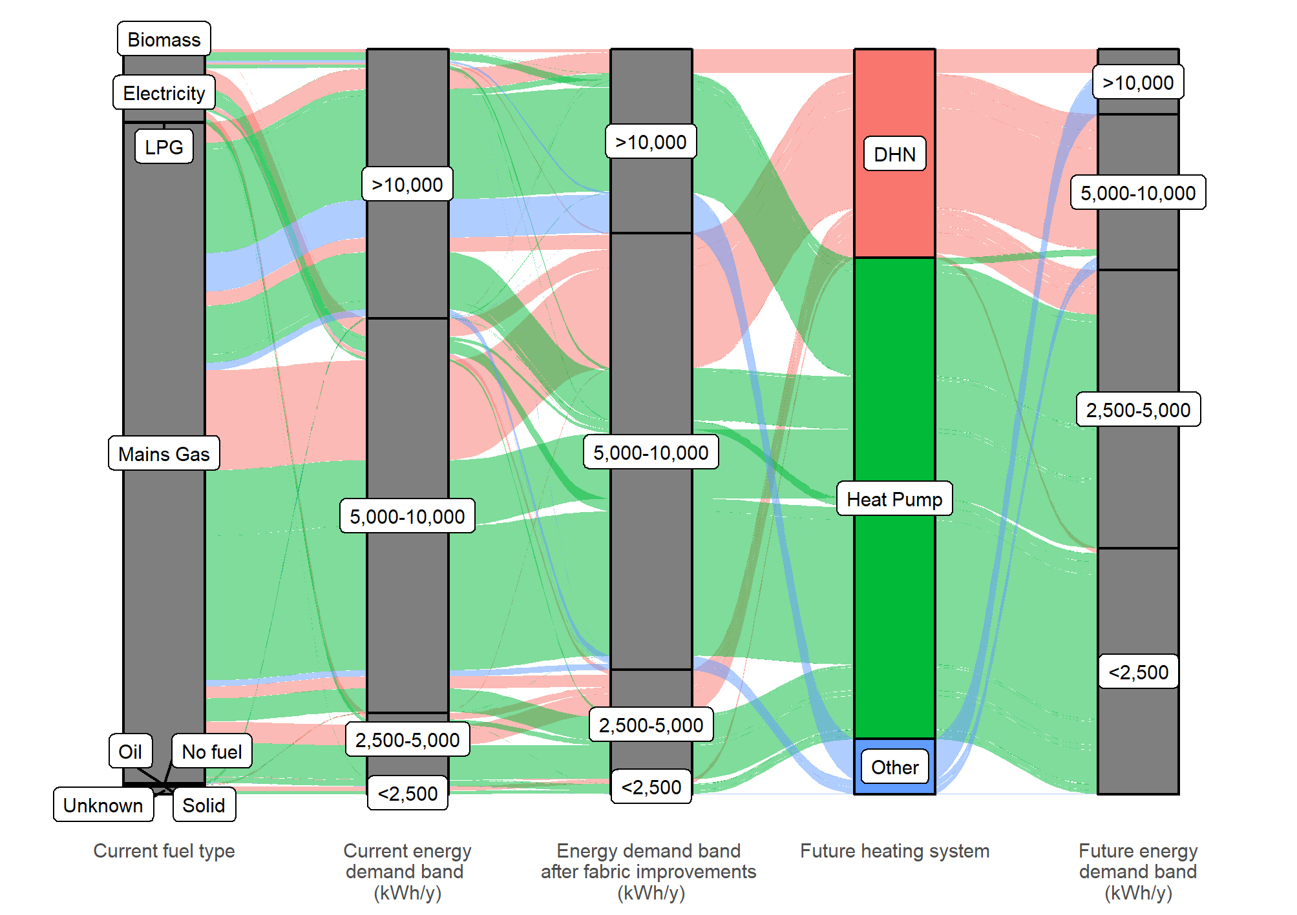

Installing energy efficiency measures significantly reduces the number of properties with heat demands of over 10,000 kWh/year and is the priority approach to tackling fuel poverty. Utilising heat pumps reduces this further to a very small proportion but also results in one quarter of homes being in the lowest band, with an annual demand of <2,500 kWh/y. For the purposes of this Strategy, heat pumps would be considered the preferred solution to minimise fuel poverty, in properties where low-cost district heating is not an option.

**Other factors**

There are several factors which affect fuel poverty and outlining the effect of energy efficiency measures in improving fuel poverty is complex. Household income after housing costs has a significant effect but is out of scope of this Strategy.

**Unheated homes**

The Scottish Housing Condition Survey 2019[18] states:

*23 % of fuel poor and 28 % of extreme fuel poor say that their heating keeps them warm enough in winter "only sometimes" or "never",*

For these households, reducing the heat demand through insulation both reduces how much it would cost them to heat their home, should they be able to do so, and limits the temperature to which the property will fall in any periods when they do not or are unable to heat it. For those at highest risk of not heating their homes the decision as to whether to focus capital spend on additional insulation measures or lower cost heating systems is therefore complex.

With insulation measures, there are a range of measures which have different costs and energy reductions and there is no single approach suitable for all buildings or situations.

## Heat Networks

Heat networks have a role to play in the future of heat in South Ayrshire. Heat networks can be either district heating schemes, which are strategic scale developments where multiple buildings are connected, smaller heat networks, within a single campus, or communal heating systems in a specific building. Within this Strategy, the phrase “heat networks” refers to district heating schemes where multiple buildings are connected by underground pipework.

The suitability of the buildings for connection to heat networks is not known. Further work such as Building Assessment Reports (BARs)[19] and engagement with stakeholders is important to inform future decisions on these sites.

Even in the zones where heat networks are an option, there are differences between the domestic properties which are most likely to be suitable, such as blocks of flats, and properties which are less likely to be suitable, such as detached houses[20].

Therefore, due to both the limited proportion of properties in areas where heat networks are likely to be viable and there being properties unlikely to be suitable for connection, it is essential that we consider all other low carbon heat sources in parallel.

This does not preclude heat networks being developed to their full potential and it may be that a phased approach to heat networks and district heating could see smaller networks initially focus on the most viable properties with further expansion at a later date.

## Individual and Communal Heat Pumps

Of the technologies currently available to supply low carbon heat, heat pumps have been assessed to be currently suitable for the majority of buildings. Heat pump deployment, and the role they play in decarbonising buildings, **has to lead to a cost of heat that is comparable to natural gas boilers and the user experience of operating the systems has to be positive**. There are examples of people having bad experiences living with heat pumps and while there are equally many good experiences, it is essential to understand what is required for heat pumps to meet the needs of residents. In order to ensure that the heat pump systems installed are of good quality and perform as expected, the sharing of good practice and case studies is emphasised.

South Ayrshire Council will work with internal stakeholders to consider the most appropriate low carbon heating system for properties that it owns as well as working closely with social landlords to share the latest information on issues such as: good practice; communication with tenants prior to installation; sharing information with tenants on how to operate systems which have been installed; peer to peer support within the community; the role of the advice services in supporting tenants.

It is essential that there is a supply chain which is capable of installing the technologies set out above. We will consider what actions the Council could take to encourage a local supply chain of low carbon heating installers.

While it is for each property owner to make their own decision on the heating system they prefer, there is a role for the Council in ensuring that accurate and up-to date information is available to households, tenants, landlords and owner occupiers to support decision making. This is likely to include signposting to national advice schemes operated by Scottish Government or UK Government.

Finally, for any new technology ensuring quality of installation is important to ensure that it meets the needs of households, tenants and property owners. The Council will work with stakeholders to identify any role that South Ayrshire Council can play in ensuring the quality of installations as well as referring to national schemes such as the Microgeneration Certification Scheme.

**Challenges**

* Pathways represent long term ambitions and commitment,
* Skills and supply chain shortfalls are a national challenge,
* Poor quality or inappropriate interventions can make fuel poverty worse.

**Focus**

* ***Priority 1:*** Ensure multi-level assessment on interventions to prevent adverse effects on fuel poverty,
* ***Priority 2:*** Engagement with further and higher education organisations on potential industry and skills development
* ***Priority 2:*** Undertake local skills assessment and identify shortfalls,
* ***Priority 3:*** Maintain engagement with UK and Scottish Government’s industry regulation on heat network development.

# Pathways for Strategic Zones

The figures below show pathways for all domestic properties within the South Ayrshire Council areas, from the left:

* the heating fuel each uses today,
* the energy demand of the property per unit of floor area,
* the energy demand after the application of reasonable energy efficiency measures, and,
* finally, the most suitable heating technology for each property at present.

These are detailed further in the **full technical report**, Section 10.

Figure 19: Decarbonisation pathway for domestic properties in Ayr

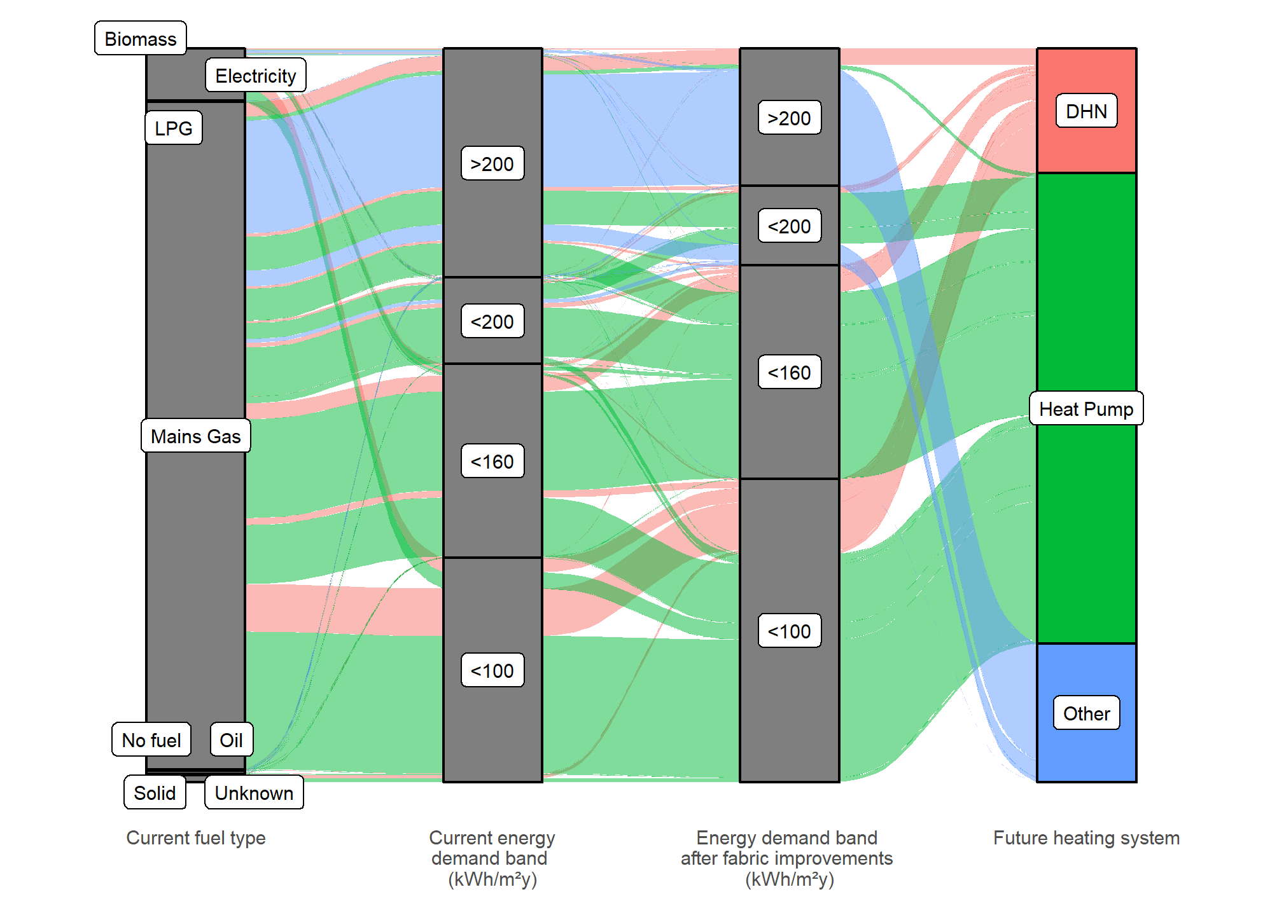

Figure 20: Heat decarbonisation pathway for Carrick

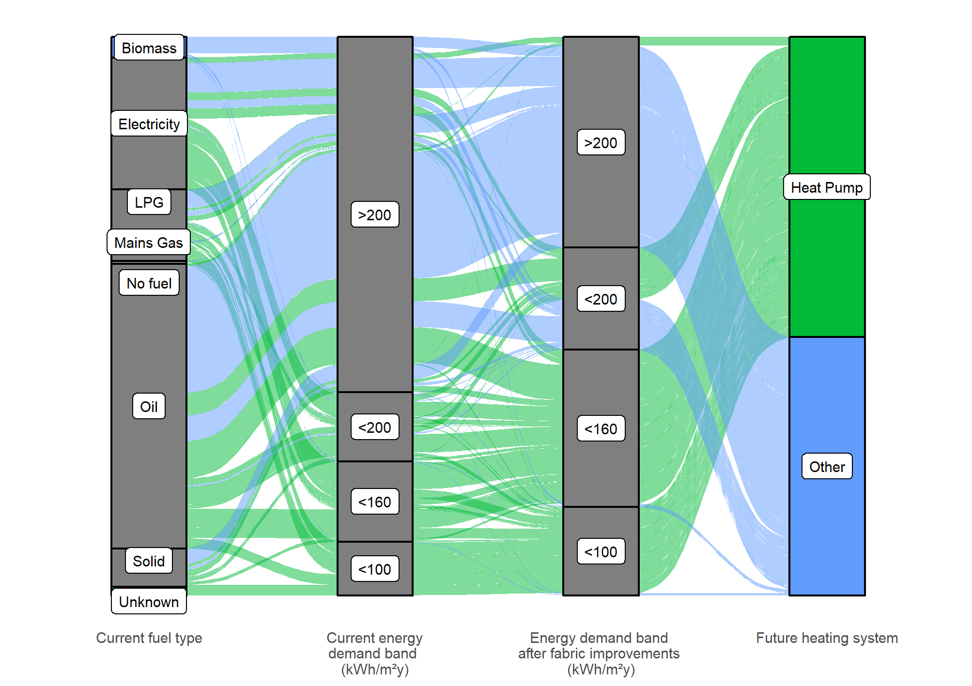

Figure 21: Heat decarbonisation pathway for Girvan

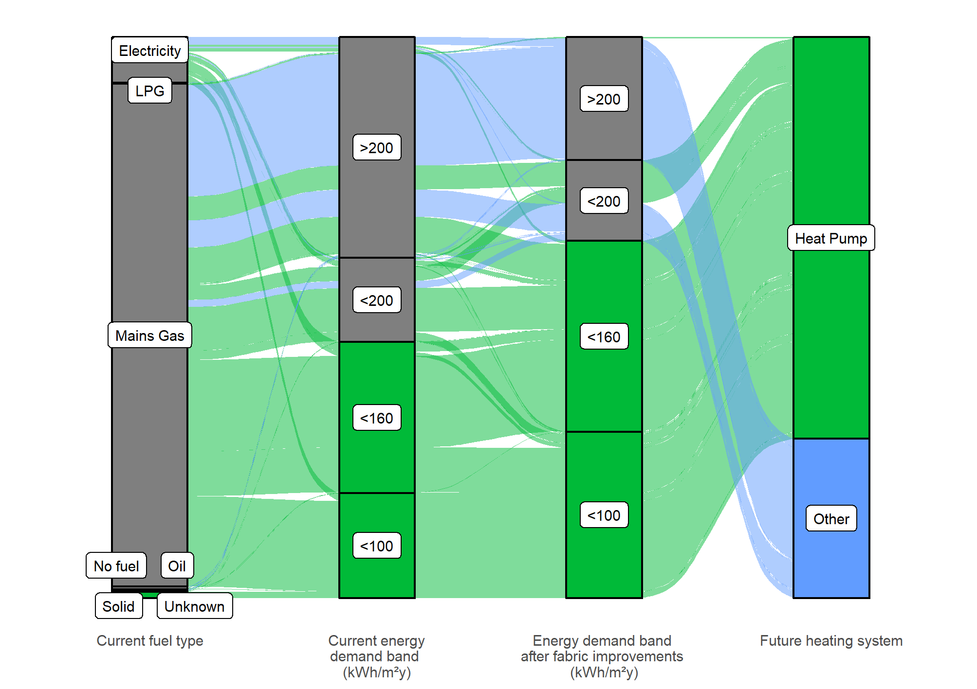

Figure 22: Heat decarbonisation pathway for Kyle

Decarbonisation and energy efficiency pathway - this shows the shift from current fuel type and energy consumption to final fuel type and energy consumption for all Kyle


Figure 23: Heat decarbonisation pathway for Maybole

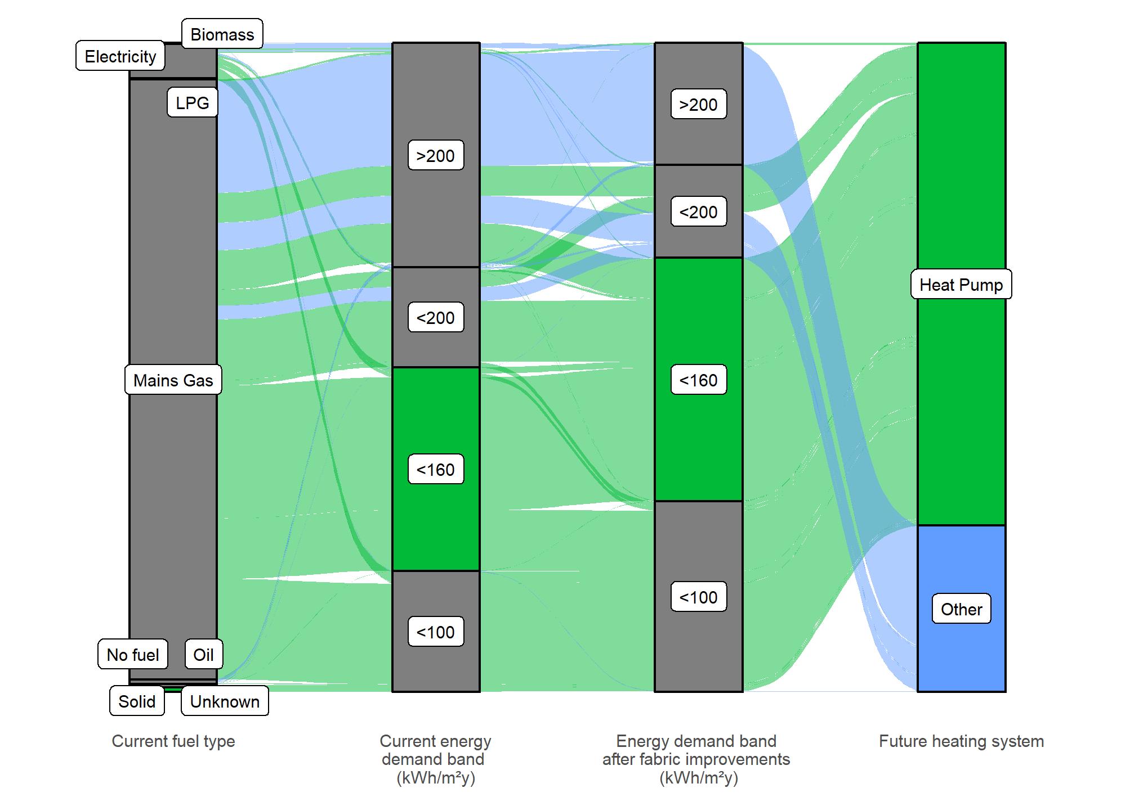

Figure 24: Heat decarbonisation pathway for Prestwick

Decarbonisation and energy efficiency pathway - this shows the shift from current fuel type and energy consumption to final fuel type and energy consumption for Prestwick


Figure 25: Heat decarbonisation pathway for Troon

Decarbonisation and energy efficiency pathway - this shows the shift from current fuel type and energy consumption to final fuel type and energy consumption for Troon


# Governance

This LHEES provides a first step towards decarbonising heat and reducing fuel poverty in South Ayrshire. In improving energy efficiency and prioritising low carbon solutions in areas where they can have the greatest impact, this strategy can support council and commercial investment, community engagement and wealth building, and an equitable energy transition. The delivery plan proposals are built from the data from the LHEES methodology and provide a series of potential projects from the challenges identified.

These challenges cannot be delivered in isolation by a single department, or by the Council alone. As such it is vital that a governance structure be put in place to ensure collaboration between internal and external stakeholders.

Figure 26 provides a structural overview for governance in this area.

Figure 26: Outline LHEES Governance model

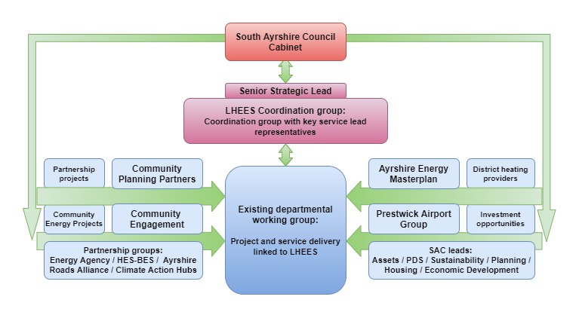

The LHEES Coordination group will provide strategic oversight and guidance for the development and implementation of the Council’s LHEES strategy and delivery plan. Each member of the group will provide insight from their area of expertise to support existing delivery plan actions and refine new and existing areas of intervention, with support from the LHEES officer. They will also ensure decisions made by the group are adhered to by services.

The group will provide information and scrutiny on:

* Development and attribution of LHEES delivery plan actions,
* Development of heat network projects,
* Risk and issue identification,
* Wider stakeholder identification and engagement,
* Dissemination of information,
* Benefits realisation and reporting.

**Group responsibilities**

Each group member would be responsible for service level identification of:

* Existing or potential projects relevant to LHEES,
* Co-working opportunities,
* Relevant legislative changes and consultations,
* Alignment of service level projects with strategic priorities,
* Attribution and implementation of service specific delivery plan actions.

**Membership**

The LHEES Coordination group membership is identified below as those with high levels of interaction and interest in the strategy and delivery plan.

Figure 27: LHEES engagement matrix

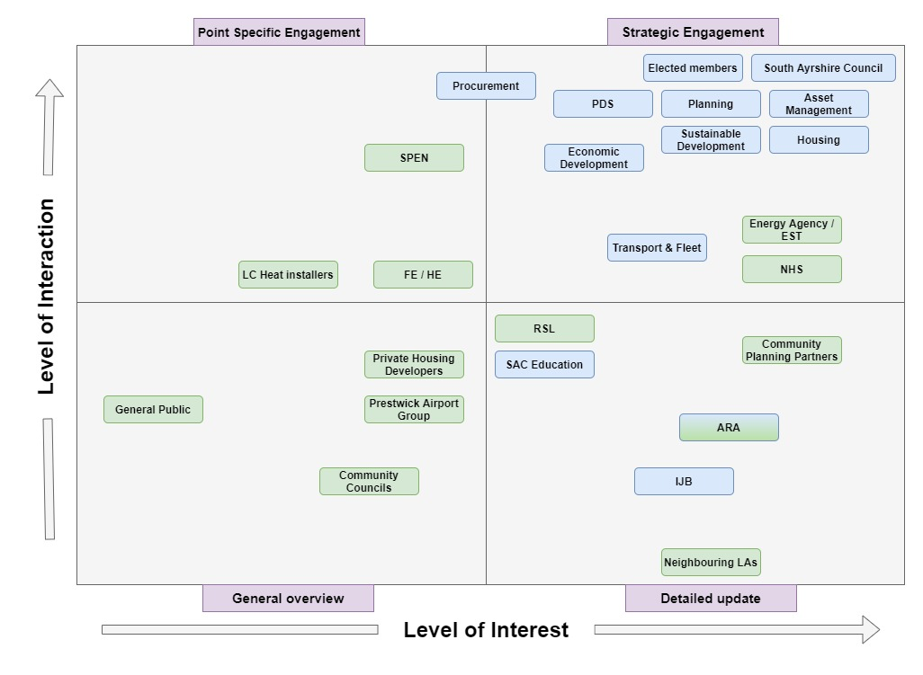

From this, we derive 4 levels of interaction with associated groups:

* **Strategic engagement** – membership of the governance group.
* **Point specific engagement** – engaged with on specific projects rather than the strategy as a whole.
* **Detailed updates** – detailed information on strategy and project progress shared regularly to assess synergies.
* **General overview** – general information about overall progress shared periodically.

As such, the following departments and officers have been identified to participate in the governance group.

**Tracking and Reporting**

The group will track and report progress through a series of routes:

**Feedback to Portfolio Holder: Buildings, Housing and Environment** by Service Lead Asset Management. Where appropriate membership officers will report actions back through in-service routes to respective portfolio holders to expand engagement.

**Local Outcome Improvement Planning** – As Energy is one of the four identified Community Planning Partnership areas, relevant six-monthly/quarterly progress reports will be provided to the board.

**Annual Cabinet report & Members Briefing** – with the annual review of the delivery plan actions, progress on existing actions and proposed actions for the year ahead will be delivered to cabinet annually, with an accompanying members brief on progress and intent for the year ahead.

**Focus**

* ***Priority 1, 2, & 3:*** Convene quarterly meetings of the LHEES Coordination group, ensuring actions are tracked through the Council’s performance monitoring systems, and where appropriate partner organisations own development routes.

Initial meetings will review and assign delivery plan objectives to services and other responsible attendees.

# Delivery Plan Proposals

As part of the LHEES process, a delivery plan has been prepared to support and direct actions. This is a live document, updated regularly to reflect changes in national and local circumstance. As such, the proposals below are an initial overview of potential actions, that are likely to evolve over the course of the next year.

The delivery plan actions will be attributed to services through the LHEES Coordination group and monitored on an annual basis.

Table 12: Delivery Plan Actions

|  |  |  |
| --- | --- | --- |
| Action No. | Action | Timescale |
| 1 | Ensure sufficient dissemination of SAC LHEES delivery plan to all key internal and external stakeholders. | 2024 |
| 2 | Set up the working groups highlighted for:   * LHEES Coordination governance group, * Specific issue areas such as mixed use/tenure and historic buildings | 2024 |
| 3 | Establish governance structure and agree meeting schedules | 2024 |
| 4 | Engage with other LA’s, Universities, NHS trusts and other large public sector organisations to learn from their experience of decarbonisation and LHEES considerations on large estates. | 2024-25 |
| 5 | Engage with the public using educational material on energy efficiency, technologies, funding opportunities, methods to reduce heating bills, and suitable tariffs to encourage early adopters of heat pumps. | 2024-26 |
| 6 | Engage with the public on heat network potentials and technologies | 2025-26 |
| 7 | Create a shared forum for lessons learnt from early adopters on heat pump operational best practices. | 2025 |
| 8 | Create ongoing case studies of SAC decarbonisation and fuel poverty reduction implementations, and learn from other case studies, to create a live up to date lessons learnt document. Including contacting MCS/Ofgem/Scottish Government/UK Government about current heat pump performance and how to make sure high COP and a good experience is achieved. | 2024-25 |
| 9 | Set up a working group with SPEN to monitor network constraints to coordinate transition work. | 2024-25 |
| 10 | Engage with other local authorities, local colleges, and local installers to assess skills gaps in heat pump delivery. | 2024-25 |
| 11 | Assess potential routes for the long-term investment required for the interventions. | 2025-26 |
| 12 | Engage with supply chains to allow the visibility of secure pipeline of work for several years to come, to encourage growth of local skills and reduce the risk of local skill shortage. | 2025-26 |
| 13 | Complete pre-feasibility studies on proposed heat network zones. | 2024-25 |
| 14 | Coordinate with Planning on LDP3 on Heat Network zone development and routes to support development | 2024-25 |
| 15 | Annual monitoring/report of gas prices compared to typical cost of heat from heat networks to ensure potential heat networks do not worsen fuel poverty. | Ongoing |
| 16 | Commence development of business cases in all heat networks deemed feasible. | 2025-26 |
| 17 | Assess loft insulation upgrades in the top third of LHEES data zones for SAC owned dwellings. | 2025-26 |
| 18 | Assess cavity wall insulations interventions in the top third of data LHEES zones for SAC owned dwellings, record ongoing progress. | 2025-26 |
| 19 | Assess hot water cylinder insulation upgrades in the top third of LHEES data zones for SAC owned dwellings. | 2025-26 |
| 20 | Assess internal or external wall insulation upgrades in the top third of LHEES data zones for SAC owned dwellings. | 2026-27 |
| 21 | Assess single to double glazing window upgrades in the top third of LHEES data zones for SAC owned dwellings. | 2027-28 |
| 22 | Assess with partner organisations and national groups any pilot studies / demonstration projects / field trials on heat pump deployment and operational best practises. | Ongoing |
| 23 | Assess heat pumps potential on case-by-case basis in properties that are currently using LPG/Oil/Solid fuels. Focus on the top third of data zones that are SAC owned. | 2025-29 |
| 24 | Assess heat pumps potential in properties that are currently using direct electric heating. Focus on the top third of data zones that are SAC owned, where they can be made suitable for heat pumps | 2025-29 |
| 25 | Coordinate with Scottish Government and collect improved datasets for 5 yearly LHEES update. | Ongoing |
| 26 | 5 yearly update of LHEES. | 2029 |

**Challenges**

* Wide range of potential actions and areas, cross-cutting multiple council departments, organisations, groups,
* Technology and legislation will develop over the course of this action plan.

**Focus**

* Maintain focus on identified LHEES priorities,
* Development and service level attribution of actions through LHEES Coordination group.

# Appendix A: LHEES Scope, Limitations and Approach

**Strategy Scope and Limitations**

The scope is focused on heat decarbonisation, energy efficiency and fuel poverty and does not include wider energy system planning directly, but the LHEES can be used as a building block for wider LA energy planning.

While there are some limitations with the domestic building dataset, which is primarily based on Home Analytics, it is of sufficient quality and reliability to allow detailed analysis and conclusions. However, the non-domestic data, which is primarily based on Non-Domestic Analytics, is less reliable overall due to a dataset that has significantly more gaps in it, and a greater variety of heat uses. For this reason, there are limitations to the level of detail in the outputs from non-domestic buildings.

**LHEES Approach**

A suggested LHEES methodology is supplied by the Scottish Government as shown in figure 27. Although the approach used is based on the proposed methodology shown below, the details have been adjusted to suit the specific context of South Ayrshire. The methodology is broken down into eight stages that align with the work set out in the LHEES Guidance.

The completion of these stages provides South Ayrshire Council with the data analysis and evidence base to enable development of this Strategy and the accompanying Delivery Plan document. The completion of work carried out in stages 1-4 feeds into the Strategy plan, and the completion of stages 4-6 alongside the Strategy feeds into the Delivery Plan.

Figure 26: Summary of LHEES Approach and Stages

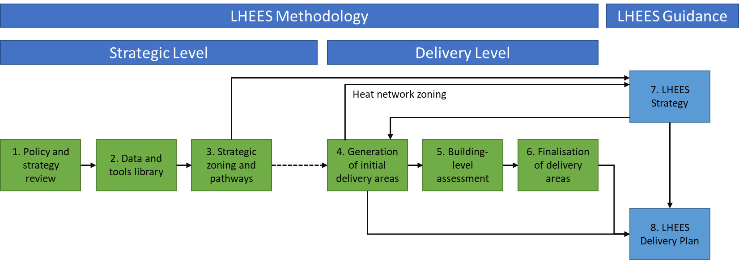

# Appendix B: Legislation Relating to LHEES

Table 13: Summary of policy and legislation

|  |
| --- |
| **UK-Wide** |
| [The Climate Change Act 2008 (2050 Target Amendment) Order 2019](https://www.legislation.gov.uk/uksi/2019/1056/contents/made): Net Zero GHG Emissions by 2050 |
|  |
| **National – General** |
| Heat in Buildings Strategy (2021) Sets out a pathway to zero emissions buildings by 2045 and includes the New Renewable Heat Target for 2030 |
| [The Heat Networks (Scotland) Act 2021](https://www.legislation.gov.uk/asp/2021/9/2021-03-31#:~:text=An%20Act%20of%20the%20Scottish,conferring%20rights%20in%20heat%20network), which was followed by the Heat Network Delivery Plan, has targeted for 2.6 TWh to be supplied by heat networked by 2027 and 6 TWh by 2030. By October 2023, Scottish Ministers are required to set a target for 2035. The Act places a duty on local authorities to conduct a review of areas likely to be particularly suitable for heat networks within its area. |
| [The Fuel Poverty (Targets, Definition and Strategy) (Scotland) Act 2019](https://www.legislation.gov.uk/asp/2019/10) which both defines fuel poverty and sets targets for fuel poverty eradication by 2040 with interim targets for 2030 and 2035. Following this, the Tackling Fuel Poverty in Scotland: A Strategic Approach was published in late 2021, which contains a strong focus on energy efficiency as a driver for fuel poverty. |
| [Climate Change (Scotland) Act 2009:](https://www.legislation.gov.uk/asp/2009/12/contents) Public bodies have a duty to contribute to Scotland’s national emission reduction target |
| [Climate Change (Emissions Reduction Targets) (Scotland) Act 2019:](https://www.legislation.gov.uk/asp/2019/15/contents/enacted) 75 % emissions reduction by 2030, 90 % emission reduction by 2040, and net zero GHG emissions by 2045 |
| [Update to the Climate Change Plan (2018-2032)](https://www.gov.scot/binaries/content/documents/govscot/publications/strategy-plan/2020/12/securing-green-recovery-path-net-zero-update-climate-change-plan-20182032/documents/update-climate-change-plan-2018-2032-securing-green-recovery-path-net-zero/update-climate-change-plan-2018-2032-securing-green-recovery-path-net-zero/govscot%3Adocument/update-climate-change-plan-2018-2032-securing-green-recovery-path-net-zero.pdf)   * By 2030 at least 50 % Scotland’s building stock heated using zero emission systems; * Retrofit buildings and achieve ultra-high levels of fabric efficiency in new builds; and * Reduce car kilometres by 20 % by 2030. |
| [Scottish Government Climate Change Plan Update – Securing a Green Recovery on a Path to Net Zero (2020):](https://www.gov.scot/publications/securing-green-recovery-path-net-zero-update-climate-change-plan-20182032/pages/2/) Focus on green recovery to deliver net zero ambitions following the Covid-19 pandemic. Emphasis on green jobs, adaptation, and tackling fuel poverty.   * “By 2040, no more than 5 % of households in fuel poverty, and no more than 1 % in extreme fuel poverty” |
| [Scottish Government Hydrogen Action Plan (2022)](https://www.gov.scot/publications/hydrogen-action-plan/): Ambition of 5GW of hydrogen production capacity by 2030 and 25GW by 2045. |
| [Climate Emergency Skills Action Plan (Skills Development Scotland / Scottish Government) (2020):](https://www.skillsdevelopmentscotland.co.uk/media/47336/climate-emergency-skills-action-plan-2020-2025.pdf) Local authorities are lead partners on Priority Area 1: Supporting a green labour market recovery from Covid-19, and Priority Area 5: Ensuring fairness and inclusion in the skills system as part of a just transition to net zero. |
| [Scotland’s fourth National Planning Framework (NPF4)](https://www.gov.scot/publications/national-planning-framework-4-revised-draft/pages/1/)   * Encourage the reuse of brownfield, vacant and derelict land for new developments.   [Draft Energy Strategy and Just Transition Plan (2023):](https://www.gov.scot/publications/draft-energy-strategy-transition-plan/) “More than 20GW of additional renewable electricity on-and offshore by 2030” |
| **National – Public Sector Specific** |
| [The Climate Change (Duties of Public Bodies: Reporting Requirements) (Scotland) Amendment Order 2020:](https://www.legislation.gov.uk/ssi/2020/281/contents/made) Public bodies must report in their Public Bodies Climate Change Duties (PBCCD) Annual Reports:   * where applicable, “targets for reducing indirect emissions of greenhouse gases” Indirect emissions include supply chain emissions, and * how they align their spending plans and use of resources to contribute to reducing emissions and delivering emissions reduction targets and report on this from March 2022. |
| [Scottish Government and Scottish Green Party: draft shared policy programme (2021):](https://www.gov.scot/publications/scottish-government-and-scottish-green-party-shared-policy-programme/)   * “All publicly owned buildings to meet zero emission heating requirements, with a backstop of 2038.” This implies that most buildings would be decarbonised well before that. The programme commits to “a series of phased targets” for decarbonisation of public sector buildings starting in 2024. This will be driven through building standards/Heat in Buildings Regulations. * “All new buildings where a building warrant is applied for from 2024 must use zero emissions heating as the primary heating source and meet significantly higher energy efficiency standards”. |
| [Public Sector Leadership on the Global Climate Emergency (2021):](https://www.gov.scot/binaries/content/documents/govscot/publications/advice-and-guidance/2021/10/public-sector-leadership-global-climate-emergency/documents/public-sector-leadership-global-climate-emergency/public-sector-leadership-global-climate-emergency/govscot%3Adocument/public-sector-leadership-global-climate-emergency.pdf)   * “Decarbonise estate by 2038 at the latest, with zero carbon direct emissions from all buildings”. * “Any fugitive emissions that can be reduced to absolute zero must be, however some areas of fugitive emissions may not be able to be reduced to absolute zero by 2045”. * Public sector bodies must set emissions reduction targets for indirect emissions (such as business travel). |

# Appendix C: Heat Pump Suitability Maps

The maps in this appendix highlight, using the methodology described in 7.7.3, which homes are ready for heat pumps today (green), will be ready with modest energy efficiency interventions (orange) and may be more difficult to convert (red).

Figure 27: Heat pump suitability map - Ayr

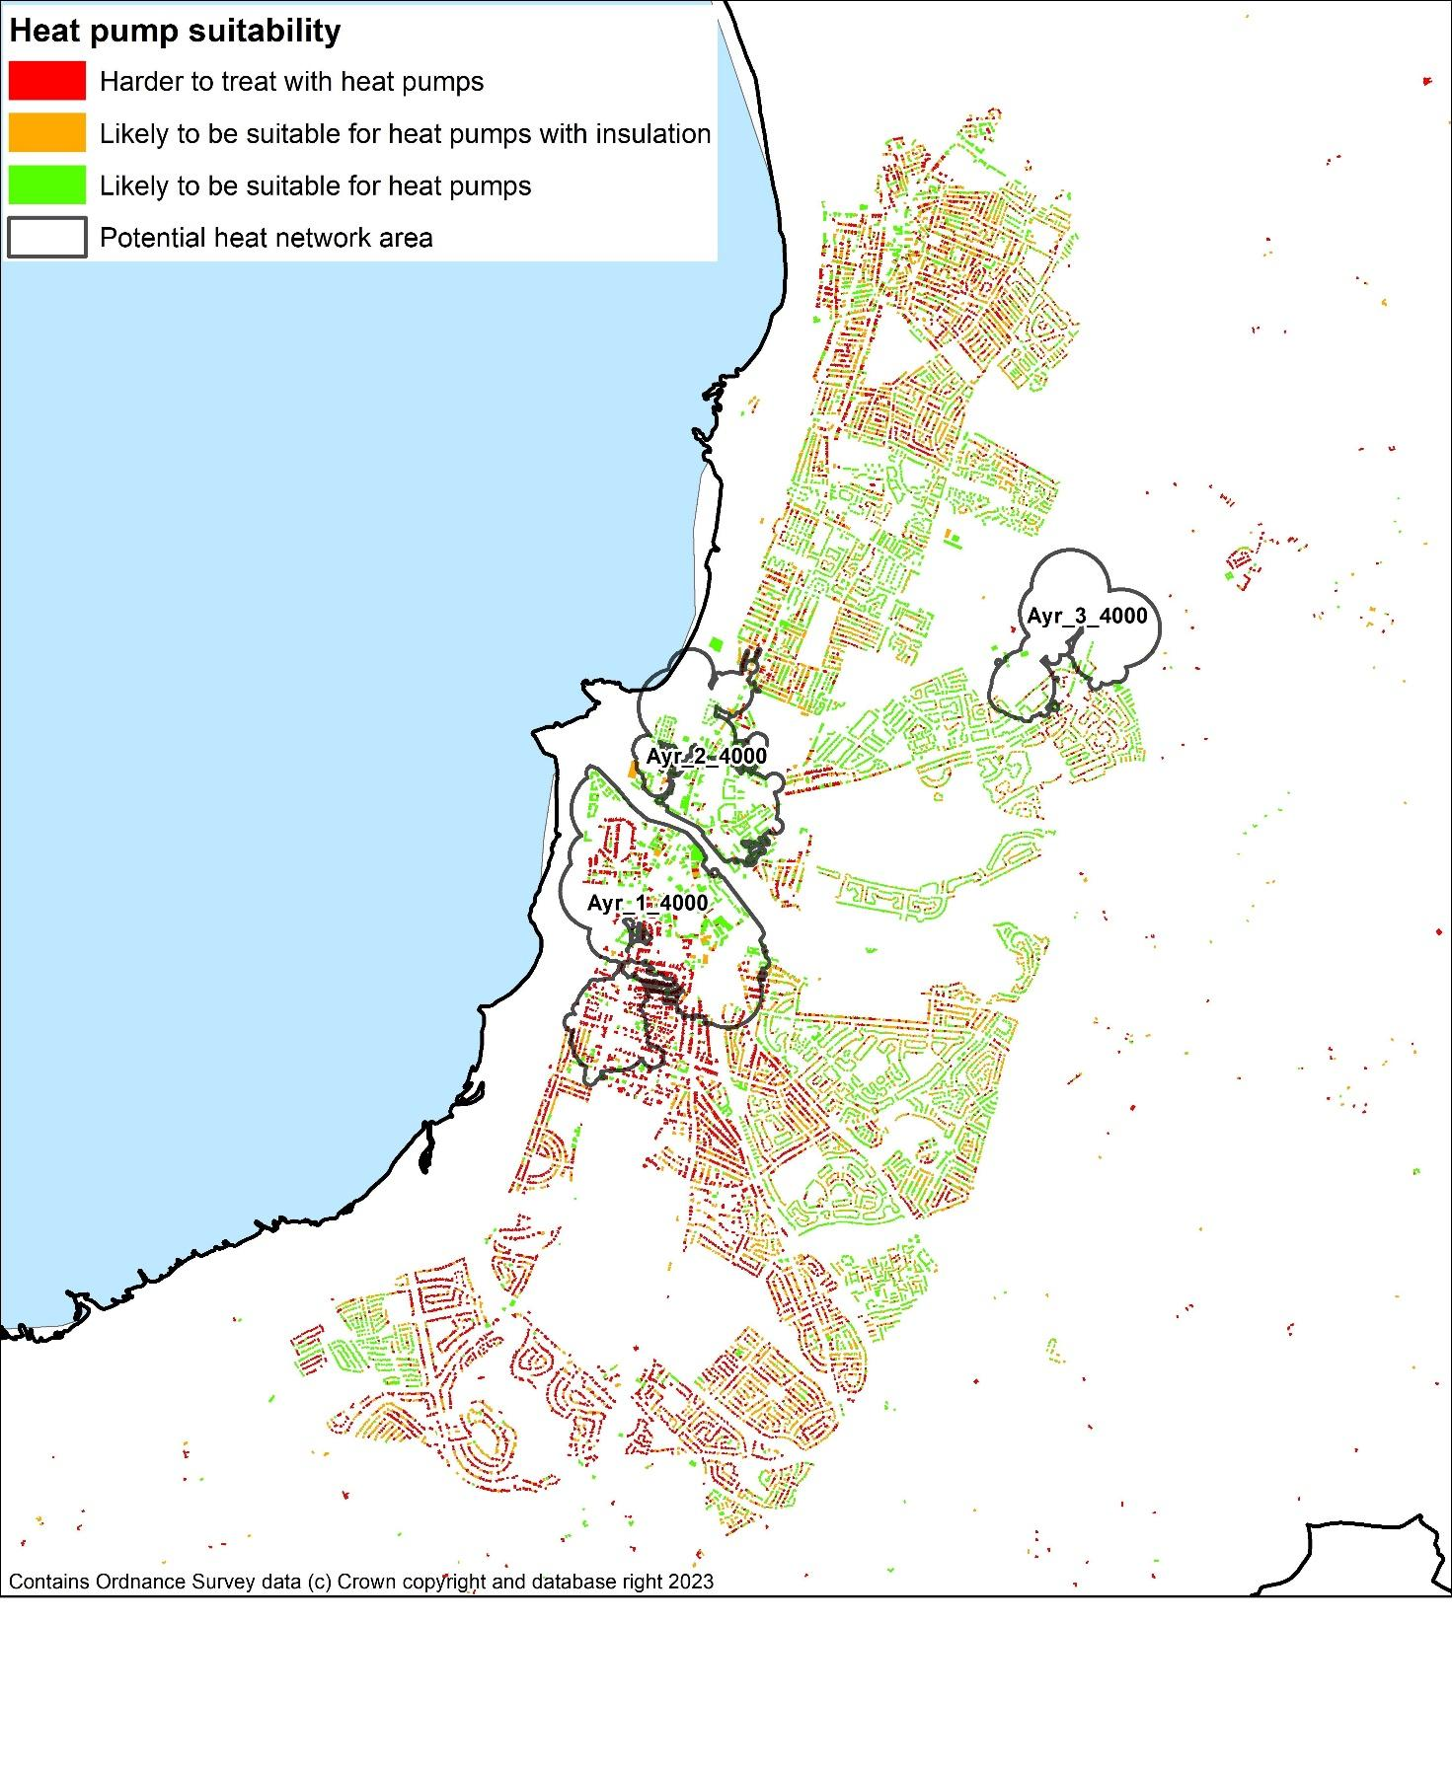

Figure 28: Heat pump suitability map - Girvan

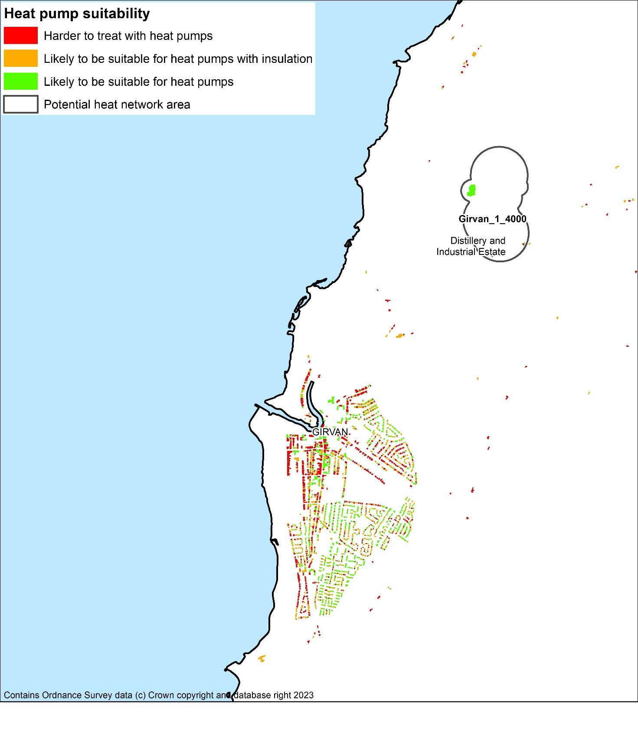

Figure 29: Heat pump suitability map - Troon

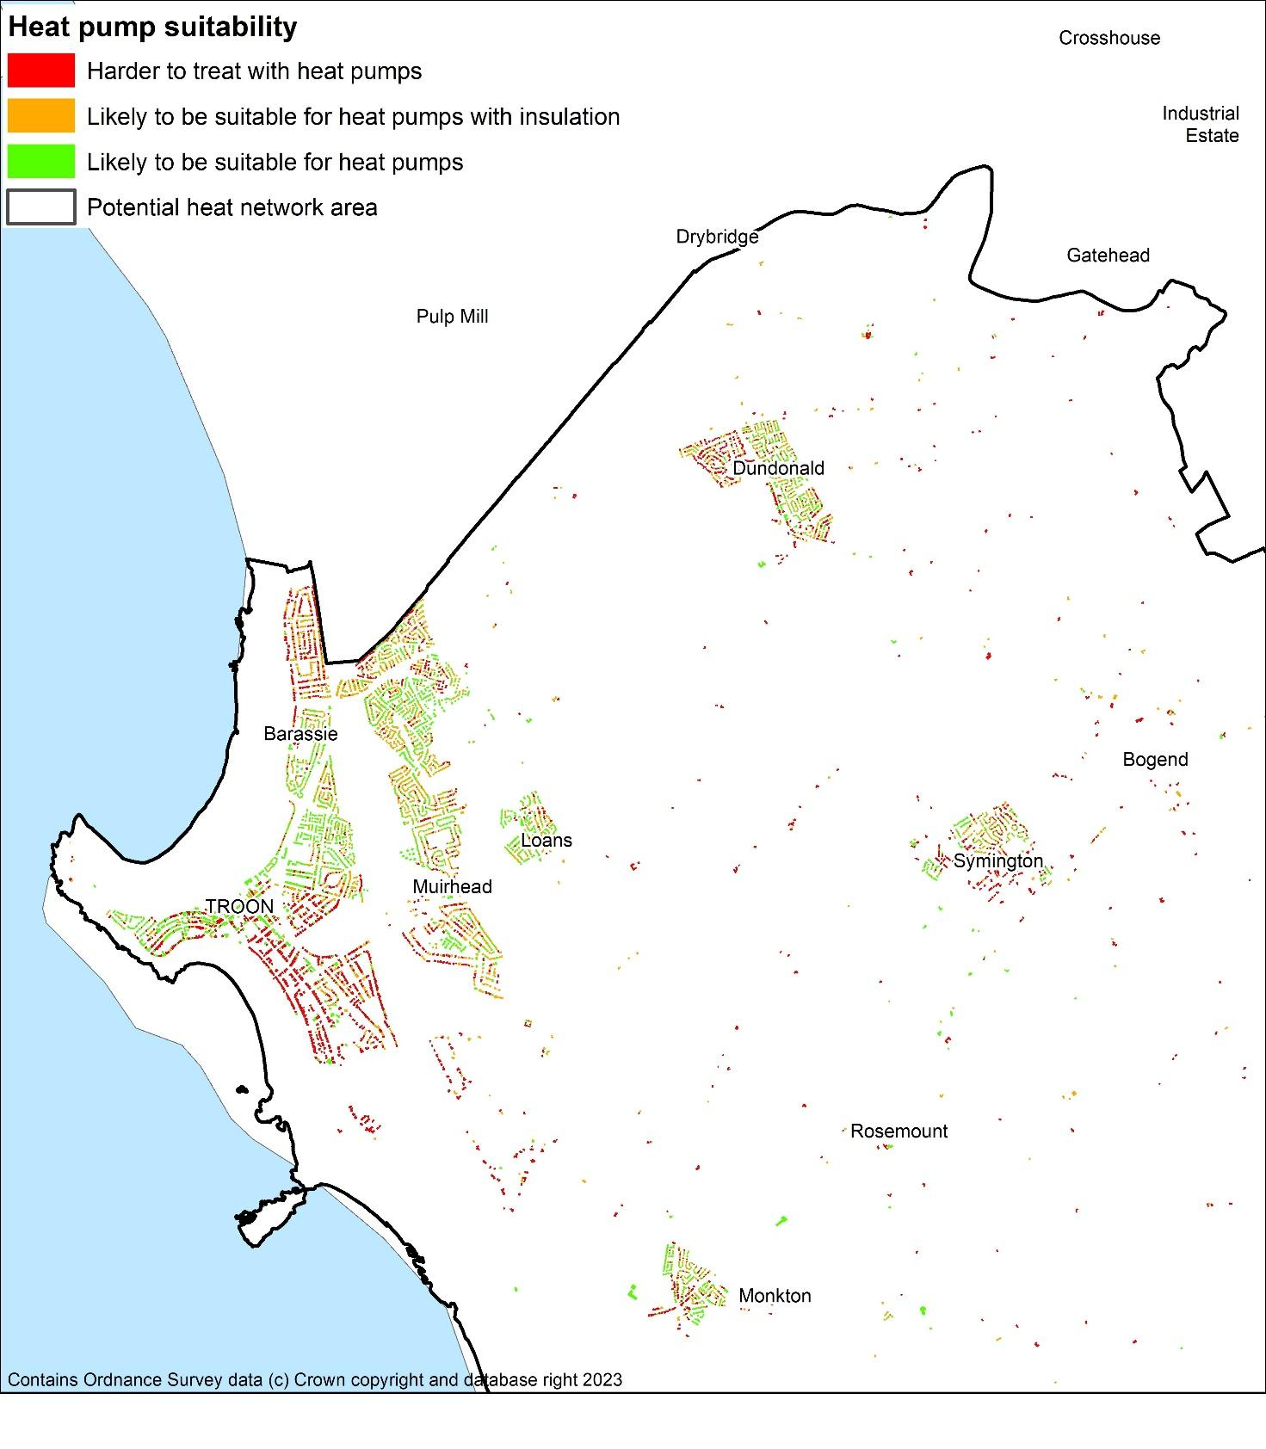

Figure 30: Heat pump suitability map - Maybole

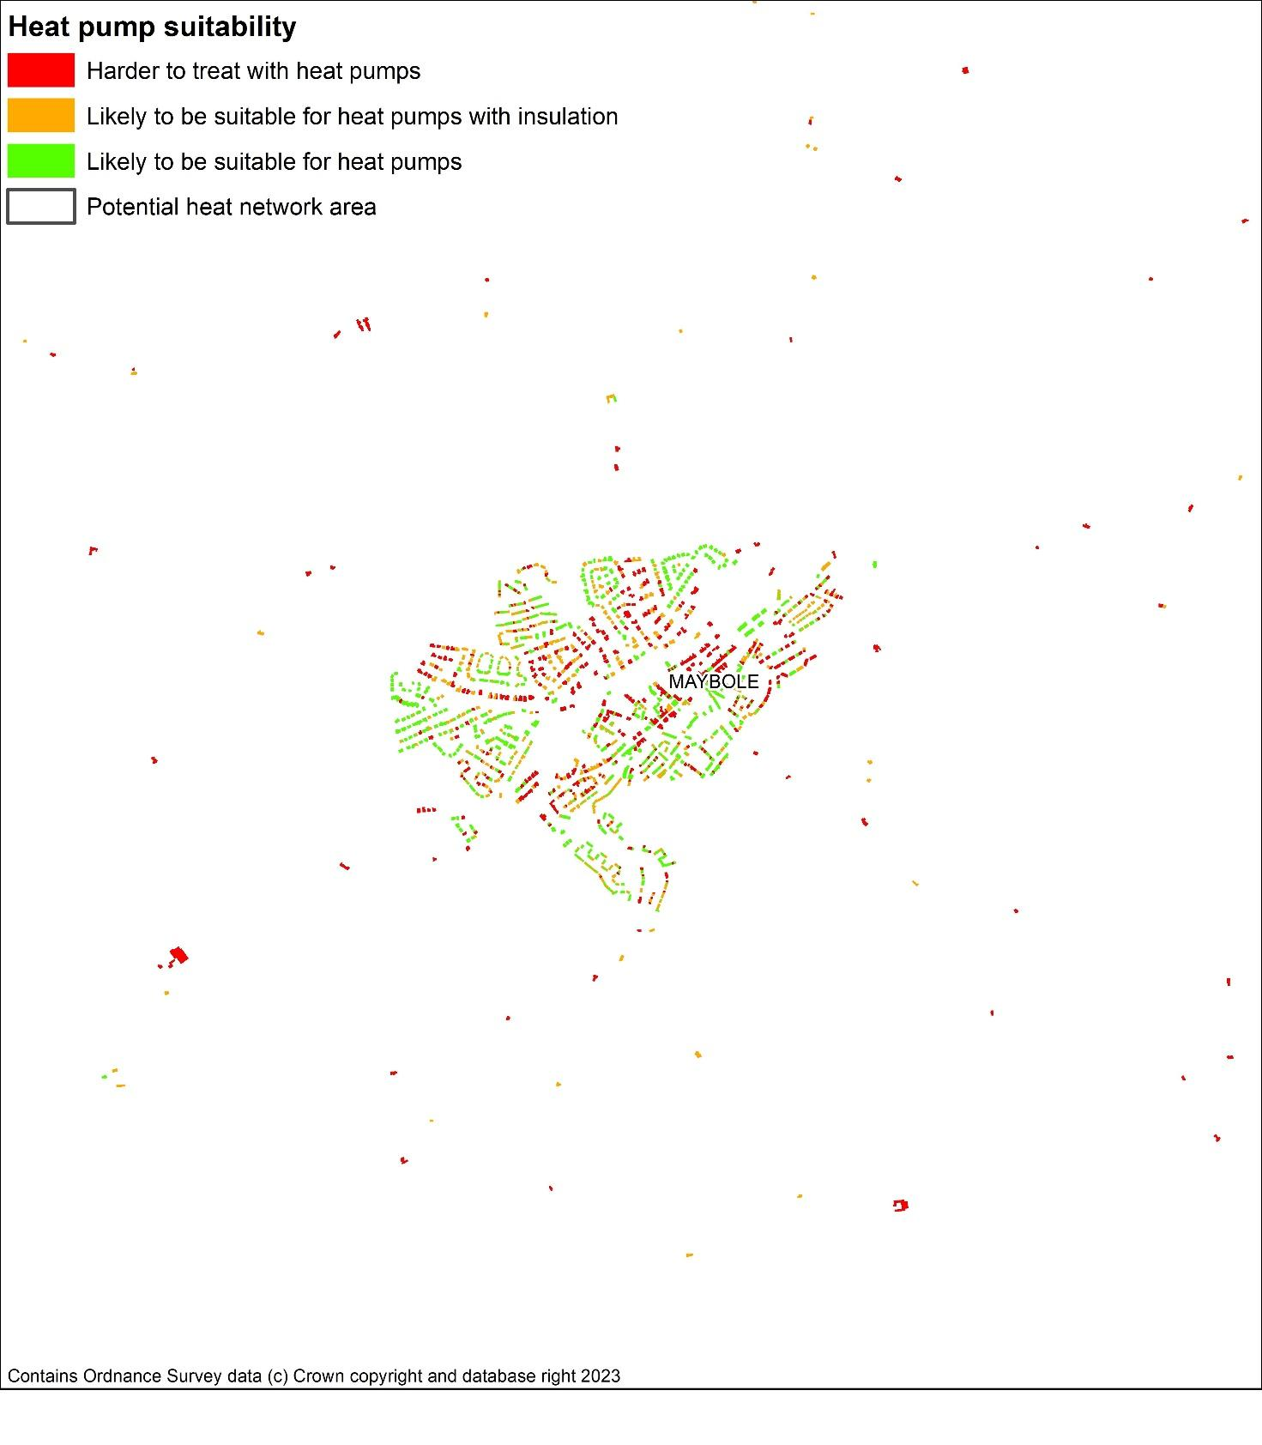

Figure 31: Heat pump suitability map - Ballantrae

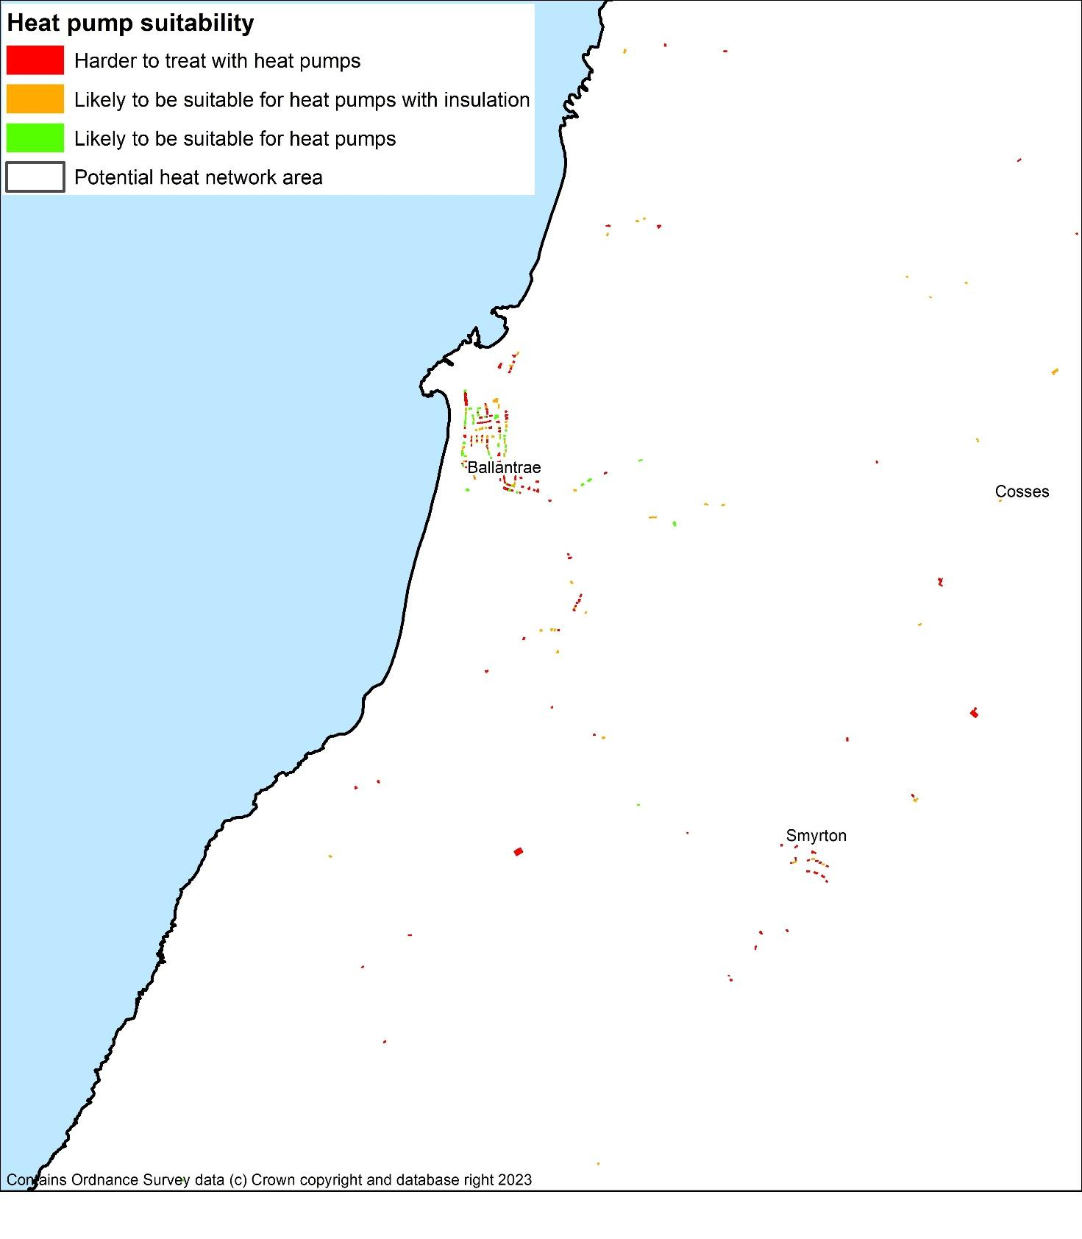

Figure 32: Heat pump suitability map - Dailly

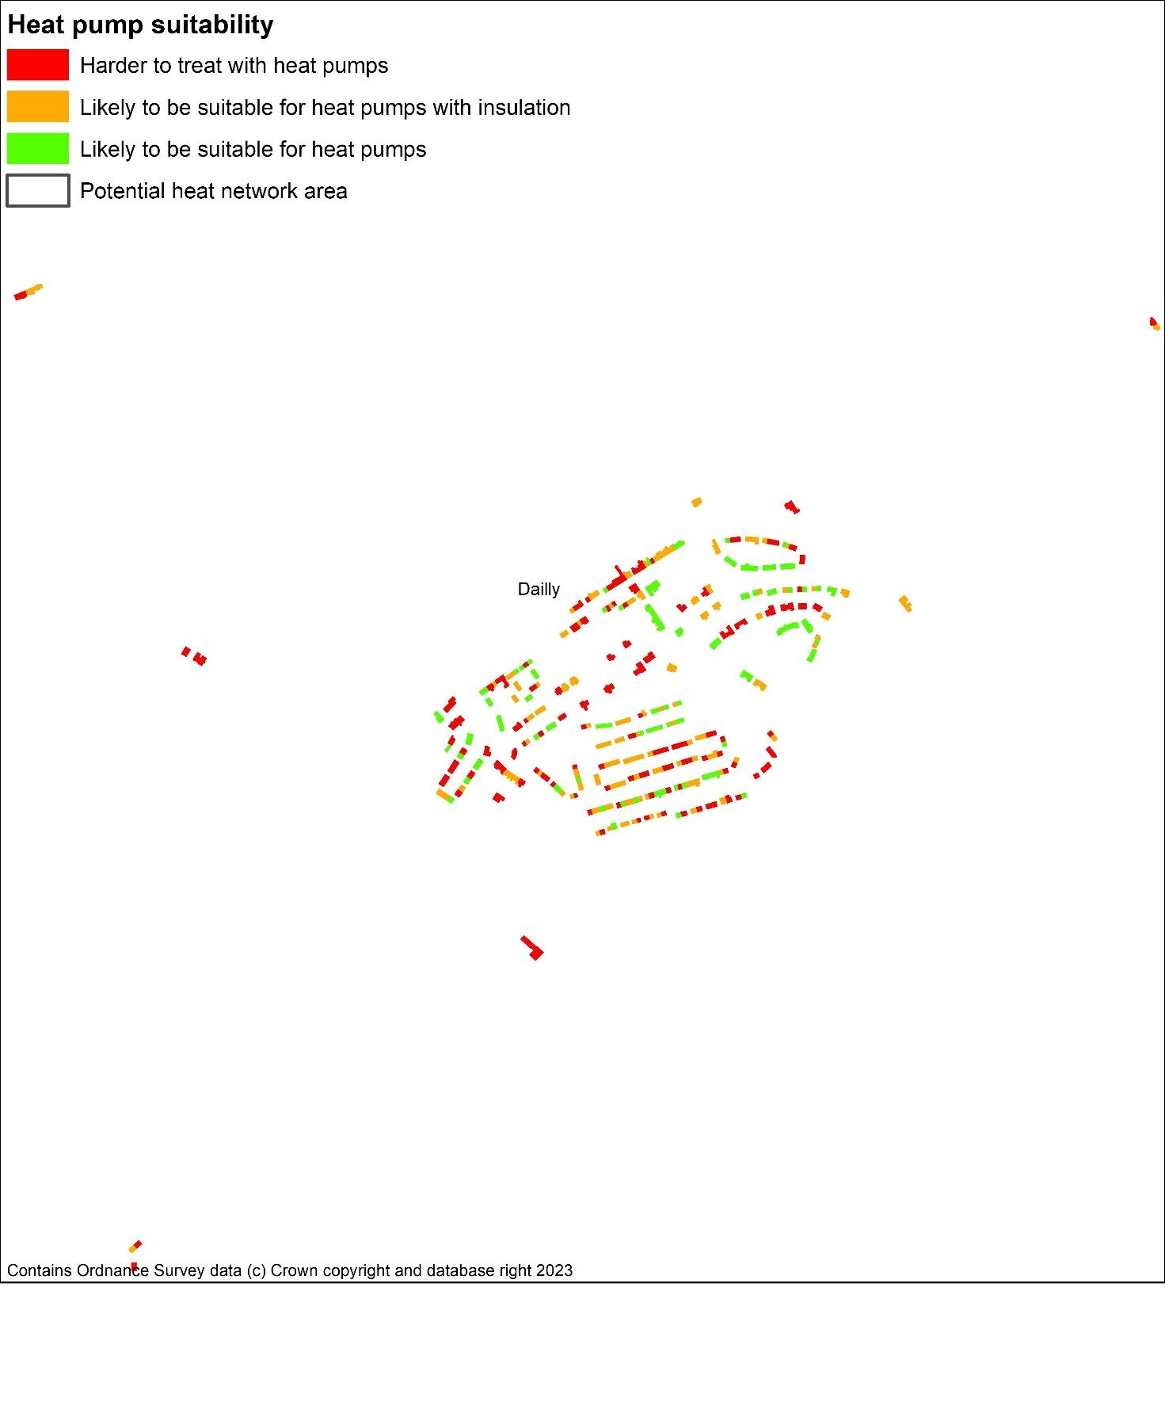

# Appendix D: Consultation Thematic Summary

**Question 1: Priorities**

**Strengths**: Public interest and a just transition are acknowledged. Alignment with fuel poverty reduction, economic development, and skills development is supported.

**Feedback**: 69% Pos / 23% Neg / 8% Neut. Concerns about ensuring a just transition for all households, particularly the most vulnerable. A need for clarification on “most vulnerable” and inclusion of health inequalities. Further information on how fuel poverty will be tackled via this strategy.

**Question 2: Considerations**

**Strengths**: The strategy considers a variety of property ownerships, heritage buildings, as well as local and national policies.

**Feedback**: 54% Pos / 23% Neg / 23% Neut. More emphasis required on public and private sector collaboration and stakeholder engagement, particularly in education. Expand stakeholder engagement strategy. Consideration of health impacts related to poor energy efficiency.

**Question 3: Challenges and Opportunities**

**Strengths**: The need for improved energy efficiency and decarbonization is recognized, particularly in off-gas areas.

**Feedback**: 69% Pos / 23% Neg / 8% Neut. Concerns about data accuracy, ensuring affordability for all (including renters), and the need for stronger public engagement. Expand data management to include cross references with internal data sources, health equalities data, and other relevant datasets that could increase accuracy of targeted measures.

**Question 4: Strategic Zones and Baseline**

**Strengths**: Using Area Based Schemes and targeting support based on existing data is supported.

**Feedback**: 62% Pos / 08% Neg / 31% Neut. Concerns about ensuring interventions reach those most at risk, potential data errors, and the need to integrate health considerations. Refine targeting and summarise area wide approach. Include good practice examples.

**Question 5: Technology**

**Strengths**: Broad agreement with the areas of focus on technology.

**Feedback**: 62% Pos / 15% Neg / 23% Neut. Need to expand on other technologies in question, including risks of internal air quality and ventilation.

**Question 6: Heat Networks**

**Strengths**: The identification of potential heat network locations and the focus on anchor loads are supported.

**Feedback**: 46% Pos / 15% Neg / 38% Neut. Higher level of uncertainty about concepts outlined indicating a need for expanded public engagement. Concerns about the feasibility and cost of large-scale infrastructure projects. National policy developments required.

**Question 7: Delivery Areas**

**Strengths**: Broad agreement with the identified focus areas.

**Feedback**: 69% Pos / 15% Neg / 15% Neut. Concerns about reaching the most at-risk households. Strengthen the focus on targeting interventions using a combination of factors such as SIMD ratings, health data, household type, prepayment meter usage, rural location, and being off the gas grid. Explore collaborating with health services and third sector organizations to identify at-risk households.

**Question 8: Pathways for all South Ayrshire**

**Strengths**: Broad agreement with the focus areas.

**Feedback**: 69% Pos / 15% Neg / 15% Neut. Lack of emphasis on public and private sector engagement, and the building sector/architectural industry. Need to look at area-wide energy generation alongside decarbonisation.

**Question 9: Governance**

**Strengths**: Broad agreement with the outlined governance structure.

**Feedback**: Ensure representation from all relevant stakeholders, including social landlords, private domestic sector, and community groups. The need for a clear timeframe for reviewing the governance structure. Formal outline for governance structure required.

**Question 10: Delivery Plan Proposals**

**Strengths**: Broad agreement with the proposed delivery plan.

**Feedback**: Clarity on responsibility for the actions is required, and more information on signposting property owners to funding and support on energy efficiency improvements to both public and private sector.

## Scottish Government Response

**Strengths**:

* Clearly outlined priorities and references throughout the document
* Strong overview of challenges faced by domestic and non-domestic buildings
* Delivery plan with actions across various timescales

**Feedback**:

* Better clarity on stakeholder engagement paths and outputs
* Improve detail on current and future stakeholder engagement plans
* Opportunity for more comparisons to national statistics, particularly for non-domestic buildings
* Potential for improved data breakdowns by building type (e.g., listed buildings)
* Room for improved presentation clarity in some sections

1. [The Local Heat and Energy Efficiency Strategies (Scotland) Order 2022 (legislation.gov.uk)](https://www.legislation.gov.uk/ssi/2022/171/contents/made)
2. [Local heat and energy efficiency strategies and delivery plans: guidance - gov.scot (www.gov.scot)](https://www.gov.scot/publications/local-heat-energy-efficiency-strategies-delivery-plans-guidance/)
3. [Heat in Buildings Strategy - achieving net zero emissions in Scotland's buildings - gov.scot (www.gov.scot)](https://www.gov.scot/publications/heat-buildings-strategy-achieving-net-zero-emissions-scotlands-buildings/)
4. An Energy System Catapult electrification of heat project in the UK finds [all housing types are suitable for heat pumps](https://es.catapult.org.uk/news/electrification-of-heat-trial-finds-heat-pumps-suitable-for-all-housing-types/).
5. [Delivering Net Zero for Scotland’s Buildings - A Consultation on proposals for a Heat in Buildings Bill (www.gov.scot)](https://www.gov.scot/binaries/content/documents/govscot/publications/consultation-paper/2023/11/delivering-net-zero-scotlands-buildings-consultation-proposals-heat-buildings-bill/documents/delivering-net-zero-scotlands-buildings-consultation-proposals-heat-buildings-bill/delivering-net-zero-scotlands-buildings-consultation-proposals-heat-buildings-bill/govscot%3Adocument/delivering-net-zero-scotlands-buildings-consultation-proposals-heat-buildings-bill.pdf)
6. [Net Zero Strategy: Build Back Greener - GOV.UK (www.gov.uk)](https://www.gov.uk/government/publications/net-zero-strategy)
7. [Heat Pump Investment Roadmap (publishing.service.gov.uk)](https://assets.publishing.service.gov.uk/government/uploads/system/uploads/attachment_data/file/1166439/heat-pumps-investment-roadmap.pdf)
8. [Heat in Buildings Strategy - achieving net zero emissions in Scotland's buildings - gov.scot (www.gov.scot)](https://www.gov.scot/publications/heat-buildings-strategy-achieving-net-zero-emissions-scotlands-buildings/pages/11/)
9. [Tackling fuel poverty in Scotland: a strategic approach - gov.scot (www.gov.scot)](https://www.gov.scot/publications/tackling-fuel-poverty-scotland-strategic-approach/)
10. [Energy Performance Certificates - Energy efficiency - gov.scot (www.gov.scot)](https://www.gov.scot/policies/energy-efficiency/energy-performance-certificates/)
11. <https://ukerc.ac.uk/news/energy-efficiency-contributed-25-of-uk-economic-growth-since-1971/>
12. <https://www.gov.scot/publications/transitions-comparative-perspective/pages/5/>
13. [Electrification of Heat Demonstration Project: winning bids, case studies and project data - GOV.UK (www.gov.uk)](https://www.gov.uk/government/publications/electrification-of-heat-demonstration-project-successful-bids#full-publication-update-history)
14. [All housing types are suitable for heat pumps, finds Electrification of Heat project - Energy Systems Catapult](https://es.catapult.org.uk/news/electrification-of-heat-trial-finds-heat-pumps-suitable-for-all-housing-types/)
15. [Lived experience of fuel poverty, Scottish Government, 03/09/2022](https://www.gov.scot/publications/research-lived-experience-fuel-poverty-scotland/pages/6/)
16. [The role of off peak electric heating in reducing fuel poverty,](https://labmonline.co.uk/wp-content/uploads/2017/11/GDHV-The-role-of-off-peak-electric-heating-in-reducing-fuel-poverty.pdf) 2017
17. [Health Inequalities: cold or damp homes](https://commonslibrary.parliament.uk/research-briefings/cbp-9696/#:~:text=Cold%20or%20damp%20conditions%20can,in%20cold%20or%20damp%20housing.) – UK Government, 2023
18. [5 Energy Perceptions - Scottish house condition survey: 2019 key findings - gov.scot (www.gov.scot)](https://www.gov.scot/publications/scottish-house-condition-survey-2019-key-findings/pages/7/)
19. [Heat networks: Building Assessment Report (BAR) guidance - gov.scot (www.gov.scot)](https://www.gov.scot/publications/building-assessment-report-bar-guidance/)
20. Detached houses may be considered to be less suitable to connect due to the individual sections of pipework that are required to connect the buildings to the network, on a linear heat density approach, the longer the connecting pipework, the “harder” the pipework has to work to satisfy loads.