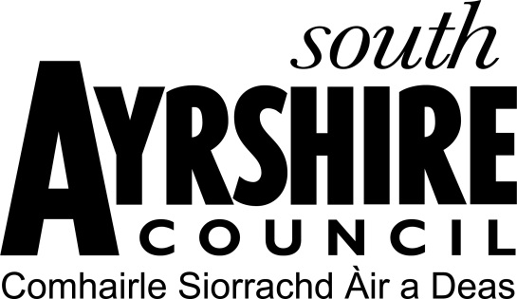

SOUTH AYRSHIRE CHARITABLE TRUST

Individual Grant Application Form – Prestwick

The South Ayrshire Charitable Trust was created in 2015. Its purposes are as follows:-

- The prevention and relief of poverty
- The relief of those in need by reason of age, ill health, disability, financial hardship or other disadvantage
The beneficiaries of the Trust Fund are the residents from time to time of the town of Ayr. In furtherance of the Trust Purposes, the Trustees may make grants from the Trust Fund to:
- Individual residents of the Trust Area.
- Groups, companies, associations or other organisations operating in the Trust Area who provide facilities, services or other assistance in accordance with the Trust Purposes which has a benefit to residents of the Trust Area.
The maximum grant available is £200

NB - the award of any grant is at the sole discretion of the trustees of the South Ayrshire Charitable Trust

The closing date for applications is 26th September at 5pm.

Name of applicant:

Address:

Postcode:

Tel No:

Email:

How long have you lived at this address?

If less than 2 years, please state your previous address:

Date of Birth:

Current Occupation:

Please indicate the number of persons in the household:

- Employed Adults (b) Unemployed Adults

(c) Retired Adults (d) Children (ages)

INCOME (Weekly) | £ | EXPENDITURE (Weekly) | £
Wages / Pensions (Self):  (net after tax and deductions) |  | Rent / Mortgage:
Wages / Pensions (Partner):  (net after tax and deductions) |  | Heating:
Please state any benefits received below: |  | Telephone:
 |  | Housekeeping:
 |  | Travel:
 |  | H.P:
 |  | Electricity:
 |  | Other (please provide details)
Total: | £ | Total: | £

Please provide details of any savings that you or your partner have:

Please detail any special circumstances you wish to be taken into account:

Please indicate what you intend to use the grant funds for:

Please indicate the reason(s) why you require these goods / assistance:

Please indicate how this grant will meet the Trust Purposes:

Total cost of Grant sought: £

Is this item / service you (the applicant) are seeking available from a statutory organisation i.e. NHS or Council:

Have you previously received funding from South Ayrshire Charitable Trust and, if so, have you completed and returned an evaluation report with evidence of spending, including receipts? Please provide details below:
Date of Award | Amount Received | Evaluation Returned Yes/No

Have you previously received a grant from the Scottish Welfare Fund? If yes, please provide details of what goods/monies you were awarded.

If you have completed this form on behalf of the applicant you must provide evidence that you are authorised to apply on their behalf i.e. Power of Attorney / Guardian

DATA PROTECTION ACT 1998

USE OF YOUR INFORMATION

It is our responsibility to keep your information safe. We will only collect the minimum amount of personal information we need to process your application form.
We will only share your information with Legal Services Team and the Trustees for them to make a decision on the eligibility of your request.
We also have a duty to manage public funds, prevent and detect fraud so we may share the information you have provided with relevant bodies as is permitted by law.

We hold completed applications for five years before destroying them.

Declaration

I confirm that the information I have provided is correct to the best of my knowledge and authorise South Ayrshire Council to use my information for the above purposes.

Signed:

Date:

Once you have completed your form fully, please email your application form together with any necessary supporting documents to:

Grants@south-ayrshire.gov.uk

Please note applications will not be considered for funding if you have received a grant from South Ayrshire Charitable Trust in previous years and not yet completed and returned the Evaluation Report along with evidence of spend.

