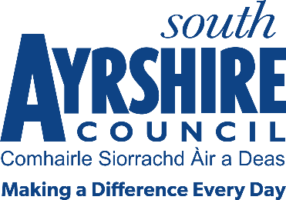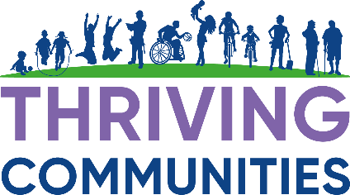

**Food Insecurity Fund**

Guidance Notes

**Background**

South Ayrshire Council is committed to reducing food insecurity within our communities and supporting Projects that aim to help reduce poverty and improve the quality of life for our residents. The Local Outcome Improvement Plan (LOIP) states that “We are committed to reducing poverty within South Ayrshire and we will continue to work in partnership to help individuals and families access financial support services that will assist with fuel poverty, income maximisation and food insecurity. Partners will ensure local support is available that assists with the cost of living by ensuring advice, guidance and support services are accessible and available across South Ayrshire.

**Why do we need to provide support?**

Low-income limits choice and restricts freedom; it can bring anxiety, stress, and uncertainty; it can be a contributory factor in family breakdown; it is a key driver in homelessness, crime, and addiction; and it can lead to significant health problems and widen health inequalities, particularly if experience of low income is long-term.

Currently in South Ayrshire there are:

* 7 (SIMD) data zones in the top 5% most deprived Index  
  (SIMD is the Scottish Governments standard approach to identify multiple areas of deprivation)
* In 2021/22, South Ayrshire had the 10th highest child poverty rate (after housing costs) nationally and was above the Scottish average - 24.4% compared to 22.6%.   This is an estimate of 4,807 children in South Ayrshire.
* In 2022/23, Trussell Trust distributed almost 9,000 food parcels for adults/children throughout South Ayrshire.  This is an increase of 40% since the previous year.
* Fuel Poverty is 24.8% compared to 24% nationally.
* 12.2% of South Ayrshire population is income deprived which is similar rate to Scotland 12.1%

**What is the grant funding criteria**?

To support people facing food poverty by:

* Strengthening/developing community food initiatives/schemes.
* Supporting activities that focus on addressing the root causes of food poverty.
* Underpinning the requirements of the Local Authority’s policies, in particular with regard to supporting children at risk, focussing on vulnerable people and helping people age well.
* Helping to develop activities by local community groups and voluntary organisations etc. to start up projects like food larders, community cafes, lunch clubs and cookery classes.
* To provide organisations with some capital funding to spend on items such as, but not limited to, food, fridges, freezers and cooking equipment.

**Funding Available**

Grants of up to £1000 are available for proposals that meet the purpose and criteria of the fund. There is no minimum grant amount. Applications can be for up to 100% of identified costs but the inclusion of any match funding in proposals will be looked upon favourably.

**Who can apply:**

**Groups and organisations** who are working directly to help reduce food insecurity within our communities. Applicants will be expected to show how the grant will improve the lives for residents.

**All applicants** must be active in our South Ayrshire Council’s area and spend any agreed funding such that it benefits residents/communities in South Ayrshire Council’s area.

**Third Sector organisations/community groups** require to have a constitution and appropriate governance and financial arrangements in place, proportionate to the value of the application.

**How to Apply**

The fund is open for applications until Thursday 6th March 2025 (5pm).

An application form is available to download on the South Ayrshire Council website.

<https://www.south-ayrshire.gov.uk/funding/>

Contact South Ayrshire Council for further information:

[**Grants@south-ayrshire.gov.uk**](mailto:Grants@south-ayrshire.gov.uk)

**Eligibility**

Applications must:

* The full project costs and will be for **capital costs**
* directly benefit South Ayrshire communities

**EXCLUSIONS**

Applications:

* **cannot** be from any South Ayrshire Council Service

**Awards Process**

An awards panel comprising of a representative from the CPP, and South Ayrshire Council officers, will review all applications and inform groups of the outcome of their submission.

The Award panel decisions are final, there is no appeals process.

Any monies awarded must be spent by the 30th November 2025

Any unspent monies will be required to be returned. Any carry forward requests for after this did must be approved by the Service Lead Thriving Communities.

**Filling in your application form**

* Please click on the relevant boxes and type your answers in full.
* Fill in the whole form.
* Please don’t state ‘See attached’ or ‘See Section…’ as an answer to any question.
* Please don’t attach additional papers or continuation sheets other than the supporting evidence required.
* Explain in full any technical or specialist terms that you use. Please avoid the use of abbreviations.
* When you’ve finished the form, please sign the declaration page.
* Applications should be emailed to the address below.
* You should keep a copy of the completed application form and any documents to support your application in case you need them in the future.

**Contact Information**

For any enquires regarding the Food Insecurity Fund please do not hesitate to get in touch, we are here to help with any questions you have and to support in any way possible. Please email us at [grants@south-ayrshire.gov.uk](mailto:grants@south-ayrshire.gov.uk)

**Submitting your application form**

Please email your completed form to:

[grants@south-ayrshire.gov.uk](mailto:grants@south-ayrshire.gov.uk)

The closing date for applications is **Thursday 6th March at 5pm.**

**Monitoring & Evaluating**

* All grants awarded will be subject to strict monitoring and evaluating procedure.
* A midterm revue may be carried out.
* Any changes to your proposed project, or any delay in spending then you must inform the grants officer immediately.
* An evaluation form will be issued on completion, and this must be returned**. All invoices/receipts and proof of payment need to be returned. Failure to return may result in you having to pay back your grant funding.**
* Any groups not submitting an evaluation form may not receive any future funding from South Ayrshire Council. You may also be asked to repay the grant if you are not able to provide satisfactory evidence that the grant has been spent for the intended purpose.