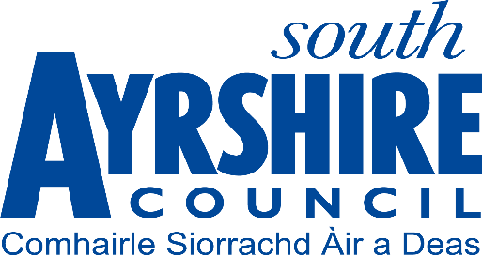

**Scottish Parliament Election Thursday 6 May 2021**

**Candidates’ Posters and Other Advertising**

Since 1 July 2010, the display of election campaign publicity material on any South Ayrshire Council property, including lighting columns, traffic sign poles and street furniture has been prohibited. Materials breaching this will be removed as a priority in line with agreed practice.

No party political or campaigning material can be placed on Council notice boards or displayed in Council buildings.

Please note that Strathclyde Police has advised that candidates must not use any photographs or images featuring police officers/ employees in any election materials.

Election Office County Buildings Wellington Square AYR KA7 1DR

Tel: 0300 123 0900

Email: [election@south-ayrshire.gov.uk](mailto:election@south-ayrshire.gov.uk)

Web: <http://www.south-ayrshire.gov.uk/council-election/>