Embedding The Promise in Practice
Summary Progress Update 2024/2025

The Promise is Scotland’s commitment to care experienced infants, children, and young people that they will grow up ‘safe, loved and respected’. Scotland has set out to achieve this promise by 2030 ensuring that families receive the right support at the right time from the right people.

In 2016 the Independent Care Review was commissioned by the Scottish Government to conduct a root and branch review of Scotland's care system. The Care Review heard over 5,500 experiences from children, young people and adults who had lived in care as well as hearing from the paid and unpaid workforce.

In February 2020 the Care Review published its findings and recommendations in a set of five reports. These reports covered the changes the Care Review proposed, plans for implementing these changes and the investment in services required to realise the changes. All five reports can be accessed here.

In 2021 the Strategic Planning Advisory group (SPAG), a sub-group of our Integration Joint Board (IJB) agreed that our Parenting Promise 2021-2030 should be aligned to South Ayrshire Community Planning Partnership (CPP). This decision was made on the basis that Corporate Parenting activity aligns with Children’s Services Planning, which is held within the CPP and that implementing the Promise requires a wider reach than may not have been achieved had the strategy remained solely within the Health and Social Care Partnership.

As a result, in South Ayrshire the Promise now sits within our Community Planning Partnership who have taken real ownership of the Promise by making it a Local Outcome Improvement Priority for South Ayrshire. There is also a real commitment from the Children Services Planning Partnership for the Promise to be woven throughout all elements of their six priorities, so that while it is a unique priority it is also reflected in all we do for infants, children, young people, and families in South Ayrshire, collaboratively.

The Promise is built on five foundations: Voice, Family, Care, People and Scaffolding. Each foundation contains a range of thematic areas (25 in total) as outlined:

VOICE: Participation/Engagement, Listening and Documenting Decisions

FAMILY: Poverty, Universal Family Support and Intensive Family Support

CARE: Decision Making, Advocacy, Relationships, Stability, Where Children Live, Moving On/Lifelong Support

PEOPLE: Leadership, Recruitment/Retention, Rules/Processes/Culture, Workforce Support

SCAFFOLDING: Rights, Data/Information, Money/Commissioning, Legislation, Scrutiny/Inspection, Governance, Education, Justice, Health

South Ayrshire has worked to develop 55 promise calls to action. Our calls set out how we would approach implementing the Promise in South Ayrshire and were aligned directly to the language used in the Promise. The calls to action offered us a clear structure and framework to understand the changes that required and are a source of motivation to achieve this change.

In 2021, we identified Ten Promise improvement areas for 2021-24 were created for which we established thirty-two associated actions and a further forty-eight benefits (measurable improvements) which we honed over time to thirty-one actions and forty-seven benefits.

Over the past four years, we have focused our whole system change to deliver on the Promise, through our ten improvement areas We have been able to measure authentic transformation through our benefits tracker on 47 measurable benefits.

Embedding-The-Promise-in-Practice-2021-24 describes the story of the journey that we have been on, and the changes made across a range of areas. It also emphasises how children and young people with experience of care have been at the heart of what we do, and how we do it.

The South Ayrshire Parenting Promise Roadmap illustrates some of the changes made between 2021-24.

Of the thirty-one promise actions identified 2021-24, fifteen (48%) are now complete a further sixteen (52%) are on target and will be carried onto plan 24-30. Over the course of 21-24 one action was superseded by a new action and two actions required an extension to the due date to accurately measure their impact.

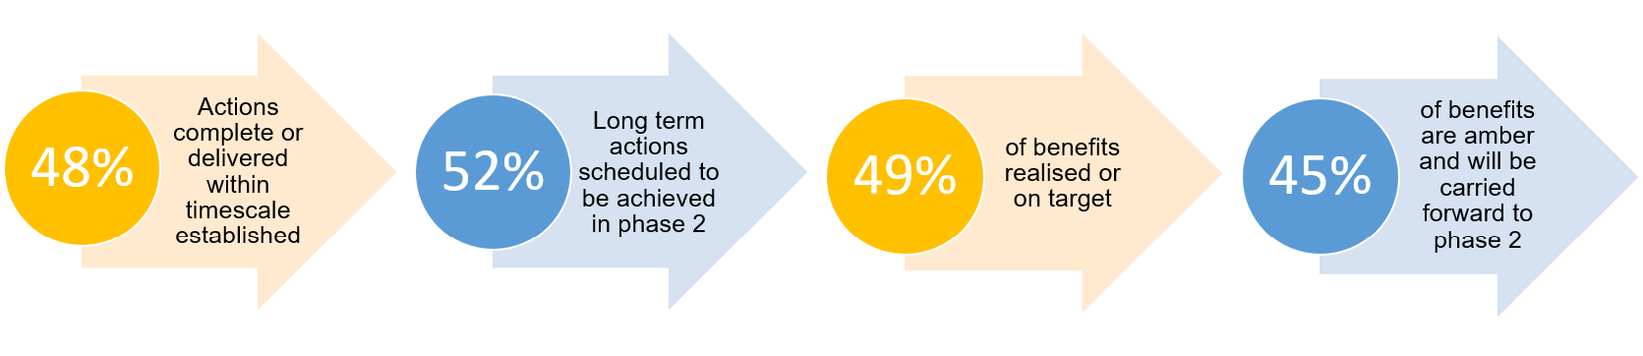

Next Steps

There is still more work to do to keep the promise by 2030. As we look ahead to the next phase of local activity, we will use national tools to help us understand our progress, such as Plan 24-30 which sets out WHO needs to do WHAT by WHEN to #KeepThePromise by 2030.
We will also use the national promise progress framework developed at the end of 2024 (see 10 vision statements below) and align this with our corporate parenting reporting to help us tell our story.
- Vision Statement One: Supporting children to stay with their families.
Where children are in their families and feel loved they must stay - and families must be given support together to nurture that love and overcome the difficulties which get in their way.

- Vision Statement Two: Supporting carers and providing stability.
Scotland must limit the number of moved that children experience and support carers to continue to care.

- Vision Statement Three: Education
Schools in Scotland must be ambitious for care experienced children and ensure they have all they need to thrive, recognising that they may experience difficulties associated with their life story.

- Vision Statement Four: Brothers and Sisters
Where living with their family is not possible, children must stay with their brothers and sisters where safe to do so and belong to a loving home, staying there for as long as needed.

- Vision Statement Five: Physical Restraint
Scotland must strive to become a nation that does not restrain its children.

- Vision Statement Six: Mental Health
Scotland must seek to uphold the wellbeing of care-experienced children and young people and ensure that there is a timely access to mental health support before crisis point so that children avoid hospitalisation.
- Vision Statement Seven: Health
Care experienced children and young people have access to support ensuring that their health needs are fully met and potential for good health is maximised.
- Vision Statement Eight: Justice and Secure Accommodation
Scotland must stop locking up children who have often experienced the failures of the state in the provision of their care.
- Vision Statement Nine: Aftercare
Young adults for whom Scotland has taken on parenting responsibility must have a right to return to care and have access to services and supporting people to nurture them.
- Vision Statement Ten: Support for care experienced adults
Care experienced adults must have a right to access supportive, caring services for as long as they require them. Those services and the people who work in them must have a primary focus on the development and maintenance of supportive relationships that help people access what they need to thrive.

All our work will continue to place those with lived experience at the heart. We will measure our success through the experiences of the people who use our services. This will require commitment and resource to do well and requires participation to be valued as central throughout all aspects of our service, design, delivery, and monitoring of our progress.

