South Ayrshire Council
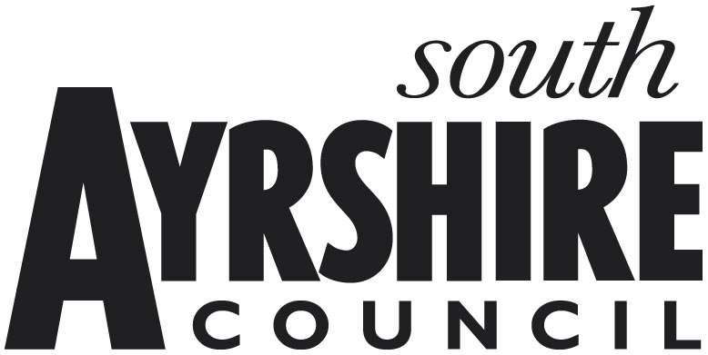

Enterprise Area Relief Scheme

The Enterprise Area Relief Scheme, as applicable to the Prestwick International Enterprise Area, may provide non-domestic rates relief from 1 April 2012 for businesses located within the Enterprise Area who are concerned with the manufacture of aircraft and spacecraft and related machinery and/or the repair and maintenance of aircraft and spacecraft, or other specified qualifying criteria. Lands and heritages must be occupied for the sole or main purpose of the qualifying activity to be eligible for this relief.
This form needs to be completed and returned as soon as possible, either by post to: South Ayrshire Council, Corporate Services, PO Box 31, Wellington Square, Ayr, KA7 2PL, or by e-mail to: business.rates@south-ayrshire.gov.uk. The declaration at paragraph 12 must be signed and dated.

- Organisation claiming relief:

Name:

Address:

- Property for which rates relief is being sought:

Description:

Address:

- Rates Reference:

- Rateable Value:

- Date of Occupation:
YES / NO
- Is the property a new build?

- If the property is an existing build, was it vacant for at least
YES / NO
3 months prior to occupation?

- Describe fully all business activity which will be carried out at the above property address:

YES / NO

- Are you liable for rates on any other property in Scotland?

- If YES, please detail below (on a separate page if necessary) any other business premises you or your company/organisation are liable for in Scotland:

Property Address | Reference Number | Rateable Value

- State Aid: Applicants should note that the Enterprise Area Relief for which they are applying is granted as de minimis aid for State Aid purposes. There is currently a ceiling of 200,000 Euros (around £165,000, although exact amount will fluctuate) of de minimis aid that can be granted over a three year period. If you consider that you have already received in excess of, or close to, this sum over the past three years, please attach details with this application form.

- Declaration

I understand that: - The Council is under an obligation to manage public funds properly. Accordingly information that you provide the Council will be used to ensure all sums due to the Council are paid timeously. The information may also be used to prevent and detect fraud. It is possible that this information may be shared for the same purposes with public bodies, including Councils or other organisations which handle public funds.

I agree that: - You may make any enquiries necessary to check the information I have given. I understand that any relief awarded to me as a result of misleading statements deliberately given on this form will be recovered in full and that I may be liable to legal action.

I declare that: - The information I have given on this form is true, complete and correct. I understand that the deliberate provision of false information in order to achieve financial gain is a criminal offence.

Name (Block capitals):

Position in Organisation:

E-Mail Address: Phone:

Signature: Date:

For Official Use Only

Date returned: ……………………. Date processed: …………………….

Relief Period: ……………....to……….............. Relief Category: …………………….

Action by: ……………………. Authorised by: …………………….

