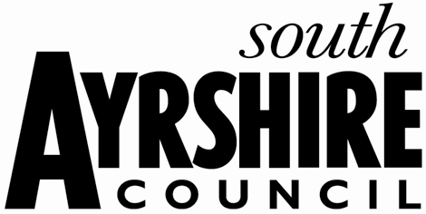
South Ayrshire Council

New Start Relief

New Start Relief offers relief on unoccupied new build properties built since 1 April 2013. The relief offered is up to 100% for 18 months, and can be applied if the following circumstances are all met for the property:

- The property is entered onto the Valuation Roll between 1 April 2013 and 31 March 2017; and

- The property is unoccupied at the time of entry onto the Valuation Roll; and

- The new entry is not as a result of a combination or division of an existing entry on the Valuation Roll or due to the refurbishment or change of an existing entry on the Valuation Roll (including conversion of a domestic property or a property previously exempt from rating).
Please be aware that for the period that New Start Relief is awarded, no other relief can apply.
Applicant & Property Details
Ratepayer Name:
Property Address:
Rates Reference No:
Rateable Value:
Date property was entered on the Valuation Roll:
Current status of property: (Delete as appropriate) |  | Occupied / Unoccupied
Has the property previously received any New Start Relief:  If Yes, please supply start and end dates of relief award: |  | Yes / No
The rateable value of your property can be found using the "search for a rateable value" facility at: www.saa.gov.uk

The exact level of relief awarded will depend on the level of other public sector assistance received by your business (see State Aid below), which includes New Start or other types of rates relief considered as State Aid, for all properties across Scotland for which your business has responsibility for the rates liability.
Are you liable for non-domestic rates on any other property in Scotland? (Delete as appropriate)
Yes | No
If Yes please detail below (on a separate page if necessary) any other business premises you or your company/organisation are liable for in Scotland:

Property Address(es):

Rates Reference Number(s) (See rates notices):

Details of any rates relief awarded, including type(s) and value of relief:

Rateable Value of Property(ies):

If any of the above properties are outside the South Ayrshire Council area, please enclose a copy of your most recent rates demand notice.
State Aid
Applicants should note that the New Start relief for which they are applying is granted as de minimis aid for State Aid purposes. There is currently a ceiling of 200,000 Euros (around £175,000, although exact amount will fluctuate) of de minimis aid that can be granted over a three year period. If you consider that you have already received in excess of, or close to, this sum over the past three years, please note in the box below or attach details with this application form.
Declaration
I understand that: The Council is under an obligation to manage public funds properly. Accordingly information that you provide the Council will be used to ensure all sums due to the Council are paid timeously. The information may also be used to prevent and detect fraud. It is possible that this information may be shared for the same purposes with public bodies, including Councils or other organisations which handle public funds. I will not be eligible to apply for any other relief on this property for the period the property receives New Start Relief if my application is successful.
I agree that: The Council may make any enquiries necessary to check the information I have given. I understand that any relief awarded to me as a result of misleading statements deliberately given on this form will be recovered in full and that I may be liable to legal action.
I declare that: The information I have given on this form is true, complete and correct. I understand that the deliberate provision of false information in order to achieve financial gain is a criminal offence.

Applicant’s Name:
Company Stamp (If applicable):
Position Held:
Telephone Number:
E-Mail Address:
Date:

