# 

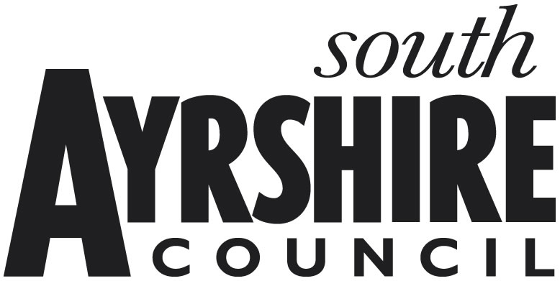

**South Ayrshire Council**

**Renewable Energy Generation Rates Relief**

From 1 April 2016, t**he Renewable Energy Generation Relief Scheme provides non-domestic rates relief to renewable energy producers involved in community renewables developments who are solely concerned with the production of heat or power (or both) from the following sources:** biomass; biofuels; fuel cells; photovoltaics; water (including waves and tides, but excluding production from the pumped storage of water); wind; solar power; geothermal.

New build property that provides renewables electricity generation, built and entered in the Valuation Roll between 1 April 2016 and 31 March 2018 only, may also be eligible for relief.

This form needs to be completed and returned as soon as possible, either by post to: South Ayrshire Council, Non-Domestic rates, PO Box 31, Wellington Square, Ayr, KA7 2PL, or by e-mail to: business.rates@south-ayrshire.gov.uk. **The declaration at paragraph 8 must be signed and dated**.

1. **Organisation claiming relief:**

Name:

Address:

1. **Property for which rates relief is being sought:**

# Description:

Address:

3. **Rates Reference:**

4. Which of the following sources are used for the generation of heat **or power (or both) at the property concerned (please tick as appropriate):**

1. biomass;
2. biofuels;
3. fuel cells;
4. photovoltaics;
5. water (including waves and tides, but excluding production from the pumped storage

of water);

1. wind;
2. solar power;
3. geothermal sources;

**Note:** **Combined Heat and Power (CHP)** systems are only considered to be renewable if they use the sources of energy listed above and have an electrical capacity of 50 kilowatts or less.

5. **Is this a Community Renewables Development** as defined in the regulations?

**YES / NO**

(If “yes”, you may be required to provide additional information)

1. The level of renewable energy generation rate relief available for **community renewables developments** depends on the combined rateable value of your business's eligible property (or properties), and is set out in the table below:

|  |  |
| --- | --- |
| **Combined rateable value of all business properties in Scotland:** | **Percentage relief (%)** |
| up to £145k | 100 |
| up to £430k | 50 |
| between £430k and £860k | 25 |
| between £860k and £4m | 10 |
| greater than £4m | 2.5 |

New property built between 1 April 2016 and 31 March 2018 used solely for the generation of renewable heat and/or power, and which is not part of a community renewables development, may receive 10% relief if RV is no more than £500,000 and 1.5% if above that figure. Between 1 April 2017 and 31 March 2018 this may be 25% relief if total installed capacity is no more than 1 megawatt.

From 1 April 2018, hydro schemes with a rateable value of no more than £5m may be eligible for 60% relief.

Please provide the address, reference number and rateable value of any other eligible properties in Scotland occupied by your business for renewable energy production:

|  |  |  |
| --- | --- | --- |
| **Property Address** | **Reference Number** | **Rateable Value** |
|  |  |  |
|  |  |  |
|  |  |  |

1. State Aid: Applicants should note that the Renewable Energy Generation Relief for which they are applying is granted as de minimis aid for State Aid purposes. There is currently a ceiling of 200,000 Euros (around £175,000, although exact amount will fluctuate) of de minimis aid that can be granted over a three year period. If you consider that you have already received in excess of, or close to, this sum over the past three years, please attach details with this application form.

1. **I/We understand that the information supplied is to the best of my knowledge and belief accurate, and that I/We understand that to deliberately provide false information for monetary advantage is a criminal offence.**

**Name (Block capitals):**

**Position in Organisation:**

**E-Mail Address: Phone:**

**Signature:** **Date:**

For Official Use Only

Date returned: ……………………. Date processed: …………………….

Relief Period: ……………....to……….............. Relief Category: …………………….

Action by: ……………………. Authorised by: …………………….