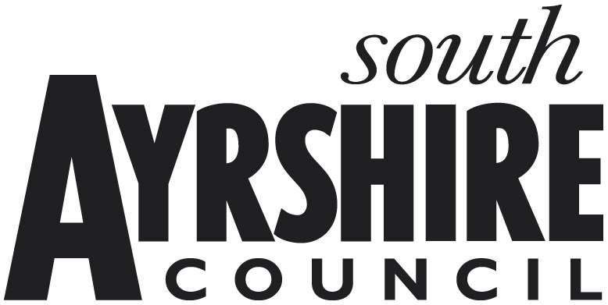
South Ayrshire Council

Small Business Bonus Scheme

This form needs to be completed and returned as soon as possible by e-mail to: business.rates@south-ayrshire.gov.uk. (a scanned copy is acceptable)

The declaration at paragraph 7 must be signed and dated.

Please complete the following questions (delete where appropriate):

1. Ratepayer Name:

2. Rates Reference:

3. Property Address:

£
4. Current Rateable Value:
YES / NO
5. Are you responsible for the rates for any other properties in Scotland?

If the answer is YES to question (5), please provide details of the address and rateable value for each property. A copy of the latest rates notice is required if the property is not in South Ayrshire. (Do not include any domestic dwelling that is subject to Council Tax)

Property Address | Rates Reference | Rateable Value | Occupied
 |  |  | YES / NO
 |  |  | YES / NO
 |  |  | YES / NO

6. You are required to advise the Council if the property is unoccupied:
YES / NO
- Is the property currently unoccupied?

- If Yes, when did the property become empty?

7. I/We understand that the information supplied is to the best of my knowledge and belief accurate, and that I/We understand that to deliberately provide false information for monetary advantage is a criminal offence.

Name:

Position in Business:

E-mail address:

Telephone number:

Signature: Date:

