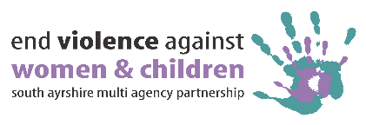
VAW Survey
21 responses were received.
The survey highlights the need for increased awareness, better access to services, and community involvement to support women and girls in South Ayrshire. ​

Which organisation are you from?
Most responses (38%) were received from South Ayrshire Council. Other organisations represented included Stepping Stones for Families ; HSCP ; Police Scotland ; Girvan Youth Trust ; and others.

Which locality do you work in?
1 in 2 participants worked across South Ayrshire and not in one locality. Other localities mentioned were Ayr South, Ayr North, Ayr Central and Carrick.

Do you feel women and girls in South Ayrshire are safe, respected and supported?
- 14% believe women and girls are safe, respected, and supported. ​
- 52% feel they are "mostly" safe, respected, and supported. ​
- 10% said "No," and 24% were "Not Sure." ​

What do you think helps women and girls feel safe and supported locally?
The most popular responses were in relation to awareness and availability of support services including the “Ask for Angela” campaign which allows women to ask for help when they find themselves in a situation that makes them uncomfortable.

Education in schools was also mentioned as well as the promotion of positive messages on social media. Other comments included building positive relationships, women/girls feeling listened to and being allowed to voice their opinions and views.

A full list of comments can be found in Appendix A at end of this report.

What are the main barriers that prevent women and girls from seeking help?
- The most popular choices were “fear of not being believed” and “stigma/shame” which both received 17 responses.
- Another popular choice with 16 responses was “not knowing where to go for help”.
- Other responses included “ fear of judgement” ; “fear of partner/husband” ; and “lack of support/advice when reporting a crime”.

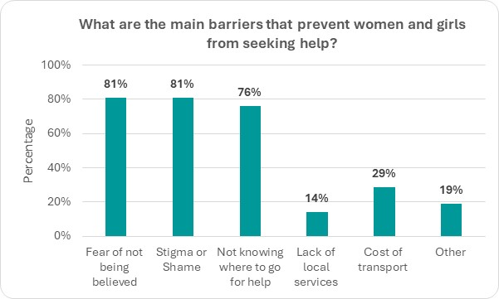

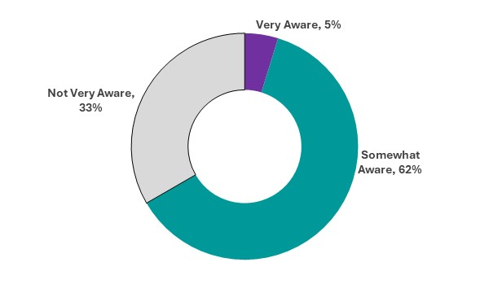
How aware do you think people in your community are about violence against women and girls and where to get support?
- 62% believe people are "Somewhat Aware." ​
- 33% think people are "Not Very Aware." ​
- Only 5% feel people are "Very Aware." ​

What more could be done locally to support women, children and young people affected by violence and abuse?
Respondents suggested more awareness raising such as more advertisement of services, drop-in meetings, and social medua.

Other suggestions included more education at a younger age, increased partnership working, and more outreach services for rural communities.

A full list of comments can be found in Appendix A at end of this report.

What would help challenge harmful attitudes in South Ayrshire?
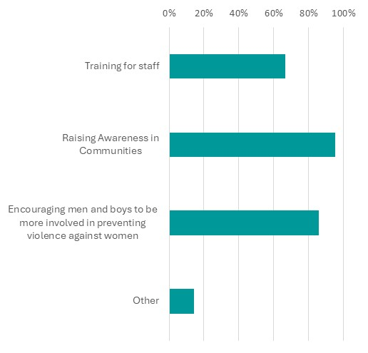
- Raising awareness in communities (20 responses) was the most suggested action. ​
- Encouraging men and boys to be involved in preventing violence (18 responses) and training for staff (14 responses) were also recommended. ​
- Other responses included “more events – make it a culture change all year” ; “more info on social media for women and men” ; and “learning in primary and secondary schools about what is acceptable”.

October 2025

Appendix A : All Comments
What do you think helps women and girls feel safe and supported locally?
Access to immediate help which is trauma informed and supportive.
Access to support agencies
Positive media messaging regarding achievements by women and girls
Included in conversations about safety
Allowing women and girls the freedom to voice their opinions and views. Businesses having a non-judgemental approach towards women and girls. Support groups and services doing what they can for women and girls.
Being able to walk through their communities without risk of any harm.
Engaging in local support services available to them both statutory and voluntary. Having a trusted person to speak to.
Financially secure, a warm home and a loving, supportive family and friends network.
Having groups or ones to ones that they can engage with, being listened to. I think the " Ask for Angela" is a great thing too.
I have worked alongside Women's Aid as part of my role and feel the support they offer is extremely valuable. I am also aware of further groups and services within South Ayrshire from the turd sector which offer support, advice and guidance to women.
I think education is being provided at school aged girls and young women and social media is useful tool.
information about where you can get help, knowing that South Ayrshire is generally a safe place to live. helpful services
Knowing that domestic abuse in all forms is taking seriously and that there are support services in place.
Other women supporting women
Partnership Working: Violence Against Women Partnership, Women's Aid and Police
Places to go for support; campaigns such as Ask Angela being widely known; misogyny being called out and not excused for banter; reducing stigma and championing women in all areas of life (home, work, socially); better street lights; safe and trusted programmes to travel alone; raising awareness that women don't need to change their behaviours, routes home from a night out, their clothes, but that the focus needs to be on supporting men's behaviours to respect women; more gender diversity in the workplace
Positive relationships with family support workers and other agencies.
Sex segregated toilets, changing rooms, homeless accommodation, support groups and forums.
Support from various agencies
Support Services, stable accommodation, place of safety accommodation, family, friends, Relevant health services, access to community support,
The support services available are of abundance in South Ayrshire, they are well promoted and services are able to provide support or signpost where required.
There are a wide range of organisations who have embedded and prioritised policies and ethos into their core fundamental beliefs. Charities like AHAC ensure everyone has a voice and are able to refer to specialists such as women's aid where necessary. We ensure staff are aware of the various issues faced by mainly women and staff are trauma informed and responsive. We provide independent housing advice and advocacy which can involve helping those who are enduring violent, non-violent domestic abuse and coercive behaviour. By ensuring our staff team is equipped with the skills to recognise and support we can empower women to make informed choices and secure positive outcomes free from abuse and threat.
AHAC believe every woman should be able to thrive and given the support and tools to flourish. Indeed many of the staff team are women who have been encouraged to succeed into management positions and lead by example. This helps service users to see that with the right support and encouragement anything is possible. Everyone should be supported to be resilient, equal, safe, heard and empowered.

What more could be done locally to support women, children and young people affected by violence and abuse?
Awareness raising; more hostels and places for support; more outreach and children and families support; challenge stigma; community training on misogyny in partnership with men's support groups. All working together to keep everyone safe.
Better lighting, more police visibility (including walking around local communities), publicity events at the weekend and in the evening as a lot of events are during traditional working hours.
Continued positive messaging about the work of support agencies, police and prosecutors
drop-in meetings, more services, more posters / signs on buses, podcasts / talks to schools and community groups / parents groups to spread the word. Designated workers for women to be able to gain trust and open up to them. More awareness about gaslighting and coercive behaviours as a lot of women are so used to it that it has became their "norm"
Earlier Intervention, Support Services in Primary School, more suitable accommodation for victims within South Ayrshire, more collaborative communication with services ie, social work, health services, support services,
Encourage organisations to work together better to actively signpost and take people to the appointments not just tell them about women's aid etc. We used to always have support workers coming into appointments to support those needing housing advice but this rarely happens now.
Faster response when concern is reported, support to the women and children
I feel more support for children exposed to domestic abuse is required, i also feel more direct support for women who are victims of domestic violence/domestic abuse would be beneficial. Easier/quicker access to alternate housing when fleeing domestic abuse/violence.
I think work needs to be focussed with boys and young men.
Increased partnership working and availability to access key services within local hubs within the community.
Isolation could be an issue. A lot of these services are based in Ayr and surrounding areas. If women need support and they live in Girvan, Maybole or any of the villages in between that could be a problem, especially if they are being financially abused, don't have access to a car or a support network around them.
I also believe men, especially young boys should be more involved especially in the violence prevention aspect. By getting them to truly understand the impact violence against women can have then it may break the cycle of violence for generations to come.
Another aspect to be looked at is 'incel' culture and the rise of abuse of women on online forums. Young boys online are being told how to treat women and they are listening, this may lead to a rise in domestic and sexual violence. A campaign in prevention may be necessary to combat this.
More advertisement of services, groups and what's out there for people to access. There is plenty of services who can support women and children affected by violence i just don't feel there is enough advertisement of these businesses/services/groups for people to know where to access them.
More education at a younger age so girls are aware what is right and what is not, also where to go for assistance.
More openness in discussions around this.
Not sure, maybe more on social media
Outreach services in rural communities, training staff ( this could be partnership led) to look out for signs of abuse and provide initial support not only for customers but for colleagues as well.
Raising more awareness of services and support avialable.
Sex segregated toilets, changing rooms, homeless accommodation, support groups and forums
Talking about it more so people have the confidence to approach the subject. Have points of contact for work/schools to encourage more women and children to disclose violence and abuse.
Wider publication of violence and abuse supports, communications and messages.

