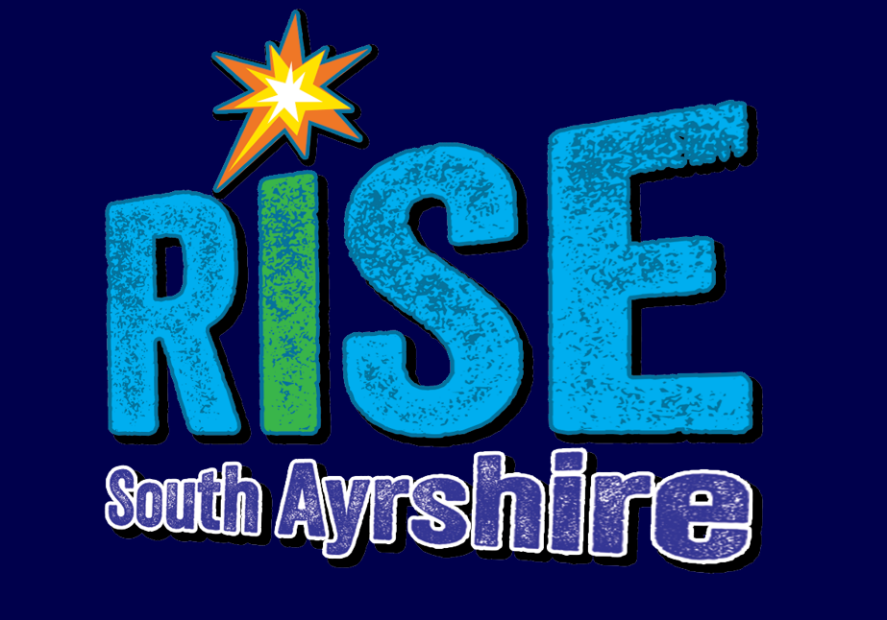

Routes into Skills and Education

Policy and Procedures
January 2026
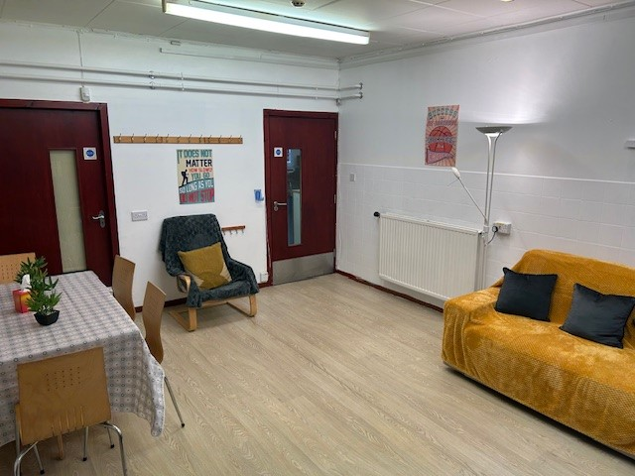

Contents

Introduction …………………………………………………………………………………………………………………….………….……3

Rationale 3

Structure 6

RISE Team 8

Curriculum 8

Links to Stakeholders 8

Referral Process 9

Introduction
RISE was established as a pilot project in January 2025.
RISE was created to support some of South Ayrshire’s most vulnerable learners who were unable to achieve in our mainstream provisions.
Rise is part of the Virtual School Team and is building upon the wider work of supporting Care Experienced learners and embedding the Promise across South Ayrshire.
It is funded by the Whole Family Wellbeing Fund until March 2026 at present. However, following a successful first year the team are exploring avenues to try to secure more permanent funding for the future. The project is staffed from Education and Health and Social Care Partnership to ensure strong links between the services and a joined up holistic support for the pupils and their families/carers.
The team consists of a Virtual Head Teacher, a Depute Head Teacher, 2 Teachers, a Welfare officer and two Social Work Assistants.
The VSHT supports decisions being made at screening about children and young people who require care and education out with South Ayrshire Council, alongside Health and Social Care colleagues.
The RISE team work closely with South Ayrshire’s Educational Psychology team, Health, Social Work Team and the Police to ensure a strong team of support based upon close communication provides timely and be-spoke supports for our young people and their families.

Rationale
Specialist Educational Support
All children and young people have a right to a high-quality education. All children need support during their educational journey and care experienced children and young people may require additional support during their time in school to meet their distinct, and often unseen, needs. While the educational outcomes of care experienced learners in Scotland have improved over the last ten years, official statistics show that there is still a gap between ‘looked after’ children and their peers. Having experience of care is not a predictor of poorer educational outcomes; the data demonstrates why it is important to provide effective, timely and responsive support to meet the individual needs of children and young people.
Rise supports pupils who have been assessed as requiring Education from highly specialist placements. The pupils have been previously supported through a range of universal and targeted interventions and high levels of support from multi-disciplinary teams. However, some young people, due to the high level of support required to meet their social, emotional and mental health needs, after robust assessments by the team around the family including the link Educational Psychologists require consideration for specialist placements for continuing Education. Traditionally these placements meant pupils were then taxied outwith the Authority to private providers. However, it was identified that some of the pupils that had been offered these placements were not engaging or achieving the positive outcomes that were anticipated within their plans. This was due to issues with attendance, a loss of sense of belonging in their own communities and the need to travel extended distances to access education. Due to the distance of the provision from local communities’ family engagement was also challenging. It was also felt that due to the disconnect with community there were difficulties developing links to ensure sustained positive destinations for these learners. The pupils identified at that time were all Care Experienced.
‘Intensive family support must be geographically located in local communities, with the explicit intention of maximising the assets of the community and community based relationships. Support must be explicitly connected to, or even housed in, locations that work for local families and the community, such as schools, health centres, village halls and sports centres.’
(Keep The Promise- Education Autumn 2020)
We felt that in order to improve outcomes for these learners South Ayrshire should pilot a provision with shared goals supported by Education and Health and Social Care Partnership
to support them within their own community.

Routes into Skills and Education
Vision​
‘RISE provides a warm and safe environment with strong relationships to build confidence and allow our young people to fulfil their learning potential. The creation of bespoke and innovative programmes for our learners will support them to ensure they access meaningful and sustainable positive destinations.’

Values

Aims
Alongside traditional learning RISE offers pupils the opportunity to be supported and scaffolded through times of difficulty in their lives. The young people explore avenues to develop confidence and resilience, enabling them to be supported through adversity. This wider support aims to encourage engagement in learning and skill development, providing the young people with greater life opportunities. These include:
- Strong emphasis upon building trusting relationships and providing pastoral support for pupils and families.
- Activities designed to build confidence, self-esteem and improve mental health.
- Developing life skills and social skills within the community and be-spoke programmes to develop cooking, hygiene and skills required for greater independence.
- Support to attend health appointments and engage with services who can support their assessed needs.
- Providing opportunities for pupils to engage with employers and learn practical skills which will be required in the workplace.
- Range of outdoor learning experiences designed in line with pupils’ interests to promote learning in an environment they are more able to engage with.
- Daily contact with families and support for issues that are impacting the family including helping them navigate the teenage years and the impact upon relationships.
- Aiming to build and then maintain relationships within mainstream education with a view to a staged return.
- Continuing to support pupils post education into sustained positive destinations e.g work experience, links to employability and skills, college preparation – visits, applications and interviews, obtaining bank accounts and bursaries.


Assessments
ASN Family Network
1-1 Support
Outreach
Family Group
Outreach
Outreach
1-1 Support
1-1 Support
UASC
Ukrainian Support Team
EAL Team
1-1 Support
ASFL
VI
EYHV
LP
EAL
Enhanced

Nurture
RISE
Positive Destinations
Life Skills
SASKA
Voc Learning
1-1 Support
Positive Destinations
S4 SQA
Central Teams
Pupil Youth Council
Project Work
Holiday Activities
Brighter Futures
SQA Pick up
After school club
1-1 Support
Welfare Officers
Virtual Schools
Head Teacher
Depute Head Teacher

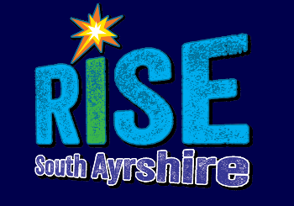
RISE Oversight Board
HTVS, QIM, Service Lead C+J, Service Lead HSCP, Principal ED Psych

Virtual School DHT

Small Steps to Wellbeing
Team Leader

WFO
2 Social Work Assistants
2 teachers

RISE Team
Virtual School HT - The HT line manages the Virtual School Team and is responsible for the strategic vision for improving outcome for care experienced children and young people.
Virtual School DHT - The DHT support the HT and is responsible for overseeing the RISE provision.
Welfare Officers – The Welfare Officers work 1-1 with young people and their families to ensure they are able to access education and to improve their wellbeing.
Class Teachers – The Class Teachers are responsible for providing a bespoke curriculum to meet the needs of our young people based in the RISE provision.
Social Work Assistants – The Social Work Assistants are responsible for supporting the pupils and their families/carers to support wellbeing and link more widely with concerns raised in the community. They access Carefirst to ensure good communication across services and complete reports as required.
The team work closely together to ensure they all develop trusting relationships with the young people and families and a strong team approach ensures a connected network of support for staff.

Curriculum Planning
The RISE staff will plan a be-spoke programme for learners. These are developed and up dated to meet the needs of the young people and are highly individual and linked to interests to encourage them to engage in learning.
The teaching staff carry out assessments to gain a clear picture of current progress and identify gaps in formal learning. The team develop creative and accessible programmes of learning which are regularly reviewed in order to support wellbeing and encourage engagement. Sessions are planned to ensure the pupil’s social, emotional and mental health needs are carefully considered and a flexible and responsive approach allows pupils to meet their learning potential.

Links to Mainstream Schools
Each young person who is placed within RISE is registered within their own catchment mainstream school. For older pupils returning from outwith education it may not be possible/suitable for them to link with mainstream education and alternative pathways to college or work will be explored. For the younger pupils who are attending RISE straight from mainstream there will be close links developed with the schools to help develop or maintain relationships and explore opportunities for visits and engagement where possible. It is hoped that with intensive support pupils would return to mainstream when they are able to re-engage.

Links to services
RISE links closely with parents and children’s houses during each session. The young people who require transported will be collected and returned to their home where staff take opportunities to be relationships with carers. Regular contact through phone calls and text also allows staff to communicate in a way that carers feel suits them best. The RISE team aim to build strong supportive links with families and children’s houses in order to help them access support and ensure the needs of the young people are fully understood.
The social work assistants work closely with the parents and the social work department to work alongside families on compulsory measures and form part of the transition plan when these are terminated to ensure continued access to support.
All young people at RISE will have access to the school nursing service as part of the project. The team link closely with other health professionals (CAMHS, Hospital admissions, GPs) as appropriate to support any health concerns that affect the young people.
The VS DHT will attend Whole Systems meetings and link with Campus Police Officers regarding reducing offending in the community for pupils.

Referral Process
RISE is accessed through the GIRFEC Allocated Resource Fund (GARF).
The young people are considered for a placement in RISE when it is deemed that, through following the GIFEC pathway, the young people have been previously supported through a range of universal and targeted interventions and received high levels of support from multi-disciplinary teams but still have significant needs that cannot be met in our mainstream provisions.
Following robust assessments by the team around the family including the link Educational Psychologists, when it is felt that, due to the high level of support still required to meet a young person’s social, emotional and mental health needs, they require consideration for specialist placements for continuing Education the referral process would commence.
The Educational Psychologist alongside the team prepares an options appraisal to assess what may be the most beneficial pathway and if RISE may be an option to be considered.
GARF meet fortnightly and as part of a large multi-disciplinary team assesses referrals to ensure all avenues of support have been explored. If it is felt that a placement at RISE would be appropriate, there is a period of consultation with the VSHT and the RISE team to discuss suitability. The DHT would then attend the next GARF meeting to discuss the package of support that could be offered and if approved a timeline for the transition process.

