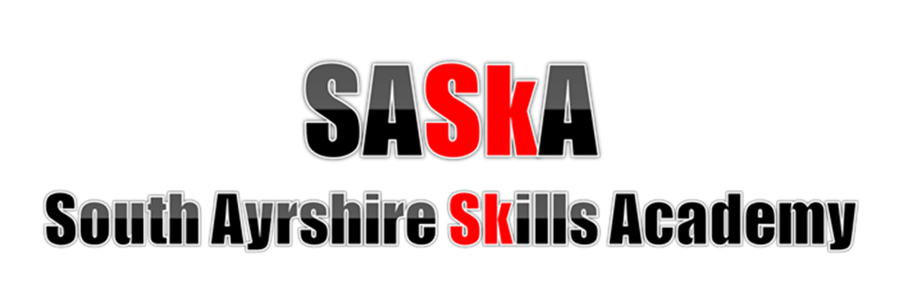

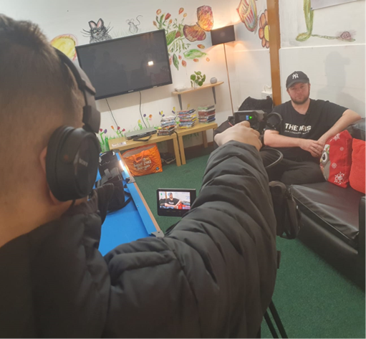

Policy and Procedures
February 2025

Contents

Introduction …………………………………………………………………………………………………………………….……………2

Rationale 2

Structure 3

Strategic Priorities 4

SASkA Team 5

Referral Process 6

Introduction
Many young people experience barriers to learning for a wide range of reasons, and some have unavoidable gaps in their educational journey. In South Ayrshire, we are committed to ensuring that every young person has the opportunity to succeed and to leave school with a strong foundation for their next steps in life, whatever pathway they choose.
This policy outlines the purpose and aims of the South Ayrshire Skills Academy (SASkA). It sets out the referral process for schools wishing to nominate young people for participation and explains how SASkA supports learners to gain meaningful qualifications, develop essential skills, and build confidence for life beyond school.

Rationale
SASkA was established in 2018 to meet the needs of S4 pupils who are at risk of leaving school with few or no qualifications and who experience low engagement with mainstream education due to a range of factors. The programme provides targeted support through a dedicated teacher and welfare officer, offering a blend of accredited qualifications and vocational learning opportunities tailored to each young person’s needs.
The vision of SASkA is to create a nurturing, respectful, and trusting learning environment where young people feel valued and supported. The programme aims to help learners achieve success, develop confidence, and build the skills required for positive destinations, with a strong emphasis on personal development, employability, and lifelong learning.
SASKA is not a stand alone education provision and is an intervention to support schools to meet the needs of some of their most vulnerable learners, to leave school with appropriate qualifications. Young people attend SASkA 50% of their school week. The expectation is that the young people attend their mainstream school the remaining part of the week. Regular and frequent communication is vital between the school and SASkA staff, as well as with families.

SQA Pick up
1-1 Support
Pupil Youth Council
Project Work
Holiday Activities
Brighter Futures
SQA Pick up
After school club
1-1 Support
Supportive School Structure
Curriculum

The SASKA Curricular design is focused on personalisation, relevance, enjoyment, challenge, coherence and progression. This structure sets the foundation for delivering, breadth and depth as young people develop knowledge, skills and confidence in learning. Staff plan annually, as well as on a medium and short term basis ensuring plans take full account of changing needs and issues. Careful tracking and monitoring therefore ensures plans and/or strategies are adjusted as needs change.

Curriculum Areas and Subjects within Senior Phase

There are instances of young people arriving to SASKA who will not have attended formal education regularly, have large gaps in their learning or whom require significant additional support as a result of their learning needs. SASKA will therefore assess their most appropriate curriculum pathway, in collaboration with the each young person, their families and the team around the young person. As a result and based on current young people’s needs, curricular areas delivered during S4 include an Interdisciplinary Learning (IDL) approach within the following SQA National 3 and 4 Skills. Vocational opportunities will be sought at all times, where appropriate and available, boosting the opportunity to raise attainment in SCQF levels.
Although many young people being supported in their learning at SASKA have experienced challenge in their personal lives and/or education, many have talents and interests which need to be fostered. Outdoor learning related to classroom work and many physical activities, provides opportunities to detect and build on these aptitudes to achieve a range of nationally recognised awards including Hospitality, John Muir, Princes Trust and Duke of Edinburgh Award.
SASkA Team
Virtual School HT - The HT line manages the SASkA Team and is responsible for the strategic vision for improving outcome for vulnerable, disengaged learners.
Virtual School DHT - The DHT supports the Virtual HT and therefore supports SASkA
Class Teacher – The class teacher is responsible for the creation and delivery of the lessons, qualifications and day to day teaching.
Welfare Officer – The Welfare Officer works t support the class teacher and also 1-1 with young people and their families to ensure they are fully able to access education and to improve their wellbeing.

Referral Process
SASkA class teacher will make contact with schools in January each year. This is to prompt schools to consider any young people who may require SASkA as an intervention or their fourth year at school.
Following this prompt, referrals should be made to Inclusion Monitoring Group (IMG), including the young person’s Child’s Plan, STINT paperwork and any qualifications already gained. Decisions are concluded by March in order to plan transition plans for the next academic year group.

Referrals should be made by Pupil Support Co-ordinators for pupils where there is demonstrable evidence of one or more of the following:-
- Pupils who are showing a level of disengagement from, or inability to cope effectively within mainstream provision which is placing them at serious risk of permanent exclusion.
- Pupils with experience of care, and meeting the other criteria will be given entitlement consideration.
- Pupils who have insufficient or inconsistent attendance (Where there is poor attendance less than 60% and it is a complex case requiring multi-professional support and where straightforward enforcement action may be deemed inappropriate).
- Pupils where a transfer to another mainstream school has not been successful.
- Pupils with additional needs that means they are struggling to cope with the curriculum and organisation of their mainstream school.
- Pupils at risk of non-attainment within their senior-phase.
- Pupils at risk of not reaching their full potential or those requiring further skills development.

Referrals will be discussed at the first Inclusion Monitoring Group Meeting after receiving them from schools, along with all associated paperwork by the deadline date agreed. Outcomes of the IMG referral moderation will be made in writing within 2 school weeks of the meeting.

Note: young people and their parents or carers must agree to the referral to SASkA. Where a young person does not agree, they will not be accepted.

A transition programme will be arranged for young people to introduce themselves, build relationships and begin to focus on the year ahead. This takes place prior to the summer break.

