

Policy and Procedures
February 2025
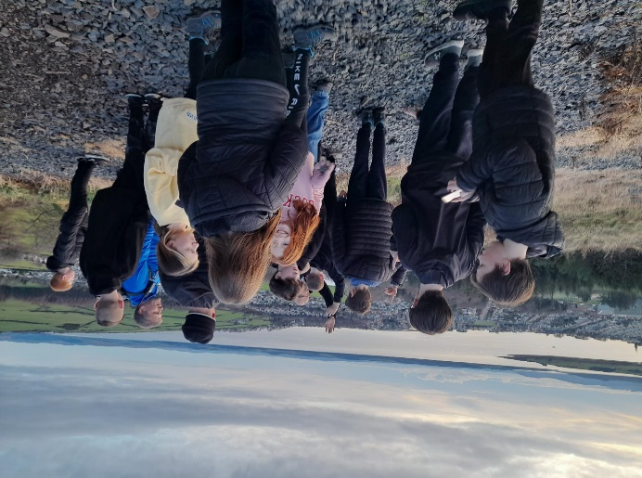

Contents

Introduction …………………………………………………………………………………………………………………….……………2

Rationale 3

Structure 4

Strategic Priorities 5

Virtual School Team 7

RISE 8

Referral Process 9

Introduction
The Virtual School was established in 2019. It was funded by the Scottish Government to improve Educational outcomes for Care Experienced Children and Young People.
The team consists of a Virtual Head Teacher, a Depute Head Teacher 5 Welfare Officers, I teacher and a Social Work Assistant.
The Virtual School Head Teacher (VSHT) has a strategic approach and overview across South Ayrshire Council. She tracks and monitors attendance and exclusions monthly and attainment for Care Experienced Young People. She works with other Education Officers such as Quality Improvement Officers and Managers, Attainment Advisors and Education Scotland.
There are positive relationships between the Virtual School team and Head Teachers and staff across the authority and there is regular communication to discuss current concerns and progress of individuals. The team work effectively with partnerships such as Health and Social Care Partnership, attending regular meetings, contributing to Child’s Plans and offering support where possible.
The VSHT supports decisions being made at screening about children and young people who require care and education out with South Ayrshire Council, alongside Health and Social Care colleagues. The team follows up any actions for these individual children, visiting residential placements and ensuring education targets are appropriate and being met successfully. This involves working closely with Educational Psychologists to co-plan for young people.
The Virtual School team work closely with South Ayrshire’s Educational Psychology team to assess and analyse pupil assessments. All interventions are screened by Educational Psychology to ensure they are appropriate, evidence based and will provide positive impact for the children and families.
The VSHT networks with Virtual School Head Teachers across Scotland and CELCIS, meeting quarterly and regularly corresponding to ensure that interventions, tracking and current issues are in line with national priorities and approaches.
There is a Care Experienced Lead Teacher in very secondary school in South Ayrshire. The VSHT and VSDHT meet with the lead teachers collectively termly and visits individual schools three times per year. Visits include observations of SQA predictions, assessing interventions in place for young people and general support and challenge around attendance and exclusions.
The VSHT is a panel member on the authority’s out with resource panel (GARF) along with Health and Social Care Partnership colleagues. This panel decide on resources and opportunities for our young people who are unable to sustain education of care conditions within South Ayrshire. Where young people are placed in educational provisions out with South Ayrshire, the VSHT is able to monitor and allocate Welfare Officers, where appropriate, to support the young person in this move. Equally, at the panel decisions are made to return and welcome pupils back to South Ayrshire.
The VSHT is part of Children and Young People Service Plan: The Promise and a member of the multi-disciplinary Promise and Corporate Parenting Executive Group. This group is comprised of Service Lead officers from Health and Social Care Partnership, along with Quality Improvement Managers from education. Work is focused on meeting the recommendations of The Promise Plan 24-30.
Rationale
The education of care experienced children and young people
All children and young people have a right to a high-quality education. All children need support during their educational journey and care experienced children and young people may require additional support during their time in school to meet their distinct, and often unseen, needs. While the educational outcomes of care experienced learners in Scotland have improved over the last ten years, official statistics show that there is still a gap between ‘looked after’ children and their peers. Having experience of care is not a predictor of poorer educational outcomes; the data demonstrates why it is important to provide effective, timely and responsive support to meet the individual needs of children and young people.
The Virtual School
The Virtual School offers an additional layer of support for the education of care experienced learners. The term ‘Virtual School’ refers to:
• The way South Ayrshire organises and directs the support they provide for care experienced children and young people.
• The group of care experienced children and young people who for whom South Ayrshire is responsible.
• The VSHT and the Virtual team who offer support to care experienced children, young people, their families, carers and schools.
• Aims to bring about positive and sustainable systemic changes to policy and practice.
• Works across all levels of the education and care ‘systems’, from practice through to operational and strategic activities.
• Emphasises the building of collaborative relationships between different agencies.
• Focuses on addressing wider factors, such as wellbeing, that can impact on children and young people’s educational and life experiences.
• Upholds the rights and ensures the wellbeing of care experienced children and young people.

Assessments
ASN Family Network
1-1 Support
Outreach
Family Group
Outreach
Outreach
1-1 Support
1-1 Support
UASC
Ukrainian Support Team
EAL Team
1-1 Support
ASFL
VI
EYHV
LP
EAL
Enhanced

Nurture
RISE
Positive Destinations
Life Skills
SASKA
Voc Learning
1-1 Support
Positive Destinations
S4 SQA
Central Teams
Pupil Youth Council
Project Work
Holiday Activities
Brighter Futures
SQA Pick up
After school club
1-1 Support
Welfare Officers
Virtual Schools
Head Teacher
Depute Head Teacher

Strategic Priorities

Care Experienced Leads
8 Care Experienced Leads across all Secondary Schools take responsibility for tracking and monitoring all aspects of young people with experience of care and reporting to VSHT and VSDHT. Face to face meetings to discuss and support attainment.

Virtual School Scotland Network
Monthly Meetings with VSHTs across Scotland to discuss legislation and National priorities. Professional Networking.

Annual report documenting expenditure; strategic approaches to supporting care experienced young people across South Ayrshire.
Care Experienced Scottish Government Reporting

Tracking and Monitoring
Monthly, termly and annual tracking of attainment, attendance and exclusions – to support and challenge schools to improve outcomes for care experienced pupils. Feeds into Government reporting and National statistics.

Termly meetings to report and up-date other corporate parents across the Authority and services on care experienced data and priorities.
Corporate Parent Executive

Multi-agency group- planning and organising care and education for unaccompanied young people.
Weekly meetings to discuss and support Education for young people living in the Children’s’ Houses.
Bi-annually meeting to up-date legislation, priorities and approaches to supporting care experienced pupils within schools.
Childrens’ Houses
UASC Settlement Hub
Designated Manager Meeting
Fortnightly panel to review young people leaving and returning to South Ayrshire both for care and education.
Embedding trauma informed approaches across all schools. Implementing the Promise Education Award. Driving National agenda linked to The Promise. Advising schools and multi agencies

The Promise
GARF

Virtual School Team
Virtual School HT - The HT line manages the Virtual School Team and is responsible for the strategic vision for improving outcome for care experienced children and young people.
Virtual School DHT - The DHT support the HT and is responsible for overseeing the RISE provision.
Welfare Officers – The Welfare Officers work 1-1 with young people and their families to ensure they are fully able to access education and to improve their wellbeing.
Class Teacher – The Class Teacher is responsible for providing a bespoke curriculum to meet the needs of our young people based in the RISE provision.

RISE
Bespoke provision designed to support Young People at risk of leaving South Ayrshire or Young People returning to South Ayrshire from out with Education Provisions to achieve their full potential and achieve sustained positive destinations.
This is a multi-agency provision between Health and Social Care and Education where Young People are identified through South Ayrshire’s GIRFEC Allocation Resource Forum (GARF).
The team comprises of the DHT, Class Teacher, Welfare Officer and a Social Work Assistant.

Referral Process
Schools who wish to refer a child or young person should in the first instance contact the VSHT to discuss suitability of the referral. The pupil support co-ordinator should then complete the form (link above) and add this to the pupil’s AYRSHARE copying in central Team Admin Lead.
The RFA will be discussed at the Inclusion Monitoring Group which meet fortnightly.
Note: This is for referral for the Welfare Team only RISE can only be accessed via GAR

