Area of land to be exempt from access rights.

Scale 1:4,000 @ A4
This is the plan referred to in the foregoing
South Ayrshire Council (Ayr Academy & Riverside Arena, Communities Fun Day) Exempting Land from Access Rights Order 2026

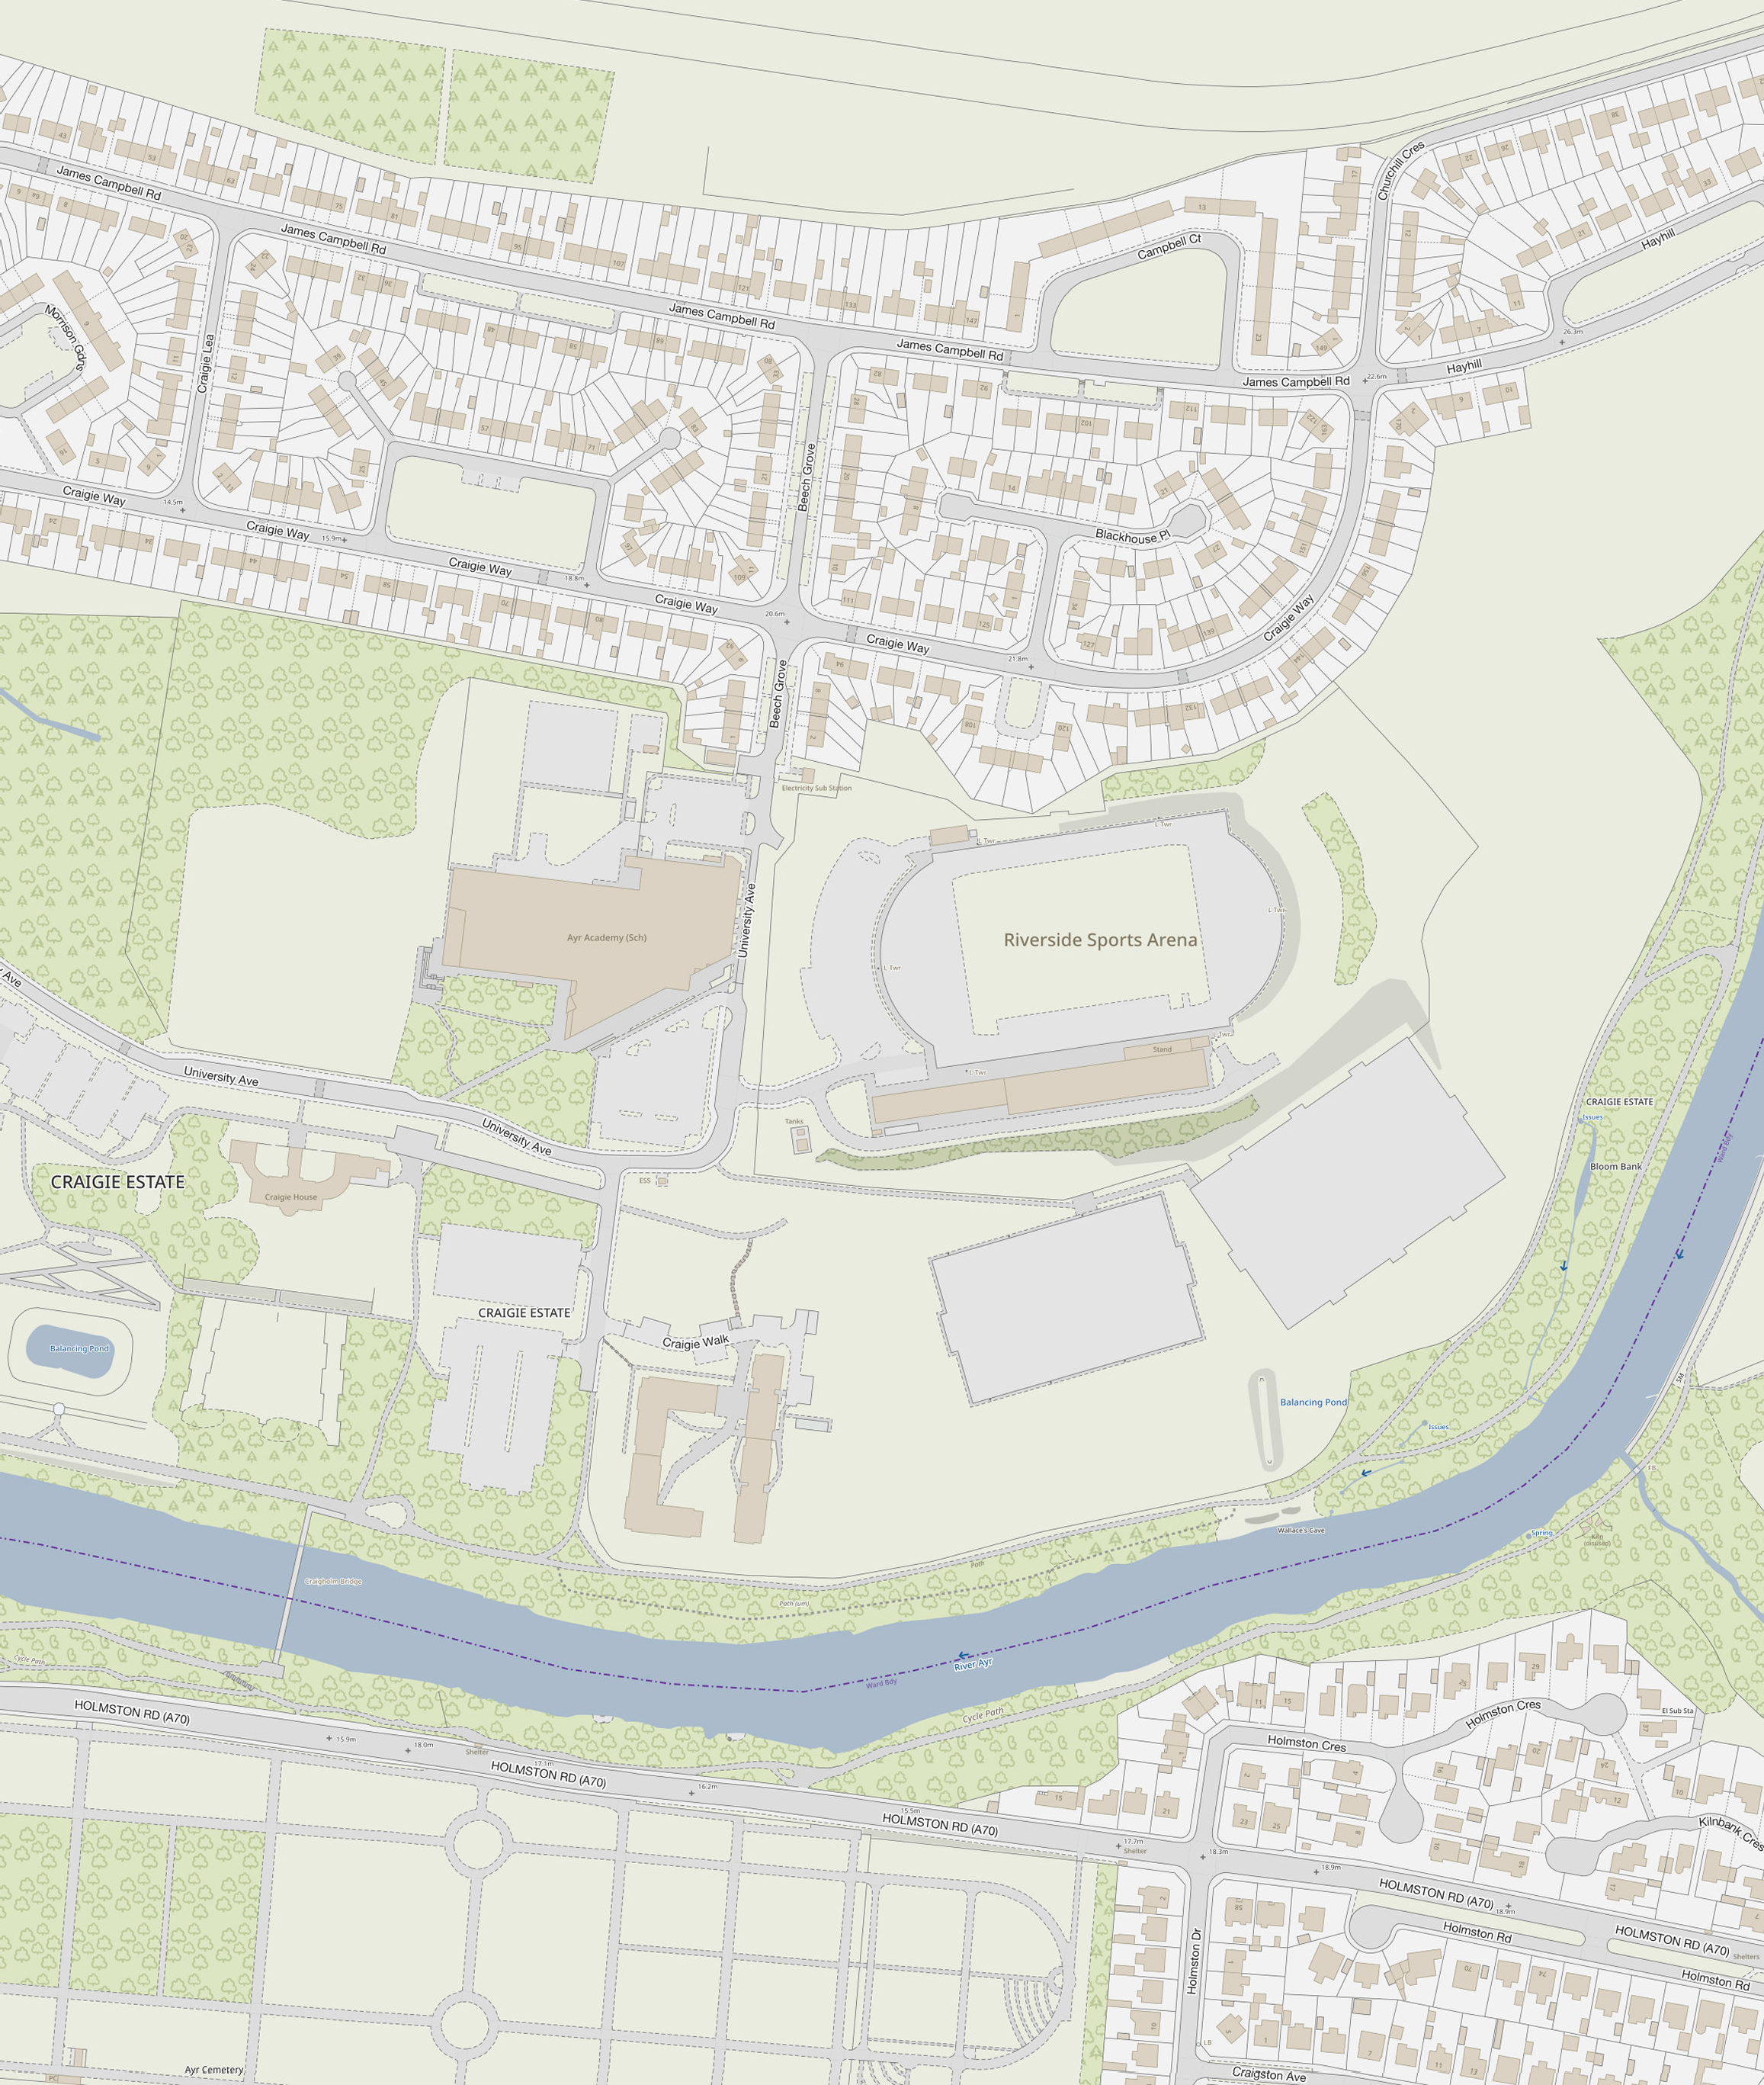
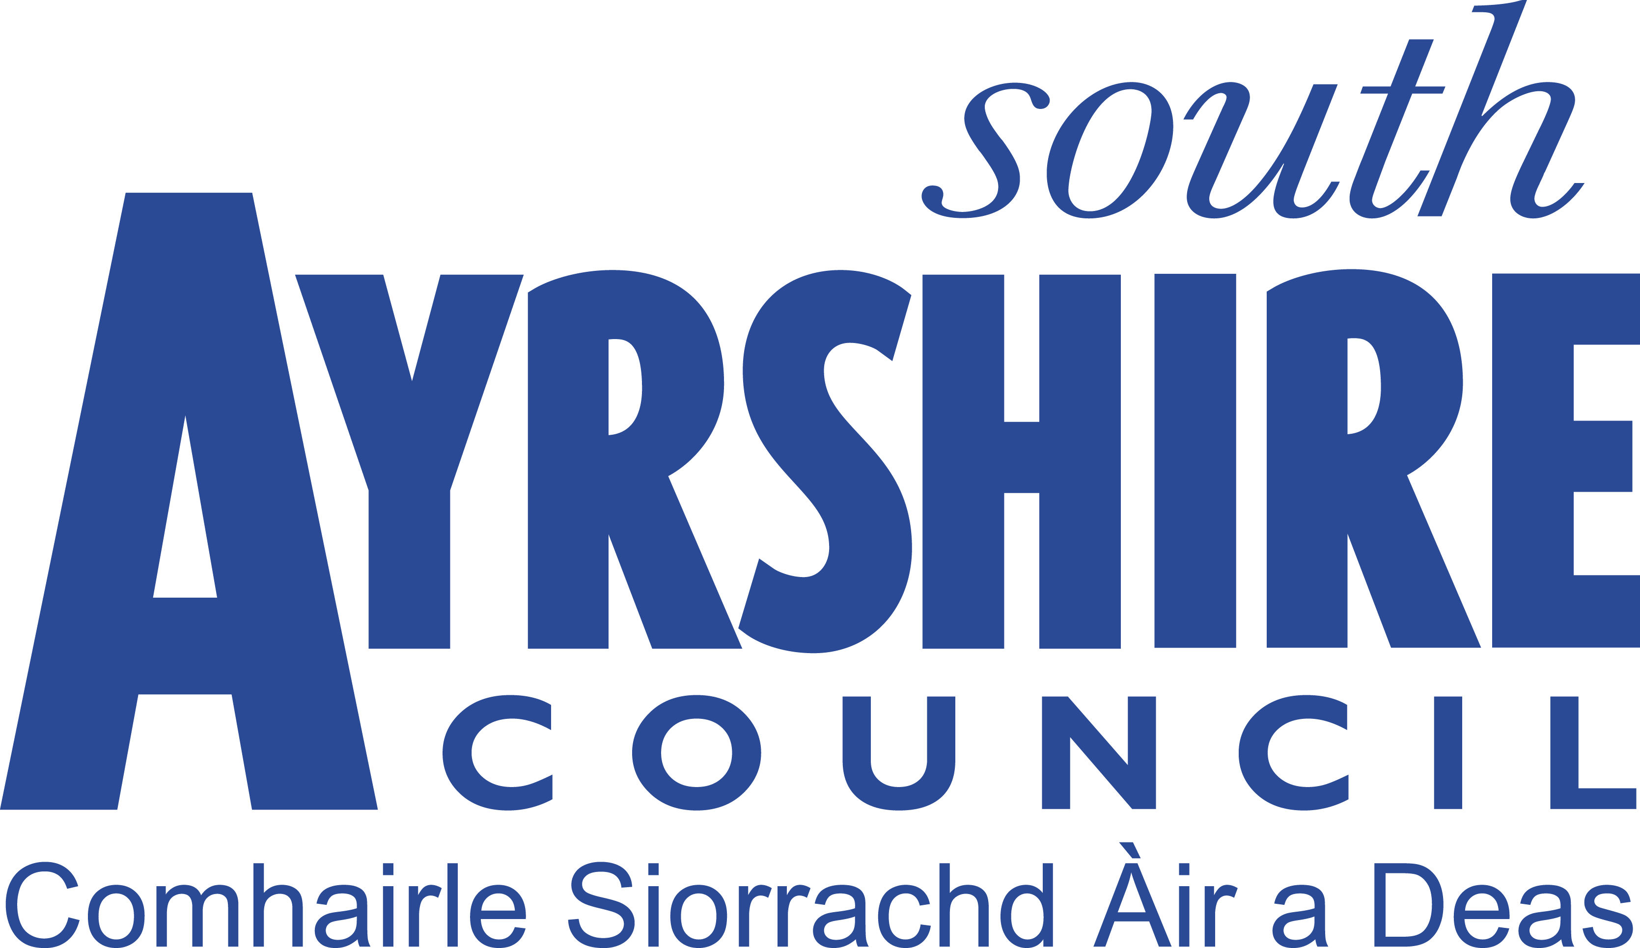
This product includes mapping data licenced from Ordnance Survey with the permission of the Controller of His Majesty's Stationery Office. © Crown copyright and/or database right 2026. All rights reserved. Licence number 100020765.

