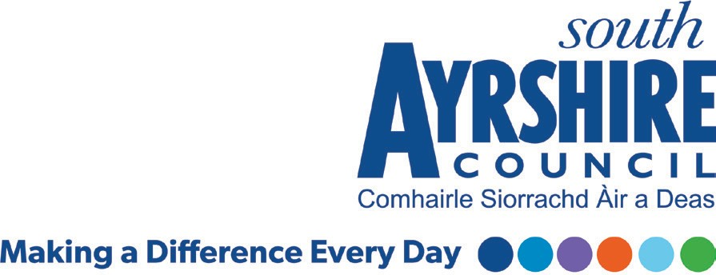

**Equality Outcomes**

**2021 - 2025**

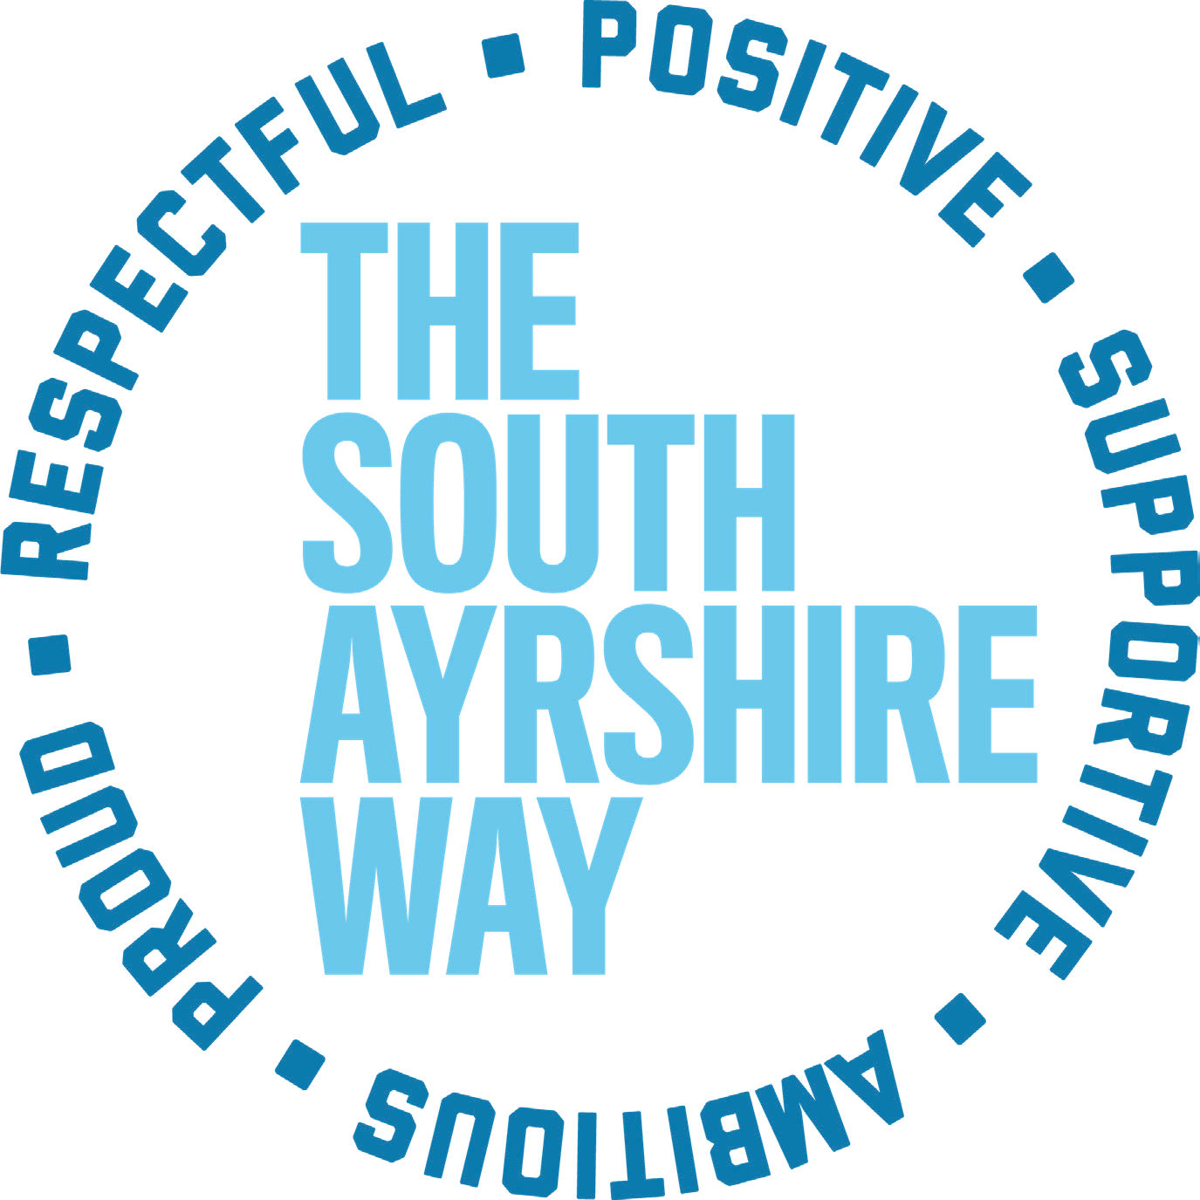

**1. Introduction**

All public authorities in Scotland must comply with the Public Sector Equality Duty, also known as the General Equality Duty, set out in the Equality Act 2010. This means that all public authorities, as part of their day-to-day business, must show how they will:

* Eliminate unlawful discrimination, harassment and victimisation and any other conduct that is prohibited under the Act;
* Advance equality of opportunity between people who share a relevant protected characteristic and those who do not share it; and
* Foster good relations between persons who share a relevant protected characteristic and persons who do not share it.

The protected characteristics referred to, as listed in the Equality Act 2010 are age, disability, gender reassignment, marriage and civil partnership, pregnancy and maternity, race, religion and belief, sex and sexual orientation. We are all likely to have more than one protected characteristic, (intersectionality) which make up our individual identities.

North Ayrshire Council and East Ayrshire Council, along with the members of the Ayrshire Equality Partnership, adopted shared Equality Outcomes for the previous term 2017-2021, while South Ayrshire Council set our own independent outcomes from 2013 onwards. For the period going forward – 2021-2025 – South Ayrshire Council have worked with our neighbouring authorities and the Ayrshire Equality Partnership to develop these Pan-Ayrshire Equalities Outcomes. Working together, we have reviewed the progress and relevance of previous outcomes, and developed, updated and appended these to provide this fresh set of outcomes.

By reviewing, revising and publishing Equality Outcomes on a regular basis, we aim to make better, more positive and fairer decisions, and show that these decisions are bringing tangible benefits for our communities and our employees.

**2. What are Equality Outcomes?**

National guidance on setting Equality Outcomes notes that these should be proportionate and relevant to the functions and strategic priorities of the organisations setting them, and that they may include both short term and long term benefits for people with protected characteristics.

From the outset of the development process, the following definition was applied to ensure consistency and rigour.

Outcomes are not what we do, but the beneficial change or effect which results from what we do. These changes may be for individuals, groups, families, organisations or communities.

Specifically, an Equality Outcome should achieve one or more of the following:

* Eliminate discrimination
* Advance equality of opportunity
* Foster good relations

Equality Outcomes have been developed on the basis that they are short to medium term (1 to 4 years) and link with longer term national outcomes.

It should be noted that a number of these Equality Outcomes link with existing policies and strategies, supporting the mainstreaming of equalities considerations into our day-to-day business. We also wish to ensure a focused effort on areas for improvement, specifically to improve equality and reduce inequalities.

**3. Rationale for Shared Equality Outcomes**

A number of organisations across Ayrshire deliver public services to local communities. In doing so, these organisations must ensure that no person or group is discriminated against on the basis of any protected characteristics they may possess.

Each public sector organisation has a requirement to develop and publish a set of Equality Outcomes. Considering the close links between many public sector organisations in Ayrshire, it was proposed that joint working in the development of Equality Outcomes should be undertaken. More importantly, as all organisations are delivering, or supporting the delivery of services to the same communities, their experience could be improved if approaches to equalities issues were consistent across these bodies. As a result, a decision was taken that public sector organisations across Ayrshire could develop a shared set of Equality Outcomes whilst still maintaining individual accountability for their part with some separate actions delivered locally.

This approach to setting shared Equality Outcomes builds on an already established joint working relationship through the Ayrshire Equality Partnership (AEP). This partnership consists of representatives from the three local authorities from North, East and South Ayrshire Councils; NHS Ayrshire & Arran; HSCP from North, East & South Ayrshire; Ayrshire College; University of the West of Scotland; Ayrshire Joint Valuation Board; Police Scotland; Scottish Fire & Rescue Service; Community Justice Ayrshire and The Terence Higgins Trust.

The Covid-19 pandemic meant that services delivered by the Council and our partners had to adapt to meet a range of immediate needs, and as such not all of the actions from the previous outcomes were fully met. However, it was agreed it would be beneficial to consolidate these outcomes along with a new set of pan-Ayrshire Shared Outcomes, to be delivered over the next four years from 2021-2025.

These new Equality Outcomes also acknowledge the Council’s renewal and recovery plan, and the potential of new delivery modes, including our future operating model across Council services. An Equality Impact Assessment has also been conducted on developing our Equality Outcomes to ensure no additional barriers have been put in place, and where necessary, mitigating actions are taken.

**4. Engagement and Consultation**

To support the development of a new Equality Outcomes plan, the Ayrshire Equality Outcome Working Group from the Ayrshire Equality Partnership undertook a consultation exercise during October and November 2020. The consultation focussed on gathering opinion on the existing four Equality Outcomes, shared across Ayrshire. They are, that:

* **Equality Outcome 1** – In Ayrshire, people experience safe and inclusive communities
* **Equality Outcome 2** – In Ayrshire, people have equal opportunities to access and shape our public services
* **Equality Outcome 3** - In Ayrshire, people have opportunities to fulfil their potential throughout life
* **Equality Outcome 4** – In Ayrshire, public bodies will be inclusive and diverse employers

As consultation took place during the Covid-19 pandemic, members of the Ayrshire Equality Partnership (AEP) recognised that traditional methods of engaging with communities and partners would not be possible due to local and national lockdowns as well as restrictions on people’s activities.

Instead, the AEP opted to consult primarily through the use of an online survey. The ten questions contained in the survey were designed and agreed by AEP members. The questions directly related to Equality Outcomes, with an additional section asking people for relevant demographic information.

The questions in relation to Equality Outcomes took both an asset and deficit approach, in that we asked respondents to reflect on positive things they have experienced as well as any negatives. In analysing responses, we took a thematic approach in which we aimed to group responses by recurring themes.

The consultation ran for a total of five weeks from 13 October 2020 until 18 November 2020. An extract of the result, which provides information from one of the ten questions asked of the consultation survey can be viewed at appendix 2.

**5. Evidence Review**

As noted previously, the review and development of these Equality Outcomes took place within the context of the Covid-19 pandemic. As such, we recognised the need to consider the likely impact of the pandemic on our communities, and to develop Equality Outcomes that also expressed our future shared partnership priorities in relation to renewal and recovery.

The Council’s own renewal and recovery planning is already well advanced and the Equality Outcomes review provided an opportunity to ensure that the Council’s identified recovery and renewal priorities are reflected in our actions.

We took a joint approach to the development of our Equality Outcomes including:

* An online consultation survey seeking views from our communities to build upon previous discussion and consultation with equality groups.
* A desk-based exercise in collaboration with various council services, with the Ayrshire Equality Partnership members to review and consider local comment, intelligence and evidence gathered from the consultation and engagement, to help shape the final Equality Outcomes and actions to deliver on these.

**6. Finalising Our Equality Outcomes and Actions**

The feedback from the aforementioned consultation informed the final Equality Outcomes and actions for 2021-2025. This also reflected the responses from South Ayrshire participants.

As public bodies, the foundation of existing good practice on equalities, established and committed through previous Equality Outcomes, allows us to continue to take this forward.

In order to provide coherence, minimise duplication and support the ongoing mainstreaming of equality into policy and practice across Ayrshire, it is important to ensure that Equality Outcomes are aligned with existing national and local strategic priorities. We have taken consideration of national policy context in the development of our shared Equality Outcomes to ensure robust and effective outcomes are set for the next four years. However, the impact of Covid-19 may result in priorities changing during this time and as such, the Equality Outcomes may be reviewed and revised where appropriate during this period.

Legislation requires the Equality Outcomes and Mainstreaming Report and future Equality Outcomes 2021-2025 be published by 30th April 2021. There is however scope built into this process for reports to be published as draft, following any amendments or changes, for instance following approval by the Leadership Panel.

The table which follows presents the overarching shared Equality Outcomes agreed with the Ayrshire Equality Partnership. It also provides a number of ‘Local Equality Outcomes’ that highlight areas recognised as immediate priorities that fit in with these overarching themes, and the actions we will take to address these. Some of these actions will be undertaken on a pan-Ayrshire-basis, while others specifically relate to South Ayrshire Council, our Education Authority and the Licensing Board. Actions referring to development and training includes all employees from these services.

The Shared Equality Outcomes and actions will support the South Ayrshire Council Plan, its vision and values, namely:

* Fair & Effective Leadership – leadership that promotes fairness
* Closing the Gap – reduce poverty and disadvantage
* Grow Well, Live Well, Age Well – health and care systems that meet people’s needs
* South Ayrshire Works – make the most of the local economy
* Stand up for South Ayrshire – increase the profile and reputation of South Ayrshire and the Council
* A Better Place to Live – enhanced environment through social, cultural and economic activities

|  |  |
| --- | --- |
| **Overarching Shared Equality Outcome 1** | **In Ayrshire, people experience safe and inclusive communities** |
| **Links to National Outcomes** | **We have tackled the significant inequalities in Scottish Society**  **We have improved the life chances for children, young people and families at risk**  **We live our lives safe from crime, disorder and danger**  **We have strong, resilient and supportive communities where people take responsibility of their own**  **actions and how they affect others** |

|  |  |  |  |  |  |  |  |
| --- | --- | --- | --- | --- | --- | --- | --- |
| **Local Equality Outcome** 1.1 | | **Victims, witnesses and partner agencies feel more confident in reporting hate incidents through a variety of methods.** | | | | | |
| **Inequality being addressed** | | **People suffer hatred and violence because of their protected characteristics** | | | | | |
| **Context** | | **Outputs** | **Actions** | **Measurement** | **Protected Characteristics** | **General Duty** | **Lead Officer and Timescale** |
| 1.1 | Hate Crime continues to rise and has a significant impact on particular communities | Increase people’s awareness of hate crime | Raise Council, Education Employees and Licensing Board Members’ awareness to better understand hate crime | Develop a Hate Crime e-learning course  Number of staff/Board Members undertake training | Disability, Sex Gender Reassignment, Race Religion and Belief, and Sexual Orientation | Eliminate Discrimination  Advance Equality of Opportunity  Foster Good Relations | Equality Officer  March 2023 |
| Work with partners to raise awareness of hate crime with community members through the development of a conference | Number of people attending the conference  Evaluation of the conference |
| Improved use of third party reporting | Increase the awareness of third party reporting | Increased reporting via third party reporting using a variety of media tools and promotional materials |

|  |  |  |  |  |  |  |  |  |  |
| --- | --- | --- | --- | --- | --- | --- | --- | --- | --- |
| **Local Equality Outcome** 1.2 | | | **More young people and care leavers have access to suitable appropriate accommodation to live independently and safely in the community** | | | | | | |
| **Inequality being addressed** | | | **Young people and Care Leavers have lack of access to suitable accommodation and supports** | | | | | | |
| **Context** | | **Outputs** | | **Actions** | **Measurement** | **Protected Characteristics** | **General Duty** | | **Lead Officer and Timescale** | |
| 1.2 | The Council’s Housing Service works with a number of partner agencies to help individuals live independently; support the needs of the most vulnerable,  including those with disabilities, at risk of homelessness and young people and care leavers | Better understanding of the needs of young people and care leavers to effectively meet their housing needs | | Continue to work in partnership to develop our services for young people through the Improving Housing Outcomes for Young Care Leavers and Youth Housing Support groups | Number of young people and care leavers taking up suitable accommodation  Number of young people and care leavers maintaining a suitable tenancy | Age  Disability  Sex  Gender Reassignment  Race, Religion and Belief  Sexual Orientation | Eliminate Discrimination  Advance Equality of Opportunity  Foster Good Relations | Equalities Officer/  Housing/  Champions Board/  Corporate Parenting Lead Officer  March 2023 | | |

|  |  |  |  |  |  |  |  |  |  |
| --- | --- | --- | --- | --- | --- | --- | --- | --- | --- |
| **Local Equality Outcome** 1.3 | | | **To embed a human rights ethos across schools in South Ayrshire to eliminate discrimination, advance equality of opportunity and foster good relations in schools and the wider community** | | | | | | |
| **Inequality being addressed** | | | **Inconsistency in developing a shared understanding of everyone’s rights and a commitment to respect one’s own and other people’s rights** | | | | | | |
| **Context** | | **Outputs** | | **Actions** | **Measurement** | **Protected Characteristics** | **General Duty** | | **Lead Officer and Timescale** | |
| 1.3 | Rights Respecting Schools  The UNICEF UK Rights Respecting Schools Award (RRSA) supports schools across the UK to embed children's human rights in their ethos and culture | All schools in South Ayrshire are registered with UNICEF | | Support the embedding of children’s rights across the curriculum | An increase in Schools achieving Bronze status  An increase in schools achieving Silver status  Increase in schools achieving Gold | All Protected Characteristics | Eliminate Discrimination  Advance Equality of Opportunity  Foster Good Relations | Equalities Officer/ Education Quality Improvement Officer  March 2023 | | |

|  |  |
| --- | --- |
| **Overarching Shared Equality Outcome 2** | **In Ayrshire, people have equal opportunity to access and shape our public services** |
| **National Outcomes** | **We have tackled the significant inequalities in Scottish society**  **We live in well-designed, sustainable places where we are able to access the amenities and services we need**  **Our public services are high quality, continually improving, efficient and responsive to local people’s needs** |

|  |  |  |  |  |  |  |  |  |  |
| --- | --- | --- | --- | --- | --- | --- | --- | --- | --- |
| **Local Equality Outcome 2.1** | | **More disabled people, older people and women access public transport safely and in comfort with an integrated service that provides accessible information, appropriate assistance and support from transport staff.** | | | | | | | |
| **Inequality being addressed** | | **Disabled people, older people and women experience difficulties accessing public transport because of safety, comfort, availability, connectivity, information and assistance, staff training and customer service** | | | | | | | |
| **Context** | | **Outputs** | | | **Actions** | **Measurement** | **Protected Characteristics** | **General Duty** | **Lead Officer and Timescale** |
| 2.1 | The barriers in accessing transport are well documented, and this can be exacerbated in relation to living in rural areas. Good access to affordable transport can support employment opportunities, contribute to better outcomes in relation to wellbeing, and help tackle poverty  Consideration of future sustainability in line with South Ayrshire Council Development & Climate Change Strategy | The barriers facing disabled people, women and older people and their needs are identified  The changes, support and resources required are understood and agreed  Delivery of a programme of travel improvements and passenger assistance | | Engagement with disabled people, women, and older people, relevant organisations and third sector orgs  Meetings with transport providers  Consultation about changes  Programme of support and improvements agreed  Test and pilot new and modified service methods, technology around vehicles, including electric vehicles and practices | | Develop system for evaluating impact and measuring progress  Collect and analyse data on disabled people, women and older people to evaluate impact and measure progress | Age, Disability, Sex | Eliminate Discrimination | Equalities Officer/  Climate Change Officer/Green Champions/  Ayrshire Equality Partnership & Ayrshire Growth Deal Officers  March 2025 |
| **Local Equality Outcome 2.2** | | **Improve engagement with Council Services and enhance access to information for marginalised and under-represented groups** | | | | | | | |
| **Inequality being addressed** | | **Opportunities to engage with marginalised and under-represented groups by considering any barriers they may be experiencing and to address these issues to improve engagement** | | | | | | | |
| **Context** | | **Outputs** | | | **Actions** | **Measurement** | **Protected Characteristics** | **General Duty** | **Lead Officer and Timescale** |
| 2.2 | Often the most marginalised in society are not included or are under-represented in any decision making or engagement with public bodies  Location, engagement, consultation, meetings and events should be considered when engaging with marginalised and under-represented groups, as this may further discourage community engagement  Accessibility to documents and materials is not always easily available to all to access information and engagement with those from marginalised and under-represented groups | The experience of marginalised or under-represented groups continue to inform decision making  Ensure processes are in place to welcome, support and encourage marginalised or under-represented groups to improve engagement with Council Services | | Continued involvement of tenants in the development and scrutiny of Housing Services through Tenant Participation (TP) Structures  BSL Action Plan to be further implemented and engage with other services e.g. Sensory Impairment  Team  Scoping review of documents and materials distributed or available from Council be checked for Accessibility by Equality Champions | | Number of TP meetings  Number of consultations  Number of events, including the TP Fun Day  Review and implement actions as per pan Ayrshire BSL Action Plan 2018-2024  Report of scoping review on Accessibility of documents and materials | Disability  Gender  Age  Sex  Race | Eliminate Discrimination  Advance Equality of Opportunity  Foster Good Relations | Equality Officer/ Housing TP Officer/Ethnic Minority Liaison Officer  September 2021  Equality Officer/  Sensory Impairment Team/  EAP  Jan 2022  June 2022 |
| **Overarching Shared Equality Outcome 3** | | | **In Ayrshire, people have opportunities to fulfil their potential throughout life** | | | | | | |
| **National Outcomes** | | | **We realise our full economic potential with more and better employment opportunities for our people**  **We are better educated, more skilled and more successful, renowned for our research and innovation**  **Our young people are successful learners, confident individuals, effective contributors and responsible citizens**  **Our children have the best start in life and are ready to succeed**  **We live longer, healthier lives** | | | | | | |

|  |  |  |  |  |  |  |  |  |
| --- | --- | --- | --- | --- | --- | --- | --- | --- |
| **Local Equality Outcome 3.1 to 3.2** | | **Young people, disabled people and women have access to training and employment** | | | | | | |
| **Inequality being addressed** | | **Young people, disabled people and women have barriers to accessing training and employment opportunities** | | | | | | |
| **Context** | | | **Outputs** | **Actions** | **Measurement** | **Protected Characteristics** | **General Duty** | **Lead Officer and Timescale** |
| 3.1 | The Ayrshire Growth Deal (AGD) aims to create employment opportunities through a Healthy Economy. Like many areas that have suffered from post-industrial decline, Ayrshire has suffered a poor health record, including long-term health issues and disability. Research has shown that work and health are inextricably linked and that working can improve health and wellbeing | | To provide support to access employment to reduce health as a constraint to build an inclusive economy | Provide support for unemployed people, in particular people with disabilities, women and residents to overcome health barriers to economic activity  To support residents to retain employment by addressing health barriers  Support local business to access health related supports to improve retention and productivity of their workforce | Number of unemployed people who declare a disability engaging at support stage to employment  Number of unemployed women engaging at support stage to employment  Number of people who declare a disability entering the AGD workforce  Number of women accessing AGD workplace supports to improve retention in the workforce | Disability  Sex | Eliminate Discrimination  Advance Equality of Opportunity | AGD/ Equality Officer  March 2023 and March 2025 |

|  |  |  |  |  |  |  |  |
| --- | --- | --- | --- | --- | --- | --- | --- |
| 3.2 | Since March 2020, the importance of employability and the challenge to ensure that ‘no one is left behind’ has been heightened further by Coivd-19 restrictions which have negatively impacted on all labour markets. The attainment gap amongst pupils is 36% between the least deprived areas and the most deprived areas.  In South Ayrshire, unemployment figures are rising with a claimant count of 7.1% in February 2021 in comparison to 4.3% in September 2020. Young people have been disproportionality affected by unemployment during this same period  Consideration to be given to ‘Vision 2030’ the SAC Strategic Economic Plan 2020-2030 | Disadvantaged and identified PC groups have increased access to relevant employment  and training opportunities.  Increased availability of suitable employment opportunities  Disadvantaged and identified PC groups have improved functional skills  to access training and employment  Disadvantaged and identified PC groups have improved interpersonal skills | To continue to support the Young Person’s Guarantee initiative in South Ayrshire with supported employment and tailored jobs scheme  Increase number of young BME people joining Modern Apprenticeship Scheme  To develop and provide support packages  To plan effectively for interventions across South Ayrshire/pan Ayrshire to support and reduce the attainment gap | Establishment of a pan Ayrshire Young Person’s Guarantee Board Number of people supported from PC groups  Number of people gaining training and employment from PC groups  Number of people accessing non -traditional roles tackling occupational segregation | Age, Disability, Race | Eliminate Discrimination  Advance Equality of Opportunity | Equality Officer/  Employability & Skills/  Education/ Economic  Development  June 2022 |

|  |  |
| --- | --- |
| **Overarching Shared Equality Outcome 4** | **In Ayrshire, public bodies will be inclusive and diverse employers** |
| **National Outcomes** | **We realise our full economic potential with more and better employment opportunities for our people**  **We are better educated, more skilled and more successful, renowned for our research and innovation** |

|  |  |  |  |  |  |  |  |
| --- | --- | --- | --- | --- | --- | --- | --- |
| **Local Equality Outcome 4.1 to 4.3** | | **Our BME, disabled and LGBT+ staff have safe and supportive work environments to thrive, and the Council is seen as an employer of choice** | | | | | |
| **Inequality being addressed** | | **BME, disabled and LGBT+ staff lack access to peer support which can lead to isolation and low morale at work** | | | | | |
| **Context** | | **Outputs** | **Actions** | **Measurement** | **Protected Characteristics** | **General Duty** | **Lead Officer and Timescale** |
| 4.1 | To develop a diverse and inclusive workforce, the Council will ensure it promotes a fair and effective leadership. The establishment of a Human Resource Working Group on Race –‘ Making Progress’, along with relaunch of E&D Forum and Equality Champions, will ensure that we seamlessly mainstream equalities and support our employees | Establishment of a Human Resources Working Group on Race – ‘Making Progress’ along with the relaunch of the Equality Champions and the Equality & Diversity Forum | To identify colleagues within the Council, Education and Licensing Board  Elected Members | HR Working Group Race – ‘Making Progress’ established  Relaunch of Equality Champions and the  Equality & Diversity Forum – number of meetings held and initiatives | All Protected Characteristics  (intersectionality)  Race | Eliminate Discrimination  Advance Equality of Opportunity  Foster good relations | Equalities Officer/  Human Resources/Reps from across SAC  Aug 2021 |

|  |  |  |  |  |  |  |  |
| --- | --- | --- | --- | --- | --- | --- | --- |
| 4.2 | People with certain protected characteristics face discrimination both in employment and the wider environment due to their protected characteristics. Whilst they will face discrimination due to this, often other challenges are faced due to intersectionality  Employee network groups can transform the experiences of employees representing different and specific groups from diverse communities | Establishment of a safe and supported environment for staff from the Council, Education and Licensing Board who identify with a particular protected characteristic | Explore with the workforce the desire to establish a BME staff network either locally or with employees from North and East Ayrshire Council | BAME staff network established | Race | Eliminate Discrimination  Advance Equality of Opportunity  Foster good relations | Equalities Officer/  Human Resources  March 2022 |
| Explore with the workforce the desire to establish a disability staff network | Disability staff network established | Disability | Equalities Officer/  Human Resources  March 2023 |
| Explore with the workforce the desire to establish a LGBT+ staff network | LGBT+ staff network established | Sexual orientation, Gender re-assignment | Equalities Officer/  Human Resources  March 2024 |
| 4.3 | The benefits of a more diverse and inclusive organisational culture are widely known and acknowledged. It will lead to an increase in the profile and reputation of the Council | Council vacancies are advertised through specialised partnership organisations who target and support PC groups | Contact various specialist organisations to seek opportunities to advertise Council vacancies to gain a range of more diverse applicants and future employees | Number of partner organisations advertising Council vacancies | All Protected Characteristics | Eliminate Discrimination  Advance Equality of Opportunity  Foster good relations | March 2022 |

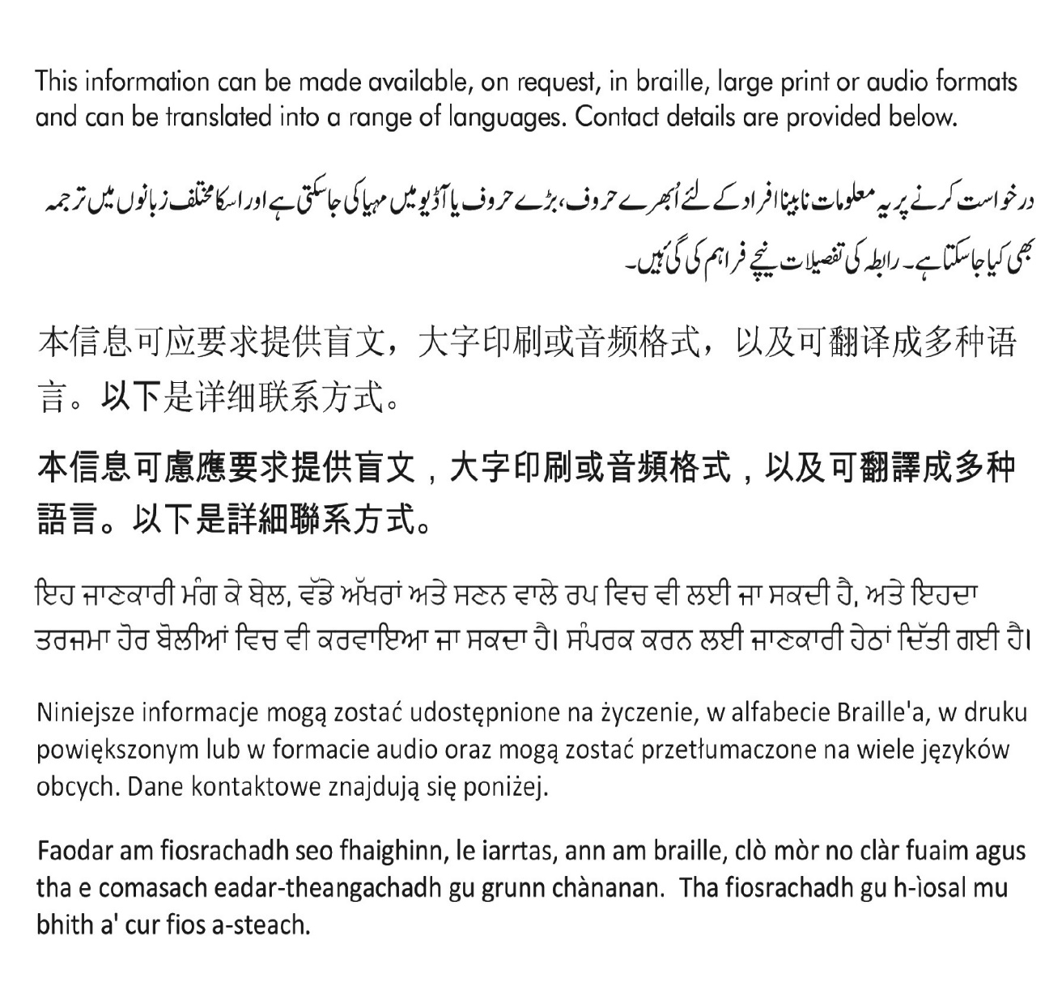

[Equalities@south-ayrshire.gov.uk](mailto:Equalities@south-ayrshire.gov.uk) Or Call: 0300 123 0900





**Appendix 2 - Extract from the Equality Outcomes Survey**

**Introduction**

To support the development of a new Equality Outcomes plan to be published by April 2021, the Ayrshire Equality Outcome Partners undertook a consultation exercise during October and November 2020. This paper shall provide an overview of the responses received.

The consultation focussed on gathering opinion on the existing 4 Equality Outcomes, shared across Ayrshire. They are, that in Ayrshire:

* people experience safe and inclusive communities
* people have equal opportunities to access and shape our public services
* people have opportunities to fulfil their potential throughout life
* public bodies will be inclusive and diverse employers

**Method**

Due to restrictions in place as a result of the Covid-19 pandemic, members of the Ayrshire Equality Partnership (AEP) recognised the challenge in place for effective engagement. Physical events and traditional engagement methods were simply not possible.

The method adopted focussed on an online survey created using the Microsoft Forms software. The question set was designed an agreed by AEP members. In all, it contained 10 questions relating directly to Equality Outcomes, plus an additional ‘about you’ section asking people for relevant demographic information.

The questions in relation to Equality Outcomes took both an asset and deficit approach, in that we asked respondents to reflect on positive things they have experienced as well as any negatives. In analysing responses, we took a thematic approach in which we aimed to group responses by a recurring theme.

**Duration**

The consultation ran for a total of five weeks from 13th October 2020 until 18th November 2020.

**Responses**

Q1 “Do you think these (Equality) outcomes are still relevant to take forward?”

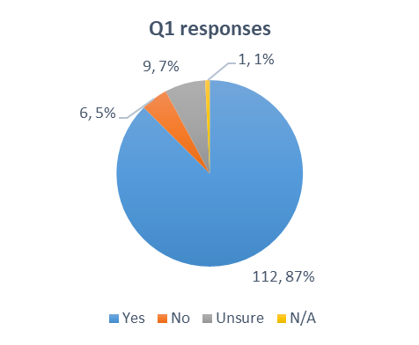This question was asked to help us identify if the equality outcomes adopted in 2017 are still relevant to progress to our next plan.

As is evidenced from the chart opposite, of the 128 responses received, most respondents - 87% (112) - agreed that the Equality Outcomes are still relevant to take forward.

7% (9) of respondents were unsure in their response. In some instances, responders indicated they agreed with some of the outcomes, but not all.

5% (6) of those who responded disagreed with the outcomes and a further 1% (1) provided no response.

**Summary of comments**

The majority of comments are positive however, state that there is room for improvement, the outcomes should be looked at in depth and that the outcomes should be continuously reviewed. Some of the suggestions are as follows:

* *I think our Councils make every effort to take on new ideas and support fair outcomes. …we are all firefighting - sticking plasters when radical surgery is required.*
* *They are more important than ever since the corona pandemic has exposed greater suffering among disadvantaged people than in the rest of our community.*
* *Extremely relevant especially their right to have opportunities to fulfil their potential throughout life and having equal opportunities to access and shape our public services*
* *Yes, they are more important than ever since the corona pandemic has exposed greater suffering among disadvantaged people than in the rest of our community.*

There may be scope to make the Outcomes more meaningful, as one comment suggests:

* *Instead of equal opportunities to access & shape public services, I'd prefer to see something about the actual outcomes as a result of that access. Similar for No. 3 having an opportunity isn't the same as a meaningful outcome.*

**Consultation – Demographic dashboard**

