
APPLICATION FOR LET

EXTERNAL AGENCIES

CHILD PROTECTION

If your group consists of Children, Young People under 18, your Group, Club or Organisation must have a Children’s Protection Policy. All leaders, helpers and employees who have regular unsupervised access to children must be checked with Disclosure Scotland. See Guidance Notes attached and South Ayrshire Council Code of Practice for Adults Working with Young People Under 18 years of Age.

(Please complete in Black Ink)

1 | Premises Required: | (tick as appropriate)
 | County Buildings: | County Hall ◻ | Committee Room – Name:

2 | Organisation:
 | Does the Organisation involve people under 18 years of age? YES ◻ NO ◻

3 | Your Name:
 | Address:
 | Telephone: |  | (Work) |  | (Home)
 | Date(s):
 | Hours of Use:

4 | Person attending responsible for the meeting / event: (if different from 3 above)

5 | Purpose of Activity:
 | Will alcohol be supplied or sold? YES ◻ NO ◻
If YES applicant MUST contact Licensing Section, Legal and Protective Services, Town Buildings, Ayr
Tel : (01292) 617683

7 | Will catering be required? YES ◻ NO ◻
 | If YES please detail below: |  |  |  | For Office Services use only:-
 | Tea:  Biscuits:  Other: |  | Coffee:  Scones: |  | Cost:

DECLARATION

I am applying on behalf of the above Club, Group or Organisation for the use of the specified accommodation and if granted, agree that the Club, Group or Organisation will accept and abide by the terms of the Code of Practice and Conditions of Let attached and signed by me and which I agree will be part of the whole Let Agreement.

8 | Signature:
 | Date:
 | Designation:

Please return to: Democratic Services
South Ayrshire Council
County Buildings
Wellington Square
Ayr KA7 1DR.

Tel: 01292 612437 Mon/Tues or 616646 Wed/Fri

Email: accommodationcountybuildings@south-ayrshire.gov.uk

Confirmation of your application will be sent as soon as possible.
For a large event it may be useful to visit prior to the event.

CONDITIONS OF LET

Health and Safety
1. In the event of an accident within the premises the lessees must report this immediately to the Council Officer and an Accident Report Form (obtainable from the Council Officer) should be completed and returned as specified on the form.
2. The lessee must ensure that all present at the event are aware of the emergency evacuation procedures from the building and the position of the assembly area after leaving the building.
3. The lessee is responsible generally for ensuring that a safe healthy environment is provided for all present at the event.
4. If your group consists of Children, Young People under 18, your Group, Club or Organisation must have a Children’s Protection Policy. All leaders, helpers and employees who have regular unsupervised access to children must be checked with Disclosure Scotland. See Guidance Notes attached and South Ayrshire Council Code of Practice for Adults Working with Young People Under 18 years of Age.
General
5. Where premises are let for the purpose of private gain by an individual or commercial organisation full commercial rates will be charged.
6. The lessee will be required to meet the cost of making good any damage to property or equipment which occurs in the course of, or as a direct result of, their occupation of the premises.
7. The lessee accepts full responsibility for any accident or injury to any person which may occur in the course of, or as a direct result of, their occupation of the premises.
8. South Ayrshire Council ("the Council") cannot accept responsibility for any loss of possessions. The lessee is responsible for ensuring that personal possessions are adequately safeguarded.
9. The subjects of let are no-smoking premises in terms of the Smoking Health and Social Care (Scotland) Act 2006 and the Prohibition of Smoking in Certain Premises (Scotland) Regulations 2006.
10. Lets are not transferable and must be used for the purpose stated in the Let Form.
11. At least 10 working days notice of the event must be given when a let is applied for.
12. The lessee is responsible for ensuring that these Conditions of Let are observed. The person supervising on the evening of the let must report to the Council Officer and sign the Let Record Form.
13. The application for let must be submitted prior to the submission of any Licensing application authorising the sale and consumption of alcohol.
14. Premises may require to be licensed to allow certain types of performance where money or tickets change hands. If a public performance is intended it is important that the applicant indicate this clearly on the Let Form.
15. The lessee must indemnify the Council against any claim arising out of breach of or an infringement of the Copyright, Designs and Patens Act 1988 or The Performing Rights Society Agreement.
16. Special conditions may apply to the letting of the kitchen and additional details may be required with each Let Application. The lessee and/or any individuals responsible for producing/handling food will be responsible for food safety and any liability arising out of any food operations. Organisers should seek help and advice before undertaking these activities.
17. Lets will not be taken more than 18 months in advance of the event
18. Charges and Conditions of let may be subject to variation by the decision of the Council.
19. All lessees shall observe such restricted letting periods as may be determined the by Council from time to time, in addition to the normal statutory holidays.
20. If the lessee fails to attend on the stated day and time on the application form, the let will be charged at the full rate. Failure by a lessee to attend for a let which is subsidised in whole or in part will result in the review of further lets to that lessee.
21. The let may be cancelled by the lessee provided at least seven days written notice is given to the Council. If the let has to be cancelled by the Council for any reason as much notice as possible will be given to the lessee.
22. The lessee must ensure that adequate insurance cover is in place to cover the cancellation of the event.
23. A let will not normally extend beyond 11.00 pm. Lets beyond 11.00 pm will be granted only when suitable arrangements can be made and then normally on Fridays and Saturdays only.
24. The use of premises for any form of gambling for commercial gain is expressly forbidden.
25. It is the responsibility of the lessee to notify the Council in writing prior to the event of any changes to the office bearers of the lessee or treasurer.
26. Applications for let, on behalf of groups and organisations must include a copy of the group's constitution and details of office bearers.

Application for let for under 18’s
PROTECTION OF CHILDREN (SCOTLAND) ACT 2003 (POCSA)

GUIDANCE NOTES

Do you provide organised and supervised services/activities for children and/or young people under 18 years of age?

If so,

- Do you know about the Protection of Children (Scotland) Act 2003?
- Do you know that you have a legal duty to ensure that anyone you recruit to a “child care position” whether paid or unpaid had not been placed on the Disqualified from Working With Children List?
- Have your leaders had child protection training?
- Are you registered with CRBS, Disclosure Scotland or with a recognised Umbrella Body?
- Have people recruited by you since 11 April 2005 into a childcare position under the terms of the Act (paid or unpaid) been vetted through Disclosure Scotland?

Where can you get more information?

The Central Registered Body Scotland (CRBS) – Helpline: 01786 849777 or e-mail: info@crbs.org.uk

A training pack for the voluntary sector is available from CRBS, which includes guidance on POCSA and health and safety matters. Organisations wishing to register with CRBS have to demonstrate that they have key policies in place such as on child protection, data protection and health and safety before being registered.

South Ayrshire Local Volunteer Organisation (SALVO), 60 Kyle Street, Ayr KA7 1RZ. Tel: 01292 263626,
Fax: 01292 267677 or e-mail: enquiries@volunteersouthayrshire.org.uk

Youth Link Scotland, Rosebery House, 9 Haymarket Terrace, Edinburgh EH12 5EZ. Tel: 0131 313 2488
Fax: 0131 313 6800 or e-mail: info@youthlink.co.uk

Disclosure Scotland, PO Box 250, Glasgow G5 1YU – Helpline 0870 609 6006 or e-mail: info@disclosurescotland.co.uk

The Scottish Executive’s Guidance for Organisations can be found at
www.scotland.gov.uk/library5/education/pcago.pdf

The Scottish Executive’s Guidance To The Voluntary Sector On Who Needs To Be Checked Against The Disqualified From Working With Children Lists is available at www.scotland.gov.uk/childprotection

Information on sports governing bodies is available from Sportscotland, Caledonia House, South Gyle, Edinburgh EH12 9DQ. Tel: 0131 317 7200, Fax: 0131 317 7202 or e-mail library@sportscotland.org.uk

PLEASE RETAIN THIS INFORMATION SHEET FOR INFORMATION AND REFERENCE.

CODE OF PRACTICE FOR ADULTS WORKING WITH
YOUNG PEOPLE UNDER 18 YEARS OF AGE

This Council supports safe and supportive environments for children, young people and those working with them and to encourage this will make information available on the Protection of Children (Scotland) Act 2003 (POCSA), and what to expect in terms of good practice, to parents/carers using our halls and premises as well as to groups who provide those services.

INTRODUCTION
This is the South Ayrshire Council code of practice on Working with Young People under the age of 18.

Please read the Code of Practice carefully and retain this for information and reference.

CHILD PROTECTION
If your group consists of Children/young people under the age of 18 years, your group must have a Children’s Protection Policy and all leaders, helpers and employees who have regular unsupervised access to children must be checked by “Disclosure Scotland”.

For information on this please see the information sheet on Protection of Children (Scotland) Act 2003 (POCSA). If you need any further information or assistance with this please contact us.

GENERAL SAFETY
Adults working with Young People under the age of 18 must: -

- Check location of telephone; first aid kit; fire exits.
- Carry out a fire safety briefing with each group and/or practice fire drill with each group once per school term.
- Never allow young people to enter facility or commence activity prior to arrival of an approved adult.
- Ensure that equipment and facilities meet safety standards and are appropriate to the age and ability of participants.
- Keep a register with details of participants including emergency contact numbers. A sessional attendance register should also be kept.
- In the event of an accident complete an accident form available from the facility caretaker/janitor.
- Follow a well-planned programme suitable for the age, experience and ability of participants.
- It is desirable that two adults are in attendance at all sessions.
- Wherever possible in mixed sex groups, there should be a male and female adult present.
- Consideration should be given to the number of adults present in relation to the number of young people and the nature of the activity.

CODE OF BEHAVIOUR
Adults working with young people under the age of 18 must: -

- Never use any form of physical punishment to discipline participants.
- Encourage an environment where each individual treats all others with respect.
- Give positive reinforcement and encouragement at all times.
- Set and monitor the boundaries between a working relationship and friendship with participants.
- Give all participants equal opportunity to participate as appropriate to their age and stage of development.
- Project a positive role model.
- Not drink alcohol or use illegal substances and not smoke when working with young people.

ADDITIONAL GUIDANCE
- Nominated South Ayrshire Council staff has the right to visit groups at any time.
- Any damage to property must be reported to the facility caretaker/janitor.
- It would be desirable to make available to parents information about the group’s activities and the adults involved.

PLEASE COMPLETE THE LET FORM AND SIGN THE DECLARATION ON THE LET FORM TO INDICATE THAT YOU AGREE TO ABIDE BY THE CONDITIONS OUTLINED. PLEASE RETAIN THIS CODE OF PRACTICE FOR INFORMATION AND REFERENCE.

EMERGENCY

EVACUATION

PROCEDURES
COUNTY BUILDINGS

On hearing the fire alarm, everyone must leave the building as quickly as possible. DO NOT PANIC

The FIRE ALARM for the building is:-

CONTINUOUS TWO-TONE SIREN

The alarm is tested on Wednesday at 9.15 am for approximately 10 seconds.
!

IF YOU HEAR THE FIRE ALARM

1.Leave the building by the NEAREST SAFE EXIT and report to the assembly point.
2.Do not go back to your office for personal belongings.
3.The instructions of the Fire Wardens or their Deputes must be obeyed at all times.
4.DO NOT USE LIFTS.
5.When you leave –

DO NOT RE-ENTER UNTIL TOLD IT IS SAFE TO DO SO
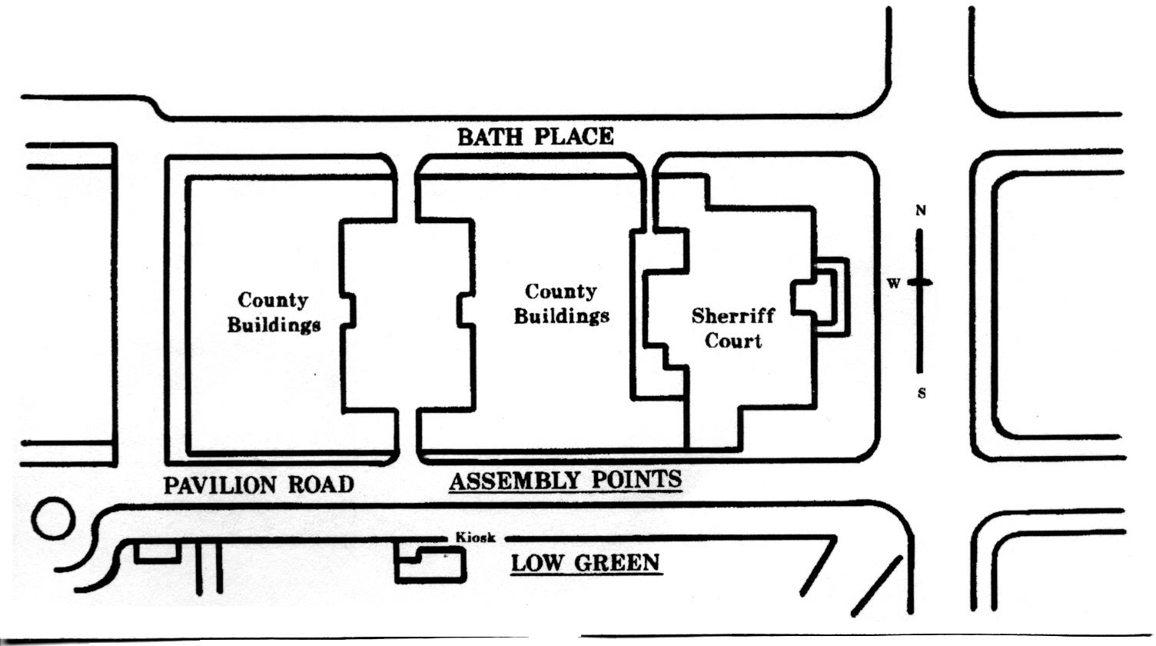
IF YOU DISCOVER A FIRE

1.Break the nearest fire alarm break glass point.
2.Leave the building by the nearest SAFE exit and report to the assembly point.

NEVER PUT YOURSELF AT RISK

Your
ASSEMBLY
POINT is

PAVILION RD:-

