

**South Ayrshire Local Outcomes Improvement Plan: *COVID-19 Response (June 2020)***

**INTRODUCTION**

This report provides an update on the extensive work taking place to support our communities during these unprecedented times focusing on the four priorities within our Local Outcomes Improvement Plan.

Community Planning Partners, along with vital support from community groups and volunteers, are ensuring that our older people who living with dementia or find themselves experiencing social isolation and loneliness are supported, engagement continues to take place with our children and young people who are care experienced and additional support is provided for children and young people who are carers.

**SUPPORTING OLDER PEOPLE TO LIVE IN GOOD HEALTH**

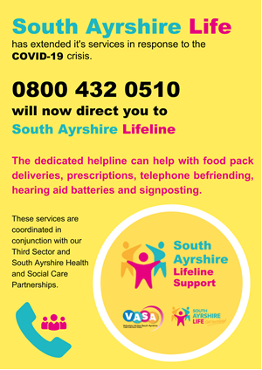**REDUCING SOCIAL ISOLATION AND LONELINESS**

VASA has established [**South Ayrshire Lifeline**](https://www.southayrshirelifeline.org/) as a single point of contact providing support for individuals (often older people or isolated people). This includes:

* Phone call centre offering advice, support, signposting and links to lots of local services;
* Also food and medicines provision;
* 150 Phone befrienders offering 1:1 support;
* Hearing Aid Service;
* Book service;
* Strictly Seniors/All about me – delivery; and
* Some beginnings of in situ support using social distancing support and Face time.

**Local Community Groups**

There has been an amazing response at community level to COVID-19 and from a variety of community groups, churches and others and, whilst addressing, principally practical needs (eg food, medication) there are good examples of wider support too. This is led by the Humanitarian Assistance Centre which has three locality hubs. Each locality hub consists of a community response hub, production kitchens and a number of locality support groups. A list of locality support groups, providing information of assistance on offer, can be found by visiting the [Locality Support Group information page](https://beta.south-ayrshire.gov.uk/media/562/Locality-Support-Groups-Updated-14-May-2020/pdf/Locality_Support_Groups_Updated_14_May_2020.pdf?m=637251410403100000) on the South Ayrshire Council website.

As part of the COVID-19 response South Ayrshire Council has engaged local foodbanks and community groups who have been distributing food parcels as part of their response. Engagement has taken place with Fareshare who are now providing weekly deliveries of food. This is then separated and distributed to nine different food providers that cover both the towns and rural villages. These food providers are giving out food parcels either on a weekly basis to people who are struggling or on a one off crisis basis. These organisations are signposting service users onto other services when appropriate.

Many of the groups listed on the information are offering practical support, some including phone based contact. An example of groups offering support include:

* ***St Meddans***
* ***Symington Village***
* ***Troon Harbour Group***
* ***Newlife Prestwick***
* ***Ballantrae Support Group***
* ***Coylton Community Support***

**Wider Community Support Groups**

Information on community support, including Locality Support Groups, can be found be visiting the [information page](https://beta.south-ayrshire.gov.uk/article/19537/Community-Support-Groups-) on the South Ayrshire Council website. There is also information on a range of local services [on local services: supports and contacts](https://www.southayrshirelifeline.org/local-services.php) page of the South Ayrshire Lifeline website.

**Tarbolton Coronavirus Community Help Group**

The Tarbolton Coronavirus Community Help group was established by Rev. Mandy Hickman Ralph and a bank of local volunteers with the aim to provide essential services to residents in Tarbolton who are socially isolated and/or vulnerable. Initially, the group established a food bank through donations from local groups, individuals and businesses and have been delivering weekly food parcels to those who require them. There is also a supply of sanitary products for residents to access. In addition, the group provide additional support to those isolated which includes collecting shopping, picking up and delivering prescriptions, arranging hearing aid batteries and arranging weekly calls and visits to reduce the risk of social isolation. Furthermore the group continue to provide soup and main meals to isolated residents and this service is greatly received by those using it. Finally, in conjunction with Tarbolton Primary School, time capsule packs were delivered to all of the children and puzzle sets and colouring packs were made available to local young people to access. One volunteer said *“I’m so pleased to live in a village where people really care for each other, no matter who you are, and you never need to feel alone. We are helping those who are lonely and isolated and it’s a great feeling to provide a service to these residents”.*

**Coylton Community Association**

Coylton Community Association is working with local volunteers to provide much needed services to local residents from Coylton. They are operating a food bank system so that food can be provided to anyone that needs it, they are supporting residents by collecting their shopping, picking up prescriptions, making weekly phone calls to check residents are well and are operating a pen pal system to reduce social isolation. The weekly calls and pen pal system provided to residents is making a significant contribution to tackling social isolation. Many of the residents feel comforted that someone is checking in with them on a weekly basis and know they can contact the volunteers out with this time. The weekly social interaction is invaluable to residents and demonstrates the importance of providing these services to vulnerable residents to reduce the risk of social isolation and loneliness. In addition, the group celebrated VE day in the community by distributing picnic bags to young people in the village so as they could enjoy a picnic and enjoy the VE Day celebrations. One resident commented *“Thank you so much for all the great work Coylton CA are doing in the village. I have got to say the VE bags were fantastic and very well organised. Thanks so much for all the hard work everyone puts in to the village”.*

**Troon, Loans and Dundonald Covid-19 Support Group**

Joanne Redford initially set up a Facebook page requesting assistance to deliver 'help' cards to all the homes in Troon and Loans, a small army of people came forward to deliver over 8,000 leaflets. Within days, Joanne received hundreds of calls and texts responding to these 'help' cards. Requests for additional volunteers was quickly sought and Joanne was inundated with people offering to collect shopping ,deliver prescriptions and provide friendly telephone chats. Posts on the Facebook group page regularly have over 5000 views and the Facebook Group is recognised locally as the main source of information and communication relating to COVID-19

Activities have included:

* Over 8,000 help cards delivered to each home in Troon and Loans including local business contact details
* Joanne personally making direct contact with over 100 homes through calls and texts and shopping on average for 4 people per day
* Additional 30 people offered to help in their own neighbourhoods
* Donated food has been distributed to support people in need out with the operating times of the food bank
* Prescriptions collected and delivered
* 545 and 50 jigsaws delivered to help combat isolation
* Organised Art Trail Page and Easter competition as a way to help bring the community together
* Keep regular contact with South Ayrshire Council COVID-19 Locality Coordinator to best support the community
* Providing ongoing communication with the extended families of people who live out with the area to reassure them that loved ones are being looked after
* Liaising with VASA and local churches to avoid duplication
* Promoting local businesses to encourage people to shop local

[**mPower**](https://ayrshire-arran.mpowerhealth.eu/contact)has moved its support for older people to providing telephone support rather than usual home visits. The service is providing bespoke one-to-one self-management support to improve their wellbeing and live safely and independently in their own homes. The following case studies provide examples of support that has taken place:

**Case Study**

Through support of mPower a:

* Referral has been made to Alzheimer’s Scotland for support/activities
* Referral has been made to Dementia Friendly Prestwick to walking group and cinema group once these are opened back up.
* Assisted waste referral
* Call blocker referral

**Case Study**

Wellbeing plan has been developed with help of daughter. The beneficiary has a severe short term cognitive impairment and is being investigated for dementia. Struggling to understand the lockdown and that she has to stay indoors.

* Linked to Befriending Services to set up a daily/every 2nd day phone call to the beneficiary
* Referred her for assisted waste collection
* Referred for a call blocker.
* The family were really grateful as all of these small aids take a lot of pressure off of them.

**Strictly Seniors** – the 7th edition has been produced and disseminated (5,000 copies) and this sets out a range of activities and supports for older people in South Ayrshire (albeit some now in abeyance because of COVID-19)



[**South Ayrshire Libraries Museum & Galleries**](https://www.south-ayrshire.gov.uk/libraries/) are working to support people in our communities by providing services digitally.  During the lockdown there has been a huge increase in the number of online registrations for our e-books and e-audio service; since the beginning of June another 105 patrons have registered. A total of 839 library users accessed the service during this time, checking out 3655 items. Those using the service include adults, children, young adults, older people and housebound. There are over 2,000 users registered for [PressReader](https://www.south-ayrshire.gov.uk/libraries/ereading/emagazine.aspx) which gives free access to a very wide and varied range of newspapers and magazines with several thousand issues read every week.  Since the beginning of June there have been 7174 logins to PressReader; library users have accessed 30,371 newspapers and magazines, and read 238, 995 articles. Registrations for digital services continues to grow. South Ayrshire Museums and Galleries have also been hosting virtual exhibitions with great success.  Of great interest were ‘[There’s nothing quite link an Ayrshire Tattie’](https://southayrshirehistory.wordpress.com/2020/04/08/theres-nothing-quite-like-an-ayrshire-tattie/) and [‘VE’ day](https://southayrshirehistory.wordpress.com/2020/05/07/ve-day-in-ayr-1945/), both virtual exhibitions.  Both exhibitions have been extremely well received with the following feedback received in relation to the Ayrshire Tattie exhibition:

*What a wonderful article, full of rich historical and cultural information. As a child I remember the ‘tattie howkers’ visiting Greenan Farm, at Doonfoot Ayr, where my grandfather lived and I was always fascinated by them. Boiling up tea in a metal can, singing and laughing as they worked and cooking around a camp fire at night, and sharing amazing stories of their adventures as they travelled around Scotland. I can still taste that rich earthy mineral taste of “ayrshires”. Thank you for documenting and preserving an important part of Scotland’s agricultural history for future generations and for bringing back happy memories of my childhood.*

The **NHS Better Health Hub** is available by telephone and video call using Attend Anywhere/NHS Near Me. Services include a **listening service** for those who are feeling isolated and/or lonely due to the pandemic or otherwise.

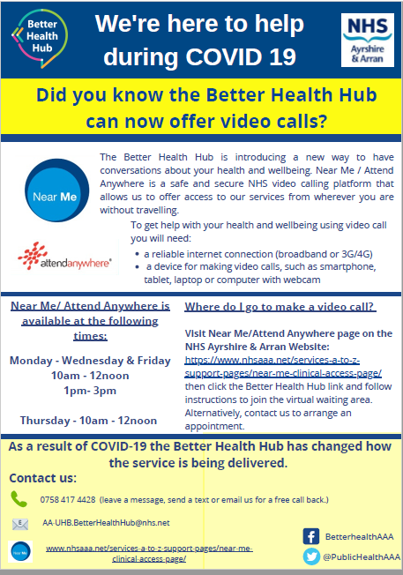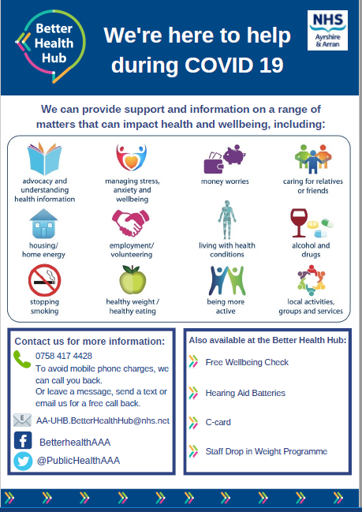

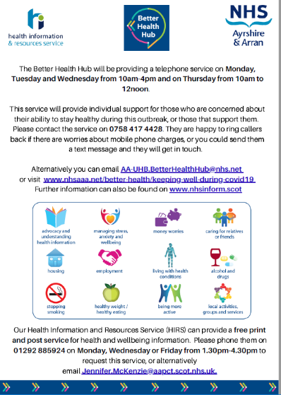**Public Health Webpage**

The Better Health webpages have information to support people to keep well during this time and can be accessed here: <https://www.nhsaaa.net/better-health/keeping-well-during-covid19/> .

For those not digitally connected, our Health Information Resources Service (HIRS) can print and post information as requested. The flyers for this service, along with other health improvement information, have been disseminated across South Ayrshire using local food delivery mechanisms set up by South Ayrshire Council and South Ayrshire LifeLine in response to the pandemic.

**SUPPORT FOR PEOPLE LIVING WITH DEMENTIA AND THEIR CARERS**

[**Alzheimer Scotland**](https://www.alzscot.org/)  and [**South Ayrshire Dementia Support Association**](http://www.sadsa.org.uk/about-us)  are both providing phone support with information and advice.

The[**South Ayrshire Carers Centre**](http://www.unity-enterprise.com/carers-centers/) is offering phone and on-line support. One to one support is also available providing information and advice.

**Dementia Friendly Prestwick** is also providing phone support and practical demonstrations of care (for example knitting packs for Biggart Hosptial)

Clinical support is taking place via **Older People’s Community Mental Health Team**:

* Providing face to face assessments on home visits for URGENT NEW REFERRALS
* Providing face to face visits for High Risk Dementia Patients
* Providing shopping support for High Risk patients
* Regular Phone Reviews for patients that would be due a review at home or at clinic.
* Phone support for carers .
* Phone review and support for Care Homes both staff and patients.
* Accessing PPE for Care Homes in an emergency.

**CLOSING THE POVERTY RELATED GAP FOR CHILDREN AND YOUNG PEOPLE**

**IMPROVING OUTCOMES FOR CARE EXPERIENCED CHILDREN & CARE LEAVERS**

Like many **South Ayrshire Champions Board** has had to change considerably how they work and have been linking in with young people and each other using a range of online methods including Facebook, Facetime, Snapchat, Instagram and Twitter. Support given to young people includes:

* Distribution of 55 craft packs to young people across South Ayrshire and beyond with great help from CLD;
* Securing of £1,750 from Cash for Kids  to distribute vouchers to 50 young people across South Ayrshire;
* The Champions Board has sent out hand written letters to let all of our young people know that we are still here for them;
* Three virtual groups are up and running for the Ayr, Girvan and Belmont groups. They have set up a scavenger hunt, quizzes, icebreakers, games and even managed virtual birthday celebrations complete with banners just like they would do in their groups and they are having our first virtual movie afternoon tomorrow complete with popcorn that has been delivered to young people in advance;
* The creation of [Spotify playlists](https://open.spotify.com/playlist/38s9cGbk6KvoJf0fbaM8cw?si=qEdtqRpRSpGF_ipgzkAKiw) with young people on the following themes: *songs that should be played out load*, *songs that make you think of summer* and *songs by a band you wish were still together*. There are more playlists to come including *songs that make you feel happy*, *songs that make you want to dance* and *songs that you’d like to sing on Karaoke;*
* In the process of setting up a Champions Board Tik Tok account and have just confirmed a new project  lockdown monologues (working title), a creative writing project that they are working on with some of their young people aged 8-26 years, the Royal Conservatoire and the Gaiety Theatre;
* Facebook posts have been popular and have set up Motivational Monday, Wellbeing Wednesday and Throwback Thursday to give everyone a pattern to the week. This forum has been used to share age appropriate information about coronavirus and self-help around mental health;
* Chloe, one of the Participation Assistants, is compiling a stay at home selfie montage gathered from young people and H&SCP staff;
* Alex, another Participation Assistant, has been connecting with young people through gaming and is becoming proficient in Roblox!;
* The Champions Board has launched a [‘**Stay Connected’**](https://www.south-ayrshire.gov.uk/grants/) fund of £10,000 to be distributed via small grants of up to £250.00 to address digital poverty and isolation. The response so far has been overwhelming. The closing date for applications was Wednesday 20th May;
* Participation assistants have been working alongside Quality Assurance reviewing Officers (QUAROs) social work and advocacy colleagues to support children aged 8 years and over to share their views at virtual reviews; and
* Consideration taken of national and local guidance for online safety for all of the online activities that are facilitated by the Champions Board and they will continue to do so through the national networks participated in.

**PROVIDING SUPPORT FOR YOUNG PEOPLE WHO ARE CARERS**

**Support for unpaid carers (including young carers)**

A survey of unpaid carers in Scotland showed that, on average, carers are picking up an additional 10 hours of unpaid care per week, helping loved ones with personal care, practical tasks and emotional support. More than half (53%) of carers told the charity they feel overwhelmed managing their caring responsibilities during the outbreak and are worried about burning out in the coming weeks. 87% of carers in Scotland said they are worried about what will happen to the people they care for if they have to self-isolate or become ill. A report has been produced on the survey findings: [Caring Behind Closed Doors](https://www.carersuk.org/images/News_and_campaigns/Behind_Closed_Doors_2020/Caring_behind_closed_doors_April20_pages_web_final.pdf).

Currently South Ayrshire Carers Centre is supporting all unpaid Young Carers registered via remote support i.e telephone support calls to check in on well-being and also providing fortnightly group Zoom sessions to still maintain an effective support service to all Young Carers virtually.

To date the Young Carers Service has managed to sustain emergency covid-19 grants from external partners such as ‘Cash 4 Kids Emergency Appeal’ and external donors such as Ayr Rotary Club and have managed to distribute 14 hardship payments to Young Carers families in direct need as a result of the pandemic. The monies contributed towards fuel payments and food vouchers.

From our external donors we have managed to reach out to our Young Carers to ensure they -receive an art pack/paint pack, (which will be delivered by a local Co-ordinator) and will ensure Young Carers can have a life outside their caring role due to the outbreak. This will alleviate some of the stresses and strains due to the impact and by having access to the art equipment, it will give young carers some time to themselves and a chance to escape.

South Ayrshire Carers centre has also been ensuring all Young Carers have access to appropriate support such as signposting to appropriate PPE equipment (through South Ayrshire Life) and advising of their entitlement on the Scottish Governments policy on Covid-19 testing with Young Carers being in priority group 4. All staff within the centre are ensuring that Young Carers are know this information.

On Friday 12th June, as part of Carers week, Young Carers Workers will run group sessions with Young Carers who received art packs and use this time as a time to chat/support. There will also be a quiz taking place via Zoom.

Although the service provided by South Ayrshire Carers Centre is currently closed, all staff are working from home however are still ensuring there is a high level of support available to all unpaid carers including Young Carers.

The Scottish Government announced that PPE should be made available to all unpaid carers through the local hubs from Monday 26th April. In South Ayrshire the main point of contact to request PPE will be through [South Ayrshire Lifeline](https://www.southayrshirelifeline.org/) operated by Voluntary Action South Ayrshire (VASA).

The HSCP is working with the Council and the Carers Centre to issue a letter to unpaid carers in South Ayrshire, the purpose of which will be to signpost them to relevant support and also for use in situations (e.g. travelling, shopping for essentials, visiting pharmacies as part of caring responsibilities) in which unpaid carers may be asked for ‘proof’ – if asked – that they are an unpaid carer.  The Partnership and the Carers Centre have jointly produced a document **Supporting unpaid carers during coronavirus** which contains information and links to relevant websites.  This document is being shared with unpaid carers via partners including South Ayrshire Carers Centre.

External communications are a priority at the moment, given the necessity of providing information and reassurances to stakeholders including unpaid carers and young carers. Current external communication activity includes:

* SAHSCP – Health and Social Care COVID-19 website: <https://beta.south-ayrshire.gov.uk/article/19507/Health-and-Social-Care>. Where there is a dedicated tab for **Support for unpaid carers**.
* SAHSCP – Twitter: <https://twitter.com/sahscp> The Partnership’s Twitter page is being maintained and updated daily.  Messaging includes national and local information and links to helpful resources for unpaid carers.
* SAHSCP – Facebook: <https://www.facebook.com/sahscp> The Partnership’s Facebook page is being maintained and updated daily.  Messaging includes national and local information and links to helpful resources for unpaid carers.

The HSCP continues to work collaboratively with South Ayrshire Council, NHS Ayrshire & Arran and wider partners – sharing key messages and informative content relevant to unpaid carers across our various social media platforms to get this information out as widely as possible. The latest national advice for unpaid carers can be found on the Scottish Government webpage – [advice for unpaid carers](https://www.gov.scot/publications/coronavirus-covid-19-advice-for-unpaid-carers/) and for children and young people by visiting the [Young Scot](https://young.scot/campaigns/national/coronavirus) website.

**WIDER COMMUNITY SUPPORT**

**Free School Meals**

South Ayrshire Council is delivering weekly food boxes to children and young people who are eligible for free school meals. The boxes contain a range of food providing contents for a healthy breakfast and lunch for a week. Food boxes are delivered from 7 production hubs across South Ayrshire, and boxes are prepared and delivered by a range of teams from South Ayrshire Council.

In addition to food, the boxes have included information leaflets on a range of topics including:

* public health;
* Dental hygiene packs
* recipe ideas and;
* a range of activities from our Active Schools Team.

To date over 3,000 boxes on a weekly basis are being delivered to families across South Ayrshire with a total of 36,577 distributed to date.

**Free Access to Sanitary Products**

South Ayrshire Community Planning Partnership want to ensure that people are still able to access supplies of products whilst public buildings and schools are closed. This is being carried out in the following ways:

* Provision of sanitary products to all households who receive free school meals in South Ayrshire – families are now being provided with weekly food boxes and this will include a supply of products (through our ‘wee white bag’ distribution) on a monthly basis – to date over 5,000 wee white bags have been distributed;
* For those who are being shielded, sanitary products will be supplied as and when required;
* Making products available for key workers;
* Independent foodbanks are being provided with supplies of products; and
* Ensuring that products are available to services/partners/community groups who are responding to local need.