**ECO-3 - Statement of Intent**

**Local Authority:** South Ayrshire Council

**Managing Agent:** Energy Agency

**Date of Publication:** 4/1/2021

**Version:** ABS - 003

**Published:**

|  |  |
| --- | --- |
| **1.0**  1.1 | **Introduction**  The Energy Company Obligation (ECO) is a government policy to help reduce carbon emissions and tackle fuel poverty. The scheme began in April 2013, and over time it has been amended. The latest changes to the scheme are to be implemented from 1st November 2018, the latest version of the scheme being termed ECO-3. |
| 1.2 | Under ECO, energy suppliers have a legal obligation to provide funding for domestic energy efficiency measures if they:   * have more than 250,000 domestic customers. * provide more than 400 gigawatt hours of electricity or more than 2,000 gigawatt hours of gas. |
| 1.3 | In ECO-2t, the predecessor to ECO-3, suppliers had two obligations:   1. Carbon Emissions Reduction Target (CERO) 2. Home Heat Cost Reduction Obligation (HHCRO)   Under ECO-3, the CERO target has been removed leaving only the HHCRO target which provides funding for fuel poor households, and low income households that are vulnerable to the effects of the cold. |
| 1.4 | Under HHCRO, a household is eligible if one of the occupants meets the Help to Heat eligibility criteria as set out in OfGEM guidance[1]. However, a supplier will now be able to achieve up to 25% of their obligation by installing measures in households that do not meet the Help to Heat criteria but are declared eligible by Local Authorities. This new mechanism, known as Flexible Eligibility allows Local Authorities to set out their own eligibility criteria for HHCRO funding to help address local needs. |
| 1.5 | Fuel Poverty can cause vulnerable and low income households to live in cold, unhealthy homes that are expensive to keep warm and push them into debt. South Ayrshire Council welcomes the increase of Flexible Eligibility powers as a means to help address this issue. |
| **2.0** | **South Ayrshire** |
| 2.1 | In South Ayrshire, 35% of households in the district are estimated to be in fuel poverty. This equates to 18,000 homes: a figure that will only increase as fuel prices rise[2]. Research has shown that the highest rate of fuel poverty was found in the owner occupier sector. The Council is keen to provide support to some of the most vulnerable homes which are located in the bottom 25% of the Scottish Index of Multiple Deprivation (SIMD). |
| 2.2 | The SIMD data zone rankings are a key source of data for determining a household’s risk of fuel poverty. The overall rankings are calculated by assessing seven categories, four of which are linked to fuel poverty: household income, employment levels, health data and geographical access.  A recent study estimated that fuel poverty in South Ayrshire was most prevalent in:   * **Older properties:** 50% of households in pre-1945 housing were in fuel poverty compared to 29% of those in properties built after 1945; * **Flats:** Flats were more likely to experience fuel poverty to those in houses (43% compared to 33%); * **Smaller properties:** 37% of households in 1 or 2 bedrooms were in Fuel Poverty compared to 34% with 3 or more bedrooms. * **Owner-occupied houses:** 35% of owner-occupiers were estimated to be in Fuel Poverty compared to 34% in the social rented sector. * **More pensioners** were estimated to be in Fuel Poverty than families. 44% of pensioners (8,000 households) compared to 23% of families and 36% of adult only households. |
| 2.3 | LA Flex will contribute towards the aims of the Councils Local Housing Strategy (2017-2022) which commits to ensuring ‘People across South Ayrshire live in well maintained, energy efficient homes and are proud of their homes. It will help to:   * Increase the number of energy efficient, safe, healthy and affordable homes to live in * Reduce carbon emissions from the domestic sector * Help to strengthen the local economy   This Statement of Intent outlines South Ayrshire Council’s approach to maximising ECO funding across the region for fuel poor, vulnerable, low income households. |
| **3.0** | **Flexible Eligibility (LA Flex)** |
| 3.1 | Flexible Eligibility funding is available to private sector households, including owner occupiers and private tenants, in line with OfGEM guidance.[3] |
| 3.2 | South Ayrshire Council will utilise Flexible Eligibility to assist with current and future EES: ABS programmes which aim to reduce fuel poverty in our communities. ECO funding will be maximised to compliment Scottish Government funding and assist the delivery of mixed tenure Solid Wall Insulation programmes in fuel poor areas, improving the energy efficiency of ‘hard to treat’ domestic dwellings. The insulation systems reduce heat demand, lower carbon emissions and regenerate areas of deprivation.  In addition, Flexible Eligibility will be used to draw down funding for additional measures across EES: ABS projects as identified by a dwelling’s Energy Performance Certificate (EPC). |
| 3.3 | Targeted households within EES: ABS projects will be eligible to be assessed for Flexible Eligibility. One of the criteria for determining project areas for EES: ABS is that the project is located within the most deprived areas according to the Scottish Index of Multiple Deprivation (SIMD). EES: ABS primarily targets households located within the bottom 25% of SIMD. |
| 3.4 | South Ayrshire Council will continue to focus on targeting households in the lowest SIMD data zones in the region. |
| 3.5 | The Energy Agency, a local charity, is employed by South Ayrshire Council to deliver the EES:ABS programme. It will be responsible for promoting the scheme to vulnerable householders in the region and collecting household data on behalf of South Ayrshire Council to determine Flexible Eligibility. |
| 3.6 | Households will be targeted by the Energy Agency during the sign up process for solid wall insulation programmes. It will also check that the householder is happy for their data to be shared with Scheme Partners. |
| **4.0** | **Eligibility Categories** |
| 4.1  4.2  4.3  4.4  4.5 | Fuel Poor (FP)  Households combining **low income** and **high heating costs** will be eligible for this category.  Eligible households will meet the criteria set out in Clause 5.0 and 6.0.  Low Income and Vulnerable to the Cold (LIVC)  Households with a **low income** and that are **vulnerable to the cold** will be eligible for this category. Eligible households will meet the criteria set out in Clause 5.0 and 7.0.  SWI In Fill (SWIF)  Households will be eligible for Solid Wall Insulation In-Fill if they meet the criteria set out in Energy Company Obligation (ECO3) Guidance: Delivery Version 1.[4]  Fuel Poor - Area Based (FP-AB)  A number of data zones in South Ayrshire are in the bottom 5% of the SIMD with extreme levels of deprivation. Flexible Eligibility will be granted for all households in these areas enabling the Council to take action at a community level to increase the impact of the scheme and benefit to residents. See Annex A.  Fuel Poor - Exceptional Circumstances (FP-EC)  South Ayrshire Council reserves the right to apply Flexible Eligibility to any household it deems to be eligible due to exceptional circumstances. |
| **5.0** | **Criteria for identifying low income** |
| 5.1 | Low income households will be identified as those in the first four Scottish income deciles as set out in the table below[5]. These equivalised income thresholds identify household incomes below 85% of the Scottish median.   |  |  |  |  |  | | --- | --- | --- | --- | --- | | Household | Single Adult  No Children | Two Adults  No Children | Single Adult  With Children | Two Adults  With Children | | ANNUAL | £14,800 | £22,100 | £26,500 | £33,800 | | MONTHLY | £1,230 | £1,841 | £2,208 | £2,816 | | WEEKLY | £284 | £425 | £509 | £650 | |
| 5.2 | Low income households will also be identified as those who receive **any** means-tested benefit including those that do not qualify under the Help to Heat criteria. These include Housing Benefit, Pension Credits (Savings Element), and any tax credits (CTC, WTC, UC). |
| 5.3 | The Council reserves the right to exercise discretion for households that do not meet the above criteria but are in financial difficulty. |
| **6.0** | **Criteria for identifying high heating costs.** |
| 6.1 | Households will be identified as having high heating costs if any of the following apply:   * The property has an EPC rating of E or below. * The property has solid walls and no current insulation exists. * The property has cavity walls and no current insulation exists. * The property’s primary heating source is not main gas. * The property is heated for long periods, or abnormally high temperatures, or both, due to disability, health or other condition. |
| **7.0** | **Criteria for identifying householders that are vulnerable to the cold.** |
| 7.1 | Households will be identified as being vulnerable to the cold if an occupant meets any of the following criteria:   * receives Carers Allowance for the care of another occupant. * has a limiting long term or terminal illness. * has a mental illness. * has a respiratory condition. * has a disability. * is 60 year old or over * has dependants of 18 years or younger living in the home. |
| **8.0** | **Declaration** |
| 8.1 | In order to access Flexible Eligibility funding, South Ayrshire Council is required to submit a Local Authority Declaration to the ECO supplier. The final decision on whether a household receives ECO measures is made by the energy suppliers and therefore inclusion in a Declaration will not guarantee installation of measures. |
| 8.2 | The final decision will depend on:   1. The survey carried out on the property and the installation costs calculated. 2. The energy savings that can be achieved for a property. 3. Whether there is adequate funding to support ECO funding for the installation of the energy efficiency measures. 4. Whether ECO obligated suppliers have already achieved their HHCRO target. |
| **9.0** | **Governance** |
| 9.1 | The Energy Agency will be responsible for collecting household data on behalf of South Ayrshire Council to determine that the householder meets the Flexible Eligibility criteria. This data will be collected through the completion of a Household Energy Efficiency Survey form, either via post or at an in-house sign-up visit with a Project Officer. |
| 9.2 | The Energy Agency will complete an LA Declaration for each household that they have determined eligible for Flexible Eligibility. The declaration clearly states the householders Flexible Eligibility category:   1. Fuel Poor (FP) 2. Low Income and Vulnerable to the Cold (LIVC) 3. SWI In Fill (SWIF) – 50% or 66% 4. Area Based (FP-AB) 5. Exceptional Circumstances (FP-EC) |
| 9.3 | An individual file will be created for each household and held securely on a customer database by the Energy Agency. |
| 9.4 | The LA Declaration will be presented to Chris Carroll, Private Sector and Landlord Registration Officer for approval and signature before submitting to the supplier. |
| **10.0**  10.1  10.2  10.3 | **COVID-19**  Flexible Eligibility will be delivered in accordance with existing and forthcoming guidance on preventing the spread of COVID 19. This will be relevant to how households are engaged through this scheme and arrangements will be in place to ensure that measures are installed safely.  Arrangements for the assessment of eligibility for the scheme will adhere to social distancing guidelines as published by Scottish Government and Health Protection Scotland.  The Council will only make declarations of eligibility, where it believes that appropriate procedures are in place to ensure the safety of the public and those involved in installing measures. Where a member of the household is shielding/isolating or is in regular contact with someone at extremely high risk of severe illness, the Council will not support installation of measures until this can be carried out in a safe manner that complies with national guidance on preventing the spread of COVID 19. |

**Statement of Intent authorisation**

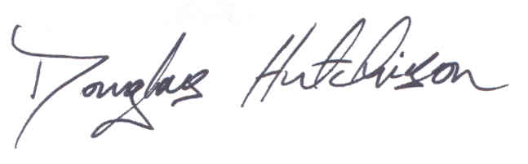

Signed:

Date 4th January 2021

**ANNEX A**

**Fuel Poor – Area Based**

The data zones noted below are in the bottom 5% of the SIMD and experience high levels of deprivation. These data zones will qualify for Fuel Poor- Area Based Flexible Eligibility.

* Ayr - S01012490
* Ayr - S01012489
* Ayr - S01012491
* Ayr - S01012492
* 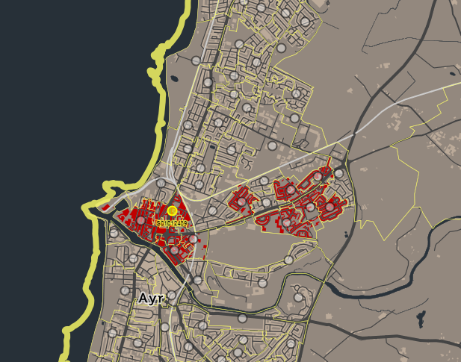Ayr - S01012502
* Ayr - S01012503
* Ayr - S01012501
* Ayr - S01012496
* Ayr - S01012497
* Ayr - S01012498
* Girvan - S01012425
* Girvan - S01012426

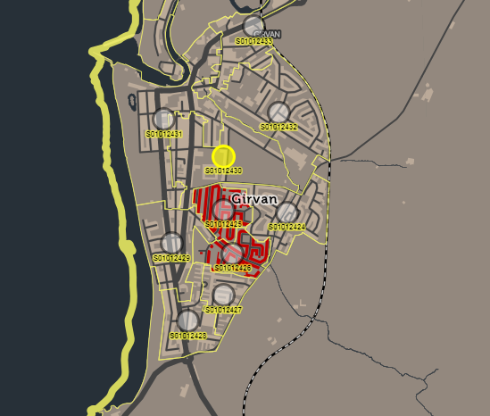

1. OfGEM (2018). *Energy Company Obligation (ECO3) Guidance: Delivery Version 1*
2. South Ayrshire Council (2017). *Local Housing Strategy 2017-22*
3. OfGEM (2018). *Energy Company Obligation (ECO3) Guidance: Delivery Version 1*
4. OfGEM (2018). *Energy Company Obligation (ECO3) Guidance: Delivery Version 1*
5. Scottish Government National Statistics (2018). *Poverty and Income Inequality in Scotland 2014-17.* Published 22 March 2018.