



**Tell Us Once** is a **free** service offered by HM Government

When someone has died, there are lots of things that need to be done, at a time when you probably least feel like doing them.

Tell Us Once is voluntary to use and very helpful. It enables you to report a death only once, telling central and local government services securely and confidentially without you having to inform them individually.

**A short information video explaining the Tell Us Once service can be viewed via YouTube:** [**https://www.youtube.com/watch?v=Xw0Ob59HFEY**](https://www.youtube.com/watch?v=Xw0Ob59HFEY)

Many services can be notified and these include:

* the local council - to update services such as Council Housing, Housing Benefit, Council Tax, Blue Badge and remove the person from the Electoral Register
* HM Revenue and Customs (HMRC) - to deal with personal tax and to update regarding Child Benefit and Tax Credits claims (contact HMRC separately for business taxes, like VAT)
* Department for Work and Pensions (DWP) - to update benefits information for example: State Pension, Universal Credit
* Passport Office - to cancel a British passport
* Driver and Vehicle Licensing Agency (DVLA) - to cancel a driving licence and to remove registered keeper details, possibly for up to five vehicles
* 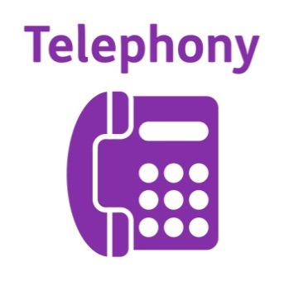Public Sector or Armed Forces Pension Schemes - to update pension records

**How do I use the service?**

After you have registered the death with the Registrar, the Registrar may complete the Tell Us Once service with you at the same time.

Otherwise, the Registrar will provide you with a unique Tell Us Once reference number, which will enable you to access the service Online via GOV.UK at [**https://www.gov.uk/after-a-death**](https://www.gov.uk/after-a-death)

If you have been issued with a Coroners Fact of Death (Interim Death Certificate) you may still be able to use the service and the Registrar will advise you how to do so.

It will help you to have all the relevant information listed below about the person before using Tell Us Once:

* date of birth
* address of the deceased
* National Insurance number
* driving licence number
* vehicle registration number
* passport number

You will also need:

* details of any benefits or entitlements they were receiving, for example State Pension, Universal Credit
* details of any local council services they were receiving, for example Adult Social Services, Blue Badge, travel pass
* the name and address of their next of kin
* the name and address of any surviving spouse or civil partner
* the name, address and contact details of the person or company dealing with their estate (property, belongings and money), known as their ‘executor’ or ‘administrator’
* details of any public sector or armed forces pension schemes they were getting or paying into

**Please note**

- Permission is required from the next of kin, the executor, the administrator and anyone who was claiming benefits or entitlements jointly with the person who died, before you give their details.

- There is no need to follow-up contact after you have used Tell Us Once unless you don’t receive a confirmation from the relevant department after a reasonable period of time, in most cases a calendar month.

- Once the various agencies informed by Tell Us Once have received notification of the death, they will make any further contact if necessary with the bereaved family.

- Tell Us Once is not a claim to benefit, therefore please contact GOV.UK or the relevant department for advice.

- Tell Us Once does not notify any commercial organisations of the death and cannot arrange for redirection of post.