**South Ayrshire Council**

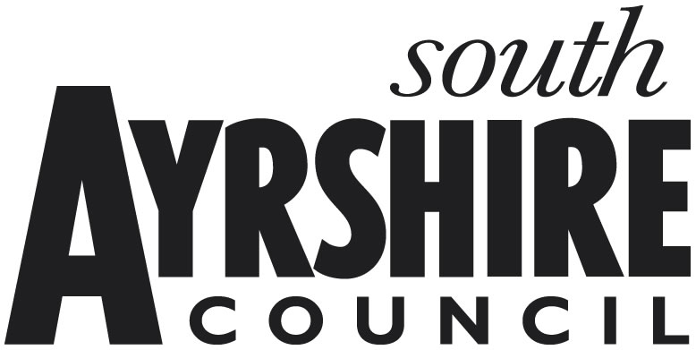

**Airports & Baggage Handlers Relief 2022-23**

**How your personal information will be used**

It is our responsibility to keep your information safe. We will only collect the minimum amount of personal information we need to process your application and we may verify the information you provide with information we currently hold on file. We may get information from third parties, or give information to them to check the accuracy of information, and we may share the information you have provided with relevant bodies to manage public funds, or prevent and detect fraud, as permitted by law. To find out what to expect when the Council collects your personal information, please visit our website - [**https://beta.south-ayrshire.gov.uk/privacy-policy**](https://beta.south-ayrshire.gov.uk/privacy-policy)

**Introduction**

This is an application form for relief available under [The Non-Domestic Rates (Coronavirus Reliefs) (Scotland) Regulations 2021, known as Retail, Hospitality, Leisure and Aviation Relief].

The 100% non-domestic rates relief for eligible properties in these sectors applies for the whole of 2021-22. [The list of eligible premises used wholly or mainly for Retail, Hospitality, Leisure and/or Aviation purposes are set out in schedules 1 and 2 of the regulations.]

If the property in question is already in receipt of 100% non-domestic rate relief in 2021-22, such as the small business bonus scheme, you should not apply for this relief.

Please complete the following questions:

**1. Ratepayer**

|  |  |
| --- | --- |
| **Ratepayer Name** |  |
| **Rates Billing Reference**  If Billing Account reference is not known, provide Assessor Property Reference (can be checked on <https://www.saa.gov.uk/>): |  |
| **Property Address (including postcode)** |  |

**Legal Structure of the Ratepayer (Please select the relevant category)**

|  |  |
| --- | --- |
| **Individual** |  |
| **Sole Trader** |  |
| **Partnership** |  |
| **Private Limited Company (LTD)** |  | **Company Number** |  |
| **Public Limited Company (PLC)** |  | **Company Number** |  |
| **Limited Liability Partnership (LLP)** |  | **Company Number** |  |
| **Charitable Organisation** |  | **Charity Number** |  |
| **Other (Please State)** |  |  | |

**2.** **Is your property currently vacant/unoccupied and in receipt of Empty Property Relief?**

**(Unoccupied does NOT include premises in suspended use resulting from lockdown restrictions)**

**(Please put an ‘X’ in the relevant box)**

**Yes No Don’t know**

**3.** **If the property is occupied, is it used wholly or mainly for one or more of the specified purposes listed below? (Please select relevant category)**

**Airports:**

|  |  |
| --- | --- |
| **Airport** |  |

**Handling Service:**

**In relation to aircraft:**

|  |  |
| --- | --- |
| **De-icing** |  |
| **Re-fuelling** |  |
| **Moving aircraft** |  |
| **Waste servicing** |  |

**In relation to aircraft passengers:**

|  |  |
| --- | --- |
| **Allocation of seating** |  |
| **Handling of baggage** |  |
| **Supervision of boarding** |  |

**YES / NO**

**4. Are you responsible for the rates for any other properties in Scotland?**

**If the answer is YES to question (4), please provide details of the address and rateable value for each property. A copy of the latest rates notice is required if the property is not in South Ayrshire. (Do not include any domestic dwelling that is subject to Council Tax)**

|  |  |  |  |
| --- | --- | --- | --- |
| **Property Address** | **Rates Reference** | **Rateable Value** | **Occupied** |
|  |  |  | **YES / NO** |
|  |  |  | **YES / NO** |
|  |  |  | **YES / NO** |

**5. Declaration**

Please read this declaration carefully before you sign and date it.

* I am duly authorised by the Ratepayer to make the application.
* I declare that the information given on this form is correct and complete to the best of my knowledge.
* I authorise the Council to make any necessary enquiries to check the information.
* I authorise the Council to cross check the information with other Councils in Scotland.
* I undertake to advise the Council of any change of circumstances, including the occupation / vacation of any other property I may occupy in Scotland which may affect liability for Non-Domestic Rates Relief.
* I understand that if I give information that is incorrect or incomplete or fail to report changes in circumstances, I (or the Ratepayer I represent) may be prosecuted.
* I understand that the Council will reclaim any incorrectly awarded Non-Domestic Rates Relief.
* I have read and understand the statement above about the use of personal information, the Revenues privacy notice is available at [south-ayrshire.gov.uk/article/27284/Other-services](https://beta.south-ayrshire.gov.uk/article/27284/Other-services)
* I claim the above relief from non-domestic rates liability.

|  |  |
| --- | --- |
| Applicant Name |  |
| Capacity (e.g. Owner; Tenant; Agent; Employee) |  |
| Telephone Number |  |
| E-mail Address |  |
| Contact Address |  |
| Your Signature |  |
| Date |  |