SoSouth Ayrshire Charitable Trust

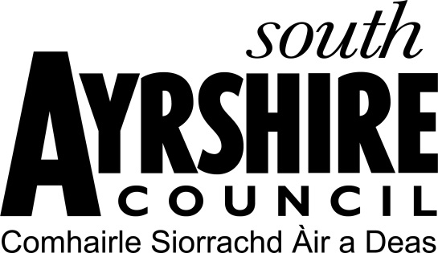

Group Grant Application Form - Ayr

The South Ayrshire Charitable Trust was created in 2015. Its purposes are as follows:-

- The prevention and relief of poverty
- The relief of those in need by reason of age, ill health, disability, financial hardship or other disadvantage
The beneficiaries of the Trust Fund are the residents from time to time of the town of Ayr. In furtherance of the Trust Purposes, the Trustees may make grants from the Trust Fund to:
- Individual residents of the Trust Area
- Groups, companies, associations or other organisations operating in the Trust Area who provide facilities, services or other assistance in accordance with the Trust Purposes which has a benefit to residents of the Trust Area.
The maximum grant available is £1000.

NB - the award of any grant is at the sole discretion of the trustees of the South Ayrshire Charitable Trust

The closing date for applications is 26th September by 5pm.

1 | Name of group / organisation:  Meeting Place or office address:  Postcode:  Office Tel No:  Email Address:  Website:

2 | Name of main contact:  Position in organisation:  Address  Postcode:  Tel No:  Email Address:

3 | What type of group / organisation are you? | Please tick all that apply:
3 | Constituted but not recognised as a charity
3 | Constituted and recognised as a charity (insert Charity number)
3 | Constituted and registered for VAT
3 | Other (please specify)

4 | When was your organisation formed?

5 | How many members?
5 | Aged under 18? |  | Aged 18 - 64 |  | Aged 65 plus

6 | Is membership open to all?
6 | Yes |  | No
6 | If no describe limits to membership:

7 | Number of staff employed? (if any)

8 | Affiliation (if any) to other Groups / Associations:

9 | What are the main activities of the group / organisation?

10 | Purpose of grant application – please advise how the grant funding would be utilised:

11 | How would the grant funding to your organisation fulfil the trust purposes and how would it benefit the residents of Ayr?

12 | What are your projected outcomes:

13 | Please include projected numbers and ages of beneficiaries:
13 | Aged under 18? | Aged 18 or over? | Elderly / Pensioner?

14 | How do you know there is a need for this project / initiative?

15 | Total cost of project/activity for which grant funding is sought. (Please provide at least 2 quotes, if applicable)
15 | Item | Amount
15 |  | £
15 |  | £
15 |  | £
15 |  | £
15 | Total Project Cost | £

16 | Your Contribution | £
16 | Contribution from other funders | £
16 | Amount of grant requested  (please indicate a specific amount – do not use phrases such as 'as much as possible' or 'at the Trust's discretion’) | £

17 | OTHER FUNDING. Have you applied for, or received, grants from any other body for your project/activity?  If so, please give details of to whom and how much (Please continue on a separate sheep if required)
17 | Body:
17 | Amount applied for:
17 | Amount received:
17 | OR
17 | When applied:
17 | When decision expected:

18 | Have you previously received funding from South Ayrshire Charitable Trust and, if so, have you completed and returned an evaluation report with evidence of spending, including receipts? Please provide details below:
18 | Date of Award | Amount Received | Evaluation Returned Yes/No

19 | Please detail all funding previously received from South Ayrshire Council:
19 | Name of funding Scheme | Date of Award | Amount Received

20 | USE OF INFORMATION  It is our responsibility to keep your information safe. We will only collect the minimum amount of personal information we need to process your application form.  We will only share your information with Legal Services Team and the Trustees for them to make a decision on the eligibility of your request.  We also have a duty to manage public funds, prevent and detect fraud so we may share the information you have provided with relevant bodies as is permitted by law.  We hold completed applications for five years before destroying them.  The Group acknowledge and agree

21 | Declaration  On behalf of (name of organisation)  I hereby apply for a grant on behalf of the Applicant from the South Ayrshire Charitable Trust as detailed above. I confirm that all information given is correct and that, if awarded a grant, the Applicant will comply with the following conditions of grant:-  The grant will be utilised for the purposes stated in this application and no other purposes. Any unused grant funds will be returned to South Ayrshire Charitable Trust.  The Applicant will complete an Evaluation Report on completion of the project or within twelve months of award, whichever is the lesser, detailing grant expenditure and providing evidence of spending including receipts.  The Applicant will accept responsibility for maintenance, and any other type of recurring costs, of the project for which the grant funding is provided.  I confirm I am an authorised signatory of the Applicant.
  Name (BLOCK CAPITALS):
  Signed: |  | Date:

22 | Please enclose the following documents:  A copy of your constitution or other founding document of your organisation  A copy of your recent accounts  A copy of your most recent bank statement  Budget for current financial year (if available)  Business Plan (if applicable)

Please email your completed form and supporting documents to:

Grants@south-ayrshire.gov.uk

Please note applications will not be considered for funding if you have received a grant from South Ayrshire Charitable Trust in previous years and not yet completed and returned the Evaluation Report along with evidence of spend.

