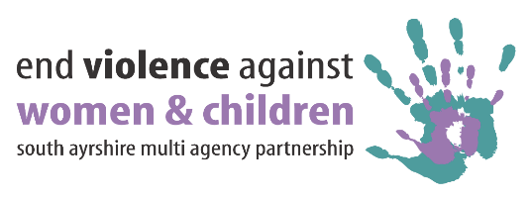

**16 DAYS OF ACTION**

**CALENDAR OF EVENTS**

|  |  |  |  |
| --- | --- | --- | --- |
| **DAY** | **TIME** | **EVENT** | **LEAD** |
| **Saturday 25th Nov**  **Sunday 26th Nov** | **All day** | **Social Media Messages across Communications** | |
| **Monday 27th November** |  |  |  |
|  |  |  |
|  |  |  |
| **Tuesday 28th November** | **9-3pm** | **Pan Ayrshire Commercial sexual exploitation conference**  **Park Hotel , Kilmarnock** | Heather.davidson@south-ayrshire.gov.uk |
|  | Trauma input | Womens aid |
|  |  |  |
|  |  |  |

|  |  |  |  |
| --- | --- | --- | --- |
| **DAY** | **TIME** | **EVENT** | **LEAD** |
| **Wednesday 29th Nov** |  | Womens safety session – all warriors Gym  All womens groups – gym session , womens aid input , networking lunch | **Heather.davidson@south-ayrshire.gov.uk** |
|  |  |  |
|  |  |  |
|  |  |  |
|  | Hystayria film showing  All Warriors Gym | Heather.davidson@south-ayrshire.gov.uk |
| **Thursday 30th November** |  |  |  |
|  |  |  |
|  |  |  |
|  | Hystayria film showing  Harbour arts centre , Irvine | **Heather.davidson@south-ayrshire.gov.uk** |
| **Friday 1st December** |  |  |  |
|  |  |  |
|  |  |  |
|  |  |  |

|  |  |  |  |
| --- | --- | --- | --- |
| **DAY** | **TIME** | **EVENT** | **LEAD** |
| **Saturday 2nd Dec**  **Sunday 3rd Dec** |  | **White Ribbon Trophy** | |
| **Monday 4th December** |  |  |  |
|  |  |  |
| **Tuesday 5th December** |  |  |  |
|  | Reclaim the night walk | [Heather.davidson@south-ayrshire.gov.uk](mailto:Heather.davidson@south-ayrshire.gov.uk)  Karen |
| **Wednesday 6th December** |  |  |  |
|  |  |  |
|  | Hystayria film showing  Dean castle , Kilmarnock | **Heather.davidson@south-ayrshire.gov.uk** |
| **Thursday 7thth December** |  |  |  |
|  |  |  |
| **Fri 8th Dec** |  |  |  |
|  |  |  |
|  |  |  |
| **Sat 9th Dec**  **Sun 10th** |  |  |  |

***PLEASE NOTE***



**16 Days of Action to end Violence Against Women and Children**

The 25th November is the International Day for the Elimination of Violence Against Women and marks the start of White Ribbon Scotland’s 16 Days of Action to End Violence Against Women. The 16 Days of Action takes place every year in countries all over the world, to tackle violence against women and engage public local activism to fight for this cause and ends on Human Rights Day which is the 10th December.

South Ayrshire’s Violence against Women Partnership (VAWP) will be raising awareness of White Ribbon Scotland and will be supporting the 16 Days of Action to End Violence Against Women and girls.

To show your support you can sign the @WhiteRibbonScot pledge to never commit, condone or stay silent about #VAW for #16days <http://www.whiteribbonscotland.org.uk/makepledge>

Read about what men can do to end #VAW in the new @WhiteRibbonScot resource #16days http://www.whiteribbonscotland.org.uk/files/WhatMenCanDo-Interactive%20version.pdf