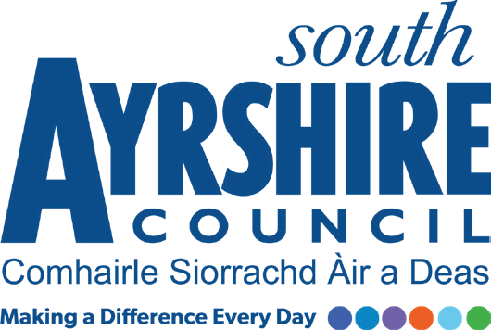



**Early Learning and Childcare**

Consultation Findings 2022

# **Overview of Consultation**

The consultation took place between 24th January 2022 – 6th February 2022.

From August 2021 children in South Ayrshire aged 3-5 yrs and eligible 2 yr olds have had access to the increased offer of 1140 hours per year of Early Learning and Childcare (ELC).

South Ayrshire council sought the views of parents/carers on the impact of the increased offer and the difference it is making for our families. We also wanted to find out what parents want for delivery of ELC which meets the needs of children and families in our communities now and in the future.

The following information gives an overview of the findings from this consultation and a summary of comments.

403 parents/carers responded to the survey.

Of those responding 389 were parents, 6 carers, 6 grandparents and 2 identified as other.

97.7% of those responding to the survey were residents of South Ayrshire.

309 parents/carers stated they had children aged between 3-5 yrs. 78 stated they had children aged 0-2 years. 74 with children aged 2-3 yrs. 187 stated they ha children aged 5-12 yrs and 29 from those with children aged 13 yrs and above.

**1. We asked parents/carers to indicate the services they would be interested in using, now or in the future?** **(parents were asked to tick all that apply)**

The majority of responses, (62%), were for services for children aged 3-5 yrs eligible for funded ELC. Less than half, (16.5%) were for services for 2 -3 yr olds funded through eligibility.

A few parents/carers, (11%) stated they would be interested in paid for services for children aged 0-3yrs.

|  |  |  |  |
| --- | --- | --- | --- |
|  | ELC for Birth – Up to 3 years paid for by parent/carer |  | 10.67% |
|  |  |  |  |
|  | ELC for 2 years up to 3 years paid for by parent/carer |  | 11.17% |
|  |  |  |  |
|  | ELC for 2 years up to 3 years funded where eligibility criteria applies |  | 16.42% |
|  |  |  |  |
|  | ELC for 3 years – 5 years old funded |  | 61.74% |
|  |  |  |  |

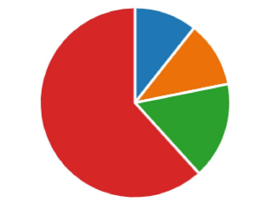

**2. We asked parents/carers to tell us what is important to them when choosing an ELC provider? (parents were asked to choose the 3 most important)**

25% of responses indicated ‘my child has the opportunity to learn, play and socialise’ as the most important when choosing an ELC provider. 20% of responses felt that a service which was close to where they live or work was also important. 18% indicated reputation and flexible session times which suited family circumstances were also important factors.

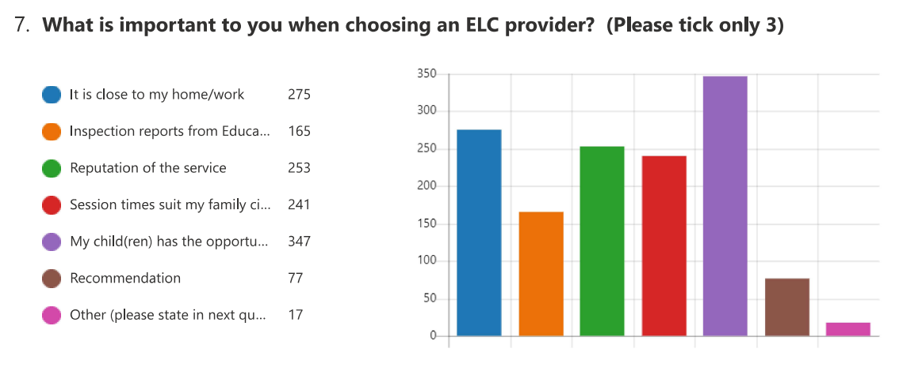

|  |  |  |
| --- | --- | --- |
|  | It is close to my home/work | 19.99% |
|  |  |  |
|  | Inspection reports from Education Scotland and Care Inspectorate | 12.06% |
|  |  |  |
|  | Reputation of the service | 18.39% |
|  |  |  |
|  | Session times suit my family circumstances | 17.51% |
|  |  |  |
|  | My child(ren) has the opportunity to learn, play and socialise | 25.22% |
|  |  |  |
|  | Recommendation | 5.60% |
|  |  |  |
|  | Other (please state in next question) | 1.24% |

**3. We asked parents/carers what the barriers are, if any, for accessing ELC services?**

The majority of responses from parents/carers, (60%), stated there were no barriers to accessing ELC. A few, (14%), stated that where they needed to pay for ELC it was too expensive and 13% felt the hours offered weren’t flexible enough.

|  |  |  |
| --- | --- | --- |
|  | I don’t want it or don’t need it | 2.46% |
|  |  |  |
|  | For ELC I need to pay for, it is too expensive | 14.29% |
|  |  |  |
|  | The hours are too inflexible | 13.17% |
|  |  |  |
|  | It is too far from home or unavailable in my area | 4.02% |
|  |  |  |
|  | I am eligible for funded ELC but can’t find a place for my child | 2.23% |
|  |  |  |
|  | Not applicable | 59.60% |
|  |  |  |
|  | Other (please state in next question) | 4.24% |

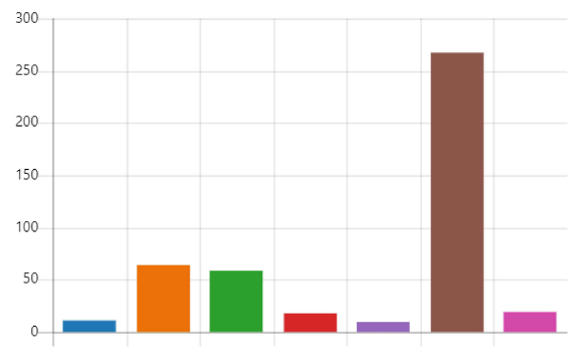

**4. We asked parents/carers what their preference would be for accessing funded hours of ELC? (parents were asked to tick all that apply)**

The majority, (59%), said their preference would prefer a Local Authority EYC. A few stated they would opt for a Private Nursery or childminder. 21% stated they felt Local Authority EYC, Private Nursery and/or childminder are all equally important.

|  |  |  |
| --- | --- | --- |
|  | Local Authority Early Years Centre | 59.21% |
|  |  |  |
|  | Private Nursery | 14.06% |
|  |  |  |
|  | Childminder | 5.15% |
|  |  |  |
|  | All are equally important | 21.39% |
|  |  |  |
|  | Other (Please state in next question) | 0.20% |

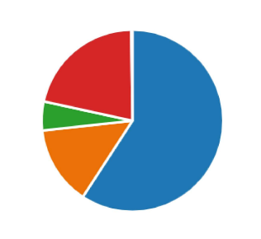

**5. We asked parents what options for the delivery of funded hours best suited their family needs?**

The options are as follows:-

* Term Time Monday to Friday 9 a.m. – 3 p.m.
* Full Year Monday and Tuesday 8 a.m. – 6 p.m. and Wednesday 8 a.m. - 12.30 p.m.
* Full Year Wednesday 2.30 p.m. – 6 p.m. and Thursday and Friday 8 a.m. - 6 p.m.
* Full Year Monday- Friday 8 a.m. – 12.45 p.m.
* Full Year Monday – Friday 1.15 p.m. – 6 p.m.

The majority of responses, 70% said the 9-3 term time option suited them best.

A few (9%) chose the full year extended morning 8 a.m. – 12.45 p.m. With 6% choosing the full year 2.5 day option at the beginning of the week and 5% chose the 2.5 day option at the end of the week. 1 % chose the full year extended afternoon option and 4% had no preference.

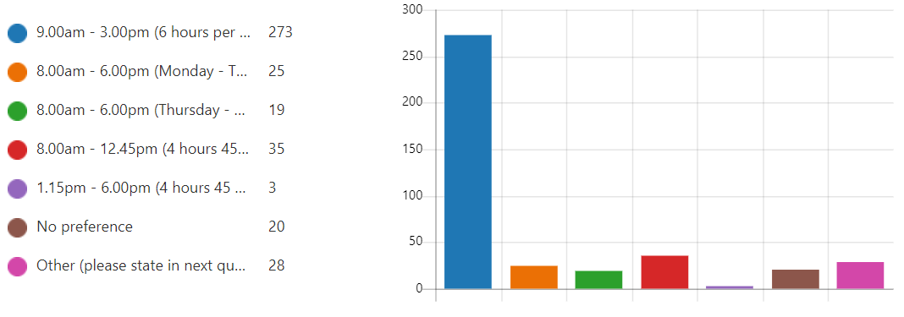

|  |  |  |
| --- | --- | --- |
|  | 9.00am - 3.00pm Term Time | 69.64% |
|  |  |  |
|  | 8.00am - 6.00pm (Monday - Tuesday and Wednesday morning - 8.00am - 12.30pm) Full Year | 6.38% |
|  |  |  |
|  | 8.00am - 6.00pm (Thursday - Friday and Wednesday afternoon - 2.30pm - 6.00pm)  Full Year | 4.85% |
|  |  |  |
|  | 8.00am - 12.45pm (Monday to Friday) Full Year | 8.93% |
|  |  |  |
|  | 1.15pm - 6.00pm Monday to Friday) Full Year | 0.77% |
|  |  |  |
|  | No preference | 5.10% |
|  |  |  |
|  | Other (please state in next question) | 4.34% |

**6. We asked parents/carers what difference, if any, access to the statutory 1140 hours of funded early years provision has made to their family? (parents were asked to tick all that apply)**

Children’s learning and development has improved was seen as the greatest impact with 28% of total responses. 23% of parents/carers indicated the difference the 1140 hrs had made to them being able to work and/or study with 22% stating the increase in hours has reduced the burden on other family members/friends to support with childcare.

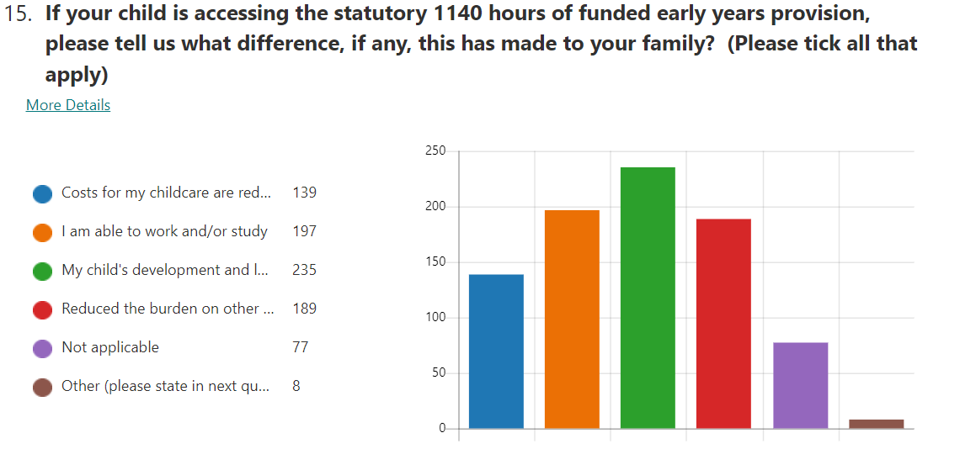

|  |  |  |
| --- | --- | --- |
|  | Costs for my childcare are reduced | 16.45% |
|  |  |  |
|  | I am able to work and/or study | 23.31% |
|  |  |  |
|  | My child's development and learning has improved | 27.81% |
|  |  |  |
|  | Reduced the burden on other family members/friends to support childcare | 22.37% |
|  |  |  |
|  | Not applicable | 9.11% |
|  |  |  |
|  | Other (please state in next question) | 0.95% |
|  |  |  |

**7. We asked parents/carers to indicate which area in South Ayrshire they would like their child to attend ELC?**

The areas with the highest demand for ELC include Girvan 22%, Ayr South 20%, Prestwick 17% and Troon 13%.

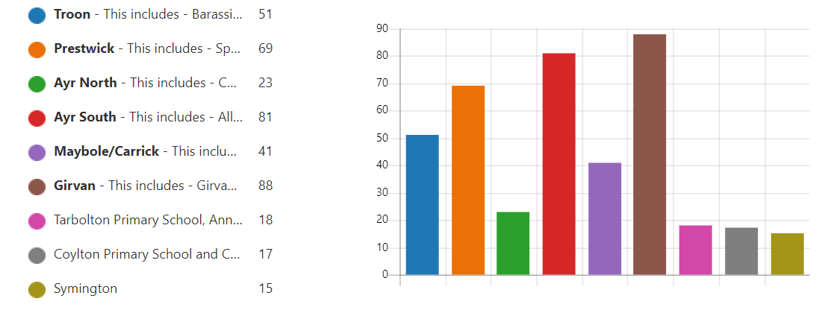

|  |  |  |
| --- | --- | --- |
|  | Troon | 12.66% |
|  |  |  |
|  | Prestwick | 17.12% |
|  |  |  |
|  | Ayr North | 5.71% |
|  |  |  |
|  | Ayr South | 20.10% |
|  |  |  |
|  | Maybole/Carrick | 10.17% |
|  |  |  |
|  | Girvan | 21.84% |
|  |  |  |
|  | Tarbolton/Annbank | 4.47% |
|  |  |  |
|  | Coylton | 4.22% |
|  |  |  |
|  | Symington | 3.72% |

**8. We asked parents/carers if Gaelic medium ELC provision was available in South Ayrshire would this be something they would wish to access for their child?**

Most parents, 78%, stated they would not be interested in Gaelic medium ELC provision.

|  |  |  |
| --- | --- | --- |
|  | Yes | 21.84% |
|  |  |  |
|  | No | 78.16% |
|  |  |  |

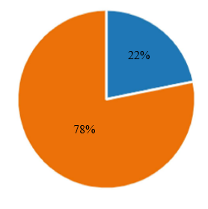

**Summary of Comments**

We offered parents/carers the opportunity to add comment on planning for future ELC delivery in South Ayrshire. A summary of the comments are as follows.

Parents/carers were keen to have the opportunity to purchase additional hours/sessions for their children and for children to have the opportunity to access services like breakfast clubs.

There were a number of comments on choice and flexibility; some parents/carers would like to see more flexible options whilst some thought the 9-3 session was too long, particularly for the youngest children.

Comments were made on the admissions priorities for South Ayrshire Council with some parents requesting priority for ELC where there are siblings in the primary school and the inclusion of catchment areas in the admissions priorities. Parents/carers also commented on the need to apply for both ante pre and pre school year.

Parents/carers wanted to see nurturing spaces developed in our settings with opportunities for children to have a nap, have more free flow to outdoors, attend swimming lessons, have musical instrument tuition, learn a second language and for menus to provide more variety.

There were also requests for more information on what happens during a day in an EYC, opportunities to meet with key workers more frequently and clarity on the bank/public holidays, particularly for children accessing full year options.

We will review our current provision taking into consideration the result of this consultation and comments from parents.

| **You Said** | **We did** |
| --- | --- |
| **Purchase of Additional Hours**   * Introduce opportunity to purchase additional hours * Option to purchase hours for 2 yr olds * Clarity on the sale of additional hours * Opportunity for nursery aged children to access wrap around care services like breakfast club and after school club where the EYC is attached to a school. | For the past few years parents/carers in South Ayrshire have had the opportunity to purchase additional hours/sessions in our EYCs where space and staffing allows. This discretionary service was on hold due to the pandemic and ongoing implications of covid-19 on staff and service delivery. This discretionary service resumed at the start of session in August 2022. Further information can be found here:- <https://beta.south-ayrshire.gov.uk/article/28234/Purchase-of-additional-sessions>  Some schools offer breakfast clubs and after school provision, normally for school aged children. Parents can find information on these services directly from the school.  Our Out of School Childcare service offers after school and school holiday childcare for children aged 3 yrs – 14 yrs. Currently these services operate in Annbank Primary, Struthers Primary (for Muirhead and Struthers), Dundonald Activity Centre and Symington Community Centre. For more information please visit our web page here:- <https://www.south-ayrshire.gov.uk/out-of-school-childcare/> |
| **Flexibility and Choice**   * More flexible options * Increase flexibility to suit working patterns * Opportunity to choose days rather than dictated * Access term time hours in a flexible way * Provision to use hours between different providers * Longer hours and 2 yr old provision in rural EYC * Hours offered for ELC need to be reflected at primary school. When child goes to school this affects the child by changing the routine * 9-3 too long a day for younger children * Flexible drop off and pick up * 9-3 option at Troon EYC | In South Ayrshire parents/carers have had access to the increased offer of 1140 hrs prior to the national roll out in August 2021. 13 of our EYCs are open 8-6 full year with a range of flexible options. Information can be found here:- <https://www.south-ayrshire.gov.uk/article/26976/Register-for-Early-Learning-and-Childcare>  ELC services are regulated by the Care Inspectorate and registered for a specific number of children. In our 8-6 EYCs our early years staff work shifts to accommodate attendance patterns. Unfortunately, we are unable to offer a fully flexible approach for parents/carers to access their funded hours.  Parents have the option to access their funded entitlement between 2 providers as a ‘blended’ place between Local Authority and/or funded provider settings. Details of funded providers working in partnership with South Ayrshire Council can be found here [Register for Early Learning and Childcare - South Ayrshire Council (south-ayrshire.gov.uk)](https://beta.south-ayrshire.gov.uk/26976)  Children aged 2 yrs who meet eligibility criteria are entitled to 1140 hrs of funded ELC. 23 of our EYCs provide places for eligible 2 yr olds. You can find more details here <https://beta.south-ayrshire.gov.uk/article/24033/Nursery-places-for-2-year-olds>  1140 hrs are an entitlement, not a requirement. Parents can choose to take all or some of the hours available. The Head Teacher/Centre Manager will be able to discuss local arrangements with you.  We continue to work on our expansion plan which includes a new stand alone EYC and an extension to Space Place EYC in the Prestwick area with both due to open August 2022. We are building a new EYC at Struthers Primary Troon and an EYC as part of the new campus in Maybole. We continue to look at suitable options for the EYC at Troon Primary. |
| **Priorities**   * Priority for ELC where there are siblings in the primary school * Include catchment areas in the admissions priorities | Places in our EYCs are allocated according to our admissions priorities which can be found here [Register for Early Learning and Childcare - South Ayrshire Council (south-ayrshire.gov.uk)](https://beta.south-ayrshire.gov.uk/26976)  Not every Primary School in South Ayrshire has an EYC therefore we are unable to offer priority to those who have siblings in the school or allocate places according to catchment areas. |
| **Additional Support Needs (ASN)**   * ELC provision for children with ASN * Information on which provisions had staff with enhanced training and understanding of ASN * Sign Language | All our EYCs are inclusive and staff support the needs of children with a range of additional support needs and work in partnership with other agencies.  Some of our EYCs use Makaton supporting children with communication difficulties in early years. Some of our centres have Makaton accreditation. |
| **Environment and Opportunities**   * Quiet room for those who need a nap during the day * Nurturing environments * Free flow access to outdoors * As much access to outdoors and nature as possible * Swimming lessons * Review of menus for more variety. * Musical instrument tuition and second language from a qualified languages teacher * Better staffing levels to take account of newly qualified to allow senior and experienced staff time to support and supervise * Smaller ratios adult:child * links to school to support transition | All our EYCs are nurturing environments with space for children to rest and relax when needed and for our youngest children we have spaces where they can sleep if needed.  Almost all our EYCs have direct access to spaces where children can choose to play and learn outdoors. Our EYCs make the most of our local green spaces and beaches.  There are currently no plans to introduce swimming lessons for children in our local authority EYCs.  All meals provided follow nutritional guidelines ‘Setting the Table’ for children aged under 5 yrs. Menus are varied and include either a starter and main course or a main course and dessert. Menus can be found here:- <https://www.south-ayrshire.gov.uk/article/24676/Early-Years-Centres-menu>  Some of our EYCs introduce children to a second language e.g. Gaelic/French/Spanish. Children engage in music, songs and rhymes, days of the week, colours and food. Children have opportunities to explore and experience music and instruments through their day to day play and learning. As a pilot this session children in one of our EYCs have had the opportunity to engage with a specialist music teacher supporting early phonics skills as well as introduction to musical instruments.  Our EYCs are staffed according to ratios set by the Care Inspectorate. Staff have access to training and time to support their professional learning.  New staff follow the Scottish Government ELC National Induction Resource and have a mentor within the setting to support them in the early stages of their career.  All our EYCs provide opportunities for transition coming into the setting, moving on to primary 1 and all stages in between. Most of our EYCs have provided parents/carers with the opportunity of a virtual visit to their setting and ‘meet the team’ using videos available on EYC social media and web sites. In some of our clusters, EYCs and funded providers are part of cluster wide transition projects. |
| **General**   * Remove the need to reapply to keep place up to starting P1 * More information as to what goes into my child’s day at nursery. * More parent teacher feedback * Clarity on the school holidays, public holidays and in service days. Wording on the information provided on the website is confusing e.g close/closed. Suggest a calendar style format with colour coding | Registering for a place when children are 3 yrs and 4 yrs allows parents/carers the opportunity of the flexibility and choice to meet family, work and other childcare commitments.  EYCs provide opportunities for parents to discuss children’s learning and progress at termly personal care plan meetings. There are also opportunities to discuss any issues or concerns with staff at drop off and pick up times. Parents can also make appointments to meet with staff and the leadership team in our EYCs.  An easy to read calendar for EYCs with details of the school closures including school holidays, public holidays, bank holidays and in service days is now available as a download here:- <https://www.south-ayrshire.gov.uk/article/28234/Purchase-of-additional-early-learning-and-childcare> |