

**SOUTH AYRSHIRE COUNCIL PARKING STRATEGY 2020 – 2024**

***Ayr Parking Consultation 05/07/21 - 16/08/21***

***Report and Recommendations***

|  |
| --- |
| Document Control |

|  |  |  |  |
| --- | --- | --- | --- |
| **Revision** | **Author** | **Description** | **Effective Date** |
| 0 | BMcD | Draft for Elected Member consideration | 28/10/21 |
| 1 | BMcD | Updated to take account of current external factors and incorporating officer report. | 01/11/22 |

|  |
| --- |
| Introduction |

The [Ayr Parking Consultation](https://beta.south-ayrshire.gov.uk/article/29781/Ayr-Parking-Consultation) took place between Monday 5 July 2021 andMonday 16August 2021. The consultation covered all the various topics described within the [Parking Strategy](https://beta.south-ayrshire.gov.uk/media/2238/SAC-Parking-Strategy-2020-24/pdf/SAC_Parking_Strategy_2020-24.pdf?m=637612661736270000) and there were nine general overview questions posed in relation to the following key areas -

* Pay and Display and Limited Waiting On-Street Parking
* Off Street Parking
* Permit Parking
* Parking Periods (When Charges Apply)
* Ayr Seafront and the Streets Leading off the Esplanade

Consultees were guided towards the Parking Strategy document for a detailed explanation of the background and rationale behind the various topics and recommendations contained therein. The consultation page was designed to give a brief summary and description of each of the topics up for discussion with appropriate questions posed against each. Details of the consultation and the results are as follows:

|  |
| --- |
| Pay and Display and Limited Waiting On-Street Parking |

There is a mixture of Limited Waiting parking restrictions within streets located on the outskirts of the existing town centre controlled pay and display parking zone. The current arrangements were implemented many years ago when there were different demands for parking within the specific locations.

Mill Street and Smith Street are currently subject to 3 hours Limited Waiting. These restrictions were implemented prior to the construction of Ayr Central and were designed to create parking bay turnover through discouraging long term commuter parking associated with e.g. the nearby train station. The various shops and businesses concentrated within this end of the town are not adequately served by the current arrangements.

In Garden Street the existing Limited Waiting restriction is 1 hour. This is prohibitive compared with the 2 hour maximum stay applied within the busier town centre streets.

Nearby streets, namely George Street, River Street and River Terrace are subject to a maximum length of stay which is also out of alignment. The current 2 hour limit should be increased to 3 hours. As a result, the following three questions were posed and the results generated are shown in the associated graphs:-

Question 1

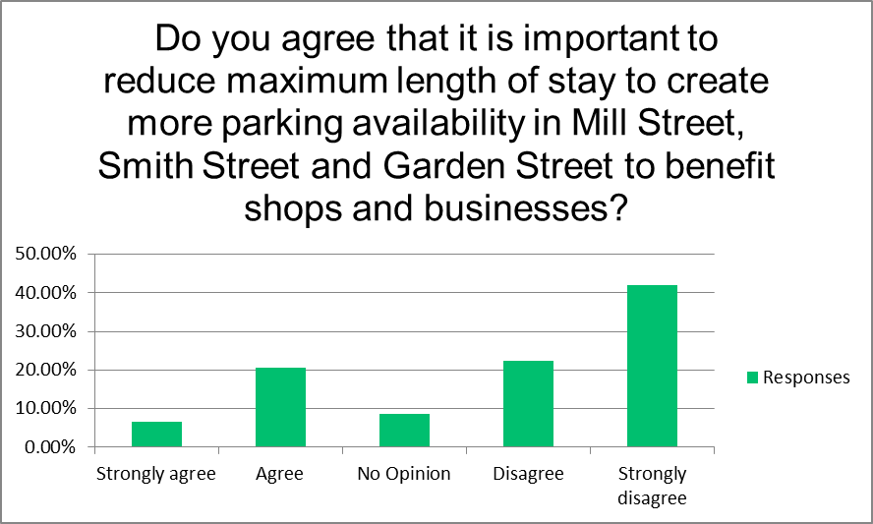

|  |
| --- |
| **27.12% of responses received were positive whereas 64.37% were negative.** |

Question 2

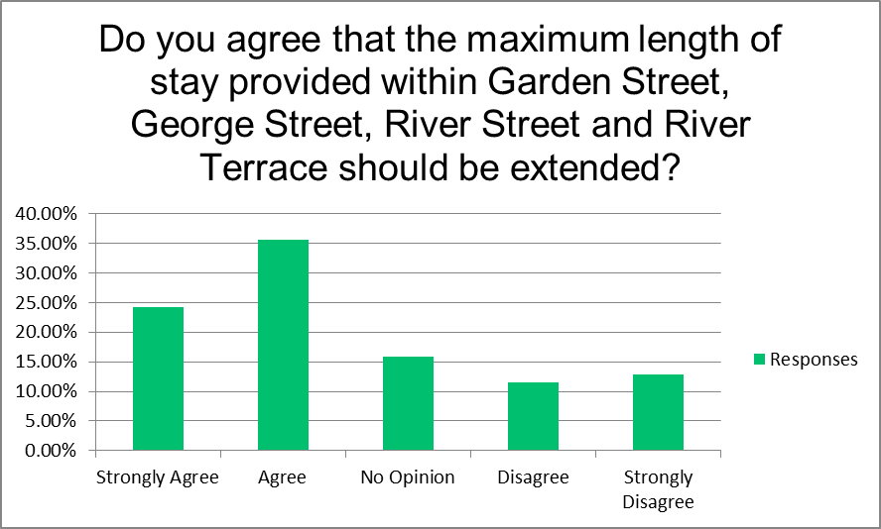

|  |
| --- |
| **59.76% of responses received were positive whereas 24.36% were negative.** |

Question 3

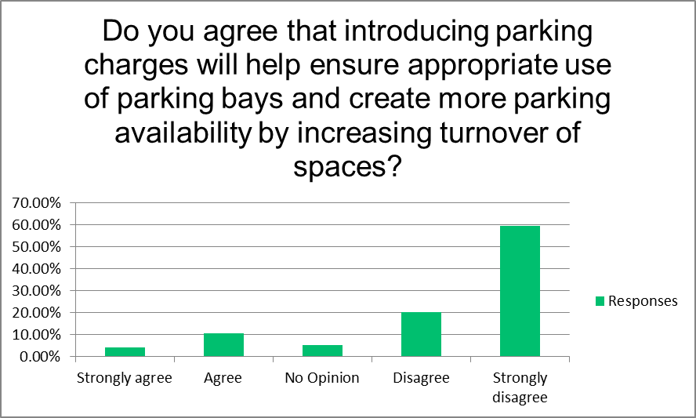

|  |
| --- |
| **15.01% of responses received were positive whereas 79.56% were negative.** |

|  |
| --- |
| Off Street Parking |

There are currently three charging car parks within the town centre located at Kyle Street, Barns Crescent and Charlotte Street. All other existing Council car parks are free of charge. The Strategy recognises the need to better manage these facilities to encourage a greater turnover of spaces particularly during peak periods.

A more integrated approach to managing the Council’s car parks which takes account of seasonal and peak period demands which also ensures a consistent approach and the best use of the facilities on offer, all to the benefit of customers of the town centre businesses and amenities, needs to be developed. Only one question was posed in this regard as detailed below:

Question 4

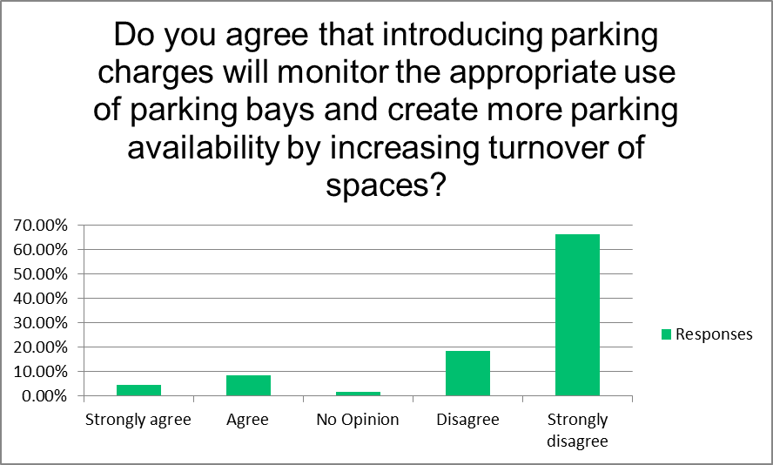

|  |
| --- |
| **13.08% of responses received were positive whereas 85.03% were negative.** |

|  |
| --- |
| Permit Parking |

Again, as detailed in the Parking Strategy, the existing permit systems in operation within Ayr require modification and overhaul. There are numerous types of permit parking arrangements in operation which have been in place for many years and are no longer fit for purpose. There is an existing scheme which offers street exclusivity to residents at the nominal cost of £0.50. There is insufficient provision to support various groups such as tradespersons, window cleaners and carers and there are further historic issues caused by indiscriminate parking in streets close to the Ayrshire College campus.

Proposals put forward to resolve these issues include the removal of residents only exclusivity within certain streets, review of the existing residents permit zone and the period the permits apply along with the introduction of an equitable charging structure.

It is also proposed to introduce a permit system which accommodates the needs of visitors, tradespersons and others. The areas subject to these proposals were listed in the consultation pages and the following two questions were posed:

Question 5

|  |
| --- |
| **37.29% of responses received were positive whereas 48.91% were negative.** |

Question 6

|  |
| --- |
| **69.62% of responses received were positive whereas 19.45% were negative.** |

|  |
| --- |
| Charging Periods |

South Ayrshire Leadership Panel have previously reviewed the charging periods across the town’s on and off street pay and display areas. The existing charging periods have been in place since 2012 and are based on established practise dating back to the mid-1990s. Charges currently apply as follows:

* On street parking Zone A - 8am - 6pm Mon - Fri, 8am - 1pm Sat
* On street parking Zone B - 9.30am - 5pm Mon - Fri, 9.30am - 1pm Sat
* Off street car parks - 24 hours 7 days per week

There is no practical basis to continue with the different charging periods and it is considered it would be beneficial to adopt a more consistent approach and the Leadership Panel have, therefore, proposed to adopt a new charging period of:-

* 11am - 6pm Monday - Saturday

Therefore, the following two questions were posed:

Question 7

|  |
| --- |
| **43.11% of responses received were positive whereas 47.73% were negative.** |

Question 8

|  |
| --- |
| **66.39% of responses received were positive whereas 22.64% were negative.** |

|  |
| --- |
| Ayr Seafront and the County Buildings Area |

During the peak season the Esplanade is regularly subject to unregulated parking over it entire length on both sides of the road. There is an opportunity to create further additional parking north of Bath Place (whilst still preserving the existing cycle route) and there are known issues within the streets in proximity to the County Buildings such as Bath Place, Pavilion Road and Cassillis Street where the existing restrictions impose a three hour limit of stay and fail to accommodate residential needs as there is no permit system currently available.

The proposals put forward to address these issues included the introduction of on street parking charges along the Esplanade and the replacement of existing limited waiting restrictions also with on street charges (and a permit system) and the following question was posed:

Question 9

|  |
| --- |
| **22.92% of responses received were positive whereas 72.84% were negative.** |

|  |
| --- |
| Conclusions |

*Pay and Display and Limited Waiting On-Street Parking*

The results received to the questions posed in relation to these topics quite clearly indicate a resistance towards the imposition of new parking charges. Consultees are supportive of the proposals to increase the maximum length of stay where it is needed on-street but the parking industry established rationale put forward which outlines the belief that parking charges are a key lever to encouraging much needed parking space turnover is not accepted. The ability to monitor parking bays more effectively through the introduction of pay and display is also not commonly accepted.

The survey results also indicate that respondents do not accept the argument that Limited Waiting parking is more susceptible to abuse and more resource intensive to monitor and does not best serve the businesses they are designed to cater for. Parking Attendants have to patrol streets and record the details of every single vehicle during their first patrol. They then have to go back after the set period to repeat the process.

A more integrated approach to parking across the Council’s car parking estate which takes account of seasonal and peak demands would benefit the business community. Pay and Display removes the reliance on physical recording of data to monitor compliance and establish whether the desired turnover is achieved. This in turn frees up valuable resource which could be deployed elsewhere such as schools or any future patrols undertaken in relation to pavement parking enforcement.

Income generated can be reinvested in modern technologies and the maintenance of existing parking infrastructure. In ensuring adequate parking turnover businesses will benefit from the fact that customers are able to find parking close to these businesses. People can and do pay for the convenience of being able to park as close as possible to their chosen destination.

However, as we continue to monitor the effects of the Covid pandemic and the cost of living crisis on parking trends and acknowledge the fact that the demand for spaces continues to be well below pre-Covid levels, the arguments put forward for the introduction of new charges continues to be undermined.

*Permit Parking*

There were two questions posed to gauge the public’s opinions around the required changes to the existing permit parking systems currently in operation. The two main aspirations set out in the Parking Strategy are for the replacement of the existing systems with modern fit for purpose systems and also for the provision of a system which adequately caters for the different types of visitor parking sessions which aren’t currently provisioned e.g. tradespersons and carers.

The previous SAC Administration instructed the introduction of an equitable charge for residents parking permits which applies across the town regardless of location. That is to say, the cost of a permit for a citizen residing within the town centre pay & display zone should be the same as a resident of a residential street out with the zone.

The existing cost within the streets currently subject to resident’s only exclusivity such as Bellevue Crescent is currently £0.50 for the lifetime of the residency whereas a permit for a Fort Street resident is £50 per annum. There is no visitor permit option available under either system.

The proposals put forward, therefore, were for the removal of resident’s only exclusive streets to be replaced by shared used bays (residents/visitors/limited waiting), the addition of various new streets to the existing residents permit zones and also the provision of a new visitor permit scheme catering for the various groups which aren’t currently able to receive a permit.

The consultation responses to the two questions posed were not as polarised as the responses received in relation to parking charges. There was only an 11.62% difference between those for (37.29%) and those against (48.91%) the proposals for the removal of the resident’s only exclusive streets. It is not possible to determine where these respondents reside. As for the question regarding the provision of a permit option for visitors, there is clear support for the introduction of such.

*Charging Periods*

The previous SAC Administration instructed a change to the on and off-street charging period to 11am - 6pm and this proposal was also put to the general public through the consultation. Further explanation around the reasons for simplifying the charging period across the town centre pay & display zone was also given, however, this has generated slightly conflicting responses.

In response to the question posed in relation to the simplification of the charging period across the town centre, there was, almost, a 50/50 split between those who were for and those who were against the proposal. It may be that the rationale put forward wasn’t quite understood but despite the feedback received there is sufficient support for this initiative.

The feedback received in relation to the introduction of the free parking period between 9am and 11am was overwhelmingly in support of this proposal.

*Ayr Seafront and the County Buildings Area*

Proposals were put forward for an integrated approach to parking along the seafront and adjacent streets which were designed to better manage the facilities on offer. These proposals attracted a lot of attention from consultees and the responses received were overwhelmingly against the proposals.

The type of issues raised were in relation to the perception that parking charges would have a negative impact on summer tourism and there were further concerns raised regarding the proposed changes to the existing cycle route and also how these proposals linked to future SAC plans to redevelop the Esplanade.

In contrast with the situation elsewhere within the town, observations indicated that parking demand along the Esplanade remained at pre-Covid levels and were perhaps more acute due to the trend towards stay at home vacations or day trips. However, it is recognised that it is prudent to link any further parking plans for the Esplanade to the aforementioned wider redevelopment plans.

This might not necessarily be true of the nearby streets around the County Buildings and surrounding areas which either adjoin or sit within close proximity with the Esplanade. These streets remain subject to Limited Waiting restrictions which may continue to prove prohibitive to workers located within the County Buildings and other businesses within the surrounding area.

Residents of these streets also continue to be at a disadvantage due to a lack of permit options. Therefore, it is proposed to separate these proposals from the Esplanade proposals and present these to the public again during the second phase consultation.

|  |
| --- |
| Recommendations |

The various issues highlighted within each part of the consultation were clearly addressed within the Parking Strategy but perhaps they weren’t adequately conveyed within the consultation pages. The questions posed may also have been too general or technical in their wording and the fact that there was no provision for consultees to submit their views within a free text box may have been counterproductive.

There were further issues with the quality of the mapping made available to review the proposals which we seek to address within the second phase consultation.

Having reviewed the responses and also feedback received independently of the consultation there is a clear resistance towards parking charges which are viewed as regressive or anti-business. It is, therefore, proposed to proceed with a further Ayr parking consultation based on the following revised proposals:

* **Pay & Display and Limited Waiting**

Proposals around the conversion of Limited Waiting parking bays to Pay and Display in Mill Street, Smith Street and Garden Street and the proposal to extend parking charges into the Council’s free car parks shall be abandoned.

Proposals to increase the maximum length of Limited Waiting stay in Garden Street, George Street, River Street and River Terrace to 3 hours shall be promoted within the second phase consultation.

* **Permit Parking**

The further development of permit scheme proposals which take account of the feedback received shall be promoted within the second phase consultation.

* **Charging Periods**

The proposal to simplify the charging periods across the town shall be promoted within the second phase consultation. Whilst not subject to any further consultation at this stage, the proposal for a two hour free period between 9am and 11am shall be further examined and put to Members for further consideration at a later date.

* **Ayr Seafront and the County Buildings Area**

Proposals relating to the Esplanade shall be abandoned.

Proposals for the conversion of Limited Waiting restrictions to Pay & Display within the other streets within the vicinity of the County Buildings and the introduction of a residents permit system shall be refined and further promoted within the second phase of the consultation. These proposals will be linked to the proposals around permit parking in recognition of the shared use (residential/commuter) nature of these streets.