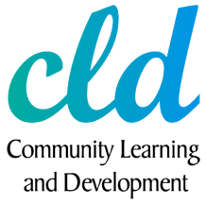

CLD 2021



CLD Learner Consultation





Please Select your Age Range

Please supply your Postcode

|  |  |  |
| --- | --- | --- |
| **PC** | **Count** | **%** |
| KA26 | 16 | 37% |
| KA6 | 3 | 7% |
| KA7 | 7 | 16% |
| KA8 | 9 | 21% |
| KA9 | 5 | 12% |
| KA10 | 2 | 5% |
| ka7 | 1 | 2% |

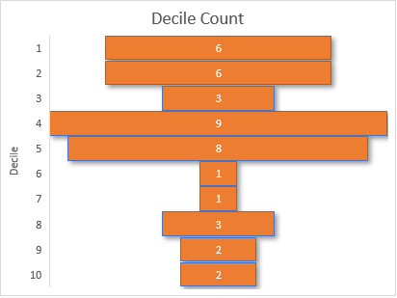

|  |  |
| --- | --- |
| **Decile** | **Count** |
| **1** | 6 |
| **2** | 6 |
| **3** | 3 |
| **4** | 9 |
| **5** | 8 |
| **6** | 1 |
| **7** | 1 |
| **8** | 3 |
| **9** | 2 |
| **10** | 2 |

What services / programmes / groups did you engage in over the past 3 years?

|  |
| --- |
| None |
| None |
| Online music classes, creative writing, work skills, spiritual development, history, story skills, mindfulness, yoga, swan autistic webinars |
| Church Property Committee and Church of Scotland Eldership and Management Board. Ayrshire Association of Burns Clubs and Alloway Burns Club. |
| None |
| None. |
| Ayr college |
| Online learning, employer based learning |
| AYR U3A FRENCH CONVERSATION WEEKLY GROUP MEETINGS OIR BADMINTON WEEKLY PLAYING SESSIONS |
| Online learning |
| None |
| Social services - fostering AC education course |
| None |
| None |
| None. |
| Adult Learning as a Tutor until Covid restrictions |
| Schools' groups, on-line learning; partnership working; training delivered on behalf of CLD; etc |
| None |
| Attended Basic IT Class and 1-1 tuition |
| Attended Living Life to the Full, WRAP, 1-1 Adult Learning, Attended Basic IT Class |
| Esol Adult Learning |
| ESOL class |
| ESOL |
| Adult Learning 1-1 |
| Youth club (sons) Online learning Family engagement |
| Adult learning group, online learning, ESOL class, parent and Child groups |
| Adult learning group, online learning, ESOL class and Parents AMD child groups |
| College |
| Access to Childhood Practice and Preperation to HNC Childhood Practice |
| Walking/gardening group |
| Wrap, Living life to the full, Girvan gardening and walking group, care course, Girvan community garden volunteering, z1 youth Trust parent hub, |
| Living life to the full |
| ı just engage ESOL Class |
| Swap Childhood practice |
| Family engagement officer |
| Swap group for childhood development |
| Adult learning group |
| Adult literacies |
| ESOL/Lit Book Group, Adult Learning Health Walking Group, 1-1 IT |
| ESOL class |
| Adult literacies and Basic IT course |
| 1-1 Literacy with Adult Learning and Employability and Skills |
| 1-1 help from Adult Learning |

What difference has this programme, group or service made to you?

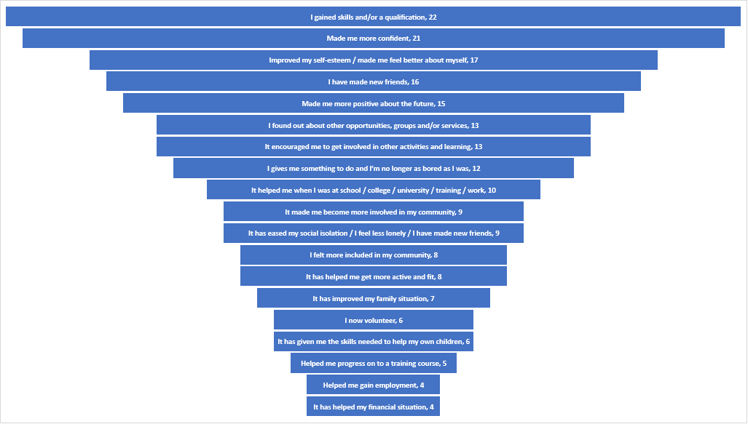

What do you think should be our priorities over the next 3 years?

|  |  |  |  |  |  |  |  |  |  |  |  |
| --- | --- | --- | --- | --- | --- | --- | --- | --- | --- | --- | --- |
| ID | Choice | 1st | 2nd | 3rd | 4th | 5th | 6th | 7th | 8th | 9th | 10th |
| 1 | Mental health & Wellbeing | 10 | 10 | 13 | 4 | 0 | 0 | 2 | 1 | 0 | 5 |
| 2 | Employability / Volunteering | 16 | 8 | 6 | 1 | 4 | 0 | 1 | 1 | 0 | 0 |
| 3 | Youth Work Provision / Youth Work in Schools | 5 | 11 | 6 | 6 | 4 | 0 | 3 | 3 | 2 | 2 |
| 4 | Sport & Physical Activity | 1 | 3 | 2 | 11 | 7 | 0 | 10 | 2 | 3 | 1 |
| 5 | Adult Learning | 3 | 5 | 4 | 6 | 4 | 0 | 2 | 11 | 3 | 3 |
| 6 | Family Learning | 1 | 4 | 2 | 5 | 8 | 0 | 4 | 6 | 4 | 1 |
| 7 | Digital inclusion | 4 | 1 | 3 | 3 | 5 | 0 | 7 | 0 | 9 | 3 |
| 8 | Outdoor Learning | 0 | 1 | 2 | 2 | 4 | 0 | 11 | 8 | 3 | 8 |
| 9 | Community Capacity / Support for local groups | 2 | 0 | 4 | 2 | 1 | 0 | 1 | 4 | 5 | 15 |
| 10 | Provision for older people | 1 | 0 | 1 | 3 | 6 | 0 | 2 | 7 | 14 | 9 |

What are the barriers from you attending our programmes or attending additional programmes? What stops you from attending?

|  |
| --- |
| Covid |
| Lack of interest , I have plenty to occupy my leisure time out With Council activities |
| Time, business cover, location if over stimulating |
| Health |
| None, I am just too old |
| None |
| Poorply advertised |
| Full time work and 3 kids |
| TIME ENERGY |
| Awareness |
| Transport |
| My age and the social volunteer work I already undertake with the Royal Air Forces Association and the Society of St. Vincent de Paul takes up all of my spare time. |
| Time |
| Poor health. |
| Time , childcare commitments, Covid restrictions |
| Covid. Have to consider social deprivation, closure of John Pollock Centre and the lack of other alternative venues in a deprived area. Cost of transport and lack of own vehicles, any socio-economic impacts can be greater for women. ie caring obligations, having to work outwith normal hours and lack of opportunity to attend any programmes. |
| Time |
| COVID has prevented me from attending classes and seeing my tutor. |
| COVID |
| The care of children and the distance and the time to arrive on time to get on the bus |
| COVID |
| Childcare, covid and time |
| Motivation was the biggest challenge. |
| Location Childcare Anxiety Money |
| Covid19 |
| Covid19 |
| Out with the programmes I have/will be attending the barrier is having the time to attend additional programmes |
| Travelling, don't drive. No bus pass, lack of finances, need to pick kids up at 3pm. |
| Work and childcare |
| Covid - 19 and travel |
| Childcare and location |
| Mostly my pain and discomfort lack of self esteem felling low |
| Child care |
| Covid |
| None |
| 90% would be mental health issues e.g. actually walking into a place and meeting new people are difficult. |
| Covid just now, time |
| Difficulties using online learning e.g. Zoom which I don't like using as I prefer to meet a tutor face-to-face. Online learning is made more difficult as I am deaf in one ear and it is difficult to understand. |
| Depression stops me+ other appointments. |

We want to make it as easy as we can for you to get involved in our services. What is the best way for you to get involved?

|  |
| --- |
| **Other Statements** |
| Prefer working with my own tutor face to face |
| Send work or activities to do at home to our address. |
| Building a bond first between tutor and learner. |
| Telegram |
| Prefer seeing a person one to one to learn. |
| Targeted support groups of peers eg autistic community |
| Attend a meeting. |
| Not relavent |

How can we improve your experience with CLD provision?

Is there anything else we can improve to make your experience with our services better?

|  |
| --- |
| No |
| Share what’s available on council site and in libraries and on Facebook so we can share |
| Report clear timely decisions. |
| I do not know |
| Forms / access material be available for on line filling in as opposed to manual writing with forms. |
| The programme seems to be directed at those who identify as deprived, socially excluded, or with behavioural issues. I think the programme needs to have a much more positive aura. The CLD goals are great, but you will not attract people to engage by characterising us as people with 'issues'. Please try to engage on a more positive and beneficial wavelength |
| No. |
| Ensure the CLD Plan is not too large and in plain English and deliver the services as that is the most important thing. Links with other partners - there has been e.g less engagement and none now with Aspire2Access, no Community Safety, Barnardo's etc. |
| No I am happy with everything I currently have. |
| Apart from improving the COVID situation everything is fine. |
| Offer technology classes to improve the class and send some homework to make learning easier. |
| Thats all |
| Training program for skill such as childcare, healthcare for who want to find jobs but do not have qualifications. |
| Better outdoor activities kayaking, water sports, cycling proficiency ( both my sons missed this due to covid) work capability finding out what I would be suited to with my different barriers I have now. |
| Not |
| Not |
| No |
| Meeting up to travel locally wee day trips to Ayr, Dailly, Barr, barrhill, Ballantrae etc? Walking a bit further afield.. Some of the wee hills so it's a bit more challenging? |
| Just advertise better I didn’t know about it until half way through the last course |
| ı dont have ıdea |
| Provision of childcare or time that suits drop off and pick up at school |
| More childcare |
| I wish to go back personally after Covid. I miss people from the adult learning group . |
| No |
| Open up the buildings to allow us to actually access the service providers. Until that can happen my learning can't progress. |
| Open the learning facilities |
| Allow in person meetings and learning. |
| At this moment I don't know. |

During the Covid-19 pandemic was there anything different we did to support you that was beneficial/or you enjoyed and you wish to be continued?

|  |
| --- |
| No |
| Courses online |
| Not that I can ecall |
| NO |
| None. |
| maybe more communication? |
| No. |
| N/A personally but aware of good work taking place across communities. |
| No I couldn't meet my tutor or attend my class. |
| I felt supported by calls and emails from LDW, 1-1 tutor and IT tutor. I wish for face-to-face to start soon. |
| Yes, I was enjoy the classes on line that is really helpful. |
| No |
| Fine |
| I enjoyed the Adult Learning Heath Walking Group. |
| Youth club - organised an online get-together for kids and provided home activities etc. I had constant online interaction with my family engagement officer this was a saviour for me.... I knew I was getting all the help I could possibly get.. this was invaluable for me. Having someone check in on me. |
| On line class |
| Remembering the Biosafety regulations |
| Keeping in contact and up to date with information that was useful and helpful |
| Zoom meetings, although prefer meeting outdoors, face to face... |
| The zoom worked for me as I had to go straight to work afterwards |
| Online Meeting |
| Blended learning |
| I have found Claire to be very patient with me as I am very hard to get in touch with at times and she is always very good at contact and not making it hard to reconnect after I have been out of touch |
| Great communication and involvement |
| I wish to continue... |
| On line support |
| Communication was good from the LDW as she kept in touch all the way through the pandemic. The walking group was beneficial both physically and mentally. |
| Got an ipad to keep my learning going on Zoom |
| Adult Learning and Employability and Skills kept in regular contact with me to assure me services were still there. |
| When we my tutor contacted me through the lockdown. |

In your own words, tells us what difference being involved in our services has had on you

|  |
| --- |
| Have not been involved, not interested |
| Makes me feel valued, validated instead of rejected |
| Not relavent |
| N/A |
| I find volunteering very beneficial an rewarding. A very much two way street. I hope I help others as I am for sure getting benefit from it. |
| Don't know. |
| I felt I improved the self-esteem of my Adult Learner |
| Some good joing working practices and engaged in worthwhile training delivered on behalf of CLD bu other partners. |
| Helped me to go out more and help me with bits of my learning. The computer course especially. |
| The biggest thing for me is giving me the confidence to get out of the house and learn new things. |
| The truth is I feel more confident and happy to talk whit someone else and express myself and It was really amazing how much being in this group has helped me |
| Whats app,zoom |
| I was shown I couldn't read words unless I used a certain colour of paper. |
| Myself and my sons have all gained alot more confidence in going outdoors and engaging with other people. I have learned new things and have more self esteem at being more capable than I thought I was. I wouldn't be as positive about the future without the services provided. |
| Excelent Service |
| I have obtained Many benefits |
| It has allowed me to do something for myself while being able to keep on my job. With it all being local it has allowed this to be possible to do both alongside one another. |
| Gets me out of house and gives me something to do |
| Meeting people, having a reason to leave house, something to look forward to, gaining certificates and some self esteem. |
| Everyone was friendly and not judging it showed me that I do have the spare time to sit for 2 hours every week and do something I want to do for myself |
| The best way to learn English. I realized that I improved my English better than before. However it is not enough yet. |
| Gained qualification for future jobs |
| I have felt more in control of my finances and feel a little more confident to sort out any other problems I have. I am still working on my confidence with communication and mixing ,also working on my pain and disability |
| It had allowed me to go on to do the HNC in childhood practise |
| I got lots of information and new knowledge and I became more confident, open for new people. I was lonely before. |
| More confident |
| It has kept me mentally sane. It gave me a purpose to keep going and helped keep my brain functioning. |
| Having the ipad has allowed me to do on line lessons believe in myself with the ipad continue with lessons with ipad |
| Improved confidence with writing and numbers and made me able to think about college at sometime in the future. |
| It has been beneficial except for the iPad because it is a nightmare to set up. |

What’s the best method to communicate with you? How do you want to find out what we offer?

Finally, is there anything you feel we should be offering as part of our programmes that we don’t currently offer?

|  |
| --- |
| Nothing |
| Forest school , horticulture and home veggrowing esp permaculture |
| Access to Council Committee Meetings. |
| I do not have gthe experience to offer afvice |
| None. It appears that you have all areas covered. |
| the Programmes are very Artsy and cultural. The programme maybe should be more balanced and offer employment training being linked to volunteering which could benefit the Council area and our environment. Not everyone want to be an artist, performer or work at the Gaiety. I think the leaders or CLD are themselves more Art and culture focussed. This flows down the program generally. This is not wrong, just saying it could be more balanced |
| No. |
| N/A |
| Everything is there in what I need with my 1-1 sessions and attending the computing class. |
| Happy with what there is. |
| Yes, of course, for the person that have children like me, they should have a nursery that does not allow us attend the facilities without having to worry about taking care of our children. |
| No |
| Health care program training for who want to find job in care sector |
| Better activities for the kids like water sports and cycling safely on roads etc When covid relaxes more activities for adults to interact in both fun ways to make friendship, and also in a learning environment learn new skills for work in a practical way ie... I would like to try dog grooming can you provide ways to do work experience for adults.? |
| Every thing is alright |
| Not |
| No |
| Music, playing/learning instruments, art, mindfulness, holistic therapies, yoga, keep fit, dance, swimming, bus/coach trips... Also for kids? |
| Childcare if needed |
| No |
| No |
| No |
| No |
| Resume in person meetings as soon as possible. |
| Being able to see my tutors face-to-face |