

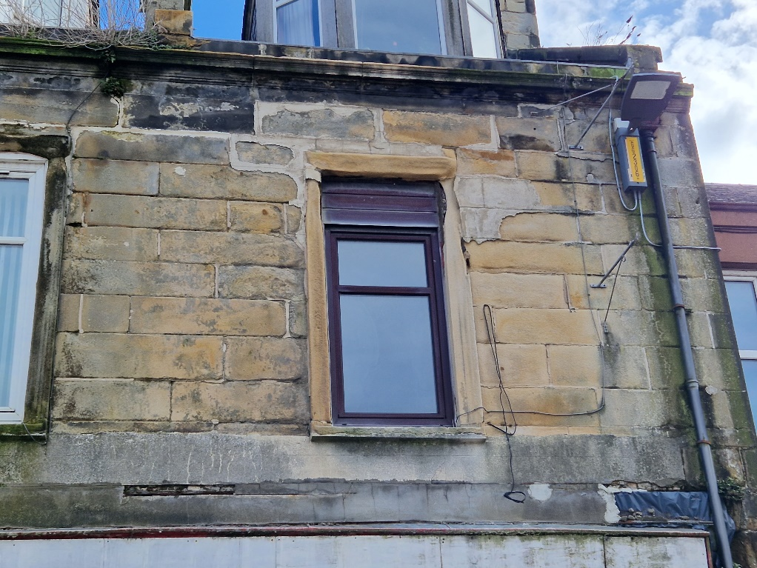

One bedroom upper flat in Girvan

Rent £350 per month

EPC Band Rating C

Council Tax Band A

**Features:**

Upper property

Double glazing

Gas central heating

Shower over bath

Carpet and Linoleum flooring

Pets allowed

Gas Hob

Built in Oven

Extractor fan hood

Unfurnished

Spacious hall cupboard

**Description**

Your Choice Lettings and Property Management are delighted to present to the market, this spacious 1 bedroom, upper flat on Dalrymple Street, Girvan.

This light and spacious flat is comprised of a large lounge, featuring a electric fire and overlooking the high street, a double bedroom located to the rear of the property as well as a generous sized kitchen and bathroom. The Kitchen has a new fitted oven as well as a fitted 4 ring gas hob and a built-in extractor fan above.

The décor of the flat is a neutral colour throughout with new carpets fitted in the living room, hallway and bedroom. The kitchen and bathroom have newly fitted linoleum. New double-glazed widows have been fitted in the kitchen, bathroom and bedroom. The bathroom has a separate shower fitted over the bath with a half glass door. There is a generously sized storage cupboard at the end of the hallway with a light and electric socket.

The local area has a range of amenities on the doorstep and nearby, and only a couple minute walk to the beach front. There are great transport links close by, where you will find buses and trains that can take you to Ayr and Glasgow as well as Stranraer, where you can access ferry links.

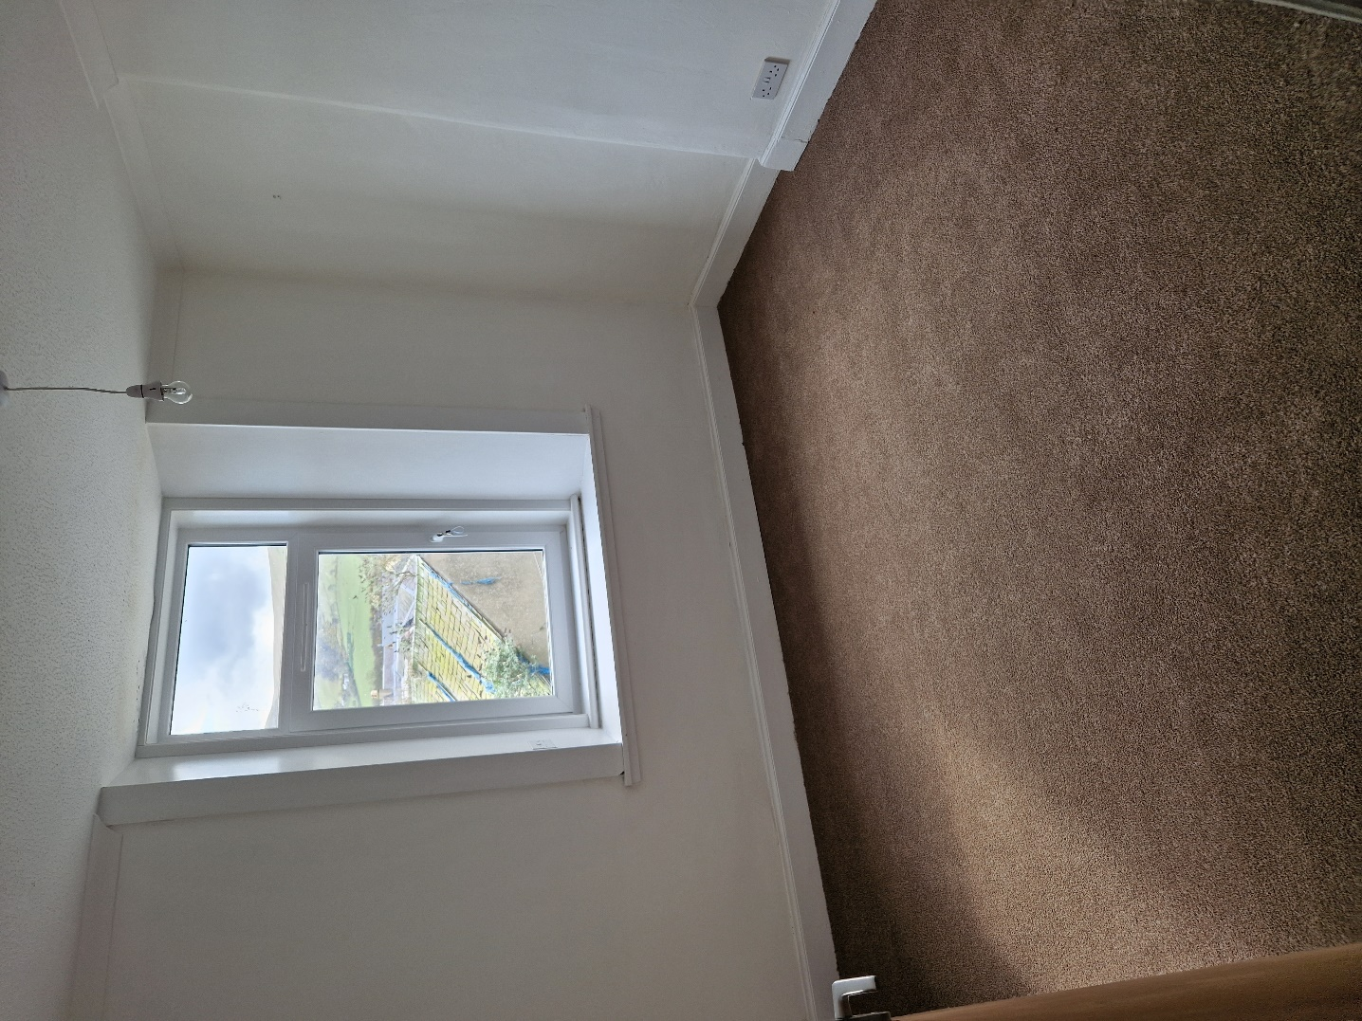

Bedroom

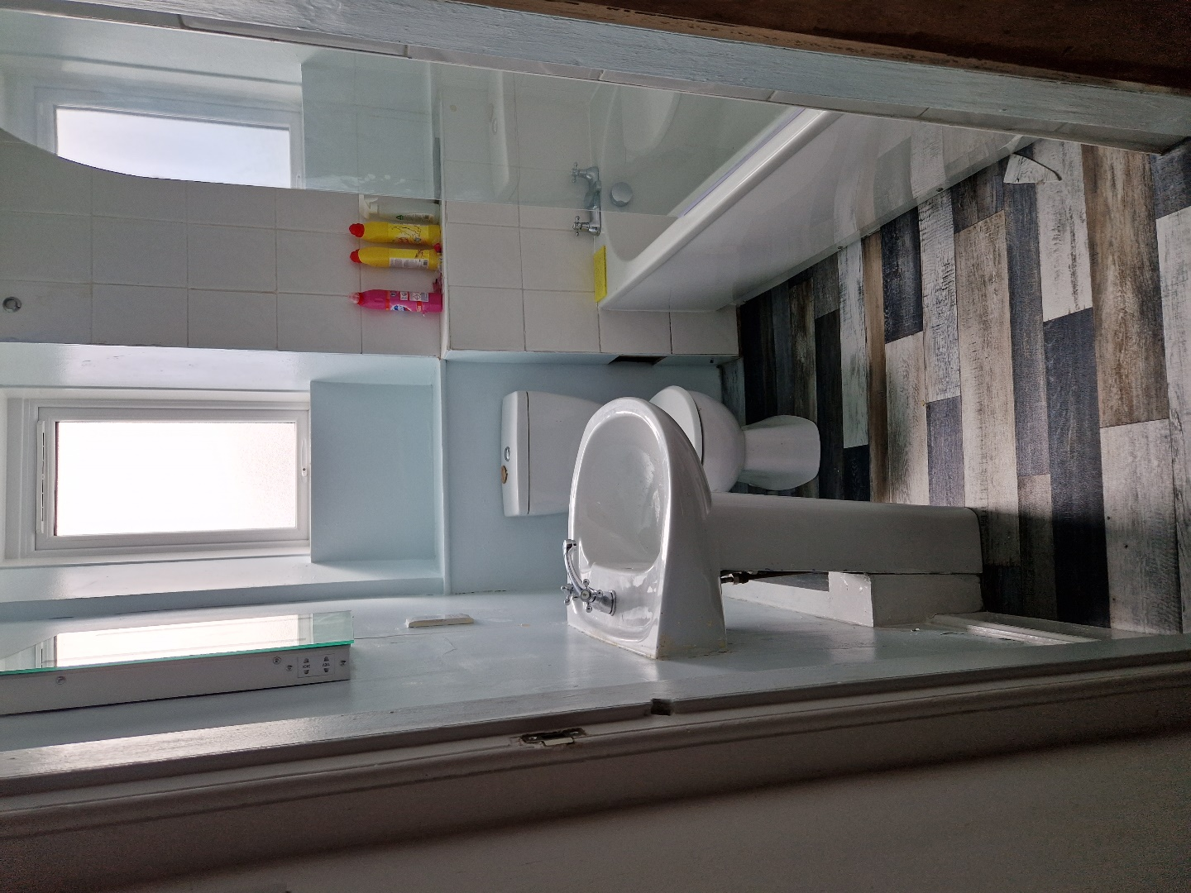

Bathroom

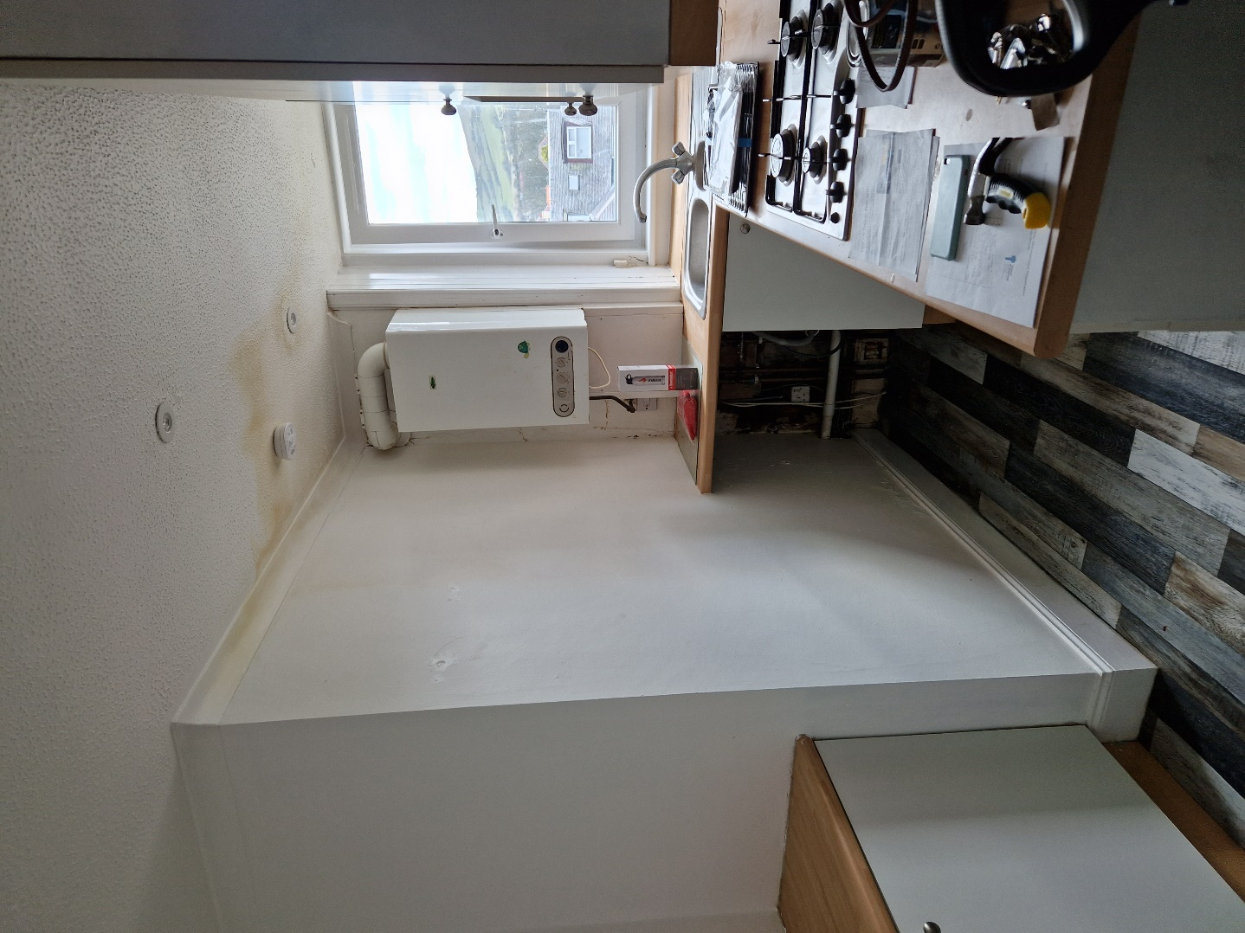

Kitchen

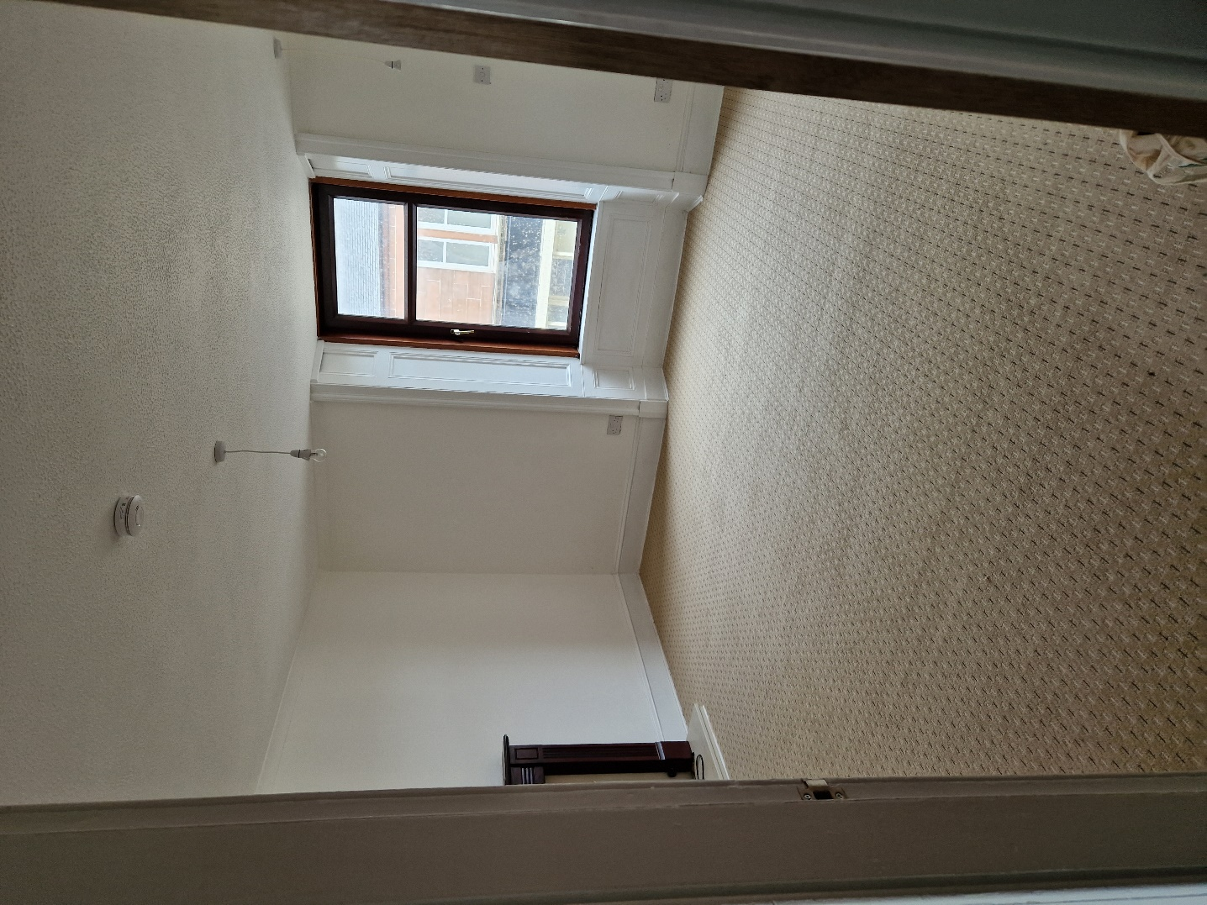

Living room

For further Information please contact Norma McGlone or Kristen Ruckledge at [Kristen.ruckledge@south-ayrshire.gov.uk](mailto:Kristen.ruckledge@south-ayrshire.gov.uk) or [norma.mcglone@south-ayrshire.gov.uk](mailto:norma.mcglone@south-ayrshire.gov.uk) or [prs@south-ayrshire.gov.uk](mailto:prs@south-ayrshire.gov.uk). Or call on 01292 473477.

Landlord Registration Number- 188041/370/12490

Letting Agent Registration Number- LARN2008004