

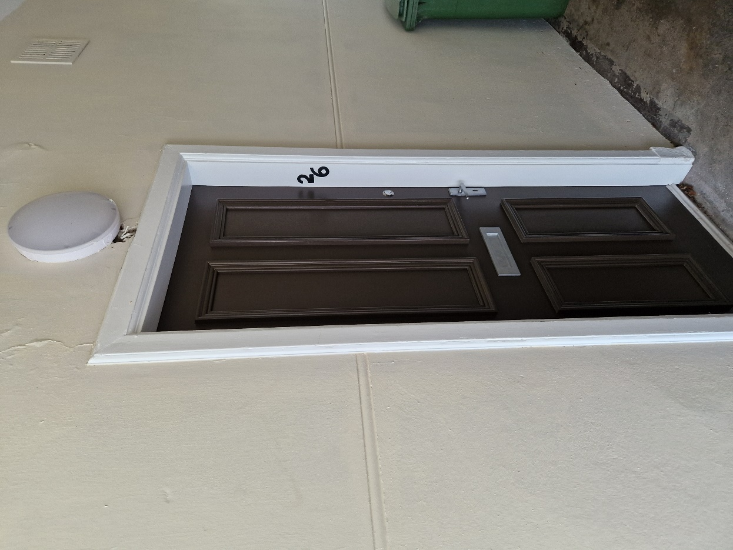

One bedroom, ground floor flat in a quiet area of Maybole

Rent £350 per month

EPC rated Band D

Council tax Band A

**Features:**

Ground level property

Double Glazed

Gas central heating

Carpet & Lino flooring

Wet Floor Shower room

Pets Allowed

Partly furnished

Electric hob and Oven

Undercounter fridge

Washing machine

**Description**

Your Choice Lettings and Property Management are delighted to present to the market, this spacious 1 bedroom, ground level flat, in a walk-in condition, located on Welltrees Street, Maybole.

This light and spacious flat, with high ceilings throughout is fully carpeted in the bedroom, hallway and living room. The bathroom has wet room flooring and Kitchen has linoleum flooring. The flat has a double bedroom situated to the front of the building, this includes a double bed, mattress, two bedside tables and a small bedside table.

The décor of the flat is a neutral colour throughout. The bathroom is a newly fitted three-piece wet floor shower room with shower curtain. The kitchen is also newly finished and contains new gas boiler, washing machine, under counter fridge, electric cooker hob with oven and grill, microwave and kettle. From the kitchen you have access to a very small, low maintenance garden area.

The local area has a range of amenities and great transport links where you will find regular buses and trains into Ayr and Glasgow.

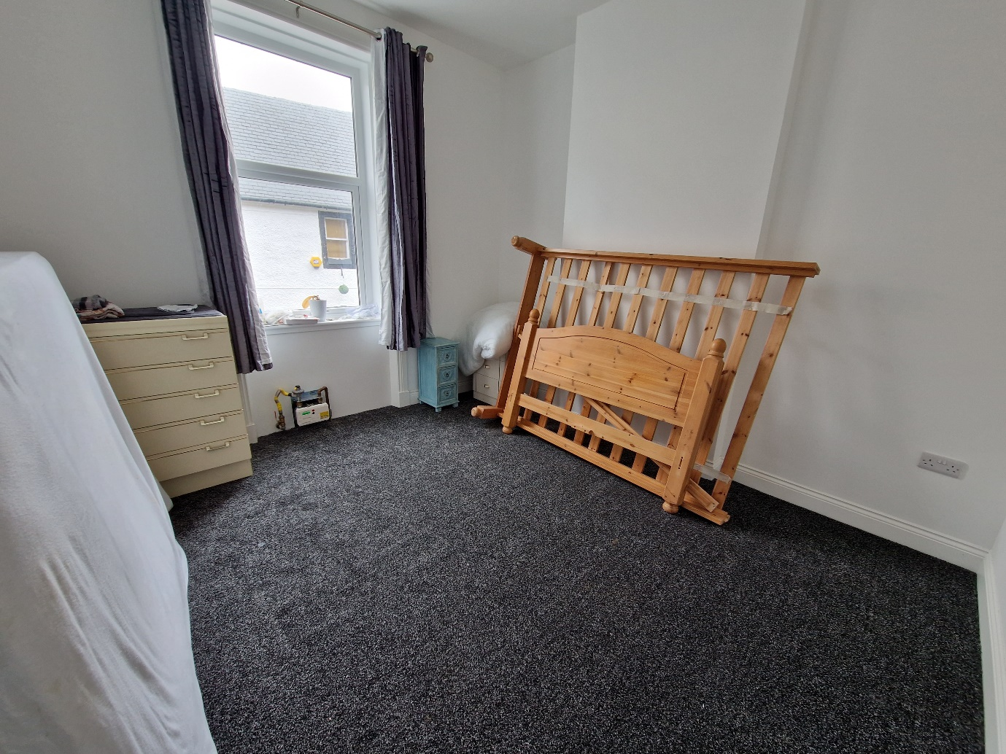Bedroom

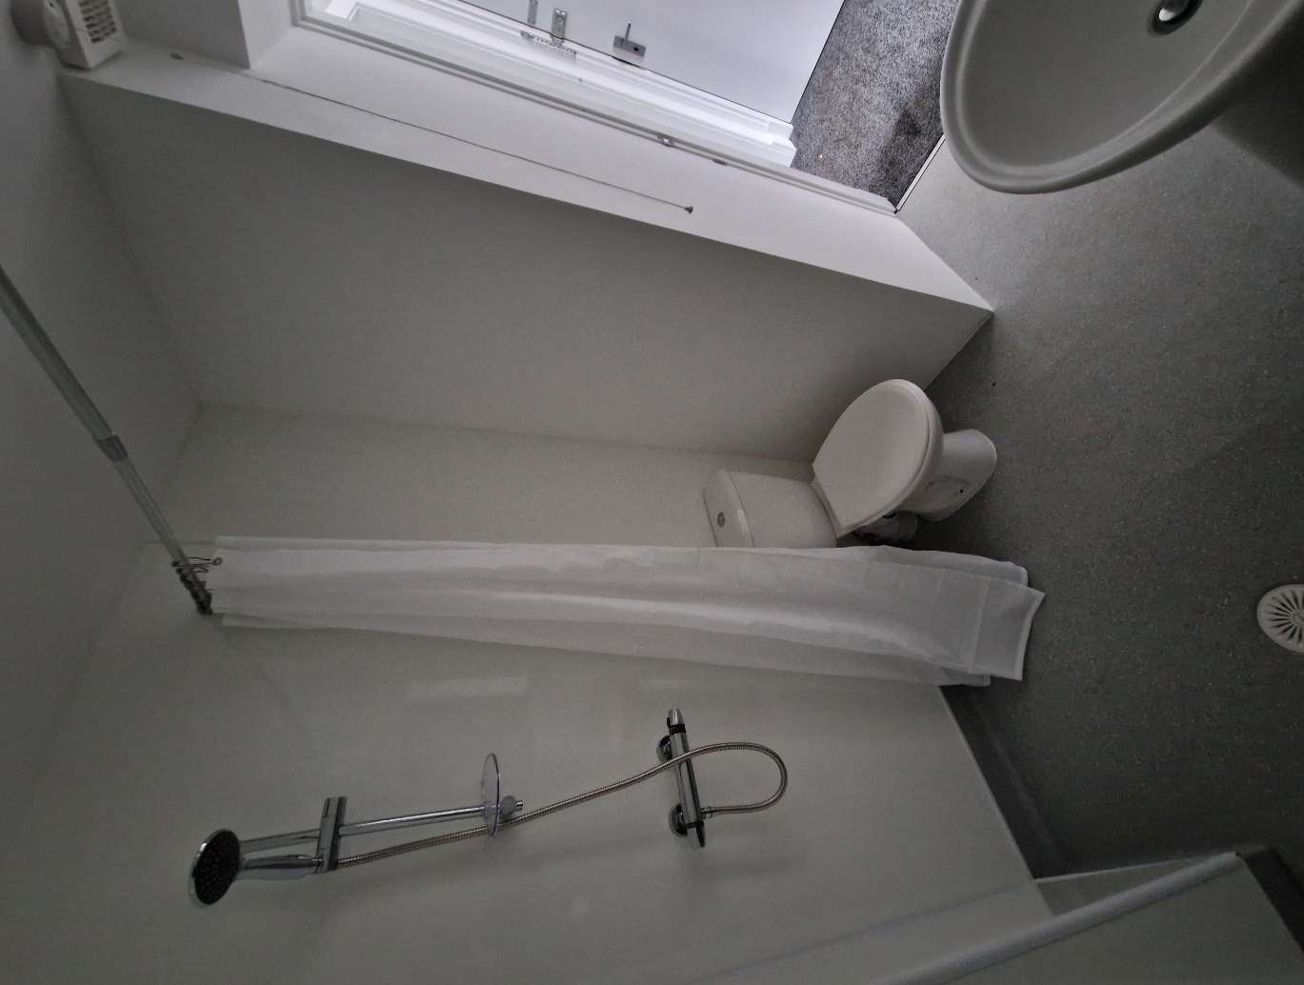

Bathroom

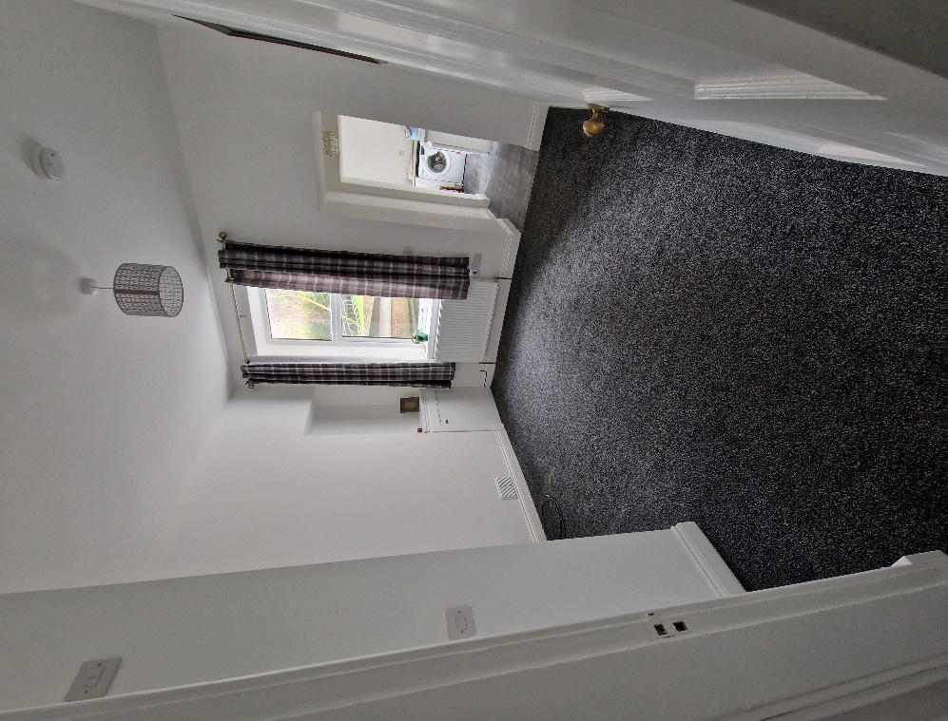

Livingroom

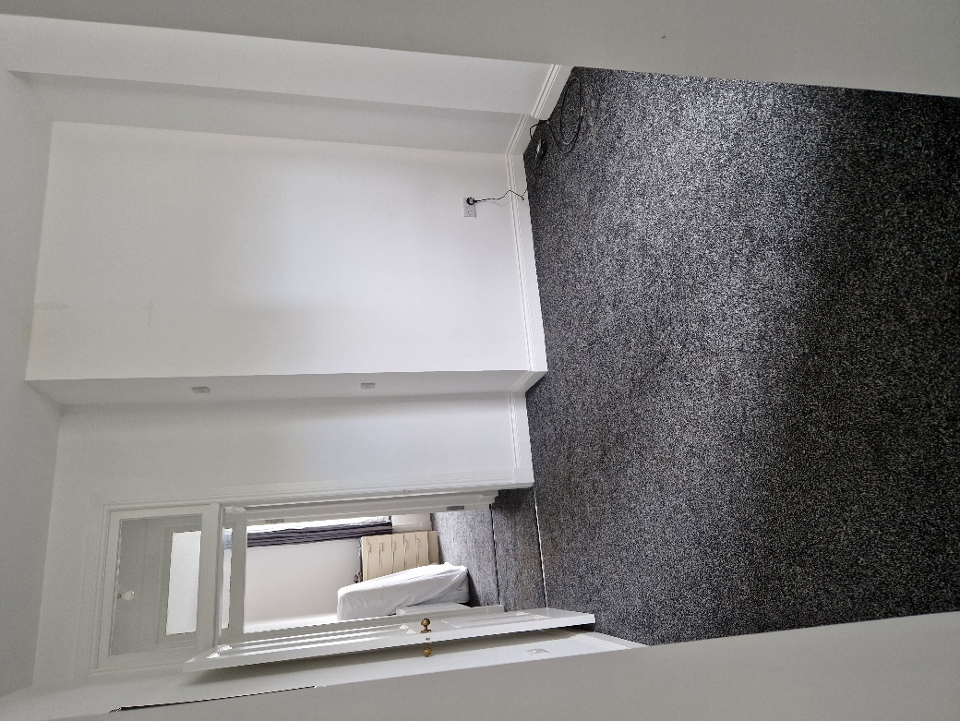

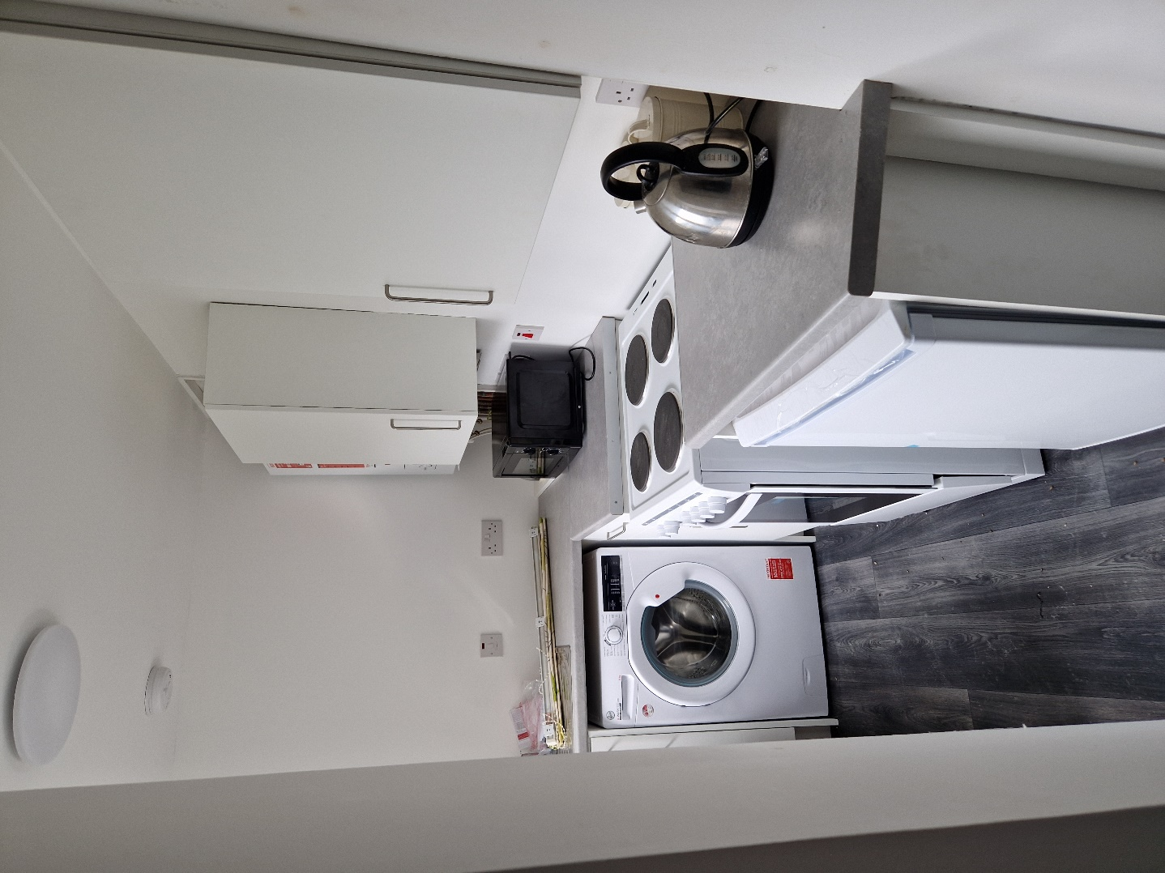

Kitchen

For further Information please contact Norma McGlone or Kristen Ruckledge at [Kristen.ruckledge@south-ayrshire.gov.uk](mailto:Kristen.ruckledge@south-ayrshire.gov.uk) or [norma.mcglone@south-ayrshire.gov.uk](mailto:norma.mcglone@south-ayrshire.gov.uk) or [prs@south-ayrshire.gov.uk](mailto:prs@south-ayrshire.gov.uk). Or call on 01292 473477.

Landlord Registration Number- 157396/370/30090

Letting Agent Registration Number- LARN2008004