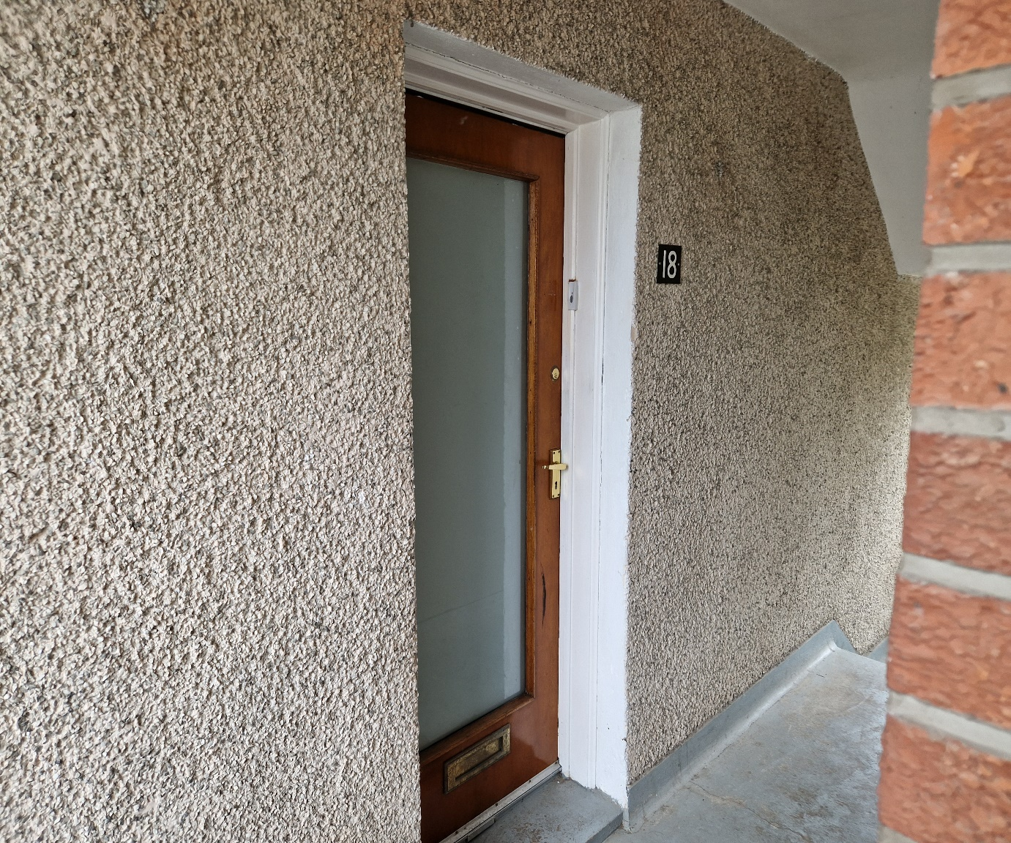

**Two-bedroom, first floor flat in a quiet area of Maybole**

Rent £450 per month

EPC rated Band D

Council Tax Band A

**Features:**

First floor property

Double Glazed

Electric heating

Garden

Kitchen-diner

Mixture of Carpet, linoleum and laminate flooring

Four-piece bathroom

Partly furnished

Built in extractor fan hood

Built in Electric hob

Built in Oven

Fridge-freezer

Washing machine

Pets Allowed

**Description**

Your Choice Lettings and Property Management are delighted to present to the market, this spacious two-bedroom flat on St Cuthberts Road, Maybole.

This light and spacious property is comprised of a large kitchen-diner, equipped with whitegoods, as well as a built-in cooker and oven. The property generously offers a large lounge and two double bedrooms, one with full length fitted wardrobes. The bathroom has a bath with overhead shower, a folding shower screen and a built-in vanity around the sink. You will find this property also offers two large storage cupboards.

The décor of the flat is a neutral colour throughout, with carpets fitted in the bedrooms, the hallway and livingroom have laminate flooring and the bathroom and kitchen have linoleum flooring. The kitchen and bathroom have newly fitted linoleum. The property has double glazed windows throughout and offers electric heating. At the back of this property there is also a garden area.

The local area has a range of amenities on the doorstep. There are great transport links close by, where you will find buses and trains that can take you to Ayr and Glasgow.

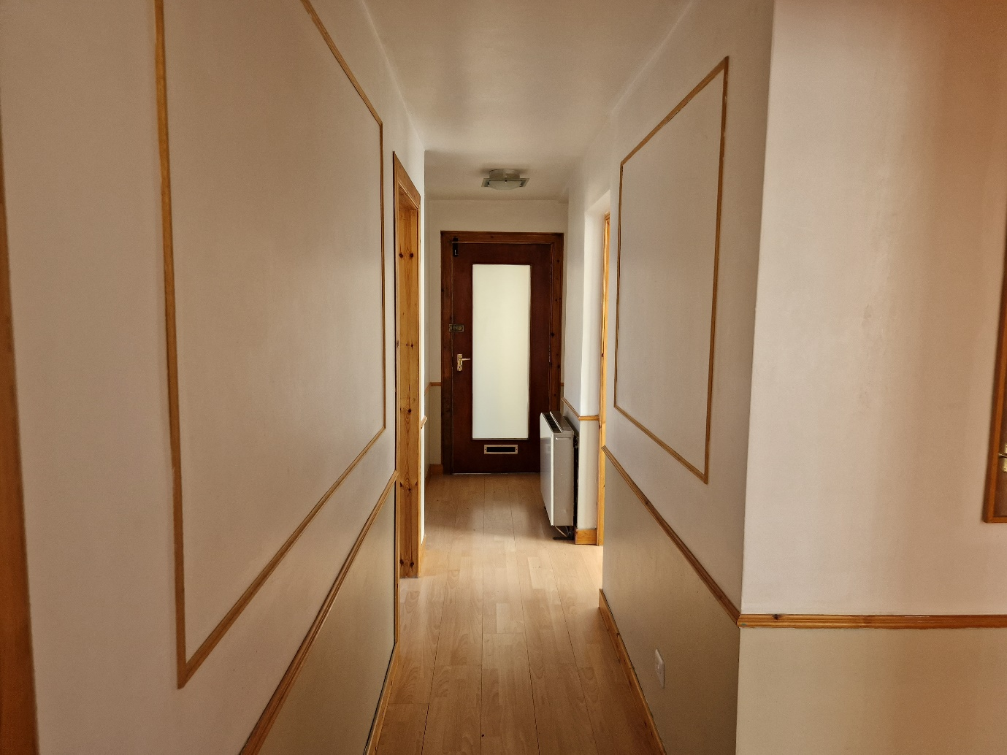Hallway

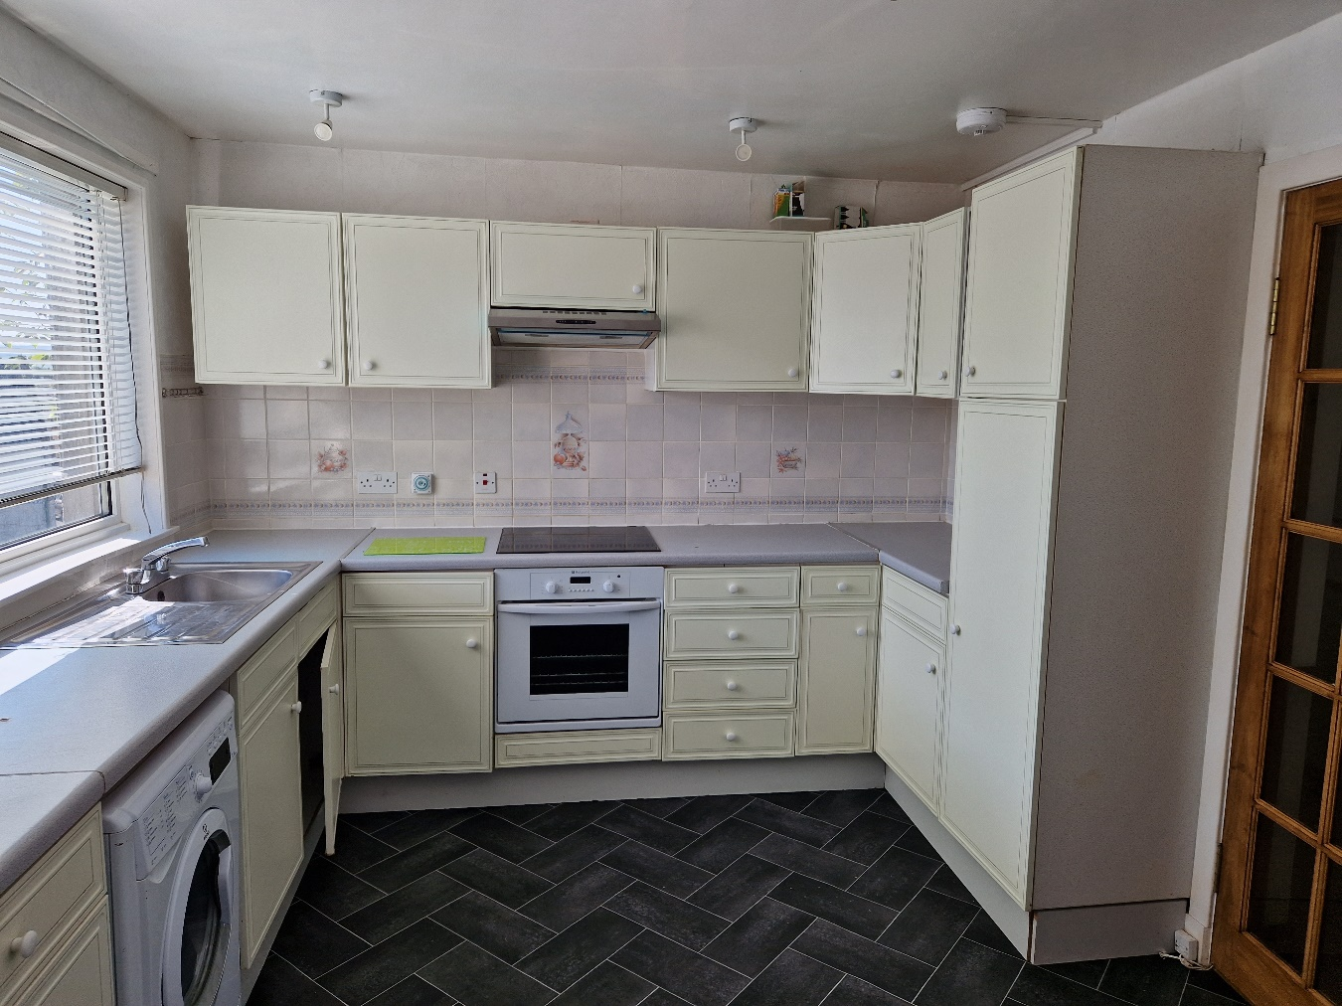Kitchen

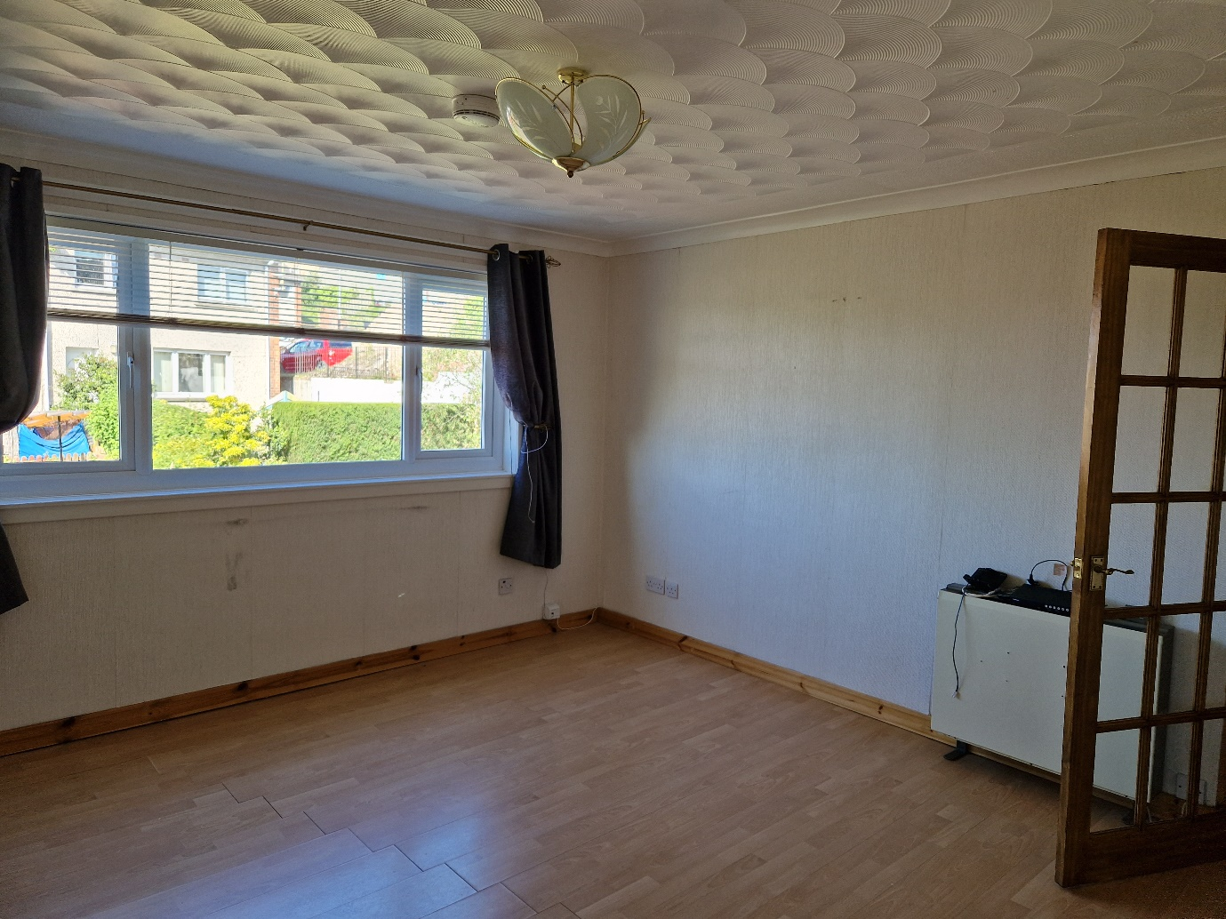Livingroom

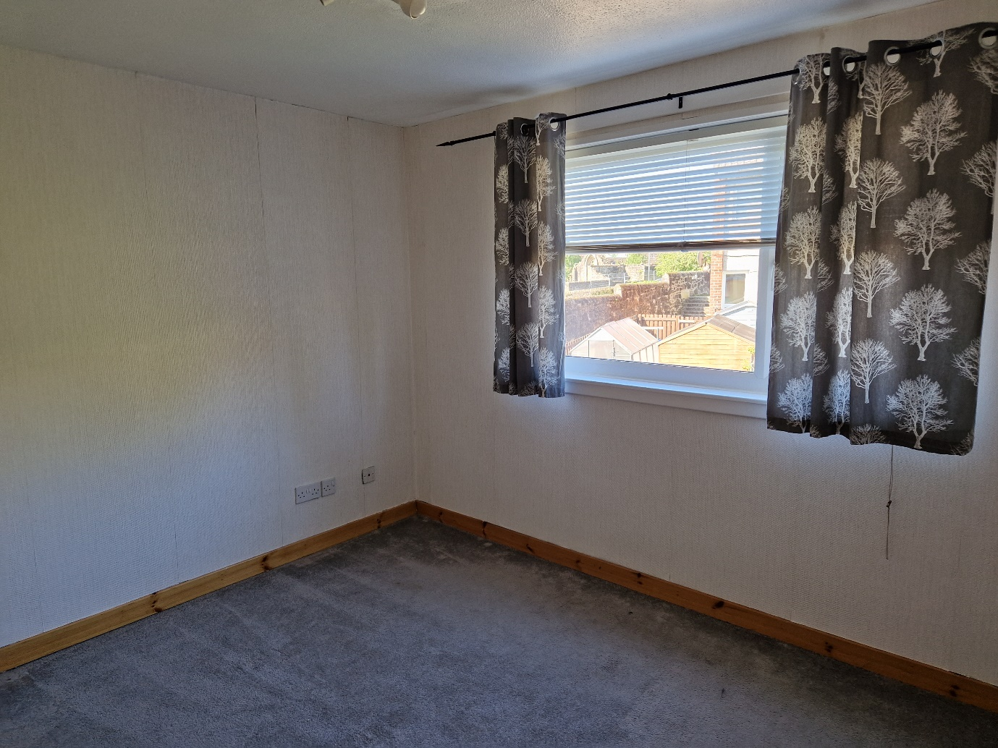Bedroom 1

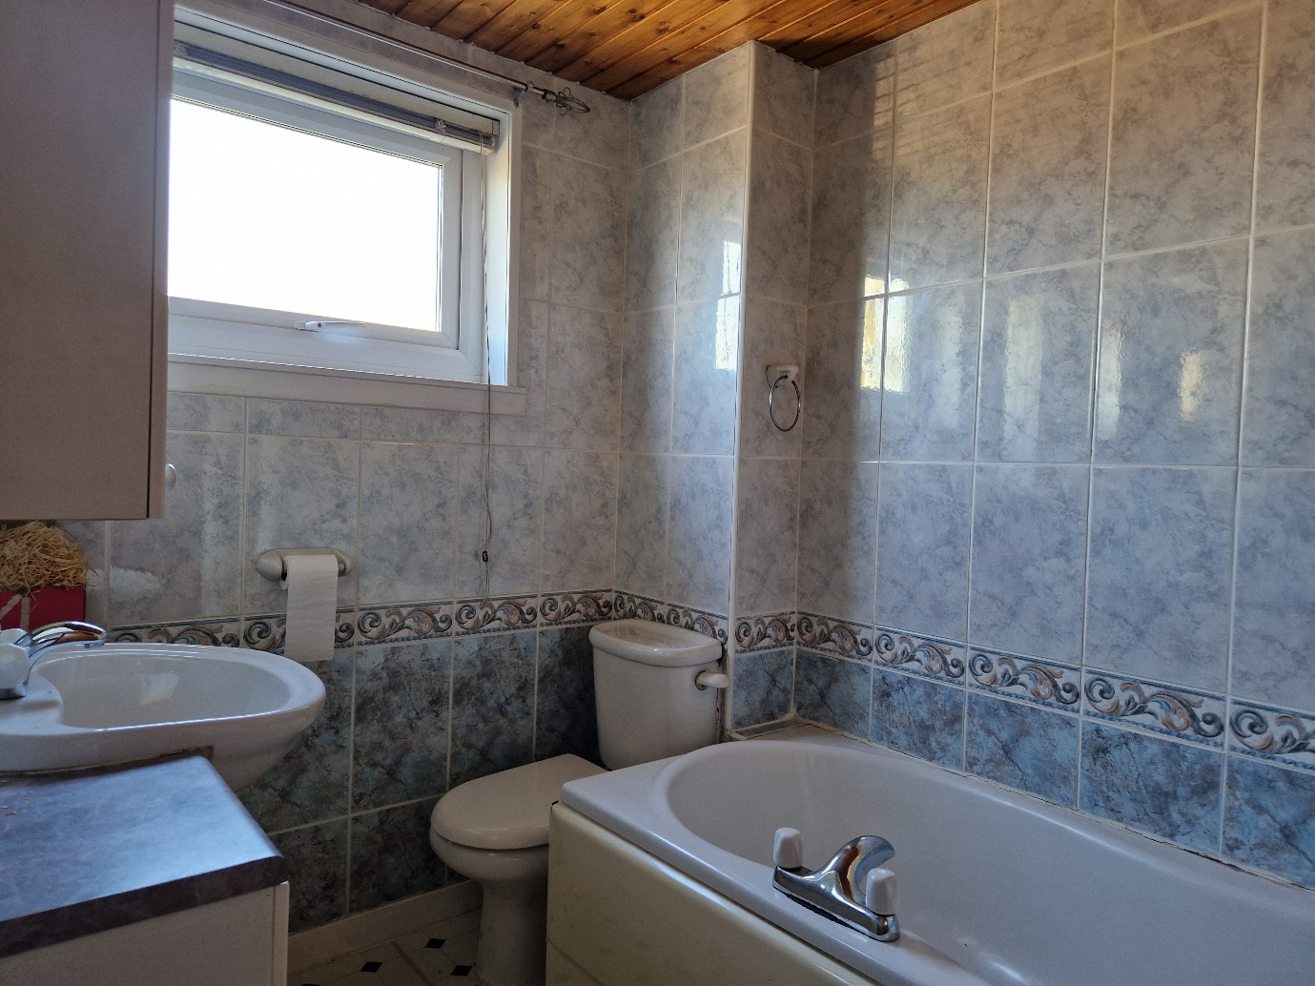Bathroom

For further Information please contact Norma McGlone or Kristen Ruckledge at [Kristen.ruckledge@south-ayrshire.gov.uk](mailto:Kristen.ruckledge@south-ayrshire.gov.uk) or [norma.mcglone@south-ayrshire.gov.uk](mailto:norma.mcglone@south-ayrshire.gov.uk) or [prs@south-ayrshire.gov.uk](mailto:prs@south-ayrshire.gov.uk). Or call on 01292 473477.

Landlord Registration Number- 988047/370/29011

Letting Agent Registration Number- LARN2008004